Consultancy Services for Design and Supervision for STP, Sewer & TE Networks Systems in Ibri

Concept Design Report
Revision 3 · September 2026

 | PO Box 579, Muscat. PC 113  Sultanate of Oman  Tel: (968) 244 84 292  Fax: (968) 244 83 039  e-mail: Renardet-oman@renardet.net

Contents
Right-click and choose Update Field to build the contents.

Figures
Right-click and choose Update Field to build the list of figures.
Tables
Right-click and choose Update Field to build the list of tables.

Abbreviations and definitions
Term | Meaning
AAF | Average annual flow: the design average of the treatment plant
APSR | Authority for Public Services Regulation
BOD | Biochemical oxygen demand
CAPEX / OPEX | Capital expenditure / operating expenditure
CESMM3 | Civil Engineering Standard Method of Measurement, third edition
COD | Chemical oxygen demand
EIA | Environmental impact assessment
GIS | Geographic information system
LPCD | Litres per capita per day
MoHUP | Ministry of Housing and Urban Planning
NCSI | National Centre for Statistics and Information
NOC | No objection certificate
OR | Occupancy rate: persons per property
PAEW | Public Authority for Electricity and Water
PE | Population equivalent
PHF | Peak hourly flow
Property | A household connection: one domestic electricity meter
Qadf | Average daily flow
Qpdf | Peak flow: the guideline's peak daily flow, equal to its peak hourly flow
SRT | Solids retention time
STP | Sewage treatment plant
TKN | Total Kjeldahl nitrogen
TSE | Treated sewage effluent, the guidelines' term for treated effluent
TSS | Total suspended solids
UTM 40N | Universal Transverse Mercator zone 40 North, WGS 84 datum
A note on the term TE
The Terms of Reference and this report use TE to mean treated effluent, the treated product of the sewage treatment plant. The NAMA design guidelines define TE as trade effluent and use TSE for treated sewage effluent. To avoid ambiguity this report writes treated effluent in full, and TSE where a guideline value is quoted.

Executive summary
This report presents the concept design for the wastewater and treated effluent systems serving Ibri, together with the sewage treatment plant that will receive the collected flow. It records the data collected, the checks applied to it, the design basis adopted and the state of the work at the date of issue. The design basis was issued on its own as the Design Basis Report and presented to Nama Water Services on 16 September 2026; this revision carries it in full.
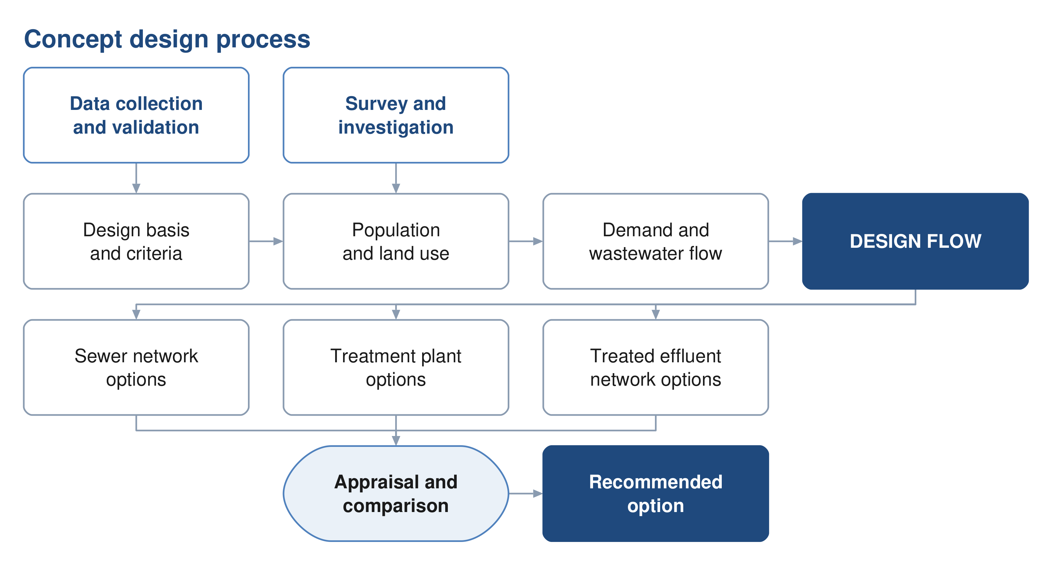
Figure 1 The concept design process, from the data collected to the recommended option.
The project area
The study area covers 531.4 square kilometres within the Wilayat of Ibri, Governorate of Adh Dhahirah, and contains twenty-five named settlements. The project boundary received covers 439.8 square kilometres; it has been extended so that every cadastral plot of the twenty-five settlements, the planned ones included, lies inside it. All spatial work is carried out in UTM zone 40 North on the WGS 84 datum.
Data collected
Data has been obtained from Nama Water Services covering the existing wastewater assets, the potable water network, electricity accounts and the cadastral plot layer. The datasets have been loaded into the project geographic information system, checked against the project boundary and assessed for completeness. Section 7 records the outcome in full. Four points are carried through the report.
Existing assets — the wastewater dataset holds two networks. The constructed network, dated 2006, comprises 111.6 kilometres of gravity sewer and 10.0 kilometres of force main. A further 199.3 kilometres of gravity sewer, 23.2 kilometres of pumping main and the whole of the 45.7 kilometre treated effluent main are recorded as proposed. No treated effluent asset has been built.
Potable water — the PAEW dataset provides 647.8 kilometres of water mains within the study area, and is adopted as the source for utility interfaces.
Electricity accounts — 33,971 meters have been placed on the plots to establish the number of properties on each and its use.
Survey — a topographic and utility survey covering the whole study area is in progress and will confirm levels, diameters and asset condition.
Design basis
Wastewater generation is derived from water demand in accordance with the NAMA design guidelines. For the Governorate of Adh Dhahirah the domestic consumption rate is 164 litres per person per day, with 22 per cent added for non-domestic and 14 per cent for governmental consumption. Return rates of 85 per cent for domestic and tanker supply and 54 per cent for the rest give the wastewater flow.
The occupancy rate is set for each settlement as its 2024 population divided by the domestic electricity meters counted in it, with a floor of four persons per property, a cap of 6.12, the highest rate among the larger settlements, and four for a settlement of fewer than a thousand people. Ibri returns 6.07. Section 14 sets out the derivation.
Population and flows
Every plot in the study area carries a population and an average sewage flow, for 2024 and for every year to the year its settlement is full. The use of each plot is determined from the meters on it and from a satellite image of September 2026; the capacity of the empty land is read from the built plots around it; each settlement grows at the rate of the official series and fills its own land before its growth moves to its neighbours. The study area holds 119,893 people in 2024 and generates 20,852 cubic metres of sewage a day. Ibri's land is full in 2056; the last settlement fills in 2070, with 349,029 people and 60,099 cubic metres a day.
Table 1 The study area in the design years
Year | People | Average sewage flow, m³/d | STP average with the margin, m³/d | STP peak hour with the margin, m³/d
2024, base | 119,893 | 20,852
2030, opening year | 139,535 | 24,216 | 26,638 | 48,003
2055, opening year plus 25 | 244,914 | 42,266 | 46,492 | 78,322
2070, saturation | 349,029 | 60,099 | 66,109 | 106,724

If the whole area drains to one STP, its design average in 2070 is 66,109 cubic metres a day and its peak hour 106,724, with the ten per cent margin and before infiltration and tankers. At the guideline's minimum loads of 60 grams of BOD and 80 grams of suspended solids per person per day the plant receives 20,942 kilograms of BOD a day at saturation.
Two industrial estates inside the town, at Al Tayyeb and Tanam, were found under the commercial tariff and are treated as special consumption. The army camp, a planned resort and two sources of tankered sewage outside the boundary are recorded in Section 16.
Decisions requested
Only what the guidelines do not settle is put to Nama Water Services for approval: 7 decisions, listed below and explained in the sections named. 8 further values are the guidelines' own or stated assumptions; they are adopted and reported. No decision had been taken at the date of this report. The largest of them is the overflow: without it 7 settlements never fill, and 75,414 people of the series have nowhere to go by 2070. Section 5 gives the decisions, the adopted values, the other matters awaiting confirmation and the 7 data requests.
Table 2 The decisions requested from Nama Water Services
 | Decision | Section
1 | Settlement boundaries | 14.2
2 | Persons per property | 14.4
3 | Use of each plot | 14.5
4 | The overflow | 14.8
5 | The design horizon | 14.9
6 | The growth beyond 2050 | 14.7
7 | Gradients and self-cleansing at the concept stage | 12.2

State of the work
The design basis, the data assessment, the population and flow series and the assessment framework are complete. The concept hydraulic calculations for the sewer network have been completed on the basis set out here, and those for the treated effluent network and the treatment plant have begun. The topographic and utility survey is in progress; the hydraulic assessment of the existing networks follows it. The options for the sewer network, the treated effluent network and the treatment plant are presented as a framework in Part F and will be completed once the decisions of Section 5 are taken.
How the options are developed and compared
Three options are developed for each of the sewer network, the treated effluent network and the treatment plant. Each set follows the character the guidelines describe: one advancing sustainability, one representing international best practice, and one based on practice already established in Oman. Every option meets the same functional requirement and the same effluent standard, so that the difference between them lies in how the result is achieved. Section 21 sets out what distinguishes them in design terms.
The options are compared over a twenty-five year period against seven criteria: total lifetime cost; sustainability, comprising carbon, circular economy and nature-based solutions; social development and in-country value; adaptability and resilience; operability; constructability; and environmental impact. Costs are discounted at five per cent. Nama Water Services sets the weight given to each criterion.
Where two options fall within ten per cent of one another on total lifetime cost they are treated as equivalent in cost, and the more sustainable of the two is adopted. Sensitivity is tested by varying the weighting between criteria, the discount rate, and the input design criteria.
Deliverables
The Terms of Reference set out forty numbered deliverables for the concept stage. This report issues the design basis, the assessment of the data, the design criteria, the population and flow series to saturation and the framework for the options and their appraisal. The options themselves, the cost estimate and the comparison follow once the design horizon is decided and the survey is complete. Section 3.1 lists each deliverable and its position.

PART A

Project, scope and process

1. Introduction and background
Nama Water Services is developing wastewater collection, treated effluent distribution and sewage treatment for the Wilayat of Ibri. Renardet S.A. & Partners has been appointed to provide consultancy services for the design and supervision of these works.
This report is the concept design deliverable. It establishes the design basis, records and assesses the data collected, and sets out the framework within which options for the sewer network, the treated effluent network and the treatment plant are developed.

1.1. Objectives
The Terms of Reference set three objectives for the work: to verify the Regional Master Plan, to establish the ultimate expected sewage flow in the Ibri catchment, and to develop the concept, preliminary and detailed designs together with the tender documentation.

1.2. Structure of this report
The report follows the structure approved for the concept stage. Part A records the project and its process. Part B presents the data and the assessment of it. Part C sets out the design basis. Part D establishes demand and flow. Part E assesses the existing system. Part F presents the options. Part G carries the technical and financial appraisal, and Part H the delivery arrangements.

2. Scope and boundaries

2.1. The study area
The study area covers 531.4 square kilometres and contains twenty-five named settlements. Ibri is the principal settlement; the remainder are distributed along the wadi system and the main road corridors.

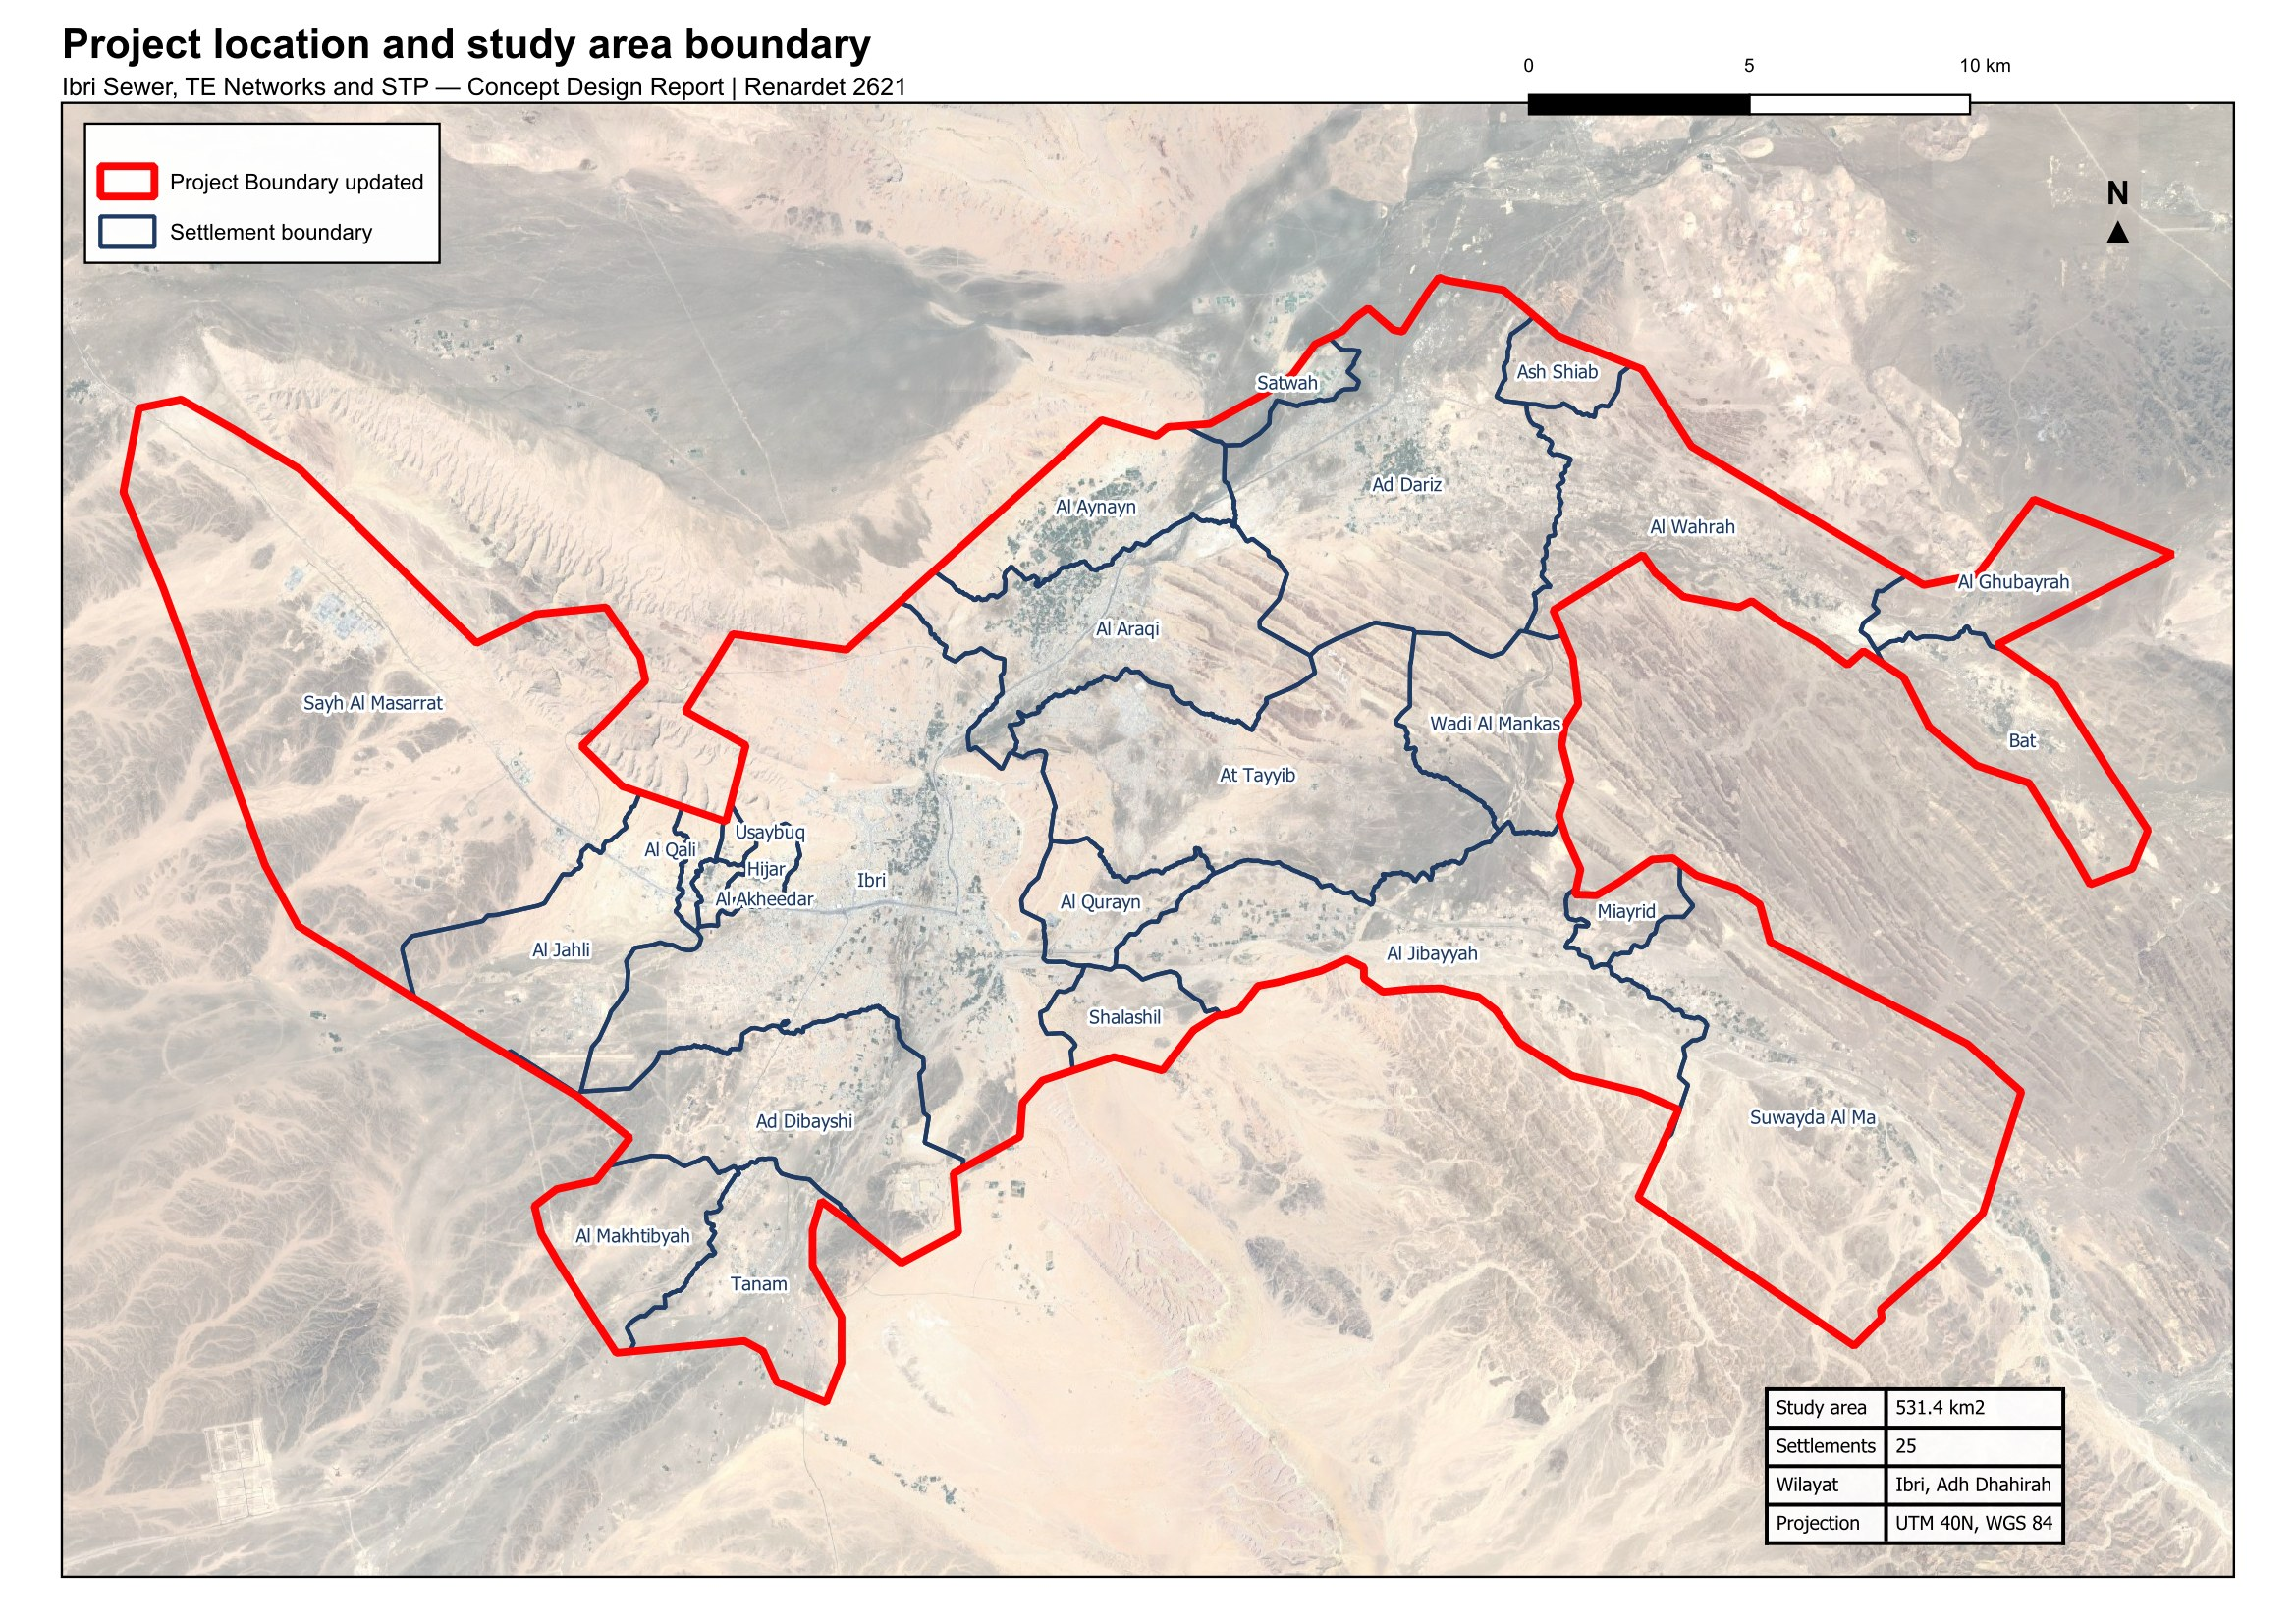
Figure 2 Project location and study area boundary, showing the twenty-five settlements within the Wilayat of Ibri.

2.2. Boundary
The project boundary received covers 439.8 square kilometres. The cadastral plots of the twenty-five settlements, the planned ones included, reach beyond it in several places. The boundary has therefore been updated to take in every plot of those settlements, and covers 531.4 square kilometres. All the work presented here is on the updated boundary, and confirmation of it is requested (Section 5.3).

2.3. Coordinate system
All spatial data is held and all measurements are made in Universal Transverse Mercator zone 40 North on the WGS 84 datum. Datasets supplied in geographic coordinates have been reprojected. Levels are referenced to the terrain model described in Section 8.

3. Programme and design stages
The design comprises four stages: concept design, preliminary design, detailed design and the preparation of tender documents. Each stage is submitted for review and approval before the following stage begins.
The Terms of Reference allow sixty days for the concept design and a further twenty-one days for review. The preliminary design stage begins on approval of the concept design for the treatment plant.
Two programmes have been issued during mobilisation, in the kick-off presentation and in the Inception Report. Confirmation of the governing programme is requested.

3.1. Deliverables at the concept stage
The Terms of Reference set out forty numbered deliverables for the concept stage. They are grouped below by subject. Those marked as issued form part of this report or accompany it; the remainder follow in the next revision as the survey and the options are completed.
Table 3 Concept stage deliverables
Deliverable | Position
Executive summary and project schedule | Issued
Data collection report and assessment of the data | Issued
Design criteria and design basis | Issued
Population forecasting and flow projection at five-year intervals | Issued: population and flow per settlement at five-year intervals to saturation, and per plot
Topographic survey and geotechnical investigation | Survey team mobilised; in progress
As-built records and GIS for the existing systems | Follows the survey
Hydraulic assessment of the existing systems | Follows the survey
Concept hydraulic calculations and capacities | Sewer network completed on the basis of this report; treated effluent network and treatment plant begun
Wastewater network options, not fewer than three | Next revision
Treated effluent network options, not fewer than three | Next revision
Treatment plant options, not fewer than three, with siting and phasing | Siting and decision matrix in progress; options in the next revision
Pumping and lifting station concept design | Next revision
Treated effluent and sludge management strategy | Framework issued; strategy in the next revision
Excess effluent and emergency overflow provisions | Next revision
Environmental impact assessment for the plant location | Follows confirmation of scope
Cost estimates and life cycle cost | Method adopted, 25 years at 5 per cent; estimates in the next revision
Risk analysis and value engineering | Next revision
Multi-criteria comparison and recommended option | Next revision
Hydraulic models in SewerGEMS and WaterGEMS | Follows confirmation of the software
Contracting strategy and implementation plan | Next revision
Register of approvals and no objection certificates | Maintained

3.2. Deliverables of the following stages
The preliminary design develops the approved concept to an estimate within ten per cent, with full survey, hazard and operability study, and preliminary bills of quantities. The detailed design completes the engineering, the drawings and the priced bills. Tender documentation follows the approved detailed design.

4. Consultation record
The following meetings have been held with Nama Water Services to the date of this report.
Table 4 Meetings held
Meeting | Date | Outcome
Kick-off meeting | 15 July 2026 | Project scope, approach, programme and organisation presented
Inception Report submission | August 2026 | Design basis, methodology and programme submitted
Design basis meeting | 16 September 2026 | Progress reported; the Design Basis Report presented; seven decisions put to Nama Water Services, none taken at the meeting; a maximum gradient of 4 per cent from the tractive-force method at head pipes indicated by Nama Water Services

Coordination with the authorities holding assets in the project area is described in Section 33, together with the register of approvals and no objection certificates.

5. Decisions requested and matters requiring confirmation
Only what the guidelines do not settle is put to Nama Water Services for approval. Section 5.1 lists those 7 decisions; each can be answered with a yes, a no, or one figure, and a no returns the design to the section named. Section 5.2 lists the values adopted from the guidelines and the stated assumptions, for information. Section 5.3 lists the other matters that await confirmation, and Section 5.4 the data requested. No decision had been taken at the date of this report.

5.1. Decisions requested
Settlements and people
1. Settlement boundaries. Approve the twenty-five settlement boundaries redrawn so that every plot lies in one settlement and there are no gaps between them (Section 14.2).
2. Persons per property. Approve the persons per property calculated for each settlement, with the floor of 4.0, the cap of 6.12 and the rule for settlements under a thousand people (Section 14.4).
3. Use of each plot. Approve the use determined for each plot from the meters and the satellite image, as the basis for placing the loads (Section 14.5).
Growth
4. The overflow. Approve the overflow: when a settlement's land is full, its further growth moves to its neighbours. Without it 75,000 people of the series have nowhere to go by 2070 (Section 14.8).
5. The design horizon. Decide the design horizon: 2055, the opening year 2030 plus 25 years, with 244,914 people and 42,266 cubic metres a day; or 2070, the year the land is full, with 349,029 people and 60,099 cubic metres a day (Section 14.9).
6. The growth beyond 2050. Approve the extension of the population series beyond 2050: the rise to 2.40 per cent a year by 2058 and that rate held to 2100. The series to 2050 is the client's own (Section 14.7).
The network
7. Gradients and self-cleansing at the concept stage. Approve the concept-stage rule: pipes laid at the Table 11 minimum gradient; the tractive-force test at 1 pascal used only to list the pipes needing early washing, with a pipe carrying less than 1.5 l/s checked as if it carried 1.5. The guideline asks for the steeper of the two gradients; this is a departure (Section 12.2).

5.2. Values adopted, for information
Settlements and people
8. The 126 meters with no plot within 15 metres. They are left out of the plot loads: about 140 people (Section 14.3).
Water and sewage rates
9. Water demand and return. 164 litres per person per day, plus 22 per cent for shops and offices and 14 per cent for government, the values the guideline publishes for Adh Dhahirah; 85 per cent of domestic and tanker supply and 54 per cent of the rest return to the sewer. The published ratios are used in place of the unit rates per pupil, bed, employee and floor area until those quantities are held (Sections 15.1 and 15.3).
10. The industrial estates. 4,500 workers at Al Tayyeb and 1,800 at Tanam at 93 litres a day each, an assumption to be replaced by the estates' records when received (Section 15.2).
Growth
11. The connection ratio. 61 per cent of properties connected in 2030, the Inception Report's ratio, used only for the early-year self-cleansing check (Section 15.8).
The network
12. Infiltration and peak flow. 720 litres a day per kilometre of sewer, added to each pipe and left out of the early-year check; the Merrimack formula above 100 properties and the Peltier formula at 100 or fewer (Sections 15.5 and 15.6).
13. Depth. 12 metres of cover is the limit at the concept stage, with a pumping station before that point; the preliminary design looks deeper where the quantities allow the cost to be calculated (Section 12.3).
The plant and the effluent
14. STP flows and loads. The average annual flow and the peak hourly flow with the 10 per cent margin as the guideline defines them; 60 grams of BOD and 80 grams of suspended solids per person per day, the guideline's minimum, until the laboratory data of the existing STP are received; the maximum day flow from that plant's records (Sections 13.1 and 15.8).
15. Treated effluent. 95 per cent of the STP inflow produced as treated effluent and 10 per cent of it lost in the distribution network (Section 17).

5.3. Other matters requiring confirmation
Each of the matters below affects work that would otherwise be carried out twice, and confirmation is requested at the earliest opportunity.
Table 5 Other matters requiring confirmation
Matter | What is to be confirmed | Reference
Project boundary | The updated project boundary of 531.4 square kilometres, which takes in every plot of the twenty-five settlements, and the extent to be surveyed | Section 2.2
Project figures | Georeferenced versions of Figures 1, 2 and 3 of the tender, which define the project location, the areas requiring as-built records and the areas subject to each design stage; they are supplied as images without coordinates | Scope of Work
Hydraulic modelling software | The software for the deliverable models: the Scope of Work requires SewerGEMS and WaterGEMS, and the staffing schedule of the tender refers to a different package | Scope of Work, pages 56, 57, 62, 65 and 73; Bidding Form 24, page 123
Environmental impact assessment | The scope required at this stage: the guidelines place the scoping at the preliminary design in one clause and the full assessment at the concept and preliminary stages in another | PAM-GUD-201, Table 2, pages 19 to 22, and Section 6.1.4.3, page 44
Terminology | That TE, as used in the Terms of Reference and in this report, means treated effluent | Abbreviations
Design manual reference | That the treatment plant location report follows Section 10.1 of PAM-GUD-203, Site Selection, which replaced item 2.1 of Section 05 of the former Wastewater Design Manual | PAM-GUD-203 Revision 01, pages 2, 63 and 64
Governing programme | Which of the two programmes issued during mobilisation governs | Section 3
Maximum gradient by tractive force | How the limit of 4 per cent at head pipes, indicated by Nama Water Services on 16 September 2026, is to be applied | Section 12.2
Margin and peak at the treatment plant | That the 10 per cent margin is applied to the peak hourly flow as to the average annual flow | Section 13.1
Potable water record | That the PAEW dataset is the current record for Ibri | Section 7.2

5.4. Data requested
7 items would improve or confirm the numbers in this report. None of them stops the concept design; each replaces an assumption with a record.
Table 6 Data requests
Item | What is asked for | Why
Tanker water and sewage tankers | Filling-station volumes by area and sewage tanker deliveries to the STP, with their source | Water supplied by tanker is not in any flow. It can only raise the loads.
Private wells | Any record of private abstraction inside the study area | The guideline requires it to be assessed. Not held.
Existing STP records | Daily inflow and the laboratory results for the Ibri STP, three years | Sets the maximum day flow and checks the per-person loads.
Industrial estates | Workforce and water use of the Al Tayyeb and Tanam estates | Replaces the assumed 4,500 and 1,800 workers.
Army camp | Occupancy and drainage arrangement of the camp west of the town | 296 hectares with no meter in the dataset.
Ibri View | The development plan of the resort at As Sulayf | Two square kilometres announced; no load carried until the plan is issued.
Non-domestic quantities | Pupils, beds, employees and floor areas by plot, where held | Would allow the unit rates of the guideline in place of the ratios.

PART B

Data

6. Data collection
Data has been requested from Nama Water Services and from the authorities holding assets in the project area. The table below records what has been requested and the position at the date of this report.
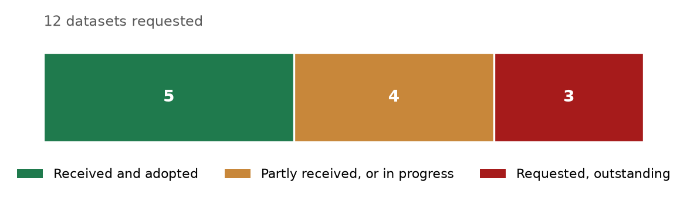
Figure 3 Position of the data register at the date of issue.
Table 7 Data register
Dataset | Received | Position
Constructed sewer network, as-built | Yes | Geometry received, dated 2006. Levels and diameters not recorded; being surveyed
Constructed force main | Yes | Received, dated 2006
Treated effluent network | Proposed only | The dataset contains no constructed treated effluent asset
Lifting station details | Partial | One station located; equipment and duty details being surveyed
Treatment plant records | Partial | Location and nominal capacity received; operating data outstanding
Electricity account data | Yes | Received
Cadastral plot data | Yes | Received. Land use and missing plots being addressed
Potable water network | Yes | Received as part of the PAEW dataset
Topographic survey | In progress | Survey team mobilised
Integrated Master Plan | No | Requested
Plant inflow and tanker records | No | Requested
Electricity, telecom and gas service records | No | To be requested from the respective owners

A topographic and utility survey covering the whole study area is in progress. It will establish cover and invert levels, diameters, materials and condition for the existing sewer, force main and treated effluent networks, together with the lifting stations, the topography and the cadastral boundaries including plot gates. The results will be incorporated in the next revision of this report.

7. Assessment of the data
Each dataset has been loaded into the project geographic information system, reprojected where necessary, and checked against the project boundary. This section records the quantity of each dataset, the proportion falling within the study area, and the limitations identified.
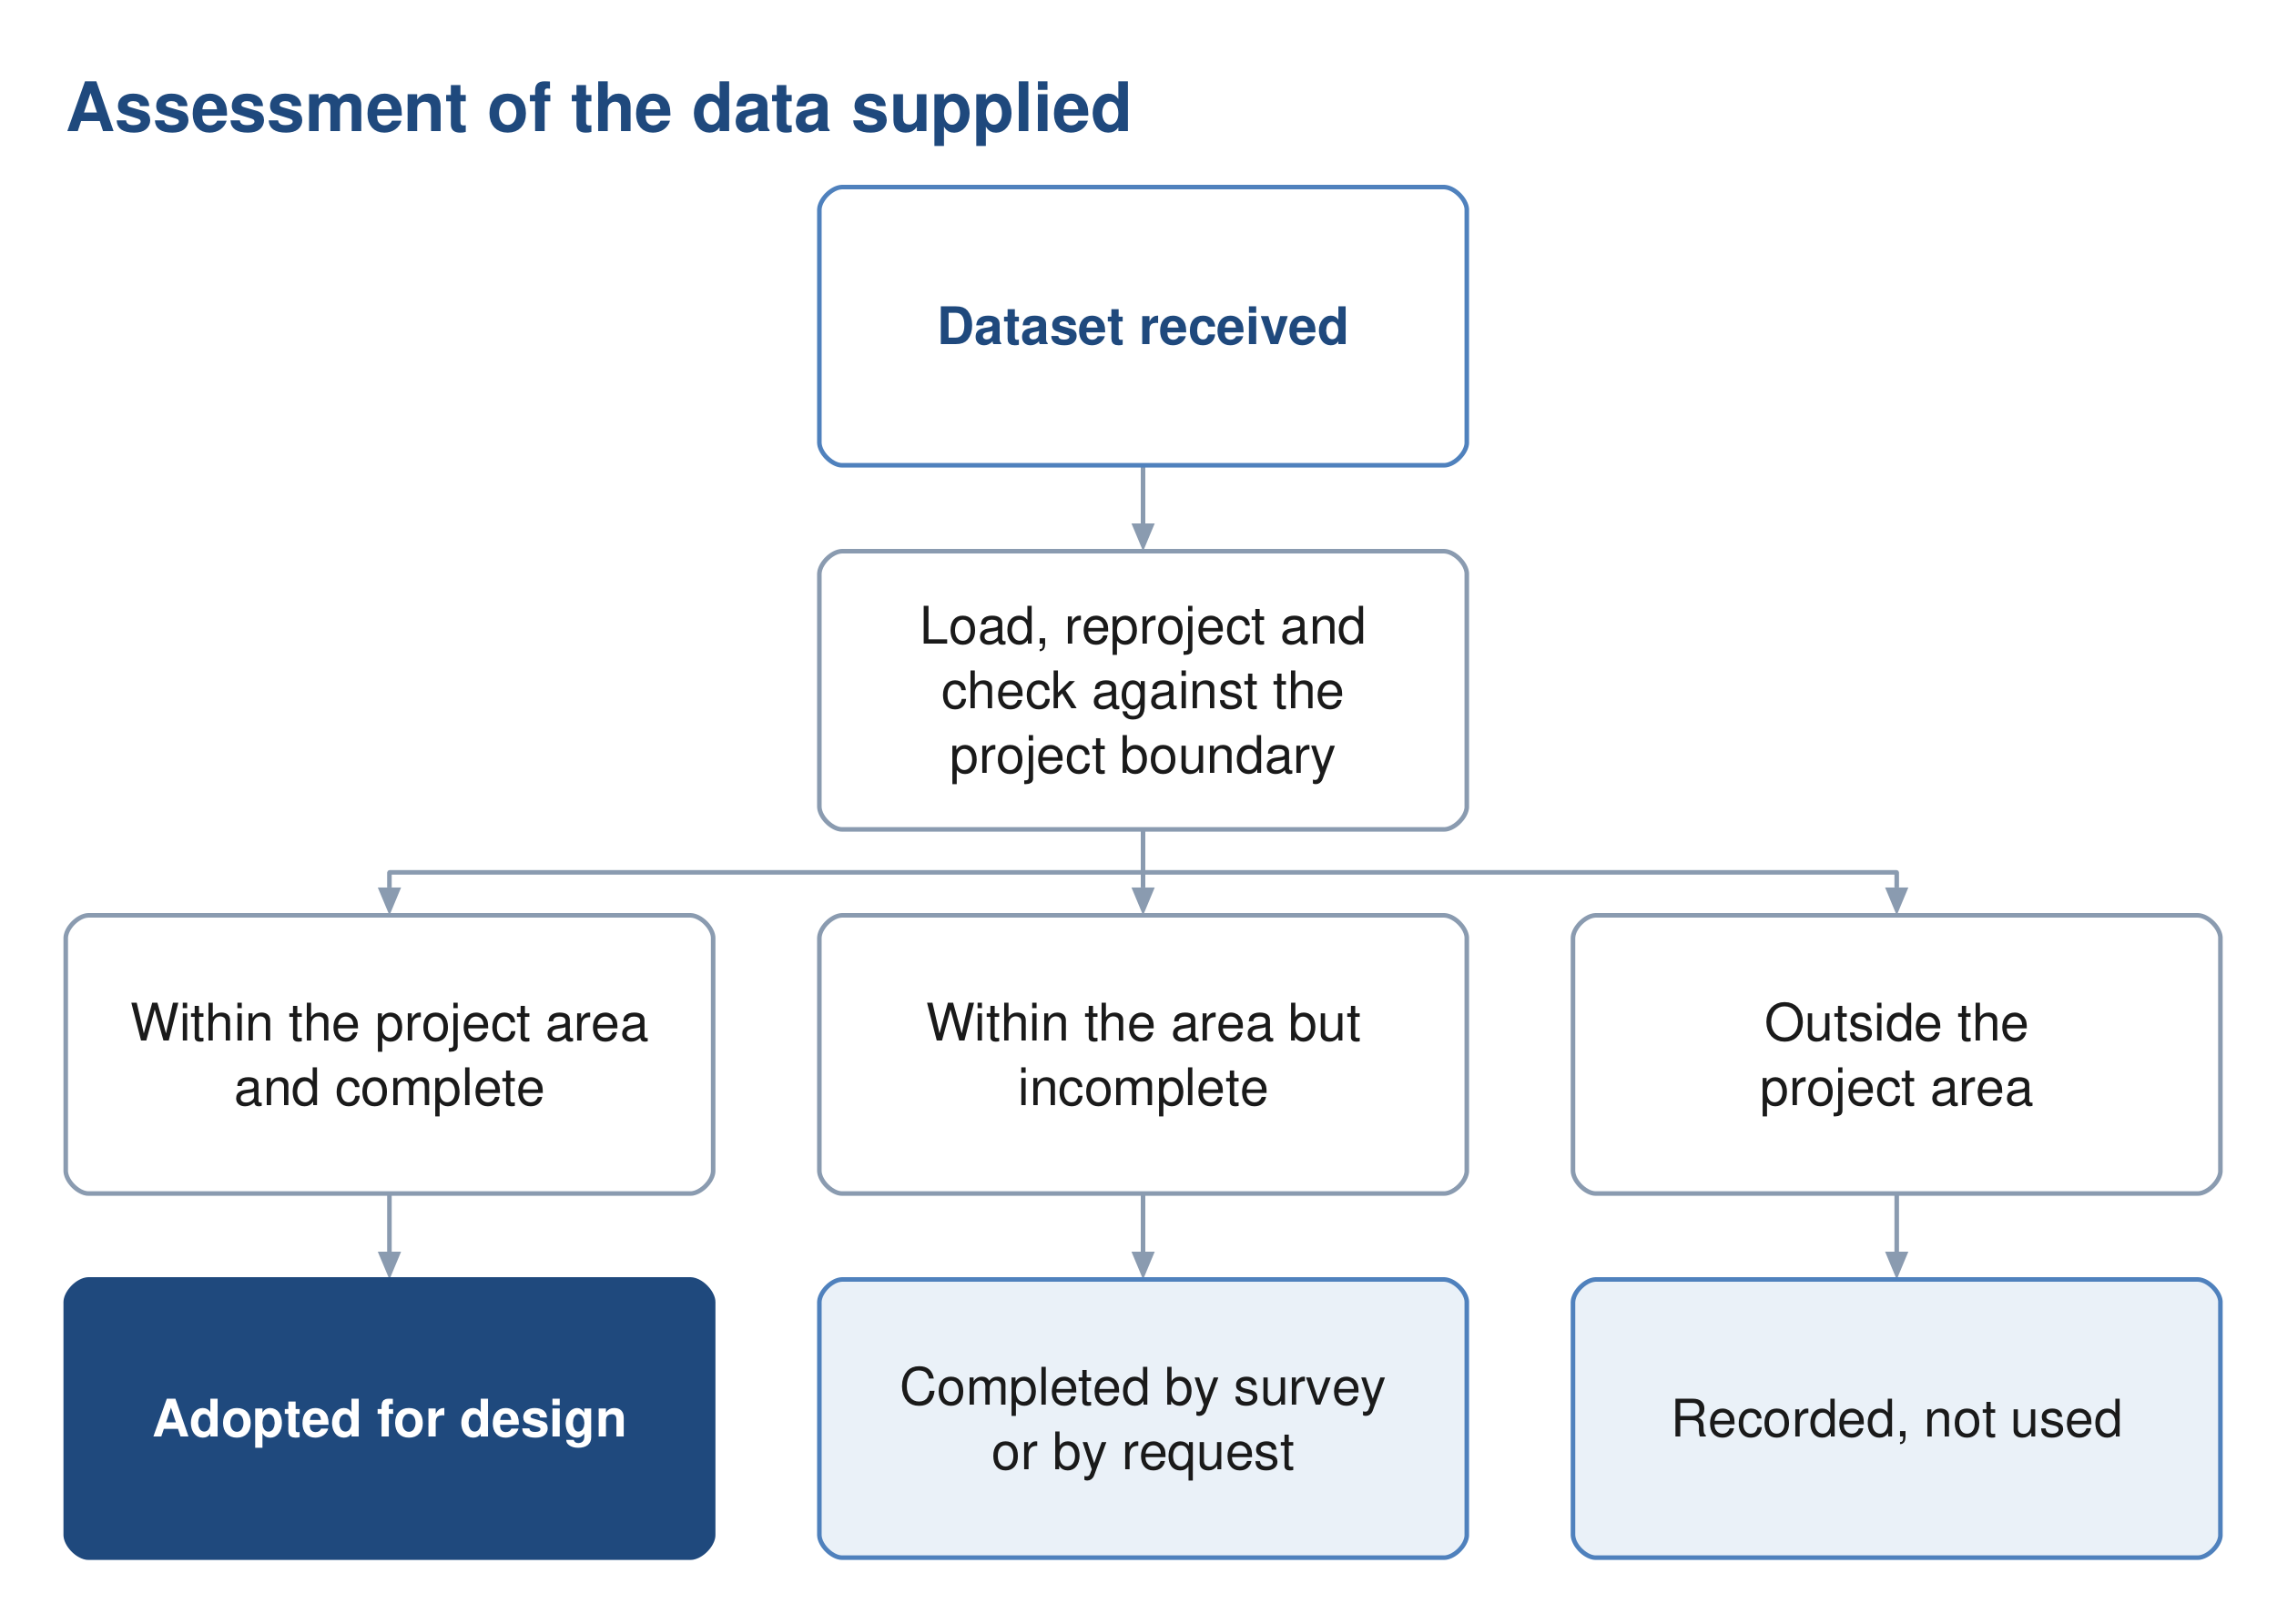
Figure 4 The assessment applied to each dataset supplied.

7.1. Wastewater assets
The wastewater dataset supplied by Nama Water Services holds two networks, not one. They are distinguished by the operational status field, and the distinction is confirmed by four further fields that agree with it on every record.
Table 8 The two networks and how they are distinguished
 | Constructed network | Proposed network
Operational status | 1 | 0
Installation date | 1 January 2006 | not recorded
Source | drawings, and closed-circuit television | asset planning
Project code | 5A-1 to 5A-5 | SUREKHA
Remark | reference data | large urban area gravity, pumping main and treated effluent networks

On that basis the assets within the study area are as follows.
Table 9 Wastewater assets within the study area, by status
Asset | Constructed features | Constructed length | Proposed features | Proposed length
Gravity sewer | 3,267 | 111.6 km | 129 | 199.3 km
Force main | 1 | 10.0 km | 8 | 23.2 km
Treated effluent main | none | none | 8 | 45.7 km
Pumping station | 1 | 1 | — | —
Treatment plant | 1 | 1,800 m3/d | 1 | 29,038 m3/d, shown as design

The distinction is material to the design. The constructed network extends to 111.6 kilometres of gravity sewer and 10.0 kilometres of force main, serving the central part of the town, and discharges through a single lifting station to the existing treatment plant. It is twenty years old and its condition is not recorded. The remaining 199.3 kilometres of gravity sewer, 23.2 kilometres of pumping main and the whole of the 45.7 kilometre treated effluent main shown in the dataset are proposed, not built. No treated effluent asset has been constructed.
Two limitations apply to the constructed network. Neither diameter nor invert level is recorded on any constructed gravity segment, so the hydraulic capacity of the existing system cannot be established from the data supplied. The client's own records carry a remark that the data is not reliable and is to be used for reference only. The survey now in progress will establish diameters, levels and condition, and until it reports, the capacity of the existing network to accept additional flow is treated as unknown.

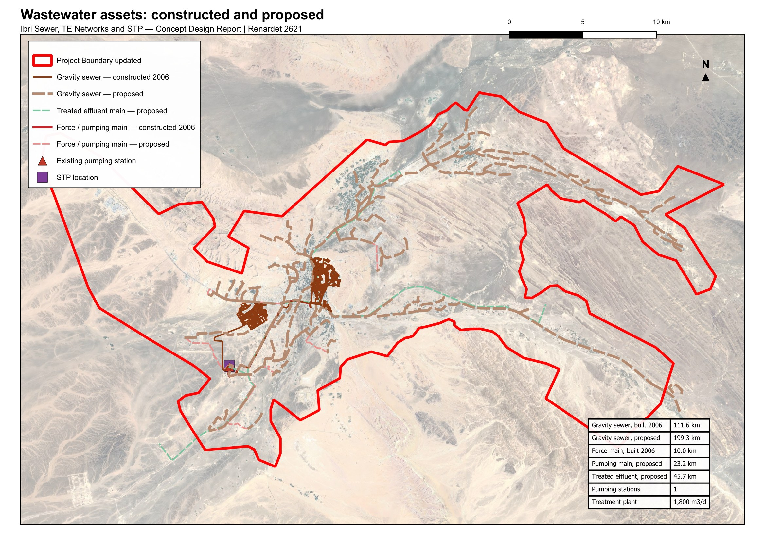
Figure 5 Wastewater assets within the study area. The constructed network, dated 2006, is shown distinctly from the alignments recorded in the dataset as proposed.

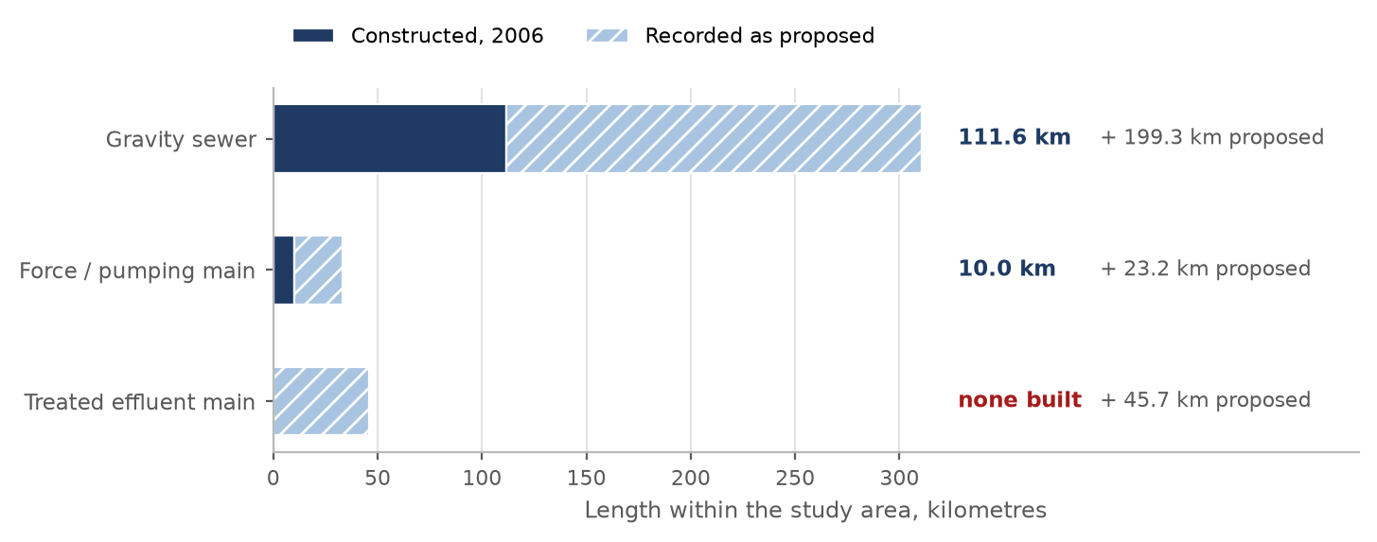
Figure 6 Length of wastewater asset within the study area, separated into constructed and proposed.

7.2. Potable water network
Two datasets describing potable water assets were supplied. They differ substantially in coverage.
Table 10 Potable water datasets
Dataset | Features | Quantity | Within the study area | Observation
PAEW water mains | 6,156 | 1,315.9 km | 647.8 km (49 %) | adopted as the source for utility interfaces
PAEW water laterals | 1,954 | 12.7 km | 8.1 km (64 %) | —
PAEW system valves | 2,866 | 2,866 points | 1,586 | —
PAEW hydrants | 965 | 965 points | 568 | —
PAEW services | 318 | 318 points | — | —
PAEW facilities | 265 | 265 points | 20 | —
NAMA water mains extract | 90 | 3.5 km | none | located near 55.80 E, 24.27 N, approximately 130 km north-west of the project area

The PAEW dataset provides 647.8 kilometres of water mains within the study area and is adopted as the source for utility interfaces. The second dataset, supplied under an Ibri file name, contains 3.5 kilometres of mains located approximately 130 kilometres north-west of the project area; none of it falls within the study area. Confirmation is requested that the PAEW dataset is the current record for Ibri.

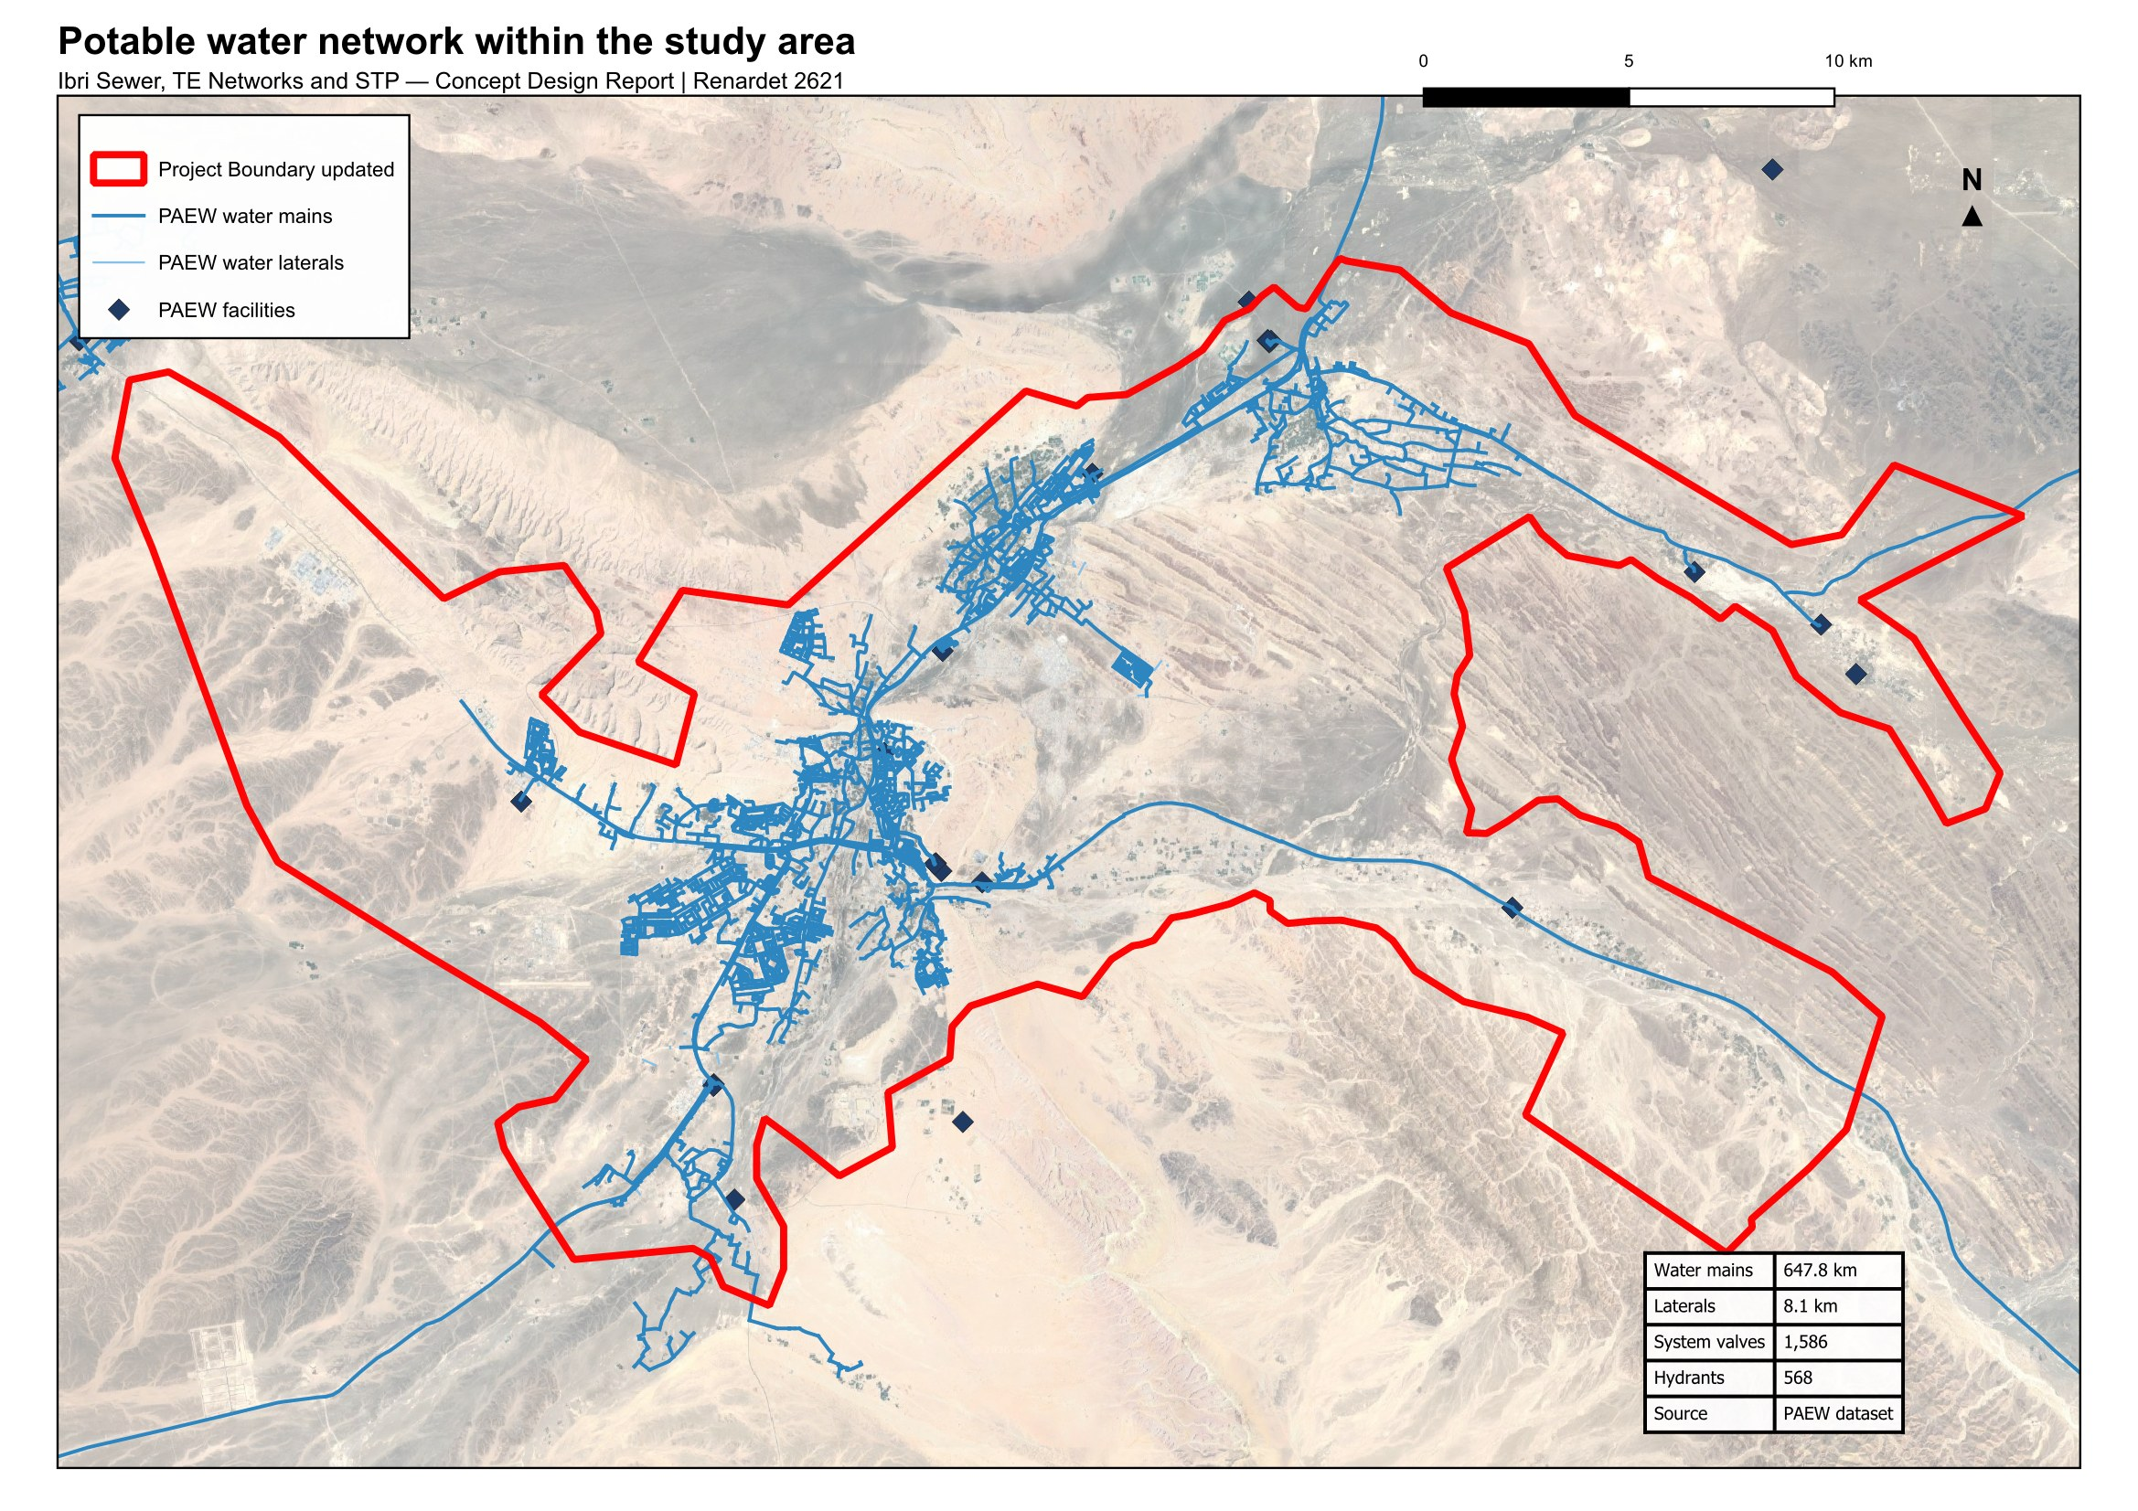
Figure 7 Potable water network within the study area, from the PAEW dataset.

7.3. Electricity accounts
The electricity account dataset contains 33,971 records, each carrying a tariff name and a coordinate. It records neither land use, floor area nor consumption, and the wilayat field is empty on every record. It establishes the number and category of connections at a location, and is used for that purpose in Section 14. The data is of 2024, which is the base year of this report.
Table 11 Electricity accounts by tariff and the category adopted
Tariff | Accounts | Category adopted
Primary Account | 10,973 | Domestic: one property
Primary Account with National Subsidy | 5,272 | Domestic: one property
Additional Account | 6,344 | Domestic: one property, a further one on the same plot
Commercial, Fisheries, Tourism | 9,392 | Non-domestic
Government, Defence | 967 | Governmental
Agricultural | 523 | Agricultural: an irrigation pump, no sewage
Industrial | 1 | Special consumption
Cost Reflective Tariff | 499 | Large consumer; use established in Section 16
Total | 33,971

The Cost Reflective Tariff is applied to consumers above a consumption threshold and is therefore a measure of size rather than of use. The 499 accounts carrying it have been placed one by one against public records, and each carries the use found and the evidence for it. Section 16.1 gives the result.
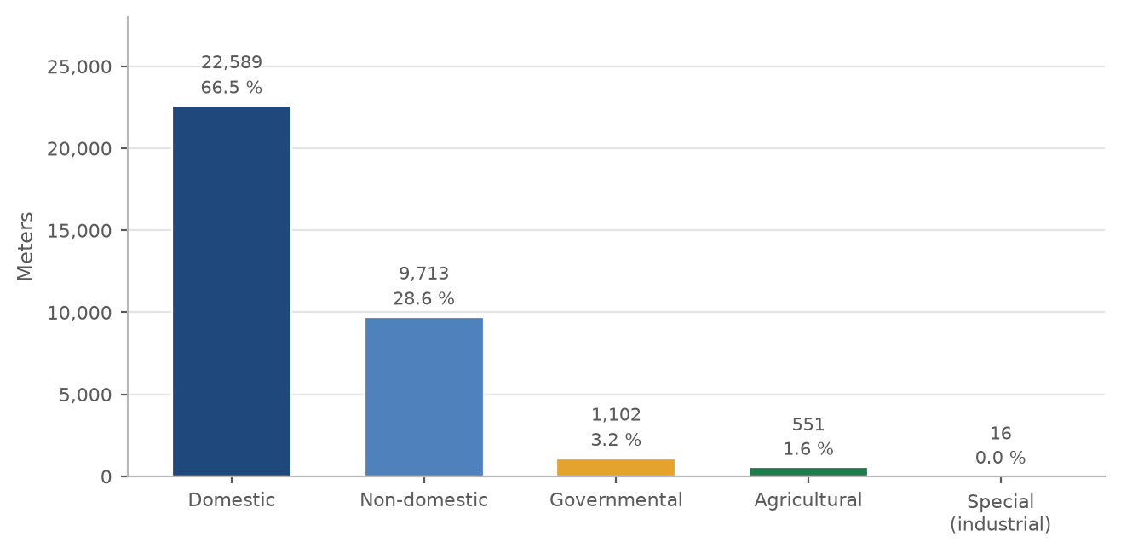
Figure 8 Electricity meters by the category adopted, after the large consumers were placed. Domestic connections, including further properties on the same plot, are two thirds of the total.

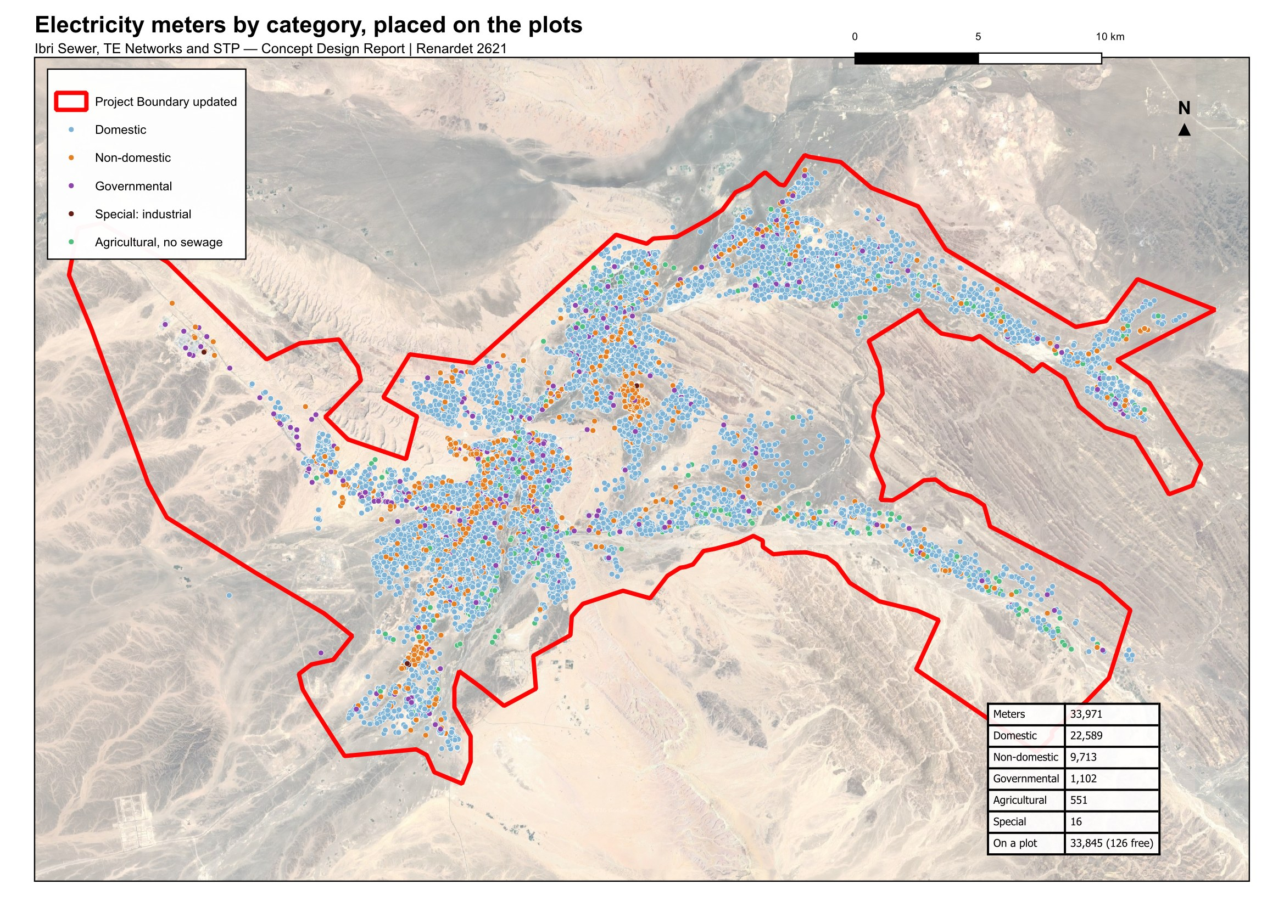
Figure 9 Electricity meters by category, placed on the plots. The pattern of connections defines the developed extent of each settlement.

7.4. Cadastral and settlement data
The cadastral plot layer supplied by the Ministry of Housing and Urban Planning, in the issue of September 2026, holds 77,265 plots with a built-or-future flag and a land-use class. The flag follows the electricity meters and is reliable. The class is not: it carries no government category, records whole districts under codes that mean unclassified, and disagrees with the meters on one built plot in seven. The use of each plot is therefore determined from the meters and the satellite image, as Section 14.5 sets out. The survey now in progress will establish the cadastral boundaries including plot gates.
The settlement boundaries supplied with the Inception Report are twenty-six polygons for twenty-five settlements, Al Aynayn being drawn as two. They outline the built cores and leave the land between them unassigned. Section 14.2 describes how every plot has been assigned to a settlement and the boundaries redrawn to meet.

7.5. Other datasets supplied
Table 12 Further datasets received
Dataset | Extent | Observation
Electricity accounts | 33,970 points | Tariff, coordinates and governorate. No land use, floor area or consumption is recorded.
Ibri Bypass scheme | 13,404 placemarks | A drawing export carrying 11,715 sublayers of blocks, hatches and dimensions. Suitable as a positional reference; conversion is required before it can be used as structured data.
Al Raybah pipelines | 3 files | Pipeline alignments at 110, 180 and 225 mm, within the project area.
Rehabilitation packages | 6 archives | Work-order submissions covering Al Sad, Khadil, Yanqul, Dhank and Hay Al Aqabah, comprising drawings, meter schedules and geodatabases.
House connection packages | 4 archives | Contractor submissions dated May and June 2026.

Five of the datasets supplied relate to areas outside the project boundary and have not been used. They are recorded here for completeness.
Table 13 Datasets relating to areas outside the project
Dataset | Extent | Location
Mudhaibi zone 6 | 544 placemarks | Wilayat of Mudhaibi, Ash Sharqiyah
Mudhaibi zone 8 | 461 placemarks | Wilayat of Mudhaibi, Ash Sharqiyah
Qabil Al Rukha | 5 placemarks | Wilayat of Mudhaibi
Qunaib | 4 placemarks | Wilayat of Mudhaibi
New location | 8 placemarks | Approximately 30 km north of the project area

8. Survey and investigation

8.1. Topographic and utility survey
A survey team is mobilised and working across the study area. The survey covers the existing sewer network, lifting stations, force mains and treated effluent network as built; the topography; and the cadastral boundaries including plot gates. Its outputs will establish the levels, diameters and condition that the supplied datasets do not carry, and will be incorporated in the next revision of this report.

8.2. Terrain model
A bare-earth terrain model at 0.5 metre resolution covering the study area is in use for the work presented here. It will be superseded by the topographic survey for design purposes.

8.3. Geotechnical investigation and trial pits
Geotechnical investigation and trial pits form part of the scope. Fifty trial pits are to be carried out at critical locations proposed by the consultant and approved by Nama Water Services. The programme of pits will be set out following the desk study of utility records described in Section 33.

9. Existing systems: as-built records and GIS
The preparation of as-built records and geographic information for the existing sewer and treated effluent systems forms part of the scope of work. The datasets supplied provide the geometry of those systems; the survey in progress will establish the levels, diameters, materials and condition required to complete the records.
The records will be prepared to the Nama Water Services specification and uploaded to the client's geographic information system for acceptance. Progress will be reported in the next revision.

PART C

Basis of design

10. Codes, standards and departures
The design follows the Nama Water Services design guidelines and standard specifications. Where a value is taken from a guideline it is cited to the guideline and page.
Table 14 Governing documents
Reference | Title
PAM-GUD-201 | General Design Guidelines, Revision 01, March 2026
PAM-GUD-202 | Water and TSE Design Guidelines, Revision 01, March 2026
PAM-GUD-203 | Wastewater Design Guidelines, Revision 01, March 2026
MD 145/1993 | Ministerial Decision, treated effluent and sludge reuse
MD 159/2005 | Ministerial Decision, discharge to the marine environment
MD 41/2017 | Ministerial Decision, ambient air quality

10.1. Departures
The departures from the guidelines that arise from the data available, and the items that await data, are set out below with the reason and the position adopted. Those the guidelines do not settle are put to Nama Water Services as decisions in Section 5; the others are adopted and reported there.
Table 15 Departures from the design guidelines
Subject | Guideline position | Position adopted | Reason
Occupancy rate | Population divided by housing units, both from NCSI | Settlement population divided by the domestic electricity meters counted in the settlement, with a floor and a cap (Decision 2) | Housing units are not published at settlement level
Non-domestic and governmental demand | Unit rates per pupil, bed, employee and floor area where detailed land use allocation is available | The published governorate ratios | The quantities the unit rates require are not recorded in any dataset held
Allocation of non-domestic demand | Distributed across the served population | Placed on the plots whose meters generate it | A residential street generates no commercial flow; the total is unchanged and only its distribution differs
Industrial estates | Determined case by case with the developer | An assumed workforce at the dry-industry unit rate | No workforce or discharge record has been supplied; the assumption is stated and is to be replaced by the record
Water supplied by tanker | Assessed from the tanker filling station records | Households on tanker supply carry the domestic rate like any other metered household; no separate tanker term | No filling-station record is held; requested
Other water sources | Private wells and other non-network abstraction assessed | Not assessed; every flow is on the network-accounted basis | No record of private abstraction is held; requested
Connection to the sewer | Coverage rising to the whole served area by the end of the period | Every metered property counted as connected; pipes and the STP are sized on the full load, and the early-year self-cleansing case takes the connection ratio of the Inception Report, 61 per cent in 2030 | Sizing on the full load is the safe side; the ratio is carried separately where over-estimation would be the risk
Design flow standard | Where detailed land use is available, design flows calculated to a stated international standard such as BS EN 752 | The planning ratios and return rates of the guideline, applied plot by plot | The quantities a detailed method requires are not held; the standard will be stated when they are
Minimum gradient | The steeper of the self-cleansing and the minimum tractive force gradients | Table 11 minimum gradients; the tractive force used at the concept stage only to list the pipes needing early washing, at a tractive tension of 1 Pa and with a floor of 1.5 l/s (Decision 7) | The tractive tension is not stated in the guidelines; the method sets gradients at the preliminary design once it is confirmed
Depth of cover | About 10 to 12 m recommended as the point where excavation cost justifies pumping | 12 m applied as the limit at the concept stage, with a pumping station before it | The excavation cost cannot be calculated without the detailed quantities
Design horizon | Completion plus twenty-five years, or the saturation of the area | Both carried: 2055 and the saturation year 2070 (Decision 5) | The Terms of Reference name both; the choice is for Nama Water Services
Growth beyond the forecast | Not extrapolated more than ten years beyond the available forecast | The Inception Report series to 2100, used for its growth rates only (Decision 6) | The land fills after 2050; the saturation year rests on the capacity of the cadastre, and the horizon to 2100 was instructed by Nama Water Services

The unit rates will be adopted for non-domestic and governmental demand as soon as the quantities they require become available.

11. Level of service and resilience
The systems are designed to convey and treat the flows arising across the design horizon without surcharge in the collection network and without loss of treatment capacity at the STP.
Redundancy — sufficient capacity is provided that the design peak flow can be achieved with any one unit out of service.
Design margin — a margin of ten per cent is applied to the STP design flow, over and above redundancy.
Flood resilience — structures are sited and set above the flood levels described in Section 29, and the STP is to remain operational during floods.
Failure — emergency provisions are described in Section 26.

12. Design criteria: collection network
The criteria below govern the gravity network. All are taken from the wastewater design guideline.
Table 16 Gravity sewer design criteria
Criterion | Value | Reference
Self-cleansing velocity | not less than 0.75 m/s at peak flow | PAM-GUD-203 p26
Preferred velocity | 0.90 m/s at peak flow | PAM-GUD-203 p26
Maximum velocity | 3.0 m/s at the design depth of flow | PAM-GUD-203 p27
Depth of flow, up to 350 mm | 0.65 of the diameter at peak flow | PAM-GUD-203 Table 10
Depth of flow, above 350 mm | 0.50 of the diameter at peak flow | PAM-GUD-203 Table 10
Roughness, Colebrook-White | 1.5 mm for all sizes and materials | PAM-GUD-203 p24
Minimum cover | 1.3 m to the crown of the pipe | PAM-GUD-203 p33
Minimum cover with protection | 0.5 m | PAM-GUD-203 p33
Recommended maximum cover | approximately 10 to 12 m | PAM-GUD-203 p33
Minimum diameter, laterals and mains | 200 mm outside diameter | PAM-GUD-203 Table 6
Maximum lateral length | 45 m | PAM-GUD-203 Table 6
Manhole spacing, 200 to 315 mm | 100 m | PAM-GUD-203 Table 12
Manhole spacing, 350 to 900 mm | 120 m | PAM-GUD-203 Table 12
Backdrop required | where inverts differ by more than 600 mm | PAM-GUD-203 p30
Inlet angle at a manhole | not less than 90 degrees to the flow | PAM-GUD-203 p19 and p30

12.1. Hydraulic formulation
Full-bore velocity is computed by the Colebrook-White equation.
$V = −2\sqrt{2gDS}\log_{10}\left[\frac{k_{s}}{3.7D} + \frac{2.51ν}{D\sqrt{2gDS}}\right]$ (1)
V: full-bore velocity, m/s
g: acceleration due to gravity, m/s²
D: internal diameter of the pipe, m
S: hydraulic gradient, m/m
k s: roughness coefficient, 1.5 mm, m
ν: kinematic viscosity of the sewage, m²/s
Gradients are set so that the self-cleansing velocity is achieved at peak flow, and are checked against the minimum gradients tabulated in the guideline. The tabulated gradients correspond to a full-bore velocity of 0.75 m/s; the velocity at the design depth of flow is verified separately for each run.

12.2. Gradients and self-cleansing at the concept stage
At the concept stage every pipe is laid at the guideline's minimum gradient for its size, rounded up to a step of 0.05 per cent, or 0.025 per cent for trunks of 500 mm and above. The steps are our rounding, so that the gradients are round figures on the drawings. The guideline asks for a second test, the minimum tractive force, and for the steeper of the two gradients to govern. At this stage that test is used only to list the pipes that will need washing in the early years, not to steepen them, because the tractive tension it needs is not given in the guideline. One pascal is used until Nama Water Services confirms a value. That is a departure from the guideline, stated here for approval.
Table 17 Minimum gradients at the concept stage
Pipe size, mm | 200 | 250 | 315 | 400 | 500 | 600 | 700 | 800 | 900 and above
Minimum gradient, mm/m | 5.00 | 3.75 | 2.70 | 2.05 | 1.55 | 1.25 | 1.00 | 0.85 | 0.75

The tractive-force test gives the minimum gradient that moves the deposited particle at a given flow.
$S_{min} = Kτ^{1.23}Q^{−0.461}$ (2)
S min: minimum gradient to move the deposited particle, m/m
τ: tractive tension, 1 pascal at the concept stage, Pa
Q: flow in the pipe, m³/s
K: coefficient, 2.33 × 10⁻⁴ for the flow in m³/s
The chart on the next page shows what the test asks of a pipe. It is a curve: the smaller the flow, the steeper the pipe must be. A 200 mm pipe at its minimum gradient of 0.5 per cent passes the test at 1.29 l/s and above. Below that, at the very head of a street, no practical gradient passes; those pipes go on the washing list. A design floor is proposed: a pipe carrying less than 1.5 l/s is checked as if it carried 1.5, for which the curve asks 0.47 per cent, so a 200 mm pipe at the Table 11 gradient always passes.
At the meeting of 16 September 2026 Nama Water Services indicated that the gradient obtained from the tractive-force method is limited to a maximum of 4 per cent at the head pipes. How that limit is applied will be confirmed with Nama Water Services (Section 5.3).
Decision 7. Approve the concept-stage rule: pipes laid at the Table 11 minimum gradient; the tractive-force test at 1 pascal used only to list the pipes needing early washing, with a pipe carrying less than 1.5 l/s checked as if it carried 1.5. The guideline asks for the steeper of the two gradients; this is a departure (Section 12.2).

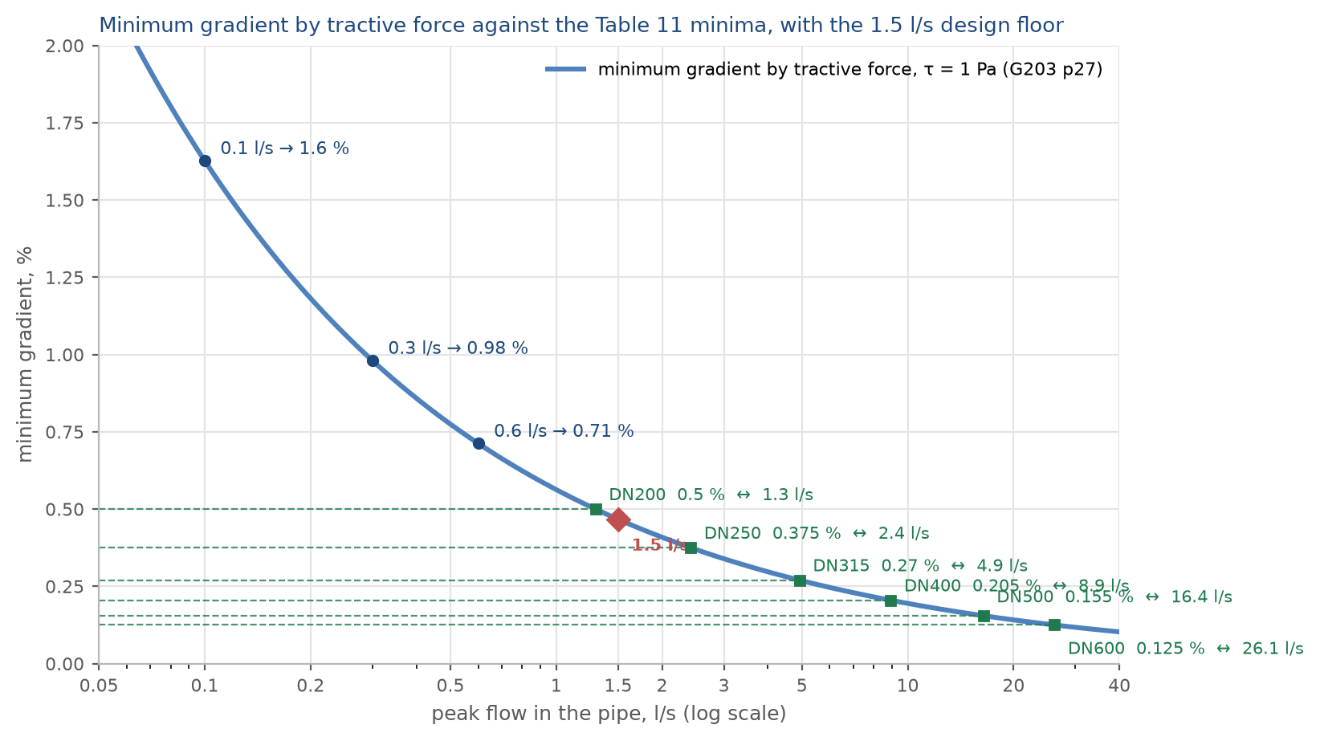
Figure 10 The minimum gradient by tractive force at one pascal against the flow in the pipe, with the Table 11 minimum of every size marked where it meets the curve, and the 1.5 l/s floor.

12.3. Depth of cover and pumping
A gravity sewer goes deeper the further it runs. The guideline recommends about 10 to 12 metres of cover as the point where the cost of excavation justifies a pumping station. That cost cannot be calculated without the detailed quantities, so 12 metres is applied as the limit at this stage: where a sewer would pass it, a station is placed before that point and the sewer restarts at normal cover. The preliminary design looks deeper where the quantities allow the cost to be calculated.
The station's duty flow is the peak flow of the catchment it drains plus the infiltration of its sewers, at saturation. The rising main is sized on that duty: at least 0.75 metres a second, 1.0 where the pumps start and stop, and at most 2.5 metres a second.
Adopted (13). 12 metres of cover is the limit at the concept stage, with a pumping station before that point; the preliminary design looks deeper where the quantities allow the cost to be calculated (Section 12.3).

13. Design criteria: treatment plant
Table 18 Treatment plant design criteria
Criterion | Value | Reference
Design horizon | not less than 15 years | PAM-GUD-203 p65
Planning life cycle | 25 years | PAM-GUD-201 p57
Design margin | 10 per cent | PAM-GUD-201 p73
Size category | large where 20,000 m³/d or above | PAM-GUD-203 p65
Organic load | not less than 60 g BOD per person per day; the measured strength at the existing STP governs once received | PAM-GUD-203 p74
Solids load | not less than 80 g suspended solids per person per day | PAM-GUD-203 p74
COD to BOD ratio, domestic | 1.8 to 2.2 | PAM-GUD-203 p74
Effluent standard | Class A of MD 145/1993 | PAM-GUD-203 p69
Total nitrogen | less than 15 mg/l as N | PAM-GUD-203 p71
Chlorine residual at the STP discharge | 0.3 to 1.0 mg/l | PAM-GUD-203 p71
Chlorine residual at the consumer | more than 0.3 and less than 1.0 mg/l | PAM-GUD-203 p130
Treated effluent produced | 95 per cent of the inflow | PAM-GUD-201 p73
Sludge produced | 0.25 kg per cubic metre of inflow, indicative | PAM-GUD-201 p78

The total nitrogen limit is the governing criterion for process selection. Class A of Ministerial Decision 145/1993 does not itself set a total nitrogen limit, and the individual nitrogen limits it does set would together permit a higher concentration than 15 mg/l. Full nitrification and denitrification are therefore required.

13.1. The flows and loads the plant is sized on
The STP is sized on three flows, and the guideline names what each one sizes: the average annual flow for the biological treatment, with the load; the peak hourly flow for everything the flow passes through; and the maximum day flow, which the guideline defines but gives no factor for. The maximum day flow is read from a year of daily records at the existing STP, requested in Section 5.4.
$Q_{AAF} = 1.10\left(Q_{avg} + Q_{inf}\right)$ (3)
Q AAF: average annual flow, the design average of the STP, m³/d
Q avg: average flow of the settlements upstream, m³/d
Q inf: infiltration of the whole network upstream, 720 l/d per km, m³/d
1.10: the 10 per cent margin the guideline requires for a new STP, over and above any standby
$Q_{PHF} = 1.10\left(Q_{peak} + Q_{inf}\right)$ (4)
Q PHF: peak hourly flow, for the structures the flow passes through, m³/d
Q peak: the Merrimack peak of the average flow of the settlements upstream (Section 15.6), m³/d
The margin is applied to the peak as to the average. The guideline does not state the order, and this reading is for confirmation. Section 15.8 gives the flows by year.
The biological treatment is sized on the load, not only the flow. No laboratory data for Ibri's sewage is held. The guideline sets a minimum for a new STP of 60 grams of BOD and 80 grams of suspended solids per person per day, and gives the strength of raw sewage below. The per-person loads are used until the laboratory results of the existing STP are received, and the sewage brought by tanker, which is far stronger, is provided for separately once its records arrive.
Table 19 Raw sewage strength the guideline gives, for the network and for tankers, mg/l
Parameter | Network sewage | Sewage by tanker, average to maximum
BOD | 350 to 400 | 350 to 1,050
COD | 700 to 900 | 1,350 to 5,000
Suspended solids | 400 to 500 | 900 to 4,300
Total Kjeldahl nitrogen | 60 to 80 | 115 to 265
Ammonia as nitrogen | 40 to 50 | 70 to 125
Total phosphorus | 10 to 15 | 16 to 35

Adopted (14). The average annual flow and the peak hourly flow with the 10 per cent margin as the guideline defines them; 60 grams of BOD and 80 grams of suspended solids per person per day, the guideline's minimum, until the laboratory data of the existing STP are received; the maximum day flow from that plant's records (Sections 13.1 and 15.8).

PART D

Demand and flows

14. Population and land use

14.1. Approach
The population of the study area, its distribution and its growth are established by counting rather than by assumption. Every domestic electricity meter is a property. Every plot takes its use from the meters on it. Every empty plot takes its future from the built plots around it. The official population series supplies the growth rate of each settlement and nothing else. The result is a population and an average sewage flow for every plot, today and in every year to the year the land is full, which is the saturation the Terms of Reference ask for.
The distribution of population across the study area is shown below from the Global Human Settlement population grid. The grid is a third-party product and is used to show where population lies, not how much of it there is.
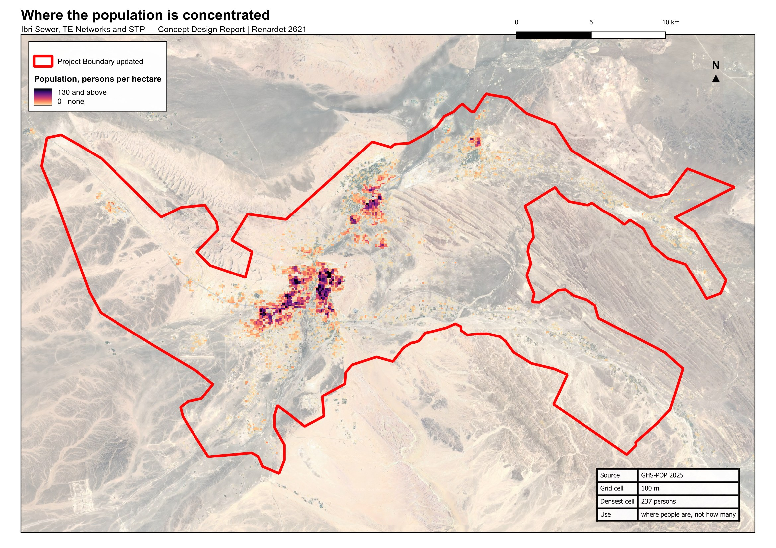
Figure 11 Where the population of the study area lies. Density is concentrated in Ibri town and along the wadi corridors, and falls away sharply beyond them.

14.2. The settlements and their boundaries
Every rule in this Part is applied settlement by settlement: the persons per property, the share of empty land that becomes housing, the growth rate and the year the land is full are all set for each settlement. So every plot must belong to exactly one settlement.
The Inception Report supplied twenty-six polygons for the twenty-five settlements, Al Aynayn being drawn as two. The polygons are drawn around the built cores. They do not touch, so the land between them belongs to nobody, and four of them, at Tanam, Satwah, Al Makhtibyah and Bat, miss part of the plots that carry the settlement's name. The map on the next page shows them in red.
The boundaries were therefore redrawn. Each of the 77,265 plots was given the settlement whose polygon contains it, or, where none does, the nearest one. The land was then divided so that every point belongs to the settlement of the nearest plot, and the shared edges were smoothed. The result, in blue on the map, covers the whole study area with twenty-five settlements and no gaps. Nothing else changed: the names, the population series and the plots are as received.
The twenty-five settlements inside the study area carry 63.4 per cent of the wilayat's population in every year of the series. The other settlements of the wilayat lie outside the boundary and are not part of the design.
Decision 1. Approve the twenty-five settlement boundaries redrawn so that every plot lies in one settlement and there are no gaps between them (Section 14.2).

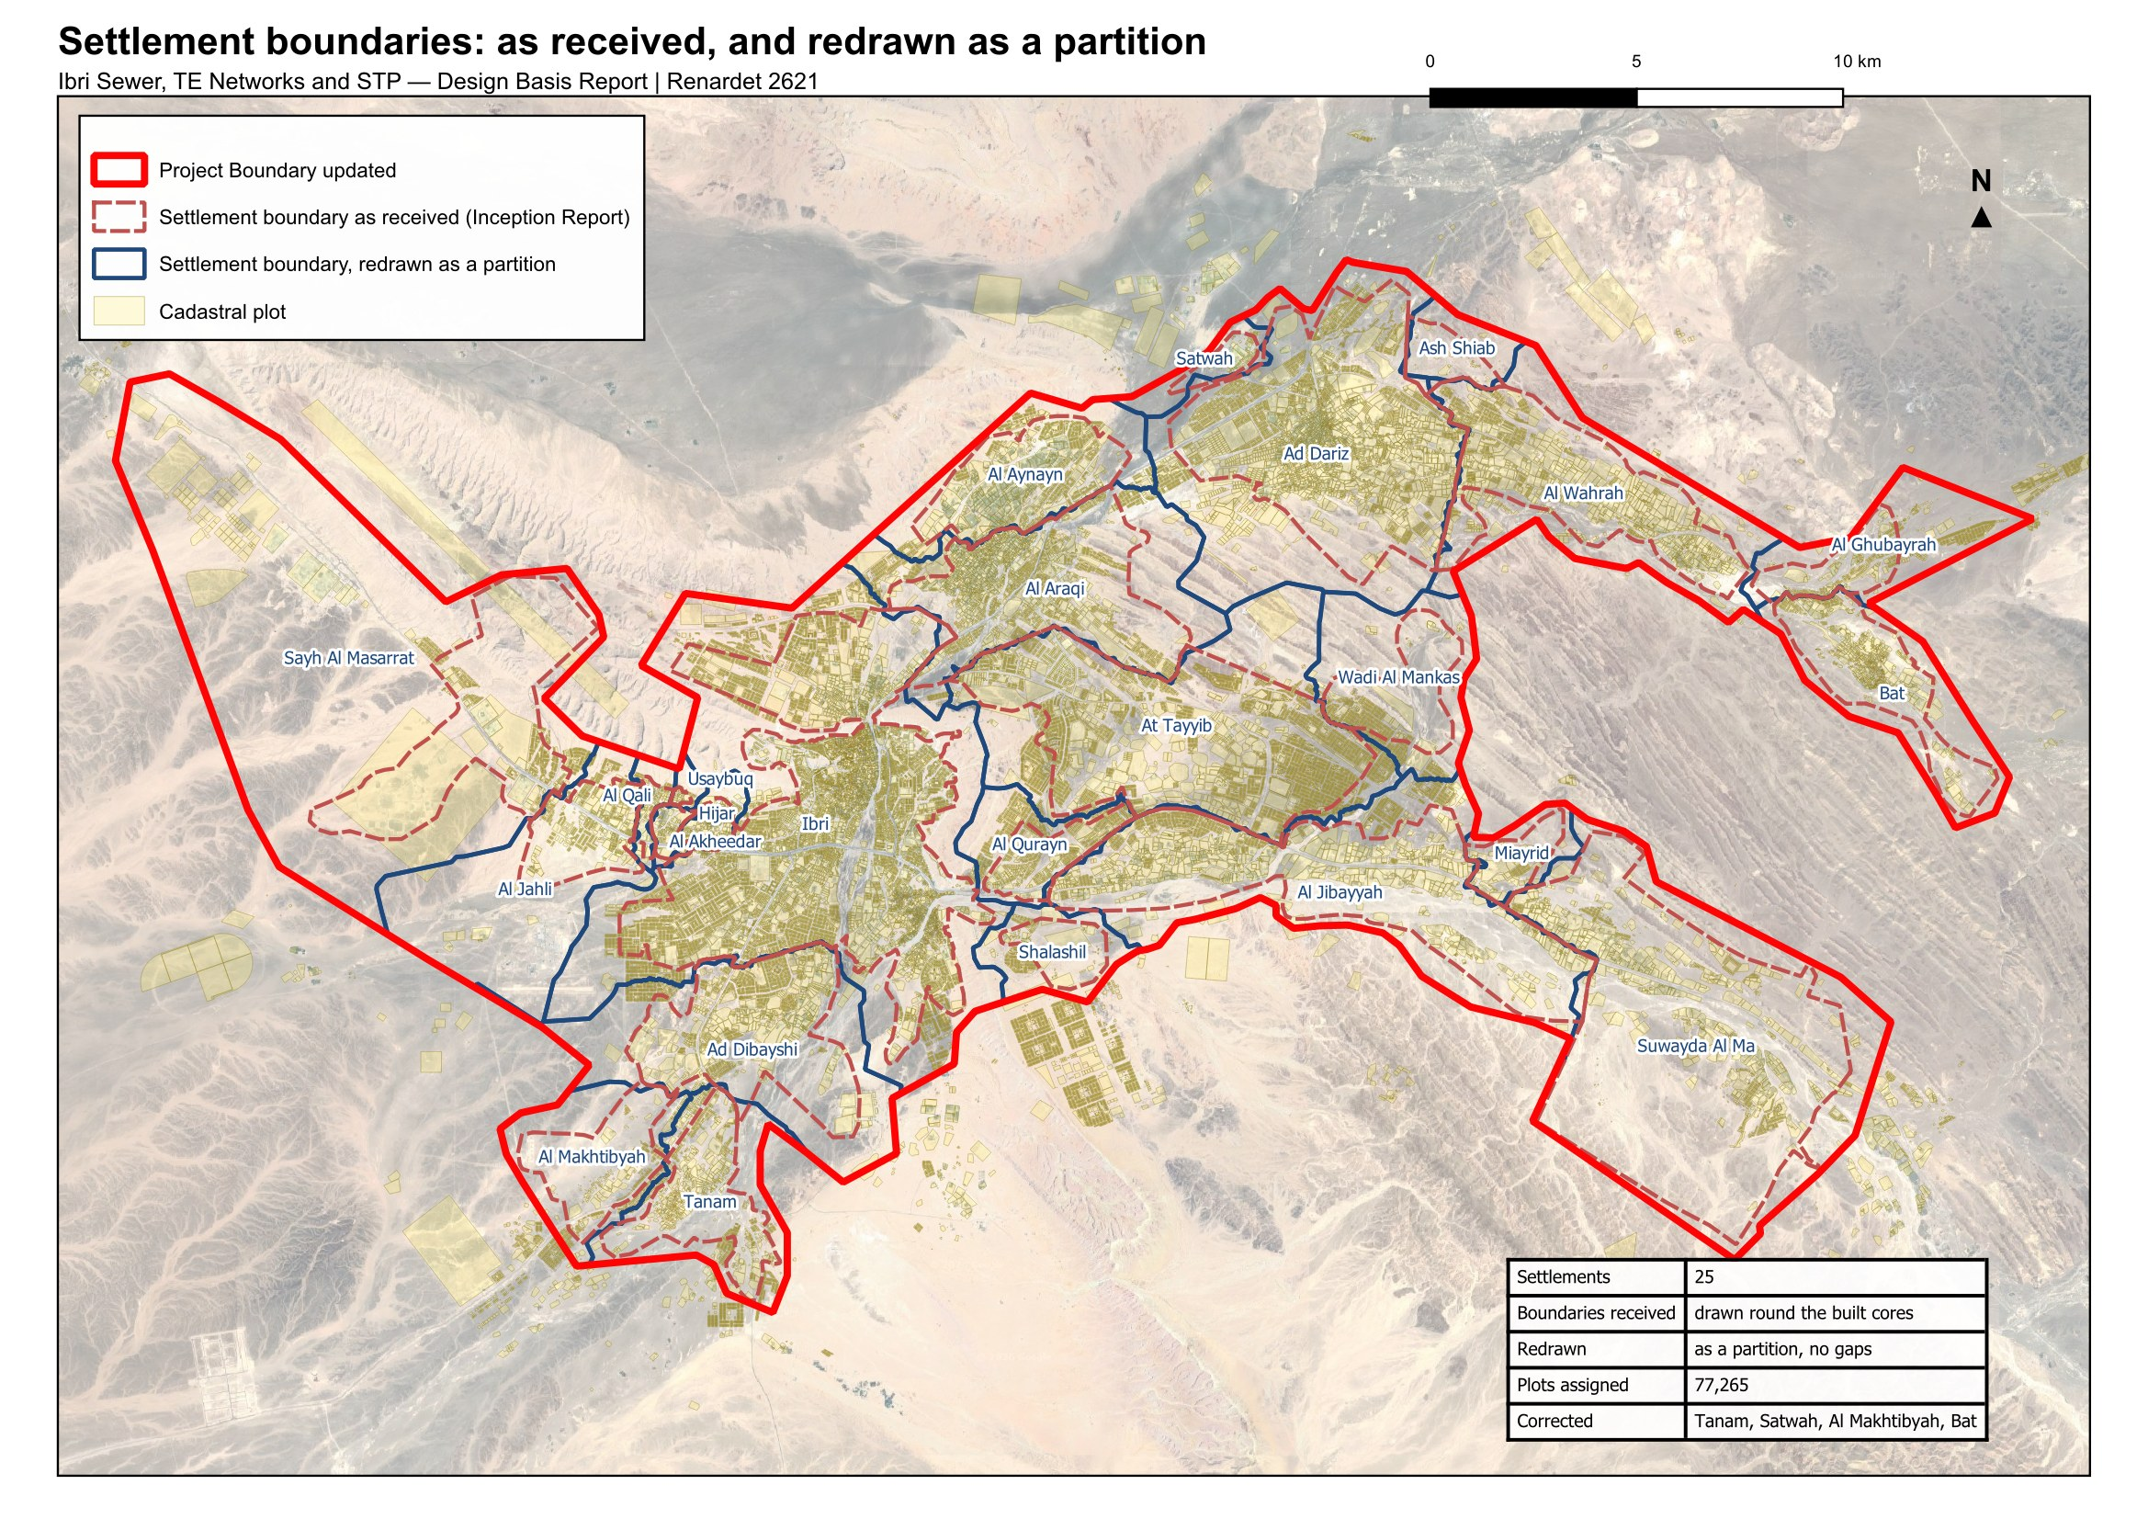
Figure 12 The settlement boundaries as received (red, dashed) and as redrawn for the design (blue). Every plot lies in one settlement and the boundaries meet without gaps.

14.3. From the meters to the properties
Each domestic electricity meter is one property. Of the 33,971 meters, 30,931 fall inside a plot. 2,914 lie on a road or in a gap between plots and were given the nearest plot within fifteen metres. 126 lie further than that from any plot and are shown below. The plots hold 22,559 domestic properties. Shop, office, government, farm and large-consumer meters carry no people.

Properties per home plot
The number of properties on a built home plot is measured in each settlement over the plots that are homes and nothing else, excluding the few plots that carry fifteen or more domestic meters, which are blocks of flats and workers' housing and would distort the ratio. Plots that also carry shops, farms or offices are counted for their people but not for the ratio.
Table 20 Properties per home plot, the principal settlements
Settlement | Domestic properties | Home plots measured | Properties per home plot
Ibri | 11,052 | 5,853 | 1.33
Ad Dariz | 2,439 | 1,567 | 1.20
Al Araqi | 2,466 | 1,282 | 1.32
Al Aynayn | 889 | 560 | 1.14
Al Wahrah | 716 | 420 | 1.22
At Tayyib | 833 | 623 | 1.09
Al Jibayyah | 524 | 291 | 1.26
Bat | 418 | 239 | 1.17

Ibri carries 1.33 properties per home plot; the principal settlements lie between 1.1 and 1.4. Four small settlements with institutional housing on a handful of plots return two or more; the thirteen settlements under a thousand people take one property per plot, as Section 14.4 sets out. The full table is given in Appendix A3.

The 126 meters with no plot within 15 metres
126 meters lie more than fifteen metres from any plot. 30 of them are domestic meters, about 140 people at their settlement's occupancy; the rest are government, shop and farm meters. Some stand on buildings the cadastre has not yet captured. Others stand on nothing: a road reserve, open ground, a pumping station. All of them are left out of the plot loads. The map on the next page shows where they are, and the figure after it shows nine of them close up, with the plots around them.
Table 21 The 126 meters by settlement
Settlement | Meters | Settlement | Meters
Ibri | 29 | Ad Dibayshi | 3
Sayh al Masarrat | 14 | Al Jahli | 3
Al Qurayn | 14 | Al Makhtibyah | 2
Al Araqi | 9 | Al Wahrah | 2
Suwayda al Ma | 9 | Shalashil | 1
Al Jibayyah | 9 | Ash Shiab | 1
Tanam | 8 | Al Qali | 1
Ad Dariz | 6 | Bat | 1
Al Ghubayrah | 5 | Al Akheedar | 1
At Tayyib | 4 | Wadi al Mankas | 1
Al Aynayn | 3
Adopted (8). They are left out of the plot loads: about 140 people (Section 14.3).

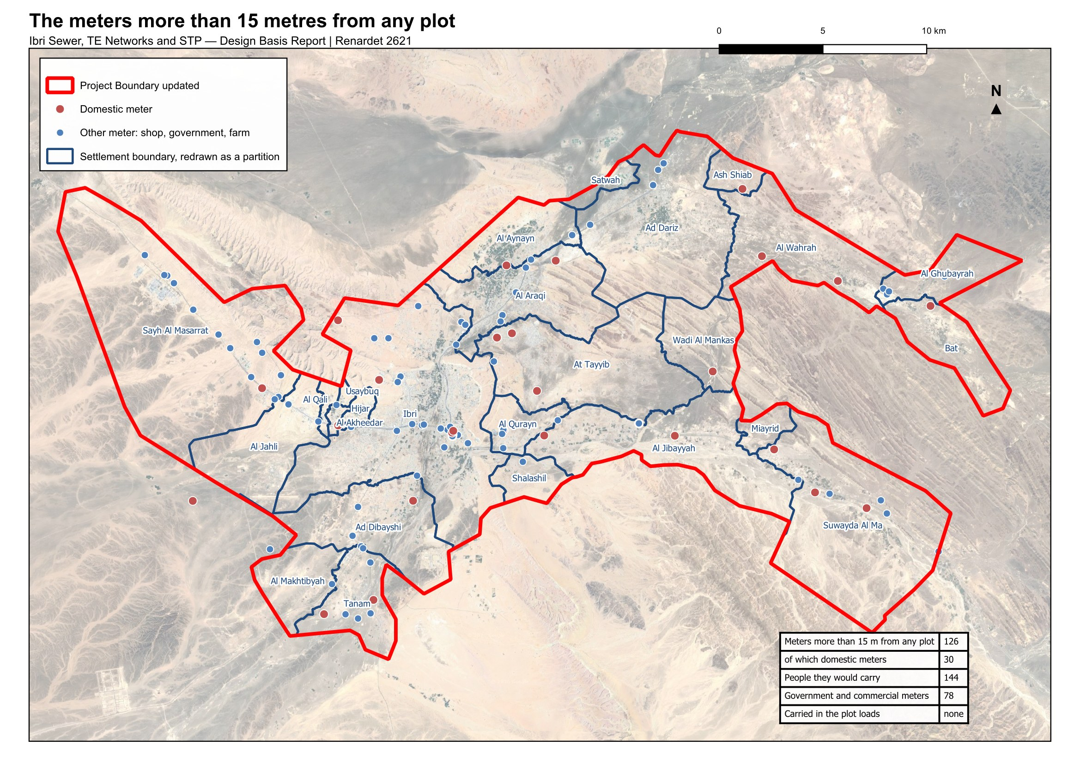
Figure 13 The 126 meters more than fifteen metres from any plot. Red: a domestic meter; blue: any other meter.
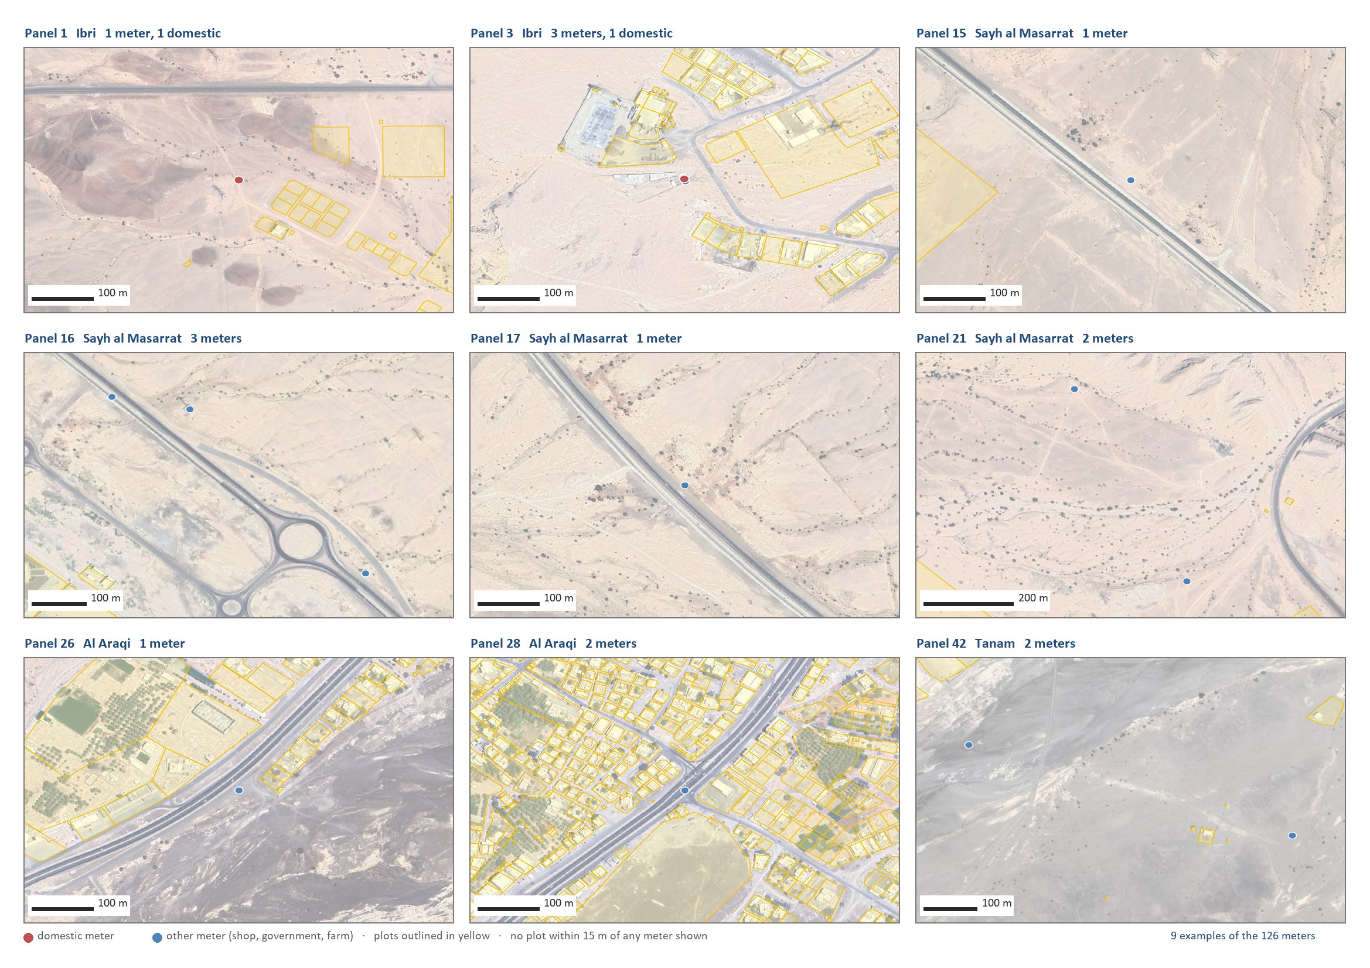
Figure 14 Nine of the 126 meters close up: on a road, in open ground, at a pumping station, on a building the cadastre does not carry. The plots are outlined in yellow.

14.4. Occupancy rate
The occupancy rate of each settlement is its population in 2024, the year of the electricity data, divided by the domestic properties counted in it.
$OR = \frac{Settlement population in 2024}{Domestic properties}$ (5)
OR: occupancy rate, persons per property
Three rules bound the result. A floor of 4.0: some settlements would otherwise return between one and four persons per property, because their meters include the housing of the police, the college and similar institutions, whose occupants the census does not count as residents. Those properties discharge to the sewer whatever the census says, so the floor keeps them in. A cap of 6.12, the highest rate among the settlements of two thousand people or more. And a settlement of fewer than a thousand people takes 4.0 outright, one property per home plot and a home share of 0.9 (Section 14.6), because it has too few meters to measure on. That rule applies to 13 settlements.
Ibri returns 6.07 persons per property. Over the whole study area the census gives 5.16. The guideline derives occupancy from population and housing units published by the statistics centre; housing units are not published at settlement level, and the counted properties are used in their place.
Table 22 Occupancy rate by settlement, 2024
Settlement | Domestic properties | Population 2024 | Rate calculated | Rate adopted | People in the design
Ibri | 11,052 | 67,106 | 6.07 | 6.07 | 67,106
Ad Dariz | 2,439 | 11,850 | 4.86 | 4.86 | 11,850
Al Araqi | 2,466 | 10,696 | 4.34 | 4.34 | 10,696
Al Aynayn | 889 | 4,554 | 5.12 | 5.12 | 4,554
Al Wahrah | 716 | 3,351 | 4.68 | 4.68 | 3,351
At Tayyib | 833 | 3,348 | 4.02 | 4.02 | 3,348
Al Jibayyah | 524 | 2,686 | 5.13 | 5.13 | 2,686
Bat | 418 | 2,557 | 6.12 | 6.12 | 2,557
Ad Dibayshi | 681 | 2,411 | 3.54 | 4.00 | 2,724
Tanam | 403 | 2,116 | 5.25 | 5.25 | 2,116
Suwayda al Ma | 301 | 1,559 | 5.18 | 5.18 | 1,559
Hijar | 352 | 1,033 | 2.93 | 4.00 | 1,408
Al Ghubayrah | 161 | 631 | 3.92 | 4.00 | 644
Al Qurayn | 147 | 549 | 3.73 | 4.00 | 588
Sayh al Masarrat | 457 | 466 | 1.02 | 4.00 | 1,828
Al Jahli | 344 | 415 | 1.21 | 4.00 | 1,376
Satwah | 27 | 263 | 9.73 | 4.00 | 108
Al Akheedar | 120 | 198 | 1.65 | 4.00 | 480
Al Qali | 56 | 191 | 3.41 | 4.00 | 224
Shalashil | 38 | 130 | 3.42 | 4.00 | 152
Al Makhtibyah | 91 | 122 | 1.34 | 4.00 | 364
Usaybuq | 21 | 91 | 4.33 | 4.00 | 84
Wadi al Mankas | 8 | 52 | 6.49 | 4.00 | 32
Ash Shiab | 11 | 47 | 4.27 | 4.00 | 44
Miayrid | 4 | 34 | 8.49 | 4.00 | 16
Total | 22,559 | 116,452 |  |  | 119,893

With the floor and the cap the study area holds 119,893 people, against 116,452 in the official series for the same settlements. The difference is the institutional housing.
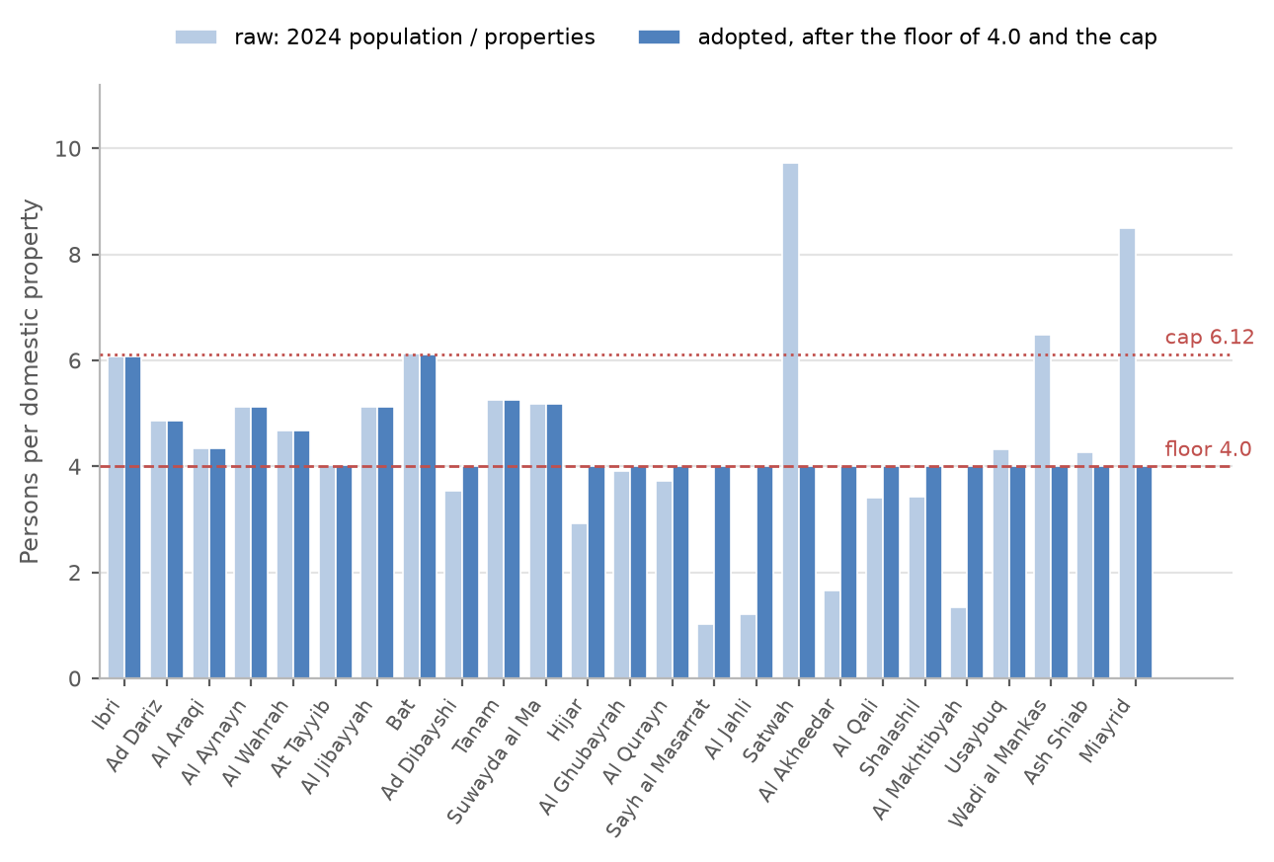
Figure 15 Occupancy rate by settlement: the value calculated from the census and the meters, and the value adopted after the floor and the cap.
Decision 2. Approve the persons per property calculated for each settlement, with the floor of 4.0, the cap of 6.12 and the rule for settlements under a thousand people (Section 14.4).
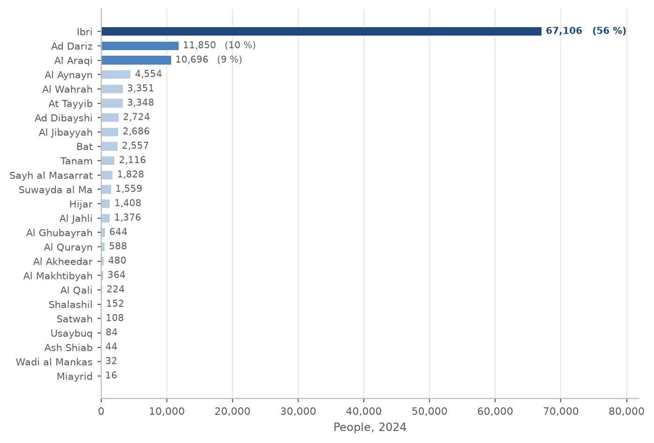
Figure 16 People in each settlement in 2024, from the domestic meters at the settlement's occupancy rate. Ibri holds 56 per cent of the total.

14.5. Land use
The cadastral layer received in September 2026 holds 77,265 plots. Its own land-use field cannot be used as it stands: it has no government class, it records whole districts under codes that mean unclassified, and on the plots that carry meters it disagrees with the meters on 24 per cent of them. The use of every plot has therefore been determined from what is on it, in a fixed order.
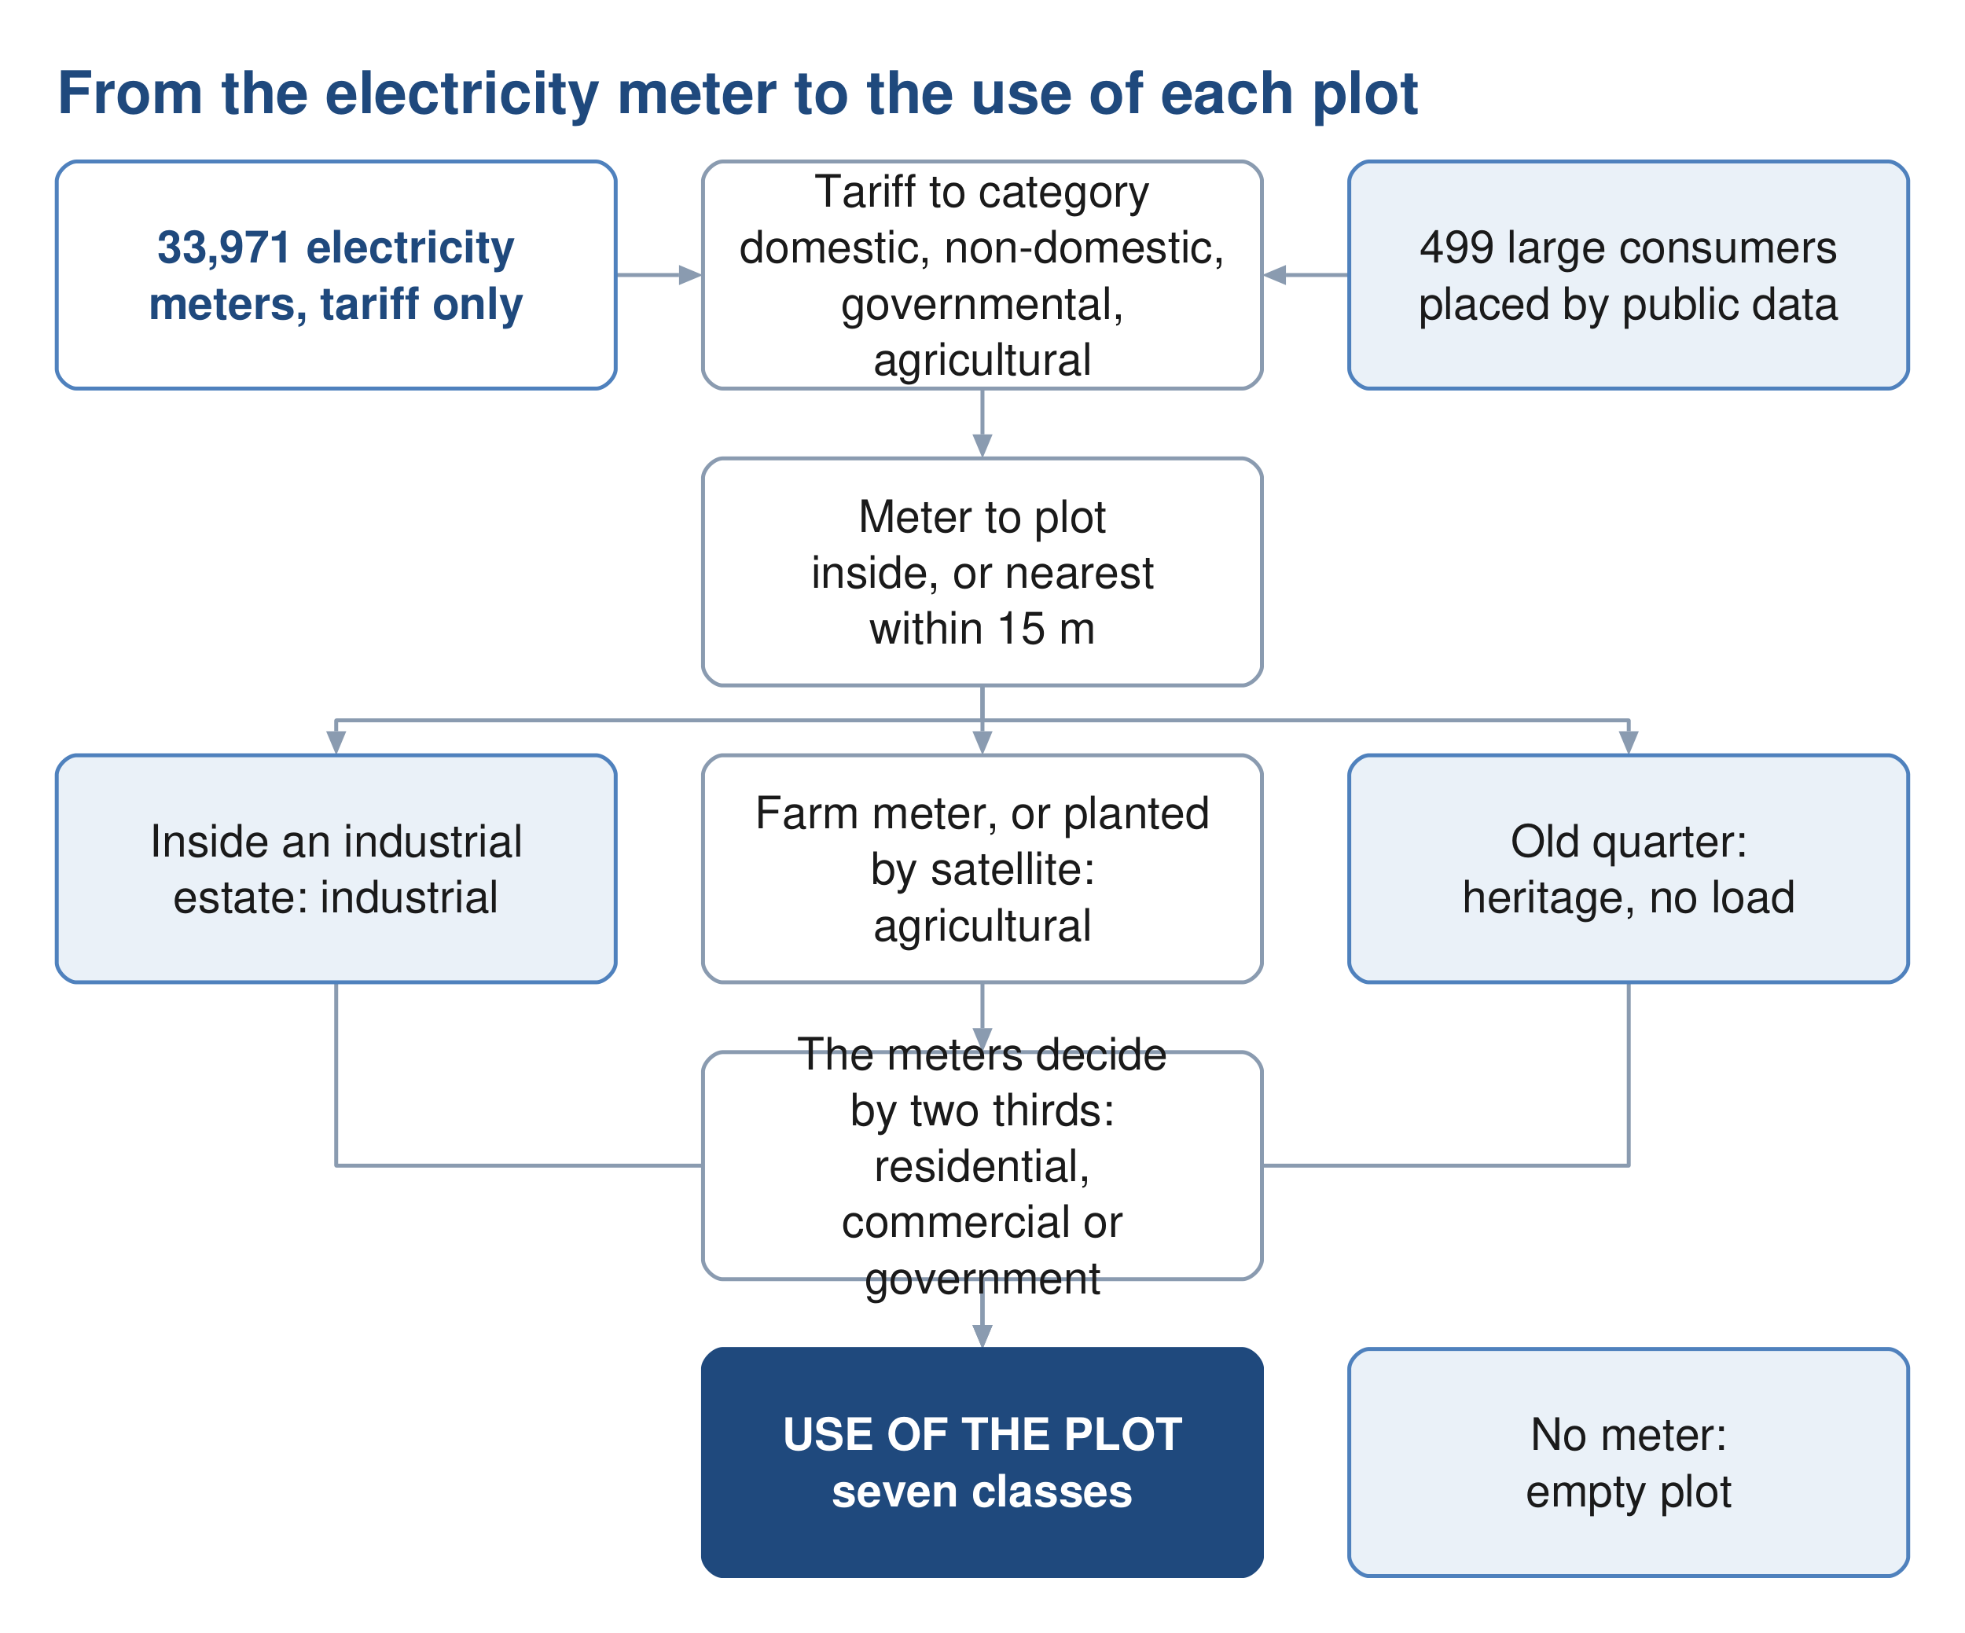
Figure 17 How the use of each plot is determined from the electricity meters, the satellite image and the plot itself.
1. a plot inside one of the two industrial estates is industrial;
2. the 177 plots of the old quarter of Ibri, recorded as tourism in the cadastre, are heritage and carry no load;
3. a plot with a farm meter is agricultural;
4. a plot the satellite image shows as planted is agricultural, unless two thirds of its meters are shops or most are government;
5. a plot whose industrial meters equal or outnumber its domestic meters is industrial;
6. otherwise the meters decide by proportion: more than two thirds domestic makes it residential, two thirds or more government makes it government, two thirds or more shops makes it commercial, and a mix is residential-commercial, or government where the government meters are the more;
7. a plot without a meter is empty.
The satellite image is a cloud-free Sentinel-2 image of 9 September 2026. It is used for one purpose: to tell a planted plot, a date-palm plantation, from a bare one, because a farm meter alone misses the plantations that pump from elsewhere.
Table 23 Use of the plots
Use | Plots | How it was decided
Residential | 12,464 | more than two thirds of the meters are domestic
Residential-Commercial | 614 | a mix, with at least as many shop as government meters
Commercial | 1,321 | two thirds or more of the meters are shops
Government | 410 | two thirds or more government; or a mix with more government than shop meters; the treatment plant
Agricultural | 1,684 | a farm meter (488) or planted on the satellite image (1,196)
Industrial | 263 | inside an industrial estate, or industrial meters that match the domestic meters
Heritage | 177 | the old quarter of Ibri; no meter, no load
Empty | 60,509 | no meter

The use decides where the shop and government water is placed and which empty plots can become homes. It does not change the total: that comes from the people and the rates of Section 15.
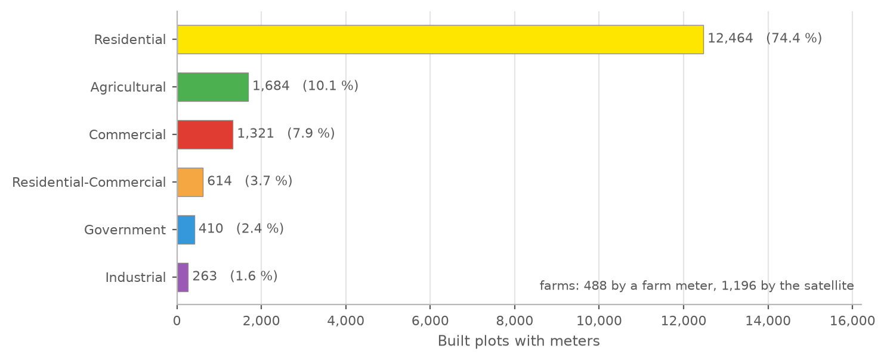
Figure 18 Use of the built, metered plots. Residential plots are 74 per cent of them; agricultural plots, 10 per cent, are found by the meter or by the satellite image.
Decision 3. Approve the use determined for each plot from the meters and the satellite image, as the basis for placing the loads (Section 14.5).

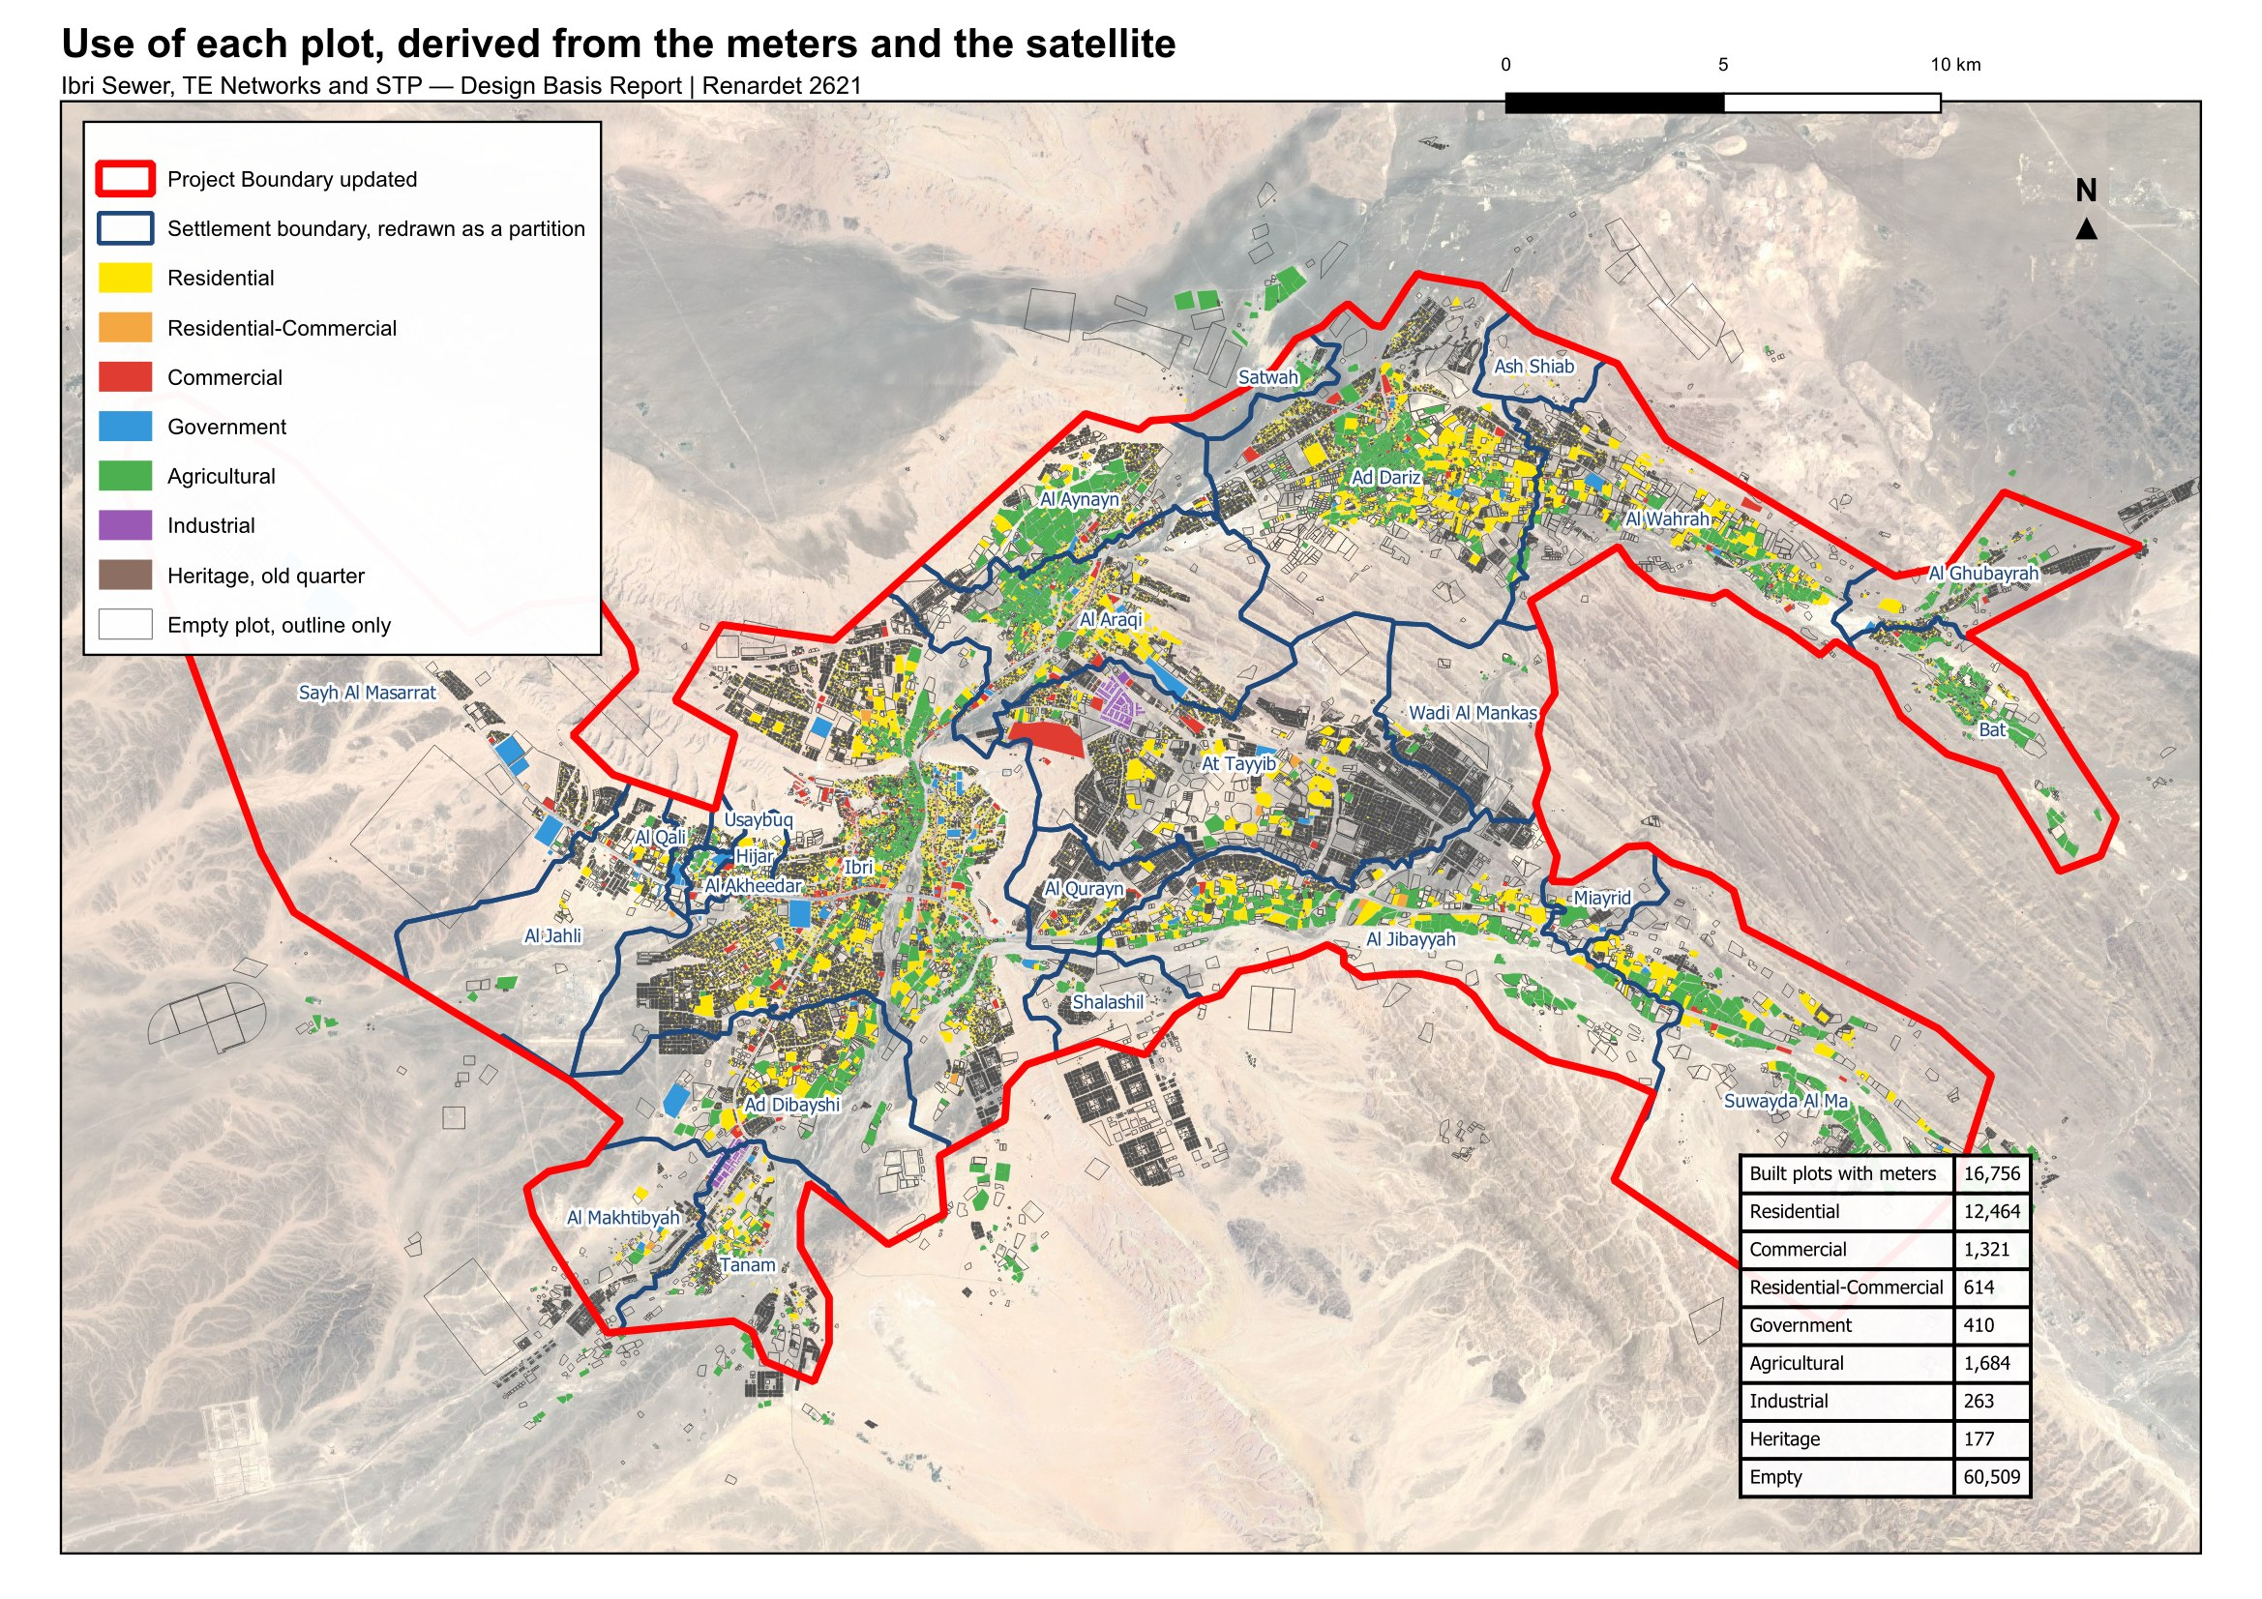
Figure 19 The use of each plot. Coloured plots are built and metered; empty plots are shown by their outline only.

14.6. Capacity of the empty land
Of the 77,265 plots, 60,509 carry no meter. Not all of them will become homes. A future home plot must look like the built ones: between 200 and 1,000 square metres, compact, not a strip. Very small plots below 200 square metres, odd shapes and everything above 1,000 square metres are left out, as are plantations, industrial plots and the heritage quarter. 46,109 empty plots pass that test.
A district also needs mosques, shops and offices, so not every home-shaped plot becomes a home. The share that does is measured in each settlement over its built, metered, home-shaped plots: residential plots divided by all. Ibri returns 0.87; among the settlements of a thousand people or more the measured share runs from 0.67 in Tanam, with its workshops, to 0.94 in Al Aynayn.
The capacity of a settlement is then its home-shaped empty plots, multiplied by its home share, by its properties per home plot and by its occupancy rate.
$Capacity = Empty home‑shaped plots × Home share × Properties per plot × OR$ (6)
Capacity: people the empty land of the settlement can hold, persons
Home share: share of the home-shaped plots that become homes
OR: occupancy rate of the settlement, persons per property
The empty land of the study area holds 229,136 people on this basis, against 119,893 living in it in 2024.

14.7. How fast each settlement grows
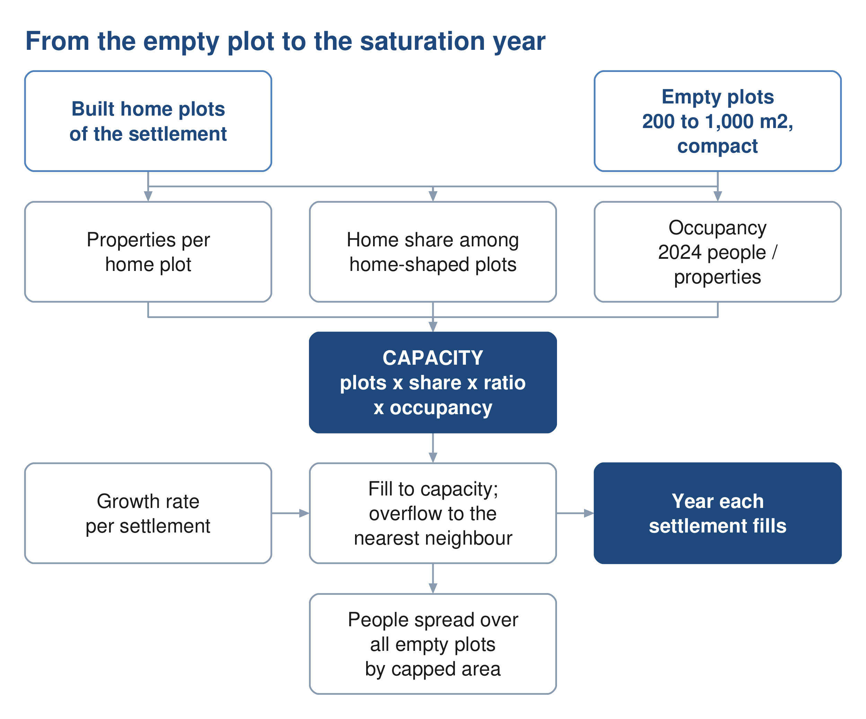
Figure 20 From the empty plot to the year each settlement is full.
The growth rate comes from the population series of the Inception Report, and nothing else is taken from it. To 2040 the series is the official forecast for the wilayat, from the statistics centre and Nama Water Services; from 2041 to 2050 it is the extension of that forecast in the Inception Report. Both are the client's own figures. From 2051 the series rises from 2.2 per cent a year to 2.40 by 2058 and stays there to 2100, the horizon Nama Water Services instructed; that part goes beyond the ten years of extension the guideline allows and is put to approval. Every settlement carries the same annual rate, applied to its counted population. The rate averages 2.6 per cent a year to 2030, 2.5 in the 2030s, 2.0 in the 2040s, 2.3 in the 2050s and 2.4 after 2060.
The series' total for 2100 is not a target. The land fills long before then.
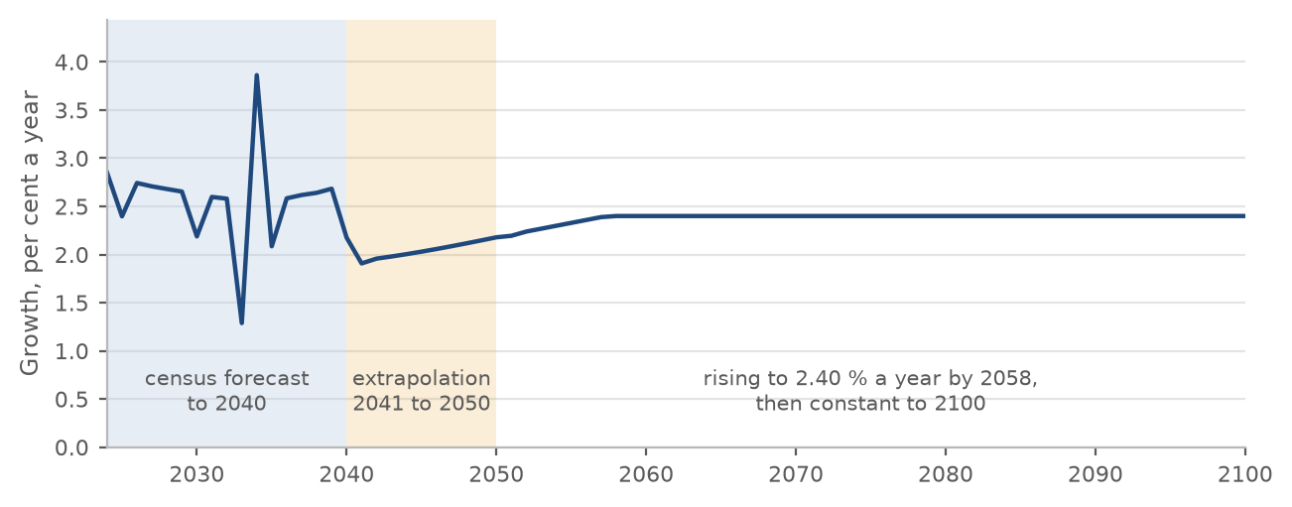
Figure 21 The annual growth rate of the series: the forecast to 2040, the extension to 2050, and the rise to a constant 2.40 per cent.
Decision 6. Approve the extension of the population series beyond 2050: the rise to 2.40 per cent a year by 2058 and that rate held to 2100. The series to 2050 is the client's own (Section 14.7).

14.8. When a settlement is full: the overflow
Each settlement grows at the rate of the series until its empty plots are built, its growth filling them together and in proportion. Then its further growth has to go somewhere. Two readings are possible, and the choice between them is the largest single decision in this report.
With the overflow: when a settlement is full, its further growth moves to a neighbour with room. Ibri's goes in parallel to Al Araqi, Al Qurayn and Shalashil, in the proportions seventy, twenty and ten per cent, then to Ad Dariz, then to the nearest settlement with room. At Tayyib's goes first to Miayrid. Every other settlement overflows to its nearest neighbour with room.
Without: each settlement grows on its own rate and stops when it is full. The growth it cannot house is lost to the study area.
The difference is large. With the overflow every settlement fills by 2070 and the study area holds 349,029 people. Without it, 7 settlements never fill before 2100, the study area holds 273,616 people in 2070, and 75,414 people of the series have nowhere to go. A sewer in those settlements sized on their own growth would be sized for land that never fills.
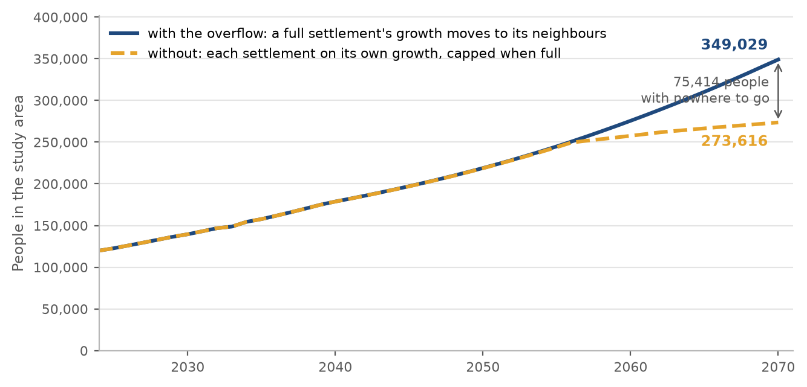
Figure 22 People in the study area by year, with the overflow and without it.
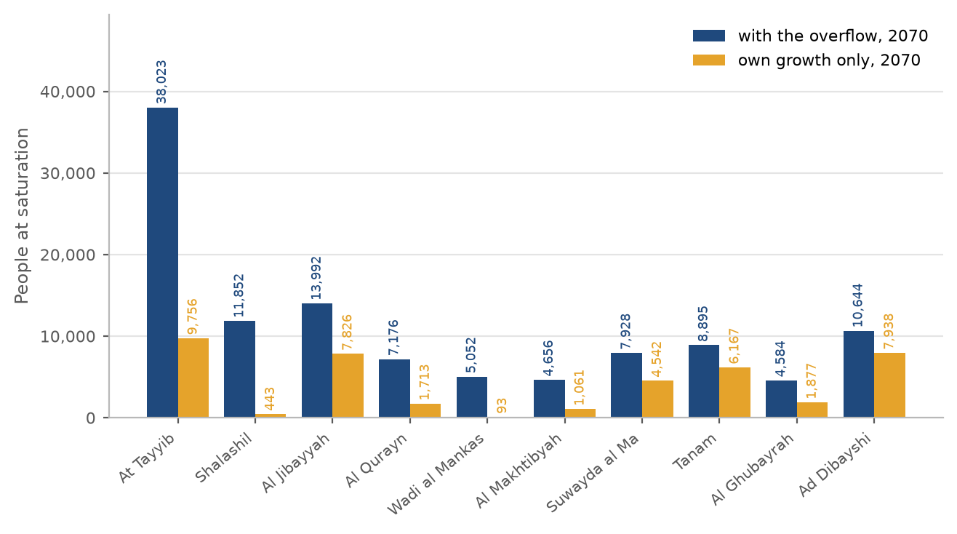
Figure 23 People at saturation in the ten settlements the choice affects most, with the overflow and without.
Table 24 Every settlement with and without the overflow: people in 2070 and the year it is full
Settlement | Capacity, people | With the overflow: people 2070 | full in | Own growth only: people 2070 | full in
Ibri | 73,299 | 140,405 | 2056 | 140,405 | 2057
Ad Dariz | 16,854 | 28,704 | 2062 | 28,704 | 2063
Al Araqi | 11,832 | 22,528 | 2057 | 22,528 | 2057
Al Aynayn | 7,459 | 12,013 | 2060 | 12,013 | 2066
Al Wahrah | 7,109 | 10,460 | 2070 | 9,765 | 2073
At Tayyib | 34,675 | 38,023 | 2068 | 9,756 | not before 2100
Ad Dibayshi | 7,920 | 10,644 | 2063 | 7,938 | 2083
Al Jibayyah | 11,306 | 13,992 | 2070 | 7,826 | 2095
Bat | 2,226 | 4,783 | 2052 | 4,783 | 2052
Tanam | 6,779 | 8,895 | 2069 | 6,167 | 2086
Sayh al Masarrat | 4,984 | 6,812 | 2069 | 5,327 | 2081
Suwayda al Ma | 6,369 | 7,928 | 2070 | 4,542 | 2094
Hijar | 1,288 | 2,696 | 2053 | 2,696 | 2053
Al Jahli | 3,684 | 5,060 | 2063 | 4,010 | 2080
Al Ghubayrah | 3,940 | 4,584 | 2070 | 1,877 | not before 2100
Al Qurayn | 6,588 | 7,176 | 2060 | 1,713 | not before 2100
Al Akheedar | 160 | 640 | 2036 | 640 | 2036
Al Makhtibyah | 4,292 | 4,656 | 2069 | 1,061 | not before 2100
Al Qali | 564 | 788 | 2054 | 653 | 2078
Shalashil | 11,700 | 11,852 | 2061 | 443 | not before 2100
Satwah | 284 | 392 | 2060 | 315 | 2080
Usaybuq | 140 | 224 | 2054 | 224 | 2067
Ash Shiab | 48 | 92 | 2056 | 92 | 2056
Wadi al Mankas | 5,020 | 5,052 | 2068 | 93 | not before 2100
Miayrid | 616 | 632 | 2070 | 47 | not before 2100
Total | 229,136 | 349,029 | 2070 | 273,616

The rule sets the order; the land sets the result. Al Araqi fills in 2057, a year after Ibri, so it takes only 163 of Ibri's people, and most of Ibri's overflow passes on: the largest route is to At Tayyib, 22,078 people, and 14 settlements take some of Ibri's growth in all. The routes carrying more than a thousand people are set out below; the full list is in Appendix A4.
Table 25 The main overflow routes
From | To | People at saturation | Donor full | Receiver starts | Receiver full
Ibri | At Tayyib | 22,078 | 2056 | 2060 | 2068
Ibri | Shalashil | 11,471 | 2056 | 2056 | 2061
Ibri | Al Qurayn | 5,856 | 2056 | 2056 | 2060
Ad Dariz | Wadi al Mankas | 4,965 | 2062 | 2062 | 2068
Al Araqi | At Tayyib | 4,873 | 2057 | 2060 | 2068
Ibri | Ad Dibayshi | 4,078 | 2056 | 2062 | 2063
Ibri | Al Jibayyah | 3,927 | 2056 | 2068 | 2070
Bat | Al Ghubayrah | 2,493 | 2052 | 2052 | 2070
Ibri | Al Makhtibyah | 2,441 | 2056 | 2063 | 2069
Ibri | Tanam | 2,010 | 2056 | 2063 | 2069
Al Araqi | Al Aynayn | 1,790 | 2057 | 2057 | 2060
Al Aynayn | At Tayyib | 1,639 | 2060 | 2060 | 2068
Al Araqi | Al Jibayyah | 1,410 | 2057 | 2068 | 2070
Ibri | Sayh al Masarrat | 1,225 | 2056 | 2063 | 2069
Ad Dibayshi | Tanam | 1,004 | 2063 | 2063 | 2069

Decision 4. Approve the overflow: when a settlement's land is full, its further growth moves to its neighbours. Without it 75,000 people of the series have nowhere to go by 2070 (Section 14.8).

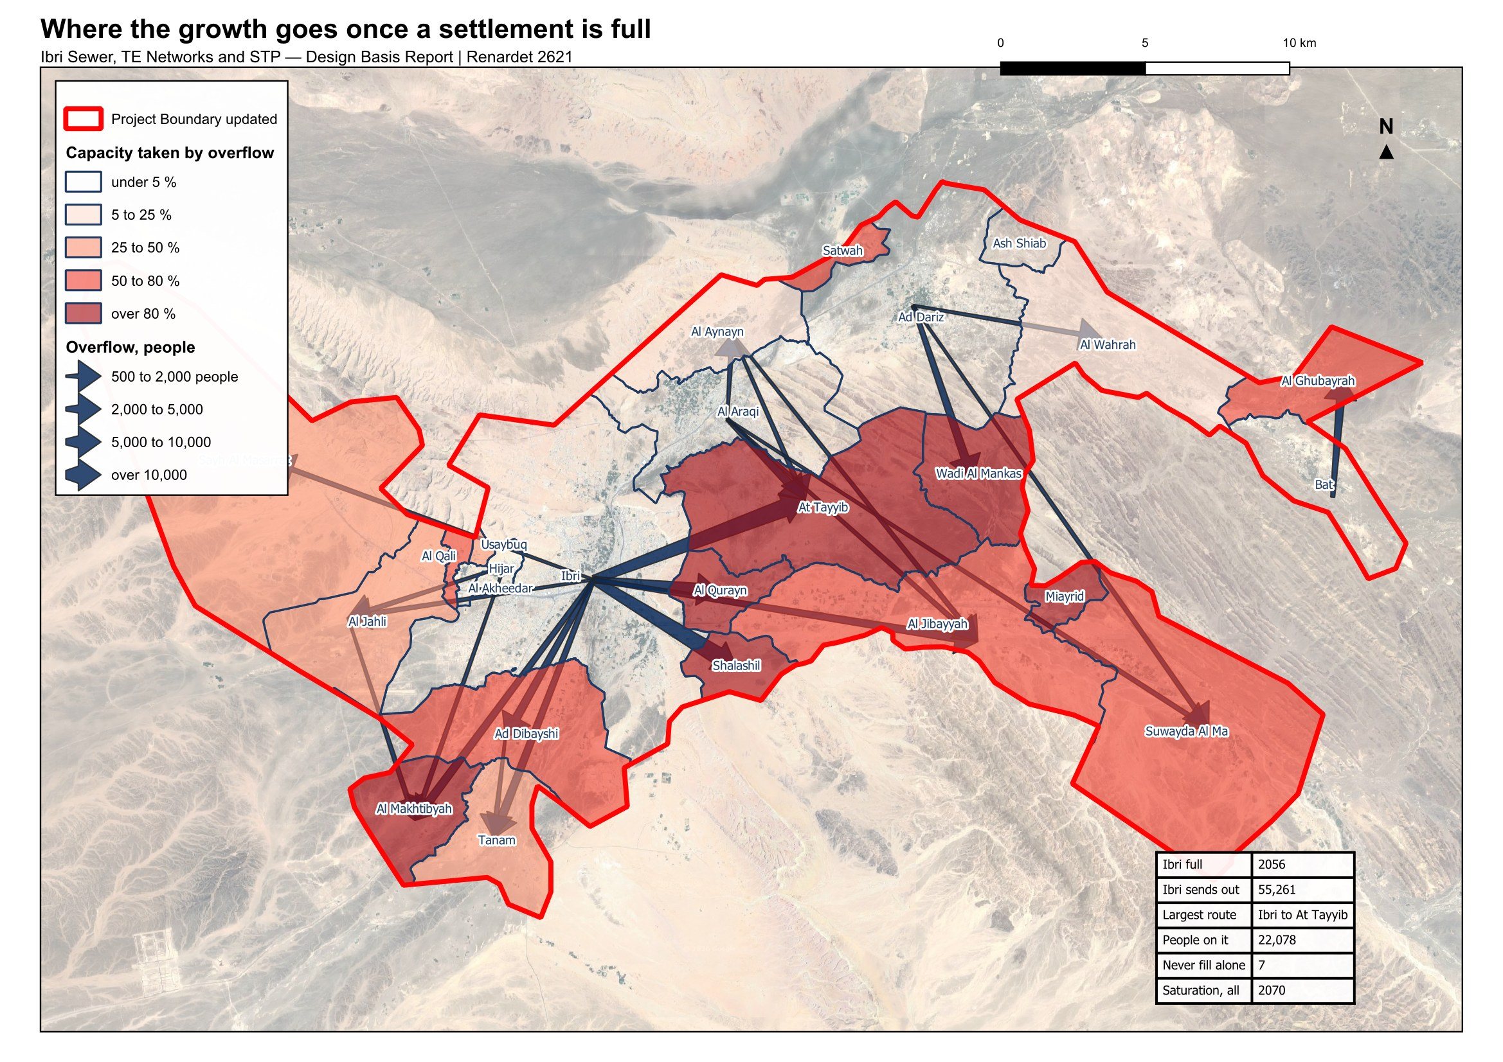
Figure 24 Where the growth goes once a settlement is full. Arrows show the routes carrying five hundred people or more at saturation; the shading shows how much of each settlement's capacity is taken by its neighbours' overflow.

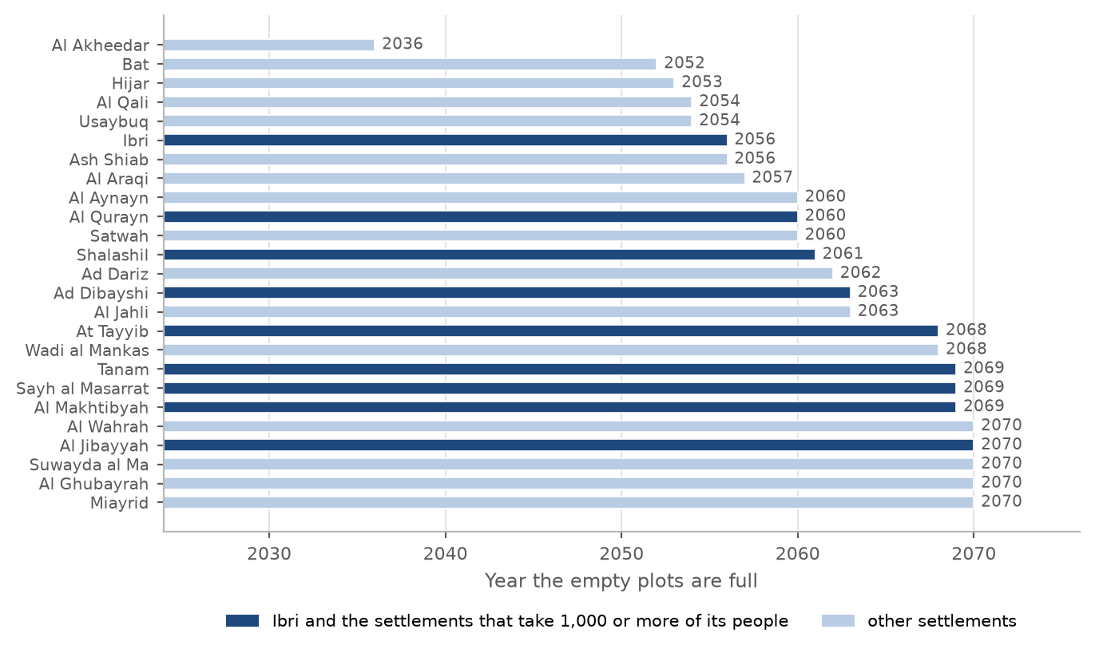
Figure 25 The year each settlement's empty plots are full. Ibri and the settlements that take a thousand or more of its people are marked.

14.9. The design horizon: 2055, or the year the land is full
The Terms of Reference name a horizon of completion plus twenty-five years. With the opening year taken as 2030, that is 2055: 244,914 people and 42,266 cubic metres a day. The Terms of Reference also ask for the saturation of the area. With the overflow, Ibri fills in 2056, Al Araqi in 2057, Ad Dariz in 2062, and the last settlement in 2070: 349,029 people and 60,099 cubic metres a day, 42 per cent more than in 2055.
The two horizons ask different things of the design. A network sized on 2055 is cheaper to build and reaches its capacity while the plots around it are still being built; the pipes under those streets would then need to be replaced or relieved. A network sized on the year the land is full is laid once, and its sewers run at low flow for longer, which the self-cleansing check of Section 15.8 is there to catch. The STP is staged either way, on the series. The horizon is for Nama Water Services to decide.
Table 26 The study area in the design years
Year | People | Average sewage flow, m³/d | What it is
2024 | 119,893 | 20,852 | today, from the meters
2030 | 139,535 | 24,216 | opening year
2055 | 244,914 | 42,266 | opening year plus 25 years
2070 | 349,029 | 60,099 | saturation: the land is full

Decision 5. Decide the design horizon: 2055, the opening year 2030 plus 25 years, with 244,914 people and 42,266 cubic metres a day; or 2070, the year the land is full, with 349,029 people and 60,099 cubic metres a day (Section 14.9).
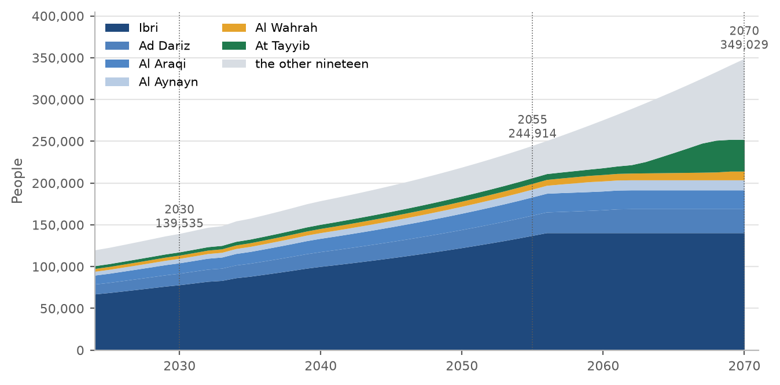
Figure 26 People by year to saturation, the six largest settlements shown separately. The flat top of each band is the year that settlement fills.
The people of every settlement at five-year steps, to the year it is full. A cell is blank once the settlement is full.
Table 27 People by settlement at five-year intervals
Settlement | 2024 | 2025 | 2030 | 2035 | 2040 | 2045 | 2050 | 2055 | 2060 | 2065 | 2070 | Full in | At saturation
Ibri | 67,106 | 68,713 | 78,099 | 88,272 | 100,066 | 110,349 | 122,535 | 137,198 |  |  |  | 2056 | 140,405
Ad Dariz | 11,850 | 12,134 | 13,791 | 15,587 | 17,670 | 19,486 | 21,638 | 24,206 | 27,350 |  |  | 2062 | 28,704
Al Araqi | 10,696 | 10,952 | 12,448 | 14,069 | 15,949 | 17,588 | 19,531 | 21,849 |  |  |  | 2057 | 22,528
Al Aynayn | 4,554 | 4,663 | 5,300 | 5,990 | 6,791 | 7,489 | 8,316 | 9,303 | 12,013 |  |  | 2060 | 12,013
Al Wahrah | 3,351 | 3,431 | 3,900 | 4,408 | 4,997 | 5,511 | 6,119 | 6,845 | 7,703 | 8,684 | 10,460 | 2070 | 10,460
At Tayyib | 3,348 | 3,428 | 3,897 | 4,404 | 4,993 | 5,506 | 6,114 | 6,839 | 8,130 | 23,972 |  | 2068 | 38,023
Ad Dibayshi | 2,724 | 2,789 | 3,170 | 3,583 | 4,062 | 4,479 | 4,974 | 5,564 | 6,262 |  |  | 2063 | 10,644
Al Jibayyah | 2,686 | 2,750 | 3,126 | 3,533 | 4,005 | 4,416 | 4,904 | 5,486 | 6,174 | 6,951 | 13,992 | 2070 | 13,992
Bat | 2,557 | 2,618 | 2,976 | 3,363 | 3,813 | 4,204 | 4,669 |  |  |  |  | 2052 | 4,783
Tanam | 2,116 | 2,167 | 2,463 | 2,784 | 3,156 | 3,480 | 3,864 | 4,323 | 4,865 | 5,961 |  | 2069 | 8,895
Sayh al Masarrat | 1,828 | 1,872 | 2,127 | 2,405 | 2,726 | 3,006 | 3,338 | 3,734 | 4,202 | 4,786 |  | 2069 | 6,812
Suwayda al Ma | 1,559 | 1,596 | 1,814 | 2,050 | 2,324 | 2,563 | 2,846 | 3,184 | 3,583 | 4,034 | 7,928 | 2070 | 7,928
Hijar | 1,408 | 1,442 | 1,639 | 1,852 | 2,100 | 2,315 | 2,571 |  |  |  |  | 2053 | 2,696
Al Jahli | 1,376 | 1,409 | 1,601 | 1,810 | 2,052 | 2,263 | 2,513 | 2,831 | 3,746 |  |  | 2063 | 5,060
Al Ghubayrah | 644 | 659 | 750 | 847 | 960 | 1,059 | 1,176 | 1,756 | 2,575 | 3,501 | 4,584 | 2070 | 4,584
Al Qurayn | 588 | 602 | 684 | 773 | 877 | 967 | 1,074 | 1,201 | 7,176 |  |  | 2060 | 7,176
Al Akheedar | 480 | 492 | 559 | 631 |  |  |  |  |  |  |  | 2036 | 640
Al Makhtibyah | 364 | 373 | 424 | 479 | 543 | 599 | 665 | 744 | 837 | 1,522 |  | 2069 | 4,656
Al Qali | 224 | 229 | 261 | 295 | 410 | 518 | 646 |  |  |  |  | 2054 | 788
Shalashil | 152 | 156 | 177 | 200 | 227 | 250 | 278 | 311 | 8,335 |  |  | 2061 | 11,852
Satwah | 108 | 111 | 126 | 142 | 161 | 178 | 197 | 221 | 392 |  |  | 2060 | 392
Usaybuq | 84 | 86 | 98 | 110 | 125 | 138 | 153 |  |  |  |  | 2054 | 224
Ash Shiab | 44 | 45 | 51 | 58 | 66 | 72 | 80 | 90 |  |  |  | 2056 | 92
Wadi al Mankas | 32 | 33 | 37 | 42 | 48 | 53 | 58 | 65 | 74 | 2,859 |  | 2068 | 5,052
Miayrid | 16 | 16 | 19 | 21 | 24 | 26 | 29 | 33 | 37 | 41 | 632 | 2070 | 632
Total | 119,893 | 122,766 | 139,535 | 157,710 | 178,781 | 197,153 | 218,926 | 244,914 | 275,608 | 310,307 | 349,029 | 2070 | 349,029

14.10. Where the growth is placed
For the network every empty plot matters, not only the ones counted as future homes, because the sewer that serves a street serves every plot on it. The people a settlement houses in a given year are therefore spread over all its empty plots up to 2,000 square metres, in proportion to plot area capped at 1,000 square metres. A very small plot takes its small share and a large plot takes no more than a full-sized home plot. The sum over the plots equals the settlement's housed population by construction, so the network total and the STP total are the same figure.

15. Wastewater generation and design flows
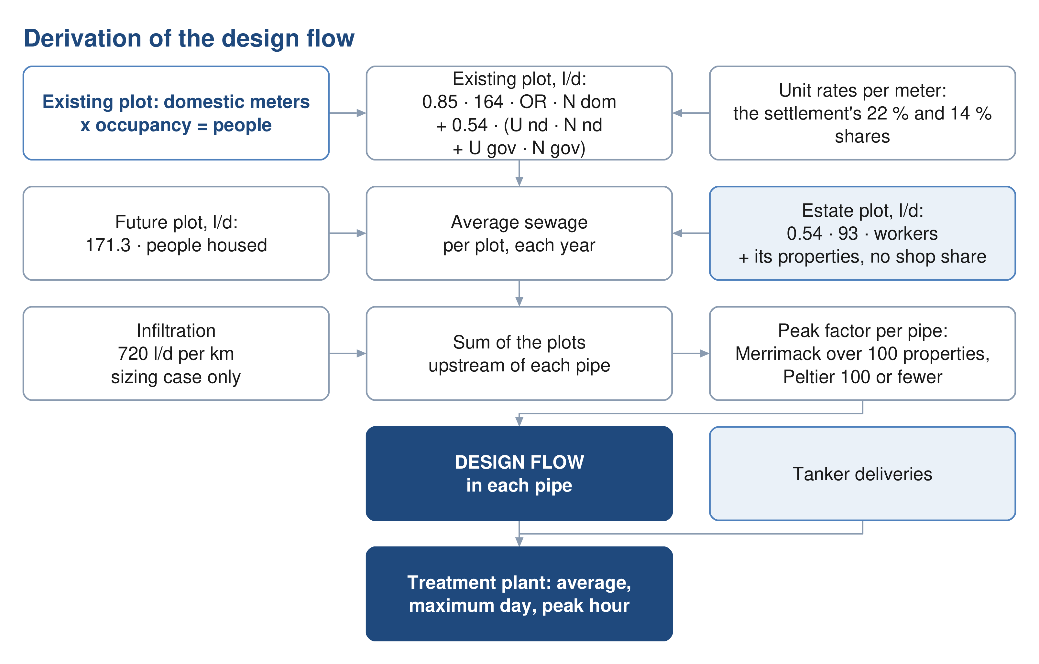
Figure 27 Derivation of the design flow, from the plot to the pipe and the STP.

15.1. Water demand
Wastewater generation is derived from water demand. Four components are carried: domestic, non-domestic, governmental and special consumption. A household supplied by tanker is metered for electricity like any other and carries the domestic rate; the tanker volumes themselves are a data request and no separate term is carried (Section 10.1).
$Q_{dom} = Population × LPCD$ (7)
Q dom: domestic water demand, l/d
LPCD: unit consumption, 164 for Adh Dhahirah, l per person per day
Non-domestic and governmental demand are established as proportions of domestic demand.
$Q_{ND} = 0.22Q_{dom}$ (8)
Q ND: non-domestic water demand of the settlement: shops and offices, l/d
$Q_{gov} = 0.14Q_{dom}$ (9)
Q gov: governmental water demand of the settlement, l/d
The proportions are the values published for the Governorate of Adh Dhahirah. The guideline calls them distributed. They come from the governorate's water balance of 2021 to 2023, all the non-domestic water divided by all the domestic water, so they stand for the everyday shops, mosques, schools and offices that come with any population, and they are added whether or not a particular village has a shop today. They do not cover named projects such as economic zones, which are added separately. Per person they are 36 and 23 litres a day, and the three are applied as separate streams, never combined into one rate. Each settlement's non-domestic and governmental water is placed on its shop and government meters in proportion to their number.

15.2. Special consumption: the industrial estates
Two industrial estates lie inside the study area, at Al Tayyeb in the north-east of the town and at Tanam beside the treatment plant. Their meters are recorded on the commercial tariff. The guideline places such estates outside the population ratios, and they are treated as special consumption: a workforce of 4,500 at Al Tayyeb and 1,800 at Tanam, spread over their industrial plots in proportion to area, at the dry-industry rate of 93 litres per employee per day. Their meters take no share of the settlement's non-domestic or governmental water: an estate plot carries its workers, and the few properties on the estates carry the domestic rate like any other. The workforce is an assumption from the number of workshop meters and is to be replaced by the estates' own records. Section 16 describes the estates and the other identified projects.
Adopted (10). 4,500 workers at Al Tayyeb and 1,800 at Tanam at 93 litres a day each, an assumption to be replaced by the estates' records when received (Section 15.2).

15.3. Return to the sewer
Not all supplied water reaches the sewer. The proportion that does is applied by category.
$Q_{ww} = 0.85Q_{dom} + 0.54\left(Q_{ND} + Q_{gov} + Q_{special}\right)$ (10)
Q ww: wastewater generated, before infiltration, l/d
Q dom: domestic demand; tanker supply is added when its records are received, l/d
Q special: water of the special consumption, the guideline's term; in the study area the two industrial estates, l/d
Water supplied by tanker returns to the sewer at the same proportion as piped supply. The domestic rate of 164 litres a day measures network water only, so tanker supply is not inside the domestic stream; it is added when the filling-station records are received (Section 10.1).
Farm meters supply irrigation pumps and are taken to return nothing, and the estates' dry-industry demand is taken to return 54 per cent, as non-domestic supply does. Both are rules of this design, not of the guideline.
Adopted (9). 164 litres per person per day, plus 22 per cent for shops and offices and 14 per cent for government, the values the guideline publishes for Adh Dhahirah; 85 per cent of domestic and tanker supply and 54 per cent of the rest return to the sewer. The published ratios are used in place of the unit rates per pupil, bed, employee and floor area until those quantities are held (Sections 15.1 and 15.3).

15.4. The flow from each plot
Applied plot by plot, the rules above give every plot an average daily sewage flow for 2024. An existing plot is built from its meters and the rates of its settlement:
$Q_{plot} = 0.85 × 164 × OR × N_{dom} + 0.54 × \left(U_{nd}N_{nd} + U_{gov}N_{gov} + 93N_{w}\right)$ (11)
Q plot: average sewage flow of the plot in 2024, l/d
OR: occupancy rate adopted for the settlement (Section 14.4), persons per property
N dom: domestic meters on the plot, one property each
U nd: non-domestic water per shop meter in the settlement, l/d per meter
N nd: non-domestic meters on the plot; none counted on an estate plot
U gov: governmental water per government meter in the settlement, l/d per meter
N gov: government meters on the plot; none counted on an estate plot
N w: workers on an industrial-estate plot
The unit rates are the settlement's non-domestic and governmental shares, divided equally among the meters that carry them:
$U_{nd} = \frac{0.22 × 164 × P_{s}}{N_{nd,s}}$ (12)
P s: people of the settlement in 2024
N nd,s: shop meters of the settlement outside the industrial estates
$U_{gov} = \frac{0.14 × 164 × P_{s}}{N_{gov,s}}$ (13)
N gov,s: government meters of the settlement outside the industrial estates
The estates' meters take no share of the pool; an estate plot carries its workers at 93 litres a day, and the properties on it, if any, at the domestic rate. A settlement with no shop or government meter outside the estates keeps that share on its houses, in proportion to their people. A future plot carries the people it houses in the year at 171.3 litres a day each, all three streams together, since where its shops will stand is not known.
The shares and the unit rates of every settlement are set out below. The sum of the plots equals the settlement in every column.
Table 28 Water shares and unit rates by settlement, 2024
Settlement | People | Domestic m³/d | Non-domestic share m³/d | Governmental share m³/d | Shop meters | Government meters | l/d per shop meter | l/d per government meter | Estates m³/d | Sewage m³/d
Ibri | 67,106 | 11,005 | 2,421 | 1,541 | 4,747 | 461 | 510 | 3,342 | – | 11,494
Ad Dariz | 11,850 | 1,943 | 428 | 272 | 820 | 82 | 521 | 3,318 | – | 2,030
Al Araqi | 10,696 | 1,754 | 386 | 246 | 1,018 | 96 | 379 | 2,558 | – | 1,832
Al Aynayn | 4,554 | 747 | 164 | 105 | 204 | 26 | 805 | 4,022 | – | 780
Al Wahrah | 3,351 | 550 | 121 | 77 | 132 | 23 | 916 | 3,345 | – | 574
At Tayyib | 3,348 | 549 | 121 | 77 | 179 | 19 | 675 | 4,046 | 419 | 799
Al Jibayyah | 2,686 | 440 | 97 | 62 | 96 | 20 | 1,009 | 3,083 | – | 460
Bat | 2,557 | 419 | 92 | 59 | 51 | 26 | 1,809 | 2,258 | – | 438
Ad Dibayshi | 2,724 | 447 | 98 | 63 | 236 | 17 | 416 | 3,679 | 27 | 481
Tanam | 2,116 | 347 | 76 | 49 | 124 | 32 | 616 | 1,518 | 105 | 419
Suwayda al Ma | 1,559 | 256 | 56 | 36 | 34 | 13 | 1,654 | 2,753 | – | 267
Hijar | 1,408 | 231 | 51 | 32 | 63 | 4 | 806 | 8,082 | – | 241
Al Ghubayrah | 644 | 106 | 23 | 15 | 105 | 4 | 221 | 3,697 | – | 110
Al Qurayn | 588 | 96 | 21 | 14 | 14 | 7 | 1,515 | 1,929 | – | 101
Sayh al Masarrat | 1,828 | 300 | 66 | 42 | 128 | 99 | 515 | 424 | – | 313
Al Jahli | 1,376 | 226 | 50 | 32 | 143 | 87 | 347 | 363 | – | 236
Satwah | 108 | 18 | 4 | 2 | 5 | 0 | 779 | on the houses | – | 19
Al Akheedar | 480 | 79 | 17 | 11 | 69 | 6 | 251 | 1,837 | – | 82
Al Qali | 224 | 37 | 8 | 5 | 5 | 22 | 1,616 | 234 | – | 38
Shalashil | 152 | 25 | 5 | 3 | 2 | 1 | 2,742 | 3,490 | – | 26
Al Makhtibyah | 364 | 60 | 13 | 8 | 45 | 4 | 292 | 2,089 | 36 | 82
Usaybuq | 84 | 14 | 3 | 2 | 0 | 1 | on the houses | 1,929 | – | 14
Wadi al Mankas | 32 | 5 | 1 | 1 | 0 | 0 | on the houses | on the houses | – | 5
Ash Shiab | 44 | 7 | 2 | 1 | 0 | 1 | on the houses | 1,010 | – | 8
Miayrid | 16 | 3 | 1 | 0 | 4 | 2 | 144 | 184 | – | 3
Total | 119,893 | 19,663 | 4,326 | 2,753 | 8,224 | 1,053 | 526 | 2,614 | 586 | 20,852

In 2024 the study area generates 20,852 cubic metres a day, of which 16,713 is domestic, 2,336 non-domestic, 1,486 governmental and 316 from the two estates.
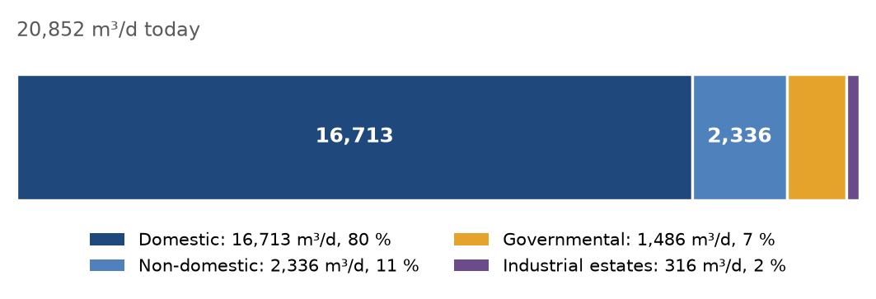
Figure 28 Average sewage flow in 2024 by stream.

15.5. Infiltration
For newly constructed networks an allowance of 720 litres per day per kilometre of sewer is included. It is a property of the pipe, not of the plot, and is added along each run. Infiltration from stormwater is not considered.

15.6. Peak flow
Peak flow belongs to the pipe, not to the plot: it is applied to the sum of the plots upstream of each pipe. Above 100 properties the Merrimack formula applies; at 100 or fewer, the Peltier formula.
$Q_{peak} = 2.65{Q_{avg}}^{0.879}$ (14)
Merrimack: above 100 properties; both flows in Ml/d
Q peak: peak flow: the guideline's peak daily flow, Qpdf, equal to its peak hourly flow, Ml/d
Q avg: average flow of the plots upstream, the guideline's Qadf, Ml/d
$Q_{peak} = \left(1.5 + \frac{1}{\sqrt{Q_{m}}}\right)Q_{avg}$ (15)
Peltier: at 100 properties or fewer
Q m: the average flow of the plots upstream, l/s
The guideline recommends that the hourly peak factor not exceed 5.0. It is a recommendation, applied as such.
Adopted (12). 720 litres a day per kilometre of sewer, added to each pipe and left out of the early-year check; the Merrimack formula above 100 properties and the Peltier formula at 100 or fewer (Sections 15.5 and 15.6).

15.7. Projection through the design period
Flows are established annually and reported at five-year intervals to saturation, as the Terms of Reference require. The study area generates 20,852 cubic metres a day in 2024, 24,216 in 2030, 42,266 in 2055 and 60,099 at saturation in 2070.
Table 29 Average sewage flow by settlement at five-year intervals, m³/d
Settlement | 2024 | 2025 | 2030 | 2035 | 2040 | 2045 | 2050 | 2055 | 2060 | 2065 | 2070 | Full in | At saturation
Ibri | 11,494 | 11,769 | 13,377 | 15,119 | 17,140 | 18,901 | 20,988 | 23,500 |  |  |  | 2056 | 24,049
Ad Dariz | 2,030 | 2,078 | 2,362 | 2,670 | 3,027 | 3,338 | 3,706 | 4,146 | 4,685 |  |  | 2062 | 4,917
Al Araqi | 1,832 | 1,876 | 2,132 | 2,410 | 2,732 | 3,013 | 3,345 | 3,742 |  |  |  | 2057 | 3,859
At Tayyib | 800 | 813 | 893 | 980 | 1,081 | 1,169 | 1,273 | 1,398 | 1,618 | 4,332 |  | 2068 | 6,739
Al Aynayn | 780 | 799 | 908 | 1,026 | 1,163 | 1,283 | 1,424 | 1,593 | 2,058 |  |  | 2060 | 2,058
Al Wahrah | 574 | 588 | 668 | 755 | 856 | 944 | 1,048 | 1,173 | 1,320 | 1,487 | 1,792 | 2070 | 1,792
Ad Dibayshi | 481 | 492 | 557 | 628 | 710 | 782 | 866 | 967 | 1,087 |  |  | 2063 | 1,838
Al Jibayyah | 460 | 471 | 535 | 605 | 686 | 756 | 840 | 940 | 1,057 | 1,191 | 2,397 | 2070 | 2,397
Bat | 438 | 448 | 510 | 576 | 653 | 720 | 800 |  |  |  |  | 2052 | 819
Tanam | 419 | 428 | 479 | 534 | 597 | 653 | 719 | 797 | 890 | 1,078 |  | 2069 | 1,580
Sayh al Masarrat | 313 | 321 | 364 | 412 | 467 | 515 | 572 | 640 | 720 | 820 |  | 2069 | 1,167
Suwayda al Ma | 267 | 273 | 311 | 351 | 398 | 439 | 488 | 545 | 614 | 691 | 1,358 | 2070 | 1,358
Hijar | 241 | 247 | 281 | 317 | 360 | 397 | 440 |  |  |  |  | 2053 | 462
Al Jahli | 236 | 241 | 274 | 310 | 351 | 388 | 430 | 485 | 642 |  |  | 2063 | 867
Al Ghubayrah | 110 | 113 | 128 | 145 | 165 | 181 | 201 | 301 | 441 | 600 | 785 | 2070 | 785
Al Qurayn | 101 | 103 | 117 | 133 | 150 | 166 | 184 | 206 | 1,229 |  |  | 2060 | 1,229
Al Akheedar | 82 | 84 | 96 | 108 |  |  |  |  |  |  |  | 2036 | 110
Al Makhtibyah | 82 | 83 | 92 | 101 | 112 | 122 | 133 | 147 | 163 | 280 |  | 2069 | 817
Al Qali | 38 | 39 | 45 | 51 | 70 | 89 | 111 |  |  |  |  | 2054 | 135
Shalashil | 26 | 27 | 30 | 34 | 39 | 43 | 48 | 53 | 1,428 |  |  | 2061 | 2,030
Satwah | 19 | 19 | 22 | 24 | 28 | 30 | 34 | 38 | 67 |  |  | 2060 | 67
Usaybuq | 14 | 15 | 17 | 19 | 22 | 24 | 26 |  |  |  |  | 2054 | 38
Ash Shiab | 8 | 8 | 9 | 10 | 11 | 12 | 14 | 15 |  |  |  | 2056 | 16
Wadi al Mankas | 6 | 6 | 6 | 7 | 8 | 9 | 10 | 11 | 13 | 490 |  | 2068 | 865
Miayrid | 3 | 3 | 3 | 4 | 4 | 5 | 5 | 6 | 6 | 7 | 108 | 2070 | 108
Total | 20,852 | 21,344 | 24,216 | 27,329 | 30,938 | 34,085 | 37,815 | 42,266 | 47,523 | 53,466 | 60,099 | 2070 | 60,099

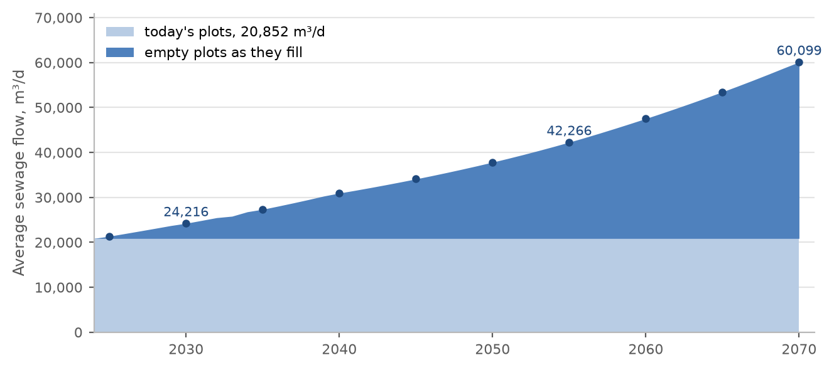
Figure 29 Average sewage flow of the study area by year, from today's plots and from the empty plots as they fill. The points mark the five-year reporting intervals.
The first map below gives the average flow of every plot at saturation. The second gives every settlement's average flow in 2055 and at saturation, and the four steps to an STP flow, so that any grouping of settlements into one or more plants can be calculated by hand. The table carries the same values.
Table 30 Average sewage flow by settlement in 2055 and at saturation, m³/d
Settlement | 2055 | 2070 | Settlement | 2055 | 2070
Ibri | 23,500 | 24,049 | Hijar | 462 | 462
Ad Dariz | 4,146 | 4,917 | Al Ghubayrah | 301 | 785
Al Araqi | 3,742 | 3,859 | Al Qurayn | 206 | 1,229
Al Aynayn | 1,593 | 2,058 | Al Makhtibyah | 147 | 817
At Tayyib | 1,398 | 6,739 | Al Qali | 135 | 135
Al Wahrah | 1,173 | 1,792 | Al Akheedar | 110 | 110
Ad Dibayshi | 967 | 1,838 | Shalashil | 53 | 2,030
Al Jibayyah | 940 | 2,397 | Usaybuq | 38 | 38
Bat | 819 | 819 | Satwah | 38 | 67
Tanam | 797 | 1,580 | Ash Shiab | 15 | 16
Sayh al Masarrat | 640 | 1,167 | Wadi al Mankas | 11 | 865
Suwayda al Ma | 545 | 1,358 | Miayrid | 6 | 108
Al Jahli | 485 | 867 | Total | 42,266 | 60,099

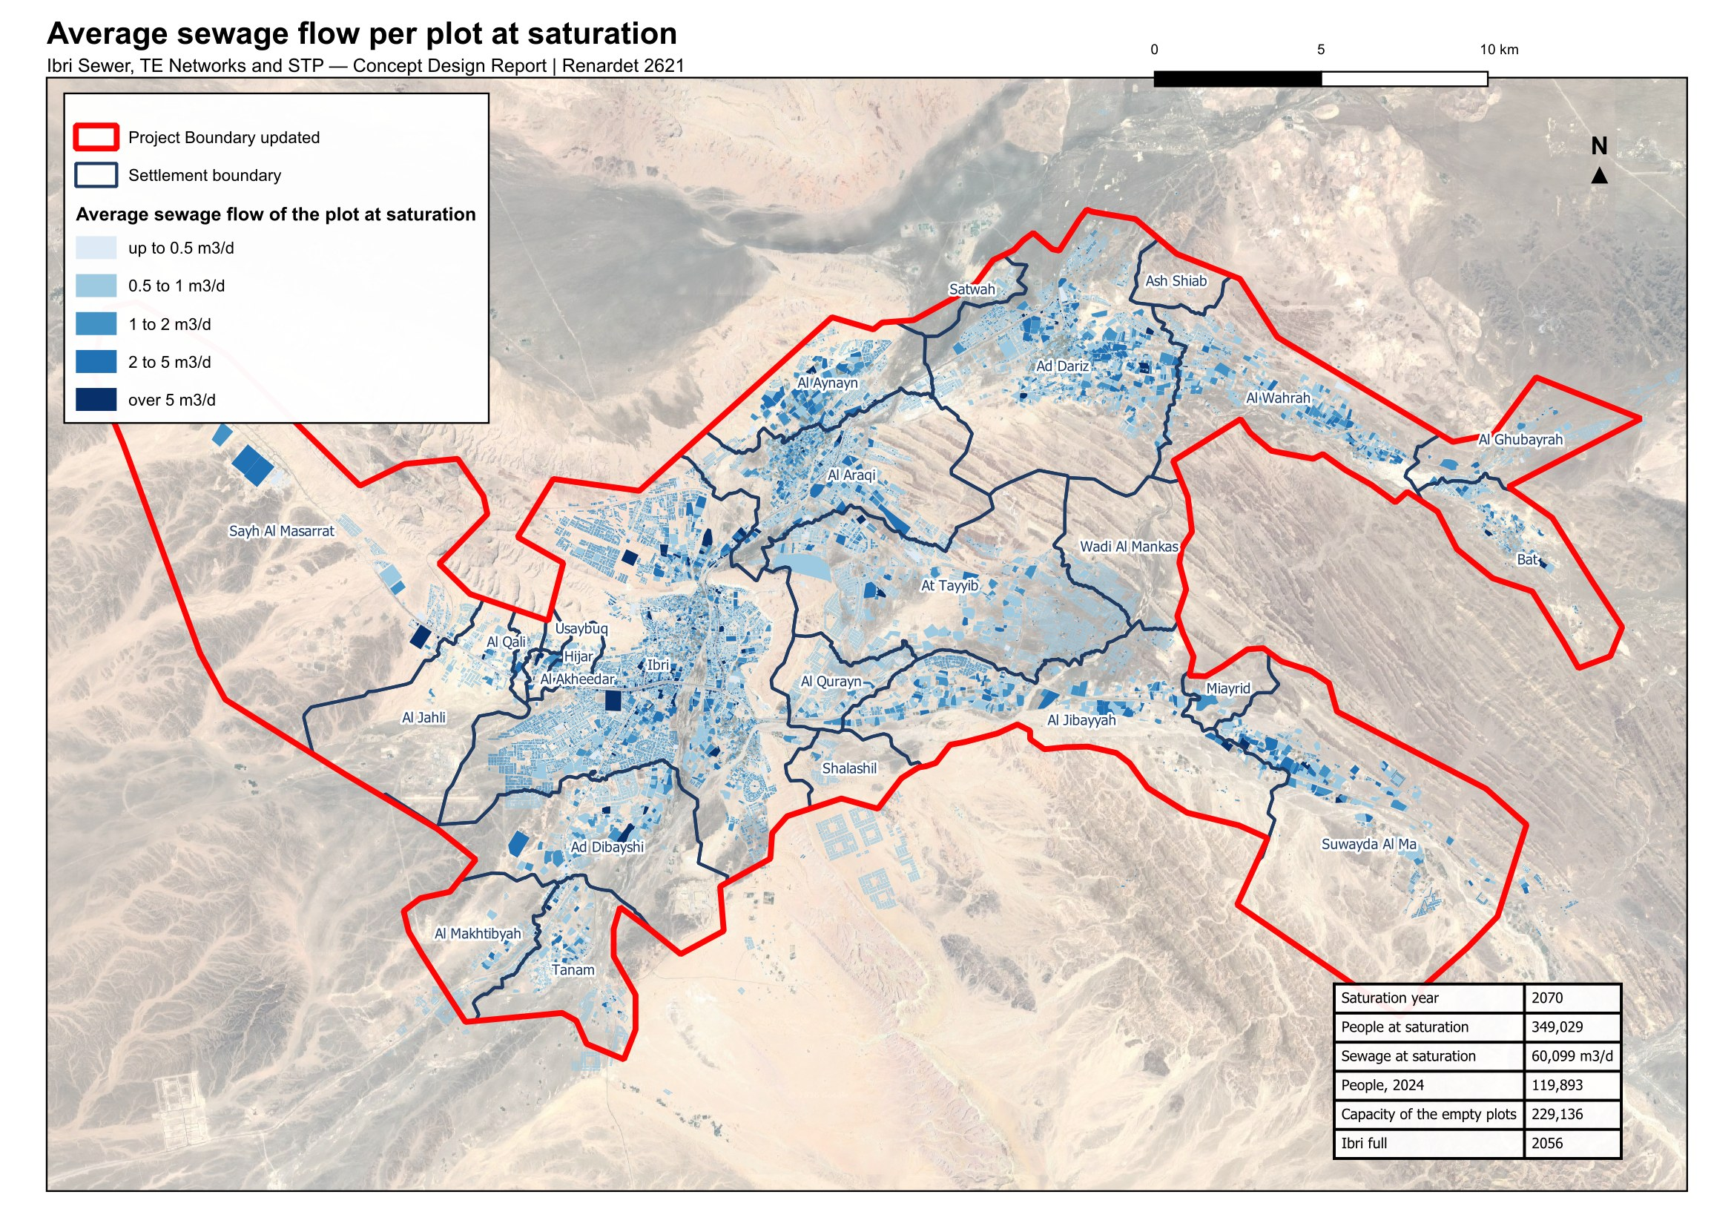
Figure 30 Average sewage flow of every plot at saturation.
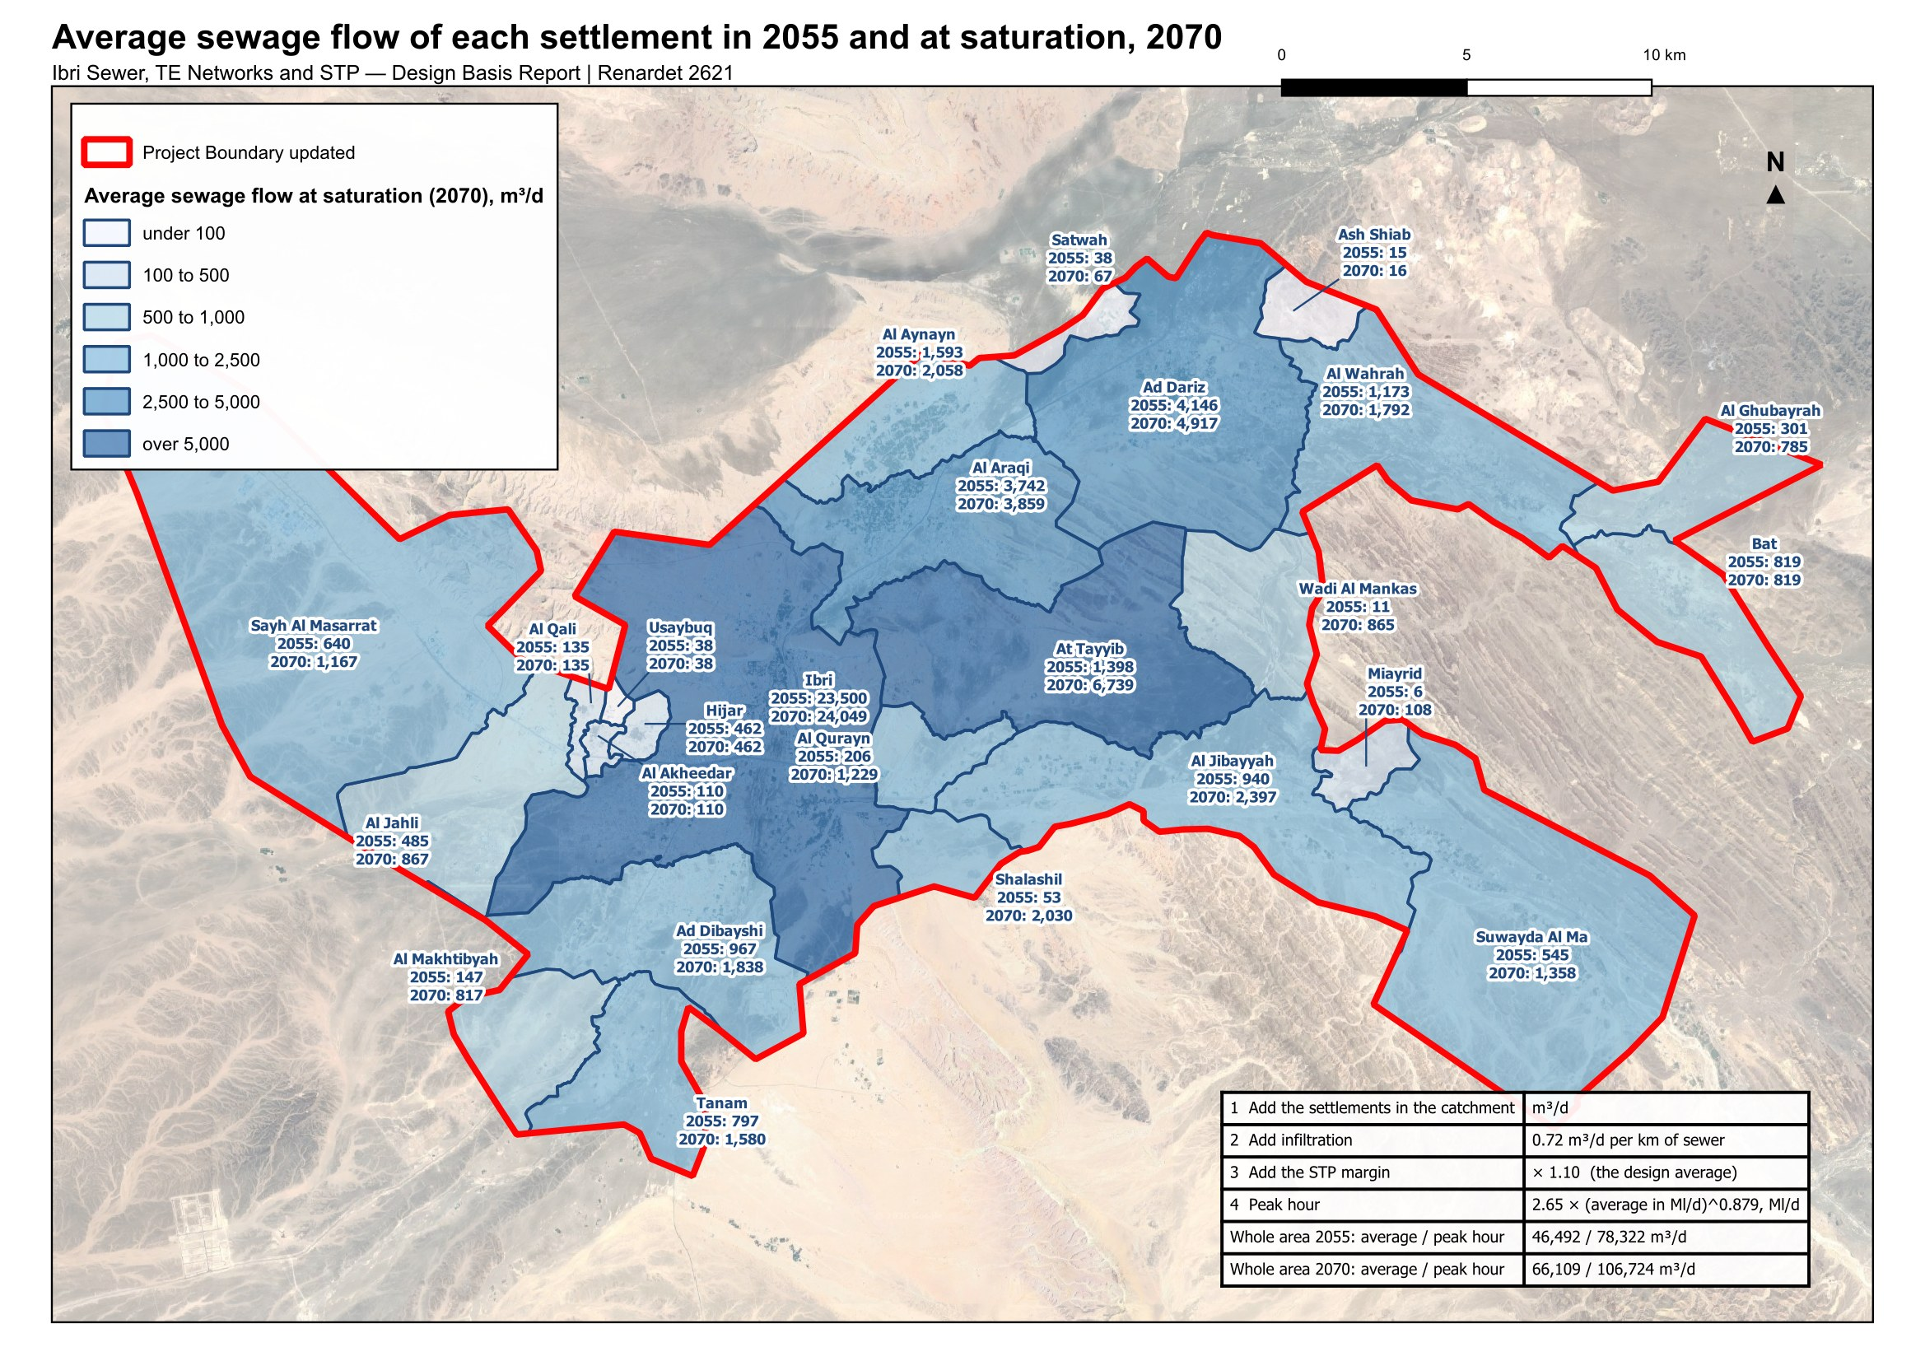
Figure 31 Average sewage flow of each settlement in 2055 and at saturation, and the four steps from the settlements in a catchment to the flow of their STP.

15.8. The flow each element is designed for
Every plot carries an average sewage flow for 2024, 2030, 2055 and the saturation year. What each element of the system is designed for follows from those plot flows by fixed rules. The rules are the same wherever the element sits, so any one of them can be checked.

The plot
The plot carries the average flow of its people and meters, and nothing else: no peak, no infiltration, no tankers. Those belong to the pipe and the STP.

The pipe
A pipe is checked twice, on two different flows, because the two checks fail in opposite directions.
Size and capacity: the flow at saturation of every plot upstream, added up, peaked, plus infiltration along the pipe. Under-estimating it surcharges the pipe.
Self-cleansing: the flow in 2030 of the plots upstream, with 61 per cent of the properties connected, peaked, and no infiltration. Over-estimating it declares a pipe self-cleansing while it silts.
The 61 per cent is the connection ratio of the Inception Report, reached by 2028. It is never applied to the saturation flow: that would give a pipe in a new district most of its final flow in a year when it carries almost nothing.
Adopted (11). 61 per cent of properties connected in 2030, the Inception Report's ratio, used only for the early-year self-cleansing check (Section 15.8).

The pumping station and its rising main
A station's duty flow is the peak flow of the catchment it drains plus the infiltration of its sewers, at saturation. Section 12.3 gives the depth rule that places it and the velocities of its rising main.

The trunk sewers and the treatment plant
The trunk sewers and the STP carry the sum of the settlements upstream. If the whole study area drains to one STP, the flows are as in the table, on the definitions of Section 13.1. The network has not yet been laid over the whole area, so its infiltration cannot be totalled; each 100 kilometres of new sewer adds 79 cubic metres a day with the margin. Tanker deliveries are added when their records arrive.
Table 31 Flows at one STP for the whole area, before infiltration and tankers, m³/d
Flow | 2024 | 2030 | 2055 | 2070
People | 119,893 | 139,535 | 244,914 | 349,029
Average flow from the plots | 20,852 | 24,216 | 42,266 | 60,099
Peak flow before the margin | 38,263 | 43,639 | 71,202 | 97,022
Merrimack peak factor | 1.83 | 1.80 | 1.68 | 1.61
Average annual flow with the margin | 22,937 | 26,638 | 46,492 | 66,109
Peak hourly flow with the margin | 42,089 | 48,003 | 78,322 | 106,724
Infiltration with the margin, to add to both | 0.79 m³/d per km of sewer
Maximum day flow | from the existing STP's records

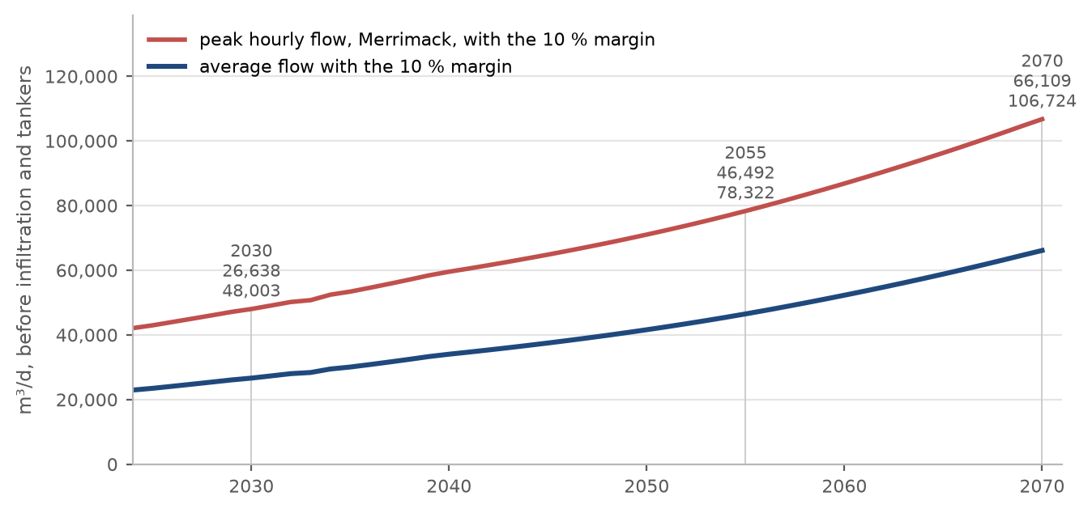
Figure 32 Average and peak-hour flow at one STP for the whole area, by year, with the margin.
At the guideline's minimum loads per person the STP receives the loads below. That is 348 milligrams of BOD per litre at saturation, at the low end of the range the guideline gives for raw sewage, 350 to 400.
Table 32 Loads at one STP for the whole area, from the per-person minima
 | 2024 | 2030 | 2055 | 2070
People | 119,893 | 139,535 | 244,914 | 349,029
BOD, kg/d | 7,194 | 8,372 | 14,695 | 20,942
Suspended solids, kg/d | 9,591 | 11,163 | 19,593 | 27,922
BOD as a concentration at the average flow, mg/l | 345 | 346 | 348 | 348
Suspended solids as a concentration, mg/l | 460 | 461 | 464 | 465
BOD at the peak factor of 1.2, kg/d | 8,632 | 10,047 | 17,634 | 25,130

16. Non-domestic discharges: industrial estates and identified projects
Sewage from industry and commerce, called trade effluent in the guidelines, affects the STP's load and how treatable the sewage is. Where its chemical to biochemical oxygen demand is above the domestic range, a separate treatment line is needed if the volume is significant. In Ibri the two industrial estates are workshops on the commercial tariff; no wet industry has been found. The estates are carried at the dry-industry rate (Section 15.2), and no separate line is foreseen at this stage.

16.1. The large-consumer accounts
The electricity dataset carries 499 accounts on the Cost Reflective Tariff, which applies above a consumption threshold and says nothing about use: a shopping centre, a hospital, a mosque and a factory all fall in it. Each account has been placed by public records: named features in OpenStreetMap, reverse geocoding, the aerial imagery and the press. 205 are commercial, 135 governmental, educational, medical or religious, 15 industrial, 28 farm pumps and 6 telecommunications or utility; 110 stand more than eighty metres from any recorded feature and are carried as commercial. Appendix A2 gives the result by use.

16.2. Identified projects
Beyond the accounts, the public record was searched for the projects the guideline keeps outside the population ratios: economic zones, camps and high-water users. Those found are listed below with the way each is treated.
Table 33 Identified projects and special consumption
Site | What it is | Treatment in the design
Al Tayyeb industrial area | 94 ha, 202 industrial plots, 1,035 meters, in the north-east of the town | Special consumption, 4,500 workers at 93 l/d
Tanam industrial area | 61 ha, 105 plots, 409 meters, beside the treatment plant | Special consumption, 1,800 workers at 93 l/d
Army camp, Northern Frontier Regiment | 296 ha, west of the town, no meter in the dataset | Recorded; no load. Its occupancy and drainage are to be confirmed (Section 5.4)
Ibri View resort | A tourism development of 2 square kilometres at As Sulayf, announced, not yet in the cadastre | Recorded; no load until its plan is issued
Ibri Industrial City (Madayn) | 10 square kilometres, 8.6 km south-west of the boundary, first phase opened 2024 on a collection tank | Outside the network; a source of tankered sewage to be confirmed from delivery records
Power station and solar plants | 7.5 to 11 km north-west of the boundary, with a construction camp | Outside the network; a source of tankered sewage to be confirmed
Central slaughterhouse | Announced; site not yet fixed | High-strength discharge requiring pre-treatment; to be included when sited

Sewage delivered by tanker is materially stronger than sewage arriving through the network. It is to be provided for separately in the STP load once the delivery records are received.

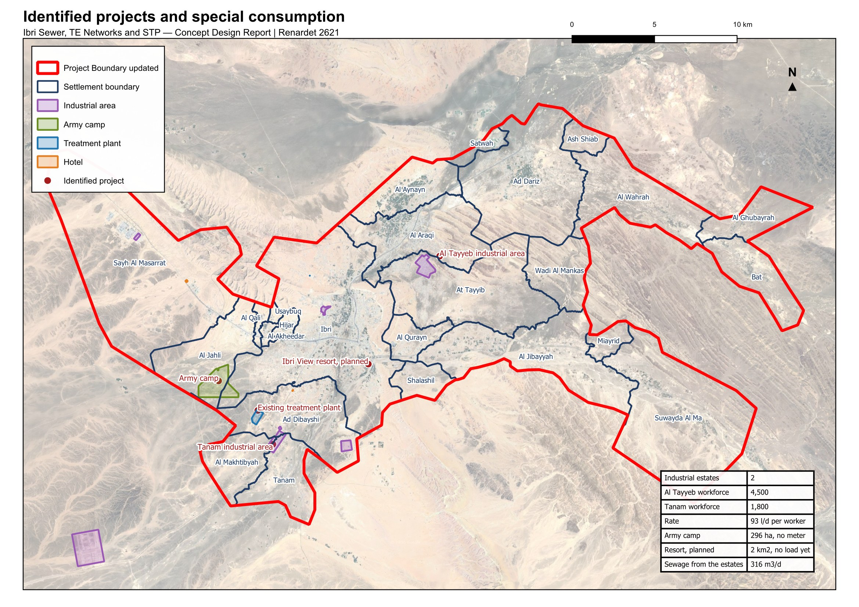
Figure 33 The identified projects and special consumers: the industrial areas, the army camp, the treatment plant and the hotel sites recorded in OpenStreetMap, the two estates among them.

17. Treated effluent demand and customers
Treated effluent is produced at 95 per cent of the STP inflow. A further ten per cent is lost within the treated effluent distribution network, so 85.5 per cent of the inflow reaches the customers.
$Q_{delivered} = 0.90 × 0.95 × Q_{inflow}$ (16)
Q delivered: treated effluent available to customers, m³/d
Q inflow: flow entering the STP, the design average, m³/d
Table 34 Treated effluent available, one STP for the whole area, m³/d
 | 2024 | 2030 | 2055 | 2070
STP inflow, design average | 22,937 | 26,638 | 46,492 | 66,109
Produced, 95 per cent | 21,790 | 25,306 | 44,168 | 62,803
Delivered, less 10 per cent in the network | 19,611 | 22,776 | 39,751 | 56,523

Adopted (15). 95 per cent of the STP inflow produced as treated effluent and 10 per cent of it lost in the distribution network (Section 17).
Customers are classified as public or private. Public consumers comprise the landscaping of highways, secondary roads, interchanges and roundabouts, and public parks. Private consumers comprise community parks, golf courses, private gardens, and nurseries and farms.
Table 35 Treated effluent demand for concept planning
Planting | Summer demand | Planting | Summer demand
Shrubs | 20 to 40 l per plant per day | Ground cover | 10 l/m²/d
Palm trees | 120 to 165 l per plant per day | Seasonal flowers | 10 l/m²/d
Other trees | 40 to 80 l per plant per day | Grass | 12 l/m²/d
Hedges | 10 l per metre per day | Roads and junctions | 10 l/m²/d

Demand varies seasonally, at 100 per cent from June to August, 75 per cent in spring and autumn and 50 per cent from December to February. The system is sized for the summer peak. Consumers whose average demand exceeds 500 cubic metres per day are assessed individually.
The identification of customers, their present and potential demand and their development plans is in progress. The register will be presented with the treated effluent network options.

PART E

The existing system

18. Hydraulic assessment of the existing networks

18.1. Purpose
The existing sewer, force main and treated effluent networks are assessed against the flows arising across the design period, to establish which assets have capacity for the future flow, which require upgrading, and where the new works connect to them.

18.2. Approach
The assessment is carried out by hydraulic model. The existing network is verified before it is modelled: the datasets supplied provide geometry but not levels, and the diameter is recorded on part of the network only. The survey now in progress establishes both, and the model will be built on the surveyed data.
Each asset is then classified as having capacity for the design flow, requiring upgrading, or requiring replacement. Where an asset is retained, the point and manner of connection to the new works is designed.

18.3. Model
The wastewater network is modelled in SewerGEMS and the treated effluent network in WaterGEMS. Models are submitted in native editable format with the calculations and assumptions, and are updated following construction.
The model is run for the design year at peak flow, for the ultimate condition, and for the opening years at low flow. The last of these establishes the period during which the network requires assisted cleansing, described in Section 22.4.
The assessment will be presented in the next revision, following completion of the survey.

19. Rehabilitation and upgrading
Rehabilitation of the existing systems forms part of the concept scope. The extent of it follows from the assessment in Section 18 and from the condition established by survey and closed-circuit television inspection.
Rehabilitation work received to date comprises contractor submissions for completed work orders at Al Sad, Khadil, Yanqul, Dhank and Hay Al Aqabah. These have been reviewed and recorded; they describe work already carried out rather than work required.
The rehabilitation schedule, with quantities and cost, will be presented in the next revision.

20. Verification of the Regional Master Plan
The Terms of Reference require the Regional Master Plan to be verified. The verification compares the flows established in Part D against those on which the master plan was based, and identifies and explains any difference.
The asset data supplied includes a treatment plant record shown as a design case with a capacity of 29,038 cubic metres per day, annotated as arising from the Regional Master Plan concept design and not yet approved. That figure is taken as the master plan position for comparison.
The comparison depends on the design horizon, which is the subject of Section 5.1, and on the flow series described in Section 15.7. It will be presented in the next revision.
The data required by Nama Water Services Asset Management Planning for the updating of the master plan will be provided in the format the client specifies.

PART F

Options

21. Options methodology
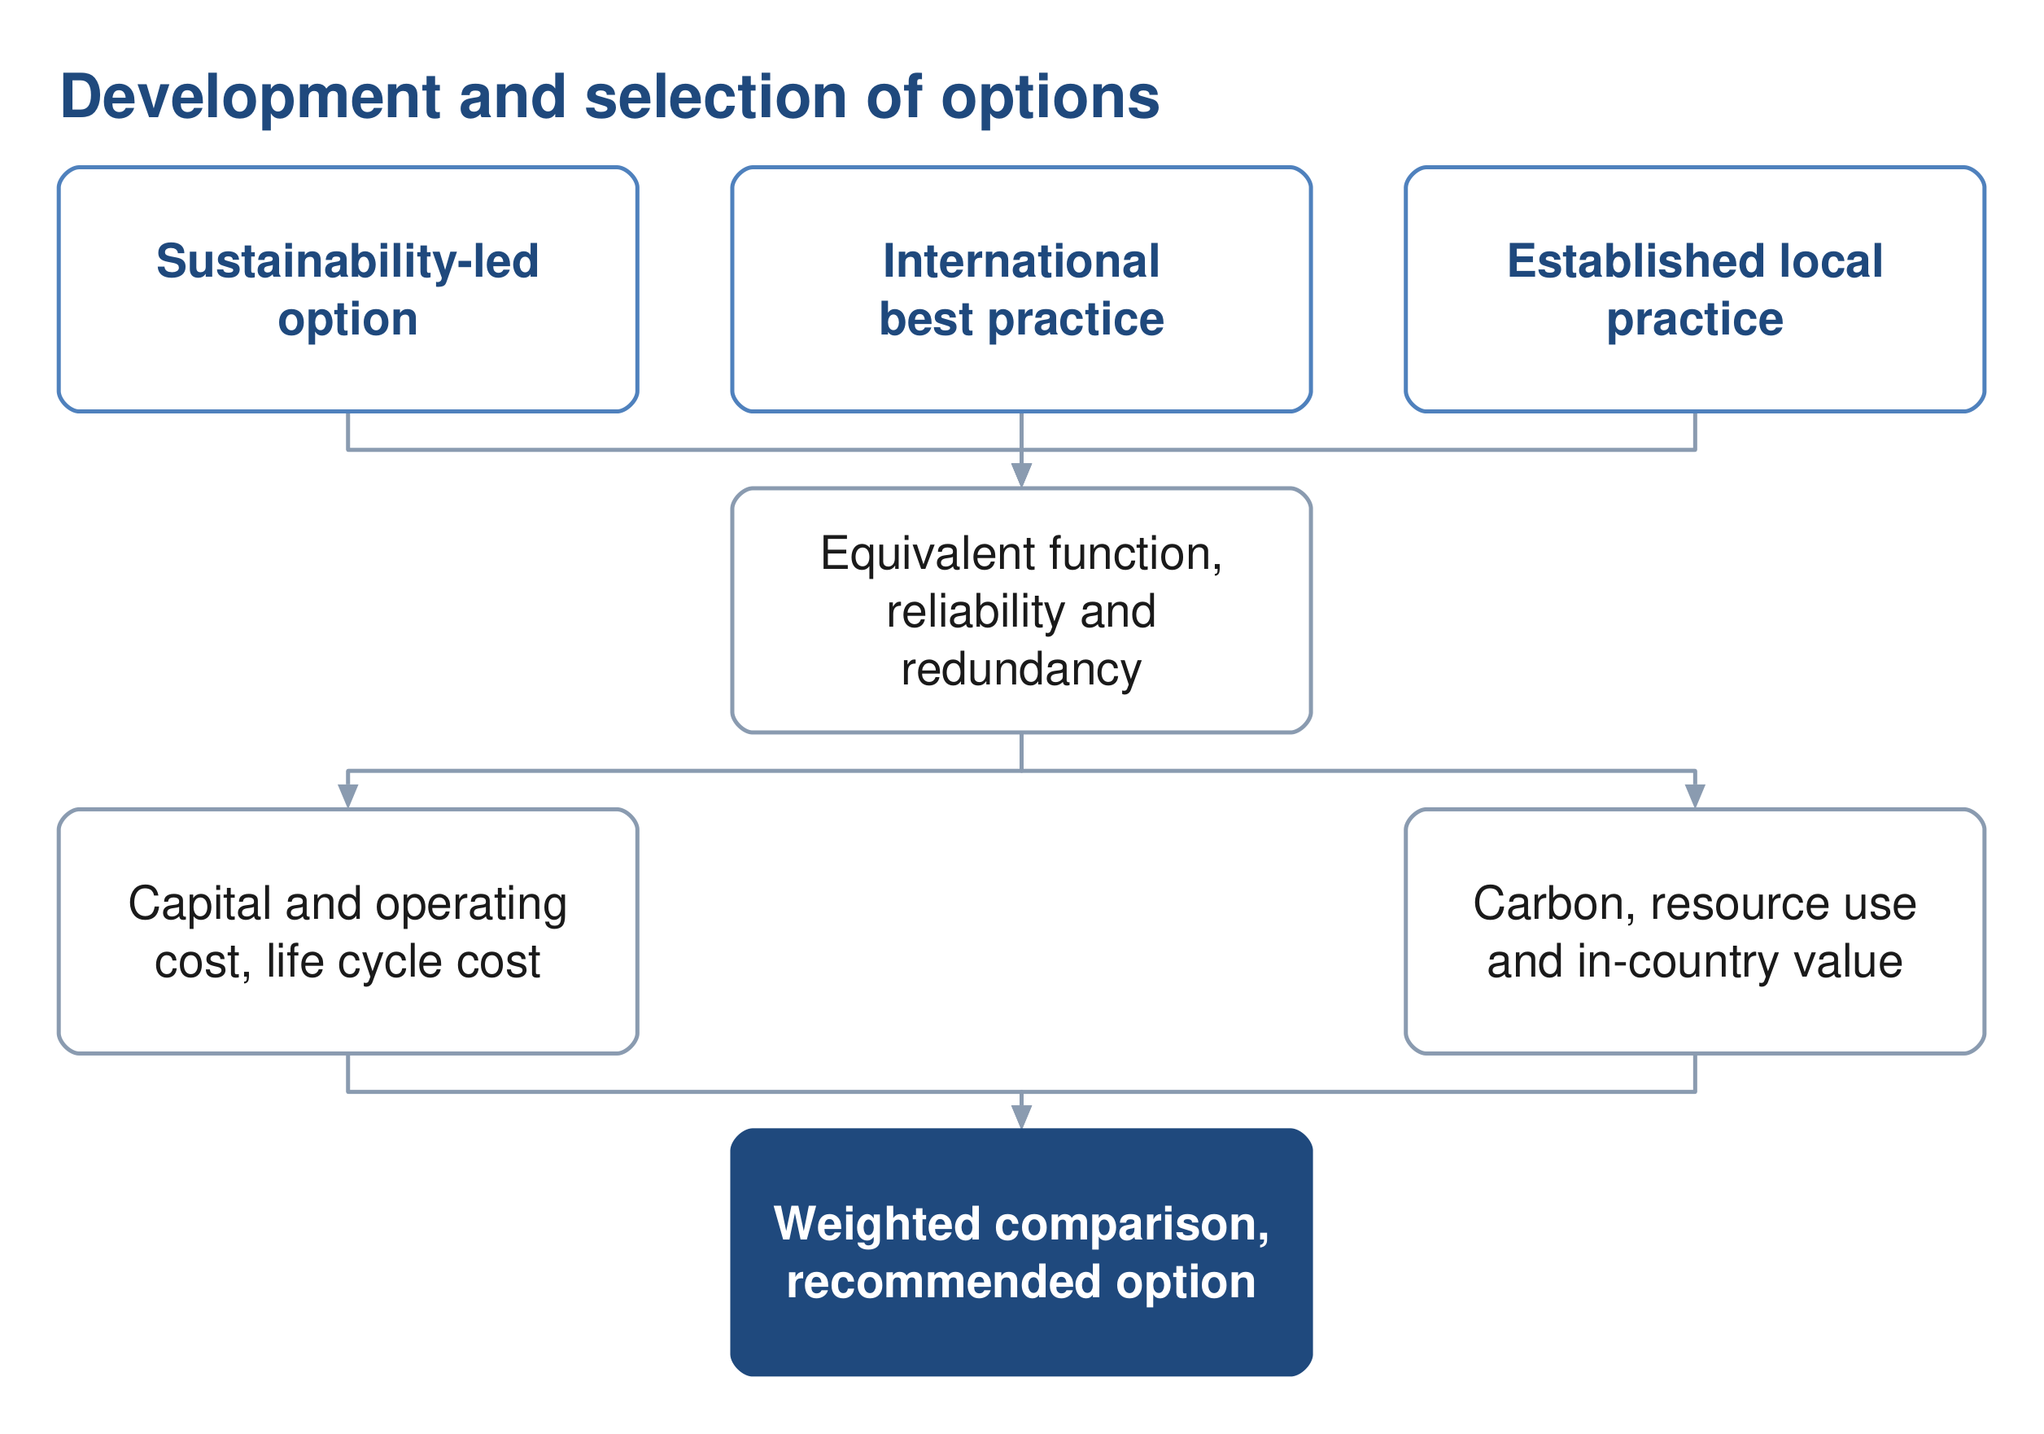
Figure 34 Development of the options and the basis on which they are compared.

21.1. Number and character of the options
Not fewer than three options are developed for each of the sewer network, the treated effluent network and the treatment plant. The guidelines indicate the character the options should take: one advancing environmental sustainability including nature-based solutions, one representing international best practice, and one based on established practice and technology available in the Sultanate.
Each option is developed to equivalent functional requirements with comparable reliability and redundancy, so that the comparison between them is not influenced by differences in scope.

21.2. The approach proposed for each option
The guidelines describe the character of the three options but do not prescribe what distinguishes them in design terms. The following approach is proposed, and is offered for comment before the options are developed.
Table 36 Proposed approach for each option
 | Sustainability-led | International best practice | Established local practice
Network | Gravity maximised, accepting deeper excavation in order to avoid pumping | Layout optimised by model, with pumping where it reduces whole life cost | Conventional layout, with pumping where the topography requires
Treatment process | Lower-energy process, with nature-based polishing where the scale permits | Highest-performing process, smallest footprint | Process already established in Oman, simple to operate and maintain
Energy | Generation on site, with a self-sufficiency target | High-efficiency plant and advanced process control | Grid supply with standby generation
Reuse | Reuse maximised, discharge to wadi minimised | High reuse at high effluent quality | Reuse to the demand identified, surplus discharged
Materials | Low-carbon and locally sourced where performance permits | Specified for performance and durability | Standard specification
Consequence | Higher capital cost, lowest carbon and operating cost | Highest capital cost, least land, best effluent quality | Lowest capital cost, most land, highest operating cost

Two constraints apply across all three. Nature-based treatment is limited by the guidelines to small plants, so it is available for outlying settlements or for polishing rather than for the main plant. And every option is developed to the same functional requirement and the same effluent standard, so that the difference between them lies in how the result is achieved and not in what is achieved.

21.3. Basis of comparison
The options are compared on capital and operating cost, life cycle cost, carbon footprint over the project lifetime, resource efficiency, in-country value and the degree to which they employ nature-based solutions. The evaluation period is twenty-five years. The weighting applied to each parameter is set by Nama Water Services. The figure on the following page shows how each option is costed and compared.

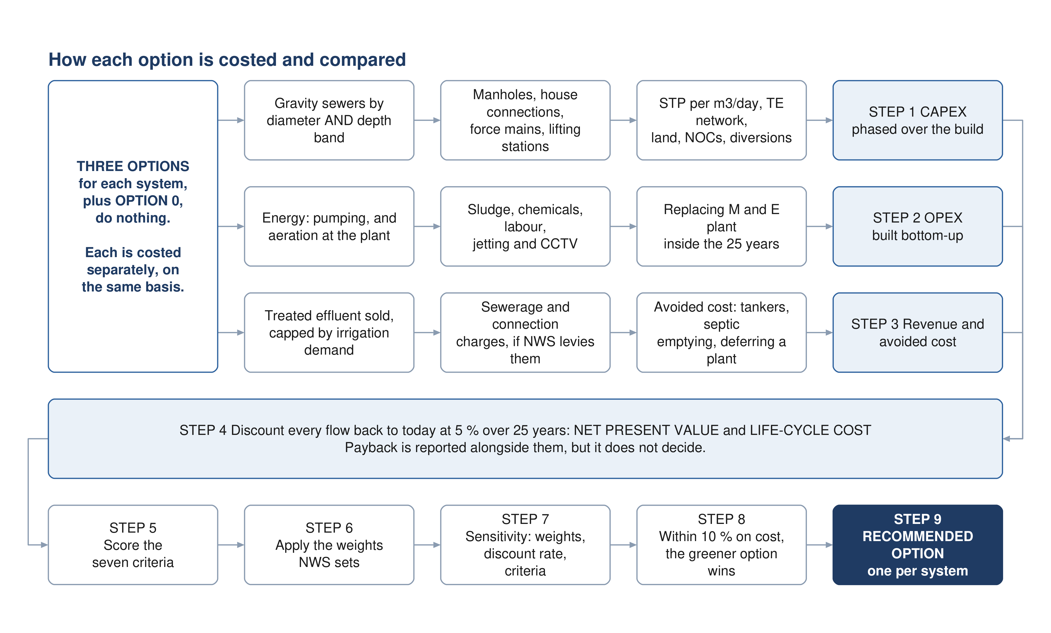
Figure 35 How each option is costed and compared. The three cost streams are established separately for every option, discounted to present value together, and only then scored against the seven criteria.

21.4. Selection
A weighted multi-criteria analysis compares the options against total lifetime cost, sustainability, social development and in-country value, adaptability and resilience, operability, constructability and environmental impact. Sensitivity is tested by varying the weighting between categories, the discount rate and the input design criteria. Where options fall within ten per cent of one another on total lifetime cost, the more sustainable option is adopted.

22. Sewer network options
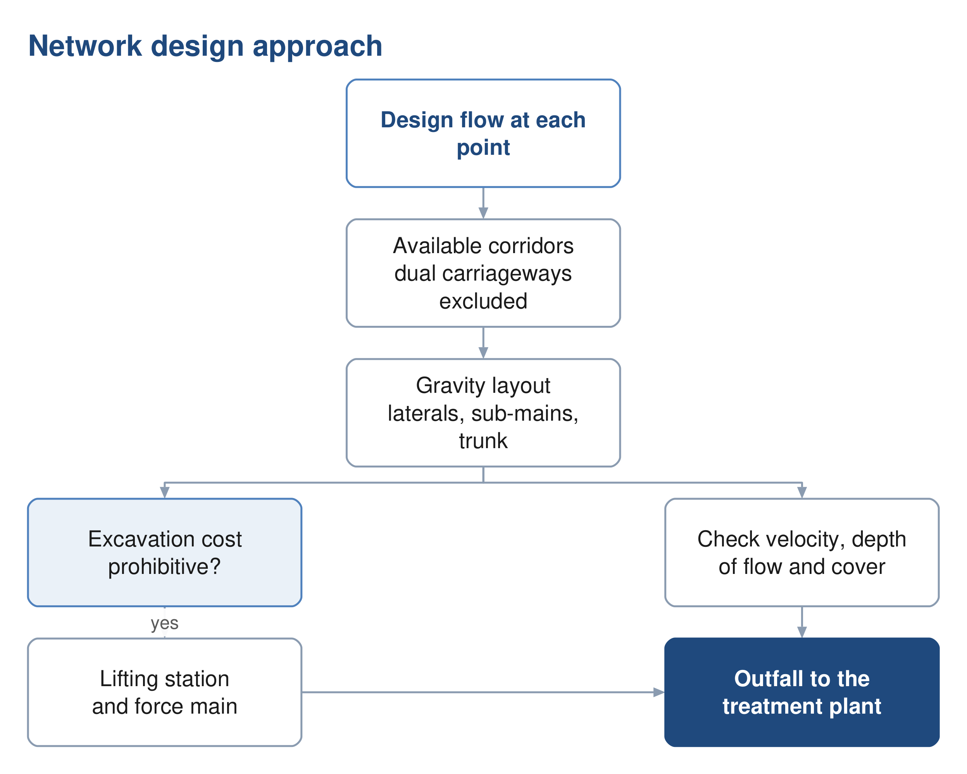
Figure 36 The network design approach, and the point at which a lifting station becomes necessary.

22.1. Principles
The network is laid out to convey the flow by gravity wherever that is feasible and cost effective, and to keep pumping to the minimum that the topography requires. The layout follows the road corridors, and the flow is directed towards the existing treatment plant site, which lies at a low elevation relative to the developed areas.

22.2. Corridor constraints
Dual carriageways are excluded as sewer corridors, as they cannot be taken out of service for construction or maintenance. Crossings of a dual carriageway are made perpendicular and, where available, through an existing underpass. Wadi crossings are designed to the cover required by the guideline.

22.3. Network hierarchy
The network is arranged in three tiers, following the arrangement of the existing network in Ibri: laterals collecting from properties, sub-mains collecting from laterals, and a trunk main conveying the collected flow to the plant. Arranging the network this way limits the number of connections made directly to the trunk main and keeps each tier to a manageable size.

22.4. Early-year operation
In the years following commissioning the connected population is a fraction of the design population, and the flow in the network is correspondingly lower. Velocities in that period may fall below the self-cleansing value, and the network requires assisted cleansing until the flow is sufficient to scour the pipes.
The period during which this applies is established for each pipe from the flow series and the connection ratio, and is presented as a schedule of the pipes affected and the years concerned, so that the operating requirement is known before the network is handed over.
The network options and the cleansing schedule will be presented in the next revision.

23. Pumping and lifting stations
A lifting station is provided where the cost of excavation to maintain gravity flow becomes prohibitive. Each station lifts the flow to a level from which gravity conveyance resumes, discharging through a force main to a receiving manhole or to the treatment plant.
Table 37 Force main design criteria
Criterion | Value
Minimum velocity, raw sewage | 0.75 m/s at minimum flow
Minimum velocity, intermittent flow | 1.0 m/s
Minimum velocity, vertical mains | 1.2 m/s
Maximum velocity | 2.5 m/s
Minimum internal diameter | 75 mm
Gradient, rising | 1 in 500
Gradient, falling | 1 in 300
Retention time | as short as the alignment permits

Retention in a force main allows sulphide to form, which is both a corrosion and an odour risk in this climate. Alignments are therefore kept short, discharges are submerged to limit turbulence, and the need for dosing is assessed for each station.
Surge analysis is carried out for each force main in approved software, and the protection required is established from it.

24. Treated effluent network options
The treated effluent network conveys the product of the treatment plant to the customers identified in Section 17. The network is sized for the summer peak demand, with storage of not less than twenty-four hours.
Where demand is below the volume produced, provision is made for the disposal of the excess, described in Section 26.
The network options will be presented in the next revision, following confirmation of the customers and their demand.

25. Treatment plant options

25.1. Capacity and phasing
The plant is sized on the flow established in Part D with the ten per cent design margin applied, and is built in phases so that capacity follows demand. The capacity of the first phase, and the years at which subsequent phases are required, follow from the flow series and are presented with it.

25.2. Process selection
Process selection is governed by the effluent standard. The total nitrogen limit described in Section 13 requires full nitrification and denitrification, which narrows the technologies that can be considered. Land area, energy consumption, operating complexity and whole life cost distinguish the remaining options.
Table 38 Indicative land requirement by process
Process | Area, m² per m³/d
Membrane bioreactor | 0.45 to 0.9
Sequencing batch reactor | 0.9 to 1.8
Moving bed biofilm reactor | 0.9 to 1.8
Integrated fixed film activated sludge | 1.2 to 2.5
Conventional activated sludge and extended aeration | 1.8 to 3.6

The areas are indicative and are used for planning. The land required includes the process units, the sludge facilities, the buffer zone and provision for the energy-efficiency measures described in Section 34.

25.3. Siting
The site is assessed against the criteria in the wastewater guideline, covering access, physical characteristics, environmental and climatic impact, social impact and cost. Two criteria carry stated requirements: the site is assessed against the twenty-five and one hundred year flood levels, and the plant is to remain operational during floods.
The buffer distance to residential areas for a plant of this size is established from odour dispersion modelling rather than from a fixed figure, and lies between 300 and 1,000 metres measured to the five odour unit contour. The modelling is described in Section 30 and precedes the confirmation of the site.
The plant options, the site assessment and the phasing will be presented in the next revision.

26. Excess effluent, emergency provisions and tankers

26.1. Tanker reception
A proportion of the wastewater arising in the area is collected by tanker and delivered to the treatment plant. Sewage delivered this way is stronger than sewage arriving through the network, and its arrival is concentrated in the working day. A dedicated reception facility is provided, with screening, grease removal, sampling before acceptance and flow equalisation.

26.2. Excess treated effluent
Where the effluent produced exceeds the demand, provision is made for its disposal. Discharge to a wadi requires the effluent to meet Class A of Ministerial Decision 145/1993, and where the wadi discharges to the sea the limits for ammonia, nitrogen and phosphorus of Ministerial Decision 159/2005 apply in addition. Any such discharge is subject to the approval of the Environment Authority and the Authority for Public Services Regulation.

26.3. Emergency provisions
Provision is made for the diversion of raw sewage in the event that the plant is out of operation, and for emergency storage. Every pumping station is provided with an emergency overflow to prevent flooding of the station or of connected properties; overflows are subject to the approval of the Environment Authority.

27. Sludge management strategy
The Oman Sludge Management Plan, as reproduced in the wastewater design guideline, identifies a sludge treatment centre performing composting at Ibri as the solution for the Governorate of Adh Dhahirah. The plant is therefore to be designed to receive and process sludge arising beyond its own catchment, and the land area, buffer distance and vehicle access are established accordingly.
Sludge is to be reused unless no form of reuse is possible, and its quality is to comply with the heavy metal limits of Ministerial Decision 145/1993. Where disposal to landfill is required, the receiving authority sets acceptance criteria including a minimum solids content of eighty per cent. That content is above what mechanical dewatering alone achieves, and drying or composting is therefore required.
Dewatering facilities are provided on site. The strategy, with the quantities arising and the disposal route for each, will be presented in the next revision.

PART G

Assessment and appraisal

28. Ground conditions
Geophysical investigation is required for all infrastructure and geotechnical investigation for all above-ground assets. At this stage the purpose is to establish a site-wide ground model and a range of parameters sufficient to select foundation types and platform levels, and to identify the risks that the detailed investigation must resolve.
Boreholes at the treatment plant and lifting station sites are taken to a minimum depth of fifteen metres or to a competent stratum, and are closely spaced at wet wells, valve chambers and electrical rooms. Groundwater monitoring is required, as the depth to groundwater governs both the excavation method and the infiltration allowance.
The ground model and the concept geotechnical report will be presented in the next revision.

29. Flood protection
The study area is crossed by a wadi system, and flood behaviour governs both the alignment of the works and the siting of the treatment plant. The site is assessed against the twenty-five and one hundred year flood levels, and the plant is to remain operational during floods.
Pumping station floor levels, transformers and standby generators are set not less than 300 millimetres above the one in fifty year flood level. Wadi crossings are designed with a minimum cover of 1.5 metres to the crown of the pipe.
The flood protection assessment will be presented in the next revision.

30. Odour assessment
Odour governs the buffer distance between the treatment plant and residential development, and for a plant of this size the buffer is established from dispersion modelling rather than from a fixed distance. The modelling establishes the distance to the five odour unit contour, using site meteorological records and the treatment processes proposed.
Odour control is provided at the inlet works, the sludge facilities and the pumping stations, with the treatment train selected from the assessment. Compliance is verified by continuous monitoring at the site boundary.
The dispersion modelling and the resulting buffer will be presented in the next revision, and precede confirmation of the plant site.

31. Climate resilience
The works are assessed for resilience to the climate conditions anticipated over their service life. The assessment considers a fifty-year horizon at two and at four degrees Celsius of warming, and addresses the effect of changes in rainfall frequency and intensity on site selection and on the design of the infrastructure.
The assessment will be presented in the next revision.

32. Environmental and social assessment
An environmental impact assessment is required for the treatment plant and its associated works. The Environment Authority is informed of the project, its objectives and its anticipated impact, and is consulted on the location of the facilities.
Each option is assessed against resource use, ecosystem disruption, pollution risk, climate resilience, socio-economic impact and land use, and the assessment forms part of the comparison described in Section 38.
The scope required at this stage is the subject of Section 5.5.

33. Utility interfaces and approvals

33.1. Approach
The proposed alignments are superimposed on the service records of each authority holding assets in the area. Where a conflict cannot be avoided by re-routing within the corridor, the cost of relocating the proposed works is compared with the cost of relocating the existing service, and the agreement of the owning authority is obtained for whichever is adopted.

33.2. Records held and required
The potable water network is available from the dataset described in Section 7.2 and provides 647.8 kilometres of mains within the study area. Records for electricity distribution, telecommunications and, where present, gas and fuel pipelines are being requested from the respective owners.
The electricity data held records the position of consumer connections. It does not record the routes of the distribution cables, which are required for clash assessment and are requested separately.

33.3. Clearances
Table 39 Separation from other services
Situation | Requirement
Force main to water main, horizontal | 3.0 m
Force main crossing a water main | the force main passes beneath, with 450 mm vertical clearance
Shallow sewer beneath a major road | 3.0 m horizontal clearance
Another service in the same trench | placed on a separate bench on undisturbed ground

Beyond these, the clearance applied is that specified by the authority owning the service.

33.4. Trial pits
Fifty trial pits are provided for. Their locations are selected at road intersections, along the routes of major existing services and along the expected routes of the trunk sewers and force mains. The programme is agreed with Nama Water Services and the municipal excavation approvals obtained before work begins.

33.5. Approvals register
Approvals and no objection certificates are required from the authorities listed below. A register is maintained recording the authority, the consent required, the date of application and the current position, and is reported to Nama Water Services.
Table 40 Authorities from which approvals are required
Authority
Ministry of Housing and Urban Planning
Environment Authority
Ministry of Agriculture, Fisheries and Water Resources
Directorate General of Roads
Regional electricity distribution company
Oman Telecommunications Company
Royal Oman Police
Ministry of Heritage and Tourism
Municipality of Ibri

34. Sustainability
The carbon footprint of each option is evaluated for both construction and operation in accordance with recognised greenhouse gas accounting standards, and is expressed in tonnes of carbon dioxide equivalent per year and per cubic metre of effluent produced.
Because the greater part of operational emissions arises from electricity consumption, the measures that reduce carbon are largely the same as those that reduce operating cost: conveying the flow by gravity wherever possible, minimising lift, selecting efficient equipment, and generating renewable energy on site. Provision for photovoltaic generation within the plant perimeter is included in the land requirement.
Resource efficiency, in-country value and the use of nature-based solutions are assessed for each option and carried into the comparison in Section 38.

35. Cost

35.1. Basis
Item | Basis
Accuracy | plus or minus twenty per cent at concept stage
Measurement | CESMM3
Rates | recent tender and contract rates, and rates from Nama Water Services pre-investment appraisals, escalated to the base date of the estimate
Price basis | current prices at the date of the estimate
Presentation | by system element

35.2. Scope of the estimate
The estimate covers the works, the associated costs and the provisions, as set out below.
Collection network — excavation by depth and by ground condition, trench support, bedding and backfill, pipework, manholes, property connections, road reinstatement, traffic management, crossings, and testing.
Lifting stations — land, civil structures, pumps and station pipework, electrical supply and standby generation, control and telemetry, odour control, and the force main with its chambers and valves.
Treatment plant — land, site preparation and flood protection, inlet works, tanker reception, biological treatment, clarification, tertiary treatment, disinfection, the sludge line, chemical systems, odour control, electrical and control installations, buildings, and commissioning.
Treated effluent network — pipework, storage, boosting, filling stations and customer connections.
Associated costs — design and supervision, survey and investigation, environmental assessment, consents and land, and physical and price contingency.

35.3. Operating cost
Operating cost is built from the duty of each asset rather than taken as a proportion of its capital cost. For a wastewater system the two largest items are energy and sludge, and neither follows capital value.
Energy — pumping at each lifting station from its duty flow and head, and aeration at the treatment plant from the oxygen demand.
Sludge — thickening, dewatering, transport and disposal, at the quantity the process produces.
Chemicals — coagulant, polymer and disinfectant at the dose rate and the flow treated.
Labour — the establishment required to operate and maintain the plant, the stations and the network.
Maintenance — jetting and closed-circuit television survey of the network, desludging, odour and corrosion control, and planned replacement of mechanical and electrical plant falling within the evaluation period.
Mechanical and electrical plant has a shorter service life than the civil works, so its replacement falls inside the twenty-five year period and is carried as a cost in the year it occurs.

35.4. Life cycle cost and net present value
Capital cost, operating cost, replacement cost and revenue arise in different years, so they are not comparable until they are brought to a common date. Each is discounted to present value at the rate the guideline sets, and the options are compared on the resulting totals.
$NPV = \sum_{t = 0}^{n}{\frac{C_{t}}{{\left(1 + r\right)}^{t}}}$ (17)
Symbol | Meaning | Unit
NPV | net present value of the option | OMR
C t | net cash flow in year t: revenue and avoided cost less capital, replacement and operating cost | OMR
r | discount rate, 0.05 | —
t | year, counted from the base date | —
n | evaluation period, 25 years | —

Total life cycle cost is the present value of capital, replacement and operating cost over the same period, and is the quantity against which the ten per cent band in Section 21.4 is applied. Payback is reported alongside it as an indicator, but it does not determine the recommendation: for a wastewater scheme a large part of the benefit is cost avoided rather than revenue earned, and a payback period computed on revenue alone would misstate the case.
The estimate, the discounted comparison and the payback figures will be presented with the options in the next revision.

36. Risk
A risk register is established at this stage and maintained through the project. Each risk carries a description, a likelihood, an impact expressed in cost or time, an owner and the mitigation adopted. Risks that fall on one option and not on another are identified as such, as they affect the comparison rather than only the total.

37. Value engineering
A formal value engineering study is required at the concept and preliminary stages for a treatment plant or pumping station above the stated threshold, carried out by an independent certified consultant. The study is arranged within the concept programme and its outcome reported.

38. Comparison and recommendation
The options are compared by the method described in Section 21.3. The comparison presents, for each option, the capital cost by phase, the operating cost by year, the net present value over twenty-five years, the carbon footprint, and the assessment against each of the remaining criteria, together with the results of the sensitivity tests.
The net present value of each option is computed by the equation of Section 35.4, at five per cent over twenty-five years.
The comparison and the recommended option will be presented in the next revision.

PART H

Delivery

39. Implementation roadmap
An implementation roadmap is prepared for the recommended option, defining the scope of the subsequent design stages, the procurement route for each element, the phasing of construction, and the framework by which performance is monitored once the works are in service.
The roadmap follows the selection of the recommended option and will be presented with it.

40. Contracting strategy
The contracting strategy establishes how the works are packaged and procured. It is developed with Nama Water Services in a dedicated workshop, and considers the division of the works into packages, the procurement route for each, and the interfaces between them.

41. Project integration
A project integration plan sets out how the water and wastewater components are coordinated through design, construction and commissioning. It also addresses the rehabilitation or replacement of the existing potable water network where its performance is found to be unsatisfactory.

42. Conclusions
The design basis for the wastewater and treated effluent systems is established and is set out in Part C. The data supplied has been assessed, and the datasets that are usable, those that require correction and those that relate to areas outside the project have been identified in Part B.
The existing wastewater assets within the study area comprise 111.6 kilometres of constructed gravity sewer and 10.0 kilometres of constructed force main, together with a further 268.2 kilometres of gravity sewer, pumping main and treated effluent main recorded as proposed. The potable water network within the area comprises 647.8 kilometres of mains. The number of properties on each plot and the use of each plot have been established from 33,971 electricity meters and a satellite image, the occupancy rate has been calculated for each settlement, and every plot carries a population and an average sewage flow for 2024 and for every year to the saturation of its settlement. The study area is saturated in 2070 at 349,029 people and 60,099 cubic metres of sewage a day.
A topographic and utility survey covering the whole study area is in progress. It will establish the levels, diameters and condition that the supplied datasets do not carry, and its completion is the principal step between this revision and the next.

42.1. Recommendations
It is recommended that Nama Water Services take the seven decisions of Section 5.1, the design horizon and the overflow first among them, confirm the other matters of Section 5.3, and supply the data requested in Section 5.4, so that the options and the appraisal can be completed on an agreed basis.

43. Appendices
Appendix | Content
A | Population, land use and flow: the working behind Part D. Issued with this revision
B | Design criteria, with references. Next revision
C | Drawings and figures. Next revision

The decisions requested, the values adopted and the data requests are set out in Section 5.

Appendix A

Population, land use and flow: the working

A1. Electricity meters: tariff to category
Each tariff in the electricity dataset is assigned to one of the guideline's categories. The large-consumer tariff is resolved account by account in A2.
Table 41 Tariffs and the category adopted
Tariff | Meters | Category | People
Primary Account Tariff | 10,973 | Domestic | one property
Primary Account Tariff (with National Subsidy) | 5,272 | Domestic | one property
Additional Account Tariff | 6,344 | Domestic | one property
Commercial | 9,385 | Non-domestic | none
Fisheries | 6 | Non-domestic | none
Tourism | 1 | Non-domestic | none
Government | 966 | Governmental | none
MOD | 1 | Governmental | none
Agricultural | 523 | Agricultural | none; no sewage
Industrial | 1 | Special consumption | none
CRT Seasonal | 298 | Large consumer, see A2 | none
CRT Time of Use | 192 | Large consumer, see A2 | none
CRT Fixed Rate | 9 | Large consumer, see A2 | none

Of the 33,971 meters, 30,931 fall inside a plot, 2,914 were assigned to the nearest plot within fifteen metres, and 126 lie further from any plot; they carry no load (Section 14.3).

A2. The large-consumer accounts
The 499 accounts on the Cost Reflective Tariff were placed by clustering them at 120 metres, matching each cluster and each single account against the named features of OpenStreetMap within eighty metres, reverse geocoding the rest, and inspecting the largest clusters on the aerial imagery. Each account carries the use found, the category adopted, the evidence and a confidence.
Table 42 Large-consumer accounts by the use found
Use found | Accounts | Category adopted | Typical sites
Commercial | 205 | Non-domestic | Bawadi shopping centre, the Al Murtafa souq, the Araqi strip, hypermarkets, banks, fuel stations
Government | 67 | Governmental | Police headquarters, post office, directorates
Education | 37 | Governmental | The university campus, the college, schools
Health | 15 | Governmental | Ibri Hospital, clinics
Religious | 16 | Governmental | Mosques
Industrial | 15 | Special consumption | The Tanam estate
Agricultural | 28 | Agricultural, no load | Farm pumps at Al Aynayn
Telecommunications, utility | 6 | Non-domestic | Exchanges, water facilities, masts
Unresolved | 110 | Non-domestic | No recorded feature within eighty metres

Confidence: 119 accounts certain, 194 likely, 186 placed on weaker evidence. The categories adopted affect only where the non-domestic and governmental water is placed, not its total.

A3. Occupancy rate, properties per plot, home share and capacity by settlement
Table 43 The settlement rates used in Part D: calculated from the data, and adopted
Settlement | Domestic properties, 2024 | Pop. 2024 | Empty plots | of which counted as future homes | Occupancy rate calculated | adopted | Properties per home plot calculated | adopted | Home share calculated | adopted | Capacity, people
Ibri | 11,052 | 67,106 | 14,203 | 10,469 | 6.07 | 6.07 | 1.33 | 1.33 | 0.87 | 0.87 | 73,299
Ad Dariz | 2,439 | 11,850 | 4,888 | 3,219 | 4.86 | 4.86 | 1.20 | 1.20 | 0.90 | 0.90 | 16,854
Al Araqi | 2,466 | 10,696 | 3,360 | 2,463 | 4.34 | 4.34 | 1.32 | 1.32 | 0.84 | 0.84 | 11,832
Al Aynayn | 889 | 4,554 | 1,780 | 1,362 | 5.12 | 5.12 | 1.14 | 1.14 | 0.94 | 0.94 | 7,459
Al Wahrah | 716 | 3,351 | 2,000 | 1,373 | 4.68 | 4.68 | 1.22 | 1.22 | 0.91 | 0.91 | 7,109
At Tayyib | 833 | 3,348 | 10,012 | 8,640 | 4.02 | 4.02 | 1.09 | 1.09 | 0.92 | 0.92 | 34,675
Al Jibayyah | 524 | 2,686 | 2,784 | 1,966 | 5.13 | 5.13 | 1.26 | 1.26 | 0.89 | 0.89 | 11,306
Bat | 418 | 2,557 | 879 | 355 | 6.12 | 6.12 | 1.17 | 1.17 | 0.88 | 0.88 | 2,226
Ad Dibayshi | 681 | 2,411 | 2,430 | 1,887 | 3.54 | 4.00 | 1.16 | 1.16 | 0.90 | 0.90 | 7,920
Tanam | 403 | 2,116 | 2,045 | 1,556 | 5.25 | 5.25 | 1.24 | 1.24 | 0.67 | 0.67 | 6,779
Suwayda al Ma | 301 | 1,559 | 1,593 | 937 | 5.18 | 5.18 | 1.60 | 1.60 | 0.82 | 0.82 | 6,369
Hijar | 352 | 1,033 | 375 | 211 | 2.93 | 4.00 | 1.69 | 1.69 | 0.90 | 0.90 | 1,288
Al Ghubayrah | 161 | 631 | 1,448 | 1,094 | 3.92 | 4.00 | 1.12 | 1.00 | 0.84 | 0.90 | 3,940
Al Qurayn | 147 | 549 | 2,051 | 1,830 | 3.73 | 4.00 | 1.14 | 1.00 | 0.93 | 0.90 | 6,588
Sayh al Masarrat | 457 | 466 | 1,745 | 1,384 | 1.02 | 4.00 | 2.52 | 1.00 | 0.92 | 0.90 | 4,984
Al Jahli | 344 | 415 | 1,235 | 1,023 | 1.21 | 4.00 | 2.16 | 1.00 | 0.78 | 0.90 | 3,684
Satwah | 27 | 263 | 181 | 79 | 9.73 | 4.00 | 1.23 | 1.00 | 0.87 | 0.90 | 284
Al Akheedar | 120 | 198 | 120 | 45 | 1.65 | 4.00 | 2.12 | 1.00 | 0.53 | 0.90 | 160
Al Qali | 56 | 191 | 220 | 157 | 3.41 | 4.00 | 2.20 | 1.00 | 0.92 | 0.90 | 564
Shalashil | 38 | 130 | 3,686 | 3,250 | 3.42 | 4.00 | 1.11 | 1.00 | 0.91 | 0.90 | 11,700
Al Makhtibyah | 91 | 122 | 1,523 | 1,192 | 1.34 | 4.00 | 1.15 | 1.00 | 0.90 | 0.90 | 4,292
Usaybuq | 21 | 91 | 60 | 39 | 4.33 | 4.00 | 1.25 | 1.00 | 0.87 | 0.90 | 140
Wadi al Mankas | 8 | 52 | 1,580 | 1,394 | 6.49 | 4.00 | 1.30 | 1.00 | 0.87 | 0.90 | 5,020
Ash Shiab | 11 | 47 | 65 | 13 | 4.27 | 4.00 | 1.10 | 1.00 | 0.87 | 0.90 | 48
Miayrid | 4 | 34 | 246 | 171 | 8.49 | 4.00 | 1.30 | 1.00 | 0.87 | 0.90 | 616
Total | 22,559 | 116,452 | 60,509 | 46,109 |  |  |  |  |  |  | 229,136

The occupancy rate adopted is the rate calculated, held to a floor of 4.0 and a cap equal to the highest rate among the settlements of two thousand or more people. A settlement of fewer than a thousand people in 2024 takes an occupancy rate of 4.0, one property per plot and a home share of 0.9, whatever its meters return: it has no sample to measure on, and it does not attract a second property on a plot.

A4. The overflow routes in full
Every route carrying fifty people or more at saturation. The donor's year is the year its own empty plots are full; the receiver starts in the first year it takes in overflow from any settlement, which can be before this donor is full, and is itself full in the last column.
Table 44 Overflow routes
From | To | People at saturation | Donor full | Receiver starts | Receiver full
Ibri | At Tayyib | 22,078 | 2056 | 2060 | 2068
Ibri | Shalashil | 11,471 | 2056 | 2056 | 2061
Ibri | Al Qurayn | 5,856 | 2056 | 2056 | 2060
Ad Dariz | Wadi al Mankas | 4,965 | 2062 | 2062 | 2068
Al Araqi | At Tayyib | 4,873 | 2057 | 2060 | 2068
Ibri | Ad Dibayshi | 4,078 | 2056 | 2062 | 2063
Ibri | Al Jibayyah | 3,927 | 2056 | 2068 | 2070
Bat | Al Ghubayrah | 2,493 | 2052 | 2052 | 2070
Ibri | Al Makhtibyah | 2,441 | 2056 | 2063 | 2069
Ibri | Tanam | 2,010 | 2056 | 2063 | 2069
Al Araqi | Al Aynayn | 1,790 | 2057 | 2057 | 2060
Al Aynayn | At Tayyib | 1,639 | 2060 | 2060 | 2068
Al Araqi | Al Jibayyah | 1,410 | 2057 | 2068 | 2070
Ibri | Sayh al Masarrat | 1,225 | 2056 | 2063 | 2069
Ad Dibayshi | Tanam | 1,004 | 2063 | 2063 | 2069
Ibri | Al Jahli | 915 | 2056 | 2054 | 2063
Ad Dariz | Al Wahrah | 863 | 2062 | 2062 | 2070
Al Araqi | Suwayda al Ma | 730 | 2057 | 2070 | 2070
Al Aynayn | Al Jibayyah | 600 | 2060 | 2068 | 2070
Ad Dariz | Suwayda al Ma | 551 | 2062 | 2070 | 2070
Hijar | Al Makhtibyah | 519 | 2053 | 2063 | 2069
Hijar | Al Jahli | 518 | 2053 | 2054 | 2063
Al Jahli | Al Makhtibyah | 507 | 2063 | 2063 | 2069
Ibri | Suwayda al Ma | 490 | 2056 | 2070 | 2070
At Tayyib | Miayrid | 441 | 2068 | 2068 | 2070
Ibri | Ad Dariz | 440 | 2056 | 2057 | 2062
Al Aynayn | Ad Dariz | 347 | 2060 | 2057 | 2062
Al Aynayn | Suwayda al Ma | 311 | 2060 | 2070 | 2070
Al Akheedar | Al Qali | 297 | 2036 | 2036 | 2054
Ad Dariz | Al Ghubayrah | 258 | 2062 | 2052 | 2070
Al Qurayn | At Tayyib | 244 | 2060 | 2060 | 2068
At Tayyib | Suwayda al Ma | 229 | 2068 | 2070 | 2070
Al Wahrah | Suwayda al Ma | 229 | 2070 | 2070 | 2070
Ad Dibayshi | Suwayda al Ma | 186 | 2063 | 2070 | 2070
Al Jibayyah | Suwayda al Ma | 183 | 2070 | 2070 | 2070
Ad Dibayshi | Sayh al Masarrat | 182 | 2063 | 2063 | 2069
Al Akheedar | Al Makhtibyah | 177 | 2036 | 2063 | 2069
Al Akheedar | Al Jahli | 176 | 2036 | 2054 | 2063
Bat | Suwayda al Ma | 175 | 2052 | 2070 | 2070
Ibri | Al Araqi | 163 | 2056 | 2056 | 2057
Al Aynayn | Satwah | 150 | 2060 | 2060 | 2060
Tanam | Suwayda al Ma | 145 | 2069 | 2070 | 2070
Ibri | Miayrid | 141 | 2056 | 2068 | 2070
Tanam | Sayh al Masarrat | 141 | 2069 | 2063 | 2069
Sayh al Masarrat | Suwayda al Ma | 125 | 2069 | 2070 | 2070
Al Qali | Al Jahli | 103 | 2054 | 2054 | 2063
Hijar | Al Jibayyah | 94 | 2053 | 2068 | 2070
Al Jahli | Al Jibayyah | 92 | 2063 | 2068 | 2070
Al Qali | Sayh al Masarrat | 83 | 2054 | 2063 | 2069
Al Qurayn | Al Jibayyah | 78 | 2060 | 2068 | 2070
Hijar | Ibri | 66 | 2053 | 2054 | 2056
Shalashil | At Tayyib | 63 | 2061 | 2060 | 2068
Hijar | Usaybuq | 60 | 2053 | 2053 | 2054
Hijar | Al Qali | 54 | 2053 | 2036 | 2054
Sayh al Masarrat | Al Jibayyah | 52 | 2069 | 2068 | 2070

PAM-GUD-201, Table 1, page 16; PAM-GUD-203, page 13. Confirmation of the preferred convention is requested (Section 5.3).
Areas measured in the project geographic information system. Confirmation of the updated boundary is requested (Section 5.3).
PAM-GUD-201, Table 11, page 60 and Table 19, page 71. The guideline states that the consumption values apply in the absence of updated figures and should be validated by NAMA before design.
The guideline derives occupancy from population and housing units published by NCSI. Housing units are not published at settlement level, and counted domestic meters have been used in their place. The departure is recorded in Section 10.
Average flows before infiltration and before the STP margin. The five-year series for every settlement is in Sections 14.9 and 15.7.
Sections 13.1 and 15.8. The loads are replaced by the laboratory results of the existing STP once received.
The workforce of the two estates is an assumption, to be replaced by the estates' records.
PAM-GUD-201, Sections 12.6 to 12.9, pages 104 to 106.
Area of the updated project boundary (Section 2.2), measured in the project geographic information system in UTM zone 40 North.
Project_Boundary.kmz, received in July 2026. A second boundary, Final_Boundary_IBRI.kmz of 521.1 square kilometres, was issued with the Inception Report package; the updated boundary contains both.
Appendix to the Form of Bid, page 147, restated as a contract term at page 177 of the tender document.
Scope of Work, pages 63 and 64 of the tender document.
Field OP_STATUE on SEWERLINE_IBRI, FORCEMAIN_IBRI and TE_LINE_IBRI. Value 1 denotes the constructed network and value 0 the proposed network.
Lengths measured within the approved project boundary in EPSG:32640. The proposed alignments are recorded in the dataset as an earlier planning proposal and are not adopted as design input; they are shown for reference and to identify any commitment already made by the client.
Field REMARKS on the constructed records. The tender records that the existing network layout is based on available information, and that the preparation of complete as-built records and GIS forms part of the consultant's scope.
The extent of the second dataset is 55.802 to 55.814 degrees east and 24.269 to 24.292 degrees north, in the vicinity of Al Buraymi.
Fields present: identifier, tariff, coordinates in projected and geographic form, governorate and wilayat. The governorate is recorded as Dahira on all records; the wilayat field is empty on all records. The positions were adjusted onto the cadastre by the client before issue.
The tariff comprises three variants in the dataset: fixed rate (9 accounts), seasonal (298) and time of use (192).
The model excludes buildings and is held in UTM zone 40 North.
PAM-GUD-201, Table 12, page 61. The rates are expressed per pupil, per bed, per employee and per square metre of floor area.
PAM-GUD-203, Table 11, page 29. The tabulated values have been reproduced using the Colebrook-White equation with a roughness of 1.5 mm at 15 degrees Celsius, and correspond to full-bore flow.
PAM-GUD-203, Table 11, page 29; Sections 4.2.2.1 and 4.3, pages 25 to 29.
The relationship of Mara, Sleigh and Taylor, PAM-GUD-203, page 27. No value of tractive tension in pascals is stated in PAM-GUD-203 or PAM-GUD-201. The audit on the test area gave 70 per cent of the length as needing early washing, all of it 200 mm pipe carrying under 1.3 l/s.
PAM-GUD-203, Section 4.6.3, page 33.
PAM-GUD-203, Section 8.1, page 50. Which chamber the main discharges into, and whether neighbouring stations are joined, are layout decisions of the options (Section 23).
Class A permits ammoniacal nitrogen at 5 mg/l, organic nitrogen at 5 mg/l and nitrate at 50 mg/l as NO3, equivalent to 11.3 mg/l as N.
PAM-GUD-203, Table 29, page 65, and Section 10.2.2.1, page 66.
PAM-GUD-201, Section 7.4.5, page 73.
PAM-GUD-203, Section 10.3.1, page 74, "at least 60 g of BOD5 per capita per day and 80 g of suspended solids"; Table 30, page 67; Table 31, page 68. Peak factors for the aeration design at a large STP: 1.2 on BOD and COD, 1.5 on TKN (page 74).
GHS-POP, European Commission Joint Research Centre, 2025 epoch at 100 m resolution, licensed under Creative Commons Attribution 4.0. The grid distributes census counts across built-up surface and is therefore modelled rather than observed.
Final_Boundary_IBRI.kmz, issued with the Inception Report R0.
A Voronoi division of the plot centroids by settlement, merged, clipped to the study area boundary and smoothed as a coverage so that neighbours share one line.
The primary, subsidised primary and additional-account tariffs count as properties. The 499 large-consumer accounts were placed by public records; their use decides only where the shop and government water is placed, not how much there is.
12,443 home plots were measured across the twenty-five settlements.
By tariff: Government 46, Commercial 32, Primary Account Tariff 18, CRT Seasonal 9, Primary Account Tariff (with National Subsidy) 6, Additional Account Tariff 6, Agricultural 5, CRT Time of Use 4.
4.0 is the rate measured at At Tayyib, 3,300 people, the smallest settlement with a sample worth measuring. The cap is Bat's. The thirteen small settlements: Al Ghubayrah, Al Qurayn, Sayh al Masarrat, Al Jahli, Satwah, Al Akheedar, Al Qali, Shalashil, Al Makhtibyah, Usaybuq, Wadi al Mankas, Ash Shiab, Miayrid.
PAM-GUD-201, Section 7.2, page 59. 116,452 divided by 22,559 properties gives the area-wide 5.16. Revision 1 of this report used a single rate of 5.32 for all settlements; the rate per settlement replaces it.
MoH_Plots, 77,265 plots, Ministry of Housing and Urban Planning, received September 2026.
Sentinel-2 Level 2A, tile 40QDL, red and near-infrared bands at 10 m. 38 per cent of the plots with a farm meter show no planting: pump sites without a crop. The treatment plant's own plot carries farm meters for its pumps and is classed as a government site.
Compactness is the plot's area against that of its smallest enclosing rectangle, not less than 0.6; the rectangle's sides may not differ by more than three to one. Built home plots have a median area of 717 square metres and a median compactness of 0.98. Shapes above 2,000 square metres are whole future districts drawn as one plot and take nothing until they are subdivided.
The thirteen settlements under a thousand people take a home share of 0.9 and one property per plot, as Section 14.4 sets out. Capacity by settlement: Appendix A3.
Inception Report R0, Section 6, and the demand workbook, sheets Pop_Wilayat and Project Pop Settlements. Wilayat population 183,564 in 2024; the twenty-five settlements are 63.4 per cent of it in every year. PAM-GUD-201 allows an extrapolation of ten years beyond the available forecast.
The settlements that never fill on their own growth: At Tayyib, Al Ghubayrah, Al Qurayn, Al Makhtibyah, Shalashil, Wadi al Mankas, Miayrid. The overflow routes reflect local knowledge of where Ibri's growth is taking place.
Terms of Reference, page 51 of the tender document. Average flows before infiltration and before the STP margin.
Totals are rounded from the unrounded values and may differ by one from the sum of the rows. A settlement's population after its saturation year is its capacity plus what it held in 2024; its growth beyond that is housed elsewhere or not at all.
PAM-GUD-201, Table 11, page 60, and page 59: the ratios "refer to spatially distributed non-domestic consumption that are to be added to the domestic consumption" and "do not apply to ... specific identified non-domestic projects such as economic zones".
PAM-GUD-201, Section 7.3.1, page 59, and Table 12, page 61, dry industry. Al Tayyeb: 94 hectares, 202 industrial plots, 1,035 meters. Tanam: 61 hectares, 105 plots, 409 meters. About five meters per plot and three to six workers per workshop give the assumed figures.
PAM-GUD-201, Table 19, page 71, which gives a single discharge ratio for domestic and tanker supply.
On 172 of 319 farm plots a household is metered separately from the pump.
164 × 0.85 + 36 × 0.54 + 23 × 0.54 = 171.3 litres per person per day; 36 and 23 are 22 and 14 per cent of 164.
The Tanam estate's plots lie across Tanam, Ad Dibayshi and Al Makhtibyah in the settlement partition, so its workforce appears under all three. Where a settlement has no shop or government meter outside the estates, the table shows that share as placed on the houses. Two plots outside the estates carry a special meter each, one on the industrial tariff and one large consumer identified as industrial; they are loaded through their shop meters, their own consumption being unknown. Totals are rounded from the unrounded values and may differ by one from the sum of the rows.
PAM-GUD-201, Section 7.4.3, page 72.
PAM-GUD-201, Section 7.4.2, pages 71 and 72. PAM-GUD-203, Table 29, page 65, defines the peak hourly flow and gives it the symbol QPDF.
Average daily flows before infiltration and before the STP margin. The ultimate flow of about 49,700 cubic metres a day stated in the Inception Report was built on the connected population and a single occupancy rate; the figures here supersede it.
Whole area: 24,216 × 0.61 = 14,772 m³/d in 2030, against 36,660 if the ratio were applied to saturation.
PAM-GUD-201, Section 7.4.5, page 73, the margin.
PAM-GUD-203, Section 10.3.1, page 74, and Table 30, page 67.
PAM-GUD-203, page 74: a COD to BOD ratio of 1.8 to 2.2 is typical of domestic sewage.
The largest groups are the Bawadi shopping centre with twenty accounts, the commercial street of Al Murtafa with nineteen, the police headquarters, the college campus and the hospital.
PAM-GUD-203, Table 31, page 68, gives tankered sewage at 350 to 1,050 mg/l BOD against 350 to 400 mg/l for network sewage (Section 13.1).
PAM-GUD-201, Section 7.4.6.1, page 73, and Section 7.4.6.3 (b), page 76: "a system loss of 10 percent of all produced TSE shall be assumed".
PAM-GUD-201, Tables 21 to 23, pages 75 and 76. The rate for roads and junctions applies in the absence of specific vegetation information and is subject to municipality approval.
The software to be used is the subject of Section 5.4.
STP_PT_IBRI.shp, record identifier 10, status Design, source recorded as Asset Planning.
PAM-GUD-201, Section 12.1, page 95.
PAM-GUD-203, Section 10.5, page 101, limits constructed wetlands to plants of approximately 500 cubic metres per day.
PAM-GUD-201, Sections 12.6 to 12.9, pages 104 to 106.
PAM-GUD-203, Sections 8.2.1 and 11.5.3, pages 50 and 181.
PAM-GUD-203, Table 28, page 64.
PAM-GUD-201, Table 8, pages 43 and 44.
PAM-GUD-203, Section 10.2.4.3, pages 72 and 73. The substituted limits are materially tighter than Class A for phosphorus and ammoniacal nitrogen.
PAM-GUD-203, Table 67, page 136.
PAM-GUD-201, Table 8, page 43; PAM-GUD-203, Table 90, page 170, which sets five odour units per cubic metre at the site boundary where the surrounding area is sensitive.
PAM-GUD-201, Section 4.3, page 33.
The account dataset described in Section 7.3 comprises point locations of metered connections.
PAM-GUD-201, Section 12.5.1, pages 98 to 100, which cites ISO 14064 and the Greenhouse Gas Protocol and gives a benchmark of 1.17 × 10⁻³ tonnes of carbon dioxide equivalent per cubic metre of treated effluent.
PAM-GUD-201 sets a design life of 25 years for assets generally; rotating plant and instrumentation are replaced at least once within that period.
PAM-GUD-201, page 57, states that the twenty-five year planning life is also the period over which net present value is calculated for the comparison of schemes; the discount rate of five per cent is given at pages 95 to 96.
Net present value and life cycle cost are not defined by equation in the Nama Water Services guidelines. The formulation above follows ISO 15686-5, with the period and discount rate taken from PAM-GUD-201.
PAM-GUD-201, Table 27, page 93, and its accompanying note.
PAM-GUD-201, Section 13, page 107.
Certain: a named feature within twenty metres, or inspected. Likely: a named feature within eighty metres, or a nearest feature by reverse geocoding. Weaker: the surroundings only.
Properties per home plot is measured over built plots whose meters are more than two thirds domestic and fewer than fifteen. Home share is the proportion of built, metered plots of home shape that are residential. Empty plots counted as future homes are those of 200 to 1,000 square metres, compact, not a strip, and not planted, industrial or heritage.

