Sultanate of Oman
Nama Water Services Company SAOC (NWS / OWWSC)

Consultancy Services for Design and Supervision for STP, Sewer & TE Networks Systems in Ibri
Tender No. T/2719110/2025

Tutorial T01 — Sewage Flow and Pollution Load Calculation
Revision 0 — August 2026

Renardet S.A. & Partners Consulting Engineers
Project No. 2621

Table of Contents
1. Purpose and Design Basis 3
1.1. Reference documents and citation convention 3
2. The Calculation Chain 4
2.1. Step 1 — Population 5
2.2. Step 2 — Water demand 5
2.3. Step 3 — Wastewater return 5
2.4. Step 4 — Additions: infiltration and tankers 6
2.5. Step 5 — Average flow 6
2.6. Step 6 — Peak flows 6
2.7. Step 7 — Organic loads 7
2.8. Step 8 — What each flow is used for 7
2.9. Step 9 — STP incoming flow and outputs 7
3. Worked Example 8
4. Guideline vs Inception R0 — Reconciliation Register 9
4.1. Open inputs 9

Purpose and Design Basis
This tutorial sets out, step by step, how sewage flows and pollution loads are calculated for the Ibri project, from population through to the flows and loads that size the collection network and the sewage treatment plant. It is intended as a compact, self-contained method statement: every numerical value is taken from the NWS design guidelines or from the project Inception Report R0 demand model, and each is cited at the point of use.

Reference documents and citation convention
Abbreviation | Document
p## | PAM-GUD-203 — Wastewater Design Guidelines v1.0 (Rev 01), page ##
G1-p## | PAM-GUD-201 — General Design Guidelines v1.0 (Rev 01), page ##
G2-p## | PAM-GUD-202 — Potable Water & TSE Design Guidelines v1.0 (Rev 01), page ##
R0 | Inception Report R0 demand workbook (Ibri Sewer Demand R0, August 2026)
Where the guidelines and the R0 model differ, both values are stated and the difference is flagged for confirmation with NWS (Section 4).

The Calculation Chain
The calculation proceeds in nine steps. Steps 1-5 build the average flow; Step 6 converts it to peak flows for hydraulic sizing; Step 7 establishes the pollution loads independently of the flows; Steps 8-9 combine them at the treatment plant.
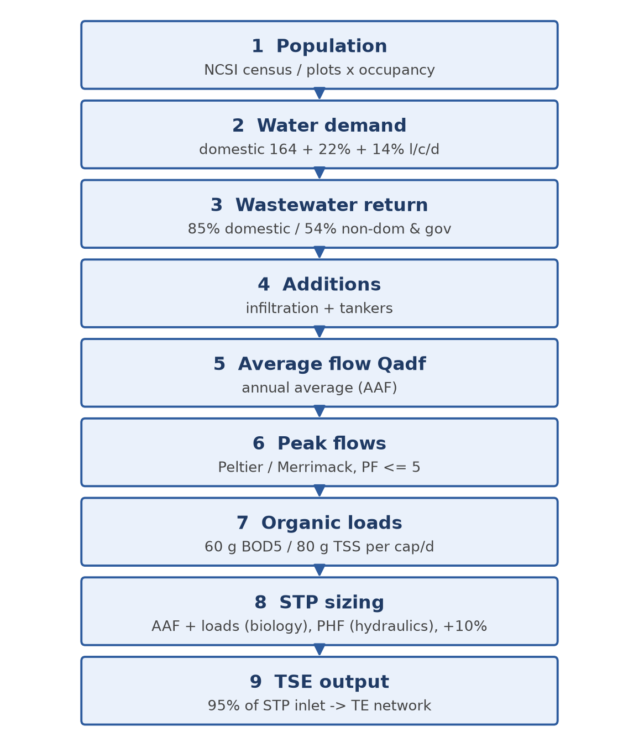
Figure 1 — Sewage flow and load calculation chain

Step 1 — Population
Two routes are used together (G1-p58). The census route projects the NCSI wilayat population and disaggregates it to settlements; it governs the dated model years (2030, 2055). The plot route multiplies the number of plots by the average properties per plot and the occupancy rate; it governs the ultimate (saturated) horizon, because saturation no longer depends on the growth rate.
Route | Formula / source | Governs
Census (top-down) | NCSI wilayat series, settlement disaggregation. Ibri: 183,564 (2024), growth 2.4-3.0 %/yr (R0) | Model years 2030 / 2055
Plots (bottom-up) | Population = plots x properties per plot x occupancy rate (G1-p58) | Ultimate / saturation
The scope horizons are the start year, 2030, 2055 and ultimate, at 5-year projection intervals; the design horizon is completion + 25 years or saturation, whichever governs (TOR p3, p14-15). The occupancy rate per settlement is to be confirmed from NCSI housing statistics.

Step 2 — Water demand
Water demand is built from the domestic per-capita consumption, increased by fixed governorate ratios for non-domestic and governmental use (G1-p60-61). For Adh Dhahirah:
Component | Value (l/c/d) | Reference
Domestic | 164 (R0 computes 163.5 from 2021-24 billing — equivalent) | G1-p60, R0
Non-domestic (+22% of domestic) | 36.1 | G1-p60-61
Governmental (+14% of domestic) | 23.0 | G1-p60
Total water demand | 223 | —
For large individual facilities (schools, hospitals, malls) the unit rates of G1-p61 Table 12 may replace the percentage approach (e.g. 130 l/pupil/d for schools, 650 l/bed/d for hospitals).

Step 3 — Wastewater return
Only part of the supplied water returns to the sewer. The return rates of G1-p71 (Table 19) are 85% for domestic and tankered consumption and 54% for non-domestic and governmental consumption:
Stream | Return | Per-capita wastewater (l/c/d)
Domestic | 85% | 164 x 0.85 = 139.4
Non-domestic + governmental | 54% | (36.1 + 23.0) x 0.54 = 31.9
Total wastewater generation | — | ≈ 171

Step 4 — Additions: infiltration and tankers
• Infiltration, new networks: 720 L/d per km of sewer (G1-p72). For existing inland networks: 10% of the wastewater flow; up to 40% for coastal/high-groundwater systems. No stormwater allowance — the system is strictly separate.
• Yellow tankers: currently about 17% of STP inflow nationally; design coverage reaches 100% by the end of the planning period (G1-p73). The R0 model collects tankered flows from settlements within 25 km of the STP.
Note: the R0 model currently applies 10% infiltration to selected settlements, whereas the guideline value for new networks is the linear 720 L/d/km — roughly an order of magnitude smaller for this network. Both are carried until NWS confirms the basis (Section 4).

Step 5 — Average flow
The average daily flow (Qadf, equal to the annual average flow AAF of GUD-203) is:
Qadf [m3/d] = Population x 171 l/c/d / 1000 + Infiltration + Tanker deliveries
GUD-203 (p65-66) distinguishes AAF (annual average), MDF (maximum day) and PHF (peak hour); each has a distinct use in Step 8.

Step 6 — Peak flows
Peaking applies to the sewage component only; infiltration is not peaked. Two formulas are permitted (G1-p71-72):
Method | Expression | Result
Peltier (IMP 2024) | PF = 1.5 + 1/√Qm, Qm in L/s | Peak factor on average flow
Merrimack | Qpdf = 2.65 x Qadf^0.879 (both Ml/d, >100 properties) | Peak daily flow directly
Cap | Hourly PF ≤ 5.0 | —
The two methods do not agree (the worked example gives PF 1.72 vs 2.48). Peltier is the current IMP 2024 method; the binding choice is to be confirmed with NWS. The R0 model additionally applies a +20% weekly peak, which has no guideline source and is likewise flagged.

Step 7 — Organic loads
Per-capita loads are fixed minimums (p74) and do not scale with water consumption:
Parameter | Value | Reference
BOD5 | ≥ 60 g/cap/d | p74
TSS | 80 g/cap/d | p74
COD (domestic) | 1.8 - 2.2 x BOD | p74
Concentration is always derived, never assumed: C [mg/l] = Load [kg/d] x 1000 / Q [m3/d]. Low per-capita water use produces concentrated sewage: expect BOD around 300-400 mg/l here. A result near 200 mg/l (European dilution) indicates an error.

Step 8 — What each flow is used for
Use | Governing flow | Additional rules
Gravity pipe sizing | Peak (hourly) flow | d/D ≤ 0.65 (D ≤ 350) / 0.50 (D > 350); v = 0.75-3.0 m/s; Table 11 minimum gradients (p26-29)
Pumping stations / force mains | Peak flow with any one pump out | v = 1.0 (intermittent) - 2.5 m/s (p39, p50)
STP hydraulic pass-through | PHF | p65-66
STP biology | AAF + organic loads | p65-66
TE / TSE pipelines | TSE = 95% of STP inlet | Roughness penalty for TE: ε +30%, C −10% (G2-p104)

Step 9 — STP incoming flow and outputs
STP incoming flow = network Qadf (including infiltration) + tankered flows + 10% operational allowance (p65 Table 29, G1-p73). A plant at or above 20,000 m3/d falls in the Large category (p65); per the TOR, the Phase I capacity relative to this threshold determines whether the new STP preliminary design remains in the consultancy scope.
• TSE production = 95% of STP inlet (G1-p73) — this feeds the TE network design.
• Sludge ≈ 0.25 kg per m3 treated (R0 planning rate; to be refined at process design).

Worked Example
A settlement of 10,000 persons served by 25 km of new sewers, all values rounded:
# | Step | Calculation | Result
1 | Population | given | 10,000 cap
2 | Water demand | 164 x 1.36 | 223 l/c/d → 2,230 m3/d
3 | Wastewater return | 164 x 0.85 + 59.1 x 0.54 | 171.3 l/c/d → 1,713 m3/d
4 | Infiltration (new network) | 720 L/d/km x 25 km | +18 m3/d (≈ 1%)
5 | Average flow Qadf | 1,713 + 18 | 1,731 m3/d = 20.0 L/s
6a | Peltier peak | PF = 1.5 + 1/√20.0 = 1.72 | peak 34.5 L/s
6b | Merrimack peak | 2.65 x 1.731^0.879 | 4.29 Ml/d = 49.7 L/s (PF 2.48)
7 | Loads BOD / TSS / COD | 10,000 x 60 / 80 / 120 g/d | 600 / 800 / 1,200 kg/d
7b | Concentrations | load / Qadf | BOD 347, TSS 462, COD 693 mg/l
8 | STP incoming flow | 1,731 x 1.10 | 1,904 m3/d
9 | TSE production | 1,904 x 0.95 | 1,809 m3/d
Table — Worked example, 10,000-person settlement
Sanity checks that should always hold: BOD concentration between 300 and 400 mg/l; peak factor between 1.5 and 5.0; infiltration far smaller than sewage flow for a new inland network.

Guideline vs Inception R0 — Reconciliation Register
The R0 demand model and the guidelines agree on the core parameters; the differences below are carried openly until confirmed with NWS at the kick-off stage:
Item | Guideline (binding) | R0 adopted | Status
Domestic per-capita demand | 164 l/c/d (G1-p60) | 163.5 computed from billing | Consistent
Return ratios | 85% / 54% (G1-p71) | Same | Consistent
Infiltration | 720 L/d/km, new networks (G1-p72) | 10% of wastewater flow | To reconcile
Peaking | Peltier / Merrimack, PF ≤ 5 (G1-p71-72) | +20% weekly peak added | Confirm basis
Tanker catchment | Not specified | 25 km radius | NWS to confirm
STP margin / TSE ratio | +10% / 95% (G1-p73) | Same | Consistent
Sludge rate | Not specified | 0.25 kg/m3 | R0 planning value

Open inputs
• Occupancy rate per settlement — NCSI housing statistics (partly available in the R0 workbook; value per settlement to be confirmed).
• Existing Ibri STP capacity, headworks invert and spare capacity.
• Model start year and confirmation of the 2030 / 2055 / ultimate horizons.

