Ibri Sewer, TE & STP — Project 2621
W4 — Sewer Network Design Pipeline
Methodology and Test-Boundary Results
Internal working document — design team
18 August 2026
Item | Value
Test area | 551 ha
Network designed | 2,359 manholes / 95.3 km
Peak flow at outfall | 83 L/s (Qadf 3,070 m3/d)
Audit result | 0 violations
Code / tests | W4/py/sewnet — 43 pytest cases, Table-11 gate

Contents
Contents 2
Executive summary 3
1. What the pipeline is 4
2. Hydraulic basis and how it is verified 4
3. How the solver designs a pipe 8
4. The house-connectability check 10
5. Test-boundary results 12
6. SewerGEMS package and referee protocol 15
7. Assumptions register 15
8. Limitations and what changes at full scale 15
9. Adversarial review 16

Executive summary
We built the sewer design pipeline, proved it end to end on the 551 ha test boundary, put it through a 21-agent adversarial review, fixed everything the review confirmed, and the final design passes its own audit with zero violations. Here is the whole story in one page.
The pipeline takes four inputs — roads, classified plots, the 0.5 m terrain and a boundary — and produces a complete gravity network: 2,359 manholes, 95.3 km of pipe (95% DN200, stepping through DN250–400 to a DN500 outfall leg), designed inverts everywhere, 13 seconds to run. Every one of the 2,987 loaded units (2,217 built plots, 522 planned, 248 unparceled buildings; 86 farms excluded per doctrine) lands on exactly one manhole — nothing silently dropped, mass balance closes exactly. Saturation flow at the outfall: Qadf 3,070 m3/d, peak 83 L/s (Merrimack).
The hydraulics were never taken on faith, and the verification regime earned its keep. The Colebrook-White solver had to reproduce all nine minimum gradients of G203 Table 11 (±5%) before it was allowed to size anything — it does, mean deviation under 2%. Then the adversarial panel attacked the code and confirmed 11 real defects, all now fixed: the spanning tree covered every road junction but skipped 25 km of cross-street edges (fixed with the standard crest-manhole layout); pipe capacity was computed on nominal diameter while OD-designated PVC-U bores smaller (now on true SDR34 bore); a broken bisection in the velocity-cap solver; and drop structures measured against the wrong datum. 43 pytest cases lock all of it in.
The honest self-cleansing picture, on the table rather than under it: 96% of pipes cannot reach 0.75 m/s at saturation peak — physically inevitable on small residential branches — and comply through the guideline's own tractive-force alternative at tau = 1 Pa, which is a pending assumption [GAP-9]. If NWS sets tau = 2 Pa, 1,626 pipes need steeper slopes. That single number is the strongest argument for pinning tau down at the kickoff.
Three findings from the test area for your eyes:
- The outfall landed 733 m from where you expected — the terrain's lowest boundary road node is at (450614, 2567397), south-center on the main corridor, z 351.2 m, not the west edge. If the real trunk connection is elsewhere, it is one config line and a 13-second re-run.
- Your elevated-roads concern was justified: 293 units (9.8%) could not gravity-connect at standard sewer depth. Deepening 213 manholes recovered all but 12, now flagged as local-solution candidates.
- One SLS pocket appeared (1 pocket, ~5 properties) — absorb-to-detail-design per rule 9. 398 drop structures (252 vortex-class) concentrate at wadi-bank crossings, exactly where detail design applies the G1-p85 crossing rules.
Also delivered on the way: T01 Rev 3 — the tutorial now teaches Colebrook-White (§14), Table 11 derived step by step, every number independently verified.
What is proven: doctrine loads in, guideline-compliant network out, auditable and re-runnable, honest about its assumptions. What is not yet proven: SewerGEMS agreement (the import package and pipe-by-pipe referee table await the ModelBuilder run), and behaviour at 36-zone scale with the finalised trunk. That is W5.

1. What the pipeline is
A re-runnable Python package (sewnet) that designs a gravity sewer network inside any boundary, given roads, loaded plots, terrain and an outfall or connection point. One config file holds the paths; criteria.py holds every design number with its PAM-GUD page reference — no number lives anywhere else in the code.
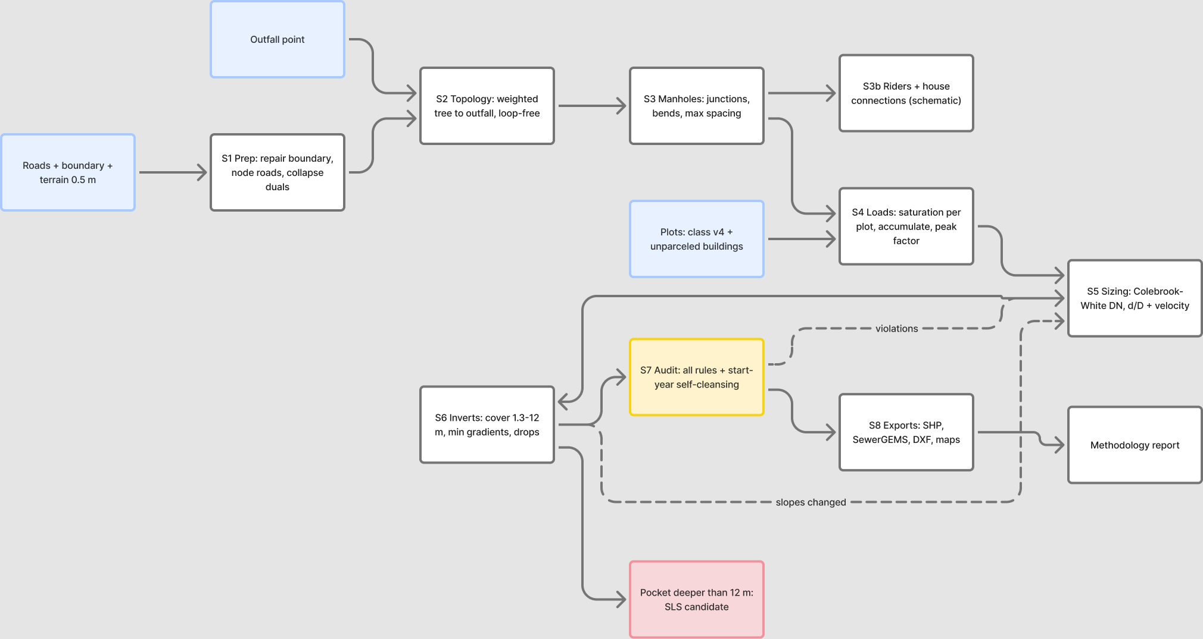
Figure 1 — Pipeline architecture. Blue = inputs, yellow = audit gate, red = SLS flag, dashed = iteration loops.
Stages, in one breath: repair and clip the inputs; node the roads and collapse dual carriageways; grow a loop-free tree toward the outfall (climb-penalised, arterial-preferring — the 'no alleys' lesson); add cross-street branches wherever loaded plots front an off-tree street (summit-split, crest-manhole layout); place manholes (junctions, bends >45°, <=100 m spacing, sub-2 m reaches contracted); load every plot at saturation; accumulate flows with peak factor and infiltration; size pipes and solve inverts together on the true pipe bore; check every house can physically reach its manhole, deepening where roads are elevated; audit everything independently; export SHP, SewerGEMS, DXF and maps.

2. Hydraulic basis and how it is verified
Element | Basis | Verification
Capacity / velocity | Colebrook-White, ks = 1.5 mm, nu = 1.141e-6 m2/s (G203-p24/25/28), partial-full circular geometry, true internal bore (PVC-U OD-series derated to SDR34 ID; GRP nominal = ID) | Table-11 gate: reproduce all 9 minimum gradients at 0.75 m/s ±5% — passes at <2% mean deviation; ID convention unit-tested
Minimum gradients | Steeper of Table 11 (p29) and tractive force Smin = 2.33e-4·tau^1.23·Q^-0.461 (p27, A9-corrected), plus a 40 mm total-fall guard per reach (p29 §4.3.1) | tau = 1 Pa tagged [GAP-9]; Q floored at Mara's 1.5 L/s minimum design flow — at the floor tractive ≈ Table 11 DN200: the methods meet
d/D limits | <=0.65 (D<=350), <=0.50 (D>350) at peak (p27 Tab 10) | enforced in sizing, re-checked in audit on the true bore
Velocity band | >=0.75 m/s at peak or tractive-compliant (p26–27); <=3.0 m/s via a slope cap whose surplus fall becomes a designed drop | audit plus the transparency statistics in section 5
Loads | Doctrine §2: every plot at saturation, 6.0 × 171.3 l/c/d ≈ 1.03 m3/d/plot; farms zero; infiltration 720 L/d/km unpeaked; PF Merrimack (mandatory >100 properties), held at its 100-property value below; Peltier comparison held the same way | mass balance to the outfall closes exactly; unknown CLASS values can never vanish silently

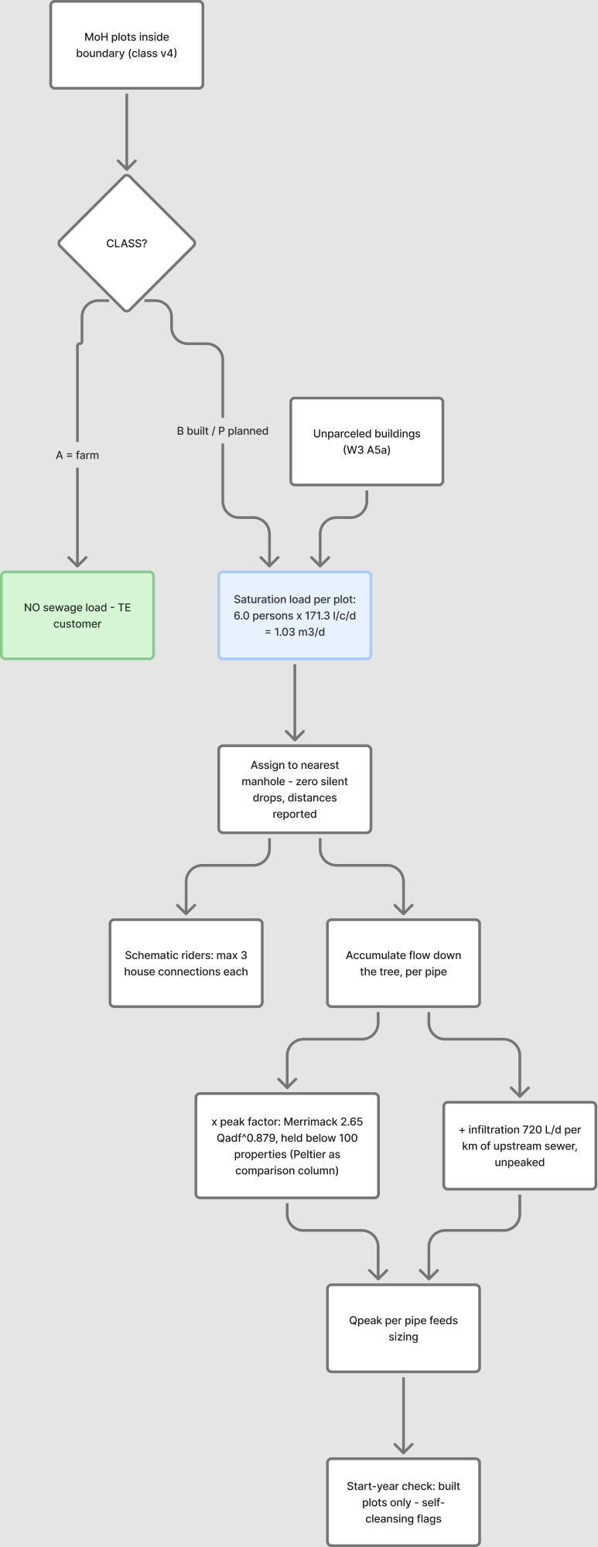
Figure 2 — Load allocation chain.

3. How the solver designs a pipe
Two passes per reach, iterated until no diameter changes (2 iterations sufficed; oscillation between adjacent DNs is detected and broken upward; a final lay pass always leaves inverts consistent with final diameters).
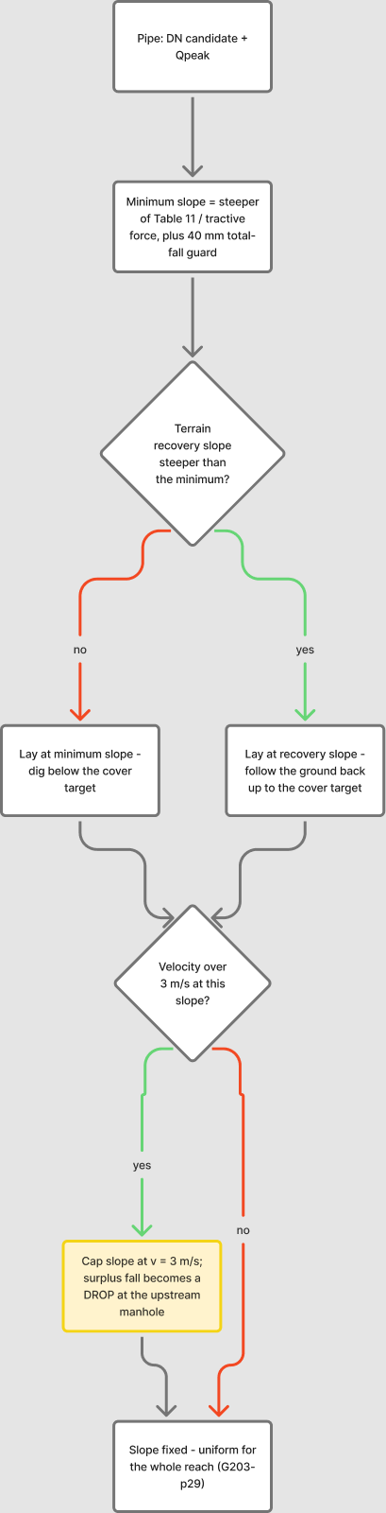 | 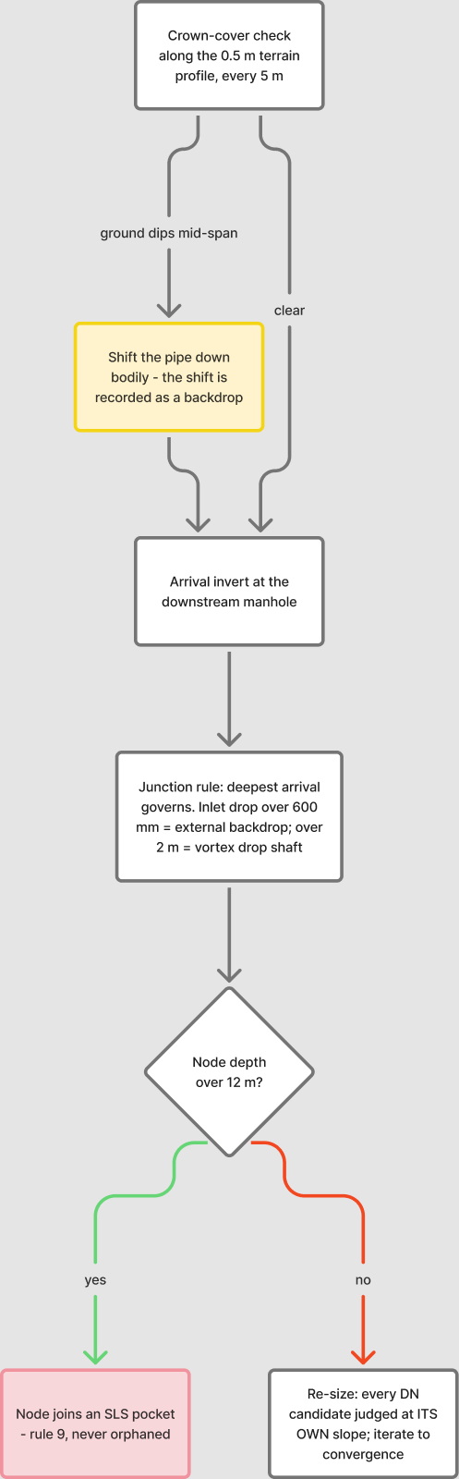
Figure 3 — Solver logic: step 1 sets the reach slope, step 2 resolves profile, junction and depth.
The details that matter:
- Uniform slope per reach (p29) — one straight line between manholes, never kinked.
- The chamber datum is the outgoing invert — manhole depth is construction depth, and every inlet drop is measured inlet-invert minus outgoing-invert, so velocity-cap surpluses and cover shifts combine into the drop they physically are. >600 mm = external backdrop, >2 m = vortex shaft (p30); the audit re-derives every drop independently, and a missing or misclassified record is a violation.
- Mid-span cover on real terrain: every reach profiled at 5 m on the 0.5 m VRT; a reach riding above dipping ground is shifted down bodily, the shift surfacing as a recorded drop.
- Sizing without the ratchet: every candidate DN is judged at its own governing slope (no-oversizing, p29), on its true bore, with velocity-infeasible candidates skipped explicitly.
- >12 m depth becomes an SLS pocket (p33 + rule 9) — never a silent orphan.

4. The house-connectability check
Roads are locally elevated for flood protection and underpasses, so houses can sit below the sewer. For every loaded unit: plot ground (0.5 m terrain) minus 0.6 m outlet depth must reach its manhole's invert with 2% fall over the connection distance. Failures raise a deepening requirement on that manhole (capped 0.5 m short of the 12 m limit) and the invert solve re-runs; anything still failing is flagged for a local solution. Test area: 293 flagged, 213 manholes deepened, 12 residual.
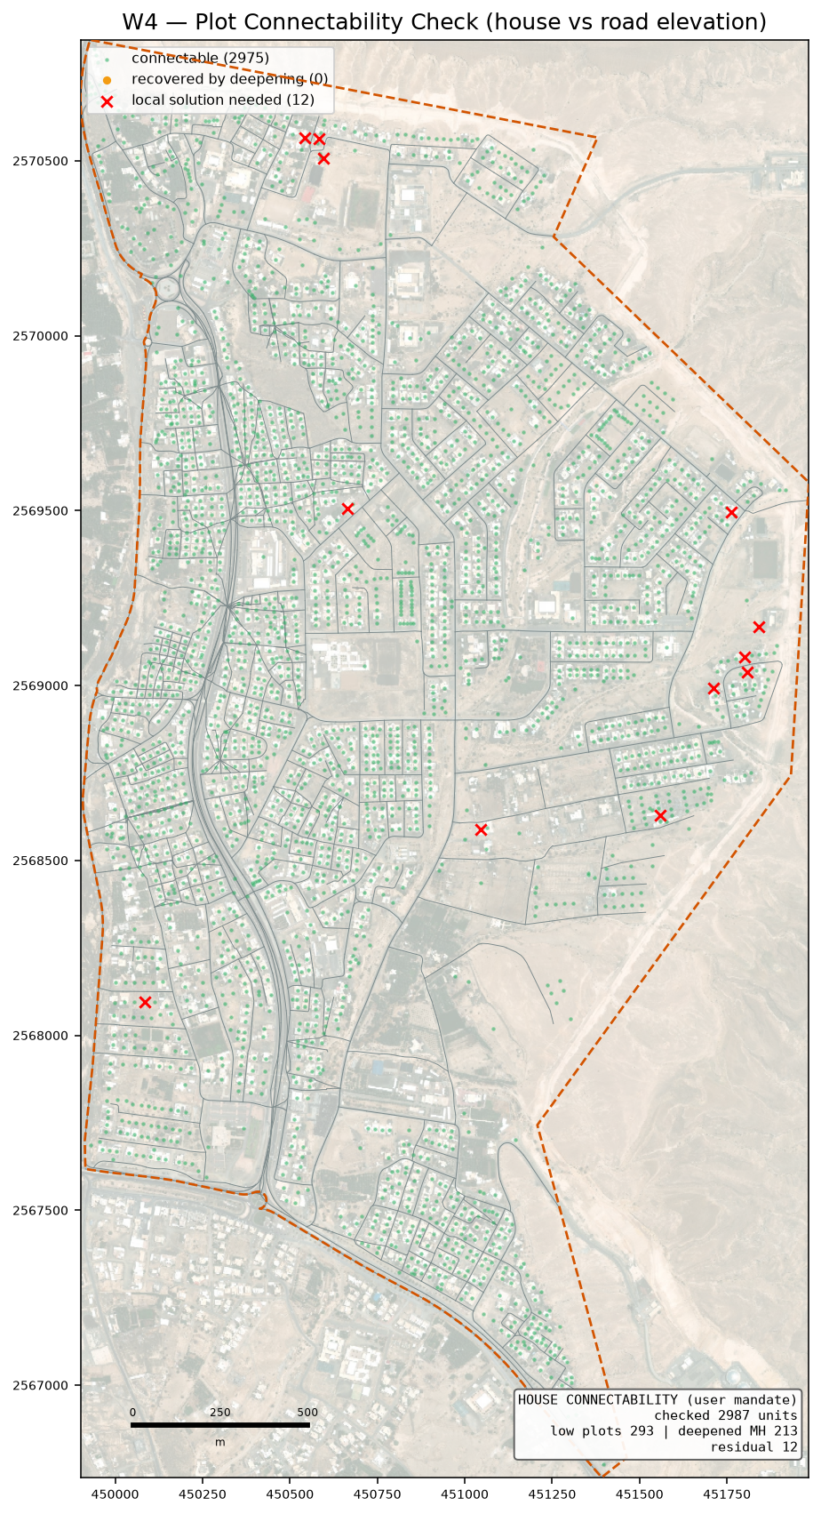
Figure 4 — Plot connectability: green connectable, amber recovered by deepening, red needs a local solution.

5. Test-boundary results
Quantity | Value
Area / roads / network | 551 ha / 98.7 km roads / 95.3 km sewers (25.27 km from cross-street augmentation; 0.56 km of unloaded streets deliberately unsewered)
Manholes / pipes | 2,359 / 2,358 (single tree, one outfall)
Diameters | DN200 90.442 km · DN250 1.53 km · DN315 1.547 km · DN400 1.564 km · DN500 0.251 km
Loaded units | 2,987 (built 2,217 + planned 522 + unparceled 248); farms excluded 86
Outfall | (450614, 2567397), z 351.24 — 733 m from user expectation
Qadf / Qpeak at outfall | 3,070 m3/d / 83 L/s (PF merrimack; Peltier column in the shapefiles)
Depths | max 15.3 m (inside the SLS pocket); gravity network otherwise <= 12 m
Drops | 398 designed structures; 252 vortex-class (>2 m), concentrated at wadi-bank crossings
SLS pockets | 1 (~5 properties, absorb per rule 9)
Low plots | 293 flagged, 12 residual after deepening 213 manholes
Audit | 0 violations (saturation run, including independent drop re-derivation)
Self-cleansing transparency | 2,259/2,358 pipes below 0.75 m/s at saturation peak — compliant via tractive at tau=1 Pa [GAP-9]; 1,626 would need redesign at tau=2 Pa; start-year flags 2,278, all tractive-compliant
Runtime | ~13 s design + ~5 s exports

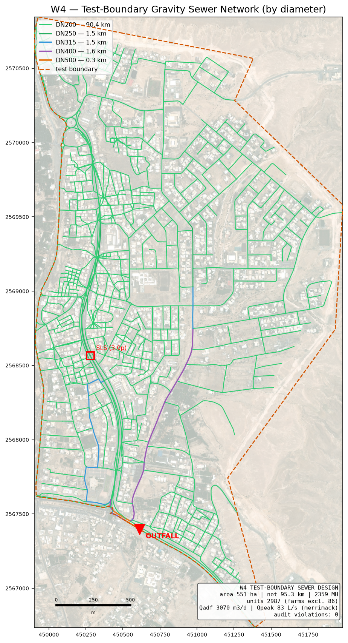
Figure 5 — Designed network by diameter, with outfall and SLS candidate.
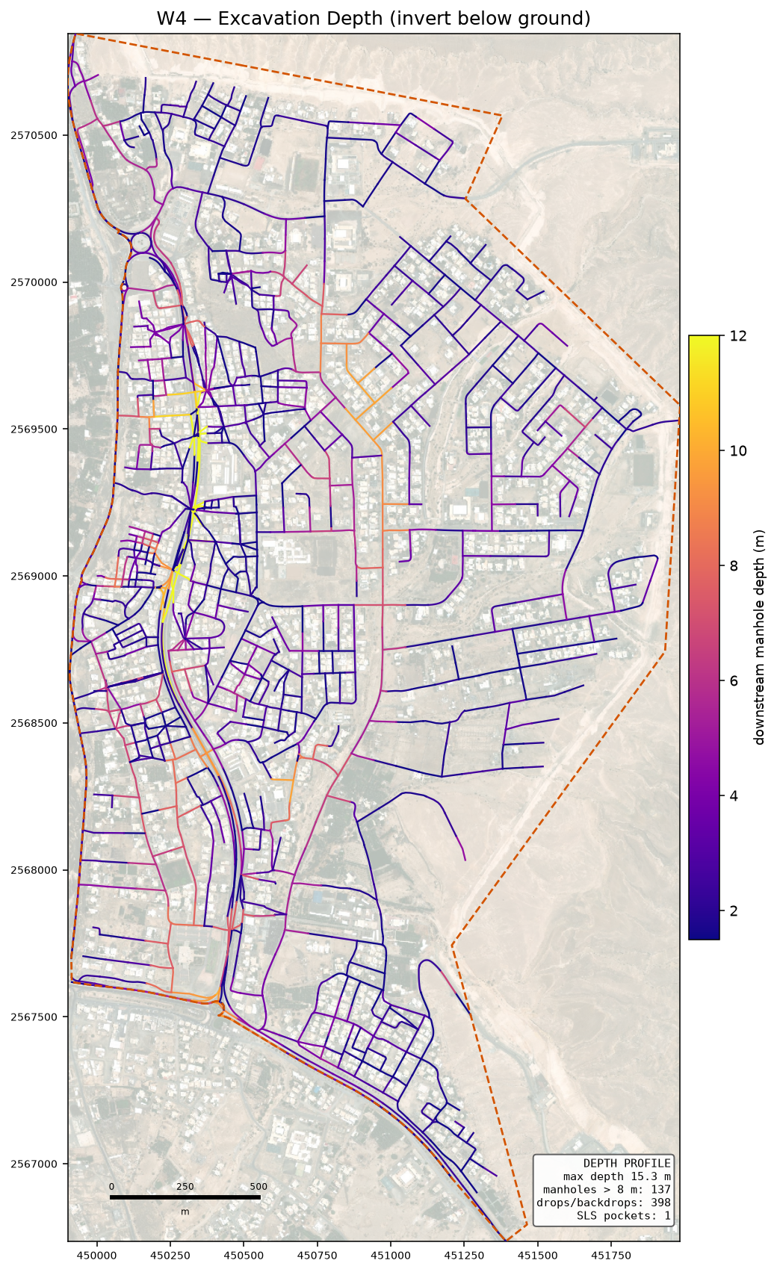
Figure 6 — Excavation depth (invert below ground).

6. SewerGEMS package and referee protocol
W4/sewergems/ holds MANHOLES, CONDUITS and OUTFALL shapefiles built to the Bentley-documented ModelBuilder mappings (explicit START_ND/STOP_ND plus vertex-snapped geometry digitised upstream to downstream, elevations not depths, numeric mm diameters), LOADS.xlsx (pattern-based rows, L/s per manhole), and IMPORT_PROCEDURE.md with the known traps — the 'Set Invert to Start/Stop Node = False' global edit being the one that silently deletes drop manholes. Manning n is exported as 0.013, the ks = 1.5 mm equivalent: the Tab-8 range 0.009–0.011 conflicts with the ks mandate and would show roughly 30% phantom capacity, so that conflict is flagged as an NWS kickoff item.
After the model run, paste SewerGEMS discharge, velocity and d/D into REFEREE_pipes.csv; any pipe deviating more than 5% from our columns is an open investigation. The design is not 'verified' until the two engines agree — deliberately a separate run, not a self-check.

7. Assumptions register
Tagged in criteria.ASSUMPTIONS with the same wording, and reported in every deliverable:
Assumption | Basis / exposure
tau = 1 Pa | GUD-203 gives no numeric design tractive stress [GAP-9]; largest redesign exposure (1,626 pipes at tau=2)
Tractive Q-floor 1.5 L/s | Mara simplified-sewerage minimum design flow; unfloored the formula demands unbounded slopes as Q approaches 0
PVC-U wall class SDR34/SN8 | true bore for hydraulics; actual class per PAM-SPC-207 pending
OR 6.0, 1 property per plot | GAP-5 (NCSI housing units missing)
Plot outlet 0.6 m, 2% connection fall | method choice for the connectability check
40 m frontage rule | an off-tree street gets a sewer when a loaded unit lies within 40 m
Manhole size ladder | 02 has no size table; GUD-203 §4.4 re-extract pending (no hydraulic effect at concept)
Rider discharge to nearest manhole | 02 silent on the discharge point
Gravity in-road position | taken from the force-main clause (p51, A9) as an inference
PF held below 100 properties | G1-p71 prescribes no formula there; Peltier held the same way
Infiltration unpeaked | add-order not stated in GUD-201 — kickoff item

8. Limitations and what changes at full scale
- The trunk is user-finalised (settled 2026-08-18) — the pipeline designs subnetworks into the given connection points, which are config entries, not structure.
- One outfall per run today; multi-connection territory competition is the W5 structural addition.
- Riders are schematic; junction losses ignored (normal-depth hydraulics) — both noted for the SewerGEMS comparison.
- The 0.5 m terrain is concept-grade for inverts near the 0.75–1.0 mm/m minimums (G1-p36); flat trunk profiles at scale need survey-grade data — already a registered data request.
- tau = 1 Pa carries the largest redesign exposure — pin it at the kickoff.

9. Adversarial review
A 21-agent skeptic panel attacked the hydraulic core after the first audit-clean run: four attack lenses (Colebrook-White implementation, solver clause compliance, load/audit doctrine, executed edge cases) followed by independent verification of every raw finding. 17 raw findings, 11 confirmed, 11 fixed, 6 refuted. The full register with fixes is in W4/docs/REVIEW_FINDINGS.md; the headline four were cross-street coverage (+25.3 km), the true PVC bore correction, the drop-datum correction, and the velocity-cap bisection repair.

