Sultanate of Oman
Nama Water Services Company SAOC

Consultancy Services for Design and Supervision for STP, Sewer and TE Networks Systems in Ibri
Tender No. T/2719110/2025

Concept Design — Methodology, Equations and Workflows
Tutorial T03 · Revision 01

A working reference for every calculation the Concept Design Report requires: what each step is for, how it is done, which equation applies, what every symbol means, and which page of which guideline it comes from.

Renardet S.A. & Partners
Project 2621 · Revision 01 · August 2026

Contents
Right-click and choose Update Field to build the contents.

How to use this document
This is a reference, not a report. It is written to be opened at the point of need: when a step of the concept design has to be carried out and the question is what exactly to calculate, with what, and on whose authority.

Reading paths
If you want to… | Read
Understand the whole chain in twenty minutes | The executive summary that follows, and nothing else
Carry out one calculation correctly | The section for that step. Each is self-contained
Check a number before it goes to the client | The equation, then its source page in the guideline itself
Know where the guidelines are wrong or silent | Section 22, and the caution boxes throughout

How each section is built
Every calculation section follows the same five parts, so the document can be navigated by shape rather than by memory.
- Purpose — why the step exists and what it feeds
- Method — how it is done, in order
- Equation — as a native Word equation, numbered
- Parameters — every symbol, its meaning and its unit
- Source — guideline and page, so any figure can be checked at source

Three conventions worth knowing before you start
Nothing here is quoted from memory. Every equation in this document was read from the guideline page itself, rendered as an image, because the text layer of the PDFs mangles fraction bars, roots and exponents. Three equations exist in the guidelines only as pictures and cannot be found by searching the text at all.
Where a formula is not NWS's, it says so. Several formulae every engineer expects to find — net present value, life cycle cost, total dynamic head, pump power, Darcy-Weisbach and Hazen-Williams in written form — do not appear anywhere in the three guidelines. Each is attributed here to its actual source. Citing NWS for them would be a fabricated reference.
Where the guideline is wrong, it is reproduced and flagged. The guidelines contain errors — a dimensionally impossible flow equation, a peak-factor formula that differs from the published original, a tanker ratio that cannot be arithmetically true. This document prints what the guideline prints, then says plainly what is wrong with it. It does not silently correct the client's own standard.

Abbreviations
Term | Meaning
AAF | Average Annual Flow, the daily volume averaged over a year
Qadf | Average daily flow — the same quantity, the guideline's symbol
MDF | Maximum Day Flow
PHF / Qpdf | Peak Hour Flow, and peak daily flow
Pf | Peak factor, the ratio converting an average flow to a peak flow
LPCD | Litres per capita per day
OR | Occupancy rate, persons per housing unit
d/D | Proportional depth — flow depth divided by pipe diameter
SRT | Solids retention time, also called sludge age
TN | Total nitrogen
OU | Odour unit; 1 OU/m³ is the concentration half a panel can detect
DS | Dry solids
NCSI | National Centre for Statistics and Information
MoHUP | Ministry of Housing and Urban Planning
APSR | Authority for Public Services Regulation
G201 / G202 / G203 | PAM-GUD-201 General Design, -202 Water and TSE, -203 Wastewater, all Revision 01 of March 2026
One term to be careful with. In G201 and G203, TE means Trade Effluent and TSE means Treated Sewage Effluent. This project, the TOR and the tender all use TE to mean treated effluent. Wherever this document says TSE it means the treated product of the STP. Say so explicitly in anything sent to NWS, or a guideline-literate reviewer will read a trade effluent network into the report.

Executive summary
The concept design turns a population into a set of pipe diameters, a plant capacity and a phasing plan. This document sets out how, in nineteen steps, and fixes every number to a page of a guideline. What follows is the whole chain in short form. Anyone who reads only these few pages should be able to do the work and know where to look when a detail is needed.

The chain, step by step
# | Step | What comes out | Section
1 | Prepare the data | A clean plot layer with counted properties and a land use for each | 3
2 | Population | People, per settlement, per year | 4
3 | Water demand | Litres per day, by consumption category | 5
4 | Wastewater generation | The flow that reaches the sewer | 6
5 | Project through time | A flow for every year to saturation | 7
6 | Peak and infiltration | The flow the pipe is actually sized on | 8
7 | Gravity network | Diameters, gradients, depths, manholes | 9
8 | Self-cleansing | Which pipes need washing, and until when | 10
9 | Lifting stations | Where gravity fails, and what pumps it | 11
10 | Septicity and odour | Retention, turbulence and control measures | 12
11 | Utility interfaces | Clearances, crossings and clash resolution | 13
12 | Hydraulic modelling | The model, calibrated and delivered | 14
13 | Existing network | What is kept, upgraded or replaced | 15
14 | STP sizing and phasing | Plant capacity, by phase | 16
15 | Treated effluent | How much is produced, and who takes it | 17
16 | Sludge | How much, and where it goes | 18
17 | Cost estimation | Capital and operating cost, by element | 19
18 | Financial appraisal | Net present value, sensitivity, risk | 20
19 | Options | Three options, and a recommendation | 21

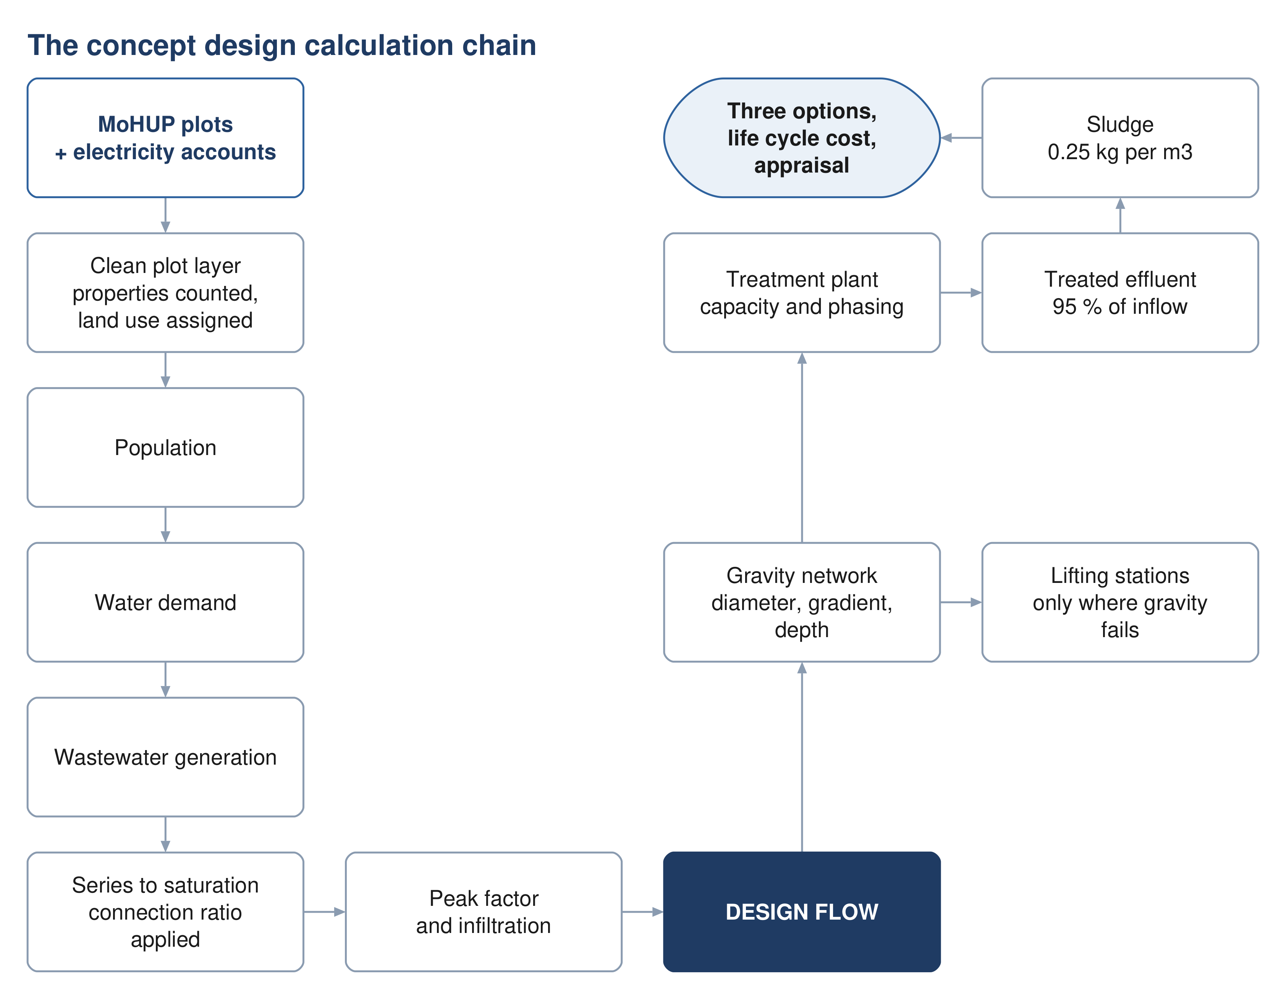
Figure 1 The concept design calculation chain. The left column establishes the flow; the right sizes the works.
Steps 1 to 6 are one continuous calculation: each is the input to the next, and an error early on propagates the whole way. Steps 7 to 16 consume that flow, largely independently of one another. Steps 17 to 19 sit across all of them and decide what gets built.

The spine of the calculation
Stripped of detail, the flow chain is four multiplications and two additions. Everything else is refinement.
$Population = Plots × Properties per plot × OR$ (1)
$Q_{demand} = Population × LPCD × \left(1 + 0.22 + 0.14\right)$ (2)
$Q_{adf} = Q_{dom} × 0.85 + Q_{ND} × 0.54 + Q_{inf}$ (3)
$Q_{design} = Q_{adf} × Pf$ (4)
The 22 % and 14 % are the non-domestic and governmental uplifts for Adh Dhahirah. The 85 % and 54 % are the proportions of supplied water that come back as sewage. The peak factor comes from Merrimack. Each is traced to its page in the sections that follow.

The numbers that govern Ibri
Quantity | Value | Where it comes from
Domestic consumption | 164 l/c/d | G201 Table 11, Adh Dhahirah
Non-domestic uplift | 22 % of domestic | G201 Table 11
Governmental uplift | 14 % of domestic | G201 Table 11
Return to sewer, domestic and tanker | 85 % | G201 Table 19
Return to sewer, non-domestic | 54 % | G201 Table 19
Infiltration, new networks | 720 l/d per km of sewer | G201 p72
Peak factor | Merrimack, over 100 properties | G201 p71
Minimum self-cleansing velocity | 0.75 m/s at peak flow | G203 p26
Maximum velocity | 3 m/s | G203 p27
Flow depth at peak | 0.65 up to 350 mm, 0.50 above | G203 Table 10
Minimum cover | 1.3 m to pipe crown | G203 p33
Recommended maximum cover | approximately 10–12 m | G203 p33
STP design margin | 10 % | G201 p73
TSE produced | 95 % of plant inflow | G201 p73
TSE network loss | 10 % of TSE produced | G201 p76
Sludge | 0.25 kg per m³ of inflow | G201 p78
Total nitrogen in the effluent | below 15 mg/l as N | G203 p71
Design horizon | at least 15 years for the STP; 25 years for appraisal | G203 p65, G201 p57

Six things that are easy to get wrong
These are the places where a correct-looking calculation gives a wrong answer. Each is explained where it arises.
Merrimack runs in megalitres per day. The formula has an exponent of 0.879, so feeding it cubic metres instead of megalitres does not scale the answer — it produces a different number entirely. Peltier, on the facing page, wants litres per second. The general peak-factor equation between them is in cubic metres per day.
The minimum gradient table is a full-bore table. Its gradients deliver 0.75 m/s when the pipe runs full. The guideline separately requires 0.75 m/s at peak flow. A pipe over 350 mm laid at the table minimum sits exactly on the limit at its design depth, and every pipe falls below it in the opening years.
The depth rule is a recommendation about cover. Ten to twelve metres is not a limit and does not refer to invert depth. What triggers a pumping station is excavation cost becoming prohibitive, and the guideline attaches no depth figure to that.
Tankered water still becomes sewage. Water delivered by truck returns to the sewer at the same 85 % as piped water. Leaving it out understates the load, and in this governorate the tankered volume is large.
Accuracy points in opposite directions. For pipe and plant capacity, under-estimating is the danger. For the self-cleansing and washing schedule, over-estimating is the danger, because it declares the pipes self-scouring while they silt. One population figure cannot serve both.
Table 12 and the percentage uplifts are alternatives. Applying unit rates to commercial plots and then adding the 22 % and 14 % counts the same water twice. Use one or the other.

Where the guidelines cannot be relied on
Three categories, each handled in full in Section 15.
Formulae that are not there. Net present value, life cycle cost, carbon footprint, multi-criteria scoring, total dynamic head, pump power, and both friction equations in written form. The guidelines name them and tabulate their coefficients but never write them. They are attributed here to ISO 15686-5, the GHG Protocol, Metcalf and Eddy, or standard hydraulics.
A mandatory method that cannot be executed. The tractive force check is required, and the required value of shear stress in pascals appears nowhere in either guideline. Any value used has to come from outside and be agreed with NWS.
Twenty-eight printing and arithmetic defects. Including a flow equation that divides where it should multiply, a peak-factor formula that differs from its published original, and a tanker ratio that cannot be true. All are listed with their page numbers.

3 Preparing the data

3.1 Purpose
Every later number rests on knowing how many properties sit on each plot and what each one is used for. The cadastral data does not say. This step builds that layer, and it is the only step whose output is a dataset rather than a number.

3.2 What the source data does and does not contain
The plot layer from MoHUP carries geometry. It does not distinguish developed from undeveloped plots, it is missing plots that exist on the ground, and it carries no land use and no count of dwellings.
The electricity account layer supplies what is missing — but only partly, and the limit matters. It carries a tariff name and a coordinate. It carries no land use, no floor area, and no consumption figure. It can therefore say what kind of customer sits at a point and how many there are. It can never say how large that customer is.
This single limitation decides the demand method. GUD-201 Table 12 prices non-domestic demand in pupils, beds, employees and square metres of floor area. None of those quantities exists in any dataset held for this project. The percentage-uplift route is therefore the one in use, and Table 12 is adopted on the day real quantities are supplied. See Section 5.4.
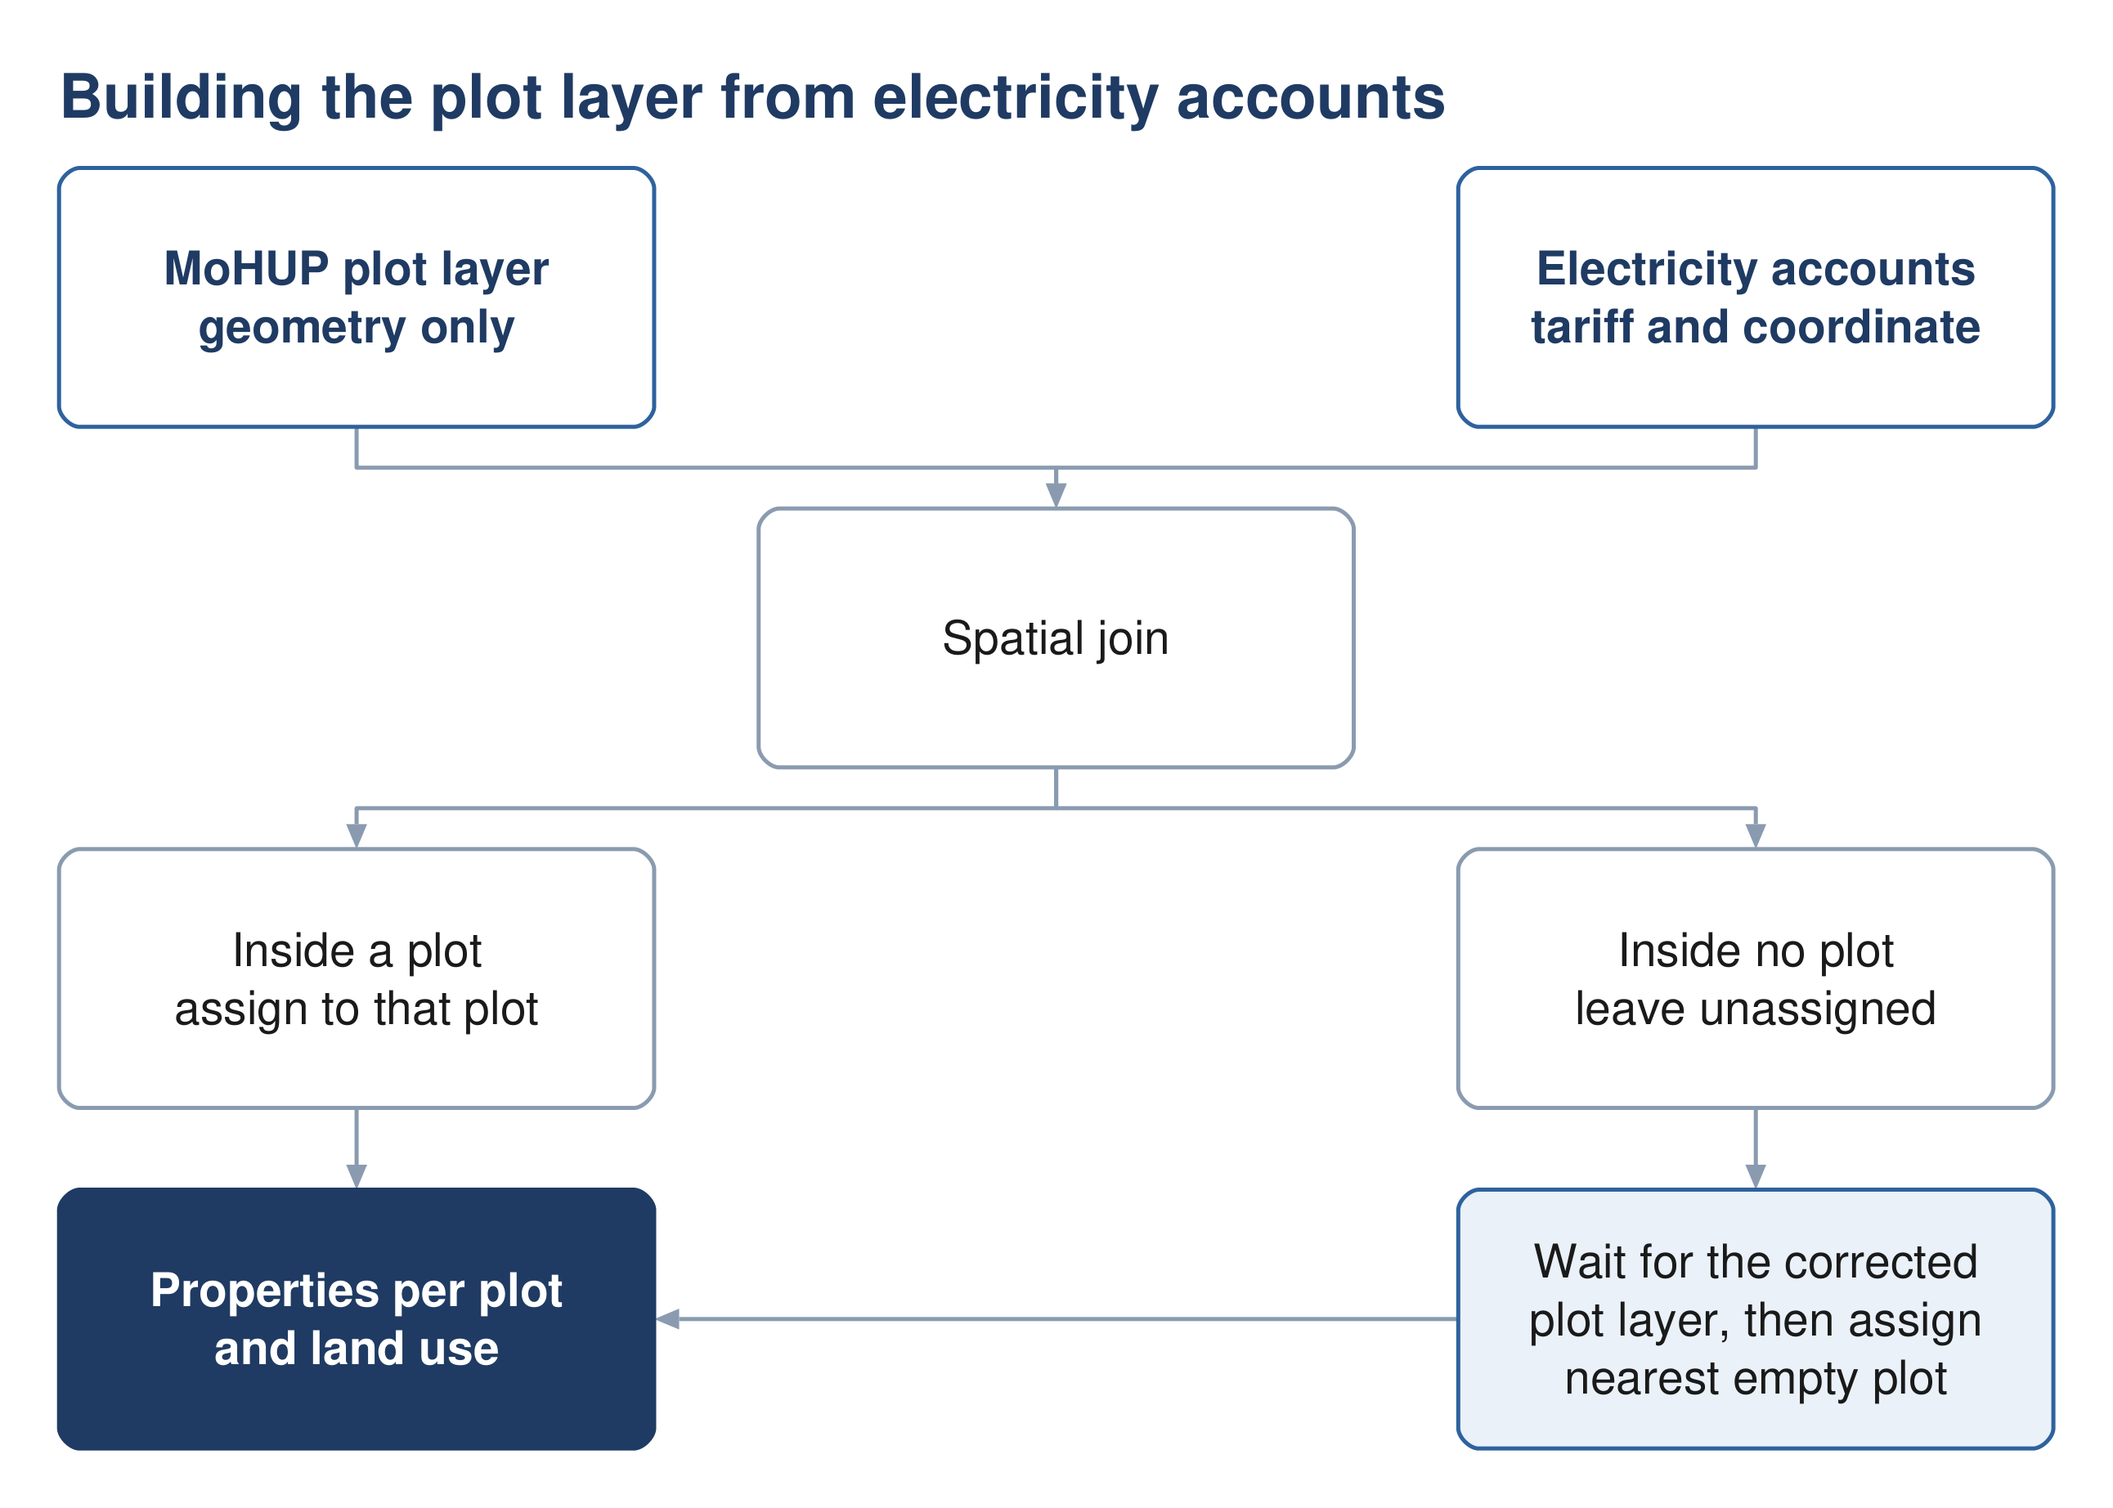
Figure 2 Building the plot layer. Points matching no plot wait for the corrected cadastre rather than being moved first.

3.3 Method
1. Points sharing an identical coordinate are stacked properties at one address, and are counted individually.
2. Points falling inside a plot belong to that plot, whatever their spacing.
3. Points falling inside no plot are left unassigned until the corrected plot layer is available. Only then are any remaining orphans moved to the nearest plot that holds none.
4. Each tariff is mapped to one consumption category. The mapping is an inference and is recorded as one.
Assign orphan points last, not first. Moving a point to a neighbouring plot moves load between streets and changes the pipe sizes on both. Many unmatched points will land naturally once the missing plots are digitised, so shifting before that step manufactures errors that the corrected data would have avoided.

3.4 Mapping tariffs to consumption categories
The electricity file names a tariff. The guideline names a consumption category. The crosswalk between them is the following, and it is ours rather than NWS's.
Table 1 Electricity tariff to guideline consumption category
Tariff as issued | Category | Treatment
Primary Account | Domestic | one dwelling
Primary Account with National Subsidy | Domestic | one dwelling
Additional Account | Domestic | a separate dwelling on the same plot
Commercial, Fisheries, Tourism | Non-domestic | carries the uplift volume
Government, MOD | Governmental | carries the uplift volume
Agricultural | No sewage load | an irrigation pump — see below
Cost Reflective Tariff (CRT) | Unresolved | a size class, not a land use
Industrial | Case by case | excluded from the uplift ratios by G201 p59

Agricultural plots
An agricultural meter powers a borehole pump. The water it lifts goes onto a field and never reaches a sewer. Where a dwelling stands on a farm plot it carries its own domestic account, which is counted normally. The test is therefore whether the plot holds a domestic meter, not whether it holds an agricultural one.
- Rule — an agricultural meter on a plot that already holds a domestic meter adds nothing
- Rule — an agricultural-only plot carries no dwelling

Cost Reflective Tariff
CRT is a consumption-threshold tariff, applied to large consumers and billed at unsubsidised rates. It says a customer is big; it does not say what the customer is. A shopping centre, a factory, a hotel and a large government building all fall into it. These accounts are therefore both the most significant consumers and the only ones the tariff cannot classify. They must be resolved against the plot layer or by site inspection before any uplift ratio is applied.
Source: G201 §7.3 p59-61 for the consumption categories; the tariff crosswalk is a project inference recorded in the concept report's inference register.

4 Population

4.1 Purpose
Population drives every flow in the chain. The guideline permits three routes to it, and the choice between them is not free: they answer different questions and are used for different parts of the design.

4.2 The three permitted routes
Route | Basis | What it is good for
Developer figures | supplied directly | takes precedence where they exist
NCSI projection | official census series | populations at dated years
Plot count | plots × properties × occupancy | the saturation ceiling

The two routes used here answer different questions. The census projection says how many people there will be in a given year. The plot count says how many there can ever be. Buried pipe, which lasts fifty years and cannot be economically re-laid, is sized on the ceiling. The plant, which is built in phases, is sized on the dated years.
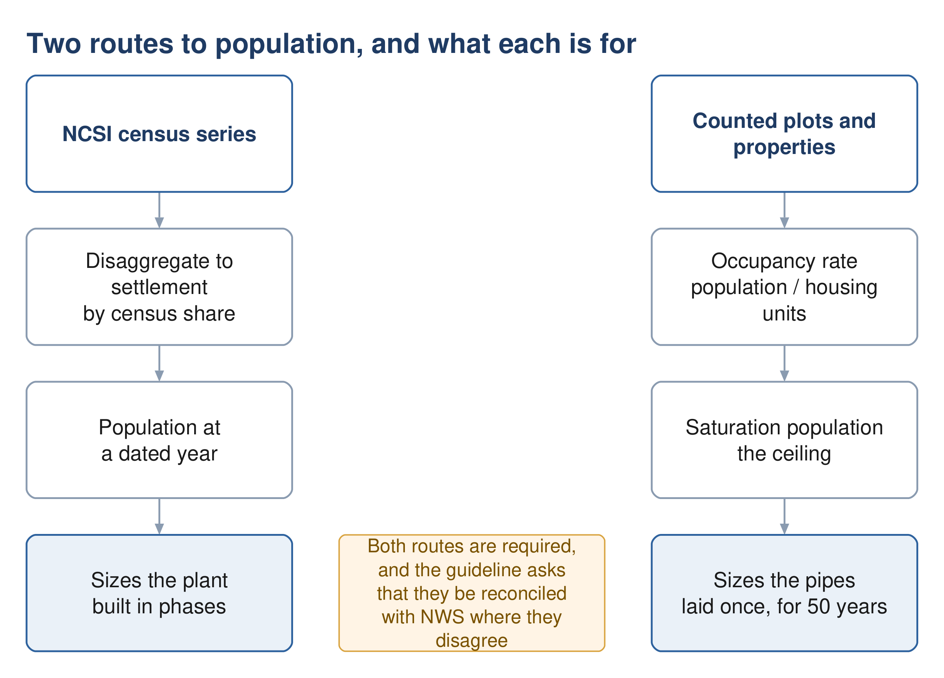
Figure 3 Two routes to population. The census route dates the plant; the plot route sizes the pipe.

4.3 Population from plots
$Population = N{}_{plots} × p × OR$ (5)
Symbol | Meaning | Unit
N plots | number of plots, classified by clear typologies | count
p | average number of properties per plot | dimensionless
OR | occupancy rate, persons per housing unit | persons per unit
Source: G201 §7.2.2 p58.

4.4 Occupancy rate
$OR = \frac{Population}{Housing units}$ (6)
The guideline requires both terms to come from NCSI, at the geographic scale of the project, using the most recent data.
A declared departure. NCSI does not publish housing units at settlement level. This project therefore counts properties from active domestic electricity accounts instead. The guideline itself uses active domestic accounts in its own derivation of consumption per capita, which supports the substitution — but it remains a departure and must be stated as one and agreed with NWS.
Two conditions make the result meaningful. Both halves of the fraction must describe the same ground: a wilayat population divided by the meters of one town gives a household size that is too large purely because people were kept and houses discarded. And only domestic accounts belong in the denominator, since a shop is not a dwelling.
Source: G201 §7.2.2 p58; the account-based derivation follows the form of the consumption formula at G201 p60.

4.5 Disaggregation and extrapolation
Where a forecast exists only at wilayat level it must be distributed to settlements in proportion to the latest census shares. Below settlement scale, the guideline directs distribution pro rata to the number of electricity accounts.
The extrapolation ceiling. NCSI forecasts run twenty to twenty-five years. Beyond that the guideline permits polynomial regression but states that it is not recommended to extrapolate more than ten years past the forecast period. A projection reaching decades beyond the underlying data is an assumption presented as a number, and any capacity argument resting on it should be defended on land availability instead.
The guideline also requires that build-out be phased. Raw plot count multiplied by occupancy assumes every plot is developed at once, which the NOTE at G201 p59 expressly warns against — it requires development percentages to be applied over the design period, particularly to avoid overestimation.
Source: G201 §7.2.1 p58, and the NOTE at p59.

5 Water demand

5.1 Purpose
Wastewater is derived from water demand, so demand is calculated first even though the project is a sewerage scheme. Demand has five components, and three of them are commonly forgotten.

5.2 The five components
Component | Basis | Clause
Domestic | population × litres per capita per day | §7.3.1
Non-domestic | 22 % uplift, or Table 12 unit rates | §7.3.2
Governmental | 14 % uplift, or project-specific | §7.3.3
Special | developer-supplied; labour camps, thirsty industry | §7.3.4
Blue tankers | from tanker filling station records | §7.3.5

The last two sit outside the percentage uplifts and are added separately. The guideline is explicit that special consumption is not covered by population forecasts, and that the uplift ratios do not apply to identified projects such as economic zones, which are determined case by case.
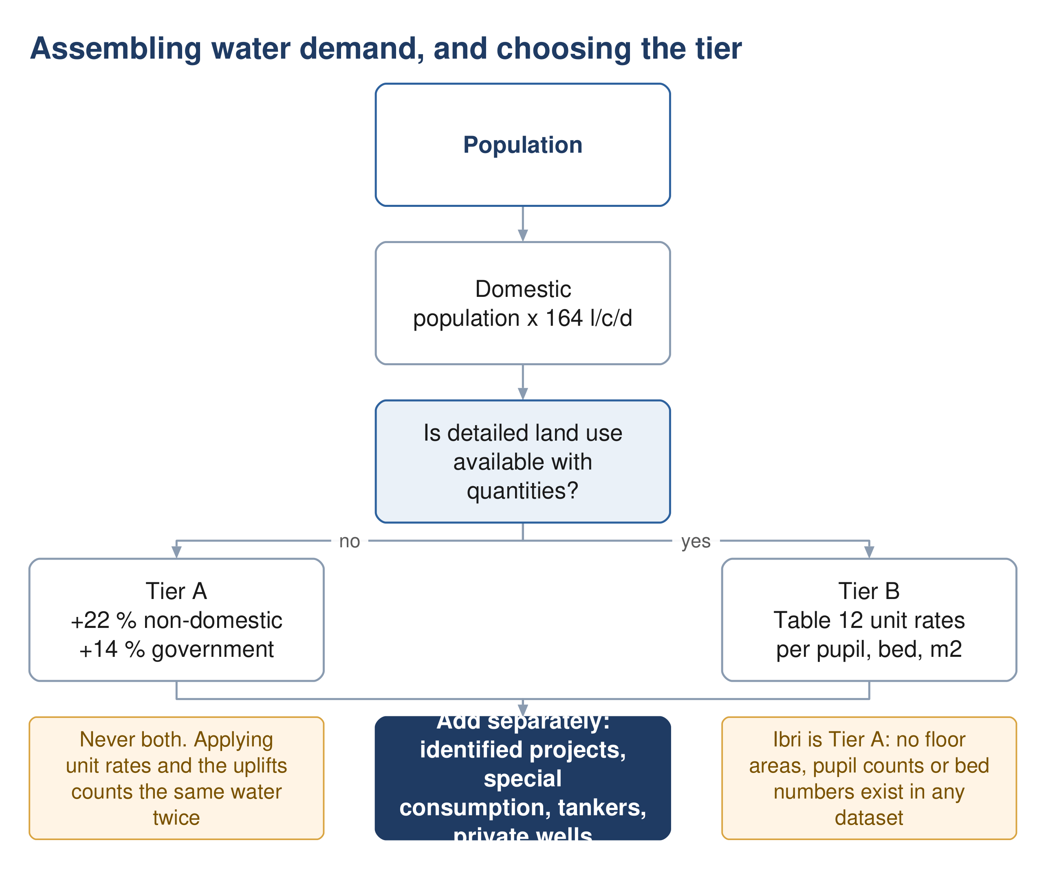
Figure 4 Assembling demand, and the point at which the tier is decided.

5.3 Domestic demand
$Q_{dom} = Population × LPCD$ (7)
Symbol | Meaning | Unit
Q dom | domestic water demand | litres per day
LPCD | unit consumption; 164 for Adh Dhahirah | l/c/d
The 164 figure is indicative, derived from the 2024 Integrated Master Plan, applies in the absence of updated figures, and the guideline states it should be validated by NWS before design. It measures network-accounted water only, so it excludes tanker deliveries and private wells.

How the figure was derived
$LPCD = \frac{Total domestic water accounted}{OR × Active domestic accounts}$ (8)
This is shown because it explains what the number is, not because it is a routine design step. Note that occupancy rate appears in the denominator: raising it lowers the consumption per capita, so the two move together and cannot be chosen independently.
Source: G201 §7.3.1 p59-60 and Table 11.

5.4 Non-domestic and governmental — the two tiers
The guideline offers two routes, and the choice is not a matter of preference.
 | Tier A — ratios | Tier B — Table 12
When | in the absence of detailed land use allocation | where detailed land use allocation exists
Method | 22 % and 14 % of domestic demand | unit rates per pupil, bed, employee, m²
Wording | the published fallback | "shall be calculated using"
Needs | population only | counts of pupils, beds, staff, and floor areas

$Q_{ND} = Q_{dom} × 0.22$ (9)
$Q_{gov} = Q_{dom} × 0.14$ (10)
The word to notice in the table heading is Distributed. These are not per-person demands. They are the governorate's measured non-domestic and governmental volumes, taken from the 2021 to 2023 water balance and spread across the population for convenience. That is why the total is right and the distribution is not: a residential-only street generates no commercial flow at all.
Never apply both routes. Table 12 unit rates on commercial plots plus the 22 % and 14 % uplifts counts the same water twice. Use one or the other. Whichever is used, identified projects, special consumption, tankers and private wells remain additive — the guideline excludes those from the ratios by name, so adding them is not double counting.

If Table 12 is ever used
Its rates are keyed to occupancy of the built area, never to plot area. Substituting cadastral area is wrong by an order of magnitude: 121 hectares of mosque plots at the mosque rate of 185 litres per square metre per day would produce roughly four times the entire ultimate flow of the scheme.
Source: G201 §7.3.2 p60, §7.3.3 p61, Table 11 p60 and Table 12 p61.

5.5 Tanker demand
Where a tanker filling station lies within or near the project area, tanker consumption must be explicitly assessed from NWS station records — historical use, the area served, and how that is expected to change over the horizon — and validated by NWS.
The published governorate ratio does not reconcile. Table 13 gives Adh Dhahirah a tanker volume of 5,145 m³/d and a ratio to networked domestic consumption of 333 %. Those two figures together imply the governorate's entire piped domestic consumption is about 1,545 m³/d, which at 164 l/c/d serves roughly 9,400 people. Ibri wilayat alone has many times that. The volume column of the table sums correctly to its printed total, so the volumes are sound and the ratio is not. It cannot be corrected from the document and should be raised with NWS.
Source: G201 §7.3.5 p61-62 and Table 13 p62.

6 Wastewater generation

6.1 Purpose
Not all supplied water returns to the sewer. Irrigation evaporates, process water is consumed, some is lost. The return rate converts demand into the flow the pipe actually receives.

6.2 Return rates
The guideline gives two rates, and only two. Governmental consumption is folded into the non-domestic figure rather than carrying its own.
Table 2 Return ratio, as a percentage of drinking water demand
Type of consumption | Discharge ratio
Domestic and tanker | 85 %
Non-domestic, including government and commercial | 54 %

$Q_{ww} = 0.85Q_{dom+tank} + 0.54Q_{ND+gov}$ (11)
Symbol | Meaning | Unit
Q ww | wastewater generated, before infiltration | m³/d
Q dom+tank | domestic demand plus tanker deliveries | m³/d
Q ND+gov | non-domestic plus governmental demand | m³/d
Tankered water generates sewage. The 85 % applies to domestic and tanker together. Water that arrives by truck is drunk, washed with and flushed exactly as piped water is; the delivery method changes nothing downstream. Omitting it understates the load, and in this governorate the tankered volume is substantial.

6.3 Non-network water sources
The guideline places a binding duty on the designer to assess other water sources within the project area — private wells, private water providers and other non-network abstraction — so that their contribution to wastewater is accounted for. No rate is given. The assessment has to be made and the assumption declared.
Source: G201 §7.4 p70, §7.4.1 p70-71 and Table 19 p71.

6.4 The alternative route where land use is detailed
Where detailed land use information exists, the guideline requires design flows to be calculated to a recognised international standard such as BS EN 752, with the standard used clearly stated and supported by site-specific evidence. This is the wastewater-side counterpart of the Table 12 switch on the demand side, and it is governed by the same condition.
Source: G201 §7.4.1 p71.

7 Projecting through time

7.1 Purpose
A single ultimate flow sizes the pipes but says nothing about when the plant must be built, or how long the network will run at a fraction of its design flow. Both answers come from a year-by-year series.

7.2 Interval
The TOR requires population forecasting and flow projection at five-year intervals. Calculate annually and report at five-year steps: the finer series costs nothing extra and is needed for the self-cleansing assessment, which turns on the earliest years rather than on any reporting milestone.

7.3 Connection ratio
Population is not the same as connected population. A new network fills gradually as properties are joined to it, and until they are, the flow is a fraction of what the population implies.
$Q_{year} = P_{year} × c_{year} × q$ (12)
Symbol | Meaning | Unit
P year | population in that year | persons
c year | connection ratio, connected divided by total population | fraction
q | wastewater generated per person | m³/person/day
The connection ratio is what makes the washing schedule answerable. It is the reason early-year flows are low enough to leave solids in the pipe. Leave it out and the network appears to reach self-cleansing velocity on the day it opens, which it does not.

7.4 Saturation
Two different meanings are in circulation and they must not be confused in the same document.
- Development ceiling — the year the last developable plot is built out. A property of the land.
- Capacity trigger — the year a particular asset reaches its capacity. A property of the design.
The first bounds the second. Where a projection carries population past the ceiling, the surplus has nowhere to live and the projection has left the physical world — which is the practical form of the extrapolation limit in Section 4.5.

8 Peak flow and infiltration

8.1 Purpose
Sewers are not sized on average flow. They are sized on the peak, plus whatever groundwater leaks in through the joints.

8.2 Merrimack
For any catchment or sub-catchment of more than one hundred properties, the guideline states that the Merrimack formula is to be used. It gives no method for smaller catchments.
$Q_{pdf} = 2.65{Q_{adf}}^{0.879}$ (13)
Symbol | Meaning | Unit
Q pdf | peak daily flow | Ml/day
Q adf | average daily flow | Ml/day
Both flows are in megalitres per day. Because the exponent is 0.879 and not 1, feeding this formula cubic metres per day does not merely scale the answer — it returns a different number. One megalitre per day is one thousand cubic metres per day. This is the single most common error in the whole chain.
$Pf = \frac{Q_{pdf}}{Q_{adf}}$ (14)

8.3 Peltier, the master plan alternative
The guideline also records the method used in the 2024 Integrated Master Plan. It is described rather than mandated, and Merrimack carries the obligatory wording.
${Pf}_{ww} = 1.5 + \frac{1}{\sqrt{Q_{m}}}$ (15)
Symbol | Meaning | Unit
Pf ww | wastewater peak factor | dimensionless
Q m | average daily flow | litres per second
This formula differs from the published Peltier relation. The classical form carries 2.5 in the numerator; the guideline prints 1. This was confirmed three separate ways — a high-resolution render of the page, a coordinate-level dump of the text showing a single raised glyph, and the text layer itself. The guideline as issued prints 1, and that is what is reproduced here. Whether NWS intended the classical form is a question for NWS. In practice it changes nothing for this project, because Merrimack is the mandated route.
Note also that Merrimack wants megalitres per day and Peltier wants litres per second, on facing pages, using symbols the abbreviation list defines identically.

8.4 The cap on hourly peak factor
The guideline states that it is recommended the hourly peak factor should not exceed 5.0. The wording is doubly hedged and is not an obligation. Truncating a small headworks at 5.0 without saying so hides a real peak.

8.5 Infiltration
Accounting for infiltration is mandatory. The three values themselves are recommendations, and they do not share a common basis — two are proportions of flow and one is a rate per length of pipe, so they are not interchangeable.
Table 3 Infiltration allowances
Case | Allowance
Existing network in a groundwater zone or coastal area | up to 40 % of wastewater flow
Existing network inland, outside groundwater influence | 10 % of wastewater flow
Newly designed network | 720 litres per day per km of sewer

Stormwater infiltration is expressly not considered, and tanker or vacuum collection carries no infiltration allowance at all.
Source: G201 §7.4.2 p71-72 and §7.4.3 p72.
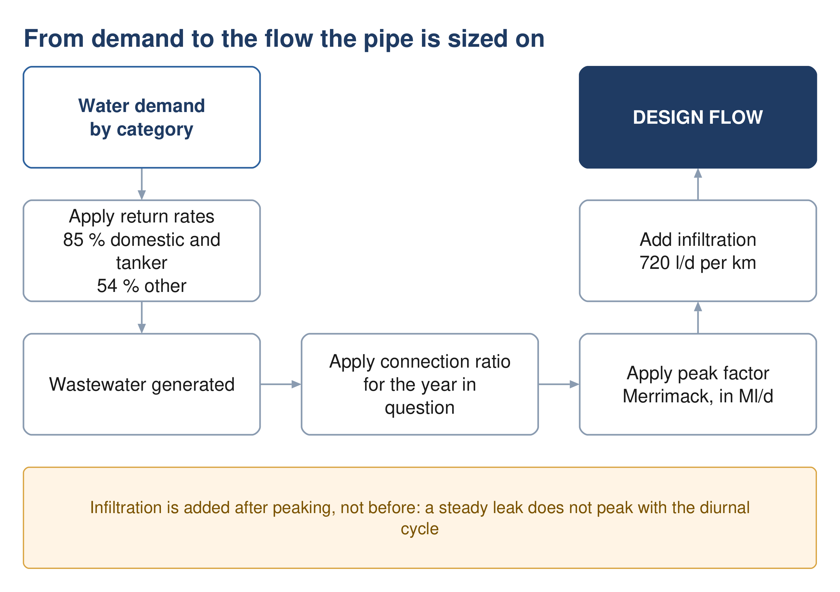
Figure 5 From demand to the flow the pipe is sized on.

8.6 Assembling the design flow
$Q_{design} = Q_{ww} × Pf + Q_{inf}$ (16)
Infiltration is added after peaking, not before. It is a steady leak and does not peak with the diurnal cycle.

9 Gravity sewer design

9.1 Purpose
Turning a design flow into a diameter, a gradient and an invert level, while keeping the pipe fast enough to scour itself and slow enough not to erode.

9.2 Which formula
The guideline requires that a recognised hydraulic formula be used and names Colebrook-White and Manning. Neither is exclusively mandated, but Colebrook-White is the one given a mandatory input and the one from which the minimum gradient table is derived.
$V = −2\sqrt{2gDS}\log{{}_{10}}\left[\frac{k_{s}}{3.7D} + \frac{2.51ν}{D\sqrt{2gDS}}\right]$ (17)
Symbol | Meaning | Unit
V | pipe-full velocity | m/s
g | acceleration due to gravity | m/s²
D | pipe internal diameter | m
S | hydraulic gradient | m/m
k s | roughness — 1.5 mm, mandatory for all sizes and materials | m
ν | kinematic viscosity; 1.141 × 10⁻⁶ at 15 °C | m²/s

Manning, where it is used
$v = \frac{1}{n}{R_{h}}^{\frac{2}{3}}S^{\frac{1}{2}}$ (18)
Symbol | Meaning | Unit
n | roughness coefficient; 0.009 to 0.011 for the plastics specified | dimensionless
R h | hydraulic radius, area divided by wetted perimeter | m
One equation in the guideline is dimensionally impossible. The relation between full-bore flow and velocity is printed as flow equals velocity divided by area, which yields units of reciprocal metre-seconds. It was verified at high resolution that the document really does print a division. Flow is velocity multiplied by area. Use the correct form and note the defect if the calculation is ever audited against the page.
Source: G203 §4.2.1 p24 and §4.2.4 p25.
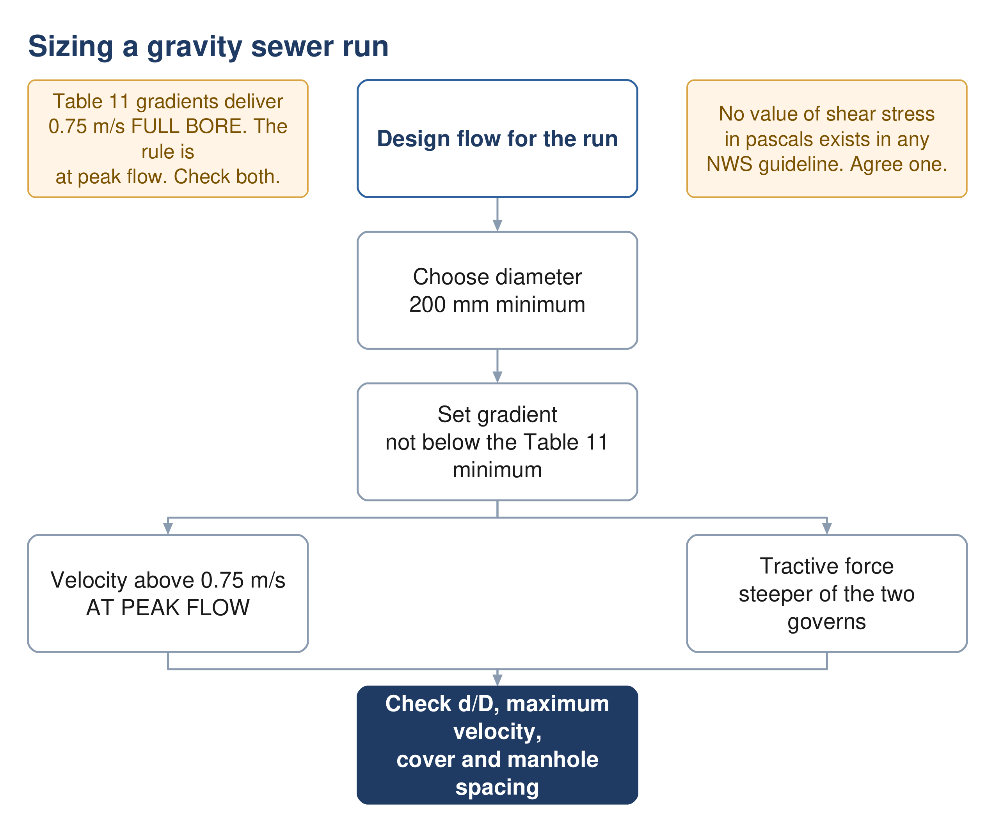
Figure 6 Sizing a gravity run. Both self-cleansing checks apply, and the steeper gradient governs.

9.3 Velocity and depth of flow
Table 4 Velocity and flow-depth criteria
Criterion | Value | Condition | Force
Self-cleansing velocity | above 0.75 m/s | at peak flow | mandatory
Preferred velocity | 0.90 m/s | at peak flow | advisory
Maximum velocity | 3 m/s | at design depth | mandatory
Flow depth, up to 350 mm | d/D = 0.65 | at peak flow | recommended
Flow depth, above 350 mm | d/D = 0.50 | at peak flow | recommended

Two checks are required together, not as alternatives: the self-cleansing velocity, and the minimum tractive force. Where they disagree, the steeper gradient governs. At the head of a system, where the velocity cannot be reached at all, the tractive force method is the one that decides the gradient.

9.4 Tractive force
$τ = \frac{W \sin{θ}}{p L}$ (19)
Symbol | Meaning | Unit
τ | tractive tension, or boundary shear stress | Pa
W | weight of fluid | N
θ | angle of the pipe to the horizontal | degrees
p | wetted perimeter | m
L | length of pipe | m
$S_{min} = Kτ^{1.23}Q^{−0.461}$ (20)
The coefficient depends on the units of flow: 2.33 × 10⁻⁴ where flow is in cubic metres per second, or 5.5 × 10⁻³ where it is in litres per second. The relation assumes a flow depth of 0.2 and a Manning roughness of 0.013 — the latter inconsistent with the roughness table for the plastic pipes actually specified.
This mandatory method cannot be completed from NWS documents. The guideline requires the tractive force check, gives the equation, and never states the required value of shear stress in pascals — not in the wastewater guideline's 201 pages, nor in the general guideline's 152. A value must be taken from the literature and agreed with NWS in writing. It must not be presented as though it came from the guideline.
Both equations above exist in the source only as images. They cannot be found by searching the text of the PDF, which is worth knowing for anyone checking them.
Source: G203 §4.2.2.1 p26-27.

9.5 Minimum gradients
The guideline tabulates a minimum gradient against diameter, derived from Colebrook-White at a self-cleansing velocity of 0.75 m/s.
Table 5 Minimum sewer gradient by diameter
Diameter (mm) | Minimum gradient (mm/m) | Diameter (mm) | Minimum gradient (mm/m)
200 | 5.00 | 600 | 1.25
250 | 3.75 | 700 | 1.00
315 | 2.70 | 800 | 0.85
400 | 2.05 | 900 and above | 0.75
500 | 1.55
These gradients are full-bore values, and that matters. Reproducing all nine rows with Colebrook-White at the mandated roughness returns 0.75 m/s running full, to within two per cent. But the velocity requirement is stated at peak flow, not full bore. At the mandated flow depth of 0.65 a pipe reaches about 0.82 m/s and passes; at 0.50 it reaches exactly 0.75 and has no margin at all; at a depth of 0.20 it manages 0.46 m/s and fails. Laying to this table is therefore not by itself compliance, and in the opening years every pipe in the network sits below the threshold. That is what the maintenance washing schedule exists to cover.
Source: G203 §4.3 p29; the part-full check is a project calculation.

9.6 Cover, depth and manholes
The minimum depth is 1.3 m to the crown of the pipe. Where that cannot be achieved, concrete protection is required and the minimum cover over pipe and protection together becomes 0.5 m.
The maximum depth rule is widely mis-stated. The guideline recommends a maximum cover of approximately 10 to 12 metres. It is a recommendation, not a limit; it refers to cover, not invert depth; and exceeding it is permitted, with the consequence being a mandatory consultation with pipe manufacturers. What obliges a pumping station is excavation cost becoming prohibitive, and no depth figure is attached to that clause.
Table 6 Maximum spacing between manholes
Pipe diameter (mm) | Maximum spacing (m)
200 to 315 | 100
350 to 900 | 120
1000 to 1400 | 150
above 1400 | 200

Any departure from this spacing needs NWS approval in advance. Manholes are required at every change of gradient, every change of diameter, every junction and the end of each lateral. A backdrop is required where invert levels differ by more than 600 mm, and is to be built outside the manhole.
No inlet may meet the flow at less than 90 degrees. The rule is stated twice in mandatory voice. It is a common source of non-compliance in automated layouts, because a geometrically convenient junction is often a hydraulically bad one.
Source: G203 §4.4 p29-30 and §4.6.3 p33.

9.7 Lengths and materials
A lateral sewer has a maximum length of 45 m. A property connection should not exceed 50 m, so that it can be maintained; beyond that a manhole is added. Minimum sizes are 160 mm outside diameter for riders and property connections, and 200 mm for laterals and main sewers.
Source: G203 §3.2 p17, Table 5 p18 and Table 6 p22.

10 Self-cleansing and the maintenance washing schedule

10.1 Purpose
A new sewer does not carry its design flow on the day it opens. It carries whatever the connected properties generate, which for the first years is a fraction of the design figure. Below a certain velocity solids settle rather than move, and the network has to be washed until the flow can do the work itself. This section establishes for how long, and which pipes.
This is the one calculation where over-estimating is the dangerous error. Everywhere else in this document, assuming too much flow is conservative. Here it is the opposite: an optimistic early-year flow declares the network self-scouring while it is silting, and the maintenance team is told to stop washing too soon. Use the low growth and low connection case.
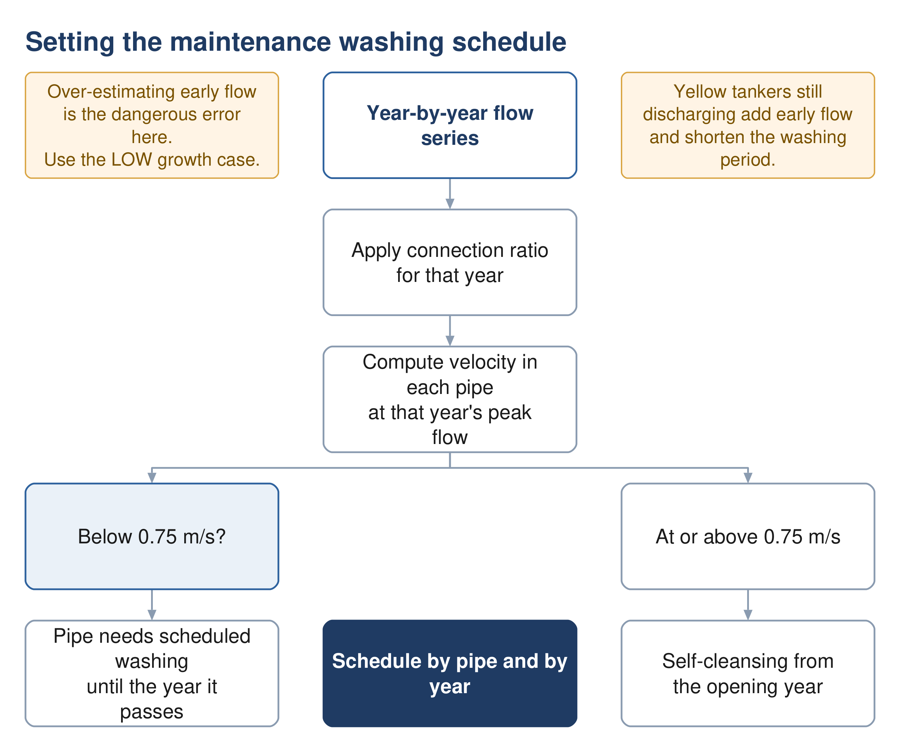
Figure 7 Setting the washing schedule. The output is a table of pipe against year, not a single date.

10.2 Method
1. Take the year-by-year flow series from Section 7, in its low case rather than its design case.
2. Apply the connection ratio for the year: only connected properties contribute.
3. Route those flows through the network and take the peak flow in each pipe.
4. Compute the velocity at that flow, part full, using the gradient and diameter actually laid.
5. Record, for each pipe, the first year in which it reaches 0.75 m/s at peak. Until that year it needs scheduled washing.

10.3 Why a pipe laid to the minimum gradient still fails this
Section 9.5 established that the guideline's minimum gradients deliver 0.75 m/s when the pipe runs full. At part-full flows the velocity is lower, and in the opening years the pipes run far below their design depth.
Table 7 Velocity at a minimum-gradient pipe, by depth of flow
Proportional depth d/D | Velocity | Status
0.65, the design depth up to 350 mm | 0.82 m/s | passes
0.50, the design depth above 350 mm | 0.75 m/s | no margin
0.30 | 0.58 m/s | fails
0.20 | 0.46 m/s | fails
0.10 | 0.31 m/s | fails

The consequence is that laying steeper than the minimum buys earlier self-cleansing, and that is a legitimate trade to make explicitly: a little more excavation now against fewer years of tankered washing later. It is a whole-life cost question, not a hydraulic one, and belongs in the appraisal.

10.4 What the guideline says, and does not say
The guideline acknowledges the problem and declines to solve it. It states that during early development phases the actual flow will usually be below the design flow, inducing a risk of clogging, and that the operator should carry out more frequent inspections and cleansing during this period. It sets no frequency, no duration and no threshold.
Yellow tankers work in our favour here. Properties still discharging to tanker are not connected, so they reduce early flow. But the guideline requires the collection system to assume the same coverage as the water supply, reaching full connection by the end of the planning period. The washing schedule should be built on the connection ramp actually forecast, not on full connection.

10.5 Output
The deliverable is a table of pipe against year showing which runs need washing and until when, and a total washing effort by year that can be costed as an operating expense in the appraisal. That last point matters: a network laid at minimum gradients is cheaper to build and more expensive to operate for its first decade, and unless the washing appears in the operating cost the comparison between options is wrong.
Source: G203 §4.2.6 p28 for the acknowledgement; §4.2.2.1 p26 for the velocity requirement; the part-full analysis is a project calculation.

11 Lifting stations and force mains

16.1 Purpose
Where gravity cannot carry the flow onward, it is lifted and pushed through a pressure pipe to the next point at which gravity can take over again. Every such station is a permanent operating cost and a permanent failure mode, which is why the guideline treats them as a last resort.
The guideline's position is unambiguous. "The use of pumping stations and pressure mains shall be avoided whenever gravity sewer designs are feasible and cost effective." A design that reaches zero pumping stations is not an unusual outcome to be defended; it is the outcome the guideline asks for.

16.2 When a station is required
There is exactly one trigger in the entire guideline set, and it is a cost trigger. Where the cost of excavation becomes prohibitive, a pumping station is to be incorporated. No depth figure is attached to that obligation. The ten to twelve metre figure discussed in Section 9.6 is a separate recommendation about cover, and exceeding it obliges consultation with pipe manufacturers rather than a pump.
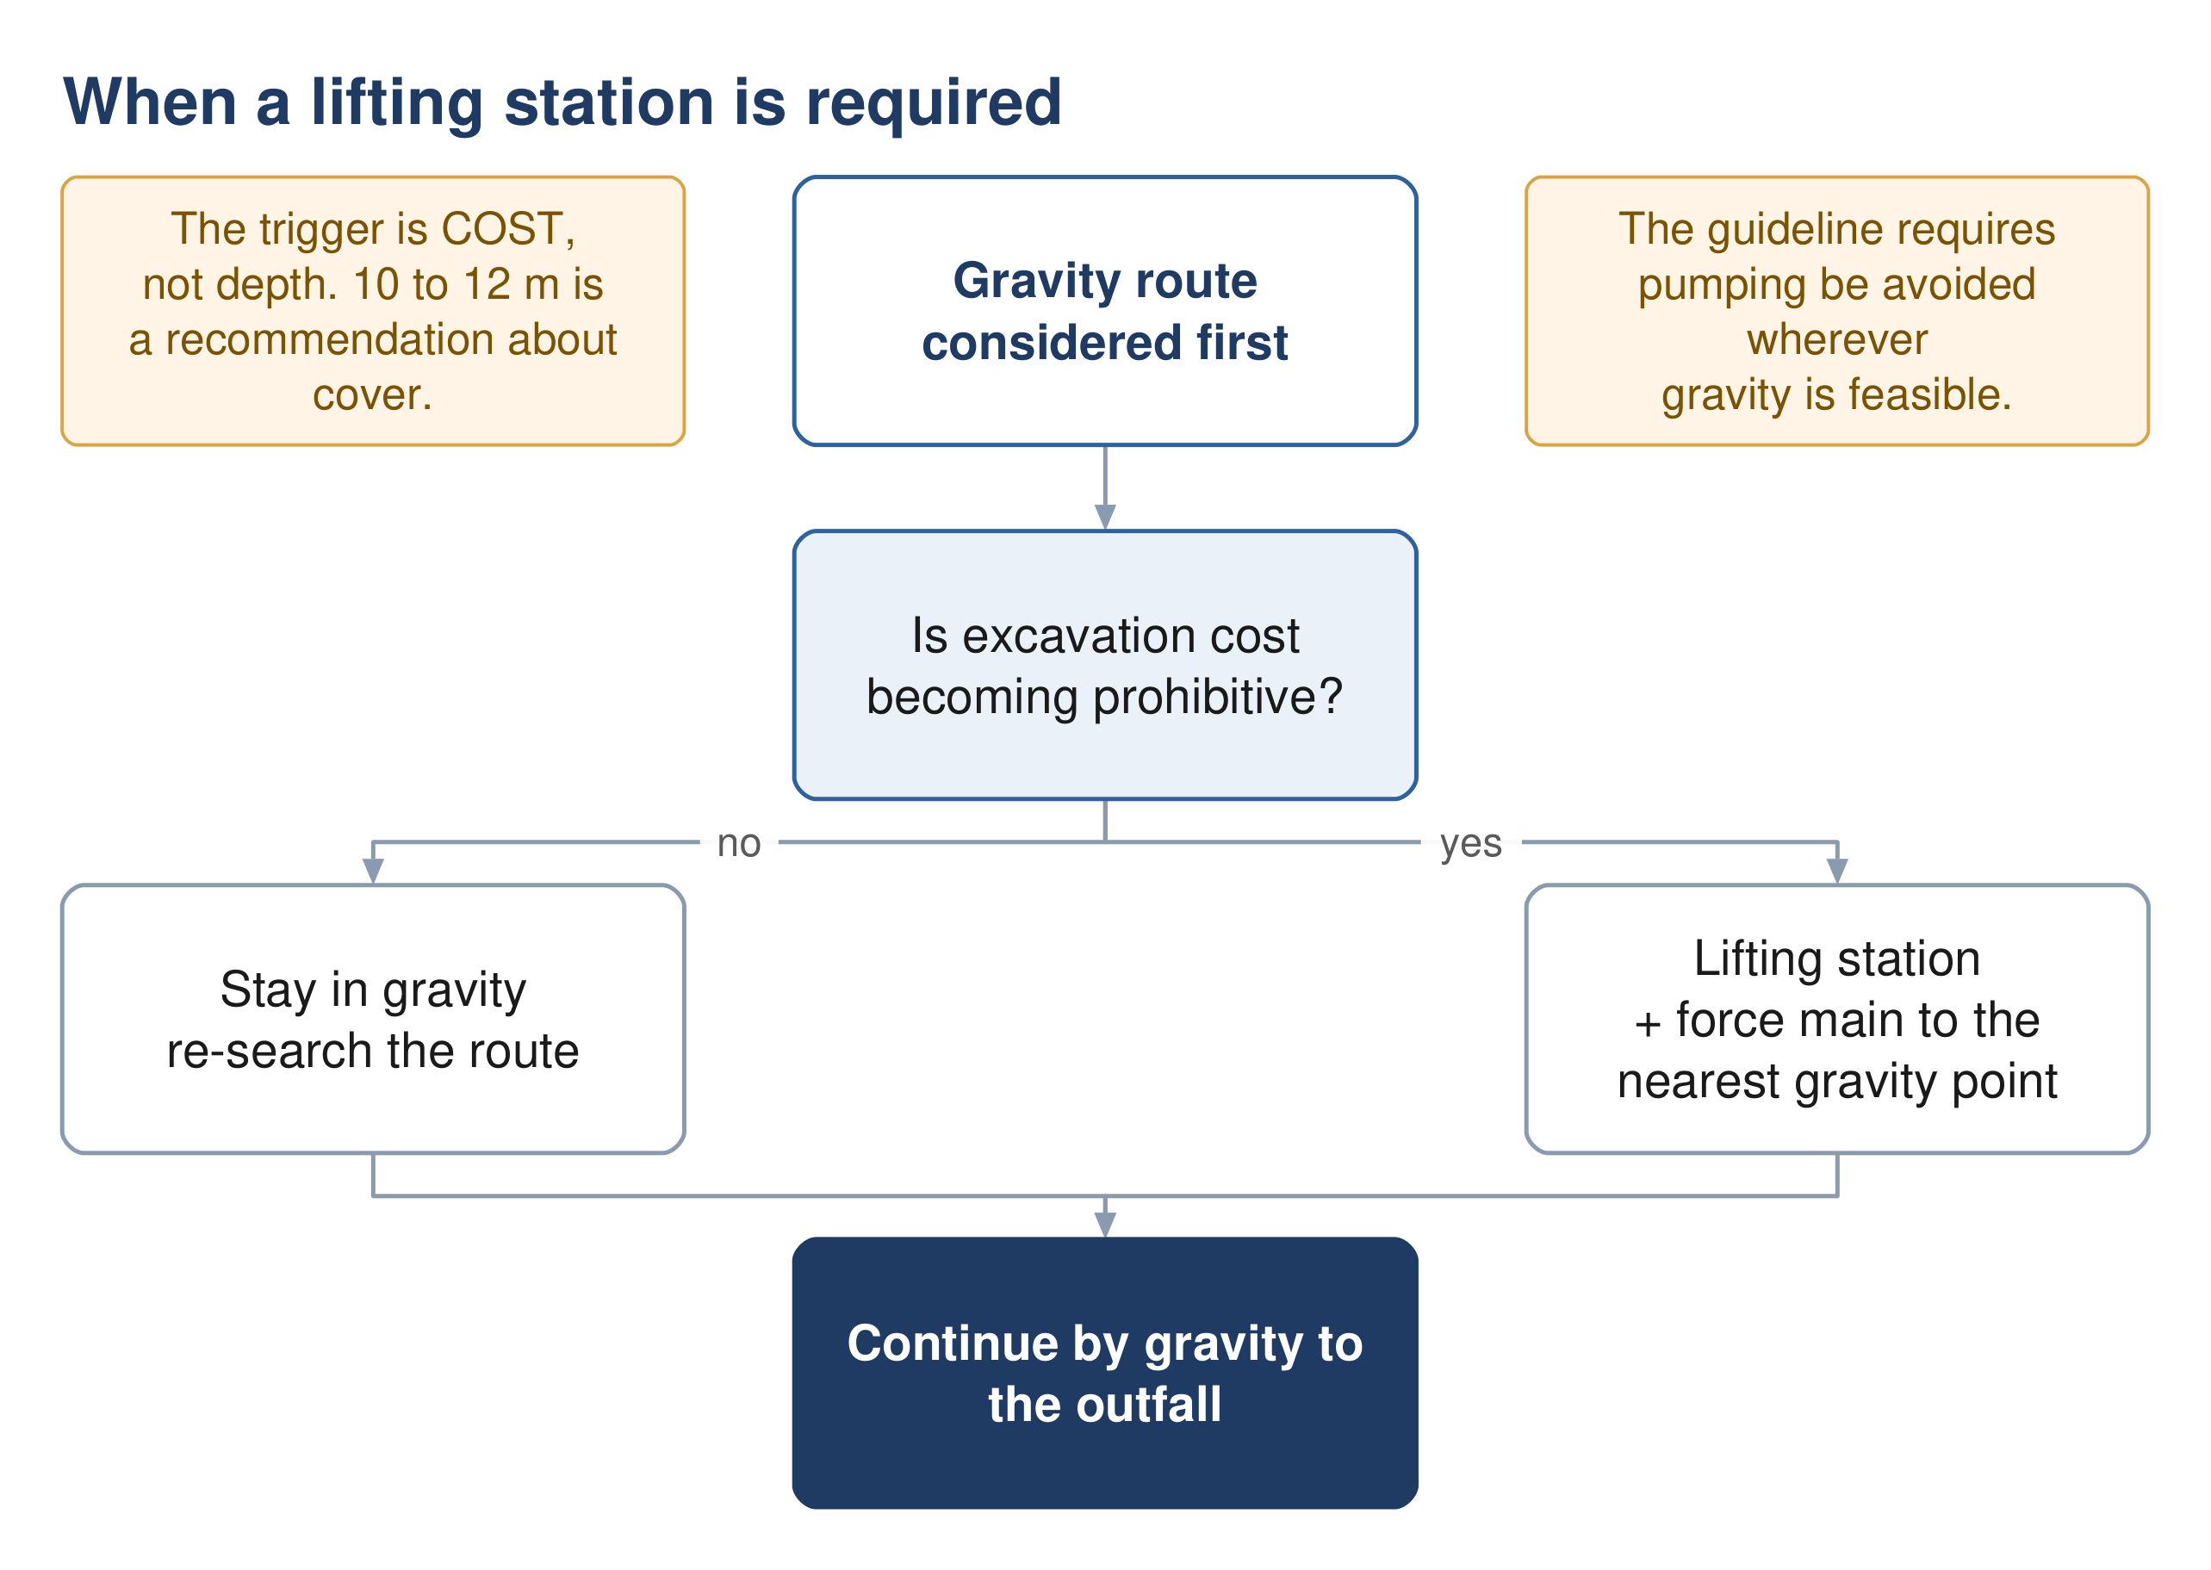
Figure 8 When a lifting station is required. The trigger is excavation cost, not depth.

16.3 Station classification
Type | Design flow | Minimum duty pumps | Standby
Type 1 | up to 100 l/s | 1 | 1
Type 2 | 100 to 300 l/s | 2 | 1
Type 3 | above 300 l/s | 3 | 1

Two tables in the guideline disagree here. One gives a Type 3 station three duty pumps; another, two pages later, gives it two. Both are printed in the same section of the same document. The three-pump reading is the conservative one, and the two tables agree for Types 1 and 2, so the discrepancy is confined to the largest stations.
Above the table sits the governing rule, which is independent of type: sufficient pumps must be provided that the design peak flow can still be achieved with any one pump out of service.

16.4 Wet well volume
The volume between the start and stop levels is set by how often the motor may be started, not by storage in any general sense.
$V = 0.25 Q T$ (21)
Symbol | Meaning | Unit
V | live volume, between pump start and stop levels | m³
Q | capacity of a single pump | m³/s
T | on-off cycle time, 3600 divided by permitted starts per hour | s
The guideline sets a minimum of ten starts per hour for motors up to 30 kW, and refers larger motors to the manufacturer and to NEMA MG 1. At ten starts per hour the cycle time is 360 seconds and the live volume becomes ninety times the pump capacity in cubic metres per second.
The equation applies to a single constant-speed pump. The guideline gives no equivalent for variable-speed or duty-assist arrangements.
Source: G203 §7.8 p48.

16.5 Suction conditions
$NPSH{}_{a} = H_{a} − H_{vpa} − H_{st} − H_{f}$ (22)
Symbol | Meaning | Unit
H a | absolute pressure on the liquid surface | m (not stated in source)
H vpa | vapour pressure | m
H st | static head | m
H f | friction head | m
A margin of at least one metre over the pump's required suction head is to be provided. The guideline gives no units and no sign convention; the form as printed assumes a suction lift, and for a flooded suction the static term is additive.

16.6 Force mains
Table 8 Force main velocity and gradient criteria
Criterion | Value | Force
Minimum velocity, raw sewage | 0.75 m/s at minimum flow | shall
Minimum velocity, intermittent flow | 1.0 m/s | shall
Minimum velocity, vertical mains | 1.2 m/s | shall
Maximum velocity | 2.5 m/s | shall
Minimum internal diameter | 75 mm; 50 mm with grinder pumps | shall
Gradient rising | 1:500 recommended | recommended
Gradient falling | 1:300 recommended | recommended
Gradient, absolute floor | never below 1:750 | in all cases
Retention time | ideally under half an hour | ideally

Diameter is not selected by a formula. The guideline requires that alternative diameters producing velocities across the permitted range be considered, and that a cost comparison determine which gives the optimum whole life cost. Where initial flows are far below future flows, two mains may be warranted rather than one.
The friction equations are named but never written. Head loss is to be calculated by Darcy-Weisbach for larger pipes and higher velocities, or Hazen-Williams for smaller diameters, with any other equation needing NWS approval. Neither formula is printed anywhere in the three guidelines — only their coefficients are tabulated. Cite the standard form, not NWS. There is also no roughness value published for a raw sewage force main; the coefficient table covers potable water and treated effluent only.
There is likewise no total dynamic head equation and no pump power equation in the guidelines. The components NWS names are static lift, friction loss, fitting losses and the velocity head difference; assembling them is standard hydraulics and should be cited as such.
Source: G203 §8 p50-55; head loss cross-referenced to G202 §7.1.3.2 p104.

16.7 Surge
$ΔH = \frac{c}{g}Δv$ (23)
Symbol | Meaning | Unit
ΔH | change in pressure | m
c | wave propagation speed | m/s
g | acceleration due to gravity | m/s²
Δv | change in flow velocity | m/s
The wave speed is described qualitatively as depending on the properties of the pipe and the liquid. No celerity equation is given anywhere in the guidelines, so it must come from standard theory.
Transient analysis must be carried out in NWS-approved licensed software; the equation is for checking, not for design. The number of simultaneous pump startups and shutdowns modelled follows N+1, so that reflected waves from earlier events can combine and reveal the true worst case. Models are first run with roughness set to near zero to capture the maximum swing, then re-run with realistic roughness.
One concession applies uniquely to wastewater: negative pressure, with air entering at an air valve, can be acceptable on a force main provided the protection and equipment are adapted to it.
Source: G201 Appendix III p145-147. G202 §10 is a one-line cross-reference to it and contains no surge content of its own.

16.8 Emergency provision
Every pumping station must have an emergency overflow to prevent flooding of the station or of connected dwellings, and overflows require Environmental Authority approval. Only extreme events should result in one, and a method to prevent or minimise overflows must be submitted for approval — chosen on least cost and least operational complexity.
No emergency storage duration is specified. Emergency storage is named as one of four permitted methods, with no duration and no sizing method attached. The 48 to 72 hour figure that appears elsewhere in the guidelines applies to a lagoon at a treatment plant, not to a pumping station, and should not be transplanted. The designer proposes and NWS approves.

12 Septicity, hydrogen sulphide and odour in the network

12.1 Why it matters here
Sewage that sits without oxygen turns septic. Sulphate-reducing bacteria produce hydrogen sulphide, which is toxic, smells at vanishingly low concentrations, and oxidises to sulphuric acid on the crown of the pipe, destroying concrete and corroding metal. In a hot climate the reactions run fast, which is why the guideline treats this as a design problem rather than an operating one.

12.2 The three levers
- Retention time — long retention lets sulphide build. Force main retention should ideally stay under half an hour, and the guideline concedes this is rarely achieved.
- Velocity — low velocity means both long retention and deposition. Gravity sewers at very low slopes carry the greatest risk.
- Turbulence — every drop, jump and unsubmerged discharge strips dissolved sulphide into the air, which is where the odour and the corrosion happen.

12.3 Prediction
The guideline offers a quantitative route and a qualitative one. The quantitative route is only partly usable.
$\frac{dS}{dt} = 3.23M_{′}\left[EBOD\right]r^{−1} − 2.1N{\left(sv\right)}^{0.375}\left[S\right]{d_{m}}^{−1}$ (24)
Symbol | Meaning | Unit
[S] | sulphide concentration | mg/l
M′ | effective sulphide flux | not stated in the source
[EBOD] | effective BOD | mg/l
r | hydraulic radius | not stated
N | empirical loss factor | not stated
s, v | energy gradient and mean velocity | not stated
d m | mean hydraulic depth, area over top width | not stated
$\left(EBOD\right) = \left(BOD\right) × {\left(1.07\right)}^{T − 20}$ (25)
The temperature correction converts BOD measured at 20 °C into the effective BOD at the actual sewage temperature. At 35 °C it multiplies the BOD by roughly 2.8, which is why the same network behaves very differently here than in a temperate climate.
The generation equation cannot be evaluated from the guideline. Seven of its nine symbols carry no units, and no values are given for the sulphide flux or the loss factor. The force-main form is worse: its rate constant has neither a value nor a unit and its temperature function has no stated form. Both establish that sulphide rises with retention time and warm temperature; neither permits a number without going to Pomeroy and Parkhurst's original work.
The qualitative route is usable as it stands. The guideline reproduces a scoring method against temperature, residence time, velocity and redox potential, summing to a risk band. Its bands overlap as printed, which is noted in Section 22.

12.4 Design measures, in the order the guideline prefers them
1. Avoid pumping altogether wherever gravity is feasible.
2. Where pumping is unavoidable, minimise retention — consider twin mains so that low flows still move quickly.
3. Discharge submerged, to absorb energy and avoid stripping sulphide into the air. Inverted siphons are not permitted on a pressure main discharge.
4. Design gravity entries to pumping stations to minimise free fall and turbulence.
5. Keep air moving: vents no smaller than 150 mm and 6 m above ground.
6. Only then consider dosing — oxygen, nitrate, iron salts or pH elevation. The guideline lists the methods and gives no dose rates, so any dosing proposal is the designer's to substantiate.

12.5 Design values where no field data exists
At the termination of a pressure main, absent measurements, the guideline requires management and monitoring to be designed for an average hydrogen sulphide concentration between 50 and 100 ppm and a peak not exceeding 200 ppm.
Source: G203 §7.7 p47, §11.5.3 p181-186, §11.3 p165-170; G203 Table 99 p185.

13 Utility interfaces and crossings

13.1 Purpose
A sewer alignment competes for the same corridor as water, electricity, telecom and, in places, gas and fuel. Clashes discovered on site are expensive; clashes discovered at concept stage are a routing decision.
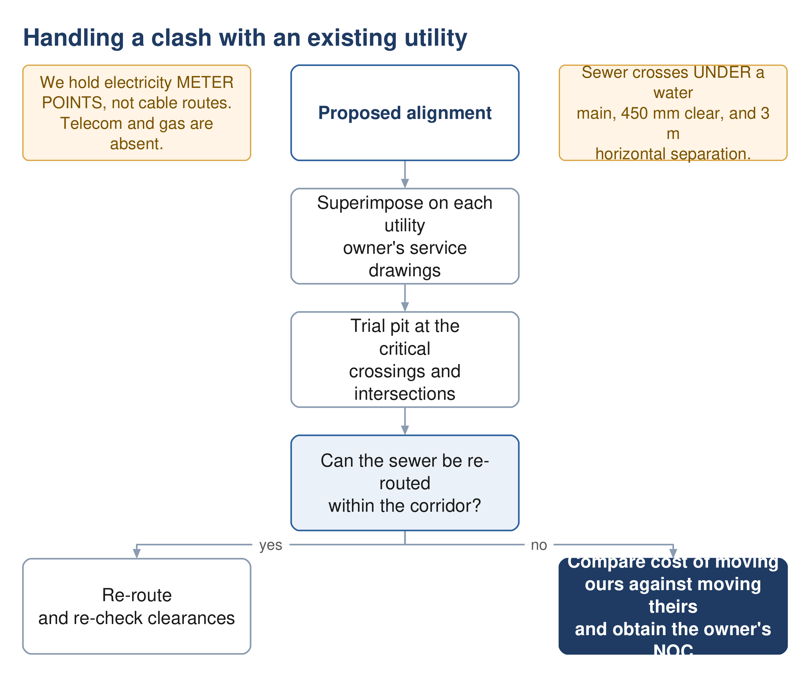
Figure 9 Handling a clash. The cost comparison runs both ways: sometimes it is cheaper to move their asset than ours.

13.2 What we hold, and what we do not
We have electricity meter points, not cable routes. The 33,970-point account layer locates customers. It says nothing about where the distribution cables run. The water mains in the NWS asset data total a few kilometres, which cannot serve a city of this size. Telecom and gas records are absent altogether. For clash purposes, the utility picture is close to blank and must be requested from each owner.

13.3 Method
1. Obtain service drawings from every utility owner with assets in the area — electricity distribution, telecom, gas and fuel operators, the municipality and the roads authority.
2. Superimpose the proposed alignment on each set.
3. Identify where trial pits are needed: road intersections, the routes of major existing services, and along the expected routes of trunk sewers and rising mains.
4. Agree the trial pit programme with NWS, obtain municipal excavation approval, and notify the service owners.
5. Where a clash is unavoidable, price moving our asset against moving theirs, and obtain the owner's agreement for whichever is cheaper.
Fifty trial pits are specified in the scope, at critical locations proposed by the consultant and approved by NWS. The formal utility survey is a preliminary-stage obligation, but the concept design must already show route viability, so the desk study and the critical pits belong at this stage.

13.4 Clearances
Table 9 Separation from other services
Situation | Requirement
Sewage force main to water main, horizontal | 3.0 m
Sewage force main crossing a water main | crosses under, 450 mm minimum vertical clearance
Shallow sewer beneath a major road or highway | 3 m minimum horizontal clearance, with a design check
Another utility in the same trench | placed on a separate bench on undisturbed soil
Force main on a highway | in the carriageway, at least 1 m from the kerb line

Beyond these, the clearance is whatever the owning authority specifies, and the guideline requires the design to respect the requirements of local municipality regulations and authorities for the separation and protection of their assets.

13.5 Crossings
Wadi crossings take a minimum cover of 1.5 m to the pipe crown against 1.3 m elsewhere. Road and utility crossings are either open cut or trenchless, and the choice is a cost and disruption judgement rather than a rule. Dual carriageways are the exception that has already been settled for this project: no sewer runs along one, and crossing is permitted only as a short perpendicular pipe.
Every crossing with another underground utility must be shown on the hydraulic long section, which the guideline requires to highlight them explicitly.
Source: G203 §8.2.2 p51, §8.2.4 p52, §4.6.3 p33; TOR p55 and p59; §4.1.2.1 and §4.1.2.2 of the scope for the survey obligations.

14 Hydraulic modelling

14.1 Purpose
The model is not a check carried out after the design; it is a contract deliverable in its own right, submitted in native editable format and updated after construction.
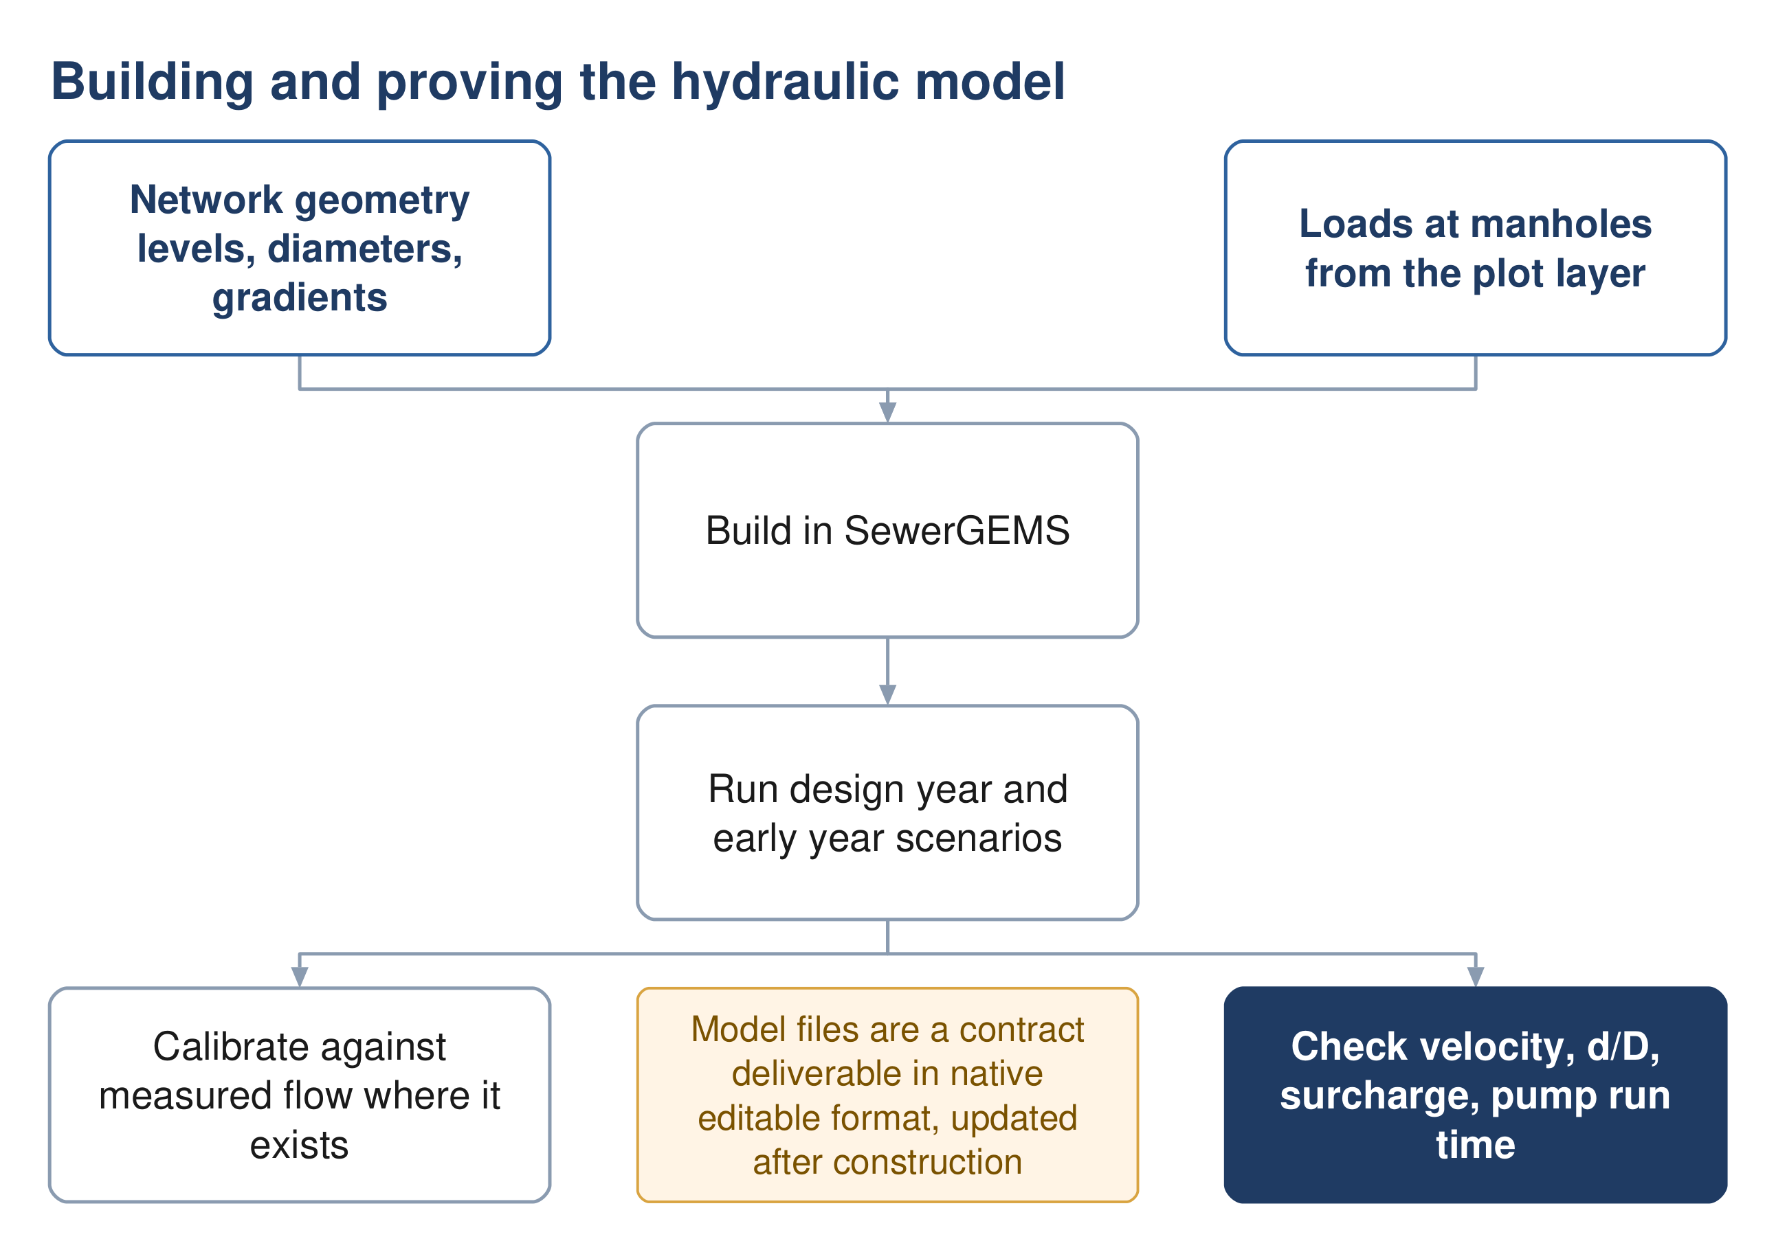
Figure 10 Building and proving the model. The early-year run is as important as the design-year run.

14.2 Software
The wastewater network is modelled in SewerGEMS and the treated effluent system in WaterGEMS, or other software approved by NWS. Note that the tender's staffing schedule names a different package, which is recorded as an unresolved conflict in Section 22.

14.3 What goes in
- Geometry — manhole coordinates and cover levels, pipe inverts, diameters, gradients, materials and roughness
- Loading — loads applied at manholes, derived from the plot layer rather than spread uniformly
- Pumping stations — number and type of pumps, duty head and flow, pump curves, age and condition, efficiency and energy consumption
- Patterns — diurnal profiles, obtained from NWS or established from data and validated by them

14.4 What to run
At minimum the design year at peak flow, the ultimate case, and the opening years at low flow. The last of these is what feeds the washing schedule in Section 10 and is the run most often omitted.

14.5 Calibration
Where measured flow exists the model is calibrated against it. The guideline sets acceptance bands.
Table 10 Wastewater model calibration acceptance
Parameter | Typical acceptance
Peak flow | ± 10 to 15 %
Volume | ± 15 %
Timing | correct peak arrival
Pump runtime | ± 10 %

The existing network must be verified before it is modelled. NWS states in the tender that its own existing-network data is inaccurate, and the inception report commits to full verification before the existing system enters the model. Modelling unverified geometry produces confident numbers from unreliable inputs, which is worse than no model.
Source: G201 Appendix III p138-145, Table 32 p145; G203 §4.2.1 p24 for the software obligation.

15 Assessing and rehabilitating the existing network

15.1 Purpose
There is already sewerage in Ibri, and the concept design has to say what happens to it: what is kept, what is upgraded, what is replaced, and how the new network integrates with it. This is a separately priced deliverable, not a preface to the new design.
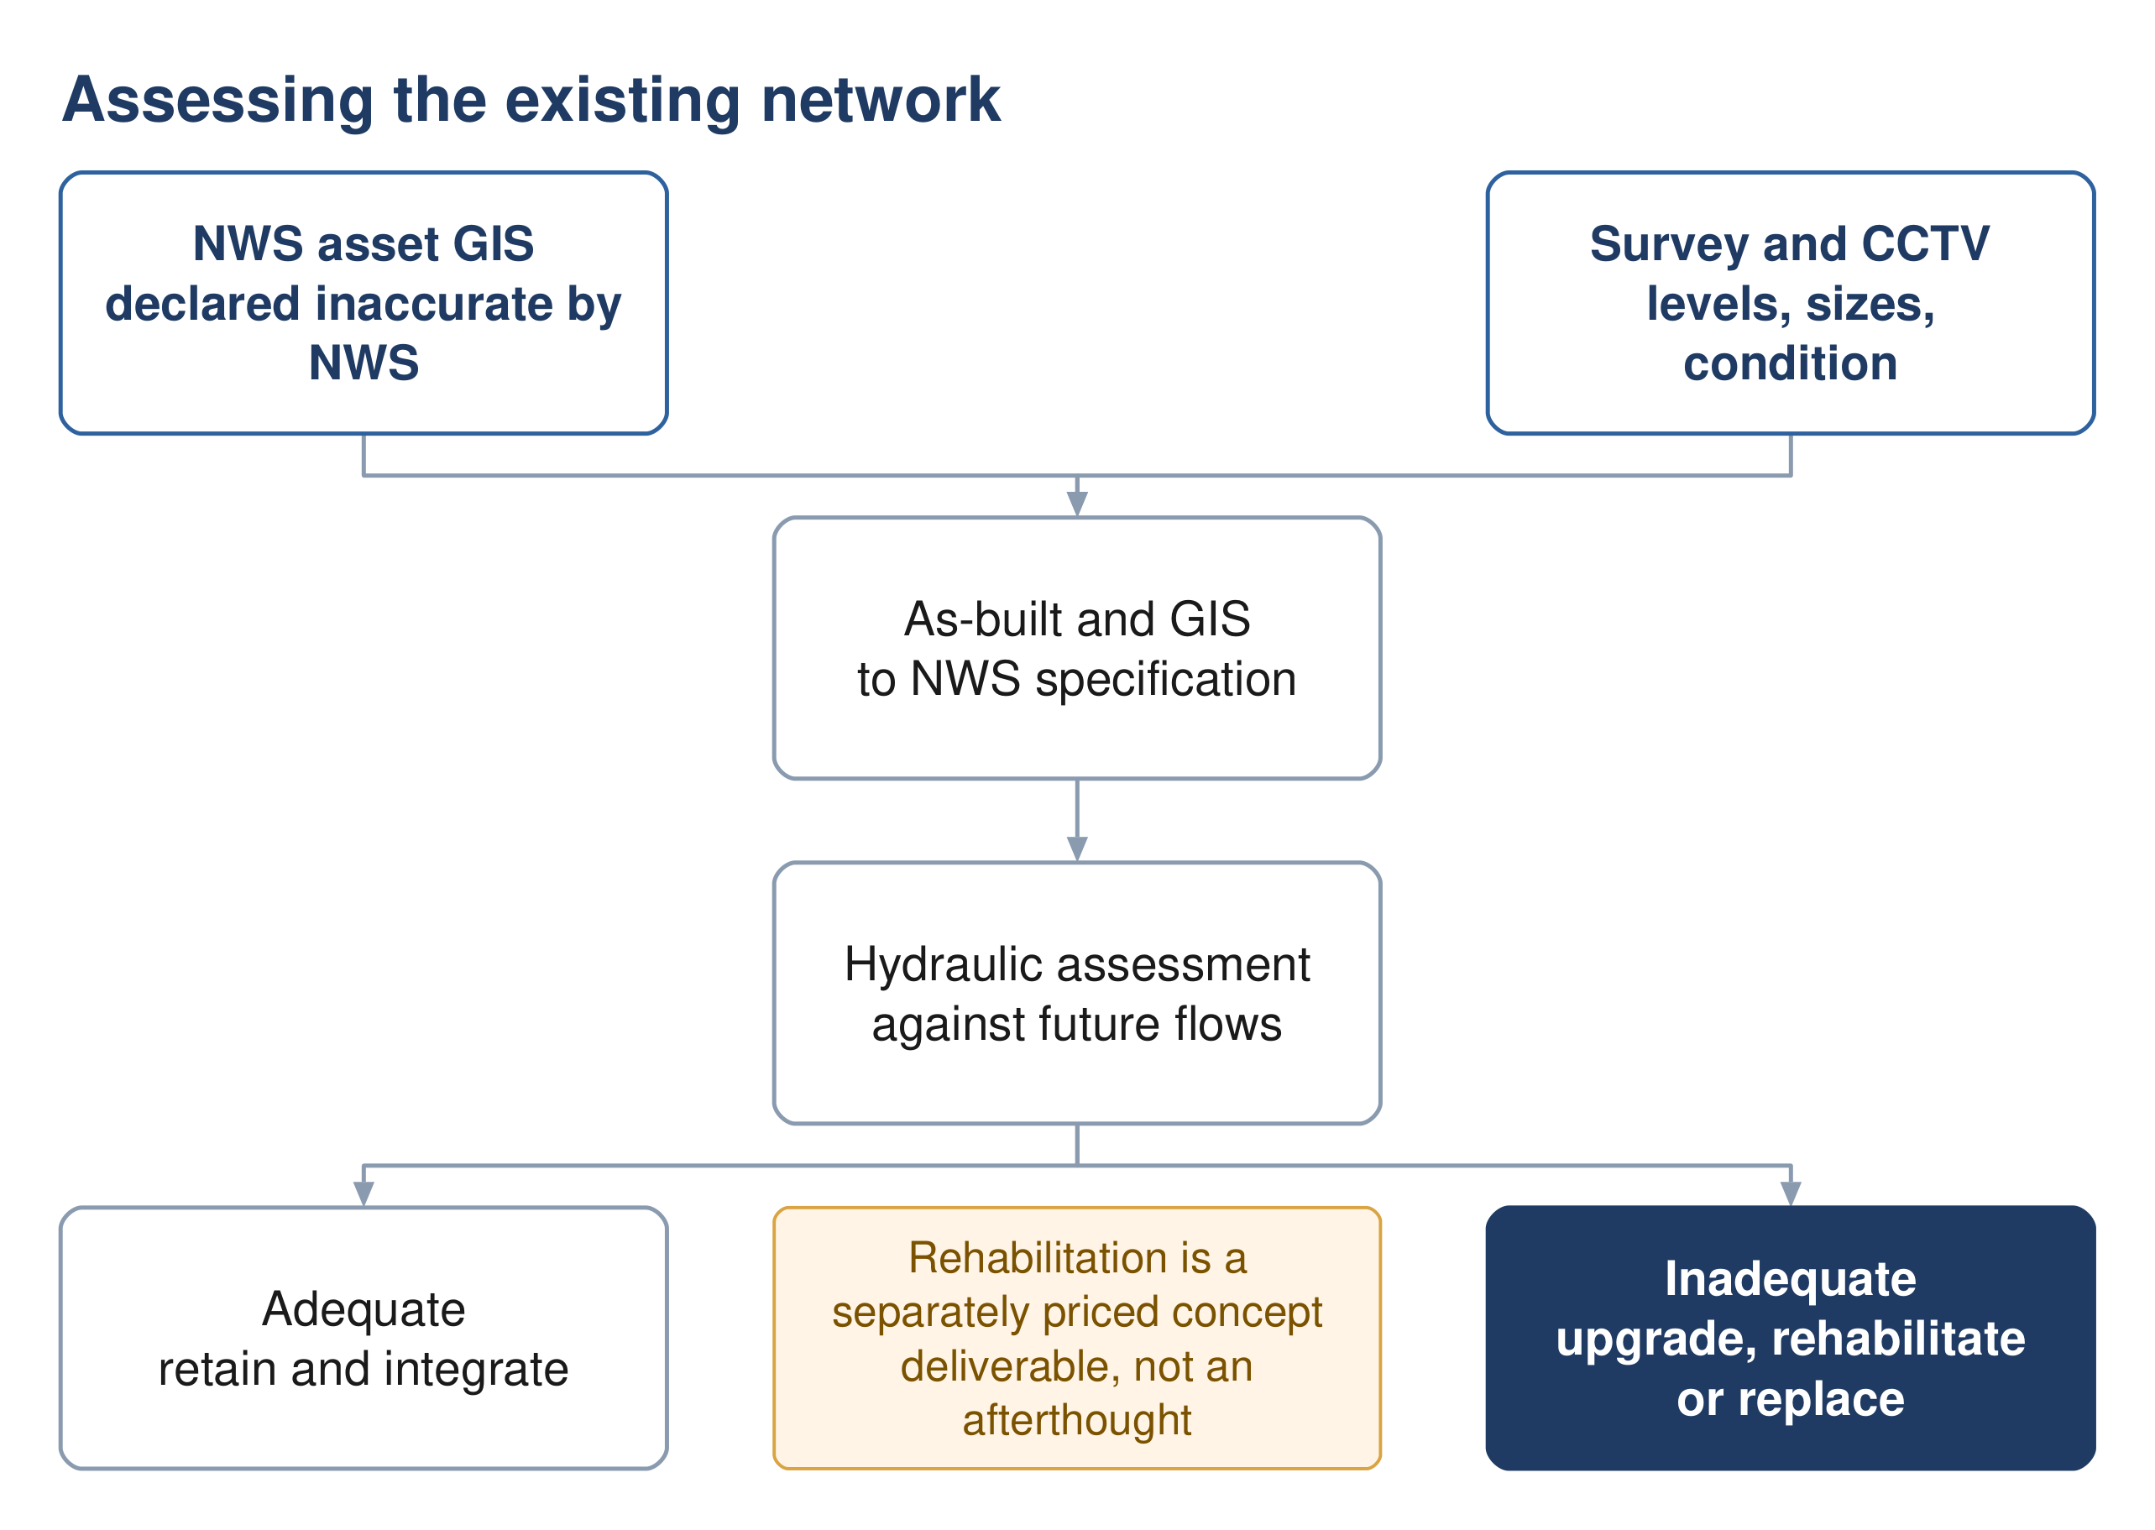
Figure 11 Assessing the existing network. Rehabilitation is a priced concept deliverable in its own right.

15.2 The data problem, stated plainly
NWS's asset GIS carries the existing sewer, force main and treated effluent networks as geometry. Most of the sewer segments carry no recorded diameter. The tender itself states that the existing network layout is based on available information and is inaccurate, and makes preparing complete as-built records and GIS part of the consultant's scope.
That clause is protection, not a burden. Because NWS has declared its own data inaccurate in the contract, the survey and as-built exercise is a funded obligation rather than a favour, and no design conclusion needs to rest on records the client has already disowned.

15.3 Method
1. Survey: cover and invert levels, diameters, materials, gradients, house connections, riders, lifting stations and rising mains.
2. CCTV inspection for condition, carried out early rather than at detailed design.
3. Build the as-built and GIS to NWS specification and upload it to their system, subject to their acceptance.
4. Model the existing network against future flows to find where capacity runs out and when.
5. Classify each asset: adequate and retained, adequate but needing rehabilitation, or to be replaced.
6. Design the integration points between old and new, and between the old plant and the new one.

15.4 What the assessment must produce
A hydraulic verdict on every existing asset against the design horizon flows; a rehabilitation and replacement schedule with quantities; the integration design; and the cost of all of it, carried into the options appraisal alongside the new works. An option that reuses more of the existing network is cheaper to build and may be more expensive to operate, and only a whole-life comparison settles it.
Source: Tender Section 08 p201; scope of work p52 and p60-61; G203 §11 p197 for the timing of CCTV and survey.

16 Treatment plant sizing and phasing

16.1 Purpose
Converting flows and loads into a plant capacity, a technology, a land area and a phasing plan.

16.2 Size categories, and why they matter
Category | Capacity
Small | below 500 m³/d
Medium | 500 up to 20,000 m³/d
Large | 20,000 m³/d and above

The large-plant classification changes four separate rules. The residential buffer stops being a flat 500 m and becomes 300 to 1000 m, set by the distance to the 5 odour-unit contour from a dispersion model. Computational fluid dynamics modelling becomes mandatory unless the TOR excludes it. The chlorine contact tank is replaced by a treated effluent storage tank performing the same function. And the organic peak factors fall to 1.2 for BOD and COD and 1.5 for nitrogen.
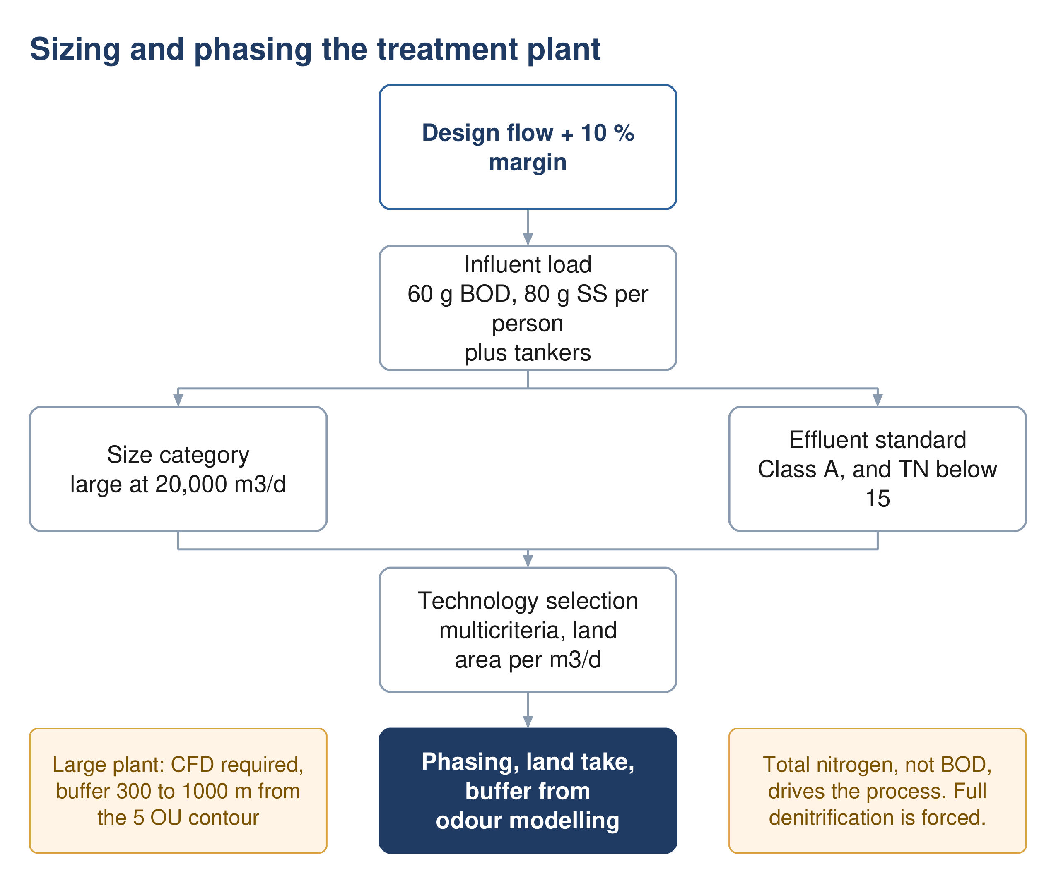
Figure 12 Sizing and phasing the plant. Total nitrogen, not BOD, drives the process choice.

16.3 Design horizon and margin
A plant is designed for a horizon of at least fifteen years and must meet the projected population, with anticipated industrial and institutional needs taken into account. Separately, the corporate planning life cycle is twenty-five years, which is also the period over which options are compared.
A ten per cent margin is applied to the design flow as an operational safety allowance, over and above any redundancy in the design rather than instead of it.

16.4 Influent characterisation
Design is to be on the basis of at least 60 g of BOD and 80 g of suspended solids per person per day. Those are floors, not typical values — the guideline's word is "at least".
Table 11 Design raw sewage characteristics, where site data is absent
Parameter | Design value | Parameter | Design value
BOD₅ | 350 – 400 mg/l | Ammoniacal N | 40 – 50 mg/l
COD | 700 – 900 mg/l | Total Kjeldahl N | 60 – 80 mg/l
Suspended solids | 400 – 500 mg/l | Total phosphorus | 10 – 15 mg/l
Inert solids | 20 % | Alkalinity as CaCO₃ | 200 – 400 mg/l
Fat, oil and grease | 50 – 100 mg/l | pH | 6.5 – 8.0
 |  | Temperature | 20 / 35 °C

These values are indicative and are to be used after agreement with NWS, in preference to which come the specific character of the catchment and NWS's own laboratory database. Sludge liquor returns, side streams and tanker loads are not included in them and must be added.

Tankered sewage is far stronger
Sewage arriving by tanker carries BOD from 350 up to 1050 mg/l, COD from 1350 to 5000, and suspended solids from 900 to 4300. Septic tank contents are described as much more concentrated than network sewage. Where tankers form a significant share of the inflow, this drives the load calculation rather than the network figures.
The trigger for a separate treatment line. Domestic sewage has a COD to BOD ratio between 1.8 and 2.2. Above that, the guideline states the influent is not effectively treatable biologically, and a separate line for high-strength wastewater is required if the volumes are significant. What counts as significant is not quantified and needs NWS agreement.

16.5 Load, and an equation the guideline does not print
The guideline gives per-capita loads, design concentrations and peak factors, but nowhere prints the relation converting a flow and a concentration into a mass load. It is standard, and is stated here as a derivation rather than a citation.
$Load = \frac{Q × C}{1000}$ (26)
Symbol | Meaning | Unit
Load | mass load of the determinand | kg/d
Q | flow | m³/d
C | concentration | mg/l
Hydraulic pass-through structures are sized on peak hourly flow. Biological treatment is sized on average annual flow and the design inlet load. Both must include recycled liquors and tanker volumes.

16.6 Process sizing
The guidelines give ranges, not equations. No oxygen demand, sludge yield, solids retention time or clarifier area equation is printed anywhere. At concept and preliminary stage the guideline directs the designer to empirical methods — Metcalf and Eddy, or DWA, formerly ATV. At detailed design it requires verification in accredited software using IWA models. The tables in the guideline are ranges to land inside, and they are the enforceable part.
Table 12 Activated sludge configurations
Mode | F:M (kg BOD/kg MLSS/d) | MLSS (mg/l) | Minimum SRT (d)
High rate | above 1.0 | below 2000 | 1
Conventional, 20 mg/l BOD | 0.25 – 0.4 | 2000 – 3000 | 2 – 4
Conventional, 10 mg/l BOD | 0.15 – 0.25 | 2500 – 3000 | 4 – 6
Conventional with nitrification | 0.15 | 3000 – 4000 | above 6
Extended aeration / MLE | 0.05 – 0.15 | 2000 – 4000 | above 10

16.7 Land area
Footprint is indicative and is used for early planning, not as a compliance limit. It must cover process units, sludge handling, buffer zones and — the guideline is explicit — the land needed for energy-efficient solutions such as a solar farm inside the plant perimeter.
Table 13 Indicative footprint by technology, m² per m³/d
Technology | Footprint | Technology | Footprint
Membrane bioreactor | 0.45 – 0.9 | Sequencing batch reactor | 0.9 – 1.8
Moving bed biofilm reactor | 0.9 – 1.8 | Conventional activated sludge | 1.8 – 3.6
Integrated fixed film | 1.2 – 2.5 | Constructed wetland | above 10

Built structures may not occupy more than 35 % of the allocated land, with a minimum five-metre setback from site boundaries.

16.8 Effluent quality
The process must be capable of meeting Class A or Class B of Ministerial Decision 145/1993. The headline Class A values are 15 mg/l BOD, 150 COD, 15 suspended solids, 200 MPN per 100 ml faecal coliforms and fewer than one nematode ovum per litre.
Total nitrogen is the parameter that actually drives the process. NWS overlays a limit of below 15 mg/l total nitrogen, which Ministerial Decision 145/93 does not contain. Class A on its own would permit around 21 mg/l once organic nitrogen, ammonia and nitrate are added. Full nitrification and denitrification are therefore mandatory in practice, and nitrogen rather than BOD or solids governs technology selection and sludge age.
If discharge to a wadi is contemplated, the standard tightens sharply. Effluent to a wadi must meet Class A, and where the wadi reaches the sea, ammonia, nitrogen and phosphorus instead take the values of Decision 159/2005. Total phosphorus falls from 30 to 2 mg/l and ammoniacal nitrogen from 5 to 1. That forces enhanced biological phosphorus removal with chemical polishing. Any wadi discharge is subject to Environmental Authority and APSR approval.

16.9 Siting and buffer
Site selection is assessed against fifteen criteria grouped under accessibility, physical characteristics, environmental and climate impact, social impact and cost. Two carry hard numbers: the site must consider the 25 and 100 year flood levels, and plants must be fully operational during floods.
For a large plant the residential buffer is not a fixed figure. It is the distance to the 5 odour-unit contour from a dispersion model, bounded between 300 and 1000 m. Odour modelling therefore has to precede siting, not follow it.
Source: G203 §10.2 p63-67, §10.3 p74-77, Table 27 p63, Table 28 p64; G201 Table 8 p43-44.

17 Treated effluent

17.1 How much is produced
$Q_{TSE} = 0.95Q_{inlet}$ (27)
The missing five per cent covers evaporation, reuse within the process, and the plant's own consumption for landscaping and dust control.
$Q_{delivered} = 0.90Q_{TSE} = 0.855Q_{inlet}$ (28)
A further ten per cent is lost in the distribution network, chiefly at joints and connections. Note the difference in force: the 95 % production ratio is an assumption the guideline permits, while the 10 % network loss is one it requires.
Source: G201 §7.4.6.1 p73 and §7.4.6.3 p75-76.

17.2 Who takes it
The TOR does not name customers. Identifying them is the consultant's task, and the guideline classifies them in two groups.
Public consumers | Private consumers
Beautification of highways and main roads | Community parks
Beautification of secondary roads | Golf courses
Beautification of interchanges and roundabouts | Private gardens
Public parks | Nurseries and farms

17.3 How much each needs
Table 14 Summer irrigation demand, for concept planning
Planting | Demand | Planting | Demand
Shrubs | 20 – 40 l/plant/d | Ground cover | 10 l/m²/d
Palm trees | 120 – 165 l/plant/d | Seasonal flowers | 10 l/m²/d
Other trees | 40 – 80 l/plant/d | Grass | 12 l/m²/d
Hedges | 10 l/m/d | Roads and junctions | 10 l/m²/d

Planting densities are 15 m for trees and 3 m for shrubs. The rate for roads and junctions applies where the vegetation type is unknown and is subject to the municipality's approval.

17.4 Seasonality and sizing
Demand runs at 100 % from June to August, 75 % in spring and autumn, and 50 % from December to February. The system is sized on the summer peak. Any consumer averaging more than 500 m³/d is to be studied individually with its own irrigation timing pattern. Reservoirs are designed for a minimum of 24 hours storage.
Source: G201 §7.4.6 p73-77, Tables 20 to 23.

18 Sludge

18.1 Purpose
Sludge handling and disposal must be considered an integral part of the treatment system, and plans and specifications for it must be incorporated into the design of every plant. It is not an appendix to the process design.

18.2 How much
$Sludge = 0.25 × Q_{inlet}$ (29)
Symbol | Meaning | Unit
Sludge | sludge produced, dry solids | kg/d
Q inlet | plant inflow | m³/d
This is a master-plan baseline and an explicit starting point, not a design figure. It is a volumetric yield tied to inflow rather than the conventional yield per kilogram of BOD removed, and the guideline does not state whether it is dry solids or wet cake — read as dry solids. The wastewater guideline gives no yield factor at all; sludge production is instead a required output of the process model.

18.3 Where it goes
Ibri is named as the governorate's sludge treatment centre. NWS's own sludge management plan lists, for Adh Dhahirah, a sludge treatment centre performing composting at Ibri STP. The plant is a receiver for the governorate, not merely a producer of its own sludge. That has consequences for land area, odour buffer, and vehicle access which must be carried into the site selection and the footprint.
Reuse is the default: Ministerial Decision 145/93 requires sludge to be reused unless no form of reuse is possible, and quality must comply with its heavy metal limits — which are referenced by the guideline but not reproduced in it, and must be obtained from the Decision itself. Sludge exceeding those limits may go to landfill only with prior ministerial approval.
Table 15 Be'ah landfill acceptance criteria
Criterion | Requirement
Solids content | minimum 80 %, dried before disposal
pH | neutral
Temperature | ambient
Daily quantity | not exceeding 60 tonnes per day
Standing | Be'ah may stop receiving sludge at any time

The 80 % threshold rules out mechanical dewatering alone. The best performance in the guideline's own tables is a plate filter press at 40 to 45 % dry solids. Drying beds reach 60 to 75 %, still short. Thermal or solar drying, or composting, is therefore effectively forced if landfill is the outlet — which aligns with the composting centre already designated for Ibri.
Onsite dewatering facilities are required at all plants unless NWS states otherwise, sized on peak weekly average flow at eleven hours a day, seven days a week, with a standby unit and solids recovery of at least 95 %.
Source: G201 §7.4.7 p78; G203 §10.6.8 p135-137 and p151-155.

19 Cost estimation

19.1 Purpose
Three options per system have to be compared on cost, and the comparison decides which one is built. An estimate that omits a whole category of work does not merely understate the total — it distorts the ranking, because the omission usually falls harder on one option than another. This section is a checklist against that.
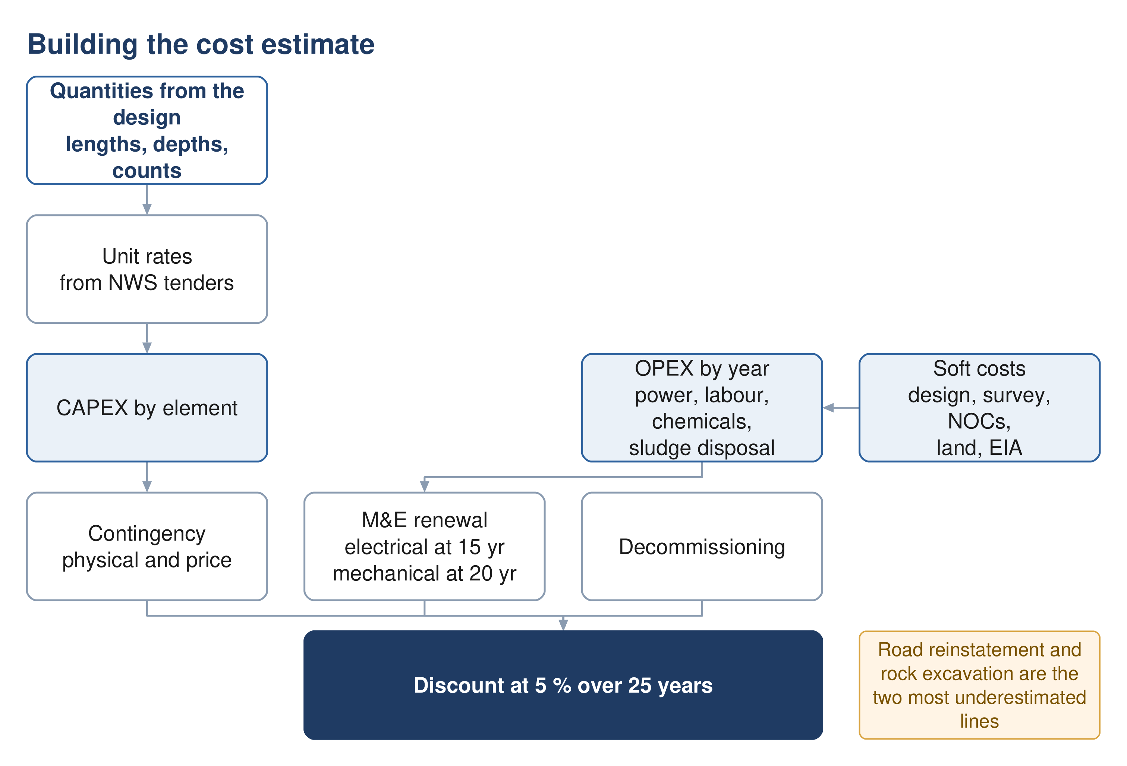
Figure 13 Building the estimate. Renewal and decommissioning sit inside the twenty-five year horizon, not beyond it.

19.2 Basis
Item | Requirement
Accuracy at concept stage | ± 20 %, and the report must state it
Measurement | CESMM3
Unit rates | most recent market rates, preferably from NWS tender or contract documents
Format | NWS will advise the required format and methodology before the design phase, on request
Basis of prices | current base prices, from the start of construction
Presentation | by asset category at feasibility; by system element, as a cost curve, at this stage

19.3 Cost breakdown — sewer network
The largest single risk in a sewerage estimate is that the pipe is priced carefully and everything around it is not. In urban work the trench, the reinstatement and the traffic usually cost more than the pipe.
Table 16 Sewer network items
Group | Items
Earthworks | Excavation by depth band; rock excavation priced separately; dewatering where the water table is met; trench support and shoring by depth; disposal of surplus and unsuitable material
Pipework | Pipe supply and lay by diameter and material; bedding and surround; selected backfill and imported fill; jointing; specials and fittings
Chambers | Manholes by depth band and diameter; backdrops; drop shafts; benching and channels; covers by loading class
Connections | Property connection sewers; connection chambers; riders; connections to the existing network; future connection stubs and end caps
Surface | Road reinstatement by surface type — asphalt, interlock, kerb, footpath, unpaved; line marking; traffic management and diversions
Crossings | Road, wadi and utility crossings; trenchless drives where open cut is not permitted; carrier and sleeve pipes; thrust and reception pits
Enabling | Trial pits; utility diversions and protection; temporary works; site establishment
Proving | Water and air tightness testing; CCTV survey; compaction testing; as-built survey

19.4 Cost breakdown — lifting stations and force mains
Table 17 Lifting station items
Group | Items
Land and site | Land acquisition and Krooki fees; site clearance and levelling; access road and turning area; boundary wall and gates; landscaping
Civil | Wet well by depth; dry well or valve chamber; base slab and dewatering during construction; protective lining; superstructure or cover slab; emergency storage or overflow structure
Mechanical | Duty and standby pumps; screens or macerators; station pipework, valves and non-return valves; lifting davit or gantry; sump pump; ventilation
Electrical and control | Incoming supply and connection charges; transformer and substation; motor control centre; standby generator and fuel storage; instrumentation, SCADA and telemetry; small power and lighting
Odour and safety | Odour control unit and ducting; gas detection; fire detection where required; welfare facilities
Commissioning | Testing, commissioning, operator training, spares holding

Table 18 Force and rising main items
Group | Items
Pipework | Pipe supply and lay by diameter and material; excavation, bedding and backfill as for gravity; thrust blocks and anchor blocks; restrained joints
Appurtenances | Air valves and their chambers; washout valves, chambers and discharge points; isolation valves at 500 to 800 m; flow meters and access chambers every 500 m; marker posts and warning tape
Termination | Receiving manhole with water seal; vent and odour control at the discharge; bell-mouth termination
Proving | Pressure testing; pigging or flushing provision; surge protection equipment identified by the transient study

19.5 Cost breakdown — treatment plant
Table 19 Treatment plant items
Group | Items
Land and site | Land acquisition; site preparation and earthworks; flood protection to the 100 year level; internal roads and hardstanding; fencing; landscaping and buffer planting; solar farm area if provided
Inlet works | Coarse and fine screens; screenings handling, washing, pressing and containers; grit removal, classification and washing; FOG removal; tanker discharge facility with screening, sampling and flow measurement; flow equalisation
Biological treatment | Reactor civils; aeration equipment and blowers; mixers; internal recycle pumps; membranes or media where used; swing zone provision
Separation and tertiary | Primary and final clarifiers with scrapers; RAS and WAS pumping; tertiary filtration; disinfection; TSE storage acting as contact tank
Sludge line | Thickening; digestion where provided; dewatering with standby unit; drying or composting; sludge storage; external sludge reception given the governorate role; conveyors and skips
Chemical systems | Coagulant, polymer, pH correction, carbon source and disinfectant dosing; bulk storage and bunding; dosing pumps and mixers
Odour | Covers and enclosures; extraction ducting; treatment units with N+1 redundancy; continuous monitoring with electronic noses
Electrical and control | Incoming supply and substation; motor control centres; standby generation; solar photovoltaic; ICA, SCADA and instrumentation; power factor correction
Buildings | Administration, laboratory, workshop, stores, welfare; blower and dewatering buildings; guard house
Emergency and disposal | Emergency lagoon at 48 to 72 hours; raw sewage diversion provision; wadi discharge outfall and its approvals; TSE filling station
Commissioning | Wet and dry commissioning; process proving to Class A; operator training; initial spares

19.6 Cost breakdown — treated effluent network
Table 20 Treated effluent items
Group | Items
Distribution | Pipework by diameter; excavation and reinstatement; valves, air valves and washouts; crossings
Storage and boosting | Reservoirs at 24 hours minimum; booster stations; chlorine residual top-up where the network is long
Customers | Customer connections and meters; filling stations with their identification, metering and control systems; driver facilities

19.7 Costs outside the works
Table 21 Soft costs and provisions
Group | Items
Professional | Design and supervision fees; topographic and utility survey; geotechnical investigation and trial pits; hydraulic modelling
Consents | Environmental impact assessment; NOCs and permits; land acquisition and Krooki fees; municipality and roads authority approvals
Provisions | Physical contingency for quantity and scope growth; price contingency for escalation to the midpoint of construction; risk allowance carried from the risk register

Contingency is not a single number. The guideline requires the estimate to include contingencies and to state the degree of accuracy. Keep the physical allowance, which covers what the design does not yet know, separate from the price allowance, which covers inflation between the estimate and construction. Merging them hides which one is driving the total, and only the first should shrink as the design develops.

19.8 Five lines that get missed
Each of these is routinely omitted, and each is large.
- Rock excavation — priced as if it were soft ground. In this terrain it rarely is, and the difference is several times the rate.
- Road reinstatement — frequently the single largest line in urban sewerage, and sensitive to surface type in a way a single average rate hides.
- Renewal inside the horizon — electrical assets last fifteen years and mechanical twenty, so a twenty-five year appraisal contains at least one full replacement of both. Omitting it flatters every option that is mechanically heavy — which is exactly the decentralised case.
- Sludge haulage — not a marginal line here, because the plant is the governorate's designated composting centre and will receive sludge from beyond its own catchment.
- Decommissioning — named in the guideline's own life cycle cost scope and almost always left out.

20 Financial and economic appraisal

20.1 Purpose
The estimate says what each option costs to build. The appraisal says what each costs to own for twenty-five years, in money of one date, so that options with different shapes can be compared. A scheme that is cheap to build and expensive to run can lose to one that is the reverse, and the appraisal is where that becomes visible.
None of the formulae in this section comes from NWS. Net present value, life cycle cost and carbon accounting are all specified in scope by the guideline and none is written as an equation anywhere in it. Cite ISO 15686-5 for life cycle cost and the GHG Protocol with ISO 14064 for carbon. What NWS does fix is the discount rate, the horizon, the cost components and the decision rules.

20.2 The cash flow to be built
For each option, a year-by-year cash flow across the appraisal period, containing five streams.
Stream | Timing | Note
Capital expenditure | in the years each phase is built | phased, not lumped at year zero
Operating expenditure | every year from commissioning | grows as connections and flow grow
Renewal | electrical at 15 years, mechanical at 20 | at least one cycle falls inside the horizon
Residual value | final year, negative cost | credit for asset life remaining beyond year 25
Decommissioning | end of life | named in the guideline's life cycle scope

Phasing is what makes the comparison honest. A centralised plant built in two phases and a set of decentralised plants built as districts develop have very different cash-flow shapes, and discounting is sensitive to shape. Lumping capital at year zero for both erases the difference the appraisal exists to reveal.

20.3 Operating cost build-up
The guideline names the components. Quantifying them is the designer's task, and each has a natural driver.
Component | Driven by | Basis
Power | kWh per year | latest APSR tariff
Labour and staffing | posts and shift pattern | per hour, day, month or year
Chemicals | dose rate times flow | coagulant, polymer, pH correction, disinfectant, carbon source
Spares and consumables | installed plant value | annual provision
Vehicles and equipment | fleet size | per hour, day, month or year
Maintenance and repairs | asset value and type | annual provision
Sludge handling and disposal | tonnes of dry solids per year | treatment, haulage and gate fees
Monitoring | sampling regime | laboratory, odour monitoring, effluent compliance
Network washing | pipes below self-cleansing velocity | from the schedule in Section 10

Power deserves particular attention: more than eighty per cent of NWS operational emissions come from electricity, so the energy line drives both the operating cost and the carbon score, and the two move together rather than trading off.

20.4 Discounting
$NPV = \sum_{t=0}^{n}{\frac{C_{t}}{{\left(1 + i\right)}^{t}}}$ (30)
Symbol | Meaning | Unit
C t | net cost in year t — capital, operating, renewal, residual | OMR
i | discount rate, 5 % unless NWS instructs otherwise | fraction
n | appraisal period, 25 years | years
t | year, counted from the start of construction | —
The period is twenty-five years even where the technical life of the civil works is fifty, which is why the residual value line matters: without it, an option built of long-lived concrete is penalised against one built of short-lived plant.

20.5 Sensitivity
The guideline names exactly three variables to test, and only three.
1. the weighting between the appraisal categories
2. the discount rate
3. the input design criteria, for example a reduction in demand
For this project the third is the one that bites. The flow estimate carries real uncertainty — the design horizon is unsettled, the existing plant capacity is unverified, and the tanker share is unknown — and the Phase I capacity sits close to a contractual threshold. A sensitivity run that does not move the flow is not testing the thing most likely to be wrong.

20.6 Risk
A risk register is carried from concept stage onward and updated through the project. For appraisal purposes each risk needs a likelihood, an impact in money, and an owner; the risk-adjusted cost then feeds the comparison alongside the base estimate. Risks that fall on one option and not another are the ones that change the ranking.

20.7 What the appraisal must produce
- capital cost by option and by phase
- operating cost by option and by year
- net present value of each option at 5 % over 25 years
- carbon in tonnes of carbon dioxide equivalent per year and per cubic metre, against the benchmark
- in-country value, assessed holistically at this stage
- sensitivity results on all three variables
- a risk register with costed impacts
- input to the Pre-Investment Appraisal Document
The tie-break makes sustainability decisive, not decorative. Where options fall within ten per cent of one another on total lifetime cost, the more sustainable option is to be adopted. Since three options compared on twenty-five year cost will often land inside ten per cent of each other, the carbon and circular economy work frequently decides the outcome — and it has to be done to a standard that can carry that weight.
Source: G201 §12.2 to §12.9 p95-106; §7.1 p57 for asset lives; Table 2 p19-22 for the concept-stage cost deliverable.

21 Options and the recommendation

21.1 How many options, and of what kind
A minimum of three options is required, and separately for the sewer network, the treated effluent network and the plant. The guideline also states what kind they should be.
1. an option that pushes environmental sustainability, including nature-based solutions
2. an internationally best-in-class, state-of-the-art solution
3. a standard solution using practice and technology already established in Oman
The three-option minimum is mandatory; the archetypes are offered as guidance. Each option must present equivalent functional requirements and comparable reliability and redundancy, so that the comparison is unbiased.
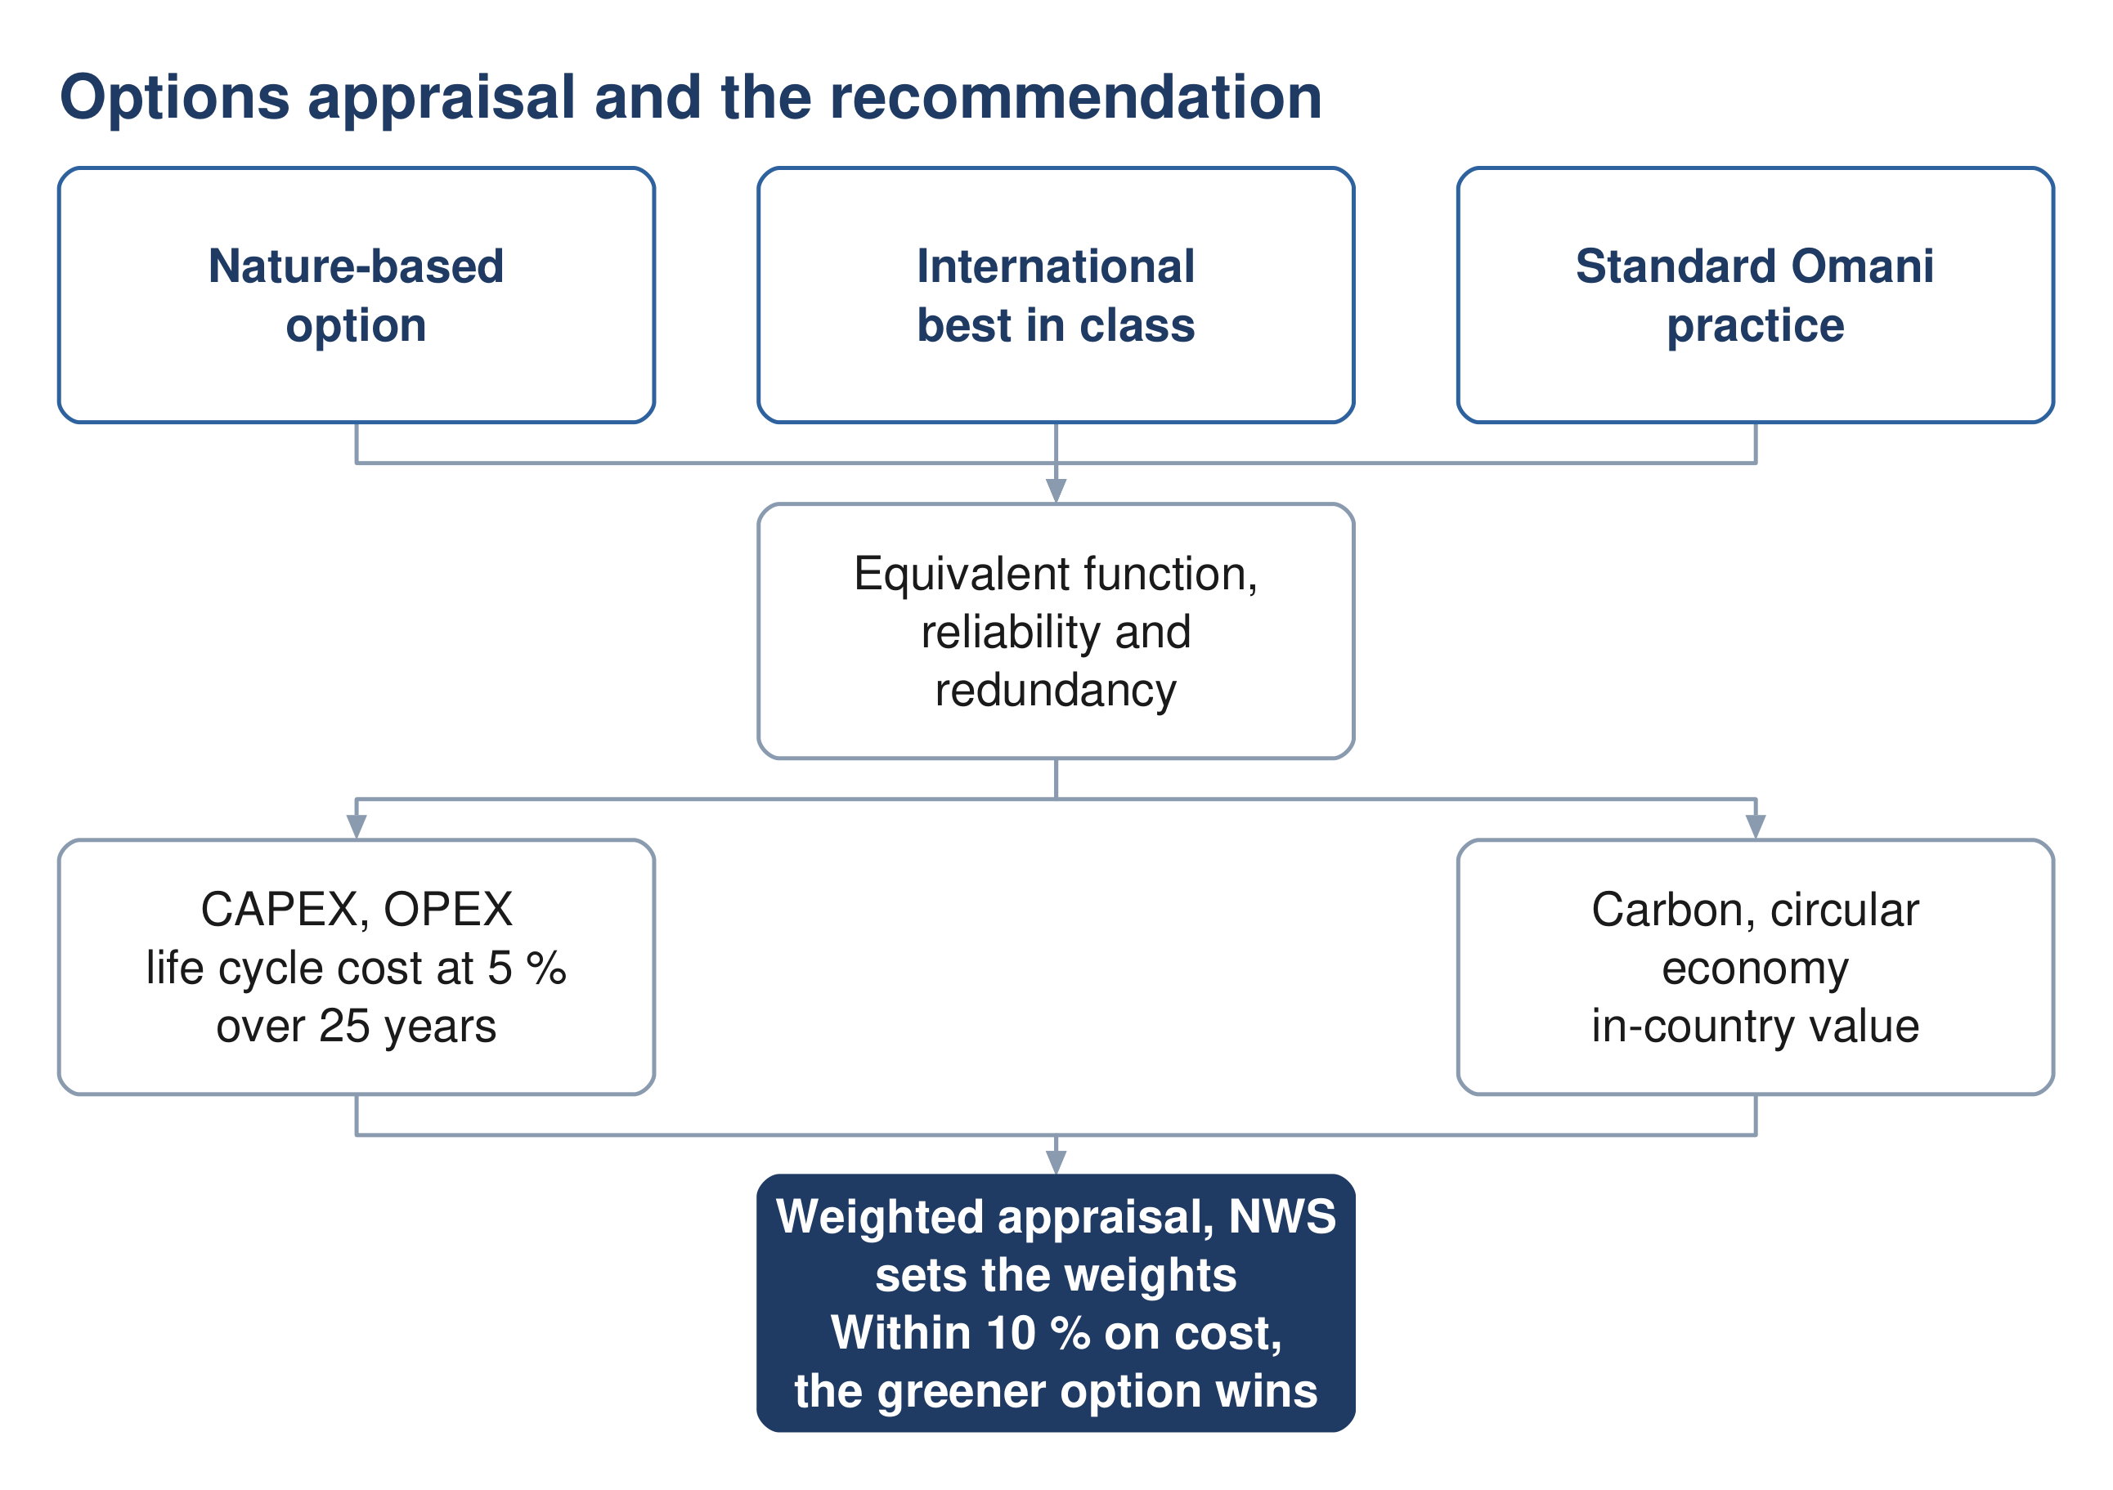
Figure 14 Options appraisal. Where costs sit within ten per cent, the greener option is adopted.

21.2 The appraisal parameters
Capital and operating cost; life cycle cost; carbon footprint over the project lifetime; resource efficiency under a circular economy approach including decommissioning; in-country value; and the degree of nature-based solution. The evaluation horizon is twenty-five years for every parameter, and NWS sets the weighting.

21.3 Cost and carbon
Cost estimation is Section 19 and the appraisal itself is Section 20. In summary, each option carries a capital cost by phase, an operating cost by year, a net present value at 5 per cent over 25 years, and a carbon footprint in tonnes of carbon dioxide equivalent per year and per cubic metre against the benchmark. One option must include a carbon reduction plan comparing a conventional base case with an optimised scenario.

21.4 Choosing
A weighted multi-criteria analysis compares the options against total lifetime cost, sustainability (carbon, circular economy and nature-based solutions), social development and in-country value, adaptability and resilience, operability, constructability, and environmental impact. No scoring scale or normalisation rule is specified, so the method must be proposed and agreed.
Sensitivity analysis varies exactly three things: the weighting between categories, the discount rate, and the input design criteria.
The tie-break rule. Where options fall within ten per cent of each other on total lifetime cost, the more sustainable option is to be adopted. This makes the sustainability assessment decisive rather than decorative whenever the costs are close.

21.5 Value engineering
Formal value engineering is triggered at concept for this project. The threshold table places a general value engineering study at concept stage, led by the design team, for projects below five million rials. Its footnote overrides that for treatment plants and pumping stations above two million, which require a formal study by an independent certified consultant at both concept and preliminary stage. The Ibri plant clears that threshold, so an external appointment falls inside the concept programme.
Source: G201 §11 p92-94 and §12 p95-106.

22 Where the guidelines cannot be relied on
This section exists because a reference document that presents its source as flawless is not usable. Everything below was verified at the page. Where the guideline is wrong, this document reproduces what it prints and says what is wrong with it; it does not silently correct the client's own standard.

22.1 Formulae that do not exist in the guidelines
Each of these is commonly assumed to be in the guidelines and is not. Citing NWS for any of them would be a fabricated reference.
Formula | Cite instead | What NWS does supply
Net present value | ISO 15686-5 | 5 % discount rate, 25 year horizon
Life cycle cost | ISO 15686-5 | the cost-stage scope list
Carbon footprint | ISO 14064, GHG Protocol | units and benchmark values
Multi-criteria score | designer's own, agreed with NWS | the criteria and who weights them
Total dynamic head | standard hydraulics | the component list, in prose
Pump power | standard hydraulics | nothing; no efficiency assumption
Darcy-Weisbach | standard form | roughness coefficients only
Hazen-Williams | standard form | C values only
Wave celerity | Korteweg | a qualitative description
Mass load from flow and concentration | standard | loads and concentrations separately
Oxygen demand, SRT, clarifier area | Metcalf and Eddy, or DWA | ranges to land inside
Surge vessel volume | — | a 20 % minimum allowance
Emergency storage at a pumping station | — | nothing; propose and get approval
Roughness for a raw sewage force main | — | potable and treated effluent only
Aquifer recharge criteria | — | absent from all three documents

22.2 A mandatory method that cannot be completed
Tractive force. The check is required, the equation is given, and the required value of shear stress in pascals appears nowhere in the wastewater guideline's 201 pages or the general guideline's 152. Any value used must come from the literature and be agreed with NWS in writing. This is the single largest hole in the gravity design chain.

22.3 Errors of substance
Where | What is wrong | How to handle it
G203 p24 | full-bore flow printed as velocity divided by area, which is dimensionally impossible | use velocity multiplied by area; note the defect
G201 p72 | Peltier printed with 1 in the numerator; the published form carries 2.5 | reproduce as printed; query NWS
G201 p62 | Adh Dhahirah tanker ratio of 333 % cannot be arithmetically true; the volumes are sound | do not use the ratio; query NWS
G201 p144 | pipeline emptying time evaluates to metres to the power one and a half times seconds squared | the guideline calls it a quick check; use a transient model
G203 p25 | Manning constant 6.3448 against an exact 6.3496 | quote the guideline value; footnote the exact one
G203 p40 / p42 | two tables disagree on duty pumps for the largest station type | take the conservative reading; flag
G203 p146 | aerobic digestion text requires 45 days retention; its own table gives 10 to 15 | the text governs; note the conflict
G203 p124 | clarifier surface loading and overflow rate do not reconcile, both stated at average flow | reproduce both; do not silently pick one
G203 p185 | hydrogen sulphide risk bands overlap and leave a gap | reproduce verbatim; flag
G203 p71 | chlorine residual worded as "at least between" | 0.3 to 1.0 at the consumer; up to 3.0 at the plant

22.4 Cross-references that do not resolve
- the TOR cites item 2.1 of Section 05 of the wastewater manual, which no longer exists after the March 2026 renumbering; the equivalent content is now §10.1
- a package-plant peak factor of 3.0 is attributed to the general guideline, which nowhere prints 3.0
- two internal references to the tanker discharge section point to the wrong subsection
- the general guideline is cited twice as AM-GUD rather than PAM-GUD
- value engineering timing is given as concept in one table and detailed design only in another
- environmental impact assessment timing is scoping-at-preliminary in one clause and full-assessment-at-concept in another

22.5 What to do about all this
Three rules keep the report defensible. Quote the guideline as it is printed, and separately say what is wrong with it — never publish a silently corrected version of the client's own standard. Where a formula is not NWS's, attribute it to whoever it belongs to. And where the guideline is silent on something it makes mandatory, propose a value, say where it came from, and obtain agreement in writing before the design depends on it.

