Ibri Sewer, TE & STP — Project 2621
W5 — Sewer Network Design
How the design is made, and what it gives for the test area
Internal working document — design team
19 August 2026
Item | Value
Test area | 551 hectares
Sewer designed | 1,744 chambers / 78.4 km
Properties served | 4,226 on 3,017 plots
Flow at the outfall | 3,620 m3/day average, 96 L/s peak
Pumping spots found | 5
Checks failing | 3 of 21

Contents
Right-click > Update Field to build the Table of Contents.

Summary
This run designs a full sewer for the 551 hectare test area: 1,744 chambers, 78.4 km of pipe, and a level for every pipe end. It serves 4,226 properties on 3,017 plots. At the outfall the flow is 3,620 cubic metres a day on average and 96 litres a second at the busiest hour. The whole run takes about 20 seconds, so any rule can be changed and the effect seen the same day.
Three things changed since the last run, and all three came from your review of the drawings.
- Roads are cleaned before use. The road file now carries a column saying which roads are dual carriageway. Those carry no pipe at all — 101 lines, 12.7 km — because we cannot dig them up, and that holds for the trunk sewer too. 12 roundabouts and 83 turning links were also dropped: they carry no houses, and following them only adds chambers.
- House connections are drawn properly. Before, a connection ran from the middle of a plot to whichever chamber was nearest in a straight line, which cut across blocks. Now each plot reaches out to the pipe it actually faces, the line starts at the plot edge, and up to three neighbours share one rider. 522 empty plots get a capped stub-out ready for when they are built.
- Properties are counted, not guessed. 3,885 electricity accounts inside the boundary tell us how many properties sit on each plot — 1.4 on average instead of the flat one per plot we assumed before. Account type also tells us which are shops or offices rather than homes.
What still needs attention: 3 checks fail. The largest is 300 pipes arriving at a chamber at a sharp angle, which needs junction layout work. 240 house connections are longer than 50 metres, mostly plots that used to face a dual carriageway and now have no near street — each needs either an extra chamber or a local answer. Neither affects pipe sizes or levels.

1. How the design is made
The work runs in steps, each one a separate piece of code, so any rule can be found and changed in one place.
Step | What it does
Read the inputs | roads, plots, ground levels, flood map, electricity accounts
Clean the roads | remove what cannot carry a sewer, join broken streets back together
Build the tree | one path from every street to the outfall, no loops
Place chambers | at junctions, at bends, and at regular spacing
Count the load | properties per plot, added up down the network
Size and set levels | pipe size and gradient chosen together, deep spots become pumping stations
Connect the houses | each plot to the pipe it faces, and check it can drain
Check everything | 21 rules re-checked independently of the design code
Write the outputs | GIS files, CAD drawing, SewerGEMS package, maps

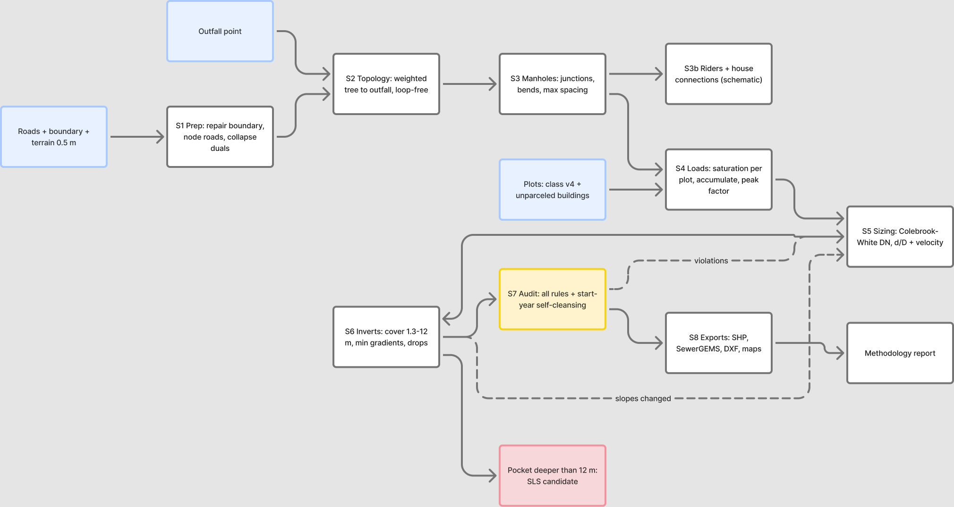
The steps in order. Blue is what comes in, yellow is the checking step, red is where a pumping station is needed, dashed lines are repeats.

2. Cleaning the roads
A road file describes how cars move. A sewer follows the street but joins at a point, so the file has to be cleaned first, or the design puts a chamber wherever the survey happened to break the line.
What was removed or changed | Amount
Dual carriageways — no pipe at all, trunk included | 101 lines
Roundabouts — they collect no sewage | 12
Rings kept because plots sit inside them (blocks, not roundabouts) | 69
Turning links and slip roads | 83
Straight streets joined back into one line | 107
Dead ends serving nobody | 4
Road length before / after | 97.4 km / 84.8 km

Everything removed is written to the corridor file with the reason beside it, so each one can be looked at and put back if the rule got it wrong. Telling a roundabout from a small block cannot be done on shape alone — a square scores higher on roundness than a real roundabout. The test used here is whether any plot sits inside the ring: a roundabout circles road, a block circles houses.

3. How much sewage, and from where
Each electricity account is one property. A plot with three accounts holds three properties. In the test area 3,885 accounts sit on 1,322 plots, giving 4,226 properties in total.
Item | Value | Where it comes from
People per property | 5 | your decision, 19 August
Sewage per person | 171.3 litres a day | guideline G201 p70-71
Properties per plot | 1.4 average | counted from electricity accounts
Plots loaded | 3,017 | built 2,217, planned 522, unparceled 248
Farm plots with houses | 30 | farming sends nothing, but houses on a farm do
Extra water leaking in | 720 litres a day per km of sewer | guideline G201 p72-73

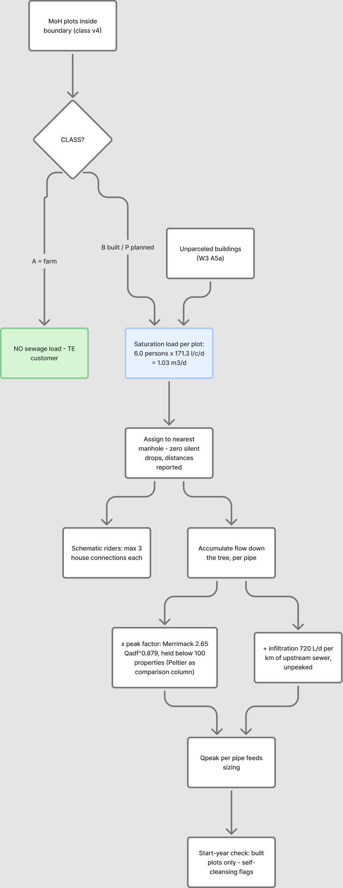
How a plot becomes a flow in the pipe.

4. House connections
The connection is schematic — the sizes are not designed. The one thing that must be right is whether the house can drain into the sewer at all, because roads are sometimes raised above the plots beside them.
Rule | Result here
Each plot joins the pipe it faces, by a short line from the plot edge | 2,495 connections
Up to 3 neighbours share one rider | 963 riders
Empty plots get a capped stub-out for later | 522 stub-outs
Houses that could not drain at first | 107
Chambers deepened to let them drain | 51
Still cannot drain — need a local answer | 0

These are kept in three separate files (connections, riders, stub-outs) so that SewerGEMS never reads them as sewers and the CAD drawing can switch them off.
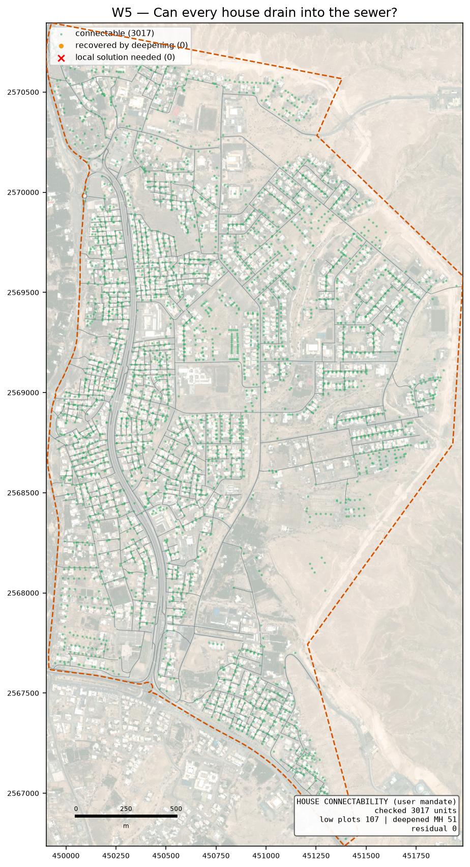
Green can drain as designed, amber needed a deeper chamber, red still cannot.

5. What the design gives
Item | Value
Chambers / pipes | 1,744 / 1,743
Sewer length | 78.4 km
Pipe sizes used | DN200 75.082 km · DN250 1.018 km · DN315 0.803 km · DN400 0.297 km · DN500 0.694 km · DN600 0.555 km
Flow at the outfall | 3,620 m3/day average, 96 L/s peak
Outfall position | (450548, 2567453), ground 351.7 m — the lowest road point on the boundary
Deepest chamber | 20.1 m (inside a pumping-station pocket)
Drop structures | 409 (256 need the tall type)
Pumping stations needed | 5
Corner chambers sitting under 2 m from a plot | 0 — flagged for the drawing
Checks failing | 3 of 21

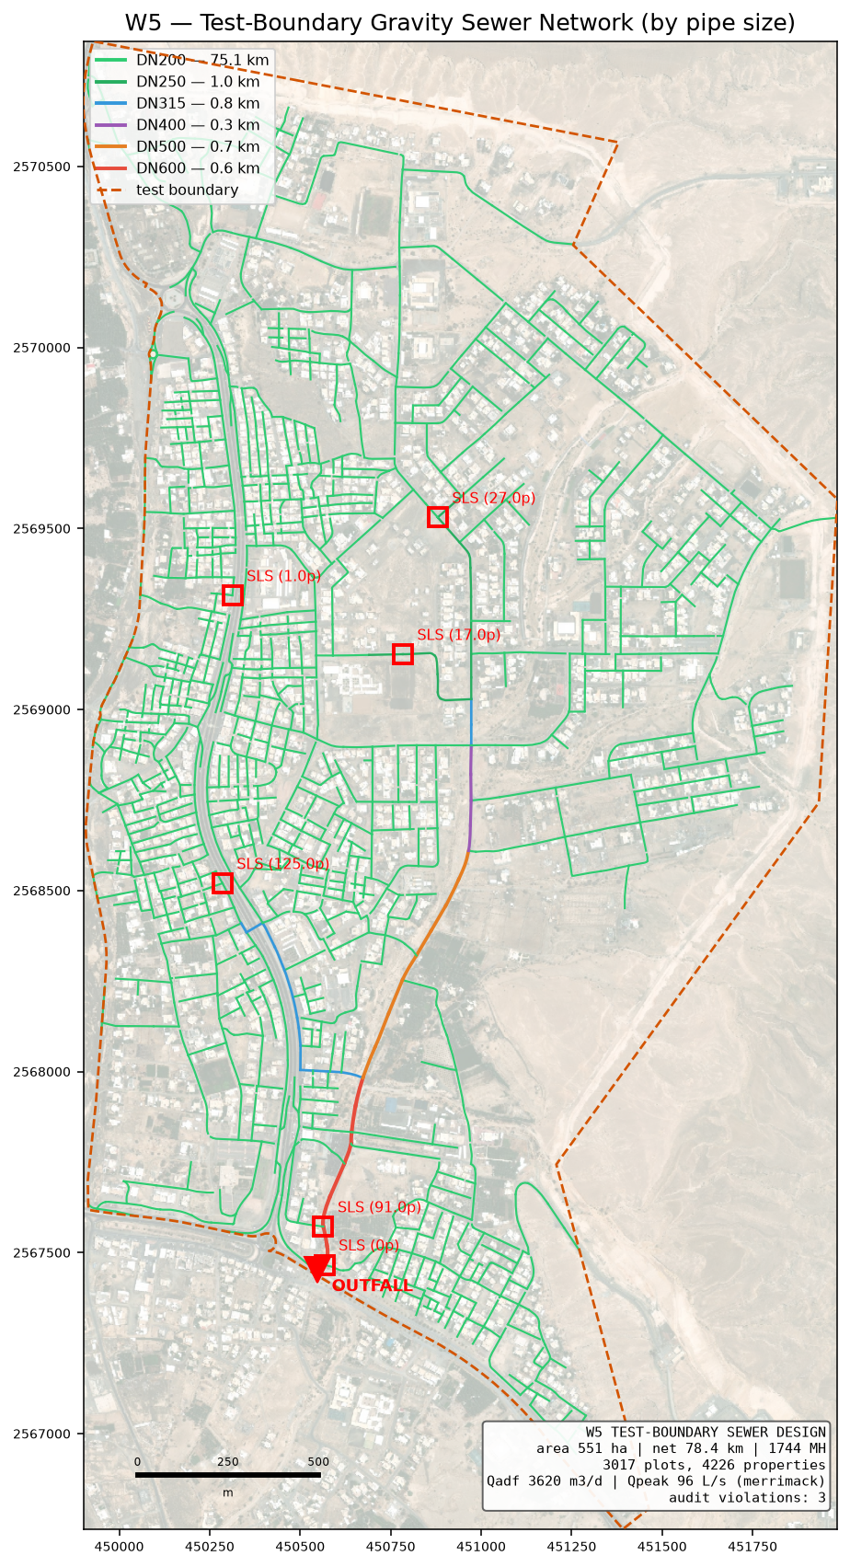
The designed sewer, coloured by pipe size.
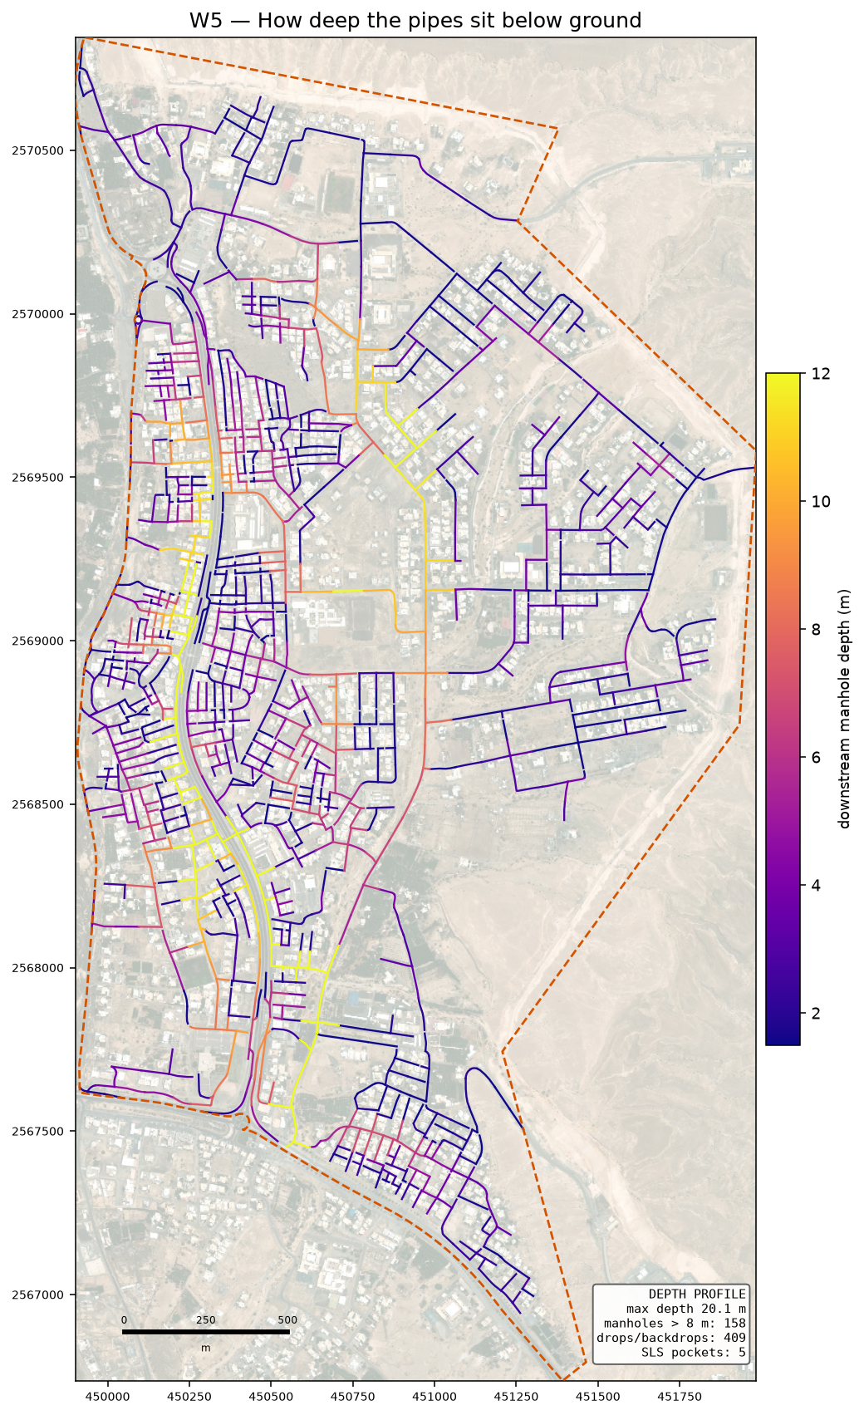
How deep the pipes sit. Dark means deep digging.

6. The checks
The design is checked by separate code that re-works every rule from the finished drawing, so the design cannot mark its own homework. Each check names the guideline page it comes from.
ID | Check | Guideline | What was found
C4 | Inlet angle | G203-p30 | 300 of 1743 inlets under 90 deg
C8 | Branch start offset | user rule / SWNETWROK 10 m | 580/582 branch heads clear
D1 | Property connection length | G203-p18 Tab 4 (A9) | 240/3017 connections over 50.0 m; longest 356 m

On self-cleaning: 1,681 of 1,743 pipes cannot reach the 0.75 m/s flow speed even at their busiest hour. That is normal on small house streets, and the guideline allows a second method for exactly this case — a minimum gradient worked out from the drag on the pipe wall. All of them meet that instead. It rests on a value the guideline never gives (1 Pascal is assumed); if NWS sets it at 2, 1,177 pipes would need steeper gradients. That single number is the best reason to settle it at the kickoff meeting.

7. What is assumed, and what is measured
Assumed | Why
Drag value of 1 Pascal | the guideline gives no number; it decides the gradient on small pipes
5 people per property | your decision, 19 August
Plastic pipe wall thickness | pipe sizes are quoted outside; the inside bore is worked out from a standard wall class
Floor areas, staff and pupil numbers | nobody supplies them, so they are worked out from plot size and building cover — replace when the land use data arrives
Where a rider joins | the guideline does not say; the nearest chamber is used

Measured | Source
Properties per plot | electricity accounts
Ground levels | 0.5 m ground model
Which roads cannot be dug | the road file's own column
Flood-prone ground | 50-year hazard map, classes 4 to 6

8. What comes next
- Your trunk line. The main pipe is yours to fix. The design then grows the side networks into it — the code takes connection points as a setting, so this is a change of input, not a change of method.
- The SewerGEMS check. The import package is ready with a comparison sheet. Once the model runs, every pipe's flow and speed can be set beside ours; anything more than 5 per cent apart gets looked at before the design is called proven.
- Junction angles. 300 pipes still arrive at a chamber too sharply. This is a layout job at junctions and is the main open item in the design itself.
- The land use data from your colleague. Missing plots and properties per plot will replace the derived figures without touching the design code.

