Cost benefit analysis methodology
Depth-Damage curves for 5 landuse categories. Unit is OMR/m2
Flood depth (m) | Residential buildings | Commercial buildings | Industrial buildings | Infrastructure - roads | Agriculture
0 | 0.0 | 0.0 | 0.0 | 0.0 | 0.000
0.5 | 20.6 | 50.4 | 31.4 | 4.6 | 0.002
1 | 31.2 | 71.9 | 53.4 | 8.0 | 0.007
1.5 | 38.9 | 88.1 | 69.7 | 12.9 | 0.009
2 | 45.5 | 102.0 | 79.5 | 15.2 | 0.010
3 | 54.8 | 118.1 | 94.9 | 17.3 | 0.012
4 | 58.7 | 125.9 | 100.7 | 19.0 | 0.015
5 | 62.0 | 131.1 | 105.8 | 20.8 | 0.017
6 | 63.1 | 133.7 | 110.8 | 21.4 | 0.018

Landuses in shapefile are Agriculture, Commercial, industry, Residential, Roads
The depth layer for all return periods (2, 5, 10, 25, 50,100, 200, 500, 1000, 10000 year) under two conditions are calculated:
- baseline
- Scheme (dam and channels protection)

Damage cost values for each return period provides two curves for the baseline and scheme conditions. These curves called Annual Expected Damage (AED). The gap between these two curves is the avoided damage. Below image shows the curves and orange area is the avoided damage.
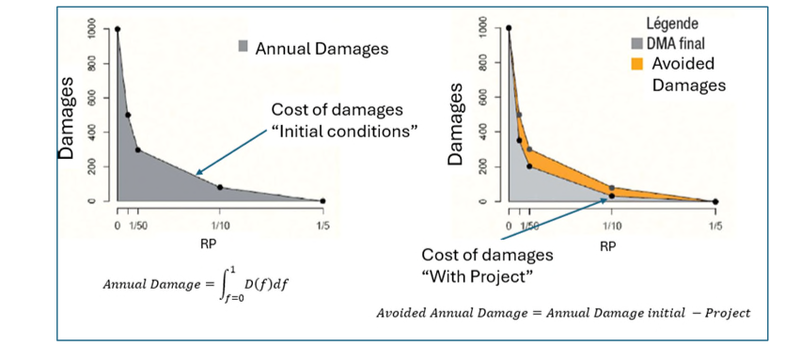

Consider below image to calculate the NPV and BCR
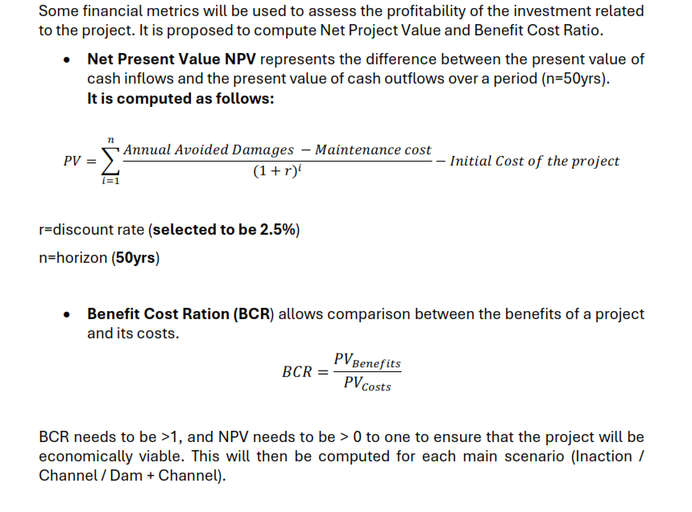

The Initial cost of project is total cost of dam, channels, and relocation.
For now assume:
Dam: 50 million OMR
Channel: 5 million OMR

The maintenance cost from below table
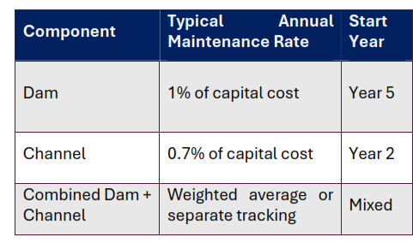
Cost of relocation should also be calculated. The outline for dam and channel will be provided. The plots that fall under the project outline + part of those plots that partially fall in the scheme will be considered. The unit price of each landuse is:
Residential: 15 OMR/m2
Commercial/Industrial: 20 OMR/m2
The project cost is total cost of dam, channels, and relocation.

