Descriptive Analysis of the Raw Data

The prepared questionnaire has received 57 organic response count. In this section we present the descriptive analysis on the dataset. There were around 12 questions in the questionnaire which can be quantitatively analyzed. Followings are the analysis summary.

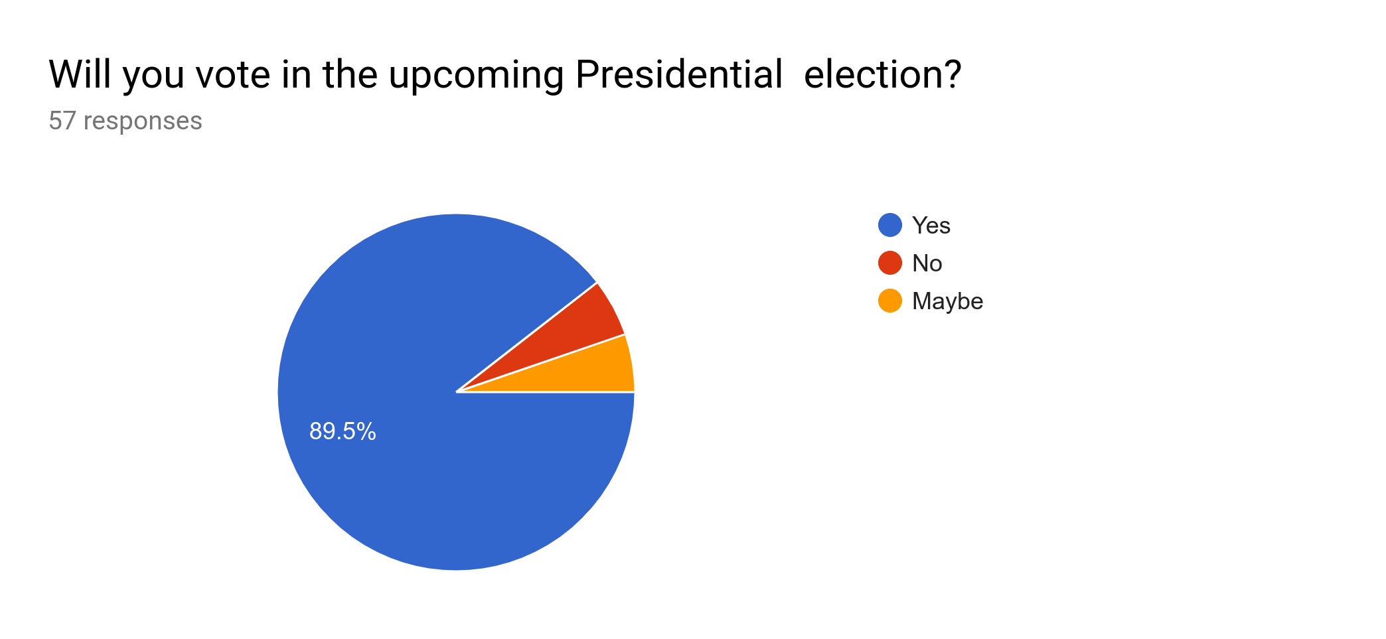

Out of the total respondents 89.5% are willing to vote in the upcoming presidential election.

When looking at the following 2 charts 82.7% of respondents says that SLPP candidate will win the upcoming presidential election in there area, But 79.2% of respondents are willing to SLPP candidate. There is a small portion of uncertainty in the given answers.

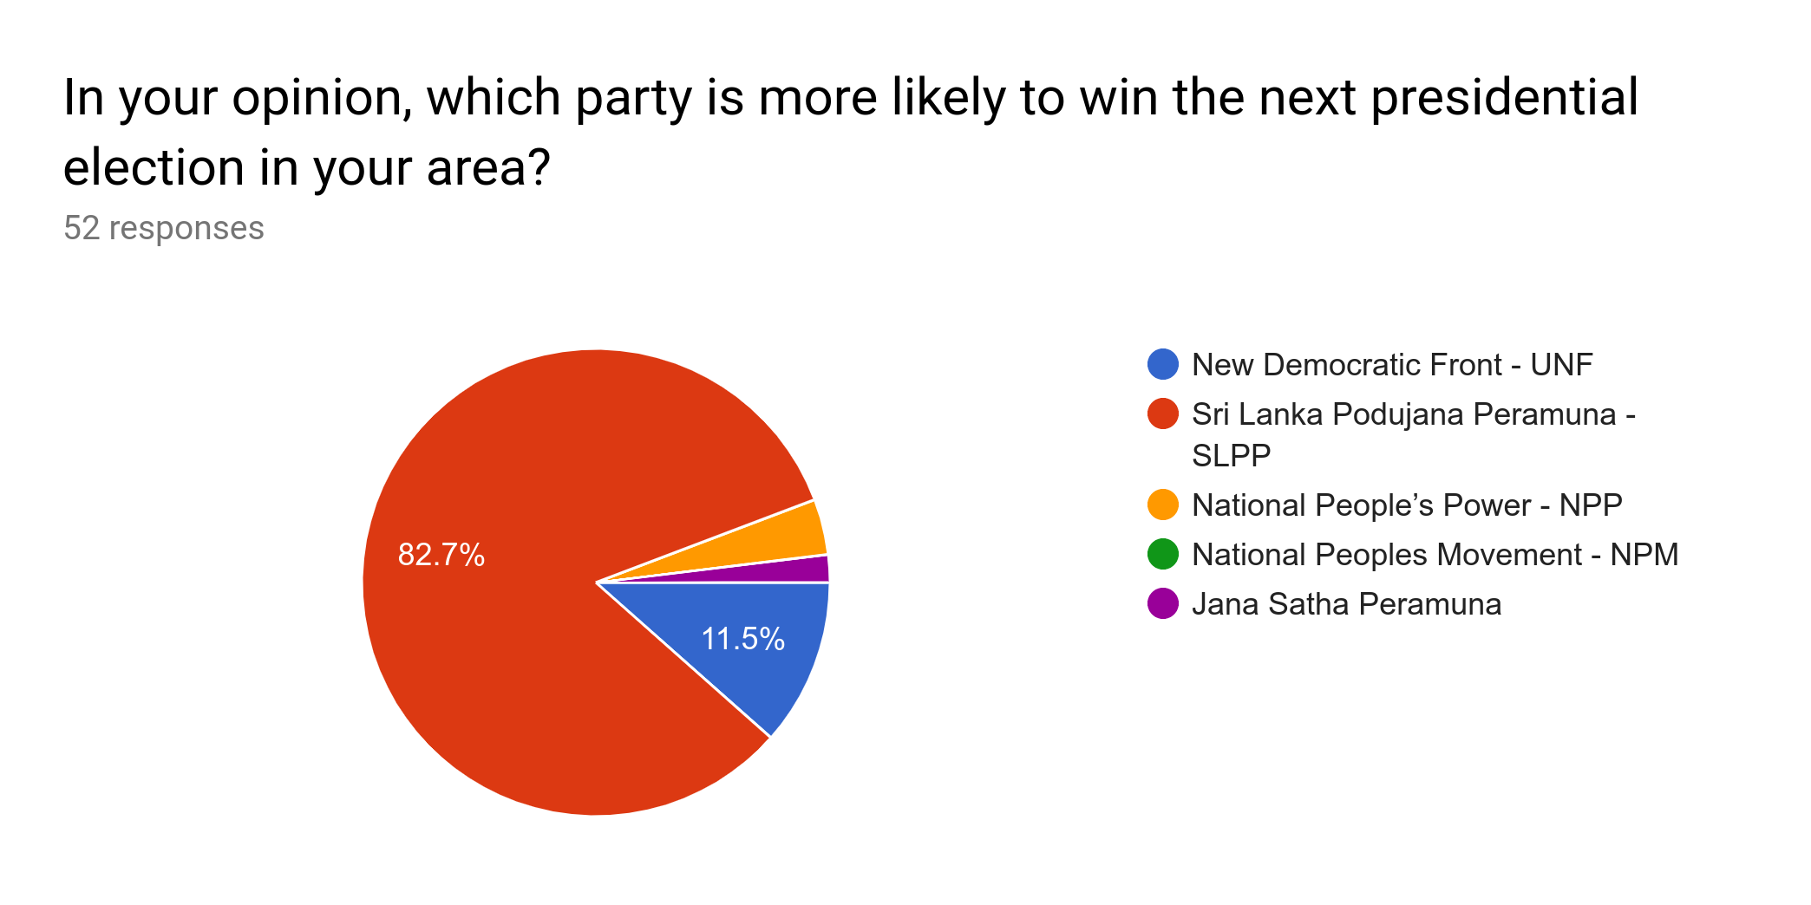

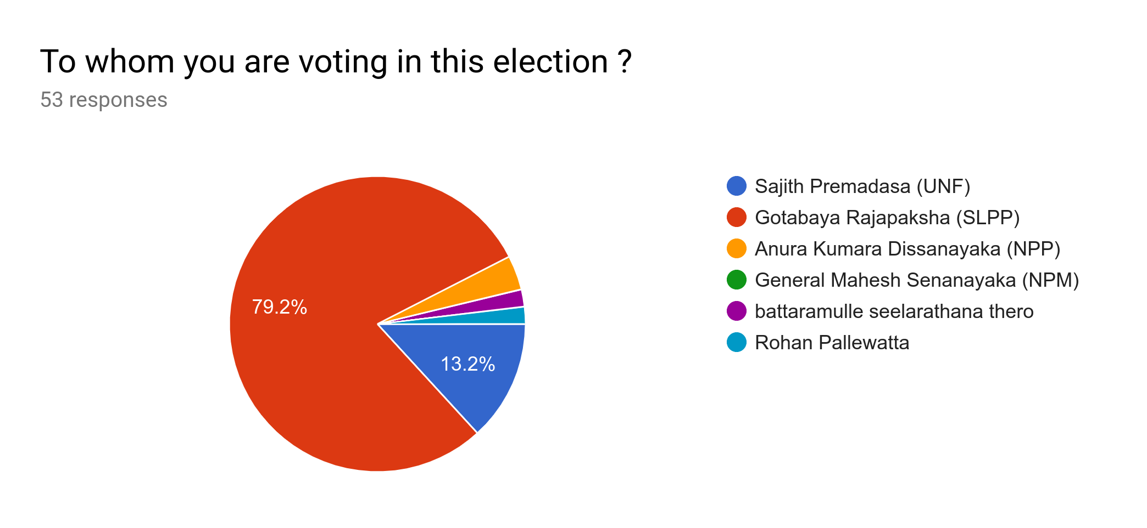

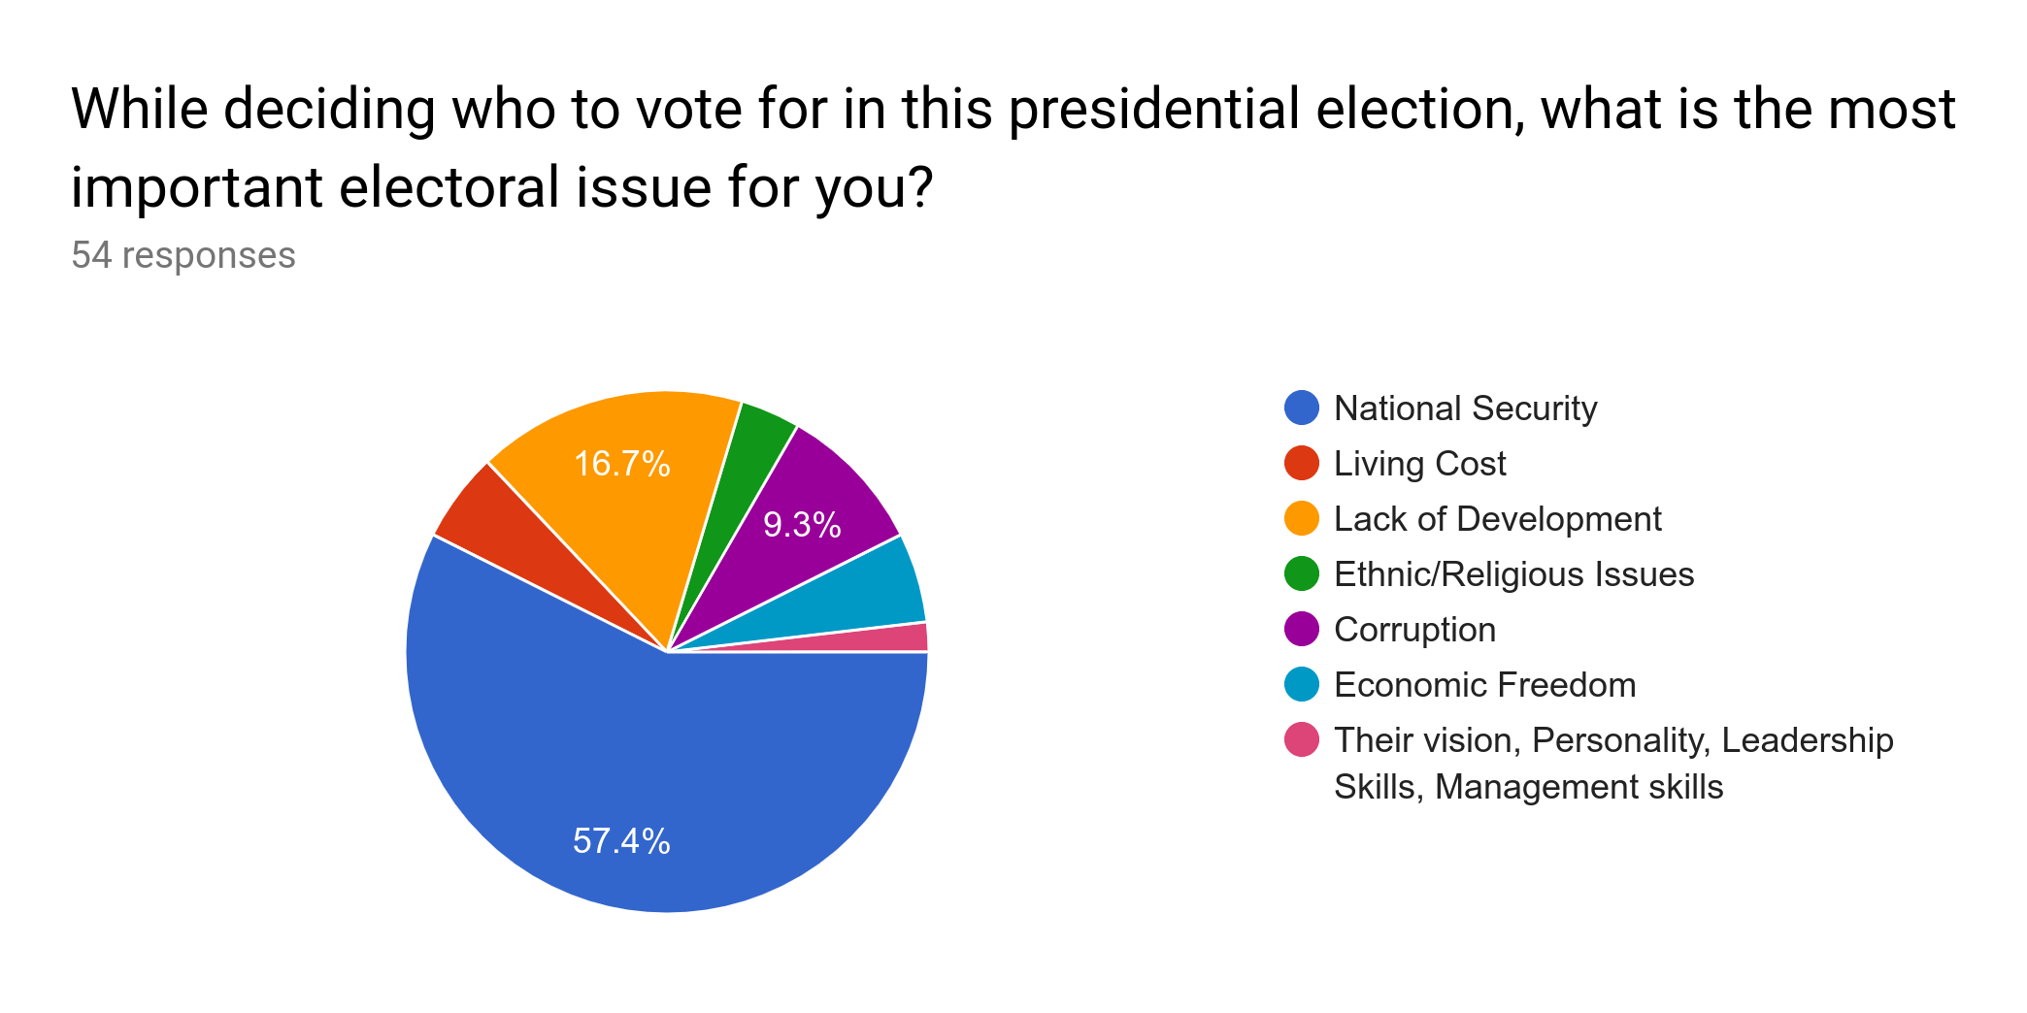

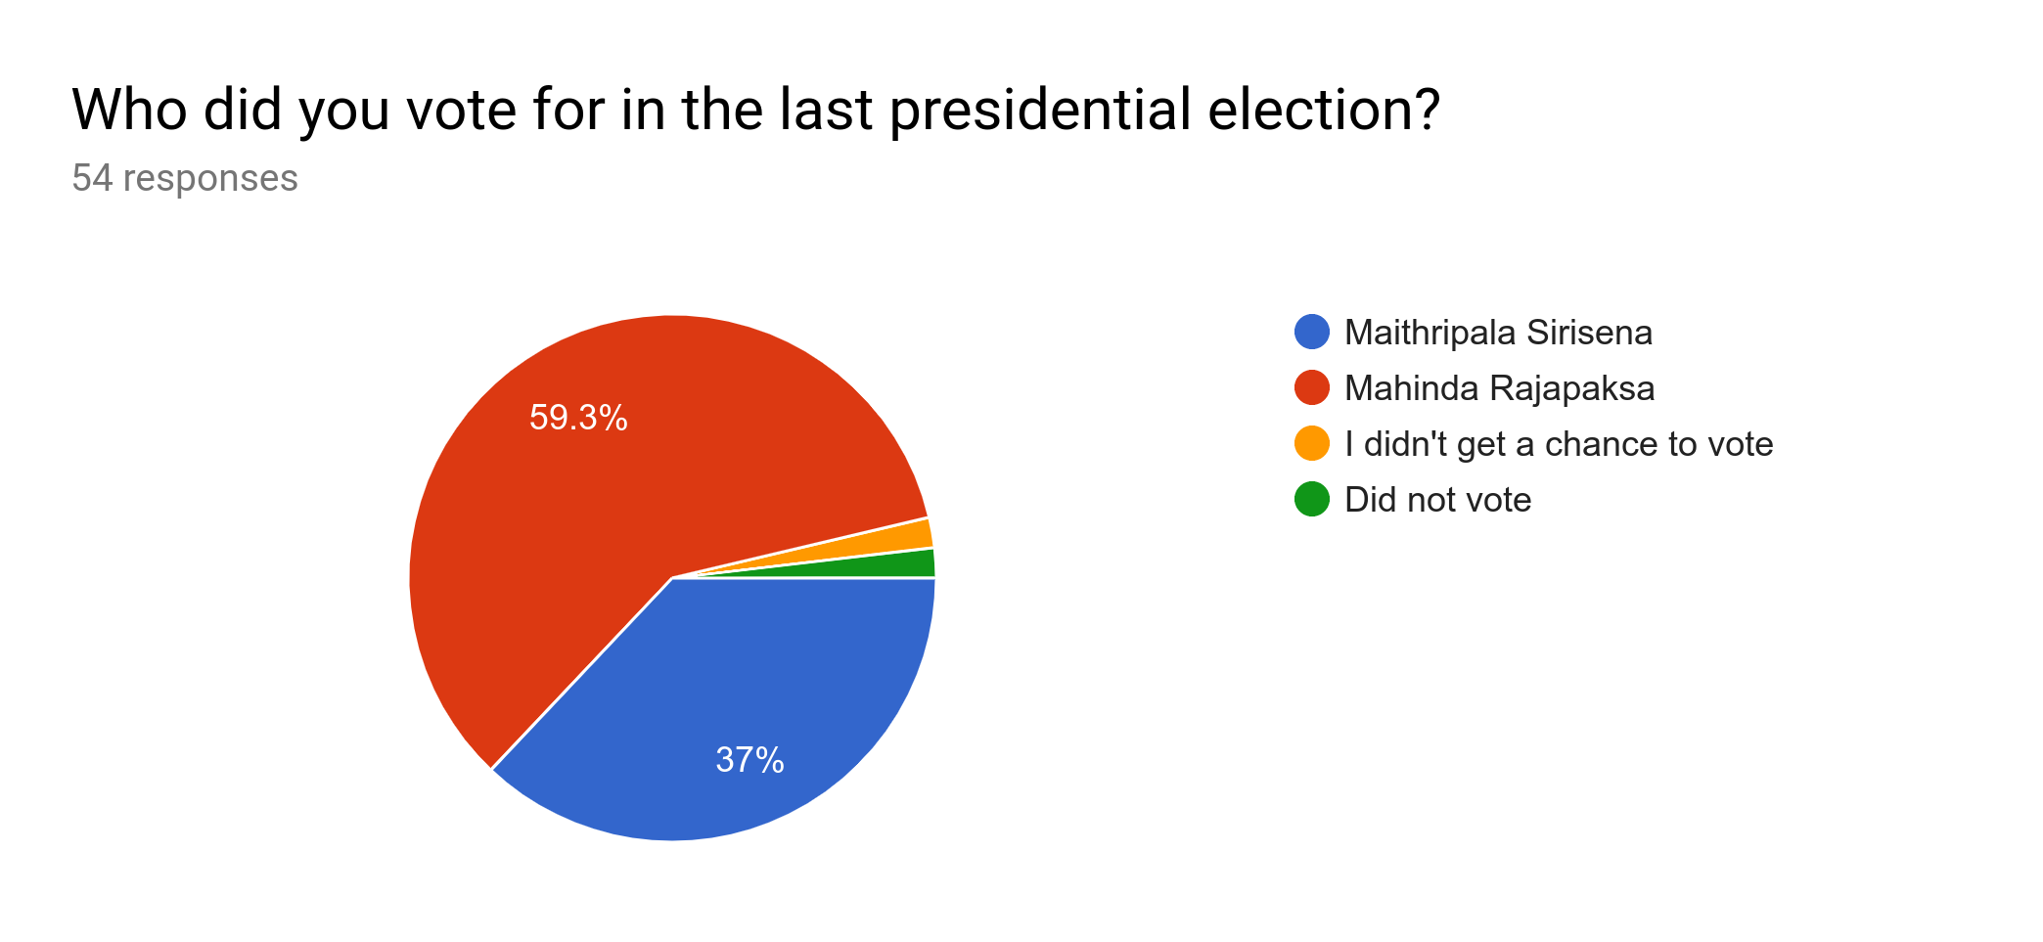

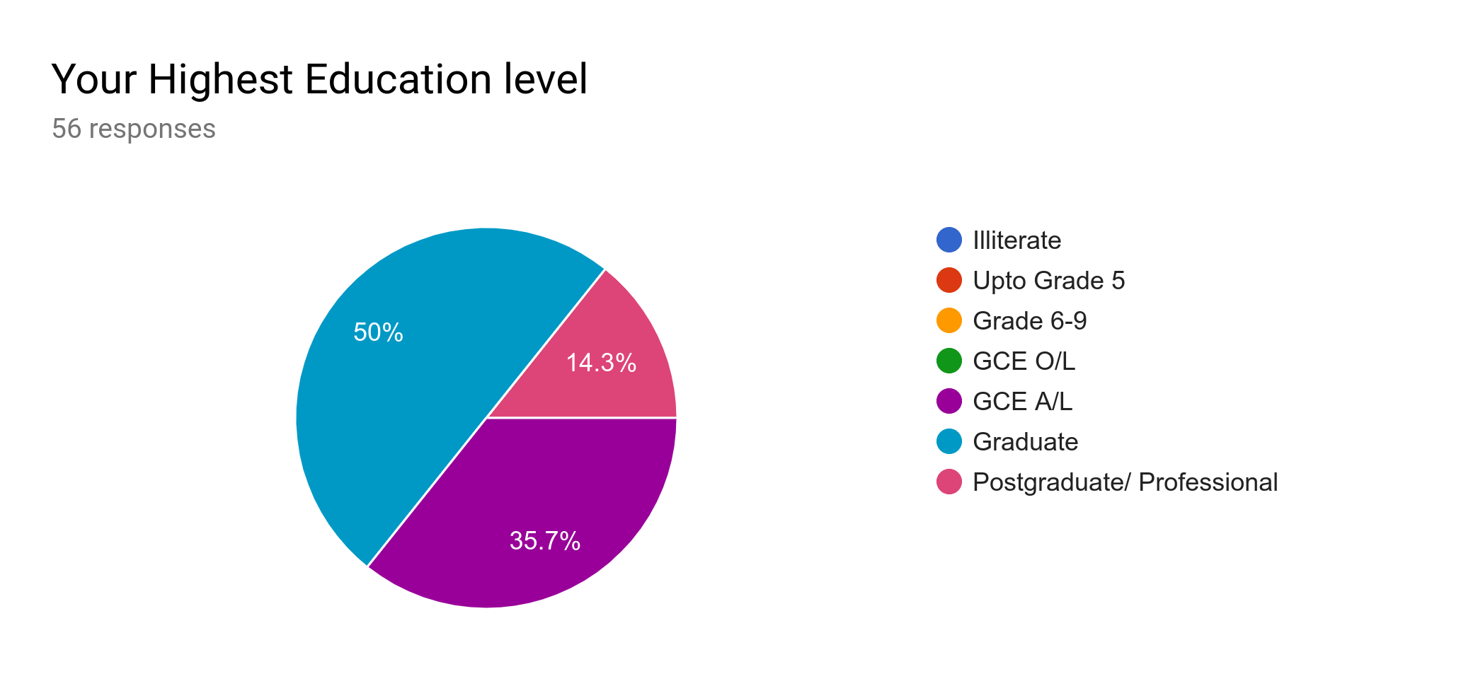

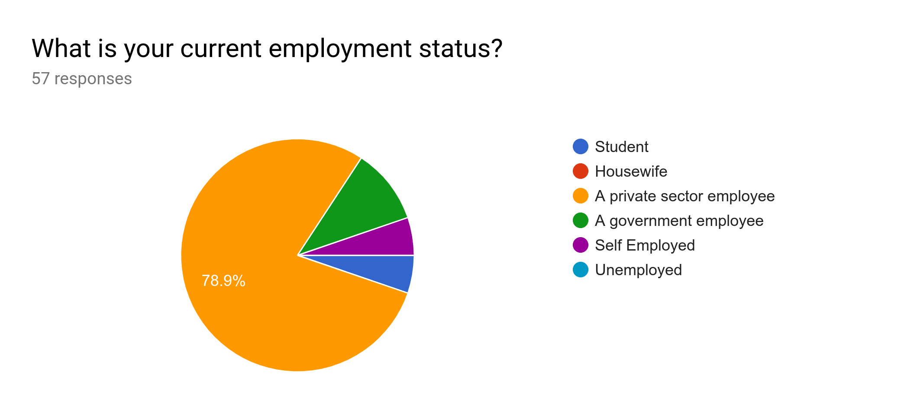

Almost all respondents have education level at lease GCE A/L, out of those around 64% are graduate or postgraduate qualified personnel. Also 78.9% of respondents are Private Sector Employees. According to those results we can identify most of the respondents are well educated people. Therefore this study will not represent all the sectors in Sri Lanka, but educated and mostly private sector employees opinion will be reflected.

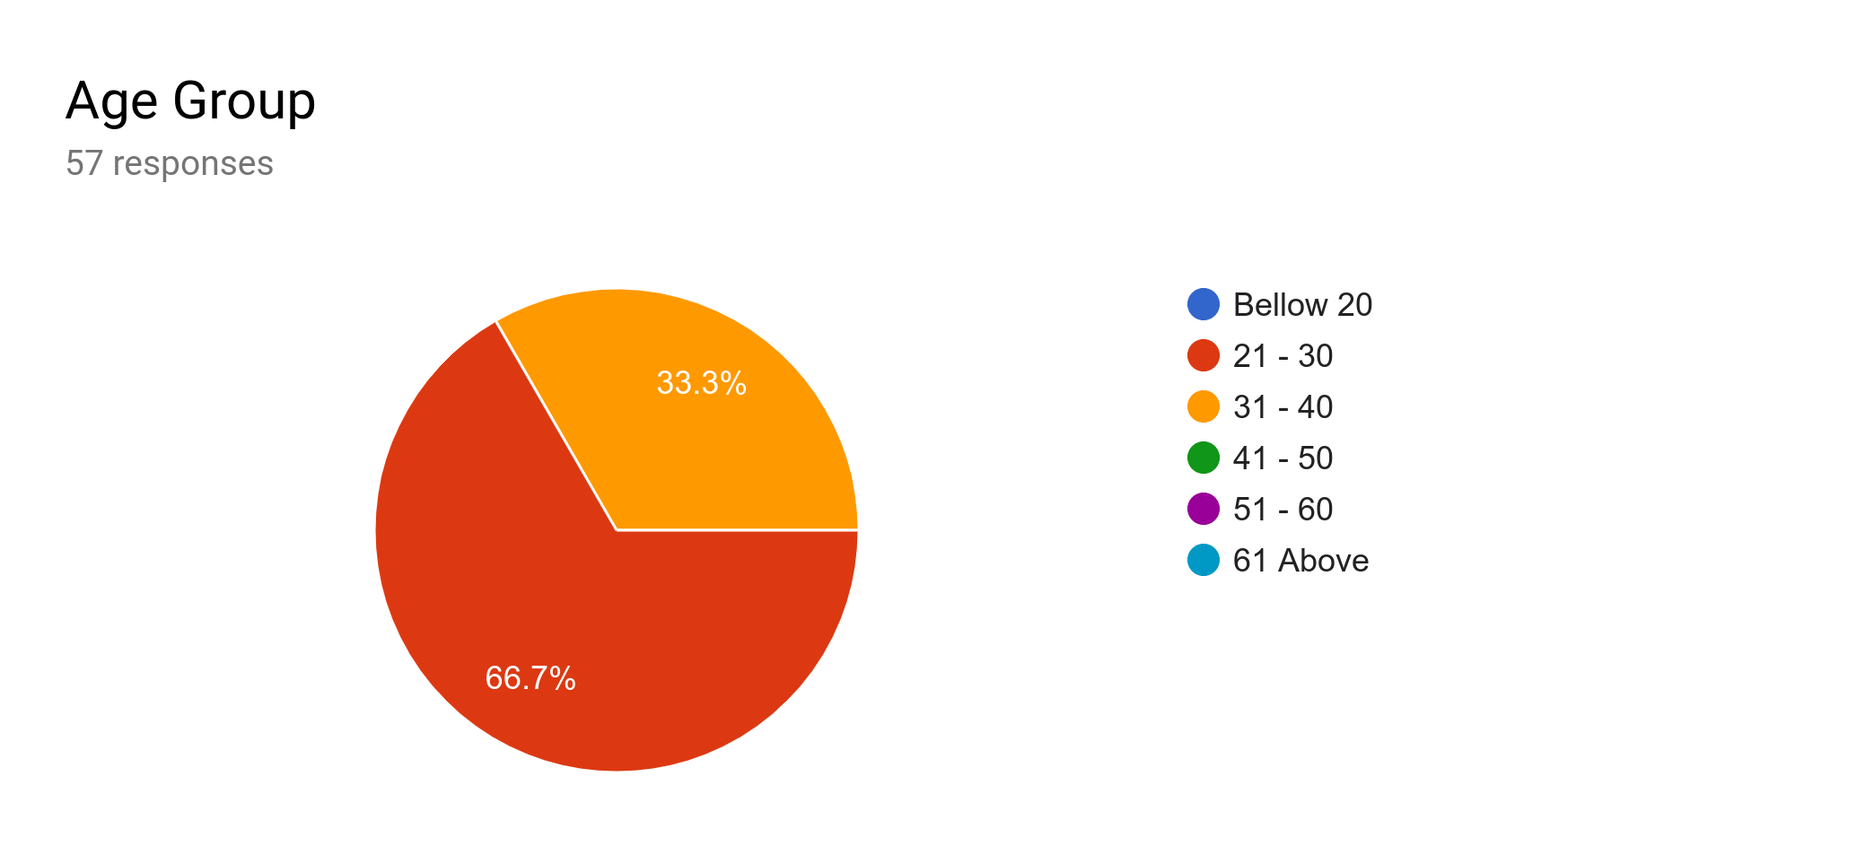

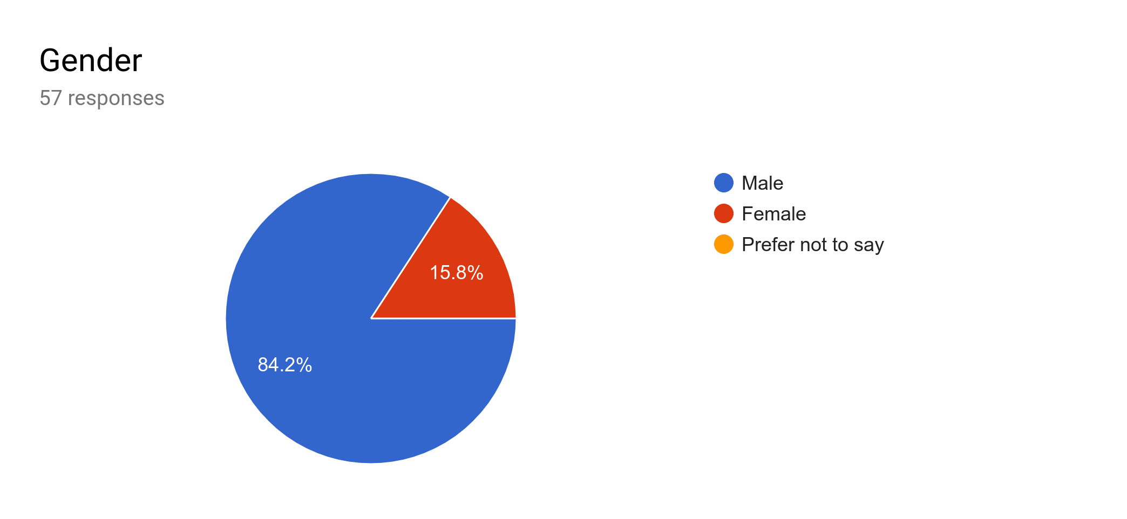

All the respondents are in age between 21-40. Also 84.2% of respondents are male

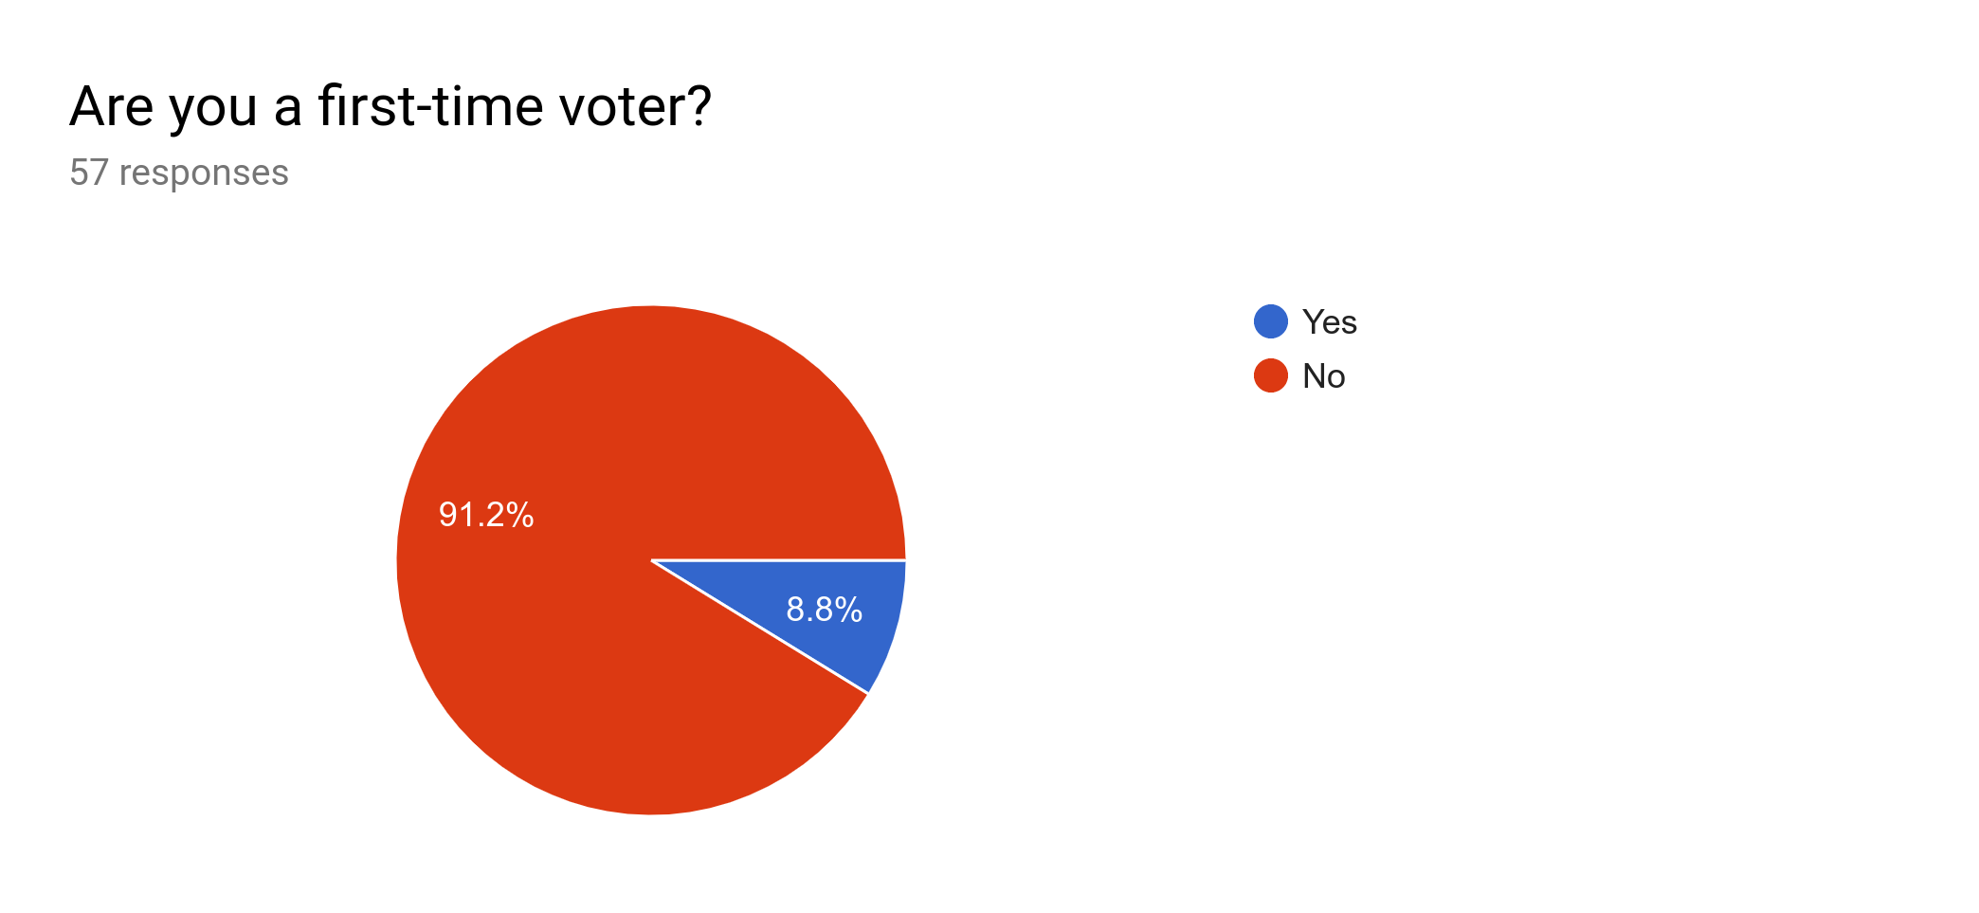

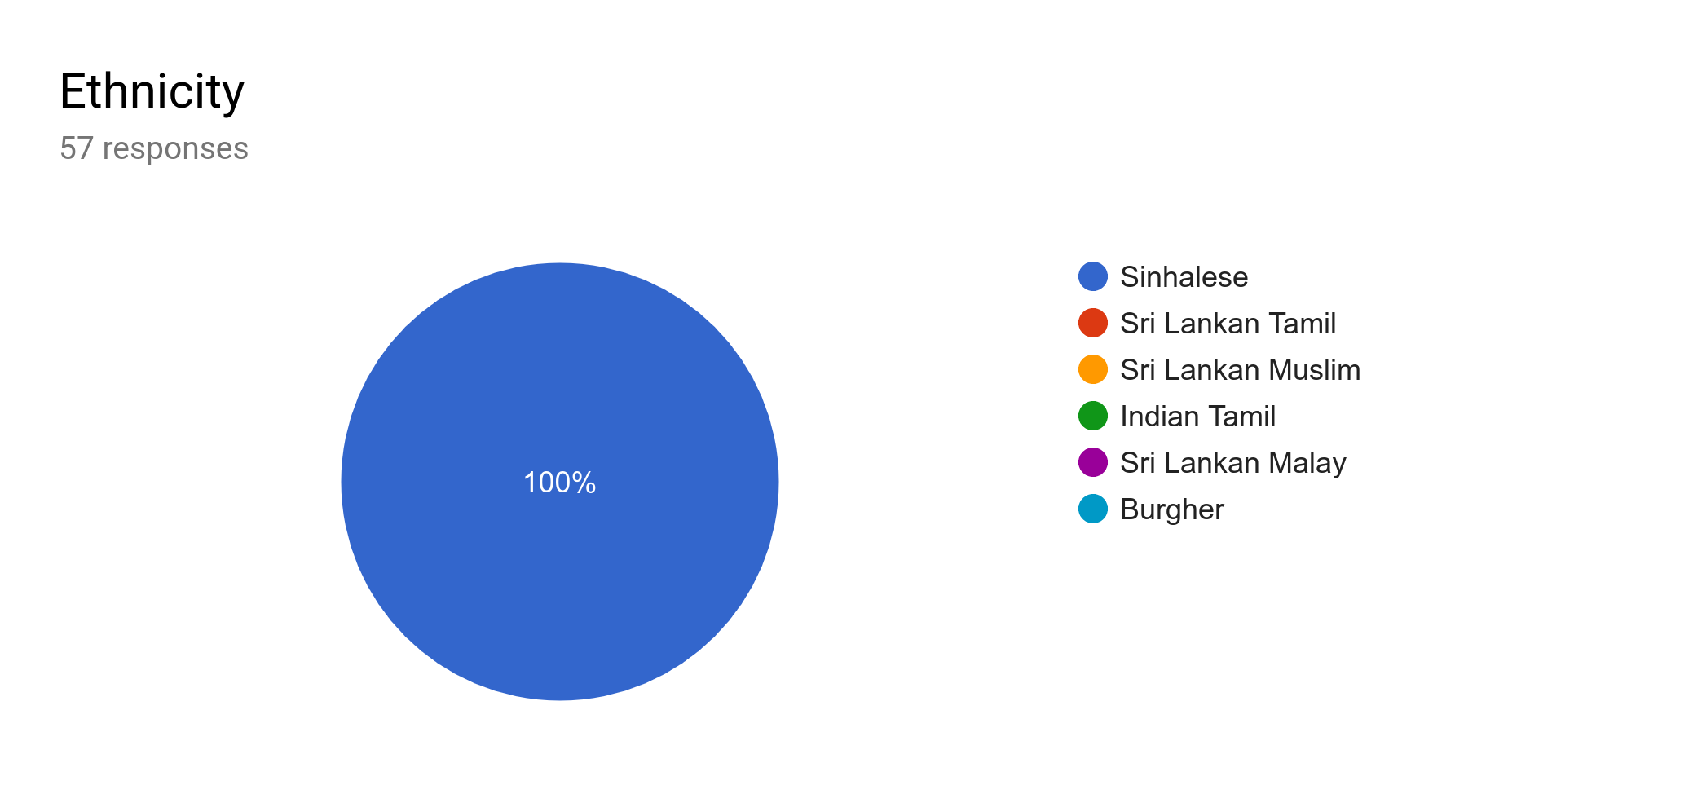

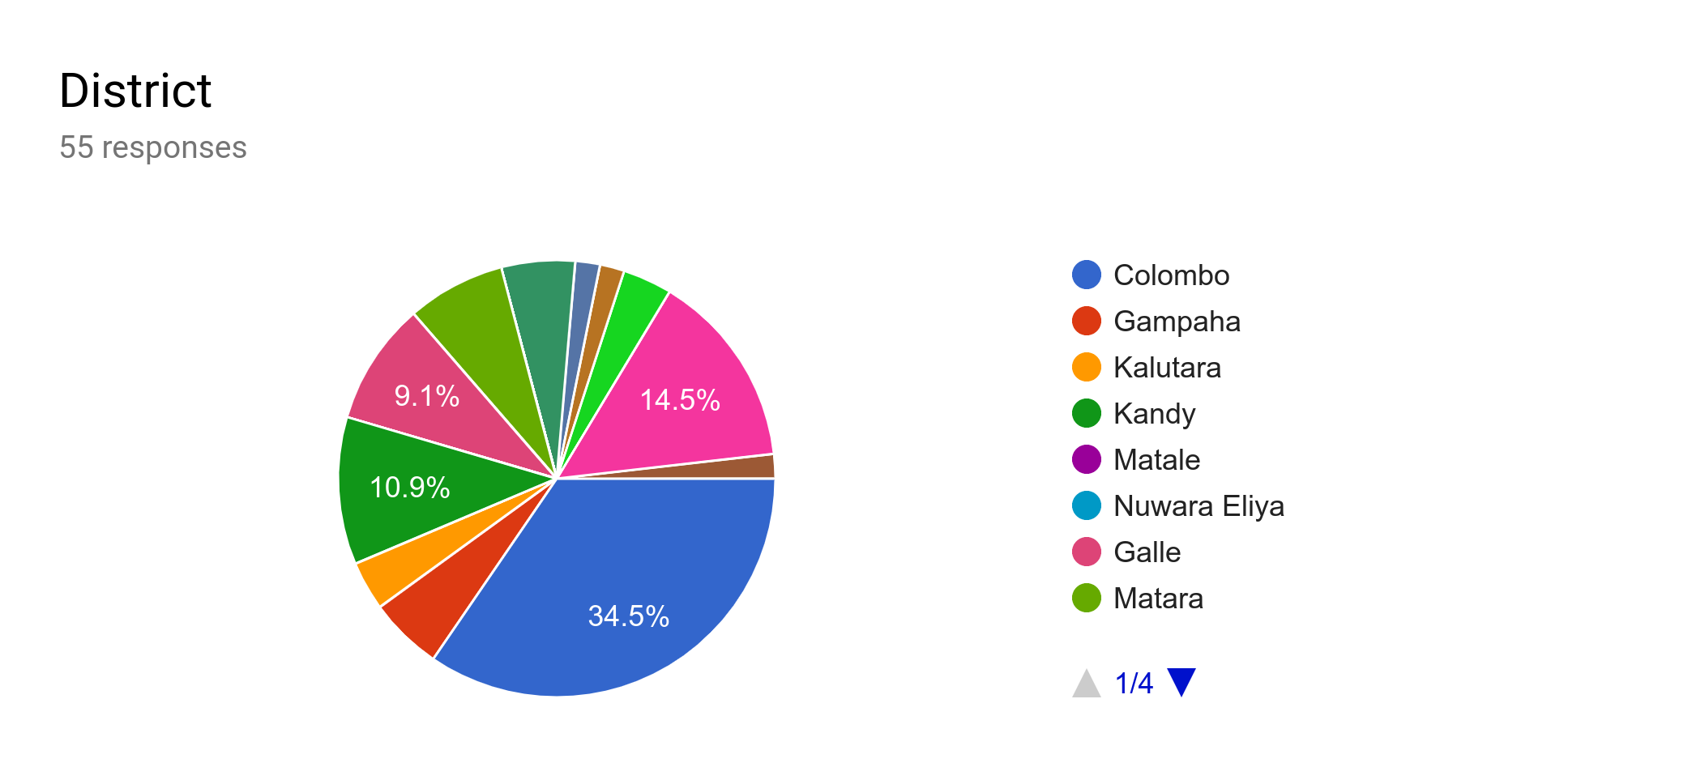

All the respondents are Sinhalese and 8.8% are first time voters. Geographically 34.5% of respondents are from Colombo district.