**第12組**

**一、題目：**食品購物網站

**二、動機：**

隨著資訊時代來臨，線上食品交易也越來越蓬勃發展，因此，我們希望運用資料庫的概念，建立一個方便且實用的線上交易平台，讓整體的購物資訊能夠得到最佳的效用，同時，也能幫助我們由日常生活的網路交易模式實際接觸資料庫的運作流程，更深入的了解這門課。

**三、資料庫內容**(資料表、欄位)

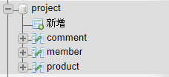

✽買家列表：

|  |  |  |  |  |  |
| --- | --- | --- | --- | --- | --- |
| 買家編號 | 帳號(email) | 密碼 | 性別 | 電話 | 地址 |

`member_id``member_email``member_pw``member_sex``member_phone``member_address

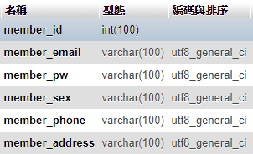

✽商品明細：

|  |  |  |  |  |  |
| --- | --- | --- | --- | --- | --- |
| 商品編號 | 名稱 | 類別 | 價格 | 庫存量 | 平均評價星等 |

`p_id``p_name``p_category``p_price``p_inventory``p_star`

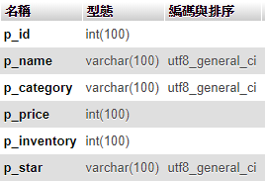

✽留言列表：

|  |  |  |  |  |
| --- | --- | --- | --- | --- |
| 留言編號 | 商品編號 | 留言內容 | 評價星等 | 買家編號 |

`comment_id``comment_pid``comment_content``comment_star``comment_mid`

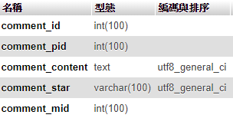

✽問答列表：

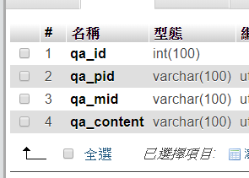

✽訂單列表：

|  |  |  |  |  |  |  |
| --- | --- | --- | --- | --- | --- | --- |
| 訂單編號 | 訂單日期 | 買家編號 | 總金額 | 付款方式 | 送貨方式 | 是否繳款 |

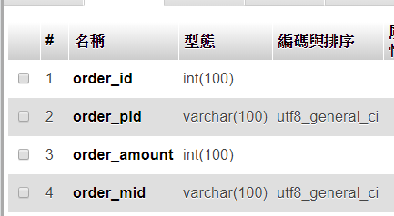

✽購物車列表：

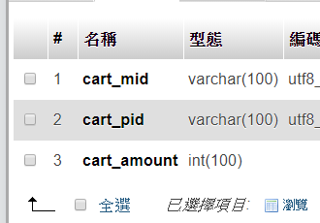

~~✽訂單明細：~~

|  |  |  |
| --- | --- | --- |
| ~~訂單編號~~ | ~~商品編號~~ | ~~數量~~ |

~~✽商品類別：~~

|  |  |
| --- | --- |
| ~~類別編號~~ | ~~商品類別~~ |

~~✽送貨方式：~~

|  |  |
| --- | --- |
| ~~方式編號~~ | ~~送貨方式~~ |

~~✽付款方式：~~

|  |  |
| --- | --- |
| ~~方式編號~~ | ~~付款方式~~ |

**四、系統簡介**

|  |  |
| --- | --- |
| 1.會員系統： 註冊、登入登出、會員資料的修改 | 2.訂單系統：  新增訂單、查詢訂單記錄、購物車 |
| 3.商品系統：  相關留言and內容查看、統計商品的平均星等  搜尋商品 | 4.留言系統：  新增留言、新增評價星等 |

**五、資料來源**

資料庫：巨匠電腦-商品訂貨資料庫

組員:0313476張文馨0513405洪瑩家0513411徐筠婷

0513459郭家妤0513149何芷菱

點心-餅乾

<http://m.herdorlife.com/system/mobile_photos/paperclips/000/000/118/original/%E6%89%8B%E5%B7%A5%E9%A4%85%E4%B9%BE02.jpg?1463017543>

調味品-番茄醬

[https://png.pn](https://png.pngtree.com/element_pic/16/11/11/05251629e500dba5ec8248829b271c43.jpg)

[gtree.com/element_pic/16/11/11/05251629e500dba5ec8248829b271c43.jpg](https://png.pngtree.com/element_pic/16/11/11/05251629e500dba5ec8248829b271c43.jpg)

日用品-

穀類/麥片-

<http://i.epochtimes.com/assets/uploads/2015/08/1506221317372483-600x400.jpg>

肉/家禽-雞

<http://www.people.com.cn/mediafile/pic/20121219/47/12033270885886458827.jpg>

特製品-沙茶粉

<http://im2.book.com.tw/image/getImage?i=http://www.books.com.tw/img/N01/003/88/N010038853.jpg&v=4fc4547d&w=348&h=348>

海鮮-螃蟹

<http://bpic.588ku.com/element_origin_min_pic/16/09/18/2057de8bc4d97ef.jpg>

|  |  |  |  |  |  |
| --- | --- | --- | --- | --- | --- |
| 1 | 蘋果汁 | drinks | 30 | 100 | https://i.imgur.com/uEIADwx.jpg |
| 13 | 餅乾 | snack | 17 | 100 | http://m.herdorlife.com/system/mobile_photos/paper... |
| 26 | 番茄醬 | sauce | 10 | 100 | http://www.corso.md/uploads/products/25/productsit... |
| 48 | 白飯 | corp | 21 | 100 | http://www.karibeerice.com/images/icons/icon3.png |
| 55 | 雞肉 | meat | 97 | 100 | http://assets.stickpng.com/thumbs/580b57fbd9996e24... |
| 61 | 沙茶醬 | processed | 23 | 100 | https://i.imgur.com/2gxKFDS.jpg |
| 65 | 螃蟹 | seafood | 31 | 100 | https://images.freshop.com/7733925/3a75dc457bd31e6... |
| 8 | 柳橙汁 | drinks | 46 | 100 | https://pbs.twimg.com/media/CzZv9oGXgAEOZ2Q.jpg |
| 4 | 啤酒 | drinks | 14 | 100 | https://s.yimg.com/wb/images/C1C82221CAF4CB3390068... |
| 6 | 綠茶 | drinks | 264 | 100 | https://i.imgur.com/wydtZxx.jpg |
| 7 | 草莓汁 | drinks | 18 | 100 | https://i.imgur.com/nU9jWwt.jpg |
| 9 | 鳳梨汁 | drinks | 14 | 100 | http://s6.gigacircle.com/media/s6_53c4853da404b.jp... |
| 11 | 咖啡 | drinks | 8 | 100 | http://img.pcstore.com.tw/~prod/M20060148_big.jpg?... |
| 14 | 糖果 | snack | 9 | 100 | https://i.imgur.com/xCDUZ3l.jpg |

(1, '蘋果汁', 'drinks', 30, 100, 'https://i.imgur.com/uEIADwx.jpg'),

(13, '餅乾', 'snack', 17, 100, 'http://m.herdorlife.com/system/mobile_photos/paperclips/000/000/118/original/%E6%89%8B%E5%B7%A5%E9%A4%85%E4%B9%BE02.jpg?1463017543'),

(26, '番茄醬', 'sauce', 10, 100, 'http://www.corso.md/uploads/products/25/productsitem_1467588605.png'),

(48, '白飯', 'corp', 21, 100, 'https://encrypted-tbn0.gstatic.com/images?q=tbn:ANd9GcS3k79NyKo1qksfXXUhlKuGJRcz0WPf2cxwM3j1Km8yLwxRJV80'),

(55, '雞肉', 'meat', 97, 100, 'http://assets.stickpng.com/thumbs/580b57fbd9996e24bc43c0ce.png'),

(61, '沙茶醬', 'processed', 23, 100, 'https://i.imgur.com/2gxKFDS.jpg'),

(65, '螃蟹', 'seafood', 31, 100, 'https://images.freshop.com/7733925/3a75dc457bd31e64e21eb55ac22ec3c9_medium.png'),

(8, '柳橙汁', 'drinks', 46, 100, 'https://pbs.twimg.com/media/CzZv9oGXgAEOZ2Q.jpg'),

(4, '啤酒', 'drinks', 14, 100, 'https://s.yimg.com/wb/images/C1C82221CAF4CB33900684AD81A4D566C68E4D85'),

(6, '綠茶', 'drinks', 264, 100, 'https://i.imgur.com/wydtZxx.jpg'),

(7, '草莓汁', 'drinks', 18, 100, 'https://i.imgur.com/nU9jWwt.jpg'),

(9, '鳳梨汁', 'drinks', 14, 100, 'http://s6.gigacircle.com/media/s6_53c4853da404b.jpg'),

(11, '咖啡', 'drinks', 8, 100, 'http://img.pcstore.com.tw/~prod/M20060148_big.jpg?pimg=static&P=1428387988'),

(14, '糖果', 'snack', 9, 100, '<https://i.imgur.com/xCDUZ3l.jpg>');

[order_id](http://localhost/phpmyadmin/sql.php?db=project&table=orders&sql_query=SELECT+%2A+FROM+%60orders%60++%0AORDER+BY+%60orders%60.%60order_id%60+ASC&session_max_rows=25&is_browse_distinct=0) [order_pid](http://localhost/phpmyadmin/sql.php?db=project&table=orders&sql_query=SELECT+%2A+FROM+%60orders%60++%0AORDER+BY+%60orders%60.%60order_pid%60+ASC&session_max_rows=25&is_browse_distinct=0) [order_amount](http://localhost/phpmyadmin/sql.php?db=project&table=orders&sql_query=SELECT+%2A+FROM+%60orders%60++%0AORDER+BY+%60orders%60.%60order_amount%60+ASC&session_max_rows=25&is_browse_distinct=0) [order_mid](http://localhost/phpmyadmin/sql.php?db=project&table=orders&sql_query=SELECT+%2A+FROM+%60orders%60++%0AORDER+BY+%60orders%60.%60order_mid%60+ASC&session_max_rows=25&is_browse_distinct=0)

qa_id qa_pid qa_content qa_mid