PWLLHELI SAILING CLUB
What the Race Hut System Does for the Club
For race officers, competitors, spectators, members, sponsors and the bar
6 October 2026

The race officer system runs the start sequence and horn from the PC in the start hut, times and scores the fleet, and puts the racing on phones, the club website and the bar TV. It lightens the race officer's job, lets a race start and finish with nobody in the hut, and gives competitors, spectators, members and sponsors far more to see than a normal club race.

At a glance
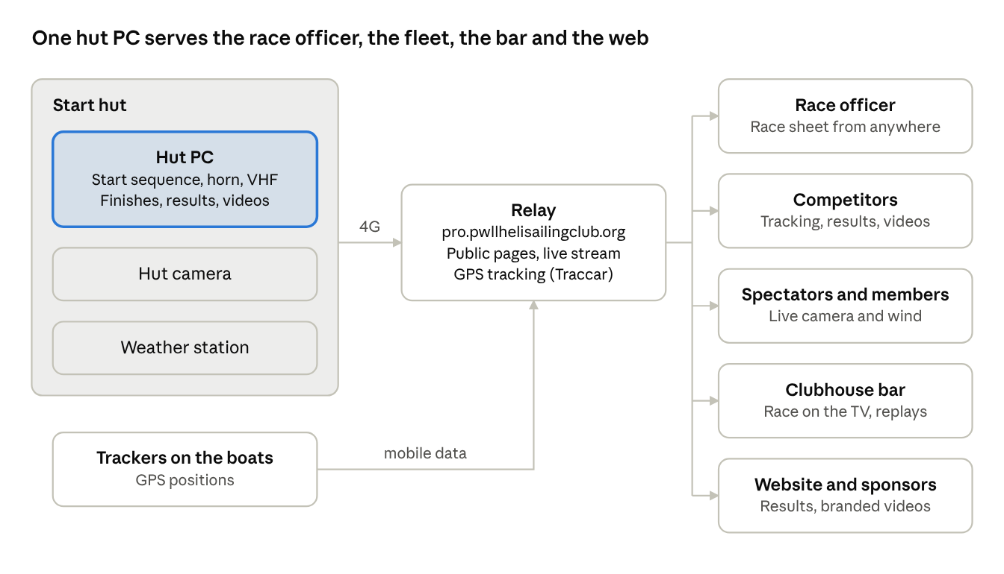
Who the system serves: the hut, the relay and five audiences
Everything starts in the hut. The relay carries it out to phones, the bar TV and the club website, and brings the trackers' positions back in.

For the race officer
The hut PC keeps the time, sounds the horn and does the arithmetic, so the race officer can watch the water instead of the clock.
Race-day job | What the system does
Start sequence | Up to six starts from one warning time. Warning, preparatory, one-minute and start signals for each, on the clock; two signals at the same moment share one horn.
Horn | The hut PC sounds the horn through a relay. The existing horn button still works without the PC.
VHF | A spoken script: a ten-minute announcement, the course read out twice, then a count from ten before every gun.
Flags | The class pennants, P, S and AP are shown on screen while they should be up, to check against the real flags.
Postponement and shortening | AP or S with the right sound signals and announcement. When AP comes down, every later signal is re-timed.
Finishes | The Finish button, the existing horn switch, a spoken or typed finish to the Virtual Race Officer, or GPS from a tracker. Every finish is time-stamped and filmed.
Ratings | No certificates to collect. Each boat's IRC rating is looked up in the RORC's published IRC listing, with its certificate number, and its YTC rating in the YTC sheet; both lists are downloaded again whenever the copy held is more than an hour old. Each entry keeps the rating it was entered with, so a later change never alters a race already sailed, and a boat with no IRC rating is left out of the IRC results rather than scored on a guess.
Results | Elapsed and corrected times worked out automatically for IRC and YTC. Series tables with discards and tie-breaks, published to the club website in one step.
Evidence | A video clip of every start signal and every finish, kept at full quality in the hut.
Records | Wind at the hut logged around every race, a log of who did what, and a nightly encrypted off-site backup.

The Virtual Race Officer takes instructions in plain English, typed or spoken: “start the Mojito series race at 11”, “Mojito's finished”. It reads each one back and acts only on a Yes. It can create races, set the start and course, enter boats, postpone, shorten, finish boats, and answer questions about positions, results and the forecast. It cannot sound the horn on command, signal a recall or abandonment, or change settings.
The race sheet works from anywhere through the club's secure web address. A race officer on the committee boat or ashore can move a start time or postpone, and the hut follows.

Racing without a race officer
A race can start and finish with nobody in the hut, as long as the hut PC is on and the boats carry trackers. The club has agreed that a race may start with nobody watching the line: a boat later judged over the line from the start video takes an alternative penalty.
How an unattended race runs:
- Someone sets the race up beforehand, from anywhere: the warning time, course and entries, on the race sheet or by asking the Virtual Race Officer.
- On the day, the hut PC runs the sequence on the clock: horns, VHF announcements and the public countdown. There is no start button to press.
- Boats with trackers are finished by GPS. A crossing of the finish line, once every mark has been rounded, is recorded and filmed automatically. This “auto-confirm” is a tick on the race sheet, already on for races set up through the Virtual Race Officer; without it, GPS finishes wait for a person to confirm.
- Results work themselves out and appear on the competitor pages, marked provisional.
- Afterwards, the race officer or committee checks the start video for boats over the line and confirms the results.
What still needs a person:
- Someone from the club in charge of the day's racing, who decides whether conditions are suitable for it to go ahead.
- Hoisting the flags. The PC shows which should be up; it does not hoist them.
- The hut PC switched on and logged in, with its clock correct.
- Trackers charged before the day. An ATC700 lasts about nine hours.
- Finishing any boat without a tracker, by the horn switch or by telling the Virtual Race Officer from the water.
- Recalls, abandonment, protests and redress.
- Safety cover.
GPS finish times are close but not exact: at 3.5 knots, a 50 m position error is 28 seconds. The finish video remains the arbiter.

For competitors
Competitors can follow their race on a phone, afloat or ashore, and watch it again afterwards: information that normally only the race officer has, or nobody has. It is all at pro.pwllhelisailingclub.org, with no login.
When | What competitors see
Before the start | The course, marks and entries with ratings. The countdown to the start. Wind at the hut, live and for the last hour. The live camera. A banner the moment a race is postponed.
During the race | Every tracked boat on the chart, with marks rounded, next mark, distance to go and speed. An estimated corrected-time leaderboard after the first ten minutes, labelled as an estimate. The chart can be wound back or played at up to 60× speed. A banner if the course is shortened.
After the race | Provisional results as boats finish. Start and finish videos (a start clip can take about 20 minutes to upload). The track replay, kept for good. A 3D replay film of the race, usually within about an hour. Series results on the club website.

For the first time, a crew can see their own start from the line, watch their finish, and replay the whole race against the boats around them. The course is also published as data, so a chart plotter or range-and-bearing app can pick up the marks.

For spectators
Anyone can watch the start and finish live and follow the fleet round the course, from the shore, at home or on the club website.
- Live camera: the hut camera at pro.pwllhelisailingclub.org/live, or the Live camera tab on the competitor pages. It fills a phone screen.
- Tracking chart: the same live chart competitors see, with the boats moving and the estimated leaderboard.
- Club website: a live-camera window can be embedded on the club's own site.
- The bar TV: the race as it happens, for anyone in the clubhouse (see In the bar).
A crowd costs no more than one viewer. The hut sends a single stream only while someone is watching, and Cloudflare passes it on to everyone else. The stream uses about 640 MB of the hut's 4G for each hour it is watched.
The club can see how many people watched, and roughly where from, in an optional statistics report on the relay. Visitor IP addresses are personal data, so the logs are kept private and short-lived.

For club members
Members can check the conditions at the start hut before heading down. The wind and the camera are on the public home page, pro.pwllhelisailingclub.org, race or no race, whenever the hut PC is on.
- Wind: direction, speed and gusts from the hut's weather station, refreshed every 5 seconds, with a history of the last 5 to 60 minutes. It is the wind at the hut, not out on the course.
- Camera: the live view from the hut across the start area: the sea state, and who is already out.
- Forecast: race officers can ask the Virtual Race Officer for the forecast. The public pages show the measured wind only.
When the hut PC is off, the address shows a holding page instead.

For sponsors
Sponsor logos go wherever the club's video goes, so every start, every finish and every replay carries them.
Where | How the logo appears
Public start and finish videos | Club logo top-left, one sponsor top-right, changing every 5 seconds
Live camera stream and snapshots | The same rotation, built into the picture
3D replay films | Club and sponsor branding on the film
Published results on the club website | Sponsor logos that link to their websites
The bar TV | In the camera clips and race replays shown on it

Logos and their website links are managed in the app's Settings, under Public branding. The full-quality evidence clips kept in the hut stay unbranded.
The relay's statistics report and Cloudflare's analytics show how many people watched, which the club can share with sponsors. There is no report per sponsor yet.

In the bar
It gives the bar something to gather round, and the 3D replay film is what people are most likely to watch after racing. The live screen shows the race as it happens; the film shows it again in a way nobody on the water could see it.
The 3D replay film:
- The fleet in three dimensions over the real coastline, sailing the course they actually sailed. Each boat heels, trims to the wind of that moment and sets a spinnaker when the angle calls for one.
- The hut camera cut in at the start and at each finish, locked to the same clock as the 3D view, so crews see their own start and finish.
- Each boat's name and speed, the race clock, the course and the true wind throughout.
- A title card, and a results card with the corrected times in both IRC and YTC, so the film stands on its own.
- It runs at 30 times real time, slowing to real time for the start and each finish. One three-boat race made an eight-minute film.
- The club burgee and the sponsors appear on it, as on the race videos.
The film is made on a separate computer with a graphics card and takes about an hour per race, so it is usually ready by the time the boats are packed away and people arrive in the bar. Anyone signed in can ask for one from the race's Results tab. The link then appears on the public race pages and in the published results, and plays from the club's video storage, so the bar TV's browser or anyone's phone can show it. That makes it the natural thing to put on in the bar after racing, while crews talk through where places were won and lost.
During racing, the bar TV shows the chart zoomed to the boats still racing, a leaderboard cycling every 15 seconds between order on the water, IRC and YTC, the race clock, course and flags, and the hut camera at the start, at each rounding of the ODM and at each finish. Straight after racing, the same view can be replayed on the TV at six times speed until the film arrives.
The live screen needs only a smart TV's web browser, or a small PC on HDMI, open at pro.pwllhelisailingclub.org/bar. It has no controls and follows the current race by itself. It needs GPS tracking; pursuit races are not shown on it yet.

What it does not replace
The system supports people; it decides nothing. Results stay provisional until the race officer and committee confirm them.
- A person in charge of the day: even with nobody in the hut, someone from the club is responsible for the racing and decides whether conditions are suitable for it to go ahead.
- Judgement: recalls, boats over the line, abandonment, protests and redress.
- The flags: someone still hoists them.
- Safety cover on the water.
- Boats without trackers, and the finishing order of pursuit races, are entered by hand.
- Upkeep: the hut PC on with its clock right; the hut's 4G link up for the public pages, video and tracking; trackers charged; the tracker SIM account in credit (if it runs dry, every tracker stops at once).
The race office still works without the internet: on the hut's own network, races, results, series, video, the horn and the weather all carry on. Only the public pages, tracking, the Virtual Race Officer and uploads need the link.

Future development: ideas for discussion
These are ideas to discuss, not decisions. Each would need the club's agreement before any work starts, and each should pass three tests: does it make it easier for competitors to race, easier for the club to run races, and is it sustainable?
Where the system still relies on people today:
- Entries: the race officer enters each boat into the series and the race.
- Trackers: someone charges them, hands them out before racing and collects them afterwards.
- The decision to race: someone from the club is responsible for the day and decides whether conditions are suitable. This should probably always stay with a person; the first two could perhaps pass to the competitors themselves.

Could competitors enter themselves?
One option is for skippers to sign in, enter their boat into a series or a single race, and pay the fee online. The app already keeps every boat with its ratings, and a boat added to one race in a series is already added to all the others, so a series entry could carry through the season with no further typing. Entries could also be checked against the club's membership list, with a weekend or event fee offered to non-members.
Questions to settle first:
- Which payment provider, and is its charge on each payment acceptable?
- Who keeps the membership list up to date, and can the system check against it?
- How would skippers manage their own accounts, forgotten passwords included, without that becoming a volunteer's job?
- What happens to fees when a race is abandoned or cancelled, and how would late entries on the day work?

Crew lists, if they become a requirement
If future safety rules require a crew list before racing, skippers could add it to their entry from a phone. The system could check that each crew member is a club member or has paid a weekend fee, and give the person in charge one list of who is on which boat. Crew names are personal data under UK GDPR, so the club would need to decide how long a list is kept and when it is deleted.

Could skippers look after their own trackers?
Instead of handing trackers out and collecting them on race days, each could be assigned to a racing skipper for the season, who keeps it charged and aboard. The app already pairs trackers with boats and reads each tracker's battery, so it could remind a skipper the evening before a race if theirs is low or has stopped reporting. The club would then only look after spares and replacements. At about £62 for an ATC700 and £11 a year to run, one question for the committee is whether skippers pay a deposit or the cost goes into the race fee.

Could the trackers act as tallies?
The trackers might also sign boats out of the marina and back in. Traccar, already running on the relay, can draw a boundary round the marina and record each boat leaving and returning, so the person in charge could see who is still out and be alerted if a boat has not come back a set time after racing.
It could support a tally rather than replace one: a flat battery, or a tracker left ashore, looks the same as a boat that has not come back, and mobile coverage thins offshore. It would work best if every racing boat carried its own tracker.

The person in charge of the day
Whatever changes, the club will need a named person responsible for the day's racing, who decides whether conditions are suitable for it to go ahead. The system could help them decide and act from anywhere: the wind at the hut, the forecast, the live camera and a tally list on a phone, and postponing or moving a start from the race sheet. The decision would stay theirs; how the role is filled is for the club to decide.

Keeping it sustainable
- Volunteer time: an idea is only worth taking up if it removes a job rather than moving it to someone else.
- Money: the running costs are known, about £403 a year (see the Race Hut System Costs document), and one option is to meet them from race fees if entries are paid online.
- Software: no licence fees. The system is published and documented on GitHub at github.com/mojito9047/pwllheli-race-officer and released under the MIT licence, so anyone can use it, and everything it builds on is free and open source. Other clubs could run it too, and help look after it.
- Looking after the system: one person builds and maintains it today. The documentation, the off-site backups and the published code all help, but the club should consider how more than one person could keep it running.

Useful links

For everyone (no sign-in)
Page | Address
The public pages | pro.pwllhelisailingclub.org
Bar tracking during races | pro.pwllhelisailingclub.org/bar
The live camera view | pro.pwllhelisailingclub.org/live

For race officers (sign in first)
Page | Address
The admin and race pages | pro.pwllhelisailingclub.org/admin
The Virtual Race Officer | pro.pwllhelisailingclub.org/admin/onwater
Survey the marks | pro.pwllhelisailingclub.org/admin/marks/ping

