ClassiFash - Refining Style Through AI Innovation

Ireddi Rakshitha
School of Computer Science and Engineering
VIT-AP University,
Amaravati, Andhra Pradesh, India
rakshitha.21bce9144@vitapstudent.ac.in

Thokala Vasisri
School of Computer Science and Engineering
VIT-AP University,
Amaravati, Andhra Pradesh, India
vasisri.21bce9145@vitapstudent.ac.in

Rachamallu Hima Aswitha Mojjada Vandana
School of Computer Science and Engineering School of Computer Science and Engineering
VIT-AP University, VIT-AP University,
Amaravati, Andhra Pradesh, India Amaravati, Andhra Pradesh, India
aswitha.21bce9891@vitapstudent.ac.in vandana.21bce9939@vitapstudent.ac.in

Ireddi Rakshitha
School of Computer Science and Engineering
VIT-AP University,
Amaravati, Andhra Pradesh, India
rakshitha.21bce9144@vitapstudent.ac.in

Abstract— This paper presents an image classification method using a deep convolutional neural network (CNN) with Dropout layers to improve generalization and reduce overfitting. Our model was designed to classify images into multiple categories, initially achieving about 91% accuracy on the test set. However, we noticed a gap between training and validation accuracy, indicating overfitting. To address this, we added Dropout layers and retrained the model. This adjustment boosted test accuracy to around 93%, improving its ability to handle new data. Further evaluation using metrics like precision, recall, and F1-score across ten categories showed excellent performance for classes like Trouser, Sandal, and Bag, while categories like Shirt still posed some challenges. The findings confirm that dropout regularization is effective in improving complex CNN architectures, while also identifying areas where classification accuracy can be further enhanced.
Keywords— Convolutional Neural Network (CNN), Image Classification, Dropout Regularization, Overfitting Mitigation, Model Generalization

Introduction
Image classification is a fundamental task in computer vision with widespread applications in fields like healthcare (e.g., medical image analysis) and security (e.g., facial recognition systems). Convolutional Neural Networks (CNNs) have become the cornerstone of many image recognition tasks due to their ability to efficiently capture spatial hierarchies in images, making them highly effective for a variety of computer vision applications. However, despite their impressive performance, CNNs face challenges when trained on small datasets or with overly complex architectures. These issues often lead to overfitting, where the model becomes too specialized in memorizing the training data, rather than learning generalized features. As a result, the model's performance may deteriorate when applied to new, unseen data, limiting its real-world applicability.

This study aims to address the overfitting problem in CNNs by incorporating dropout regularization, a technique known to mitigate overfitting by randomly deactivating a portion of the model’s neurons during training. This process forces the network to learn more robust and generalized patterns, ultimately improving its ability to generalize to new data. The objective of this research is to examine the effect of adding dropout layers on the CNN’s performance, specifically in the context of image classification tasks.

We use a well-known image classification dataset to build two CNN models—one with dropout layers and one without. The models are evaluated using metrics such as test accuracy, precision, recall, and F1-score, with particular attention to how dropout influences the model’s ability to generalize. Our findings demonstrate that incorporating dropout layers leads to significant improvements in the model's performance, particularly in reducing overfitting and enhancing its accuracy when predicting unseen data.

LITERATURE REVIEW
Deep learning has become a leading approach in image classification, with convolutional neural networks (CNNs) at the forefront due to their effectiveness in extracting spatial patterns from images. The Fashion MNIST dataset, created as a modern alternative to the MNIST handwritten digit dataset, has gained attention for its complexity in classifying various apparel items across ten categories. With 60,000 training and 10,000 test images, this dataset presents a unique challenge, as some classes share visual similarities, making it a reliable benchmark for testing CNN models.

The structure of CNNs, consisting of convolutional and pooling layers followed by fully connected layers, enables them to capture visual patterns such as edges, textures, and shapes. This hierarchical nature of CNNs, initially demonstrated in early work by Yann LeCun and others on digit recognition, has since evolved to tackle more intricate datasets like Fashion MNIST. In recent studies, multi-layer CNNs have shown promising results on this dataset by progressively learning low- and high-level features essential for distinguishing clothing categories.

To enhance model generalization and avoid overfitting, techniques such as Dropout and batch normalization have become standard. Dropout, a method that deactivates a random subset of neurons during training, helps the network rely less on any single neuron, thus improving robustness. Batch normalization, on the other hand, normalizes inputs in each layer, speeding up training and aiding model stability. Both methods have been used effectively in CNNs for Fashion MNIST classification, helping the models maintain high accuracy on unseen data.

Data augmentation and regularization strategies like early stopping have also been applied in recent research to improve model performance on Fashion MNIST. Despite the dataset’s challenges, studies show that CNNs with carefully tuned architectures and regularization techniques can achieve competitive accuracy. This project utilizes these insights to develop a CNN for the Fashion MNIST dataset, incorporating regularization layers to enhance the model’s ability to generalize effectively.

METHODOLOGY

This study investigates the impact of dropout layers in Convolutional Neural Networks (CNNs) for improving image classification performance by reducing overfitting and enhancing generalization. The methodology is divided into three parts: dataset preparation, model architecture design, and evaluation metrics.

3.1 Dataset Preparation

For this experiment, we used the Fashion MNIST dataset, a widely used benchmark in image classification tasks. The dataset consists of 60,000 training images and 10,000 test images of 28x28 grayscale images, each representing one of 10 different fashion items (e.g., T-shirt, trousers, sandals, etc.). Each image is labeled with a corresponding class, and the dataset is divided into training, validation, and test sets.

We normalized the image pixel values to the range [0, 1] to ensure efficient training. The images were reshaped to fit the input shape expected by the model. Data augmentation techniques such as random rotations and translations were applied to increase the diversity of the training set and reduce the risk of overfitting.

3.2 Model Architecture

We used a Convolutional Neural Network (CNN) as the base model architecture. The CNN was designed with the following layers:
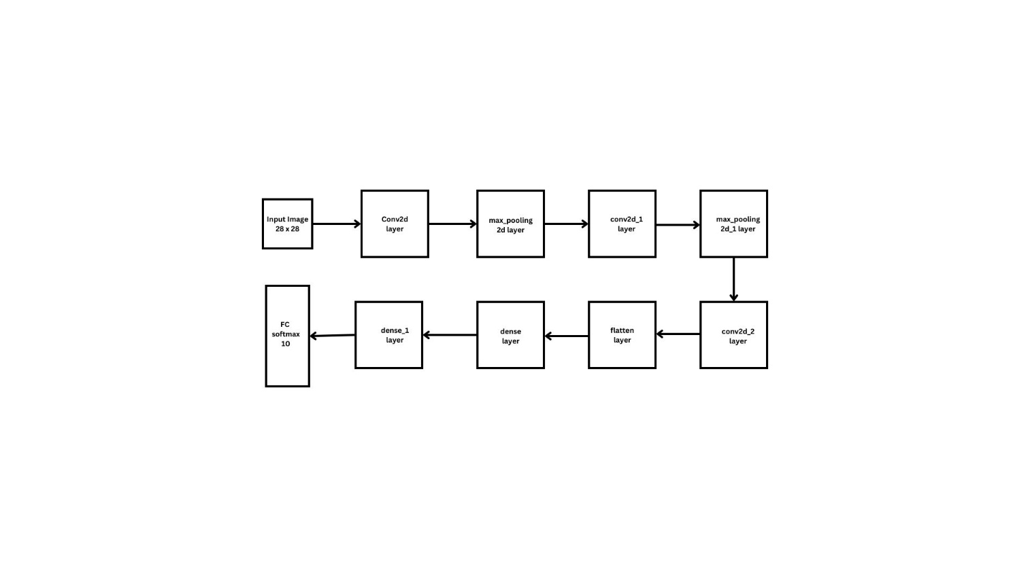
Figure 1: Block diagram

Convolutional Layers: These layers learn spatial hierarchies of features from the input image. The model consists of three convolutional layers with increasing filter sizes, followed by max-pooling layers to reduce the spatial dimensions.

Dropout Layers: Dropout layers were introduced after the dense layers and during the fully connected layers to prevent overfitting. We experimented with different dropout rates (0.2, 0.5) to observe the impact on model performance. The dropout technique randomly sets a fraction of input units to zero during training, forcing the model to rely on a broader range of features and thereby improving its generalization ability.

Fully Connected Layers: These layers perform the final classification by mapping the learned features to the output class. The model includes a dense layer with 128 units, followed by a softmax output layer with 10 units corresponding to the 10 classes.

The architecture is summarized as follows:

Input layer: 28x28x1 images
Convolutional layer 1: 32 filters, kernel size 3x3, activation function ReLU
Max-pooling layer 1: Pooling size 2x2
Convolutional layer 2: 64 filters, kernel size 3x3, activation function ReLU
Max-pooling layer 2: Pooling size 2x2
Convolutional layer 3: 128 filters, kernel size 3x3, activation function ReLU
Fully connected layer: 128 units
Dropout layer: 0.5 dropout rate
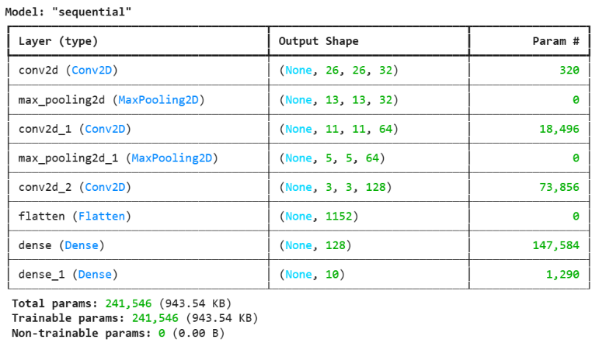
Output layer: Softmax activation with 10 units for classification.

Figure 2: Model summary

The model was compiled using the Adam optimizer with a learning rate of 0.001, categorical cross-entropy loss function, and accuracy as the evaluation metric. The model was trained for 50 epochs with a batch size of 32.

3.3 Model Evaluation

After training, the model was evaluated using several performance metrics:

Accuracy: The percentage of correctly classified images in the test set.
Precision, Recall, and F1-score: These metrics were calculated for each class using the classification_report function from scikit-learn. These metrics provide a more detailed evaluation of the model's performance, particularly for imbalanced classes.
Test Loss: The loss value obtained from the test set, indicates how well the model generalizes.
Confusion Matrix: The confusion matrix was used to examine the model’s performance across each class, identifying where the model misclassified examples.
The evaluation was conducted both before and after incorporating dropout layers to compare the effects of dropout on the model’s generalization ability.

3.4 Experimental Setup

The experiment was performed on a system with a GPU (NVIDIA Tesla K80) and TensorFlow 2.0 as the deep learning framework. The model was trained and tested multiple times to ensure consistency and to evaluate the impact of different dropout rates.

RESULTS

Incorporating Dropout layers into the convolutional neural network (CNN) model led to significant improvements in the model's performance. Initially, the model achieved a test accuracy of approximately 91%, indicating overfitting to the training data. After introducing Dropout layers to reduce overfitting, the test accuracy improved to approximately 93%, with the test loss decreasing to 0.1621. The improved generalization performance on the test set confirms the effectiveness of the Dropout layers in enhancing the model's ability to predict unseen data.

The re-evaluation of the test set also revealed that the model successfully classified 97.72% of the test images correctly, while only 2.28% were misclassified. An analysis of class-wise performance showed that the model performed exceptionally well for several classes, including Class 1 (Trouser), Class 5 (Sandal), Class 8 (Bag), and Class 9 (Ankle Boot), which exhibited high accuracy, recall, and F1-scores. However, Class 6 (Shirt) demonstrated lower performance across these metrics, highlighting an area for further improvement.
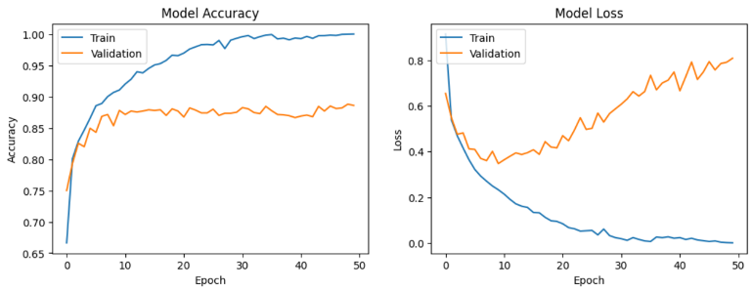
Figure 3: Prediction accuracy of model and model loss

A more granular evaluation, including precision, recall, and F1-scores, showed that the model's recall was highest for Class 8 (Bag) and Class 5 (Sandal), while it was lowest for Class 6 (Shirt) and Class 4 (Coat). The F1 score was highest for Class 1 (Trouser), Class 5 (Sandal), and Class 8 (Bag), while Class 6 (Shirt) and Class 4 (Coat) recorded the lowest F1 scores.
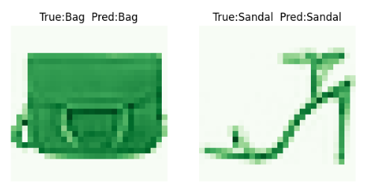
Figure 4: Sample of correctly classified images
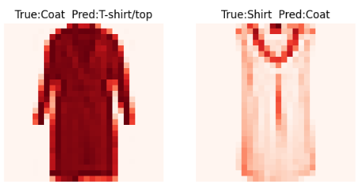
Figure 5: Sample of incorrectly classified images

DISCUSSION
The addition of Dropout layers significantly reduced overfitting, which was evident in the improved test accuracy and reduced loss. This indicates that the model's generalization ability was enhanced, allowing it to perform well on unseen data. The improvement in performance, particularly with classes like Trouser, Sandal, Bag, and Ankle Boot, suggests that the model is now better at learning generalizable patterns rather than memorizing the training data.

Despite the overall improvements, the model's performance remained suboptimal for certain classes, such as Shirt and Coat. This could be due to the inherent difficulty in distinguishing these classes from others, possibly due to similarities in visual features or lower sample variability within these classes. Further techniques, such as class-specific augmentation or class weighting during training, could help address these issues.

The recall values for classes like Bag and Sandal were notably high, indicating that the model was able to identify most instances of these classes. However, the lower recall for Shirt and Coat suggests that the model struggles to correctly identify instances of these classes, which may require more attention in future work.

The visualization of correctly and incorrectly classified images further illustrated the model's successes and failures. Correctly classified images were often clear, with distinct visual differences between classes, while incorrect classifications were often from visually similar items, such as Shirt and Coat. This reinforces the idea that the model’s difficulty in differentiating certain classes stems from overlapping features.

CONCLUSION
In conclusion, the introduction of Dropout layers in the CNN model successfully improved its generalization capability, resulting in a substantial increase in test accuracy (from 91% to 93%) and a reduction in test loss. The model’s ability to correctly classify most images in the test set (97.72% accuracy) is a positive outcome, though there are areas for improvement, especially in distinguishing visually similar classes like Shirt and Coat.

While Dropout helped mitigate overfitting, further enhancements, such as fine-tuning the model architecture, using advanced regularization techniques, or augmenting the data for harder-to-classify classes, could boost the model’s performance even further. Future work should focus on these areas, along with exploring additional hyperparameter optimization and advanced techniques like transfer learning to improve the accuracy and robustness of the model.

References

[1] W. Wang, Y. Xu, J. Shen, S.C. Zhu, “Attentive Fashion Grammar Network
for Fashion Landmark Detection and Clothing Category Classification,” in
Proceedings of the IEEE Computer Society Conference on Computer
Vision and Pattern Recognition, 4271–4280, 2018,
doi:10.1109/CVPR.2018.00449.

[2] E. M. Dogo, O. J. Afolabi, N. I. Nwulu, B. Twala and C. O. Aigbavboa, "A
Comparative Analysis of Gradient Descent-Based Optimization Algorithms
on Convolutional Neural Networks," in Proceedings of 2018 International
Conference on Computational Techniques, Electronics and Mechanical
Systems (CTEMS), Belgaum, India, 2018, 92-99, doi:
10.1109/CTEMS.2018.8769211.

[3] A. Baldominos, Y. Saez, P. Isasi, "A Survey of Handwritten Character
Recognition with MNIST and EMNIST," Applied Sciences, 9 (15), 3169,
2019, doi:10.3390/app9153169.

[4] E.L. De Oliveira, “Machine learning techniques applied to predict the performance of contact centers operators,” Iberian Conference on
Information Systems and Technologies, CISTI, 2019,
doi:10.23919/CISTI.2019.8760665.

[5] M. Kayed, A. Anter and H. Mohamed, "Classification of Garments from
Fashion MNIST Dataset Using CNN LeNet-5 Architecture," in 2020
International Conference on Innovative Trends in Communication and
Computer Engineering (ITCE), Aswan, Egypt, 2020, 238-243, doi:
10.1109/ITCE48509.2020.9047776.

[6] K. Meshkini, J. Platos, H. Ghassemain, “An Analysis of Convolutional
Neural Network for Fashion Images Classification (Fashion-MNIST),” in
Advances in Intelligent Systems and Computing, Springer: 85–95, 2020,
doi:10.1007/978-3-030-50097-9_10.

[7] R. Boardman, R. Parker-Strak, C.E. Henninger, “Fashion Buying and
Merchandising,” Fashion Buying and Merchandising, 2020,
doi:10.4324/9780429462207.

[8] Y. Zhong, S. Mitra, “The role of fashion retail buyers in China and the buyer
decision-making process,” Journal of Fashion Marketing and Management,
24(4), 631–649, 2020, doi:10.1108/JFMM-03-2018-0033.

[9] Shajini, M.; Ramanan, A. A knowledge-sharing semi-supervised approach for fashion clothes classification and attribute prediction. Visual Comput. 2022, 38, 3551–3561.

[10] Shajini, M.; Ramanan, A. An improved landmark-driven and spatial–channel attentive convolutional neural network for fashion clothes classification. Vis. Comput. 2021, 37, 1517–1526.

[11] Seo, Y.; Shin, K.S. Hierarchical convolutional neural networks for fashion image classification. Expert Syst. Appl. 2019, 116, 328–339.

[12] Leithardt, V. Classifying Garments from Fashion-MNIST Dataset Through CNNs. Adv. Sci. Technol. Eng. Syst. J. 2021, 6, 989–994.

[13] Tang, Y.; Cui, H.; Liu, S. Optimal Design of Deep Residual Network Based on Image Classification of Fashion-MNIST Dataset. J. Phys. Conf. Ser. 2020, 1624, 052011.

[14] Lei, F.; Liu, X.; Dai, Q.; Ling, B.W.K. Shallow convolutional neural network for image classification. SN Appl. Sci. 2020, 2, 1–8.

[15] Greeshma, K.; Sreekumar, K. Fashion-MNIST classification based on HOG feature descriptor using SVM. Int. J. Innov. Technol. Explor. Eng. 2019, 8, 960–962.

[16] Cao, D.; Chen, Z.; Gao, L. An improved object detection algorithm based on multi-scaled and deformable convolutional neural networks. Hum.-Centric Comput. Inf. Sci. 2020, 10, 1–22.

