Dry-Season Irrigation Effects on Tree Water Relations, Sap Flux, and Height Growth
Results
We monitored 88 trees from 12 species, divided between Control (n = 44) and Irrigated (n = 44) treatments, across seven measurement campaigns spanning the dry season (early June to early September).
Irrigation produced a sustained divergence in soil water content
Soil water content (SWC) was monitored continuously in Control and Irrigated plots from early June to early September (Fig. 1). Across the full monitoring period, SWC was significantly higher in Irrigated than in Control plots (12.7 ± 3.1% vs. 9.2 ± 1.9%, mean ± SD; linear mixed-effects model with sampling date as a random effect: F_{1,548.5} = 495.9, p < 0.001). Both treatments declined similarly from early June toward a dry-season minimum around late July, after which scheduled irrigation produced repeated transient recoveries in the Irrigated treatment that were absent from the Control treatment (Fig. 1). This sustained separation confirms that the irrigation manipulation produced the intended divergence in substrate water availability throughout the experiment.
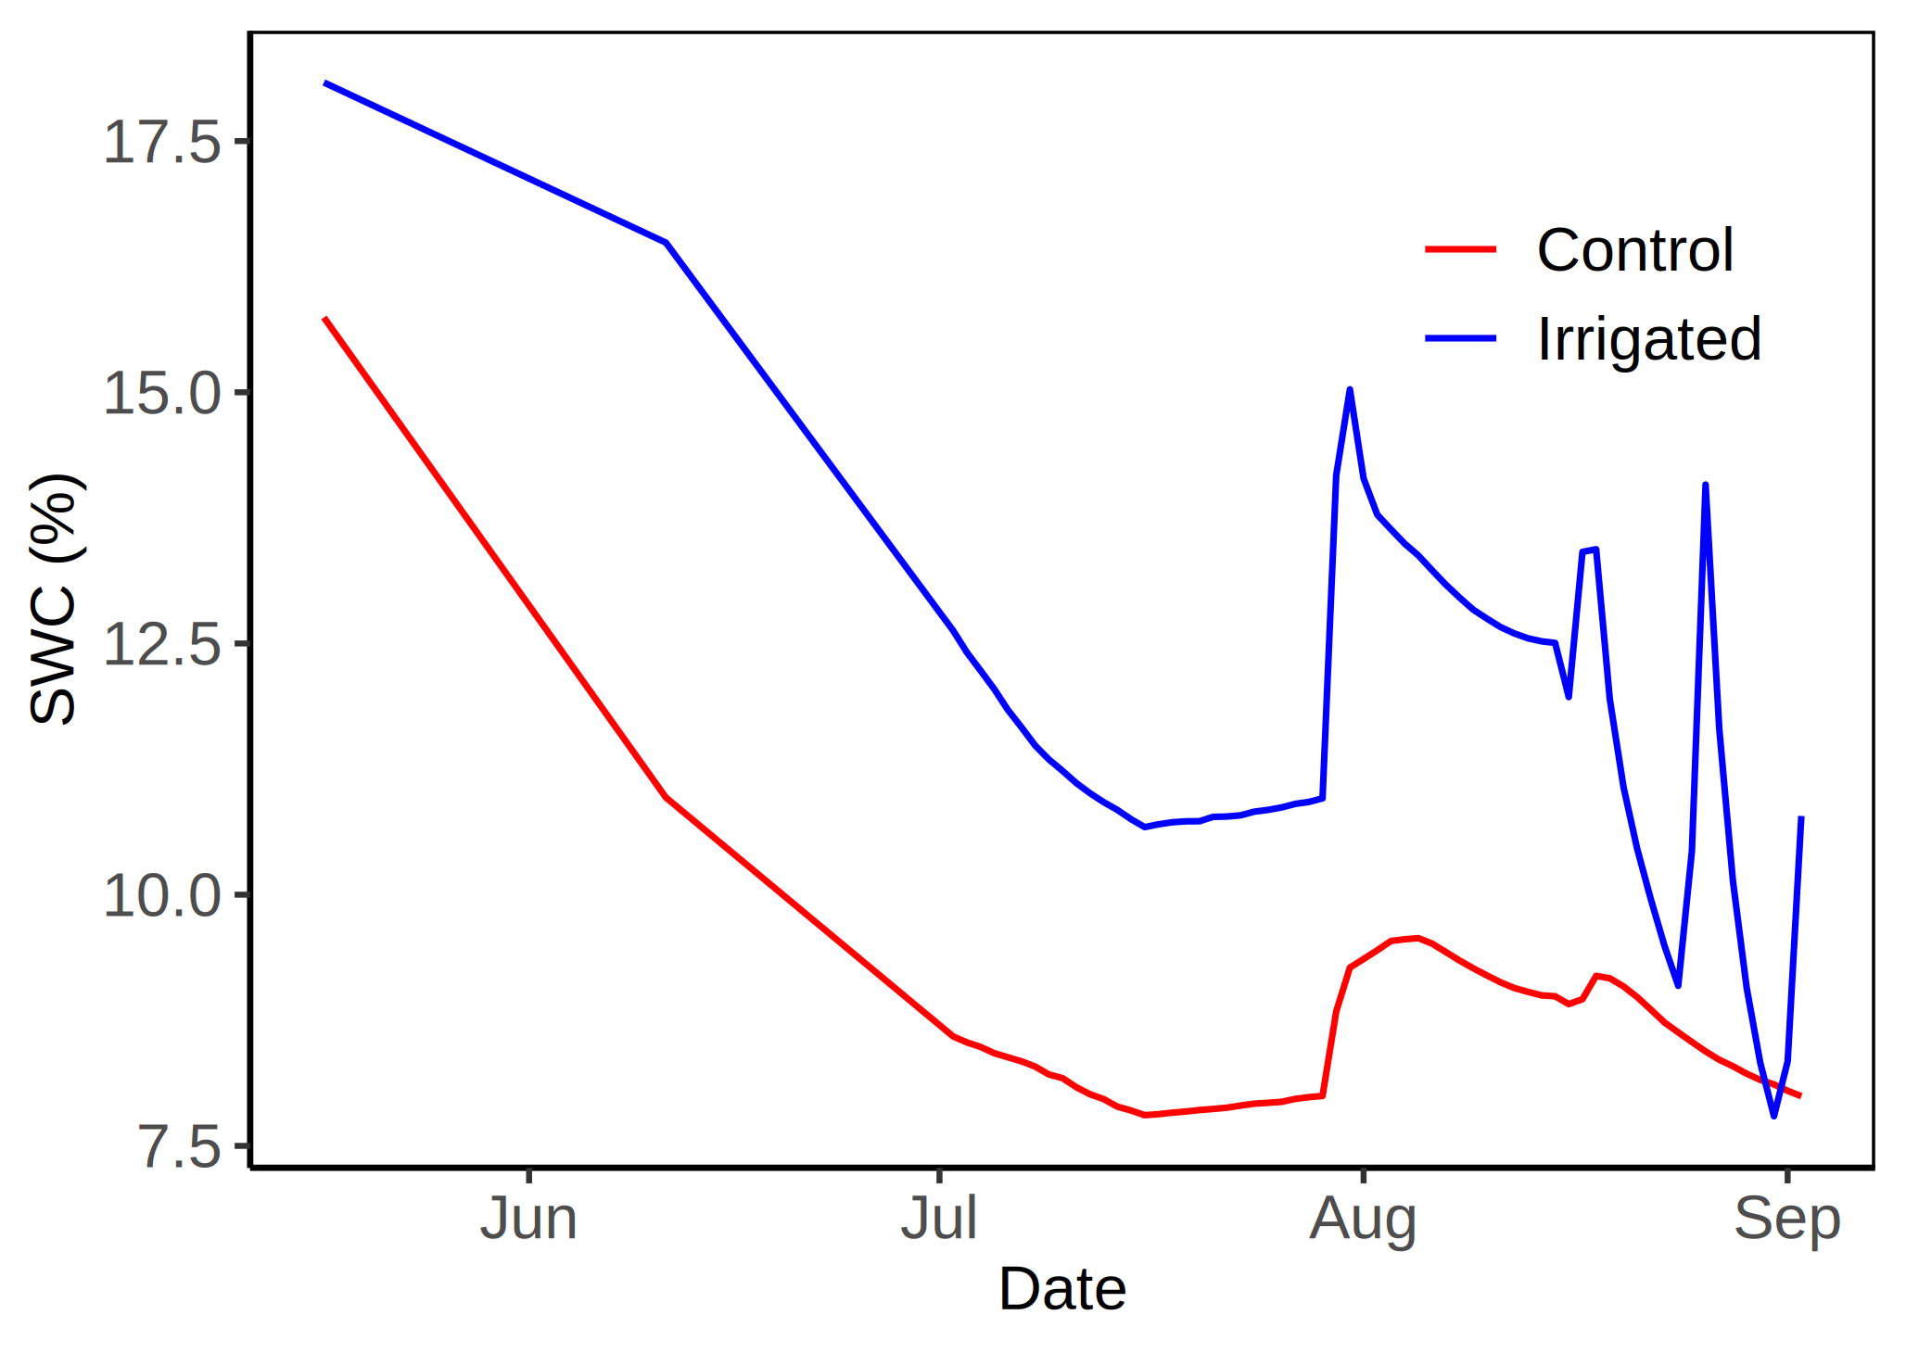
Fig. 1. Seasonal course of volumetric soil water content (SWC) in Control and Irrigated plots from early June to early September. Lines show plot-level means through time.
Seasonal dynamics of water status and sap flux
Predawn water potential (ψ_{pd}), midday water potential (ψ_{md}), the daily water-potential drop (Δψ = ψ_{pd} − ψ_{md}), and sap flux density were measured across the seven campaigns in both treatments (Fig. 2). Linear mixed-effects models (Species × Month × Treatment, with tree identity as a random effect) showed that ψ_{pd} and ψ_{md} both declined significantly as the dry season progressed (main effect of Month: ψ_{pd}, F_{6,358.3} = 87.10, p < 0.001; ψ_{md}, F_{6,356.0} = 67.37, p < 0.001) and were significantly less negative in Irrigated than in Control trees overall (Treatment: ψ_{pd}, F_{1,70.4} = 112.87, p < 0.001; ψ_{md}, F_{1,73.2} = 32.50, p < 0.001; pooled across campaigns, ψ_{pd} averaged −1.04 ± 0.04 MPa in Control versus −0.76 ± 0.03 MPa in Irrigated trees). The size of this Control–Irrigated gap itself changed across the season (Month × Treatment: ψ_{pd}, F_{6,357.2} = 17.51, p < 0.001; ψ_{md}, F_{6,355.0} = 8.70, p < 0.001), and was greatest in early September, when Control trees reached ψ_{pd} = −2.03 ± 0.13 MPa compared with −0.87 ± 0.05 MPa in Irrigated trees, but negligible in early August, when the two treatments briefly converged (ψ_{pd} = −0.56 ± 0.03 MPa in both). Letters above each campaign in Fig. 2 (Tukey-adjusted pairwise comparisons among months, from mixed-effects models with heterogeneous among-campaign variance, fitted separately within each treatment) identify campaigns that differed significantly from one another within a treatment; campaigns sharing a letter were not significantly different.

Fig. 2. Seasonal dynamics of (top to bottom) predawn water potential (ψpd), midday water potential (ψmd), the daily water-potential drop (Δψ = ψpd − ψmd), and sap flux density (F) across Control (left) and Irrigated (right) treatments. Points and error bars show means ± SE for each campaign; letters above each month denote significant pairwise differences among months within a treatment (Tukey-adjusted; months sharing a letter did not differ significantly).
Despite these substantial treatment effects on absolute water potential, the daily water-potential drop (Δψ) showed no significant effect of Treatment (F_{1,80.0} = 1.99, p = 0.16), no Month × Treatment interaction (F_{6,364.6} = 0.89, p = 0.50), and no three-way Species × Month × Treatment interaction (F_{60,364.1} = 0.66, p = 0.97), although it differed among species (F_{12,78.4} = 12.42, p < 0.001) and across months (F_{6,365.6} = 7.73, p < 0.001). Trees in both treatments therefore regulated the daily decline in water potential to a similar degree, indicating a measure of hydraulic homeostasis that was independent of the large treatment difference in absolute water status.
Sap flux density declined from a seasonal high in early June to a minimum in mid-July before recovering somewhat toward early September (Fig. 2), and was modestly but significantly higher in Irrigated than Control trees overall (0.32 ± 0.02 vs. 0.28 ± 0.02 kg h⁻¹; F_{1,72.5} = 4.56, p = 0.036), with the treatment difference again varying across the season (Month × Treatment: F_{6,373.4} = 4.10, p < 0.001). Unlike water potential, sap flux showed no significant Species × Month, Species × Treatment, or three-way interaction (all p > 0.10).
Because two species were not represented in both treatments (one species absent from Control, another absent from Irrigated), the fixed-effect design matrices for all four mixed models were rank-deficient; the Type III F-tests reported above should accordingly be interpreted with some caution, although the direction and significance of the main Treatment and Month effects were consistent across all four water-relations variables.
Environmental drivers of water status
Pooling across treatments and campaigns, ψ_{pd} (R² = 0.40, p < 0.001) and ψ_{md} (R² = 0.36, p = 0.002) became less negative, and sap flux density increased (R² = 0.44, p < 0.001), with increasing soil water content (Fig. 3). In contrast, Δψ was unrelated to SWC (R² = 0.01, p = 0.74), reinforcing the seasonal-dynamics result above that the daily water-potential drop was decoupled from ambient soil moisture availability, even though ψ_{pd} and ψ_{md} individually tracked it closely.

Fig. 3. Relationships between soil water content (SWC) and predawn water potential (ψpd), midday water potential (ψmd), the daily water-potential drop (Δψ), and sap flux density (F), pooled across treatments and campaigns. Lines show fitted linear regressions.
Height-dependent drought sensitivity
The relationship between tree height and ψ_{pd} depended on both treatment and campaign (Fig. 4). Among Control trees, taller individuals maintained significantly less negative ψ_{pd} than shorter individuals during the three driest campaigns of the season — mid-July (R² = 0.38, p = 0.033), mid-August (R² = 0.41, p = 0.019), and early September (R² = 0.37, p = 0.027) — but no significant height–ψ_{pd} relationship was detected in the four remaining Control campaigns (early June, mid-June, early July, early August; all p > 0.05). Among Irrigated trees, a significant height effect was detected only in mid-June (R² = 0.36, p = 0.04) and in no other campaign. Taller trees therefore appear to have been better buffered against the most severe seasonal water deficits under water-limited (Control) conditions, an advantage that was largely undetectable once soil moisture was supplemented by irrigation.
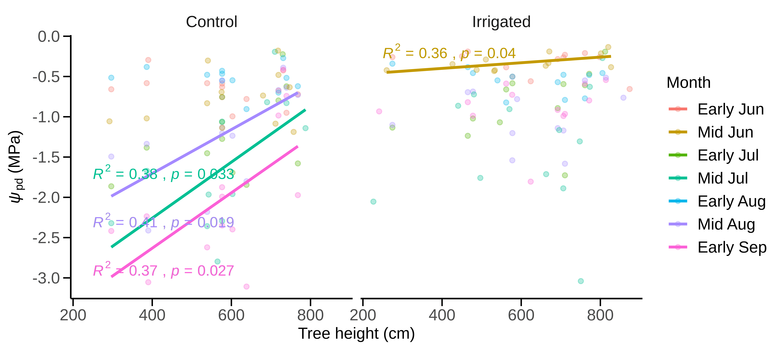
Fig. 4. Relationship between tree height and predawn water potential (ψpd) across measurement campaigns, shown separately for Control (left) and Irrigated (right) treatments. Regression lines and R²/p-values are shown only for campaigns in which the height–ψpd relationship was statistically significant.
Consistent with this, when expressed instead as the percentage change in ψ_{pd} at the individual-tree level (i.e., without species-mean aggregation, which otherwise inflates explanatory power), the relationship between tree height and the overall magnitude of seasonal ψ_{pd} decline was not statistically significant in either treatment (Control: R² = 0.06, p = 0.103; Irrigated: R² = 0.01, p = 0.539; not shown). The height advantage detected campaign-by-campaign in Fig. 4 therefore did not extend to a simple linear relationship with the total magnitude of seasonal decline across the full dataset.
Growth consequences of water use
Relative height growth rate (RGR) was positively related to both sap flux density (R² = 0.125, p = 0.001) and the percentage seasonal decline in sap flux density (R² = 0.08, p = 0.009) when pooled across treatments (Fig. 5). Neither relationship differed significantly between Control and Irrigated trees (sap flux × Treatment interaction: F_{1,79} = 0.55, p = 0.46; % decline in sap flux × Treatment interaction: F_{1,79} = 0.26, p = 0.61), which justifies the pooled analysis shown in Fig. 5 and indicates that the positive coupling between water use and height growth operated similarly in both treatments. Trees that sustained higher sap flux, or that experienced a smaller proportional decline in sap flux over the dry season, achieved faster height growth regardless of irrigation treatment.
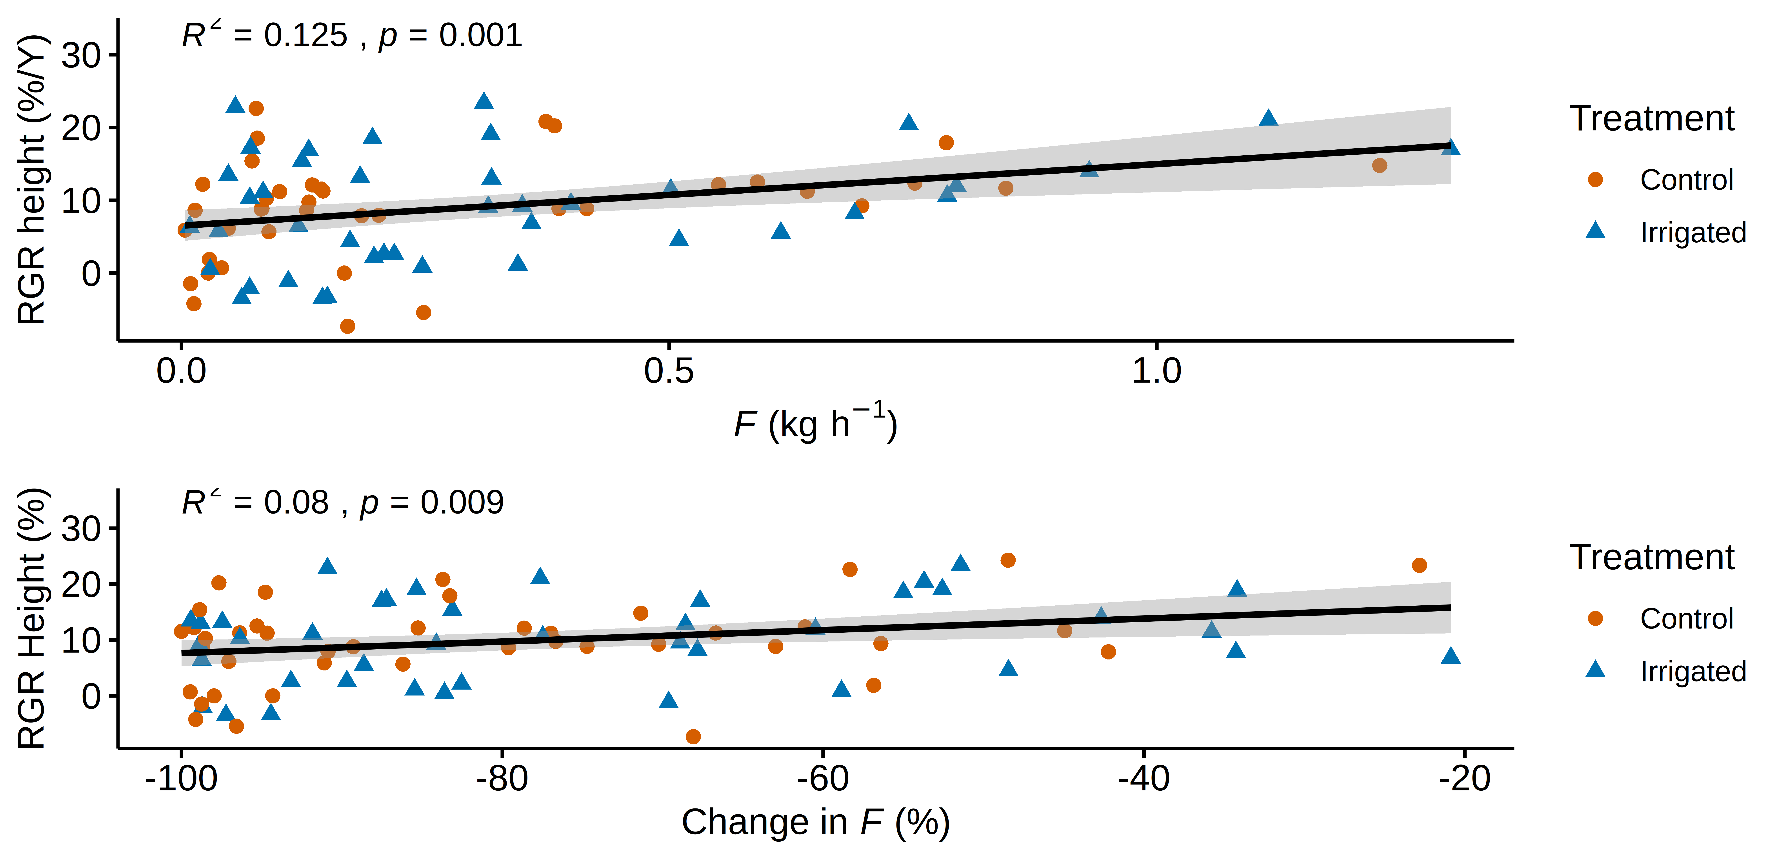
Fig. 5. Relationship between relative height growth rate (RGR) and (a) sap flux density (F) and (b) the percentage seasonal decline in sap flux density, pooled across Control and Irrigated treatments. Shaded bands show 95% confidence intervals.

