Welcome Sign In Sign Out

* United States
  + [en-US](/us/en/about-us.html)
  + [es-US](/us/es.html)
* Canada
  + [en-CA](/ca/en/about-us.html)
  + [fr-CA](/ca/fr.html)
* Switzerland
  + [de-CH](/ch/de.html)
  + [fr-CH](/ch/fr.html)
  + [it-CH](/ch/it.html)
* Germany
  + [de-DE](/de/de.html)
* France
  + [fr-FR](/fr/fr.html)
* Spain
  + [es-ES](/es/es.html)
* Italy
  + [it-IT](/it/it.html)

  
<#>

* [Home](/us/en.html)
  + [Magazine](/us/en/magazine.html)
  + [Adventures](/us/en/adventures.html)
  + [FAQs](/us/en/faqs.html)
  + [About Us](/us/en/about-us.html)

Search

# About Us

## Our Contributors

*Meet the outstanding individuals responsible for bringing you the most compelling stories across the globe.*



### Stacey Roswells

##### Artist | Photographer | Traveler

Facebook

Twitter

Instagram

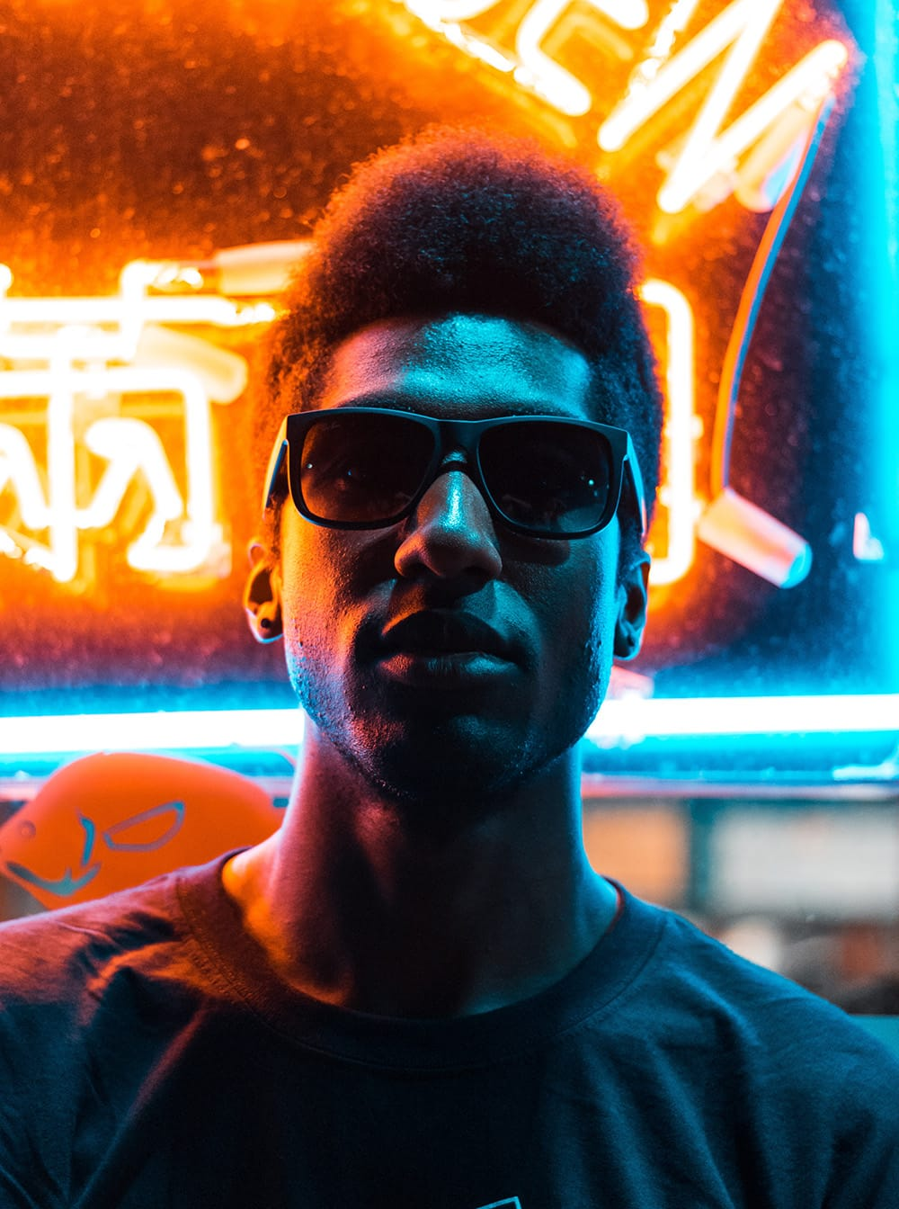

### Jake Hammer

##### Influencer | Writer

Facebook

Twitter

Instagram

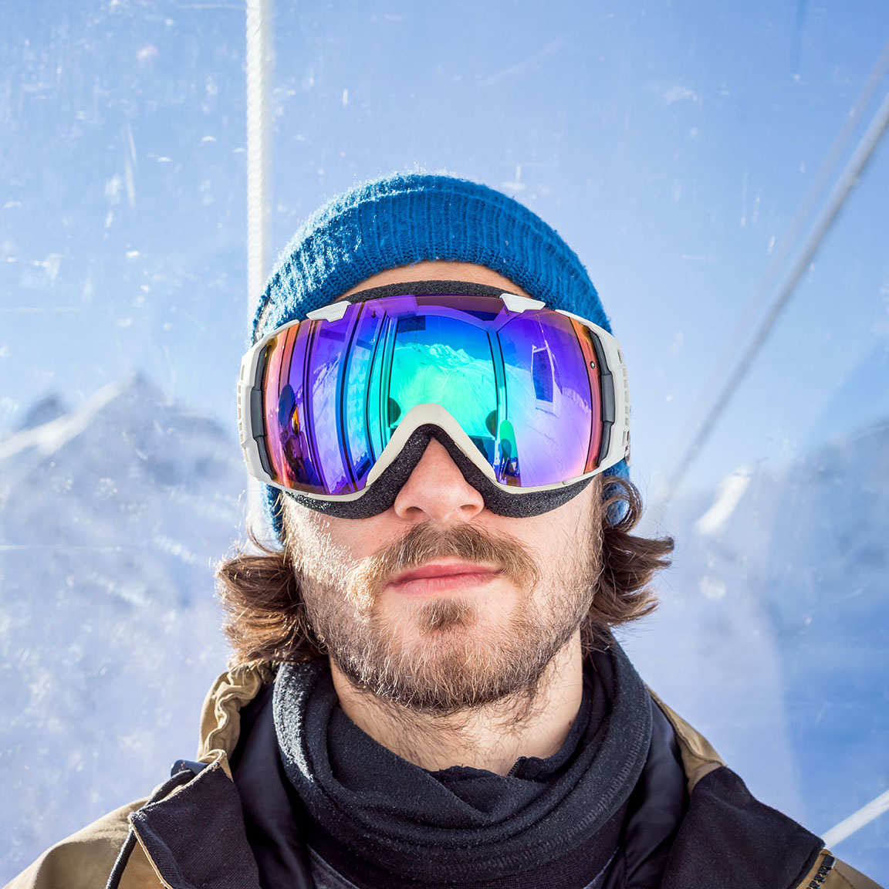

### Ian Provo

##### Photographer

Facebook

Twitter

Instagram

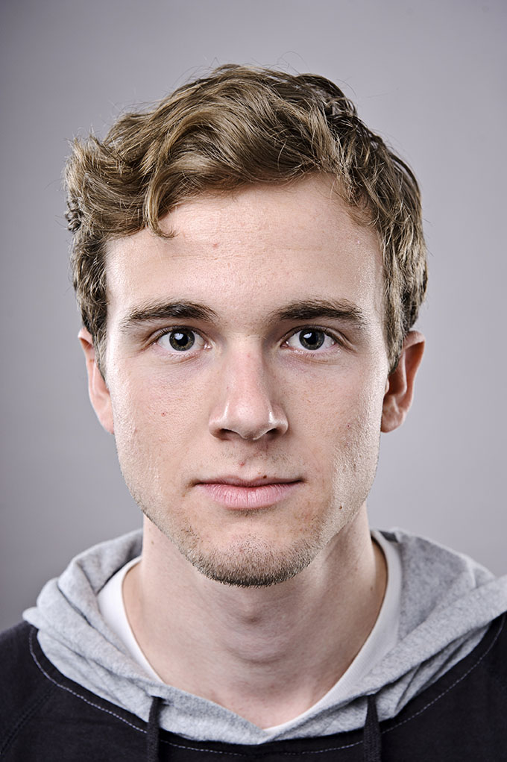

### Jacob Wester

##### Skater | Writer

Facebook

Twitter

Instagram

## WKND Guides

*Meet our extraordinary travel guides. When you travel with a certified WKND guide you gain access to attractions and perspectives not found on the pages of a guide book.*



### Sofia Sjöberg

##### Photographer | Youtuber

Facebook

Twitter

Instagram



### Justin Barr

##### Artist | Rock Climber

Facebook

Twitter

Instagram

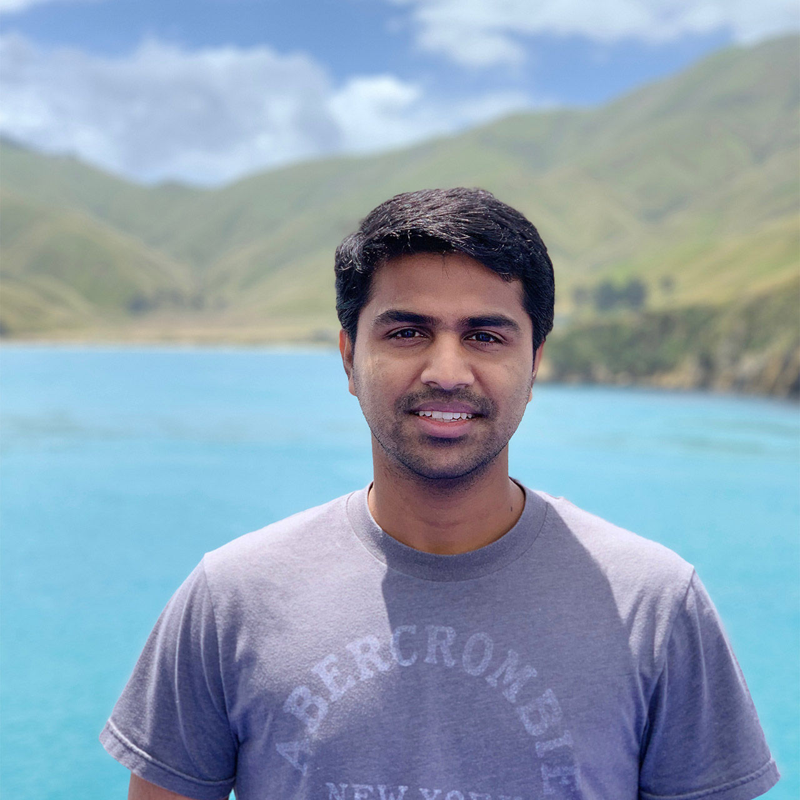

### Kumar Selveraj

##### Photographer | Surfer

Facebook

Instagram

Twitter

  
<#>

* [Home](/us/en.html)
  + [Magazine](/us/en/magazine.html)
  + [Adventures](/us/en/adventures.html)
  + [FAQs](/us/en/faqs.html)
  + [About Us](/us/en/about-us.html)

#### Follow Us

Facebook

Twitter

Instagram

Ⓒ 2019, WKND Site.

WKND is a fictitious adventure and travel website created by Adobe to demonstrate how anyone can use Adobe Experience Manager to build a beautiful, feature-rich website over a single weekend. This site is built entirely with Adobe Experience Manager [Core Components](https://docs.adobe.com/content/help/en/experience-manager-core-components/using/introduction.html) and [Archetype](https://github.com/adobe/aem-project-archetype) that are available as open source code to the public. The entire [site source code](https://github.com/adobe/aem-guides-wknd/) is available as open source as well and is accompanied with a [detailed tutorial](https://docs.adobe.com/content/help/en/experience-manager-learn/getting-started-wknd-tutorial-develop/overview.html) on how to recreate the site.

Many of the beautiful images in the WKND site are available for purchase via [Adobe Stock](https://stock.adobe.com/).