Dropped Object Prevention Policy
At Rig Runner, we are committed to ensuring a safe work environment. As such, we establish a formal Dropped Object Prevention Plan at every worksite where dropped object hazards are present. This plan outlines potential hazards, control measures, inspection protocols, and responsibilities to safeguard our personnel and the integrity of our operations.

Roles, Responsibilities, Training, and Competencies
Rig Runner assigns specific roles and responsibilities related to dropped object prevention for each job. We ensure that all personnel are properly trained and competent in identifying and mitigating dropped object hazards. Our training programs are tailored to the unique responsibilities of each role, emphasizing the critical importance of dropped object prevention across all levels of our workforce. As outlined in the Rig Runner Safety Manual under section ”Critical Lifts”

JSA Risk Assessment
Before any work begins, Rig Runner conducts a Job Safety Analysis (JSA) Risk Assessment to identify specific dropped object hazards associated with the task. We implement controls to mitigate these risks and maintain clear communication throughout lifts and other activities where dropped objects could pose a threat.
As outlined in the Rig Runner Safety Manual Under Section “Hazard Identification and Risk Assessment”

Inspection and Maintenance of Equipment at Height
All equipment installed at height by Rig Runner is regularly inspected and maintained according to Original Equipment Manufacturer (OEM) guidelines and our internal policies. These inspections are vital to confirm that equipment remains secure and operationally safe.

Comprehensive Inspection Programs
Rig Runner is committed to maintaining rigorous inspection programs, including:
- Independent inspections at least every three years.
- Systematic inspections for specific high-risk equipment.
- Unplanned inspections as circumstances demand.
- Training of qualified personnel to carry out these inspections with expertise.
These inspections are crucial for ensuring the continued safety and reliability of equipment used at height.

Lifting & Hoisting Program
Rig Runner maintains a robust Lifting & Hoisting program to ensure that critical lifts are properly identified, and that comprehensive Risk Assessments are conducted. Our program includes accurate methods for determining and verifying load weights to prevent accidents.

Pre-Shipment Inspections
Before transporting any equipment, Rig Runner performs thorough pre-shipping inspections to ensure that all items are secure and that no dropped object hazards are present during transit. As outlined in the Rig Runner Safety Manual Under Section “Load Securement”

Ensuring Effectiveness of DROPS Implementation
Rig Runner is committed to continually monitoring and improving the effectiveness of our Dropped Object Prevention System (DROPS). We implement methods of assurance, such as audits, inspections, and safety performance reviews, to evaluate the success of our policies and procedures. We also encourage feedback from all team members to enhance our practices and ensure a safer working environment.

Establishment of Restricted Access & No-Entry Zones
Rig Runner establishes Restricted Access and No-Entry Zones on all job sites based on the scope of work and identified dropped object risks. These zones are clearly marked, and all personnel are informed to prevent unauthorized access.

Stop Work Authority

Stop Work Authority (SWA) is the responsibility and authority of any individual to stop work when an unsafe condition or act could result in an undesirable event. By failing to exercise SWA when needed, your behavior sends the message that the practice is acceptable.

Stop Work Authority
It is your responsibility – and you have the authority
Your ideas and concerns are important

Any employee or contractor is responsible and authorized to stop any work that does not comply with these tenets and there will be no repercussions.

What is a dropped object

A dropped object is:
“Any object, with the potential to cause death, injury or equipment/environmental damage, that falls from its pre- vious static position under its own weight.”

When referring to dropped objects, consider:
- Hand tools being used at heights
- Hand tools/equipment left behind after working at height
- Operations conducted at height
- Equipment mounted at a height that, following contact, vibration or environmental conditions, could fall, i.e., piping, lights, cameras, rigging gear, etc.
- Temporary equipment at height
- Where personnel are working on a level directly below the work site
- Lifting operations

Recommended Actions

  - Create a dropped objects work group specific to the site.
  - Complete a Incident Report on KPA.
  - Use the Report to develop an inspection program.
  - Introduce working at height procedures.
  - Complete Equipment JSA to account for tools used for jobsite specific activities.
  - Raise overall dropped objects identification and mitigation among the workforce.
  - Train relevant personnel to identify and mitigate dropped objects processes.
  - Secure tools from dropping to lower levels.
  - Following Job Safety Environment Assessment (JSEA) guidelines, erect signage and physical barriers to restrict access before work is conducted overhead.
  - All rigging risk assessments require consideration of the risks involved in moving equipment at height.
  - Review and revise JSAs for dropped objects potential.
  - Introduce regular dropped objects campaigns.
  - Complete a Hazard Hunt as part of the Daily JSAs.
  - Review handling and securing procedures for tubular components As part of the JSA process.
  - Introduce area ownership and hold personnel accountable in accordance with Rig Runner SOPS.

  - Inspect personal protective equipment (PPE), for example, safety harness, lanyard and chin straps.
  - Inspect all overhead equipment and locations for loose items that may present a hazard during maintenance activities.

What is a Hazard?

A hazard is a condition or action with the potential for an unplanned release of, or unwanted contact with, an
energy source that may result in harm or injury to people, property or the environment.
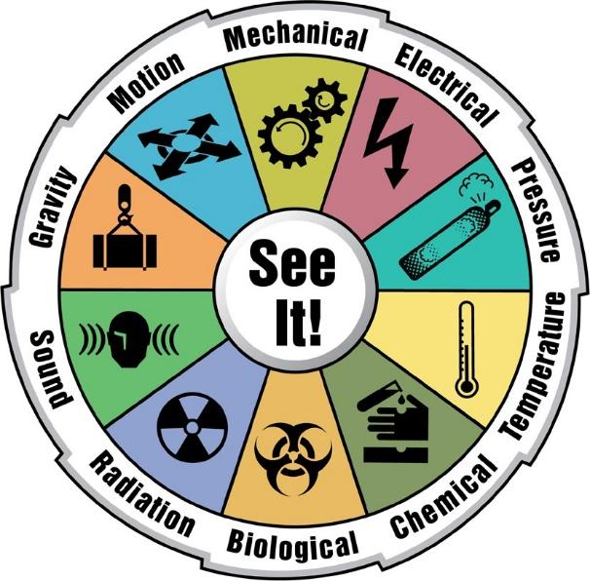
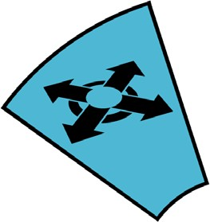
Motion

What to Do Following a Hazard Hunt

- Use SWA to immediately address the imminent hazards.
- Prioritize hazards and identify actions required to eliminate or mitigate.
- Enter maintenance items into database.
- Leaders communicate a summary of the Hazard Hunt by email to their immediate manager.
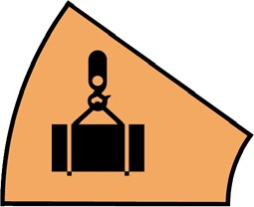
Gravity

Area Ownership

Site management should clearly identify all risk areas and assign risk area ownership.
- Divide the location into areas.
- Assign the areas to an individual or group to check the area as often as the level of risk demands.
- Use checklists for consistency.
- Identify actions for each area of concern.
- Deal with all actions.
- Include any transportable or temporary equipment.
- To make the area safe, use SWA if a dropped object is found.

Pre-Job Risk Assessment

Complete a pre-job risk assessment such as a JSEA before beginning any job/task, with the following goals in mind:
- Identify any dropped object hazards before starting a job or task and communicate these at a toolbox talk.
- Include discussions on tools and equipment in the JSEA.
- Ensure all personnel are involved in the discussion, understand the associated hazards and implement the mitigation.
- Include the use of a dropped objects checklist.

References

Here are some examples of some dropped objects posters. Others are available by contacting:




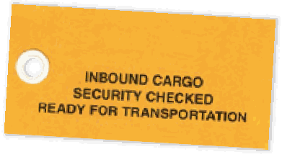
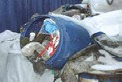
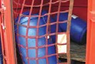
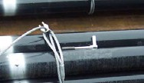

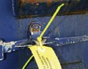
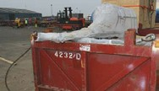
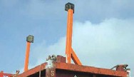
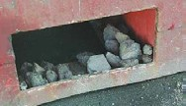
http://www.dropsworkpack.com/
SNAG HAZARDS
A Snag Hazard is best defined as any lift which has a potential for the lifting set to snag on its contents whilst being lifted.
Snags risk the weight of the load being transferred from the certified lifting points to a loose object which has no load bearing capacity. In general nothing should protrude outwith the cargo-carrying unit.
It is also important to recognise that even items contained within a CCU or frame can become a Snag Hazard, because when loading/offloading offshore the vessel rises and falls and, as such, the lifting gear has the potential to fall into the unit and snag on its contents. A tarpaulin, net or other means, should be used to cover such items.
DROPPED OBJECTS
A Dropped Object is defined as any loose item found on cargo which is not properly retained and therefore has the potential to fall off whilst in transit by road or sea.
The most common example of this is hand tools which have been used in preparation of the lift – eg a spanner used for tightening bull dog grips on pipe bundles or pliers used for removing split pins from the lifting gear of a CCU.
The law of physics dictates that even the smallest nut can have a devastating effect when it falls 90 feet in the air on to a seaman handling cargo on the deck of a supply vessel. Similarly, if an object falls off of a truck travelling at a speed of 40 miles per hour and strikes the windscreen of a car, it is clear that this could have disastrous results.
These protruding legs could easily become This unit is protruding both over the top and entangled with the lifting gear causing a hazard over the edge of the CCU causing a hazard to to those involved in loading or offloading. those involved in loading and offloading.
Loose debris in forklift pocket. This is a common Ratchet Spanner left on tubulars by slinging crew. occurrence which causes a hazard to road users
and everyone involved in the lifting operation.
SECURING DOORS
In addition to securing the cargo, it is also vitally important that the CCU doors are also properly secured.
Most CCUs have metal door handle mechanisms consisting of a locking bar complete with locking cam at each end, securing handle and handle retaining clip. The door must be closed properly and all components must be fully engaged and further secured by a securing device such as a metal karabiner, a ‘Customs’ type metal seal or a wire door seal.
All lifts should have attached an inspection tag to either identify its current transit status as inbound or outbound cargo.
The tag shall be annotated by the relevant persons to confirm that the CCU is properly prepared, packed and sea fastened in a manner to satisfy the conditions that it could reasonably expected to encounter during transport.
SECURING CARGO
All cargo carried within CCUs should be restrained for ‘worst weather conditions’. The restraining devices should have a predetermined breaking strain – eg ratchet straps or cordstrap (rope is not recommended). In certain cases a combination of wood and straps can be used and in extreme cases it may be necessary to use mechanical aids such as turnbuckles.
All closed units should have a container net to ensure that objects do not fall out when opened.
It is advisable to cover objects within an open unit with a net or tarpaulin.
DURING FORKLIFT OPERATIONS REMEMBER
SAFETY FIRST REGARDLESS OF URGENCY AS
UNDUE HASTE OR SPEED KILLS!
Please refer to the UKOOA Guidelines for the Safe Packing and Handling of Cargo to and from Offshore Locations.
COMPLACENCY IS A KILLER...
IF YOU SEE AN UNSAFE ACT, STOP THE JOB AND TAKE TIME OUT FOR SAFETY
e campaignteam@dropsworkpack.com t +44 (0)1224 861811
f +44 (0)1224 860323 w www.dropsworkpack.com

AND SECURITY
CARGO SAFETY


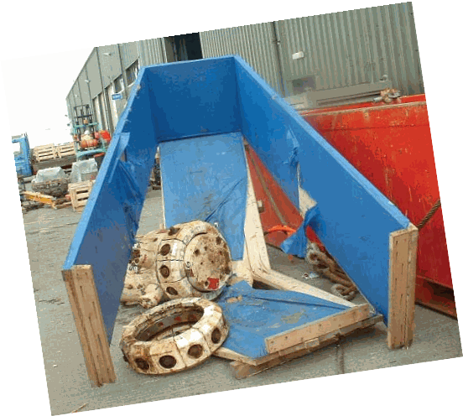

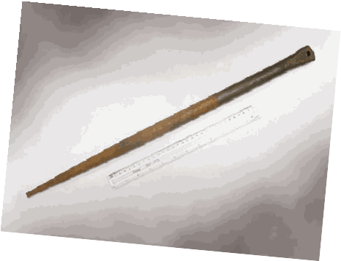

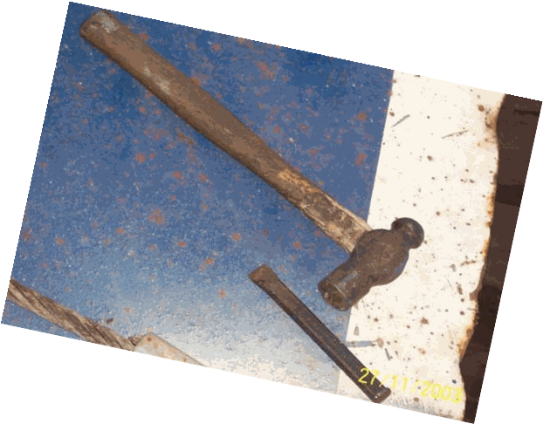



Dropped Objects are among the Top 10 causes of Fatality and Serious Injury in the Oil and Gas Industry

The top three causes of fatal accidents are…
falls from height… being struck by moving vehicles… and being struck by falling objects (RoSPA)

For further information or details of any DROPS product, including DROPS Membership, DROPS Training and DROPS Workpacks, visit our website or contact the DROPS Administration Team:
e campaignteam@dropsworkpack.com t +44 (0)1224 861811 w www.dropsworkpack.com

AT
WORK

AND
LEISURE
HOME
AT




