2020
Games Programming
Resit
Sam Clements

Declaration

I confirm that the code contained in this file (other than that provided or authorised) is all my own work and has not been submitted elsewhere in fulfilment of this or any other award.
Sam Clements.

Contents
Declaration 1
Display.H 2
Mesh 3
Shaders 5
Main Game 7

Display.H
Much of the code to view the game and create the initial window in which it operates is contained within Display.h
(Figure 1)
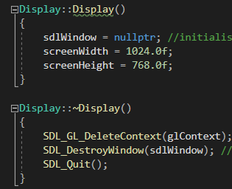
first is the constructor which sets the screen width and height.
~Display function is the destructor for the display class. It deletes the context the display window and then runs SDL_Quit to close the process.
(Figure 2)
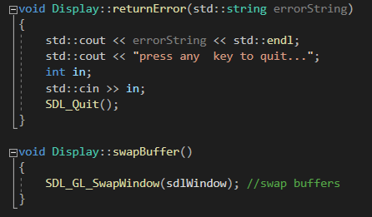
The return error function is used to provide information on errors as they are encountered it uses std::cout and a string provided by another error message. When called it will print the string provided by another error message given a detailed description of the error encountered before again using std::cout to encourage the users to press any key to quit. Once a key has been pressed it is taken in by std::cin and then SDL_QUIT will run to close the window much like in the destructor class. The swapBuffer function acts to swap the buffer window containing the information created by openGL to the display window when called.

(Figure 3)
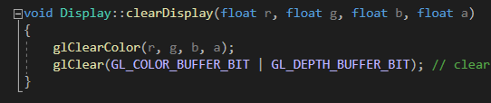
the Clear Display function takes in the red, green, blue and alpha values as a float, GLClear is used to clear the colour buffer and then subsequently refill it with GL_DEPTH_BUFFER_BIT.

(Figure 4)
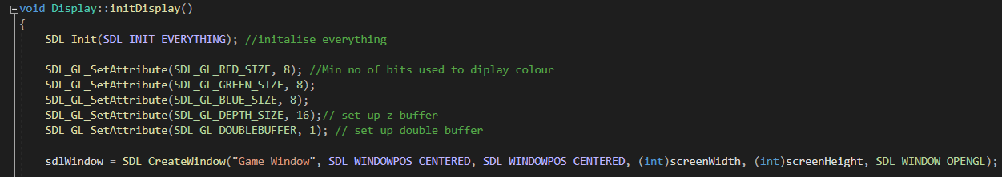
initDisplay is the next function it starts by initializing the SDL followd by setting colour attributes, as in the clear display function these attributes are red, green blue and these values are subsequently assigned a value of 8. The next attributes are the depth and doublebuffer which are assigned the values of 16 and 1 respectively.
After the attributes all have an assigned value sdl create window is used to create a game window that takes an int value for both screen width and screen height.

(Figure 5)
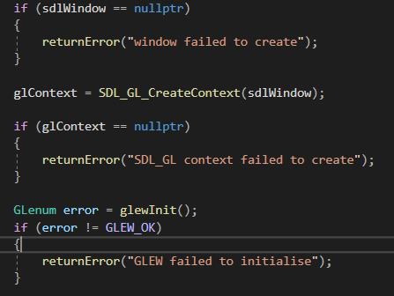
This is followed by a series of error messages that utilize the code found in figure 2 to display detailed error messages based upon the potential problem encountered such as the window failing to create or GLEW failing to initialise.

(Figure 6)
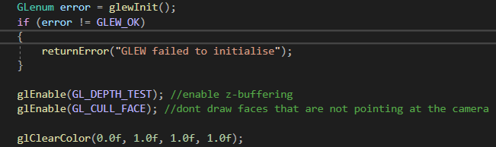
Finally in the initdisplay function is glEnable (GL_Depth_TEST) and glEnable(GL_CULL_FACE) which prevent the rendering of the back of objects or objects behind other objects.

Mesh
(Figure 7)
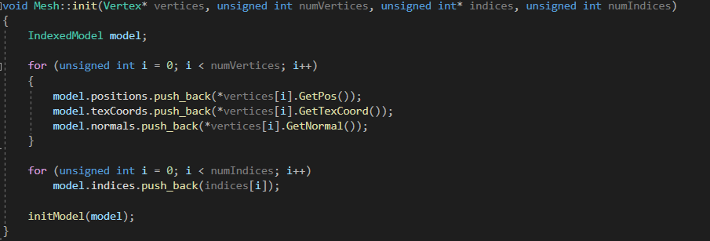
The Mesh init function takes 4 arguments being vertex and three unsigned integers. It contains two for loops based upon an unsigned integer I and increases it whilst the value of I is under the number of vertices. The second for loop operates much the same but based upon the number of indices.
(Figure 8)
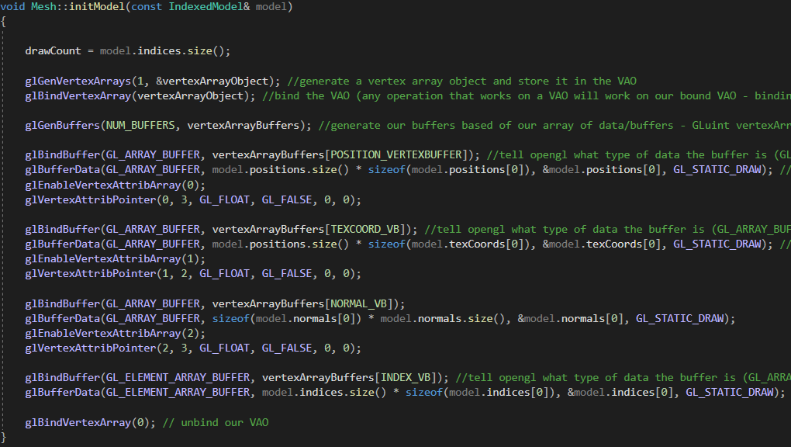
The initModel function takes a const indexedModel reference as an argument. It begins by taking in a draw count values based upon a models indices. A vertex array is then generated and bound as a vertex array object. glGenBuffers operates to allow openGl to pull Gpu data and write it. The buffer is bound much the same as the previous vertex array the scope of this data is gathered and then stored by GLBufferData and GL_STATIC_DRAW. The vertex array is enabled and accessed storing this information as floats. This process happens again for TEXCOORD_VB and NORMAL_VB. INDEX_VB goes through the same process minus the storing of data as floats. The vertex array is then unbound.

(Figure 9)
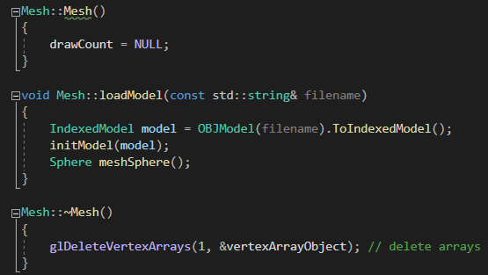
The initModel function is followed by the constructor, loadModel function and destructor. The constructor simply sets the draw count to NULL. The loadModel function sets the model to be loaded in the game the initModel function is called and a sphere is created to work as a collider.
The destructor deletes the vertex array object.

(Figure 10)
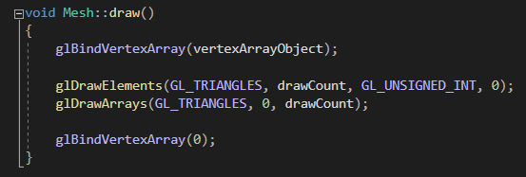
The draw function uses the glBindVertexArray much the same as the initModel function. GlDrawElements specifies that triangles will be used and the vertex array is again unbound as seen in initModel.

Shaders

(Figure 11)
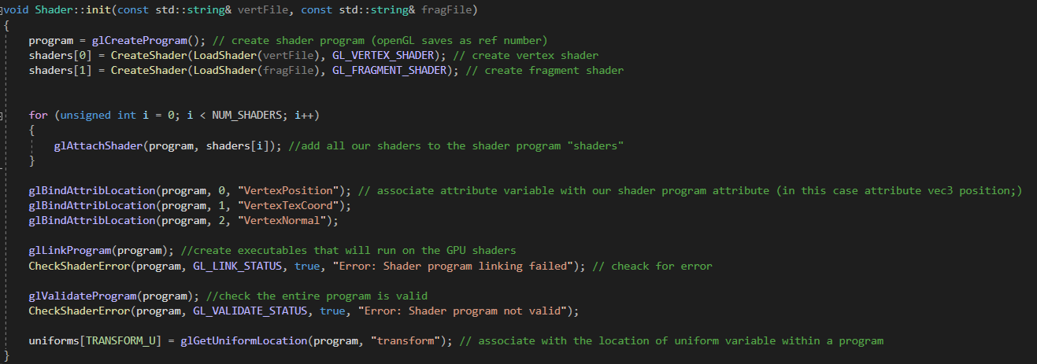
The init function contained within shader.ccp takes an argument consisting of 2 const strings, vertFile and fragFile. First a shader program is created followed by a vertex and fragment shader. The Vertex shader takes object coordinates and transforms them into clip coordinates (a projective coordinate system used to selectively enable render options) in order to provide fustrum coordinates (the currently onscreen area of the rendered world or the players field of view). The Fragment shader takes place after the rasterization phase of the graphics pipeline and takes the pixel coordinates and the attribute values provided during the rasterization phase to assign colour values to pixels. These shaders are attached via a for loop. glBindAttribLocation specifies the data to be read for each variable Vertexposition is bound to location 0, VertexTexcoord is bound at 1 and finally VertexNormal is bound to 2.
glLinkProgram serves to create executable that can be run by the Gpu shaders, the program is then checked for validity and an error check is ran.
(Figure 12)
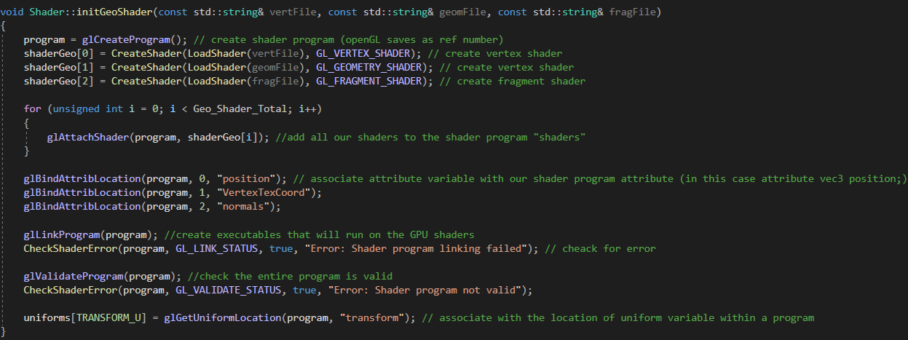
The initGeoShader Function acts in an almost identical manner as the init function seen above in Figure 11, but for the use of geometry shaders. The Geometry shader is an optional shader stage that takes in an input of vertices that comprise a single primitive, the geometry shader has full knowledge and access to all the vertices that the primitive is comprised of, it can then alter these inputs to create new primitives or destroy existing ones.
(Figure 13)
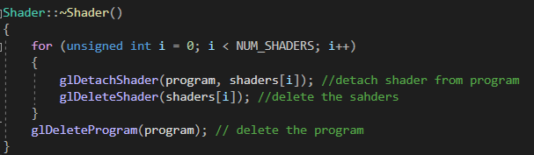
The Shader destructor utilizes a for loop using an unsigned integer I and increases it whilst the value of I is under the number of shaders. This for loop detaches and deletes the shaders and finally deletes the program.
(Figure 14)
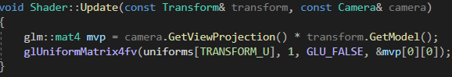
The update function takes an argument comprised of a const Transform and a const camera reference. It is used to create the Mvp or model view projection matrix and then update the transform uniforms.

Main Game
(Figure 15)
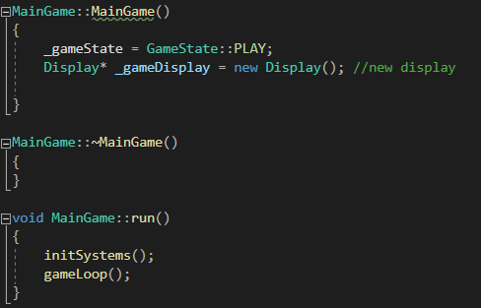
MainGame.ccp starts with a constructor and destructor. The constructor serves to set the game state and initialise the display.
The run function calls the initSystem function and the gameLoop function.

(Figure 16)
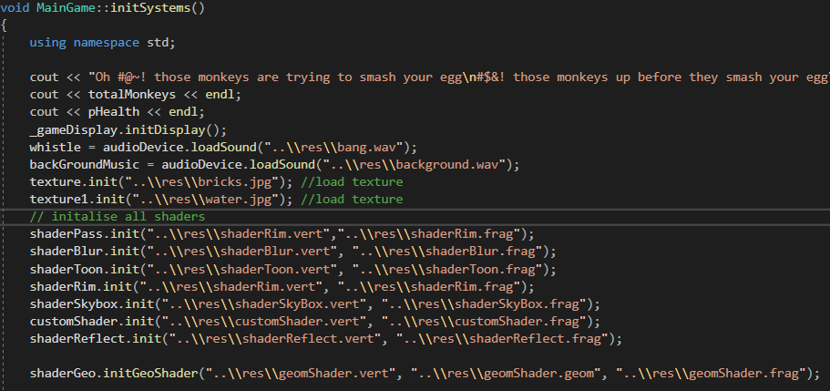
initSystems starts with declaring the use of namespace std before printing the games instructions, the total number of monkeys an the players current health. The initDisplay function found in figure 4 is called. Two Wav files are called to provide sound to the game. A series of shaders are subsequently initialised using the Toon shader, Rim lighting shader, geo shader and reflect shader found in the res folder of the program, a skybox is also initialised with the following lines of coding dedicated to providing information on its vertex position.
(Figure 17)
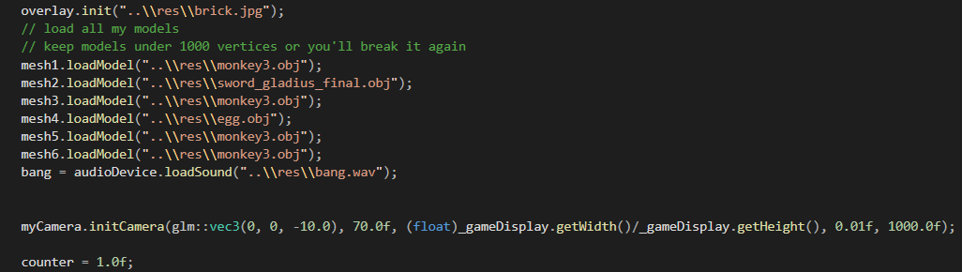
This is followed by assigned models to 6 meshes, the models comprising the characters featured in the game along with an errant audio file and the initialisation of the camera.
(Figure 18)
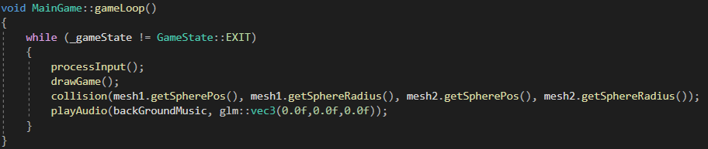the gameLoop Function called in figure 15 checks that the current gamestate does not equal GameState::EXIT and proceeds to call the processInput function and drawGame function along with setting the background audio to play.
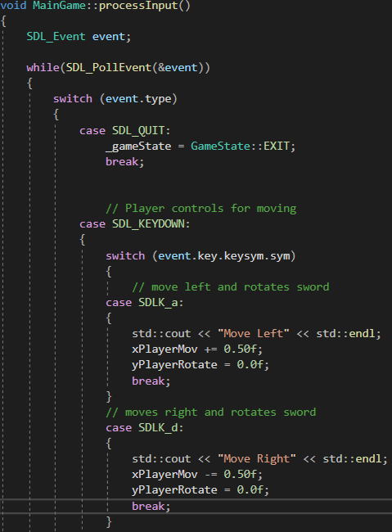
(Figure 19)
The processInput function is used to create the player controls to do this an SDL_Event is created and named event, a switch statement is then used to check for keystokes with A moving the player left and setting the swords rotation to 0.00f to ensure its pointing in the right direction, D doing the same but moving right, W moving the plyer and up and setting the sword to rotate 1.6f to ensure its pointing horizontally and s moving the player down.
(Figure 20)
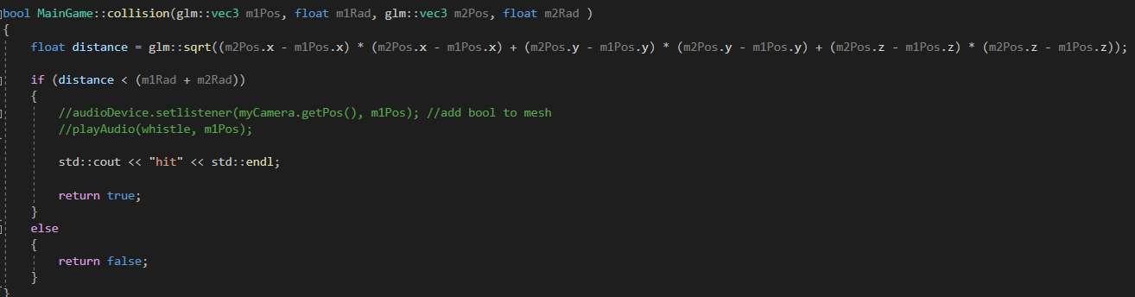
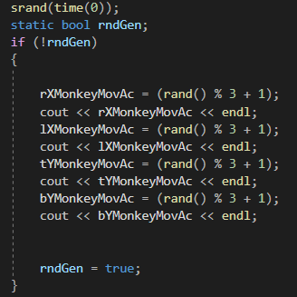
The collision function takes an argument comprising two vector 3’s and two floats, these contain the position and radius information of a meh’s collision sphere, a distance float is created to check the distance between these two meshes, the distance is calculated via Pythagoras.
The draw game function contains the information for drawing the meshes, setting shaders textures and generating most aspects of the game. It starts with a random number generating setting 4 values between 1 and 4 to create a random speed for the monkey’s movements. This is followed by setting the position, rotation, scale and shader of all the objects one at a time. After the creation of the sword object are a series of if statements detailing the collision between the monkey’s and the players sword, afterwards the egg is set up the same as the monkeys and again followed by a series of if statements governing the collisions between it and the monkeys. After this the win and lose conditions are created.

