Guide for categorize ASB account details.

Go to ASB accounts for MJ and export 3 following accounts.
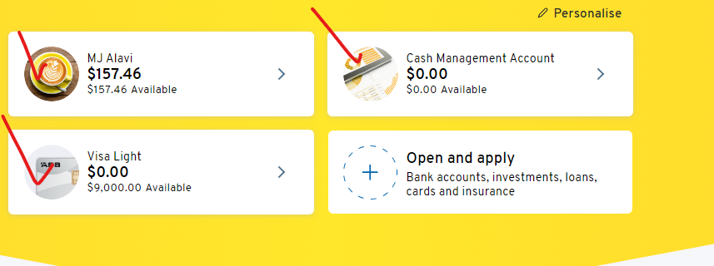
Make sure you select correct dates for financial year. For example, for FY2024 select 01/04/2023 – 31/03/2024.
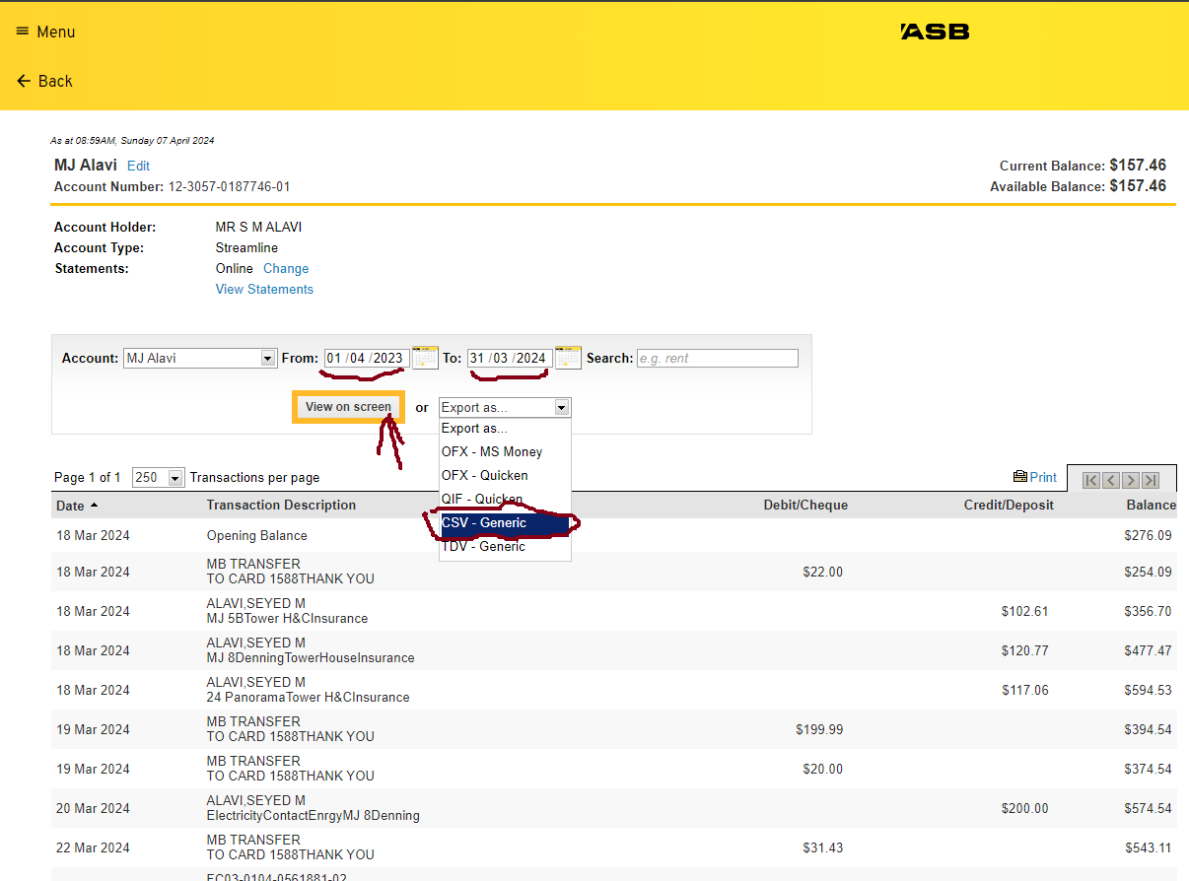

Note: For ASB Credit Card you need to multiple amounts with (-) as the value is other way Around. For example, for all description as “PAYMENT RECEIVED THANK YOU” should be positive and all expenses we take out from credit should be Negative. This is important for final file.

Export file to CSV with following format. FY20xx-20xx_account number
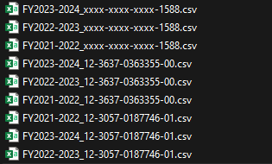

Then you need to tidy of your file.
- Duplicate sheet and name it as “working copy”
- Remove 3 rows on the top in “working copy”. Only leave the column name in first row
- Add Categories/Sub Categories/ DetailsCategorys at the end
- Do Manual check which mentioned under the note section here for each bank account and set correct value to Categories/Sub Categories/ DetailsCategorys. You can play with filter and copy and paste these values. To make it easier please always open categories.csv file and copy exact value from there.
  - If any new categories you want to add, make sure you copy exact one to categories.csv file as it’s source of through for all categories.
  - If there are new descriptions that you want to add in existing categories in categories.csv file. Please add them with ‘|’ in between.
  - If you see you have to many categories which wasn’t identified. You can use ChatGPT to sort it out following “How to Add Categories to ASB bank Account statement” which use categories.csv and create new expense.csv unique file and by chat gpt it will generate ChatGPT.csv file which you get those value and add to your “working copy” plus update main categories.csv file.
    - You can find an example of chat GPT under ASB credit account 2024. 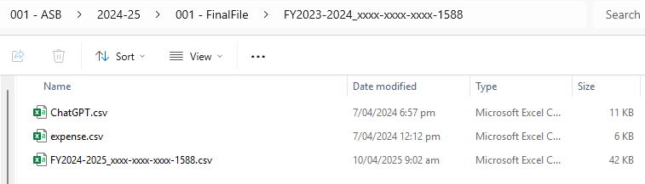
Go to your excel file and make sure Developer Tab shows in ribbon bar. Here is how you can activate it in excel. https://support.tetcos.com/support/solutions/articles/14000143232-how-to-enable-developer-tab-in-ms-excel-
and run ASB.bas macro on it. To run Macro you can follow this link.
https://support.tetcos.com/support/solutions/articles/14000143233-how-to-import-vba-script-bas-file-in-ms-excel-

How to Add Categories to ASB bank Account statement
Go to statement excel file and duplicate expense tab and name it as workingcopy. Make it like this screenshot.
Then use PivotTable to get all unique descriptions in on page.
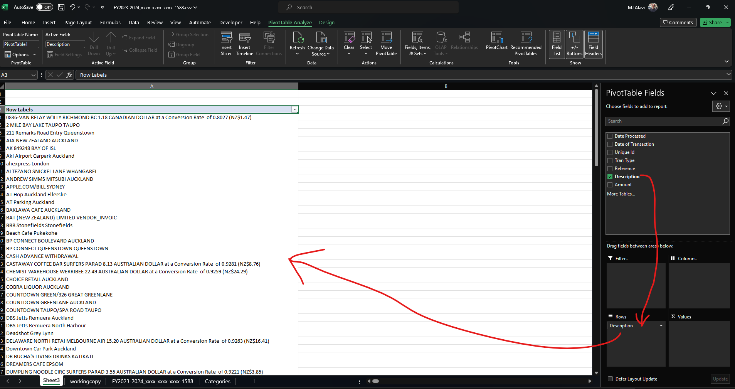
Save unique description in expense.csv file which we will use it later to match it with categories.csv file with ChatGPT.

Now ask ChatGPT:
Use provided categories.csv file as input to categorize expenses description on expense.csv file. Output should have all description on expense.csv file and match with categories in categories.csv. If you are not certain, try to guess best match possible. If description has Conversion Rate and you can’t match it with any category, then put it under Travel and if can’t guess then put Unknown to related column.
Show output as a csv comma separated with full description [description, Categories, SubCategories, DetailsCategories] here.
Here is Categories.csv file.
[Copy file here]
- Note: review all filter and make sure they match with good result. Specifically check travel section that might be some expenses for personal use which need to be move to other expenses if it’s not related to travel.
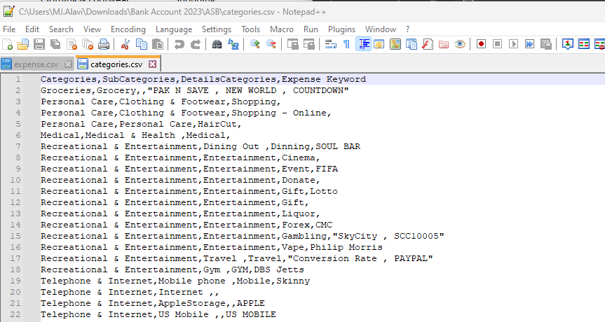
Here is expense.csv file.
[Copy file here]

Make sure change first line to description and also remove 2 last lines.
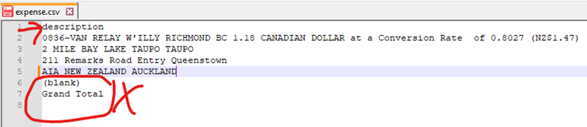
Save output in ChatGPT.csv file.
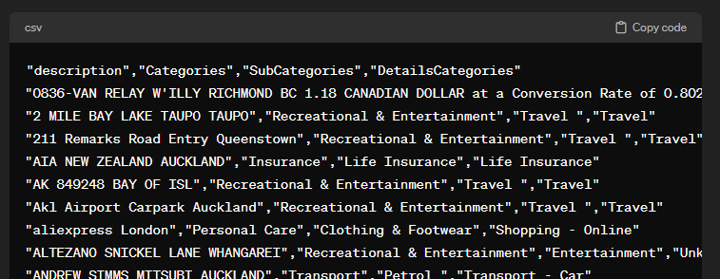
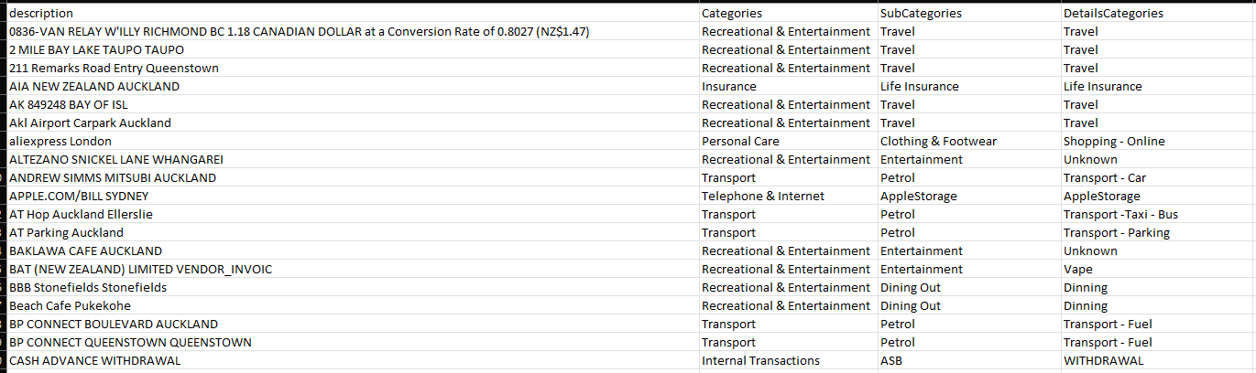
Look for any Unknown and try to match it with best in cateogires.csv file. You can always add new keywords to cateogires.csv file which can help to get better match in future.
Now open your Bank file – workingcopy and add use vlookup to fill information from ChatGPTfile to it. 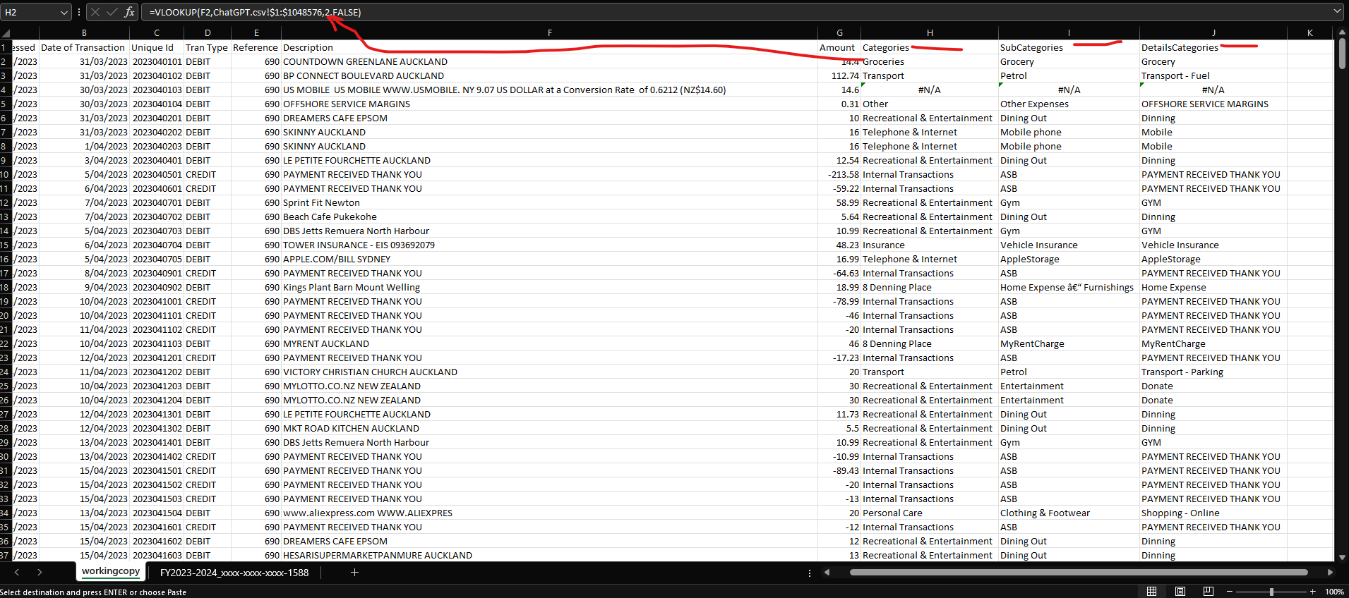
Categories =VLOOKUP(F2,ChatGPT.csv!$1:$1048576,2,FALSE)
SubCategories =VLOOKUP(F2,ChatGPT.csv!$1:$1048576,3,FALSE)
DetailsCategories =VLOOKUP(F2,ChatGPT.csv!$1:$1048576,4,FALSE)

Apply above formula to all of row. You will get some N/A columns try to fill them manually.
After fix all issues copy all 3 columns to main sheets next to each row.

Make sure copy only value and not copy formula.
This will be final file for this account.
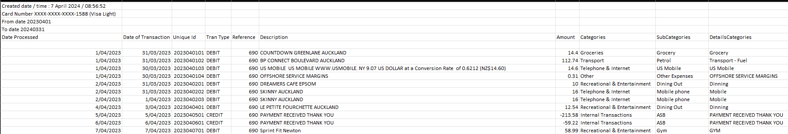

Notes:
Do all above in following order.
- ASB MJ Credit card
  - Use all above logic to sort out categories for this.
- ASB MJ Cach account
  - Most of transactions are internal. Add Memo to Category keyword and mark them all internal transactions. If there is any transaction which is not internal, it’s easier to sort them out manually.
- ASB Day-to-day MJ Account
  - Most of transactions are internal. It’s easier to filter them by “Paye” and mark internal transactions categories manually first.
    - These “Paye” consider as internal transactions. (Internal Transactions, ASB, Internal)
      - D/C FROM ALAVI,SEYED M
      - D/C FROM S TAEBI
      - D/C FROM Seyed Mojtaba Alavi
      - MB TRANSFER
      - FN TRANSFER
    - These “Paye” are rental income 24Panorama (24 Panorama Road, Income , Rent)
      - D/C FROM MYRENT LTD
    - These “Memo” are internal transactions. (Internal Transactions, ASB, Internal)
      - BILL PAYMENT TO Sam KiwiBank
      - BILL PAYMENT TO somaye taebi
      - FC12-3075-0188523-00 somaye taebi
      - FC38-9016-0440511-00 Sam KiwiBank
      - FC38-9016-0440511-00 Sam KiwiBank rates
    - This “Memo” is related to grocery from bdifood (Groceries, Grocery, Grocery)
      - BILL PAYMENT TO StaffBidone MJ Alavi 64170
      - FC12-3075-0140191-02 StaffBidone MJ Alavi 64170
    - Rest of Them should be small enough to go through manually.

Guide for categorize ANZ account details.
Go to ANZ accounts for MJ and export 4 following accounts.
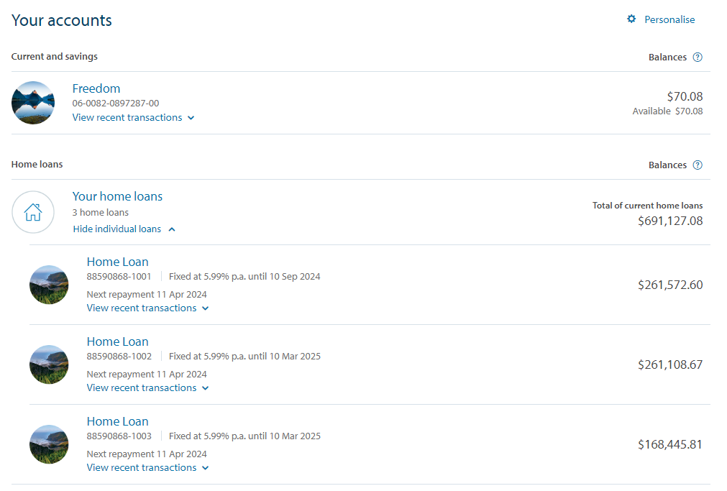

Make sure you select correct dates for financial year. For example, for FY2024 select 01/04/2023 – 31/03/2024.
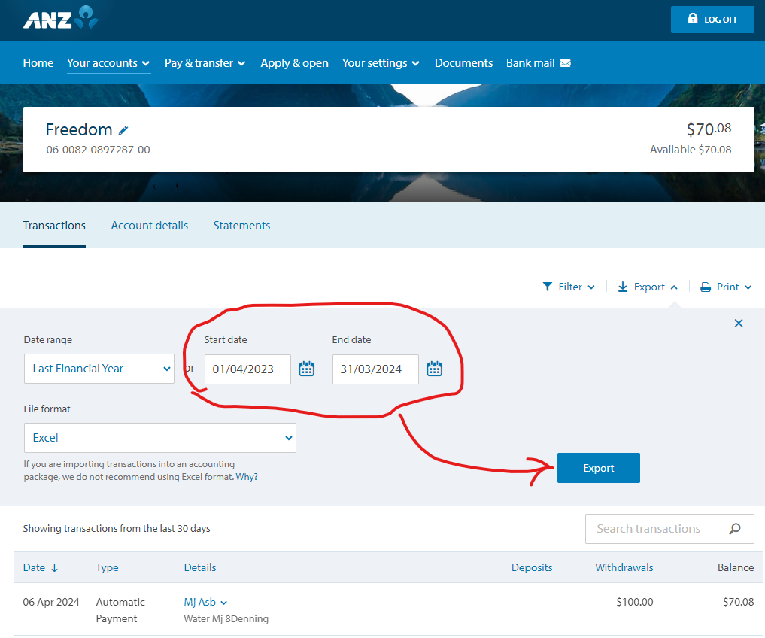
Export file to xlsx with following format. FY20xx-20xx_account number
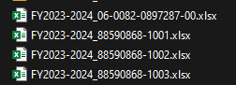
- For loan account xxxxxxx – 100x (there is 2 kinds of details. “Loan Payment”, “Loan Interest”). You can do it Manually for 3 accounts above. Make sure these Categories are added to categories.csv file.
  - For “Loan Payment” set category to (24 Panorama Road, Mortgage, RePayment)
  - For “Loan Interest” set category to (24 Panorama Road, Mortgage, Interest) 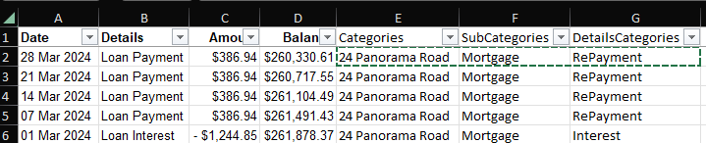
- For day-to-day account do following category manually
  - Any row has “Details” as “88590868-1001, 88590868-1002, 88590868-1003” set category to (Internal Transactions, ANZ, Internal)
  - Any Row has “Details” as “Bidfood Limited” set category to (Income, Salary, MJ) Note: make sure all values are positive.
  - Any row has “Details” as “Sam Kiwibank” set category to (Internal Transactions, ANZ, Internal) make sure all values are Negative.
  - Any row has “Details” as “Contact Energy” set category to (8 Denning Place, Electricity & Gas, Electricity & Gas)
  - Any row has “Details” as “Inland Revenue Dept” set category to (Other, Other Expenses, IRD)
  - Any row has “Details” as “Mj Asb” set category to (Internal Transactions, ANZ, Internal) make sure all values are Negative.
  - Any row has “Details” as “S Taebi” set category to (Internal Transactions, ANZ, Internal) make sure all values are Positive.

Guide for categorize Kiwi account details.
Go to Kiwi accounts for Sam and export 10 following accounts.
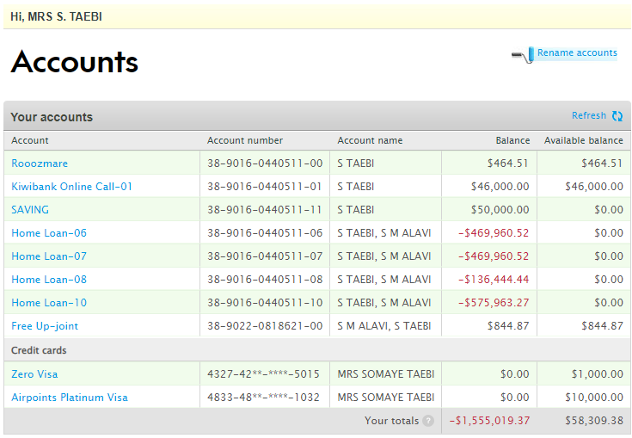
Make sure you select correct dates for financial year. For example, for FY2024 select 01/04/2023 – 31/03/2024.
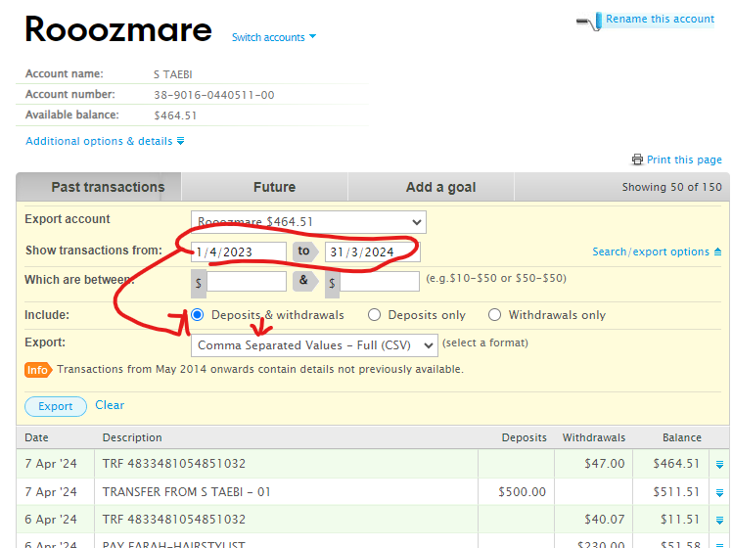
Export file to csv Full of following format. FY20xx-20xx_account number
Note: for credit card account it’s only available for 6 months period in current year, so you need to select 3 ranges for each credit card. (For Example 1/4/2023 - 30/6/2023, 1/7/2023 – 31/12/2023, 1/1/2024 - 31/3/2024)
Note: If you Apply for new credit card make sure check statement PDF as old data is not available in account. If you replace credit card, all details should be already existed under new card. But double check it.

- For loan account 38-9016-0440511-xx (06,07,08) (there is 2 kinds of Memo. “AP#”, “Loan Interest”). You can do it Manually for 4 accounts above. Make sure these Categories are added to categories.csv file.
  - For “AP#” set category to (8 Denning Place, Mortgage, RePayment)
  - For “LOAN INTEREST” set category to (* Denning Place, Mortgage, Interest)
  - Note: there are some other categories when loan term is change. If it’s negative, then use it as Interest and if positive apply RePayment category to it.
- For loan account 38-9016-0440511-10 (there is 2 kinds of Memo. “AP#”, “Loan Interest”). You can do it Manually for this account. Make sure these Categories are added to categories.csv file.
  - For “AP#” set category to (5B Cleary, Mortgage, RePayment)
  - For “LOAN INTEREST”” set category to (5B Cleary, Mortgage, Interest)
Note: there are some other categories when loan term is change. If it’s negative, then use it as Interest and if positive apply RePayment category to it. If you see the amount is big and match with loan amount, make sure use category as (Loans and Liabilities, Mortgage-5BCleary, Mortgage-5BCleary)
- For Saving account 38-9016-0440511-11 / 13 set category as (Saving,KiwiBank,KiwiBank)
- For Join account 38-9022-0818621-00, You can do it Manually for this account. Make sure these Categories are added to categories.csv file.
  - any “OP Bank Account Number” which is (38-9016-0440511-00 or 38-9016-0440511-01 or 38-9016-0440511-10) set category as (Internal Transactions, KiwiBank,Internal)
  - any “Memo” match with “Fixed Rate Lock Option” mark it as (5B Cleary Road, Mortgage, Loan Expense)
  - any “Memo” match with “CASH CONTRIBUTION” mark it as (Saving,KiwiBank,KiwiBank)
  - any “Memo” match with “SHORTFALL” mark it as (5B Cleary Road, Mortgage, Lump Sum Payment)
- For Saving account 38-9016-0440511-01 You can do it Manually for this account. Make sure these Categories are added to categories.csv file.
  - any “Memo” match with “Bill Payment Rent myRent” mark it as (5B Cleary Road, Income, Rent)
  - any “Memo” match with “TRANSFER TO / FROM S Taebi or Alavi” mark it as as (Internal Transactions, KiwiBank,Internal)
  - any “Memo” match with “HSBC” mark it as (Saving,KiwiBank,KiwiBank)
  - any “Memo” match with “INTEREST CREDIT” mark it as (Saving,KiwiBank,KiwiBank)
  - any “Memo” match with “IRD WITHHOLDING TAX 17.500%” mark it as (Other, Other Expenses, IRD)
  - any “Memo” match with “TFR FROM 1811371” mark it as (Internal Transactions, KiwiBank,Internal)
- For Daily account 38-9016-0440511-00 You can do it Manually for this account. Make sure these Categories are added to categories.csv file.
  - any “Memo” match with “Bill Payment Rent myRent” mark it as (5B Cleary Road, Income, Rent)
  - any “Memo” match with “TFR or Transfer(Credit ,Bill Payment to Sam or MJ” mark it as (Internal Transactions, KiwiBank,Internal) note: Make sure capture anything between ANZ, ASB and internal kiwiBank between MJ and Sam As all are internal. Check specifically MJ word and Sam word.
  - any “Memo” match with “SOUTHERN CROSS” mark it as (Insurance, Health Insurance-SAM, Health Insurance-SAM)
  - any payment to friends for dinning out need to be capture under (Recreational & Entertainment, Dining Out, Dinning) here is some examples: 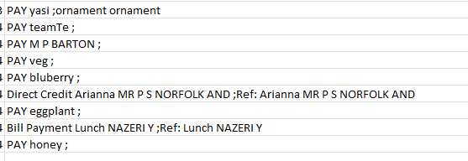
  - Note: some payment to Mina should be cover under home Expense and for Farah under HairCut
  - Any payment for IRD under “INLAND REVENUE DEPARTMENT ;Ref: 1239391360 I IT 113165197 INC” should mark as (5B Cleary Road, Property Tax, Property Tax)
  - There are some random Memo, you can sort them out manually base on best guess. 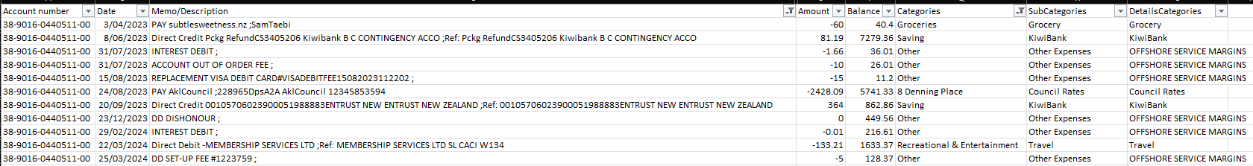
  - Any Memo with “Salary KIWIBANK FORTNIGHT” mark it as (Income, Salary, SAM)
- For Credit Card “FY2023-2024_4833-48__-____-1032” first merge all csv to one file and then go through it in xlsx file 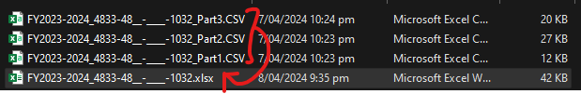
  - This one is main expense account and need to use ChatGPT to finalize it. But before that try to guess any categories for Travel, Home expense, parking and Grocery as it will reduce a time for ChatGPT to focus on other categories. To do that filer all travel one and mark categories as travel. Then remove filter and select filter to show only blank Categories. Do the same thing until you reduce the list of description, then go through page 5 in this document and use the same thing we did for ASB account.

After sorting out all bank accounts files. Now we put all details together in one file named “AllBankAccountsExpense.xlsx”. you can find this file in folder “004 - HomeLoan_ExpenseDetails”. this file has a format as (Bank, Type, Account, Date, Description, Amount, Categories, SubCategories, DetailsCategories.)
For bank field: get ANZ,ASB,KiwiBank
For Type field: Credit (for credit Card), Loan (For loan accounts), Saving (for saving and day-to-day Account)
For Account Number: use bank account number to make visibility, and for credit Card hide some numbers for security.
It’s manual process, to go through each file for bank account and copy details in this file.
To facilitate it, you can copy one bank account details and auto fill Bank, Account and Type. Then go to another bank account file. This way you can fill those 3 fields easily.

Note:
- before start make sure you have empty “AllBankAccountsExpense.xlsx”.
- For Description column you can join multiple columns to keep app description. For example, for ASB, you can join below fields and then use this new field for allbankaccountExpense file. Make sure copy value not formula.
  - Here is formula for kiwibank Accounts”.
    - =C2&" "&D2&" "&E2&" "&F2&" "&G2&" "&H2&" "&I2&" "&J2&" "&K2&" "&L2
- After copy data, make sure compare the count number and make sure filters are off. This help to reduce errors.
- 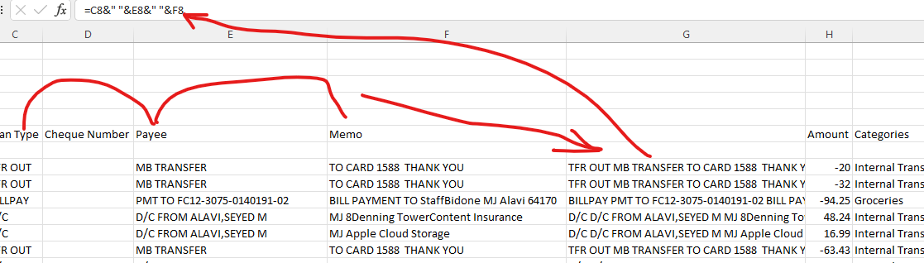

At this stage we have all bank Account in one sheet in AllBankAccountsExpense.xlsx. name the sheet as “All Banks FY-20xx-20xx” depend on financial year. Here is example 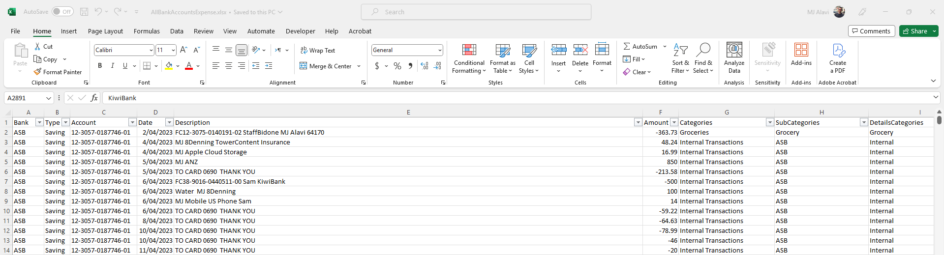

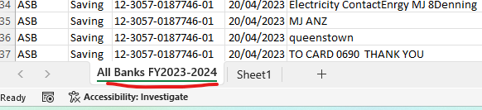

After sorting out all bank data, you can create new Sheet1(later we rename it to Expense2024-2025) and use pivot table to have all categories sum amount in one sheet. If you use previous year AllBankAccountsExpense.xlsx it already has it. You just need to update and refresh details. There are 2 buttons in PivotTable tab which help to link it correctly and refresh data properly.
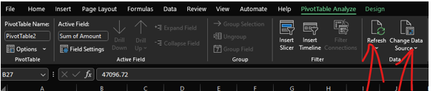
At the end you should have something like this
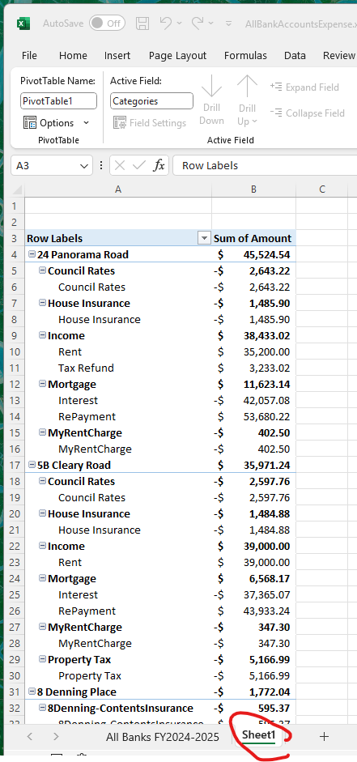

Now you can rename Sheet “Expense2024-2025.

Above sheet is the source we use for “HomeLoan.xlsx”. “AllBankAccountsExpense.xlsx” file is the main source for of expenses which later will be use on final file “HomeLoan.xlsx”.
Guideline for HomeLoan.Xlsx is in another guideline which named “Guide_HomeLoan.docx”

Here are categories which will be use to Expense details files later on. This is important to match everything correctly to get correct outcome at the end.

Categories
- Groceries
  - Groceries ['New Mortgage look'!F23]
    - ['New Mortgage look'!F23]
      - =GETPIVOTDATA("Amount",Expense!$A$3,"Category","Grocery")/12
- Personal Care
  - Clothing & Footwear ['New Mortgage look'!F29]
    - ['New Mortgage look'!F29]
      - =(GETPIVOTDATA("Amount",Expense!$A$6,"Category","Shopping")+GETPIVOTDATA("Amount",Expense!$A$6,"Category","Shopping - Online"))/12
  - Personal Care ['New Mortgage look'!F25]
    - ['New Mortgage look'!F25]
      - =GETPIVOTDATA("Amount",Expense!$A$6,"Category","HairCut")/12
- Medical
  - Medical & Health ['New Mortgage look'!F24]
    - ['New Mortgage look'!F24]
      - =GETPIVOTDATA("Amount",Expense!$A$3,"Category","Medical")/12
- Recreational & Entertainment
  - Dining Out ['New Mortgage look'!F28]
    - ['New Mortgage look'!F28]
      - =GETPIVOTDATA("Amount",Expense!$A$6,"Category","Dinning")/12
  - Entertainment ['New Mortgage look'!F27]
      - ['New Mortgage look'!F27]
        - =(GETPIVOTDATA("Amount",Expense!$A$6,"Category","Cinema")+GETPIVOTDATA("Amount",Expense!$A$6,"Category","Donate")+GETPIVOTDATA("Amount",Expense!$A$6,"Category","Gift")+GETPIVOTDATA("Amount",Expense!$A$6,"Category","Liquor"))/12
  - Travel ['New Mortgage look'!F30]
    - ['New Mortgage look'!F30]
      - =GETPIVOTDATA("Amount",Expense!$A$6,"Category","Travel")/12
  - Gym ['New Mortgage look'!F26]
    - ['New Mortgage look'!F26]
      - =GETPIVOTDATA("Amount",Expense!$A$6,"Category","GYM")/12
- Telephone & Internet
  - Mobile phone ['New Mortgage look'!F39+'New Mortgage look'!F40]
    - ['New Mortgage look'!F39] Manual Mobile Sam
    - ['New Mortgage look'!F40] Manual Mobile MJ
  - Internet ['New Mortgage look'!F34]
    - ['New Mortgage look'!F34] Manual Internet
- Transport
  - Petrol ['New Mortgage look'!F32]
    - ['New Mortgage look'!F32]
      - =(GETPIVOTDATA("Amount",Expense!$A$6,"Category","Transport - Car Park")+GETPIVOTDATA("Amount",Expense!$A$6,"Category","Transport - Fuel")+GETPIVOTDATA("Amount",Expense!$A$6,"Category","Transport - Parking")+GETPIVOTDATA("Amount",Expense!$A$6,"Category","Transport - Rental Car")+GETPIVOTDATA("Amount",Expense!$A$6,"Category","Transport -Taxi"))/12
- Insurance
  - Health Insurance-SAM ['New Mortgage look'!F66]
  - Life Insurance ['New Mortgage look'!F65]
  - Vehicle Insurance ['New Mortgage look'!F60]
- 8 Denning Place ['New Mortgage look'!B7]
  - Electricity & Gas ['New Mortgage look'!F41]
    - ['New Mortgage look'!F41] Manual Electricity
  - Council Rates ['New Mortgage look'!F70]
  - Water ['New Mortgage look'!F37]
    - ['New Mortgage look'!F37] Manual Water
  - 8Denning-HouseInsurance ['New Mortgage look'!F61]
  - 8Denning-ContentsInsurance ['New Mortgage look'!F62]
  - Home Expense – Furnishings ['New Mortgage look'!F31]
    - ['New Mortgage look'!F31]
      - =GETPIVOTDATA("Amount",Expense!$A$6,"Category","Home Expense")/12
- 24 Panorama Road ['New Mortgage look'!B6]
  - Council Rates ['New Mortgage look'!F71]
  - House Insurance ['New Mortgage look'!F63]
  - Property Tax ['New Mortgage look'! G81]
- 5B Cleary Road [['New Mortgage look'!B5]
  - Council Rates ['New Mortgage look'!F72]
  - House Insurance ['New Mortgage look'!F64]
  - Property Tax ['New Mortgage look'!G82]
- Other
  - Kiwisaver-MJ ['New Mortgage look'!D76]
  - Kiwisaver-Sam ['New Mortgage look'!D77]
  - AppleStorage ['New Mortgage look'!F35]
    - ['New Mortgage look'!F35] Manual Apple Storage
  - US Mobile ['New Mortgage look'!E36] ['New Mortgage look'!F36]
    - ['New Mortgage look'!F36] Manual US Mobile
  - MyRentCharge ['New Mortgage look'!E38] ['New Mortgage look'!F38]
    - ['New Mortgage look'!F38] Manual MyRentCharge
  - Other Expenses ['New Mortgage look'!E33] ['New Mortgage look'!F33]
    - ['New Mortgage look'!F33]
      - =(GETPIVOTDATA("Amount",Expense!$A$6,"Category","IRD")+GETPIVOTDATA("Amount",Expense!$A$6,"Category","Immigration"))/12
- Loans and Liabilities
  - Credit Card-KiwiBank-SAM ['New Mortgage look'!B19] ['New Mortgage look'!D19]
  - Credit Card-KiwiBank-SAM ['New Mortgage look'!B20] ['New Mortgage look'!D20]
  - Credit Card-ASB-MJ ['New Mortgage look'!B21] ['New Mortgage look'!D21]
  - Mortgage-8Denning SUM('New Mortgage look'!G53+'New Mortgage look'!G54+'New Mortgage look'!G55)*26/12
  - Mortgage-5BCleary =SUM('New Mortgage look'!G52)*26/12
  - Mortgage-24Panorama =SUM('New Mortgage look'!F48+'New Mortgage look'!F49+'New Mortgage look'!F50)*52/12

