HomeLoan.xlsx

Sheet ‘New Mortgage look’
Financial year start from 1April to 31March Next year. Example of 2024 (1April 2023- 31March2024) that means if today date is more than 31March2024 then we are in 2025 financial year. Always update today Date when review file. It’s first line in document as below screenshot.
- Manually update value of properties (Make sure update a date too)
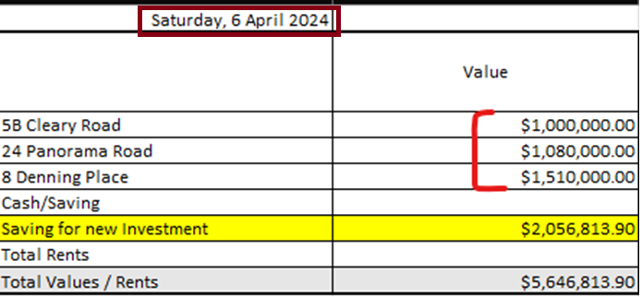
- Manually update KiwiSaver values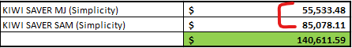
- Manually update CreditCard limits
- Manually update Saving account values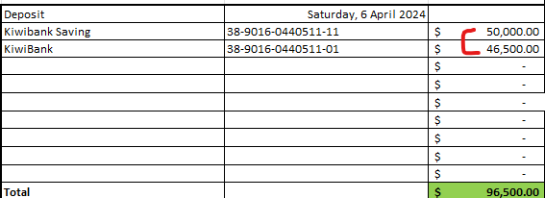

- Every time updating HomeLoan.xlsx file, make sure you have copy of previous financial year cost. Thet can help to compare it with current financial year. (Any new categories can be manually entered value if it doesn’t match with current categories.
- 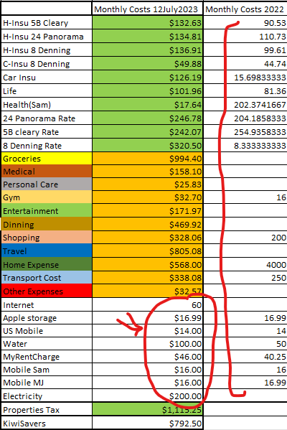
- By end of financial year make sure get copy of expenses and capture them here Manually. This copy is come from current expenses and copy over by end of 31 March each year. 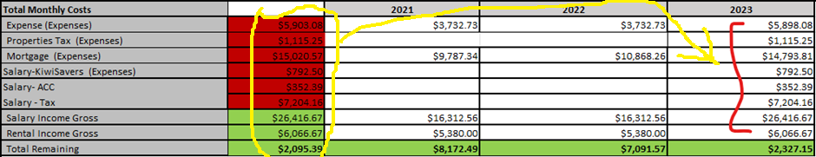

- HomeLoan
  - All highlighted value need to manually updated. Specially by end on date of fix term (fix until column)
    - Make sure bank account, current mortgage, and rate always up to date.
    - Make sure if mortgage payment is weekly then marking background green on weekly. If it’s fortnight, then this column needs to be green.
    - Update above details and “Start fix Date”, “Fix Until” every time mortgage fix time due. Put calendar reminder for any of them that will be happen in this financial year.
- Insurance
  - Get details from Tower Insurance(Web dashboard), AIA (MJ Email), Southern Cross (Sam login)
  - All area marked here need to be updated manually from above sources.
- Council rates
  - For any existing and new property update following column. Make sure every quarter mark them as bold if you already paid for it.
- Income
  - Anytime you have salary promotion make sure update it here. You can calculate it from http://paye.net.nz/calculator/ . Do not change any formula here and only update columns which mark red from below picture. Note: in paye website make sure you select correct kiwi saver contribution. Value of net salary should match with your payslip.
- Tax IRD
  - Every year after financial year finish (31March). You have time until July to file previsional tax for next financial year. After filing you will see provisional tax in your IRD account. Get following details from there and input here. Make sure mark payment day Bold when you paid. Add any new property tax here if you have in future.
- Simulate income from Property compare to salary
  - This simulate current income property to a person salary in New Zealand. You can go to paye.net.nz and play with calculator to find what salary can cover weekly rent (Gross weekly). Then you can put all details here. Make sure in calculator don’t pick kiwisaver value.

Sheet ‘Expense’
- This is important part of expense. All values here will be feed to ‘New Mortgage look’ sheet and all other summary pages. Make sure you understand it properly.
- Data in “All Bank FY20xx-20xx” tab is coming from ‘AllBankAccountExpense.xlsx’. Make sure you link it properly to current financial year to avoid confusion.
  - Open both “HomeLoan.xlsx” , “AllBankAccountExpense.xlsx“.
  - In “AllBankAccountExpense.xlsx” go to Sheet “All Bank FY20xx-20xx”
  - Now go back to “HomeLoan.xlsx” and go to “Sheet expense”.
  - There is 2 buttons in PivotTable tab which help to link it correctly and refresh data properly.
  - 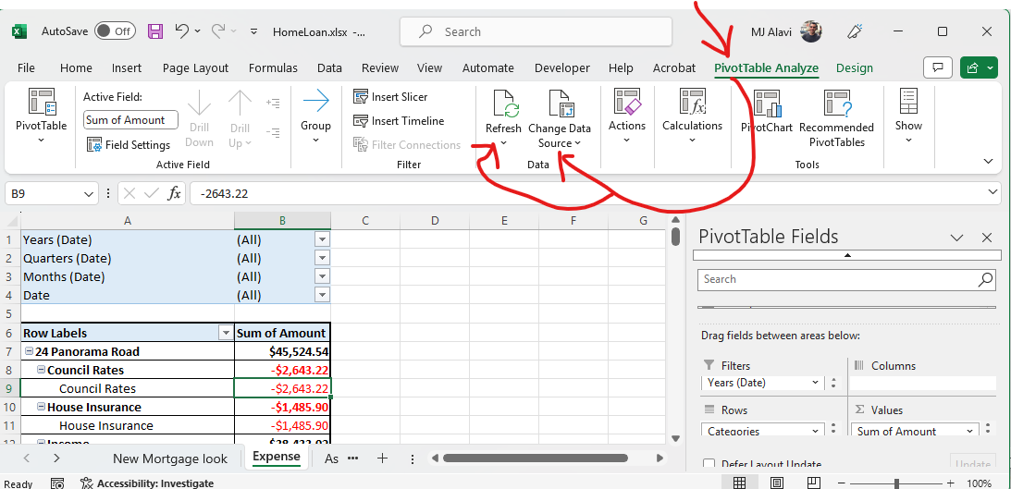
- Click on Change Data Source and click on arrow key shows in the below picture.
- 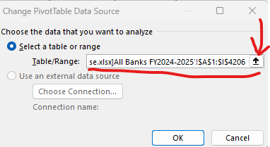
- Now go back to AllBankAccountExpense.xlsx file and select all rows and column from sheet “Bank FY20xx-20xx”
- After select all data you should see similar Table/Range from previous picture. Then click OK.
- Now you have all Data in expense sheet. If your data not look similar to below picture, try to add fields and column from pivot section.
- 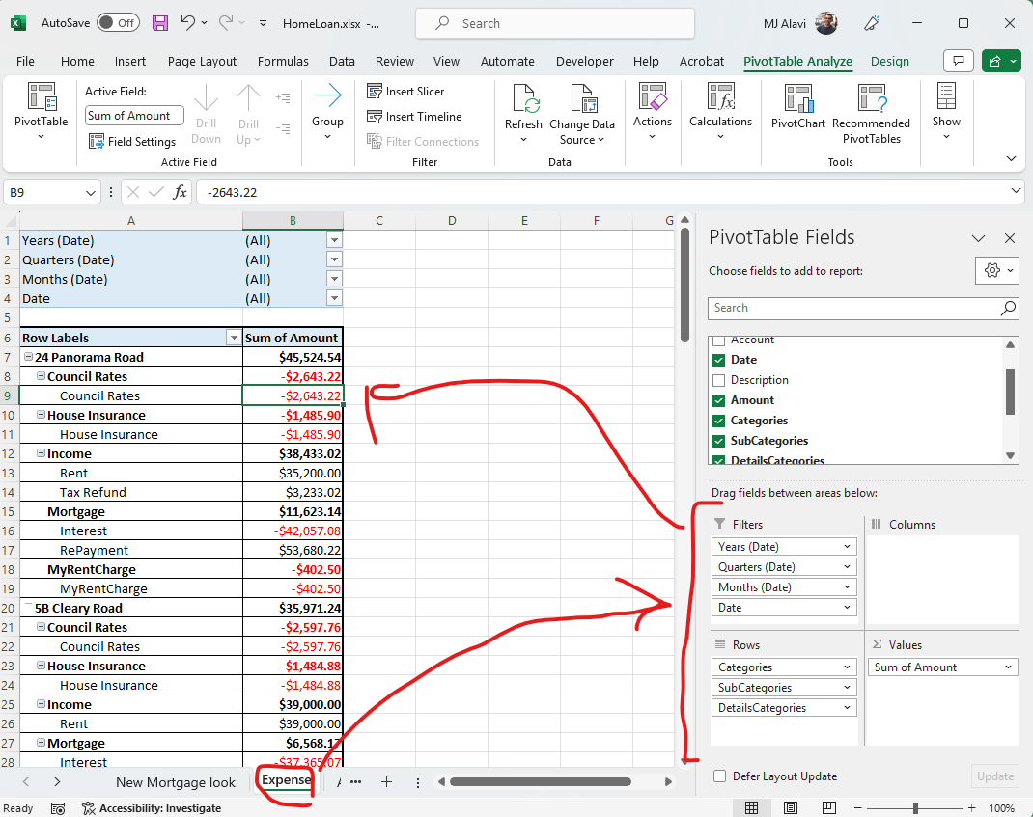
- (Note: if you have this file in your local or Google drive make sure address is correct otherwise it will not update data)
- After select correct data source you can click on Refresh button and refresh all details.
- Note: make sure you always set following filters to All to get result correctly. Don’t filter anything.
- 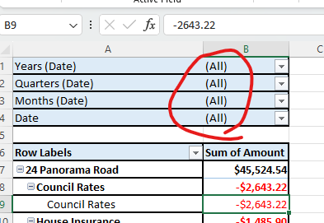
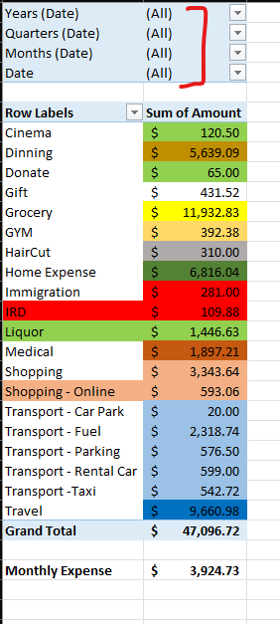
- Colouring code from above is match with colouring in ‘New Mortgage look’ sheet to make sure we get same values. If you update colouring, then apply it in both places.

Sheet ‘Assets, Liabilities, Income, Expenses, Summary’
All these sheets give you full picture for your financial view. Summary page, give you overview in one page. There is also a link in pages which linked to details. It helps to understand where data is coming from. There is a column name Linda Loan Asset, which is value we get from Mortgage broker last time reviewed our finance. We keep it here to make sure we have some base line. You can add also previous year result to current financial year for comparison too.
Make sure at end of financial year get a copy of HomeLoan.xlsx file and rename it to HomeLoanFY20xx-20xx.xlsx.(replace xx with financial year.) That help to keep record of changes for each year.
