---Space (Arial 18 Bold) ---
Formatting Guide to Authors for Paper Submission in the OGPC 2024
(Center, Bold, Arial 18, max 20 words in English)
---Space (Arial 18 Bold) ---
First Author's name ¹, Second author's name ^{2,*} ... (Arial 10 Bold)
--- Space (Arial 12 Bold) ---
1. First author's affiliation
2. Second author's affiliation
--- Space (Arial 12 Italic) ---

ARTICLE INFO |  | ABSTRACT
Article history:  Received:  Received in revised form:  Accepted:  Keywords:  Maximum 6 words;  Arial 11 regular.  * Corresponding author (Arial 11 regular);  E-mail:  Tel.:  Fax: |  | These instructions give you guidelines for preparing papers for OGPC. Because Photonics is produced in DOC, strict adherence to format is required. The use of this template is useful for estimating the length of the papers. The electronic file of your paper will be formatted further at OGPC. Use this document as a template if you are using Microsoft Word 2003 or later. Define all symbols used in the abstract and the conclusion. Do not cite references in the abstract. Abstracts should be limited to 150 words. OGPC accept brief communications and full length papers. Typeset: Arial 11 regular.

1. Introduction
The main text format consists of a flat left-right columns on A4 paper (quarto). The margin text from the left, right, top, and bottom 3 cm. The manuscript is written in Microsoft Word, single space, Arial 12pt and maximum 12 pages, which can be downloaded at the website: https://ogpc2024.pgu.ac.ir/.
A title of article should be the fewest possible words that accurately describe the content of the paper. Indexing and abstracting services depend on the accuracy of the title, extracting from it keywords useful in cross-referencing and computer searching. An improperly titled paper may never reach the audience for which it was intended, so be specific.
The Introduction should provide a clear background, a clear statement of the problem, the relevant literature on the subject, the proposed approach or solution, and the new value of research which it is innovation. It should be understandable to colleagues from a broad range of scientific disciplines.
Organization and citation of the bibliography are made in IEEE style in sign [1], [2] and so on. The terms in foreign languages are written italic (italic). Authors are suggested to present their articles in the section structure: Introduction - The Proposed Method/Algorithm (optional) - Research Method - Results and Discussion – Conclusion [3].
Literature review that has been done author used in the chapter "Introduction" to explain the difference of the manuscript with other papers, that it is innovative, it are used in the chapter "Research Method" to describe the step of research and used in the chapter "Results and Discussion" to support the analysis of the results [2]. If the manuscript was written really have high originality, which proposed a new method or algorithm, the additional chapter after the "Introduction" chapter and before the "Research Method" chapter can be added to explain briefly the proposed method or algorithm [4].

2. Research Method
Explaining research chronological, including research design, research procedure (in the form of algorithms, Pseudocode or other), how to test and data acquisition [1], [3]. The description of the course of research should be supported references, so the explanation can be accepted scientifically [2], [4].
Tables and Figures are presented center, as shown below and cited in the manuscript.

Table 1. Molar flow and molar composition of gas turbines flue gases.
Component | Mole (%) | Molar Flow (kg mol/hr)
CO₂ | 2.44 | 33.31
H₂O | 7.28 | 99.36
O₂ | 17 | 232.08

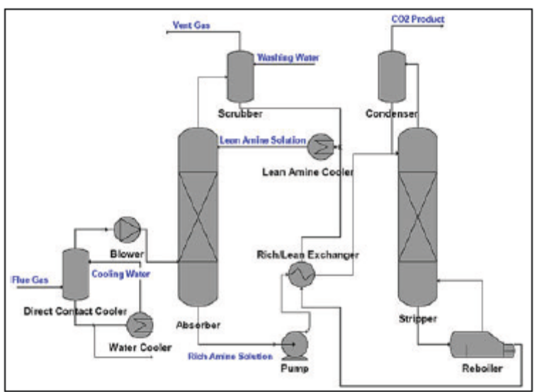
Figure 1. Flow sheet of CO₂ capture from flue gases by using amine-based system.

3. Results and Analysis
In this section, it is explained the results of research and at the same time is given the comprehensive discussion. Results can be presented in figures, graphs, tables and others that make the reader understand easily [2], [5]. The discussion can be made in several sub-chapters.

3.1. Sub Bab 1
xx

3.2. Sub Bab 2
yy

4. Conclusion
Provide a statement that what is expected, as stated in the "Introduction" chapter can ultimately result in "Results and Discussion" chapter, so there is compatibility. Moreover, it can also be added the prospect of the development of research results and application prospects of further studies into the next (based on result and discussion).

References
The main references are international journals and proceeding. All references should be to the most pertinent and up-to-date sources. References are written in IEEE style. Please use a consistent format for references – see examples below:

Print References
Book
Author(s). Book title. Location: Publishing Company, year, pp.
Example:
- W. K. Chen. Linear Networks and Systems. Belmont, CA: Wadsworth, 1993, pp. 123-35.

Book Chapters
Author(s). "Chapter title" in Book title, edition, volume. Editors name, Ed. Publishing location: Publishing company , year, pp.
Example:
- J. E. Bourne. "Synthetic structure of industrial plastics," in Plastics, 2nd ed., vol. 3. J. Peters, Ed. New York: McGraw-Hill, 1964, pp.15-67.

Article in a Journal
Author(s). "Article title". Journal title, vol., pp, date.
Example:
- G. Pevere. "Infrared Nation." The International Journal of Infrared Design, vol. 33, pp. 56-99, 1979.

Articles from Conference Proceedings (published)
Author(s). "Article title." Conference proceedings, year, pp.
Example:
- D. B. Payne and H. G. Gunhold. "Digital sundials and broadband technology," in Proc. IOOC-ECOC, 1986, pp. 557-998.

Papers Presented at Conferences (unpublished)
Author(s). "Paper title," Conference name, Location, year.
Example:
- B. Brandli and M. Dick. "Engineering names and concepts," presented at the 2nd Int. Conf. Engineering Education, Frankfurt, Germany, 1999.

Handbook
Name of Manual/Handbook, edition, Publishing Company, Publishing location, year, pp.
Example:
- Transmission Systems for Communications, 3rd ed., Western Electric Co., Winston-Salem, NC, 1985, pp. 44–60.

Standards/Patents
Author(s)/Inventor(s). "Name/Title." Country where patent is registered. Patent number, date.
Example:
- E.E. Rebecca. "Alternating current fed power supply." U.S. Patent 7 897 777, Nov. 3, 1987.

Report
J. K. Author, "Title of report," Publishing Company, Publishing location, Rep., year, vol.
Example:
- R. E. Haskell and C. T. Case, "Transient signal propagation in lossless isotropic plasmas," USAF Cambridge Res. Labs., Cambridge, MA, Rep. ARCRL-66-234 (II), 1994, vol. 2.

Dissertations and Theses
Author. "Title." Degree level, school, location, year.
Example:
- S. Mack. "Desperate Optimism." M. S. thesis, University of Calgary, Canada, 2000.

Electronic References
Books
Author. ( year , Month day). Book title. ( edition ). [Type of medium]. vol. (issue). Available: site/path/file [date accessed].
Example:
- S. Calmer. (1999, June 1). Engineering and Art. (2nd edition). [On-line]. 27(3). Available: www.enggart.com/examples/students.html [May 21, 2003].

Journal
Author. (year, month). "Article title." Journal title. [Type of medium]. vol. (issue), pp. Available: site/path/file [date accessed].
Example:
- A. Paul. (1987, Oct.). "Electrical properties of flying machines." Flying Machines. [On-line]. 38(1), pp. 778-998. Available: www.flyingmachjourn/properties/fly.edu [Dec. 1, 2003].

World Wide Web
Author(s)*. "Title." Internet: complete URL, date updated* [date accessed].
- M. Duncan. "Engineering Concepts on Ice." Internet: www.iceengg.edu/staff.html, Oct. 25, 2000 [Nov. 29, 2003].

* If you can’t find this information, exclude it.

Exact page number References
To refer readers to specific page numbers in a text, use the number of the reference followed by a colon (:) and the page numbers.
Example:
Johnson suggests that citing will lead to a decrease in being cited for plagiarism [1:28-29].
The [1] refers to the numbered reference and the 28-29 refers to the pages being cited.

Note:
Please be sure to check for spelling and grammar before submitting your paper.

