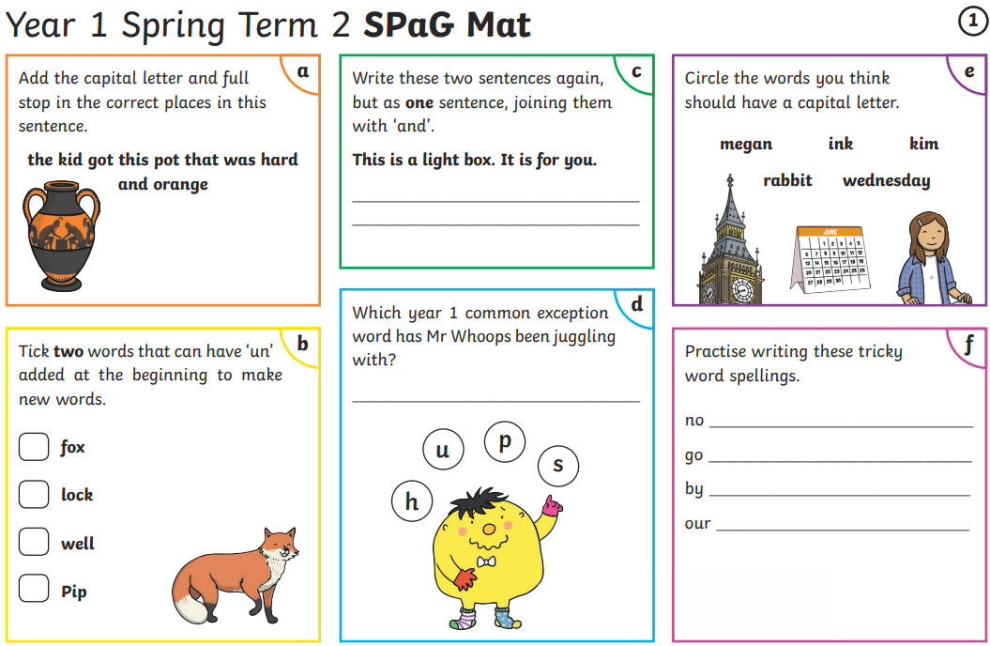
The kid got this pot that was hard and orange.
This is a light box and it is for you.
push
X
X
X

