ARCHITECTURAL DESIGN SERVICES
Professional Fee Offer & Preliminary Agreement
TWO ADJOINING PLOTS · MIXED-USE DEVELOPMENT · BASATINE, TRIPOLI
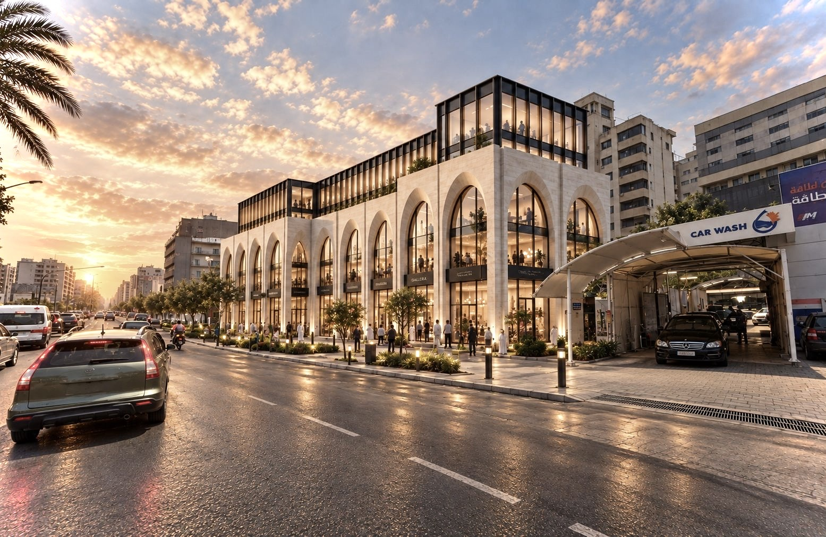
CLIENT  Mr Tarek Karame | ARCHITECT  Arch. Mo Kabbara | DATE  18 September 2026 | REFERENCE  MK-TAK-P07-2026-02

Project Proposition
One coordinated architectural vision is proposed across two adjoining plots. The larger plot will be developed as the principal mixed-use project under the complete architectural scope. The smaller plot will receive a focused schematic concept intended to strengthen its market positioning and support a future land sale.
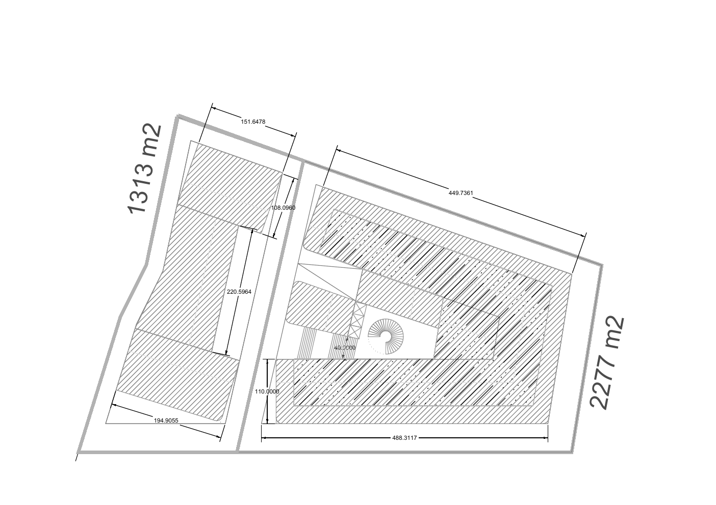
LARGER PLOT  Approximately 2,277 m²  Full architectural design scope, permit drawings, execution design, visualizations and follow-up. | SMALLER PLOT  Approximately 1,313 m²  Sales-oriented schematic design only, developed to attract buyers and demonstrate development potential.
Urban design intent: the smaller-plot concept will retain the architectural language, material logic, proportions and public-realm character of the larger project so that both sites read as a coherent urban composition. This coordination does not extend the smaller plot into permit, execution or construction documentation.

Preliminary Design Schematic
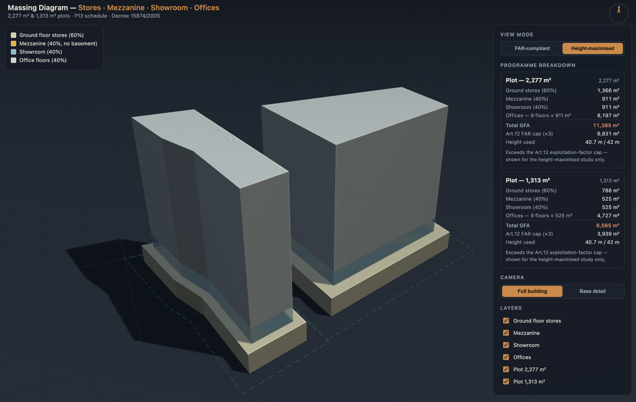
PROGRAMME  Stores · mezzanine · showroom · offices · residential uses subject to the approved brief. | DESIGN RELATIONSHIP  Two coordinated masses with a consistent façade family, scale, landscape and street identity. | PLANNING STATUS  All areas and massing remain preliminary and subject to survey, zoning and authority confirmation.

1. Parties and Appointment
This Professional Fee Offer and Preliminary Agreement (the “Agreement”) is made between Mr Tarek Karame (the “Client”) and Arch. Mo Kabbara (the “Architect”) for architectural design services relating to the two adjoining plots described below.
The Client appoints the Architect to perform the services stated in this Agreement. The appointment becomes effective when both parties sign the Agreement and the Phase 1 payment has been received, unless otherwise agreed in writing.

2. Project Description
The proposed project concerns two adjoining land parcels within Plot No. 7 in the Basatine area of Tripoli, Lebanon. The larger plot, approximately 2,277 m², is the principal mixed-use development and receives the full scope stated in this Agreement. The smaller adjoining plot, approximately 1,313 m², receives a schematic design concept for land-sale and buyer-attraction purposes only. Both concepts will share a coordinated architectural identity to preserve urban harmony and consistency.
- Three basement levels, primarily for parking, technical rooms, storage and building services;
- Ground-floor retail stores and showrooms;
- Office accommodation;
- Residential apartments; and
- Associated entrances, circulation cores, service spaces and external landscaped areas.

3. Preliminary Planning and Development Basis
Larger plot | Approximately 2,277 m² - full architectural scope and permits
Smaller plot | Approximately 1,313 m² - schematic land-sale concept only
Combined indicative land area | Approximately 3,590 m²
Total zoning coefficient | 3.00
Larger-plot zoning-counted floor area | Approximately 6,831 m²
Smaller-plot zoning potential | Approximately 3,939 m², indicative only
Maximum ground coverage | 60% of the plot
Maximum height | 42 m + 1 m technical allowance = 43 m
Entrance allowance | Approximately 35 m² per entrance, subject to final planning

Preliminary Area Calculation
Item | Calculation | Indicative result
Larger plot FAR allowance | 2,277 m² × 3.00 | 6,831.00 m²
Larger plot ground coverage | 2,277 m² × 60% | 1,366.20 m²
Larger plot upper-floor balance | 6,831 − 1,366.20 | 5,464.80 m²
Indicative balconies + walls | 5,464.80 × (20% + 15%) | 1,912.68 m²
Indicative larger-plot total | 1,366.20 + 5,464.80 + 1,912.68 | 8,743.68 m²
Smaller plot FAR potential | 1,313 m² × 3.00 | 3,939.00 m²
The detailed calculation is provided for the larger plot, which is subject to the full design and permit scope. The smaller-plot figure is an indicative schematic potential for land-sale positioning only. The treatment of balconies, walls, basements, exemptions and all areas must be confirmed with the competent authorities.

4. Scope of Architectural Services
The Architect will develop the project through the following five phases. Percentages represent instalments of the agreed total professional fee, not percentages of physical completion or construction cost.
Scope allocation: all five phases apply to the larger plot. For the smaller plot, the included service is limited to the coordinated schematic concept and supporting sales-oriented presentation material described under Phase 1. Later permit, execution, interior, authority or construction-stage services for the smaller plot are excluded unless separately agreed in writing.
25% | PHASE 1 | Schematic Design  - Review the Client’s brief, available survey information and preliminary planning parameters.  - Develop the architectural concept, massing, functional distribution and overall design direction.  - Present two architectural design directions at schematic level for comparison and selection by the Client; one selected direction will proceed to further development.  - Prepare preliminary site planning, floor plans, key sections and elevations at schematic level.  - Prepare preliminary basement parking and access concepts, typical residential layouts, material palettes and up to six schematic 3D views across the two directions.  - Present the preferred concept for the Client’s review and written approval.  - Prepare a coordinated schematic concept for the smaller adjoining plot for land-sale presentation, buyer attraction and demonstration of development potential, while maintaining the architectural spirit and urban consistency of the larger plot.

25% | PHASE 2 | Design Development & Permit Drawings  - Develop the approved concept, layouts, elevations, sections, cores and principal materials.  - Coordinate architectural information with the Client and appointed specialist consultants.  - Prepare the architectural drawings reasonably required for the planning and permit submission.  - Respond to routine authority comments relating to the architectural submission.

25% | PHASE 3 | Execution Design & Architectural Renderings  - Prepare architectural execution drawings and principal construction details appropriate to the agreed design stage, including general plans, elevations, sections, cores, typical wall sections, façade setting-out, balconies, parapets, railings, and typical door/window and finish schedules.  - Coordinate architectural interfaces with structural and building-services information supplied by others.  - Develop material integration and key façade, entrance and common-area details.  - Prepare up to six design-development renderings: main street view, secondary corner view, bird’s-eye view, commercial/showroom frontage, residential entrance, and terrace/courtyard or landscaped area.

Phase Approvals
At the end of each phase, the Architect will issue the relevant package for review. The Client shall provide one consolidated written response. Written approval, or instruction to proceed, authorizes commencement of the next phase.

4. Scope of Architectural Services (continued)
15% | PHASE 4 | Visuals & Marketing Materials  - Produce up to 12 final high-resolution photorealistic images based on the approved design.  - Exterior images: hero bird’s-eye, main daytime façade, secondary corner, pedestrian-level façade, retail/showroom frontage, residential entrance, evening/dusk view, and terrace/courtyard or landscaped area.  - Interior images: residential lobby, typical apartment living/dining space, typical kitchen or master bedroom, and office reception or representative showroom.  - Prepare a project cover image, simplified fact sheet, selected coloured plans, unit-type diagrams, material palette, façade concept board, presentation PDF and up to six social-media crops derived from the final images.  - Each final image includes one approved camera position, one draft review, one consolidated correction round and one final high-resolution issue.  - Marketing copywriting, media buying, website development, printing and animation are excluded unless added in writing.

10% | PHASE 5 | Finalization, Design Follow-up & Fine-tuning  - Undertake minor design adjustments and fine-tuning after completion of the principal design packages.  - Support final architectural material and finish selections.  - Provide limited interior-concept input for the main residential lobby, one typical apartment living/dining area, one representative office reception and one representative showroom, including general colours, materials, lighting direction and visualization furniture suggestions.  - Provide design clarification and minor updates for up to 90 days after the final design issue. Site supervision and redesign are not included.

5. Deliverable Format and Revisions
- Unless otherwise agreed, formal deliverables will be issued electronically in PDF format. Editable CAD/BIM, 3D model and source files remain working instruments of the Architect and are not included automatically.
- The fee includes up to two consolidated revision rounds during each of Phases 1-4, provided the revisions remain consistent with the approved brief and do not reverse an earlier approval. The Client’s selection of one schematic direction closes the alternative-direction exercise.
- Additional alternatives, repeated fragmented comments, substantial redesign, or changes arising from a revised Client brief, land information, regulations, consultant information or authority requirements will be treated as additional services.
- The programme and precise drawing list will be agreed after receipt of the verified survey, legal planning information and complete Client brief.
- The fee includes up to two coordination meetings per phase and up to four design-coordination site visits in Tripoli. Additional meetings, visits, travel or construction attendance are additional services.
- A change exceeding 5% of the agreed development area, a change of use or floor count, or reopening a previously approved phase requires a fee and programme adjustment.

6. Client Information and Responsibilities
- Provide accurate ownership documents, cadastral plans, topographical and boundary surveys, geotechnical information and applicable planning records.
- Appoint and pay all required structural, civil, MEP, fire-safety, geotechnical, traffic, quantity-surveying and other specialist consultants.
- Nominate one authorized representative and provide timely, consolidated instructions and approvals.
- Pay all authority, permit, printing, testing and third-party fees directly unless otherwise agreed.
- Promptly inform the Architect of decisions or circumstances that may affect scope, cost, programme or approvals.

7. Professional Fee and Payment Schedule
ORIGINAL PROFESSIONAL FEE | USD 43,000
AGREED DISCOUNT | 15% (USD 6,450)
DISCOUNTED PROFESSIONAL FEE | USD 36,550 (Thirty-six thousand five hundred fifty United States dollars)
TAXES | Exclusive of VAT and any applicable withholding or statutory taxes, unless written otherwise
PAYMENT ACCOUNT | To be stated on the Architect’s invoice

No. | Milestone | % | Amount
1 | Schematic Design - due upon signing and before commencement | 25% | USD 9,137.50
2 | Design Development & Permit Drawings - due before Phase 2 | 25% | USD 9,137.50
3 | Execution Design & Architectural Renderings - due before Phase 3 | 25% | USD 9,137.50
4 | Visuals & Marketing Materials - due before Phase 4 | 15% | USD 5,482.50
5 | Finalization & Design Follow-up - due before Phase 5 | 10% | USD 3,655.00

Payment Conditions
- Invoices are payable within seven calendar days of issue.
- The Architect may pause work where an invoice remains unpaid after written notice. The programme will be adjusted for the resulting delay.
- Payments for work already performed are non-refundable. Any bank transfer, currency conversion or intermediary charges are borne by the Client.
- Additional services will commence only after written approval of their scope and fee or hourly/daily rate.

8. Services Not Included
Unless expressly added through a written amendment, the fee excludes:
- Structural, civil, MEP, fire, geotechnical, landscape, traffic, environmental, acoustic, lighting, kitchen, signage and other specialist design services;
- Bills of quantities, cost consultancy, tender administration, contractor procurement and construction management;
- Continuous site supervision, clerk-of-works services, contractor means and methods, health and safety responsibility, or certification of construction;
- Measured surveys, legal/title verification, authority and permit fees, physical models, printing, travel and accommodation; and
- Full interior-design packages, detailed joinery, furniture procurement, branding, animation, website development and post-occupancy services.
- For the smaller adjoining plot: permit drawings, authority submissions, design development, execution drawings, detailed interior design, tender documents, construction coordination and site supervision.

9. Principal Terms
9.1. Preliminary information
The project areas, height, coefficients and development potential in this Agreement are preliminary assumptions for defining scope and fee. They do not constitute a survey, title opinion, permit approval, legal development-right confirmation or construction guarantee. All parameters are subject to verification against the official survey, cadastral records, setbacks, road alignments, parking, accessibility, fire-safety, structural, services and authority requirements.
9.2. Programme
The Architect will prepare an indicative programme once the required information, consultant appointments and Client decision dates are confirmed. Authority review periods, third-party performance and delays caused by incomplete or changed information are outside the Architect’s control and will extend the programme reasonably.
9.3. Changes and additional services
A material change to the plot information, approved programme, development area, number or use of floors, regulations, approved design, Client brief or authority requirements may require a written adjustment to the scope, fee and programme. Work outside the agreed scope will not be undertaken without written authorization, except urgent protective action requested by the Client.
9.4. Consultants and coordination
The Architect may coordinate architectural information with specialist consultants, but each consultant remains responsible for the adequacy, accuracy and compliance of their own design. The Architect is not responsible for contractor workmanship, construction methods or departures from the issued architectural documents.
9.5. Intellectual property and use
The Architect retains copyright and authorship in all drawings, models, images and design material. Once all fees due have been paid, the Client receives a non-exclusive licence to use the issued material solely for this project and site. The material may not be reused, altered by others, sold or applied to another site without the Architect’s written consent. The Architect may photograph and publish the project for professional portfolio purposes, excluding confidential commercial information, unless the Client objects in writing.
9.6. Suspension and termination
Either party may terminate this Agreement by giving 14 calendar days’ written notice. The Client shall pay for all services completed, authorized additional services and committed third-party costs up to the termination date. The Architect may suspend services following written notice of overdue payment, unsafe conditions, unlawful instructions or prolonged Client inactivity.
9.7. Professional standard
The Architect will perform the services with reasonable professional skill and care appropriate to the agreed scope and project stage. No approval, commercial result, construction cost or programme outcome is guaranteed.
9.8. Communications and entire preliminary agreement
Email and signed electronic copies are acceptable for notices, approvals and execution. This document records the current preliminary agreement between the parties and may be amended only in writing and accepted by both parties. A more detailed consultant agreement may replace it by mutual written consent.
9.9. Good-faith resolution and governing law
The parties will first attempt to resolve any disagreement through good-faith negotiation. Unless replaced by a later written agreement, this Agreement is governed by the laws of Lebanon and disputes not resolved amicably shall be referred to the competent courts of Tripoli, Lebanon.

10. Acceptance and Signatures
By signing below, the Client and the Architect confirm that they have read, understood and accepted this Professional Fee Offer and Preliminary Agreement, including its scope, assumptions, exclusions, payment schedule and principal terms.
AGREED TOTAL PROFESSIONAL FEE
Currency: USD Amount in figures: USD 36,550 (after 15% discount)
Amount in words: Thirty-six thousand five hundred fifty United States dollars

FOR THE CLIENT  Name: Mr Tarek Karame  Address: ________________________________  Email / phone: ________________________________  Signature: ________________________________  Date: ________________________________ | FOR THE ARCHITECT  Name: Arch. Mo Kabbara  Email: mo@mokabbara.com  Website: www.mokabbara.com  Signature: ________________________________  Date: ________________________________

Before Signing
Complete the Client contact details and signature dates. Each party should retain a signed copy. Because this document may create legal obligations, the parties may obtain independent legal and tax advice before execution.

Appendix A · Area Distribution and Plot Diagram
The following supplied diagram records the preliminary relationship and indicative areas of the two adjoining plots. It forms part of the project reference information and remains subject to verification by the official cadastral and topographical documents.

