**Main Requirements of TCLI**

1. There is no registration for author and institute
2. admin are the one to register them manually
3. Yeah, can give Forum menu in the apps so when user will hit on the menu, they will be redirected to web forum page. is it okay ?
4. borrowed book history page
5. club page
6. phone number in the registration form
7. last reading book alert in the user dashboard
8. Payment gateway paypal and flutterweb

**Admin Panel Figma Corrections:**

1. registration a user ar country nite hobe and admin panel a map view thakbe users list dekhar jonno
2. admin email notification pabe, new author book submit, new user create, package purchase etc
3. admin book list a read count and borrow count add korte hobe
4. book create a paid/free assign kora
5. user list a search bar add korte hobe
6. users list a subscriptions remaining days add
7. users list a institutions and author create button dite hobe
8. admin borrowed book list dekte pabe of users and percentage of completion
9. role based user add

**Questions & Answer:**

1. Admin will able to upload books for author ?

Ans: Yes I think this will be a good feature to have in addition to the admin being able to approve or decline what an author submits.

1. Institution activities explain please ?

Ans: ”As pertains the institution login, how it works is that TCLI has an agreement already with these institutions to access books. They will also have designated book access; all this will be captured from the admin end....eg we could have school A, and school B and based on curriculum school A has access to 5 books, school B as access to 6 books. Hence once the portal is created for school A, when they login via their institution login those 5 books show

1. as free user will get two free book access monthly. so will they able to read the books without borrow ? when admin will create books then admin will assign the book is free or paid. so that we can consider the book as paid content which is accessible for paid users. so my question is when you will give two books monthly for free users so will they get books from free book list or paid book list ?

Answer: Yes the free user can only borrow two books monthly.   
And yes, they will only be able to borrow from the list of free books as categorized by the admin.

up on their portal, the only other books other than this that may be showing may be other free books in the library available to general/all users.”

**Pricing Summary**

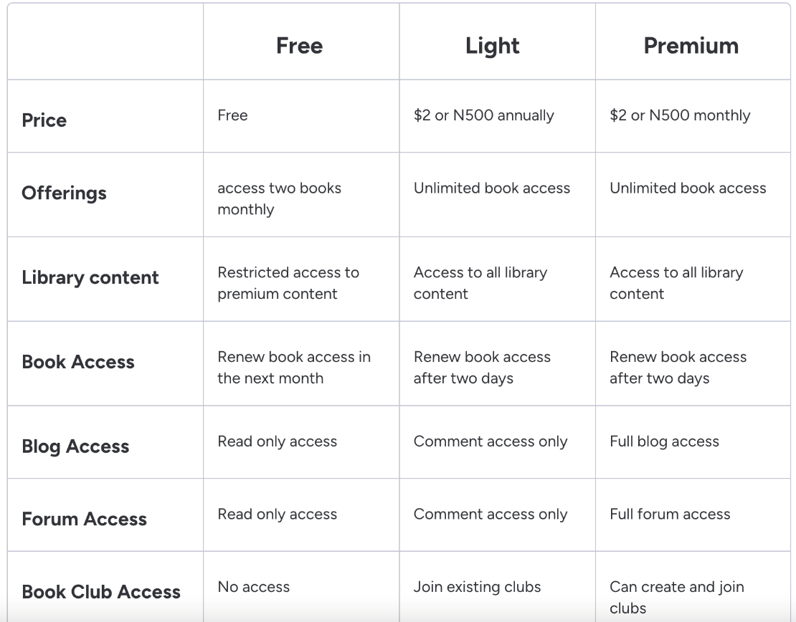

1. Free users monthly 2ta books borrow korte parbe
2. Premium books access pabe na, club no access, blog and forum read only access
3. Free user je book ta borrow korlo seta return dewar por 2 months ar moddhe borrow korte parbe na, but paid users ra 2 din por re borrow korte parbe
4. Book borrow ta 30 days ar jonno hobe
5. Questions: after 30 days system will automatically mark the book as returned & remove from the users borrowed book list ?

**Corrections:**

1. Books page ar link 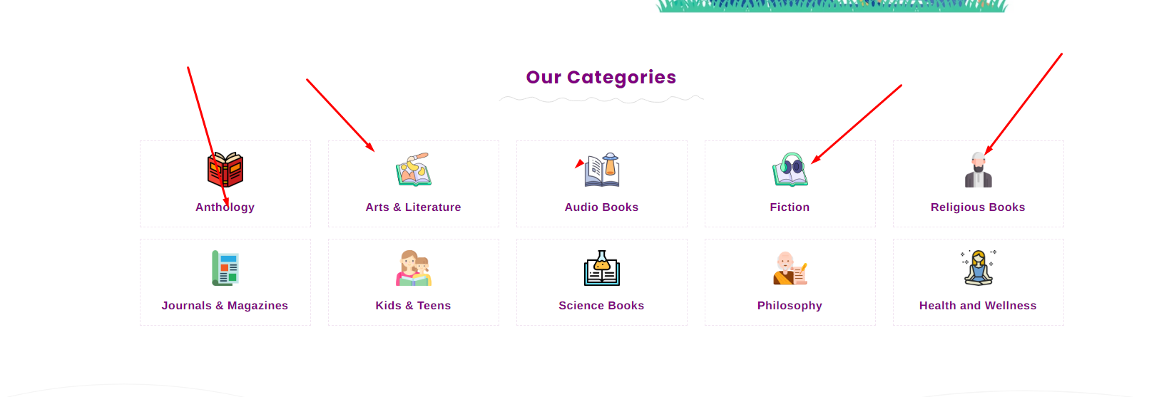
2. No data thakle not found image, use gif image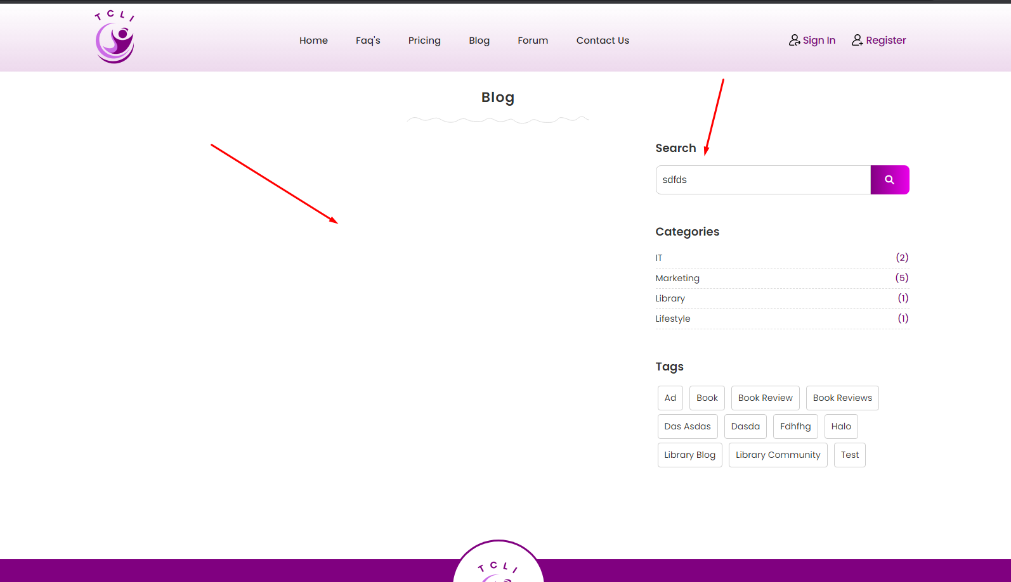

<https://www.google.com/url?sa=i&url=https%3A%2F%2Flhongtortai.com%2Fcollection%2Fgif-images-no-results&psig=AOvVaw3lzPhErj2rc_LaAJW-Ixbq&ust=1700542540432000&source=images&cd=vfe&opi=89978449&ved=0CBEQjRxqFwoTCOD6h-Pk0YIDFQAAAAAdAAAAABAa>

26 November, 2023

Remaining Task:

1. As an Admin, I should be able to view a map of users by country
2. Admin user ke inactive kore dile proper message dite hobe: “You are blocked by administration. Please contact with us” and user ar profile admin panel theke active/inactive korle password change howa jasse, anyway, user profile a country, age, gender ay information golo update korar option dite hobe and admin jokhon profile view korbe user’s ar then data golo show korbe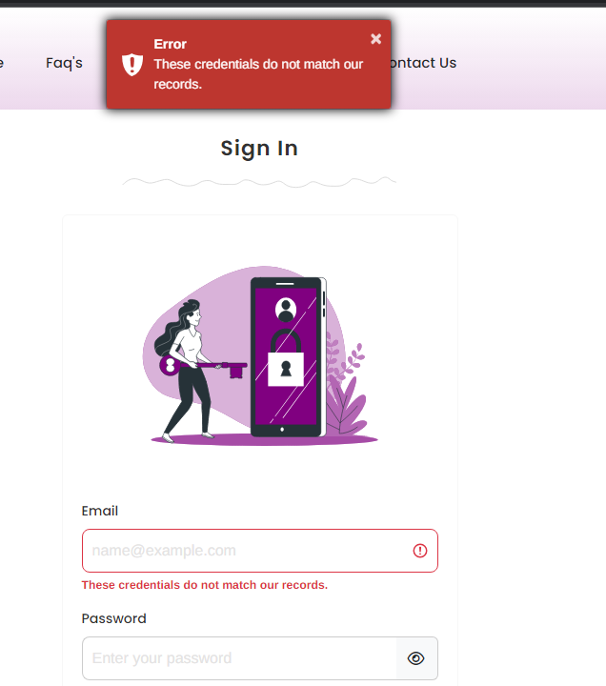
3. As an Admin, I should be able to view books borrowed by a user and their percentage completion
4. Book analytics ar akta screen korte hobe, number of borrows, number of completed reads, completion percentage etc also author ay analytics dekbe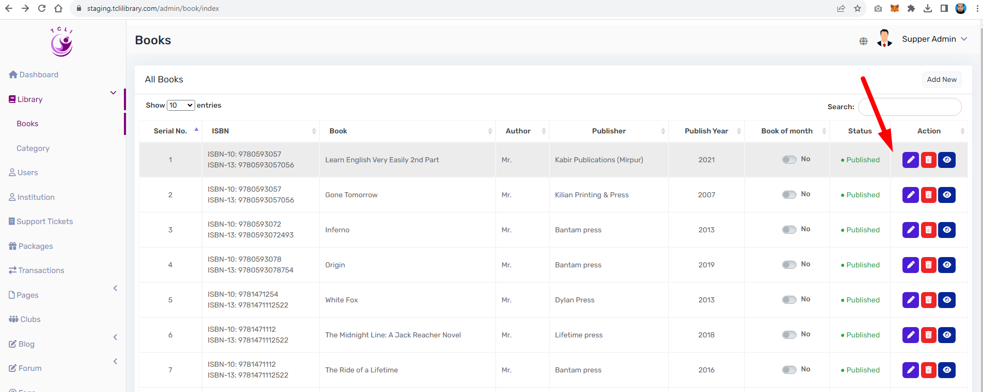
5. User view a subscription record thakte hobe, current subscriptions and expiry date etc 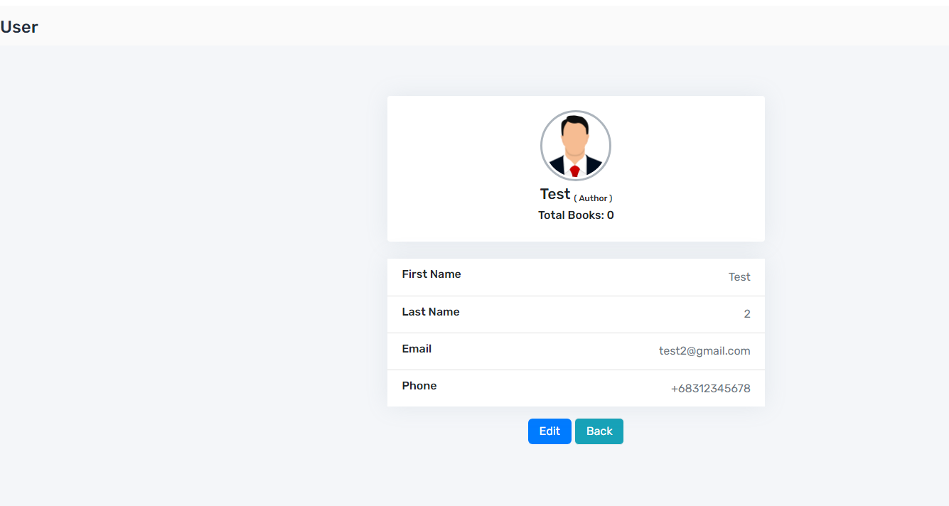
6. Book read count 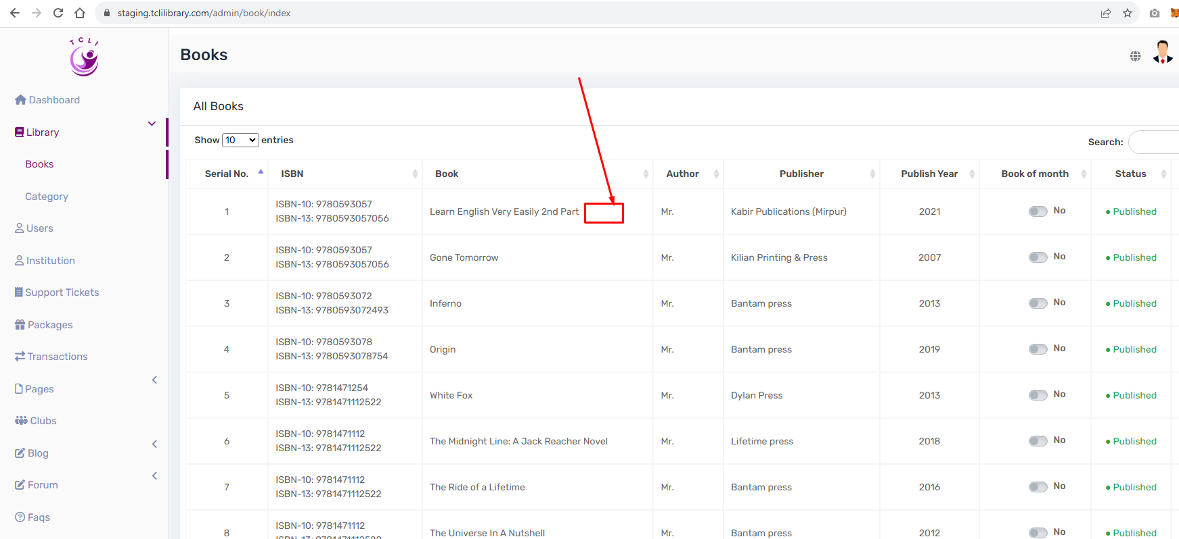
7. Admin role based users is missing (DLW64)
8. As a user, I should be included on the audience list eg mailChimp so that I receive regular emails from the library mailchip: [accounts@dhakasoftwares.com](mailto:accounts@dhakasoftwares.com) pass: j1a[KpGoU73p
9. Setting a payment gateway and mailhchimp setup