. Update not working.

.Test mail not working.

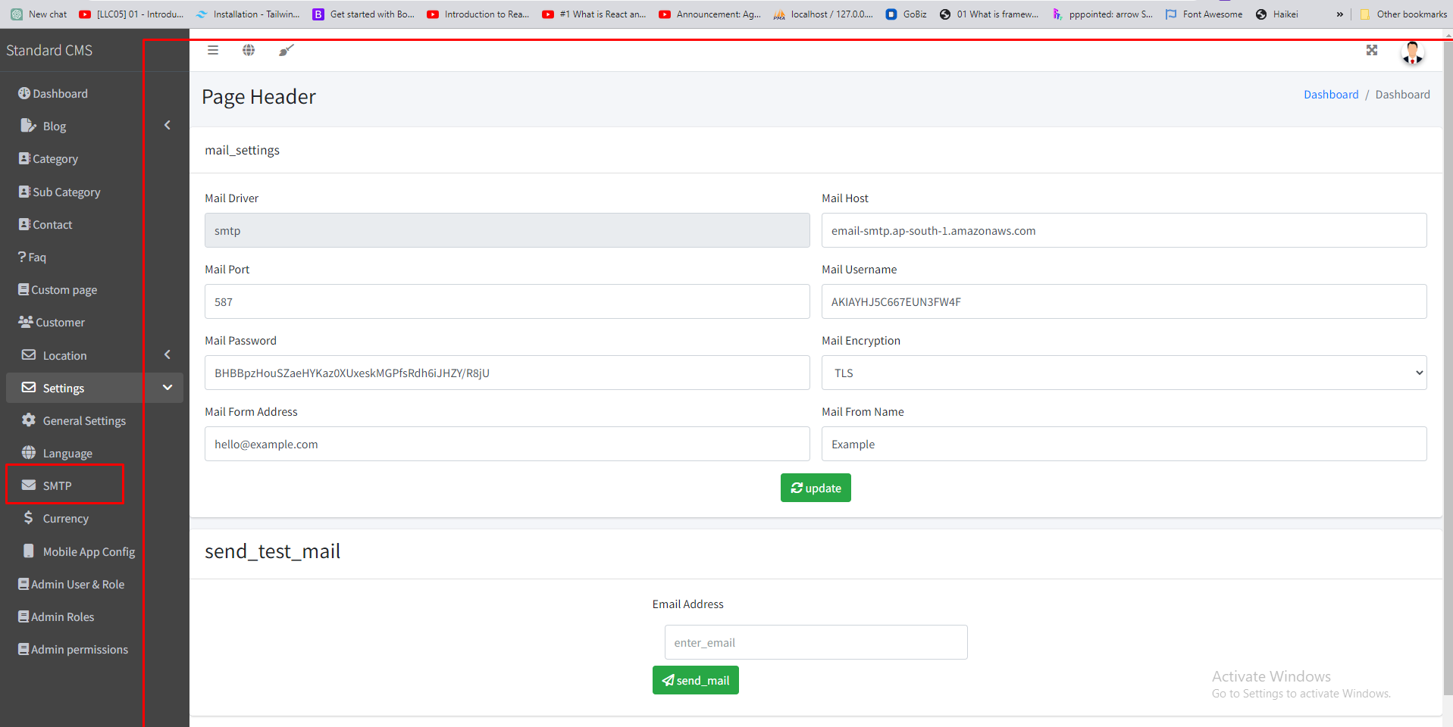

.Add button not working

.Check Example button error

.Delete & update not working

