1. Rich text editor, character limit remove.
2. Merchant select thake na on validation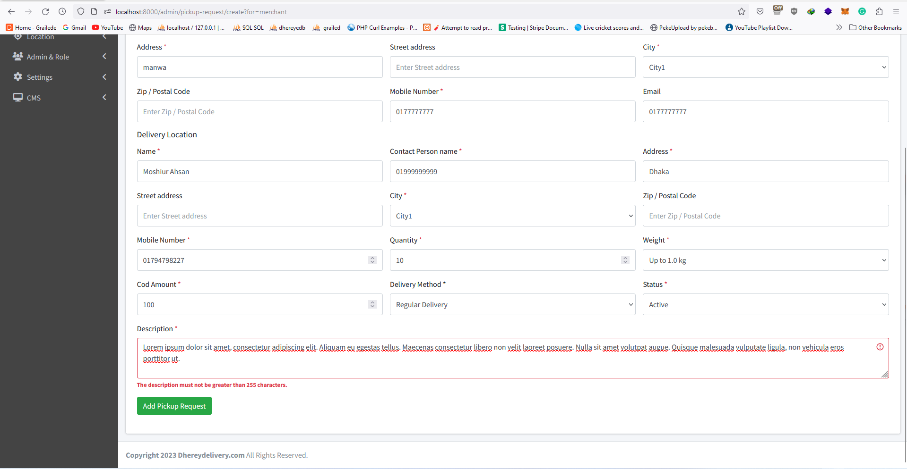
3. Price group add and edit e Start mark for required field. Frontend validation nai old data o theke na.  
   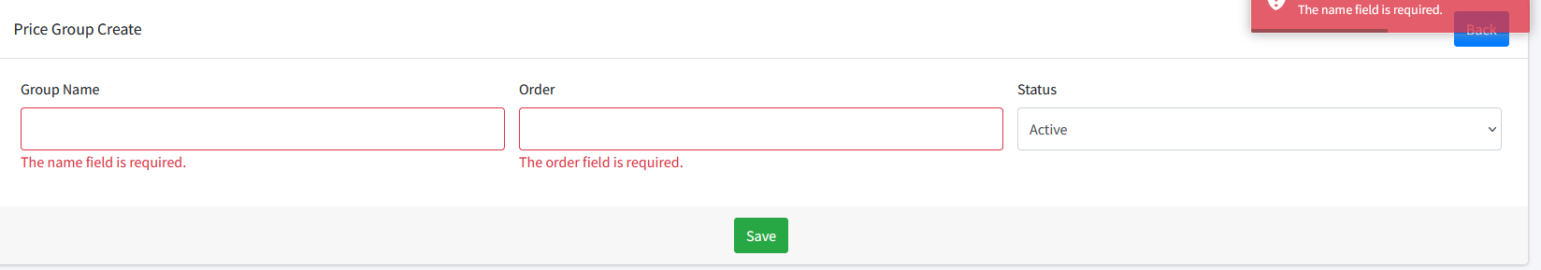
4. Sidebar modify(pending)  
   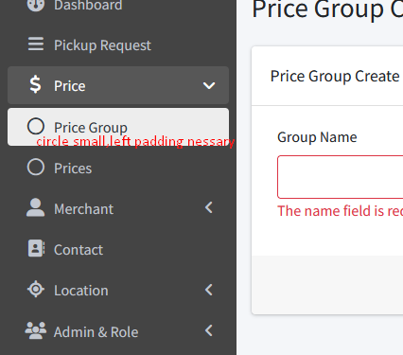
5. 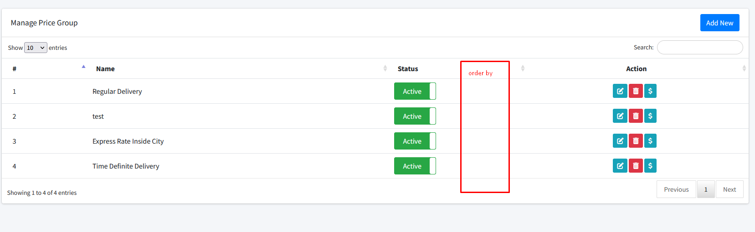
6. Delete e alert hobe.
7. Price e Frontend start mark for required field ,and frontend validation nai edit page er card title thik nai  
   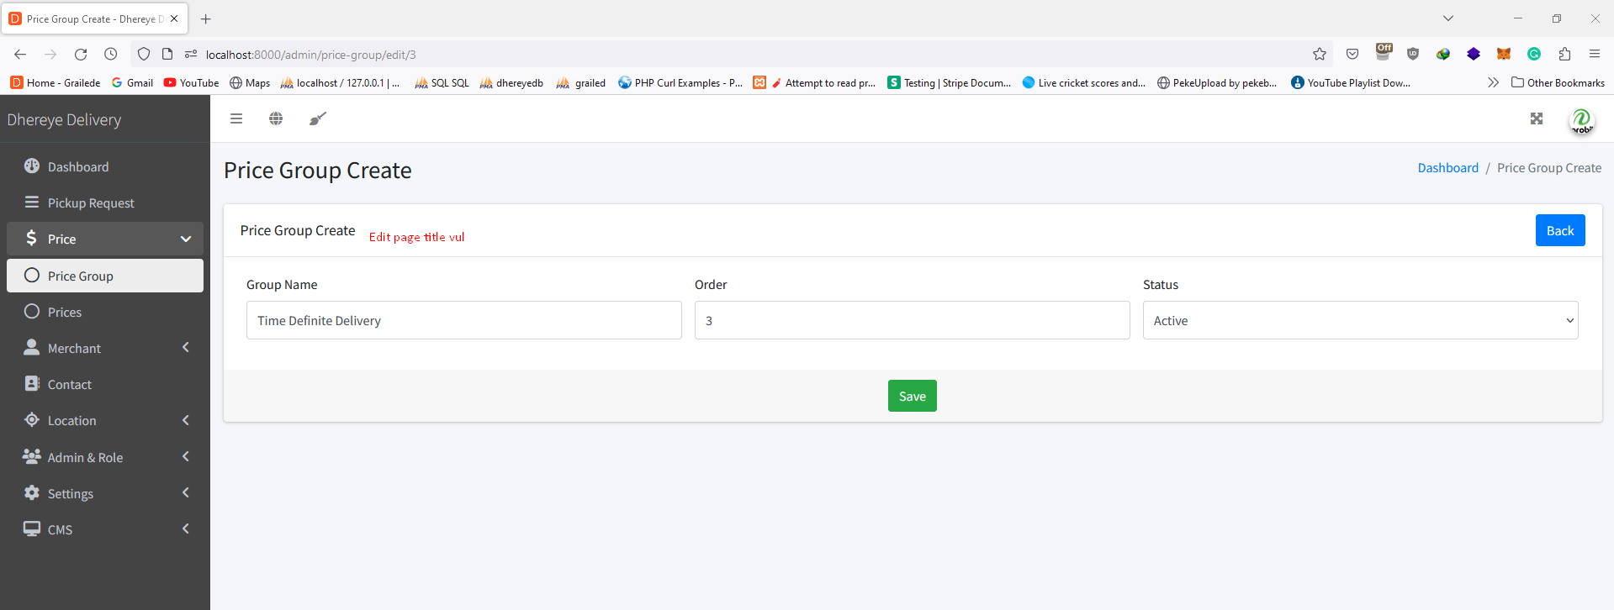
8. No start mark ,no frontend validation in price add and edit validation e old data thake na  
   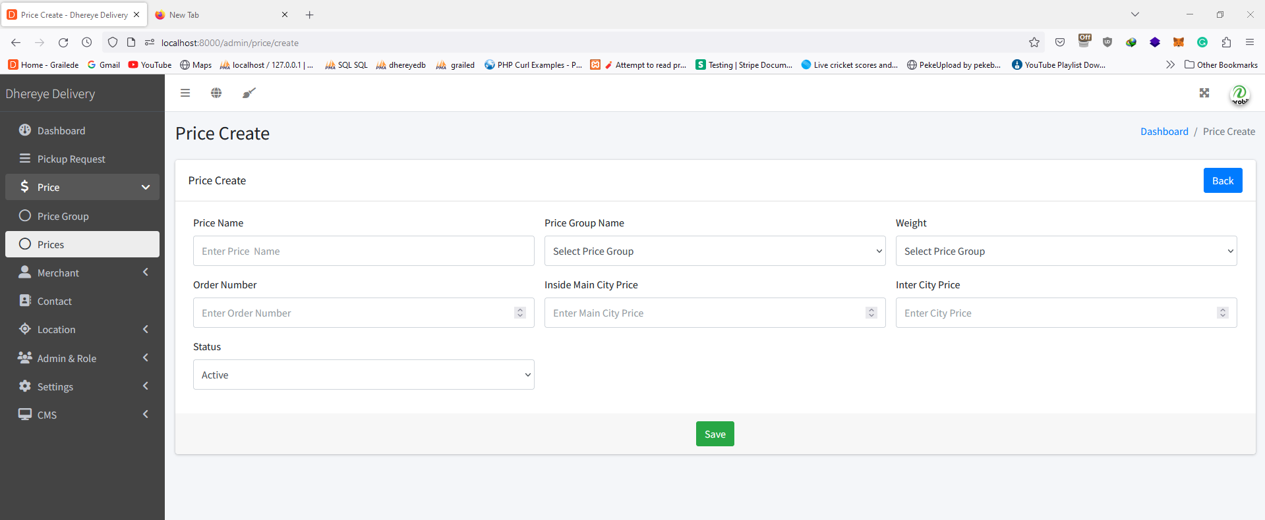
9. Old data check merchant create.  
   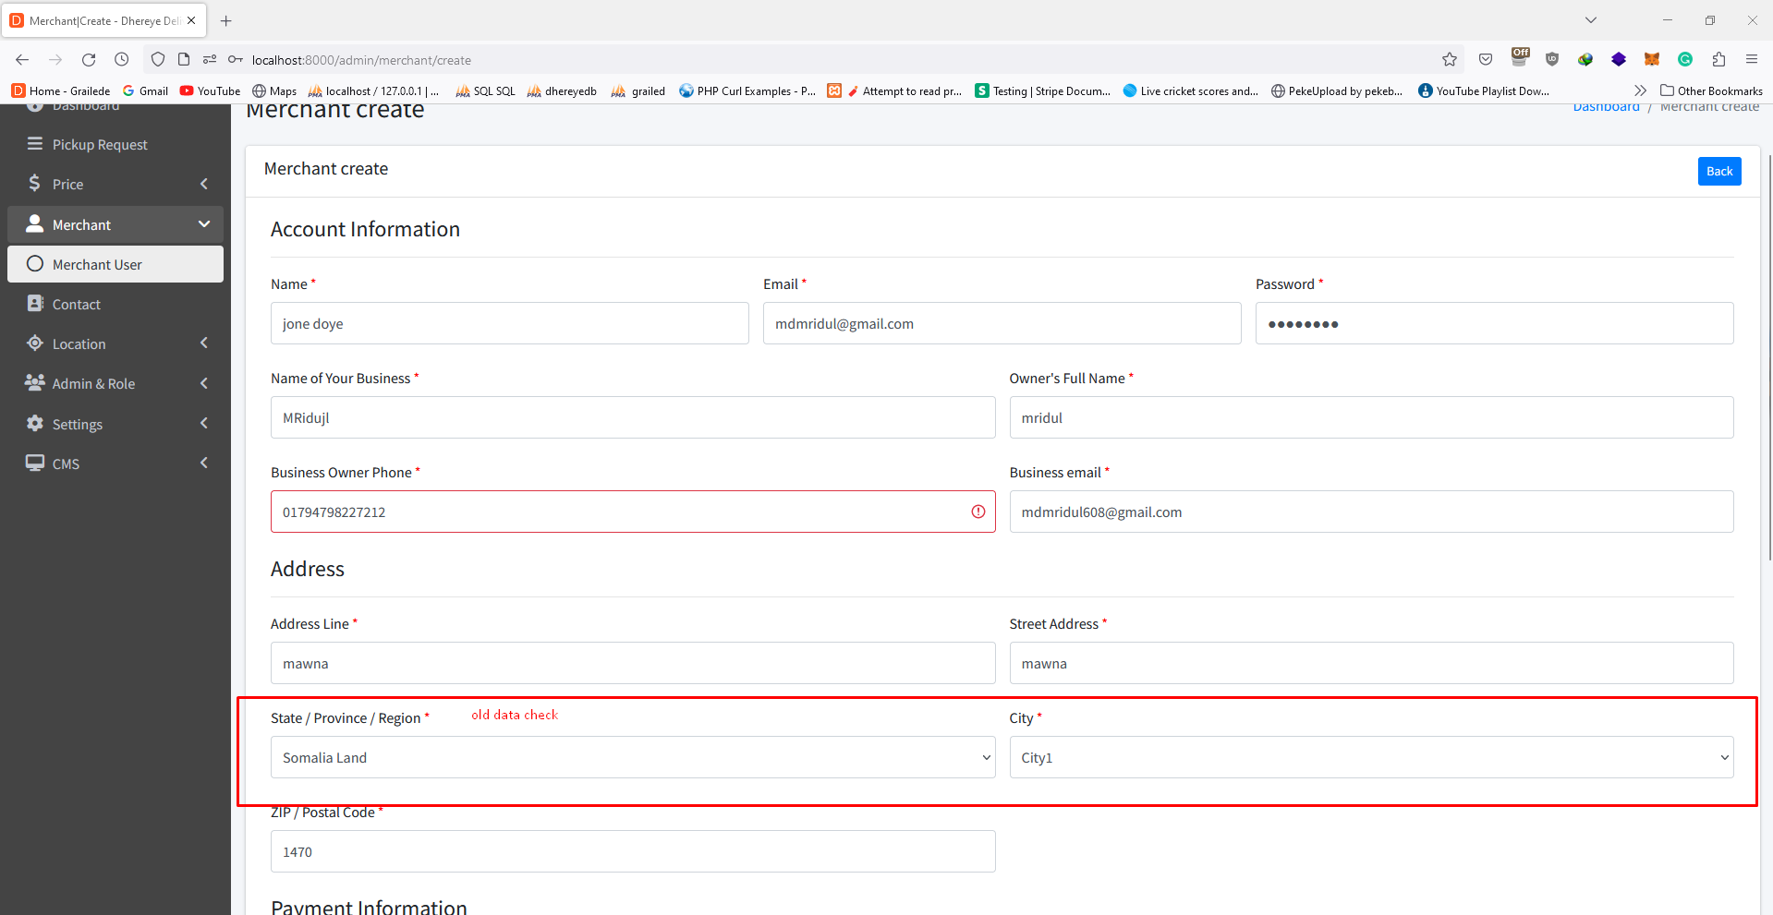
10. Star mark nai country add and edit   
    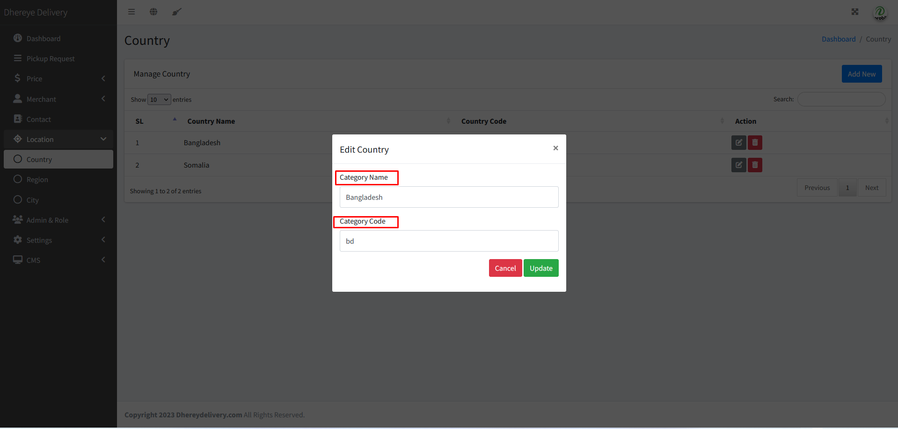
11. Country edit error   
    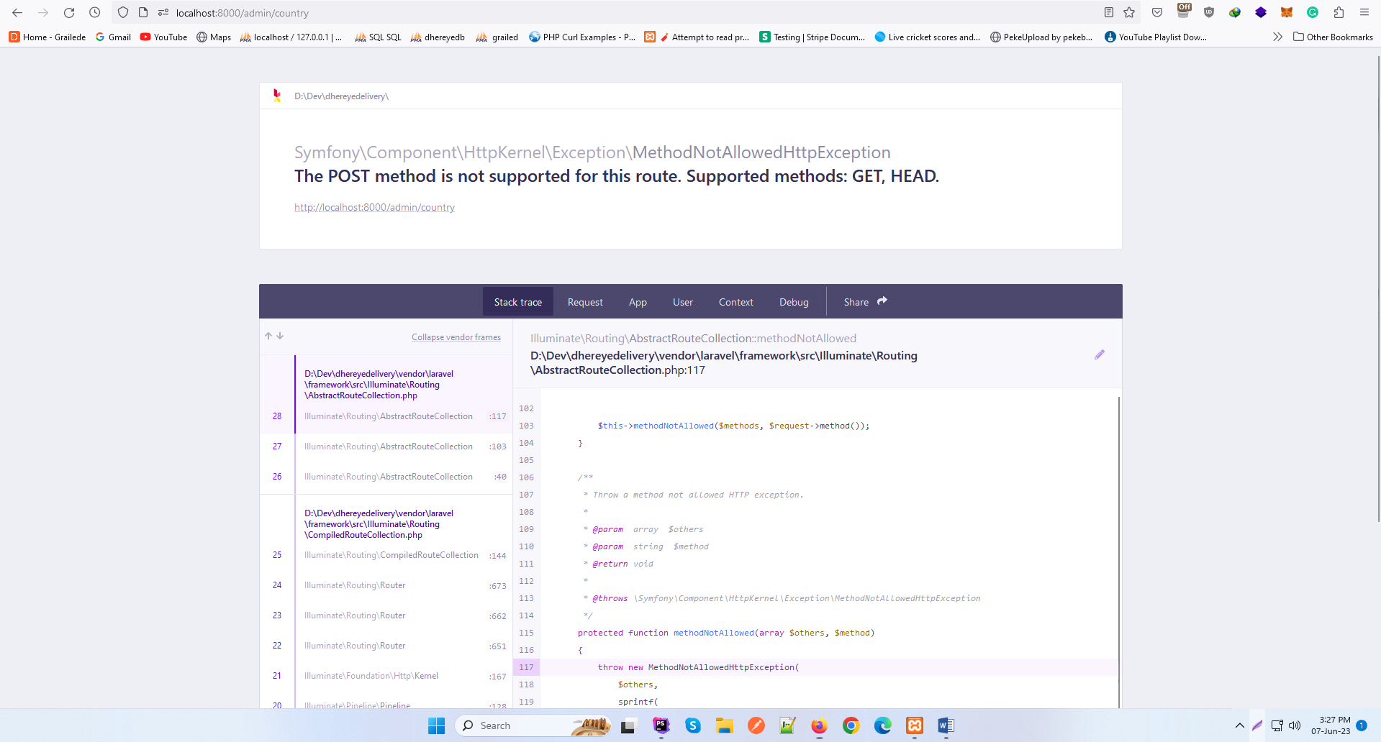
12. Start mark and frontend validation check wrong button on edit modal region.  
    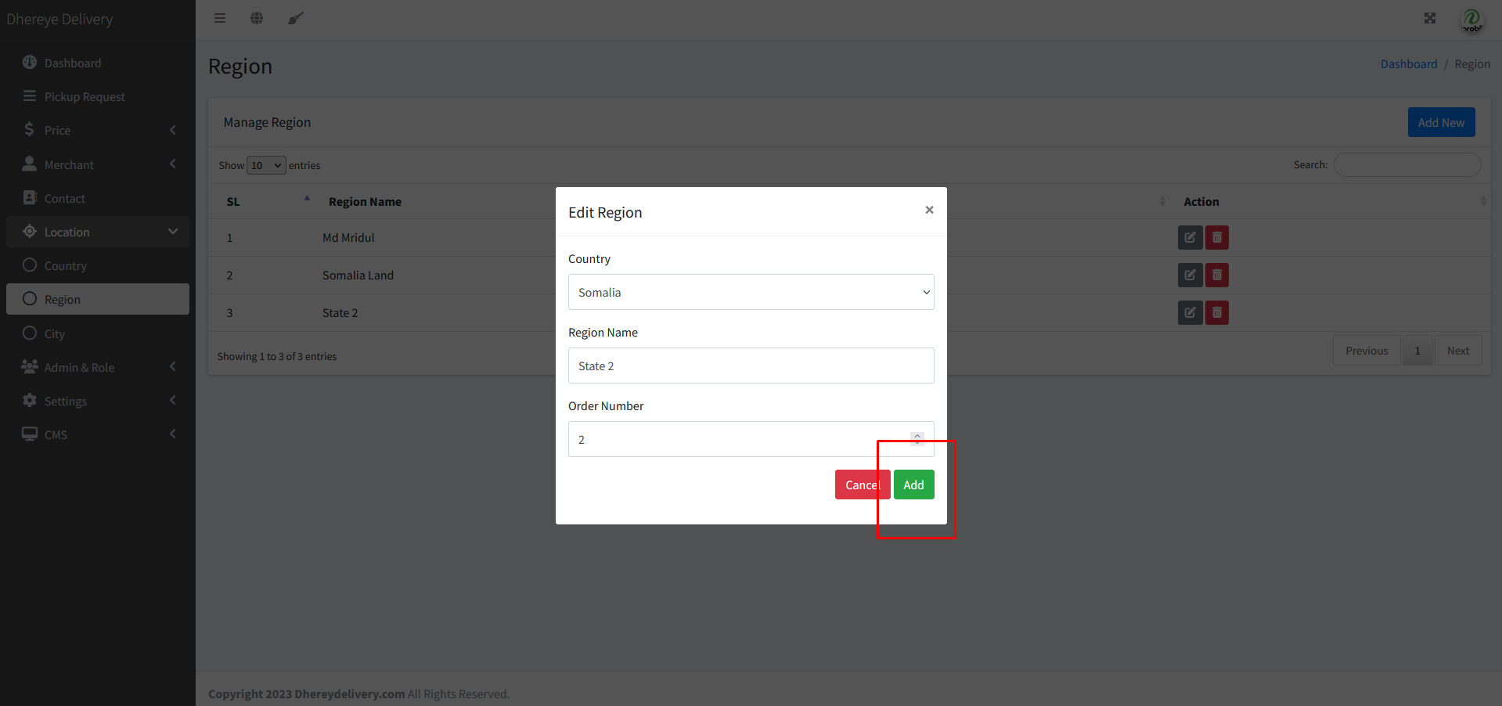  
    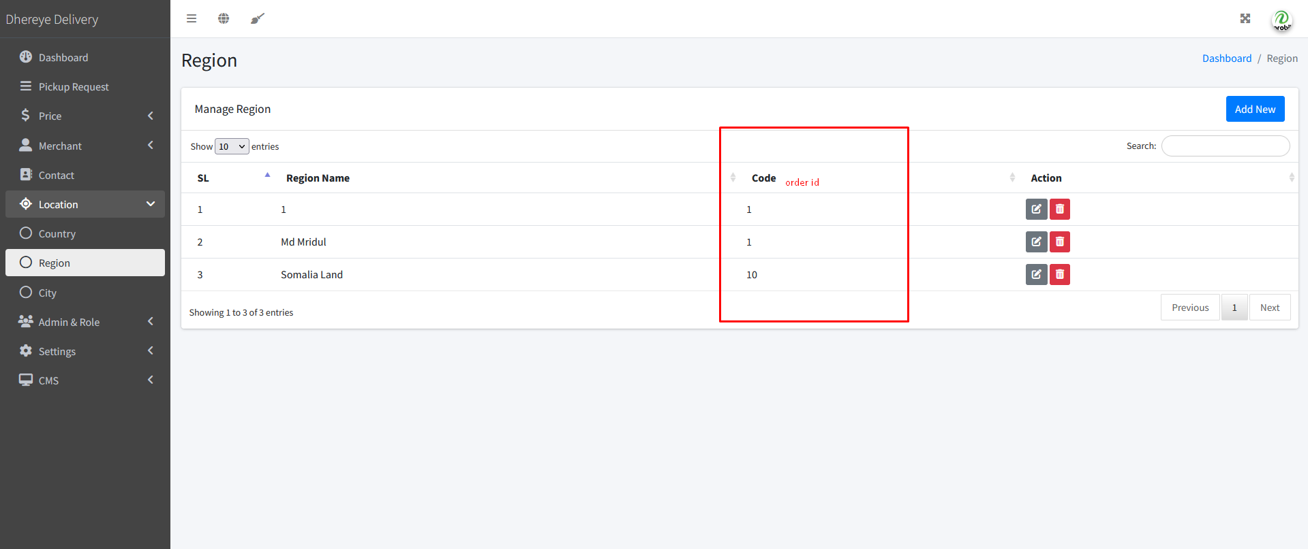
13. City add edit e frontend star mark nai and old value thake na on validation.  
    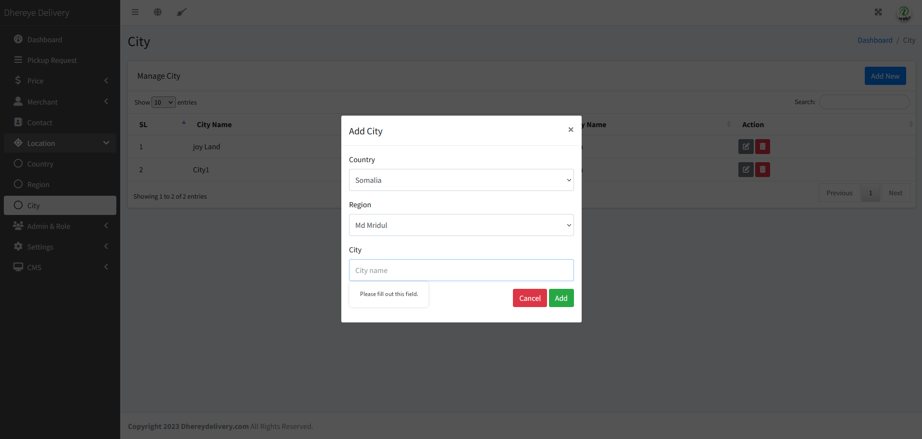
14. Role e gele sidebar select thake na  
    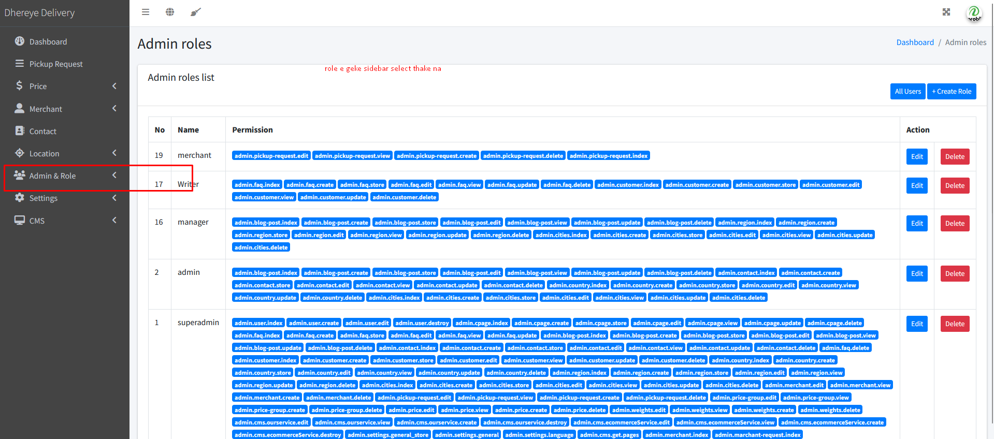
15. Title thik nai at admin permission ,back button thik nai in permission add and edit  
    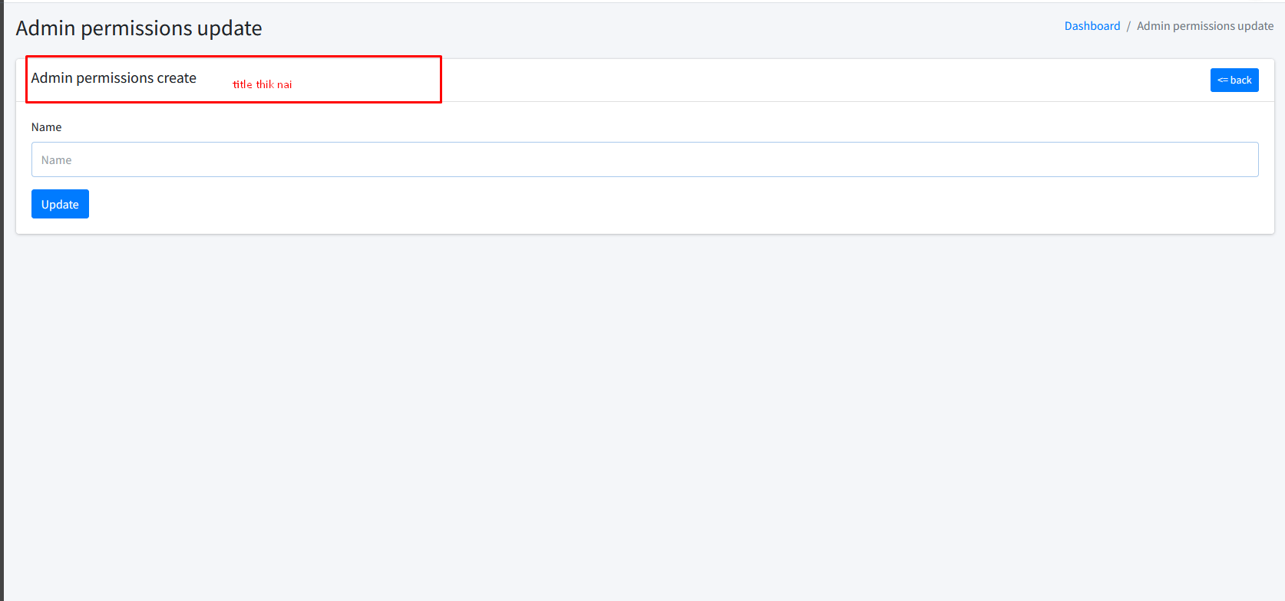
16. Title thik nai role edit  
    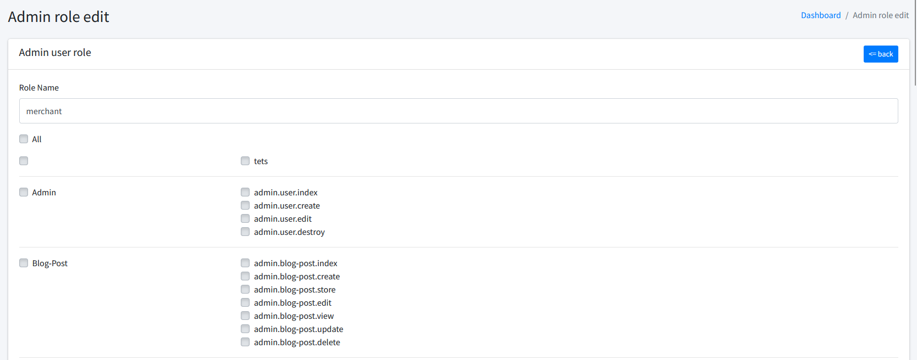
17. Language e edit kaj kore na(pending)  
    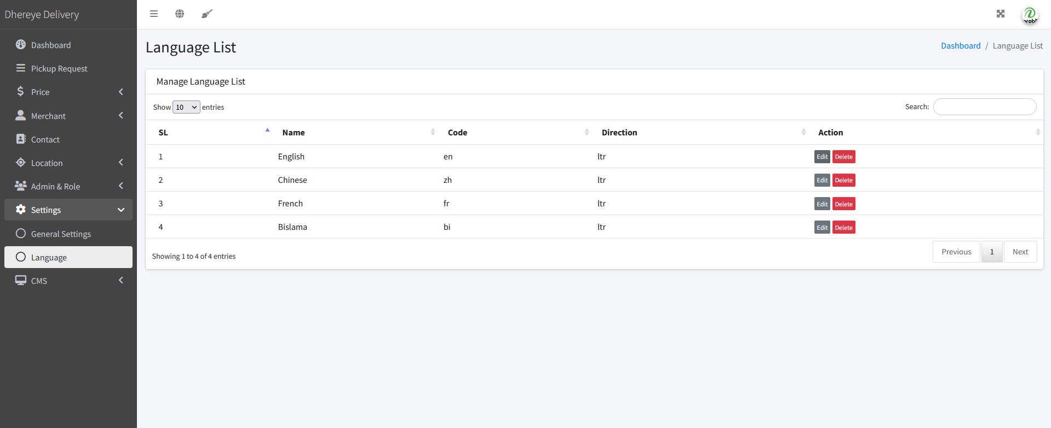
18. Our service e card title thik nai add and edit er and no star mark for requid field in and no back button in add and edit page.  
    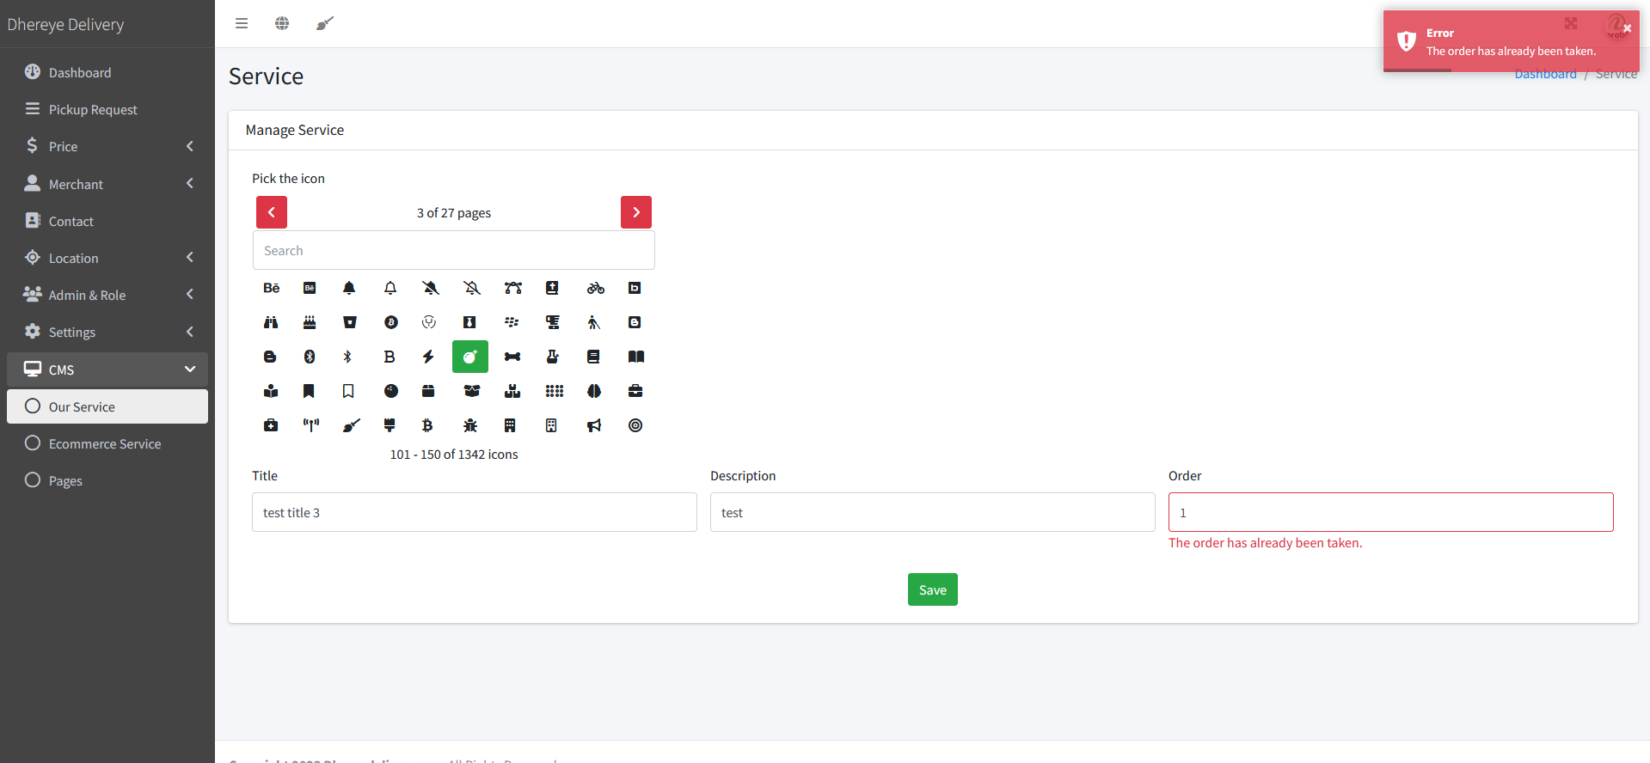
19. E-commerce Service e card title thik nai add and edit er and no star mark for required field and  
    No back button in add and edit page. Add rich text editor, need a default image  
    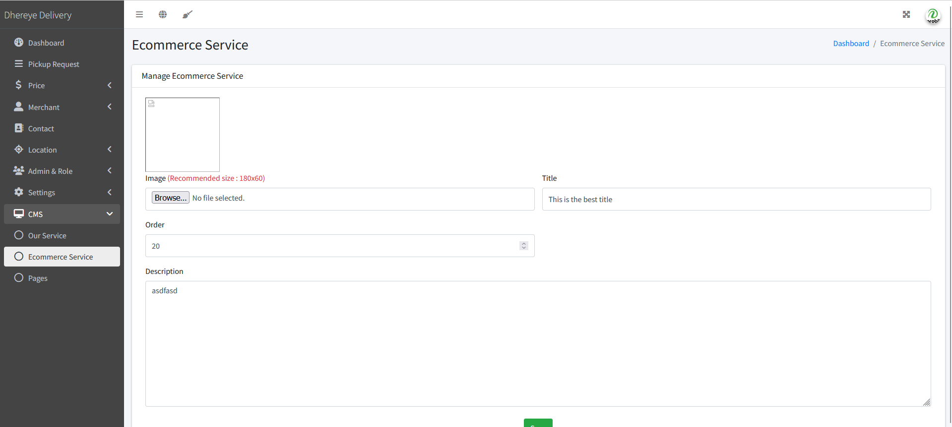
20. no star mark for required field and add rich text editor.  
      
    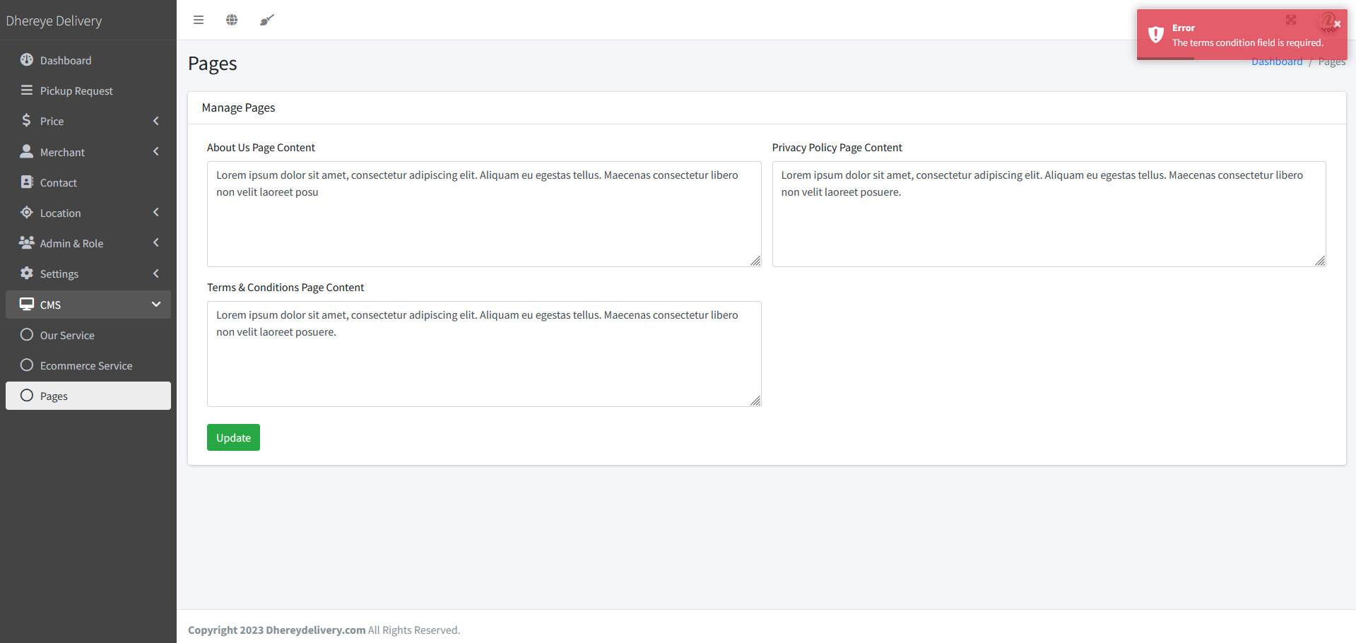
21. no star mark in profile update   
    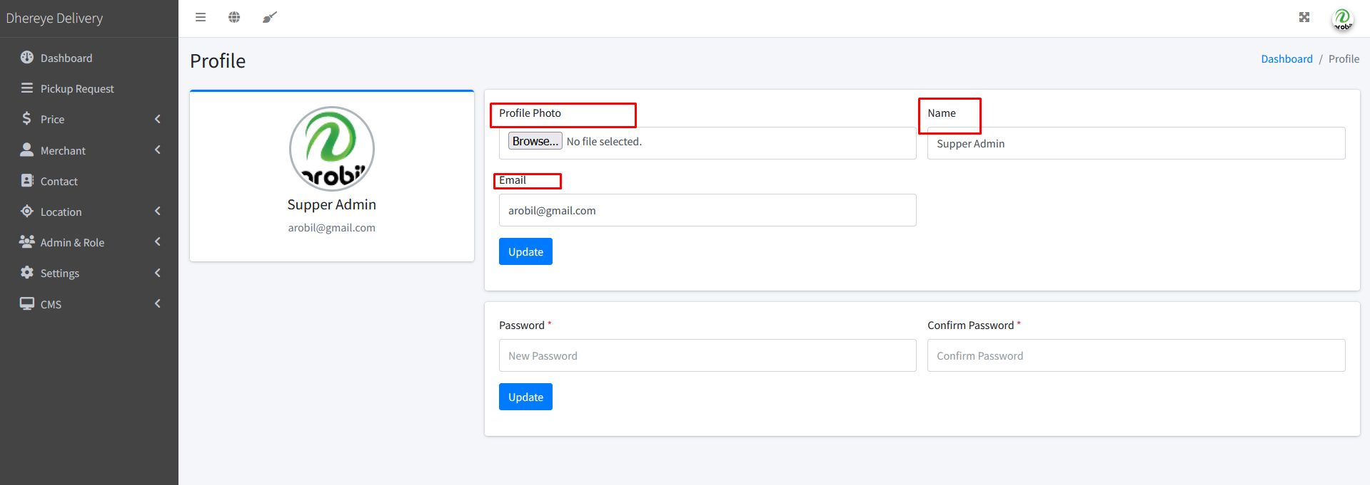
22. Id will be ID A screenshot of a computer

    Description automatically generated with medium confidence
23. Id will be ID
24. A screenshot of a computer

    Description automatically generated with medium confidence
25. A screenshot of a computer

    Description automatically generated with medium confidence
26. A screenshot of a computer

    Description automatically generated with medium confidence
27. A screenshot of a computer

    Description automatically generated with medium confidence
28. A screenshot of a computer

    Description automatically generated with medium confidence
29. Merchant er change password another form submit a korte hobe
30. Delivery Module
31. Payment Module with merchant
32. Add new link in footer section 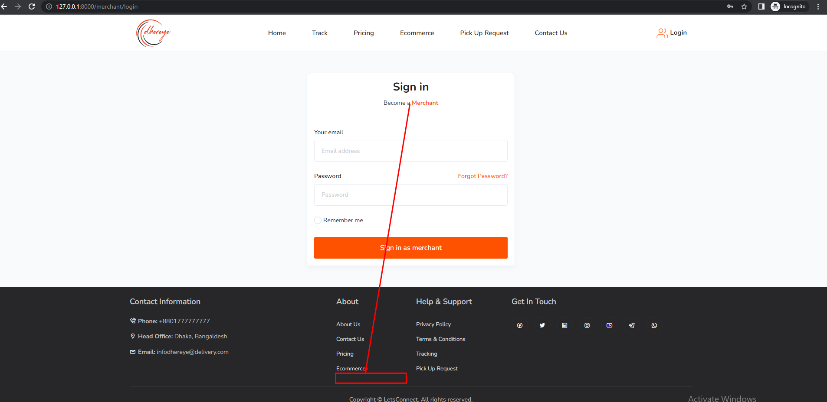
33. Merchant requestA screenshot of a computer

    Description automatically generated