Wednesday, April 26, 2023

Static Page List – Dhereye Delivery

1. About us page.
2. Home page our service section 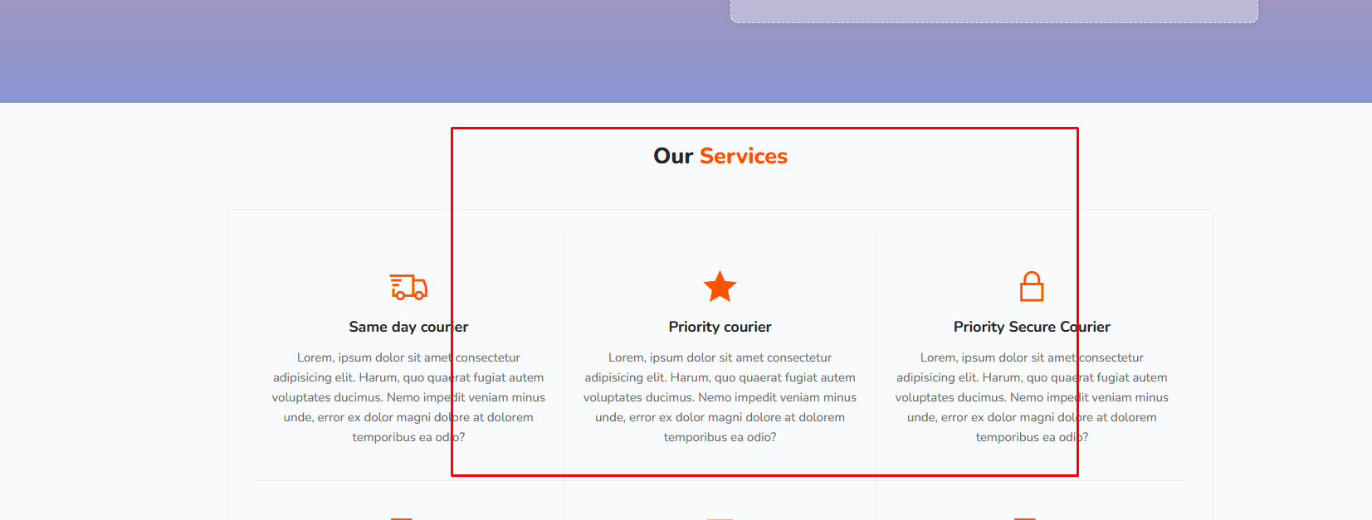
3. Ecommerce page – e-commerce service section
4. Privacy Policy Page
5. Terms & Conditions
6. Tracking page –no 
7. Tracking Page – Static Data