**Dhereye Delivery Web Application**

1. Delivery Web application with driver apps
2. Website Landing page with get quote for merchant api
3. Merchant dashboard to create orders
4. Api sandbox and api documentation
5. Driver web login and apps to maintain order shipping.
6. Admin panel to control whole website

Reference site

<https://sonarcourier.com/>

<https://www.nrbxpress.com/>

<https://parcelxpressbd.com/pricing>

**07 Oct, 2023**

1. Currency is not correct as per setup data, A screenshot of a computer

   Description automatically generated
2. Word limit proper message A screenshot of a computer

   Description automatically generated
3. Need to remove it A screenshot of a computer

   Description automatically generated
4. Copyright text dynamic, home page section static
5. Logo and fav icon missing in the api page A screenshot of a computer

   Description automatically generated
6. Delivery pricing a delivery time define korte hobe
7. Need to explain 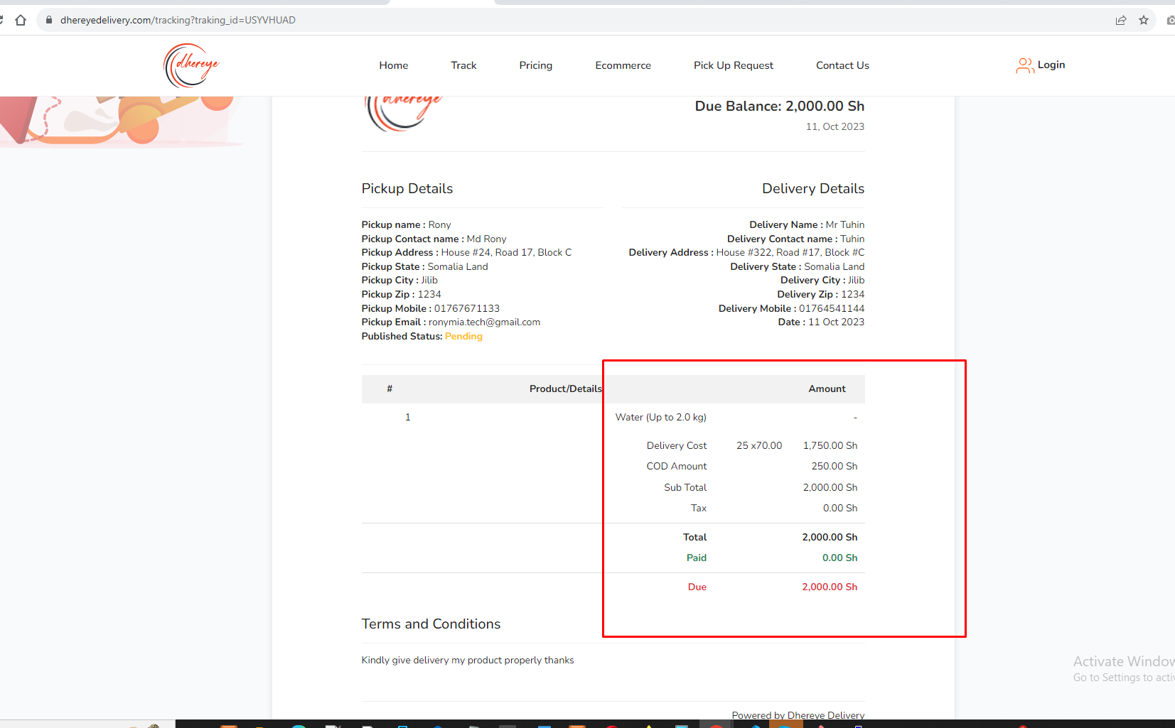
8. Email setup for pickup request
9. Need to print dynamically A screenshot of a computer

   Description automatically generated
10. This menu has nothing A screenshot of a computer

    Description automatically generated
11. Delivery boy profile extra data A screenshot of a computer

    Description automatically generated
12. Cod final due to merchant users 