As a user, I want to add a new product or update a current product in the system.

Case 1: Add a new product

1. Click “Manage Products” in Main Screen:

2. Display “Manage Products” screen:



3. Display “Product is SAVED successfully!” screen when saved product.

Case 2: Update a current product

1. Click “Manage Products” in Main Screen:

2. Display “Manage Products” screen:



3. Input the Product ID

4. Display “Load Product” screen with ProductID:

5. Click “Save Product” button after changing data to get “Product is SAVED successfully!” screen

As a user, I want to add a new customer or update a current customer in the system.

Case 1: Add a new customer

1. Click “Manage Customers” in Main Screen:

2. Display “Manage Customers” screen:

3. Display “Customer is SAVED successfully!” screen when saved customer.

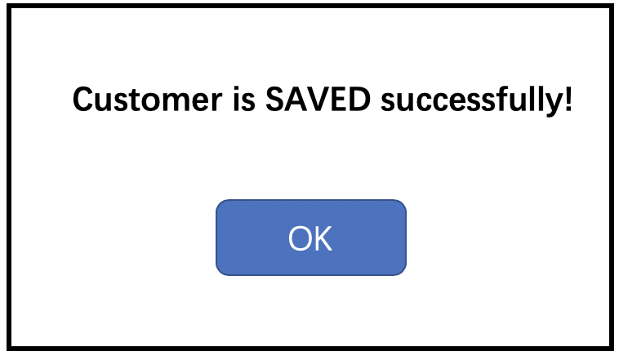

Case 2: Update a current customer

1. Click “Manage Customers” in Main Screen:

2. Display “Manage Customers” screen:

3. Input the Customer ID

4.Display “Load Customer” screen with CustomerID:

5. Click “Save Customer” button after changing data to get “Customer is SAVED successfully!” screen



As a user, I want to add a new purchase or update a current purchase in the system.

Case 1: Add a new purchase

1. Click “Manage Purchase” in Main Screen:

2. Display “Manage Purchase” screen:

3. Input data then save purchase by Clicking “Save Purchase”

4. Display “Purchase is SAVED successfully!” screen

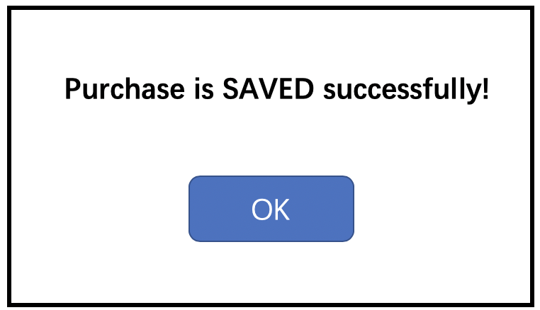

Case 2: Update a current purchase

1. Click “Manage Purchases” in Main Screen:

2. Display “Manage Purchases” screen:

3. Input the Purchase ID:

4. Display “Load Purchases” screen with data:

5. Click “Save Purchase” button after changing data to get “Purchase is SAVED successfully!” screen

