Report on my website

This website is an online bookshop with three pages, index.html, pay.html, and success.html, the report consists of the usability, accessibility features and design decisions.

Features:

Responsive grid: Changes format of grid depending on size of screen, enables users of all devices to be able to use website accordingly.

Clear navigation labels: Uses Nielsen’s IA principle of intuitive findability and allows easy access to all pages of the website. (See change between figure 1 and figure 2)

Descriptive alt text: Users who are using devices which are not loading images, are still given a description of the following image e.g. “Cover of Oldboy "

Drop down navigation on mobile: Users on mobile or smaller devices, can use the drop-down navigation bar so the screen space isn’t constantly taken up by the nav bar. (see figure 3)

Colour and contrast: Grey background is placed on the descriptions of the book to allow easy readability for the user as users will not read text if not easy to read.

Font: Arial sans-serif ensures wide device support and uses line height of 1.6 for readability.

Figure 3

Figure 1

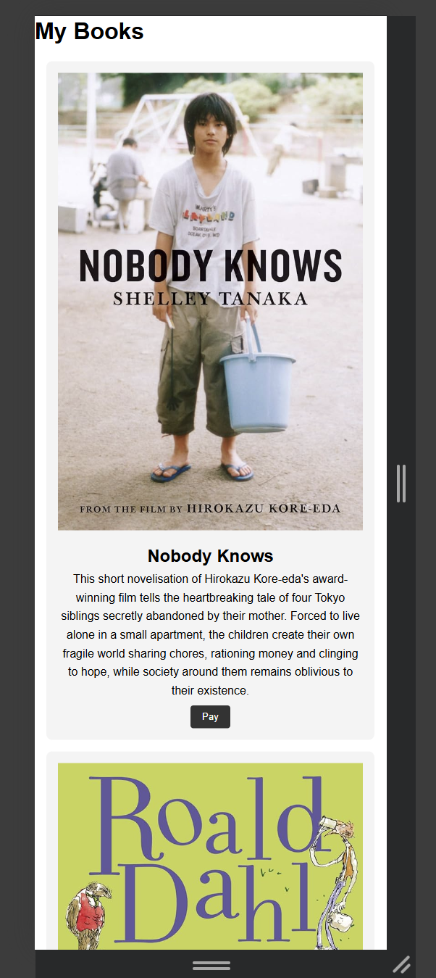Figure 3

This project allows me to demonstrate responsive design, and good accessibility practices. By using CSS features such as media and flex, as well as taking into account research of others for accessibility, the site is able to adapt depending on the size of the device, while remaining easy to navigate for the user. Moving forward I would integrate more ideas to make the process of buying a book easier such as adding a scrolling wheel when waiting for payment to be confirmed.