
Module code and name: | 7BDIN013C-Data mining and Machine Learning
Assessment: | Project coursework
Student ID: | 002222
Submission deadline: | 11.12.2025
Wordcount | 2000
Results date and type of feedback
Result (Pass or Fail)
Feedback

Table of Content
Depression and Mental Health multi-class Classification: Predicting Depression types and Identifying key significant factors 3
1.1 Introduction 3
2.1 Description of the EDA 4
Table 1: EDA analysis for numerical values 5
Diagram 1. Distribution of Sleep_Hours & SocialMedia_Hours 5
Diagram 2. Distribution and Boxplot of Depression_ Score 6
Diagram 3: Correlation Heatmap for numerical variables 6
Diagram 4: Distribution for categorical features (Group 1) 7
Diagram 5: Distribution for categorical features (Group 2) 7
Diagram 6: Distribution for categorical variables (Group 3) 8
Table 2: Chi-square test results for categorical features 9
Diagram 7: Cramer’s V heatmap for categorical features 10
3.1 Dataset preparation 10
4.1 Machine Learning algorithms 11
4.1.1 Logistic Regression 11
4.1.2 Naive Bayes Classification 13
4.1.3 Decision Tree Classification 14
4.1.4 Random Forest Classification 16
Summary evaluation metrics 20
5.1 Conclusion 21
6. References 22

Depression and Mental Health multi-class Classification: Predicting Depression types and Identifying key significant factors

Introduction
Depression is a prevalent and significant mental health disorder, impacting more than 350 million individuals worldwide (Aldkheel & Zhou, 2023). It affects emotional well-being, work, academic pursuits, interpersonal relationships, and fundamental daily activities including sleep, nutrition, and decision-making. If left untreated, it may endure for an extended period and markedly elevate the risk of self-harm and suicide. It ranks as the second leading cause of death for individuals aged 15–29, underscoring its significant public health relevance (Aldkheel & Zhou, 2023).
Extensive research indicates its broader societal implications. Research published in the BMJ indicates that 2% of individuals experience depression in isolation, whereas 8% are affected by both anxiety and depression, leading to functional impairment and increased healthcare utilization (Hale, 1997). In England and Wales, approximately 5,000 suicides are recorded each year, with 15% of clinical depression cases leading to suicide. The findings underscore the necessity for early detection and efficient mental health support.
As corporations, colleges, and healthcare institutions implement data-driven wellbeing strategies, models that reliably diagnose depression kinds and identify their strongest risk factors are needed. Early detection allows early action, lowers healthcare costs, and supports patients before symptoms worsen.
This study's dataset supports this business need. Mendeley Data provided the publicly available mental health survey data (https://data.mendeley.com/datasets/xppzm3kv9g/1). The 1,998 cleaned and encoded survey responses cover demographic, lifestyle, behavioral, and psychological characteristics. The dataset helps academics, students, and analysts examine mental health patterns and build depression prediction algorithms.
This structured dataset is ideal for multi-class classification because the goal variable represents job-, family-, and love-related depression. Such granularity helps organizations identify which causes cause distinct depression kinds and how to adjust support systems.
Description and Analysis of Dataset
The dataset has these feature groups:
- Statistics: age, gender, education, employment
- Sleep, diet and social media use are lifestyle factors
- Psychological indicators:vitality, self-esteem, symptoms
- Coping strategies, mental health support
- Depression labels: multi-class categories for respondents
The dataset authors encoded all variables, reducing preprocessing issues and preparing the data for machine learning. Given its structure and study objective, the dataset is ideal for:
- Classification algorithms with several classes
- Studying feature importance and explainability
- Exploratory data analysis for behavior patterns
- Early mental health intervention detection modeling
This study used various machine learning algorithms, such as Logistic Regression, Random Forest, Naïve Bayes, and Decision Boundary visualisations, to identify the best classifier and significant depression type predictors. This multi-class categorical dataset performed best with tree-based models like Random Forest, which handled non-linear relationships and feature interactions better.
The aim of this report is:
- Multi-class machine learning models predict depressive kinds
- Determine the most important psychological, behavioral, and demographic elements
This research informs educational, clinical, and workplace wellbeing decisions by combining data-driven models with real-world mental health insights.

2.1 Description of the EDA
There are 21 features in the collection, with 4 numerical variables and 17 categorical variables. To make things clear, the Exploratory Data Analysis(EDA) was done separately for the two groups. The dataset shape is 1998 rows and 21 columns.
Significant predictors were found using Chi-square test to assess their statistical connection with Depression_Type for categorical variables. These properties were examined using comparative distribution plots. A Cramer’s V correlation matrix was also calculated to assess categorical variable associations and identify the most important depression type classification features.

Table 1: EDA analysis for numerical values
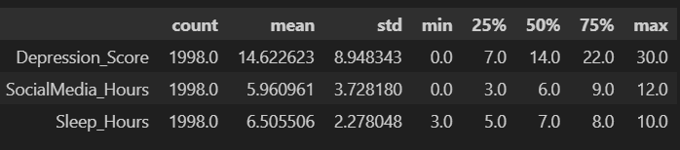
The table 1 shows that three quantitative variables: Depression_Score, Social Media Hours, and Sleep_Hours. The descriptive statistics indicate that the mean depression score is 14.6, with a range from 0 to 30, reflecting considerable variability in symptom severity. Participants dedicate and average of 6 hours daily to social media and approximately 6.50 hours to sleep. The variation observed across all three variables indicates significant disparities in lifestyle and mental health status among respondents.

Diagram 1. Distribution of Sleep_Hours & SocialMedia_Hours
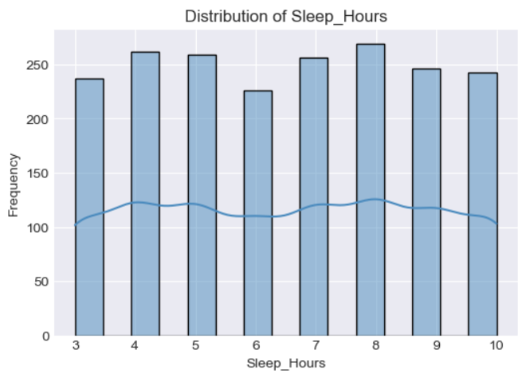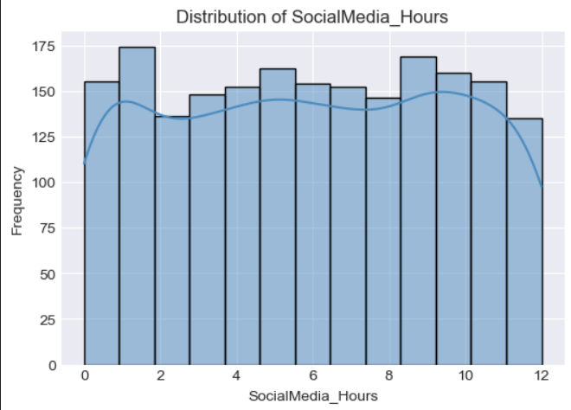
The Social Media hours distribution seems to be quite consistent between 0 and 12 hours, indicating that respondents’ level of social media use vary greatly. This broad distribution implies that social media usage patterns varied greatly and may have distinct effects on mental health outcomes. The majority of people sleep between 4 and 9 hours, with a fairly even distribution for Sleep_Hours. This indicates that respondents’ sleep patterns varied, ranging from inadequate sleep to sufficient rest(Diagram 1).
There is no significant skewness or extreme outliers in the Depression_Score distribution, which is dispersed throughout the whole range (0-30). The majority of individuals lie somewhere in the middle, showing a combination of mild, moderate, and
high symptom levels, according to the histogram and boxplot. The feature is helpful for modeling because of its broad and well-balanced variance(Diagram 2)

Diagram 2. Distribution and Boxplot of Depression_ Score
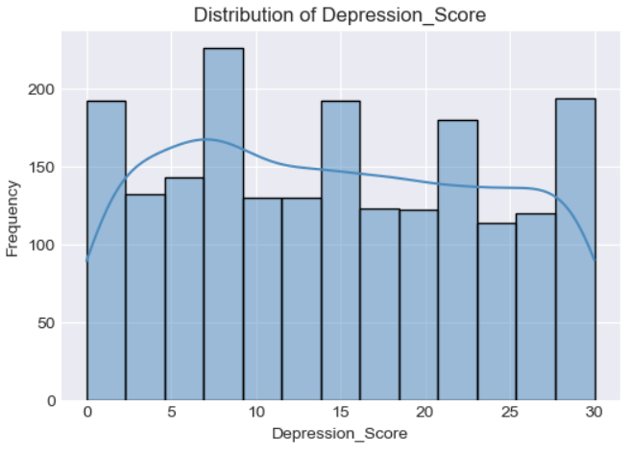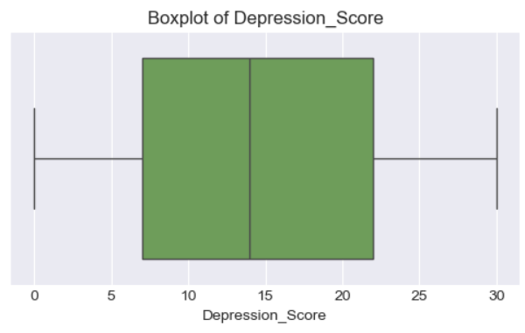
The correlation heatmap demonstrates weak correlations between numerical features. Neither SocialMedia_Hours (0.02) nor SleepHours(-0.023) had a substantial linear link with depression_score. Sleep_Hours and SocialMedia_Hours likewise have little association (0.0038). The numerical aspects seem mostly independent( Diagram 3)

Diagram 3: Correlation Heatmap for numerical variables
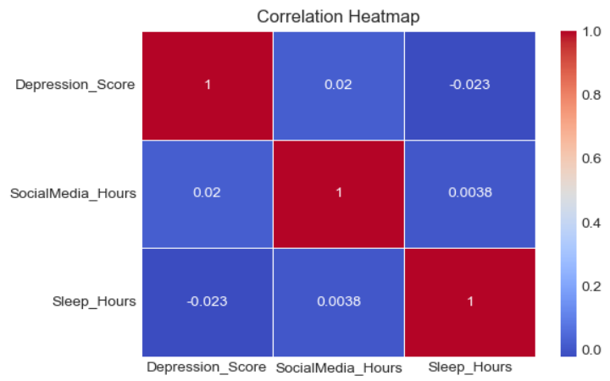
Diagram 4 shows that gender is virtually balanced, however the age distribution is predominantly characterized by the middle-aged category. Age originally comprised continuous numerical values. For easy of interpretation, it was categorized by age groups and examined as a categorical variable. The Education_Level and Employment_Status variables exhibit significant concentration in a singular category, signifying restricted variability in these attributes. A majority of respondents express symptoms of both Low potentially influencing their predictive role in classifiying types of depression

Diagram 4: Distribution for categorical features (Group 1)
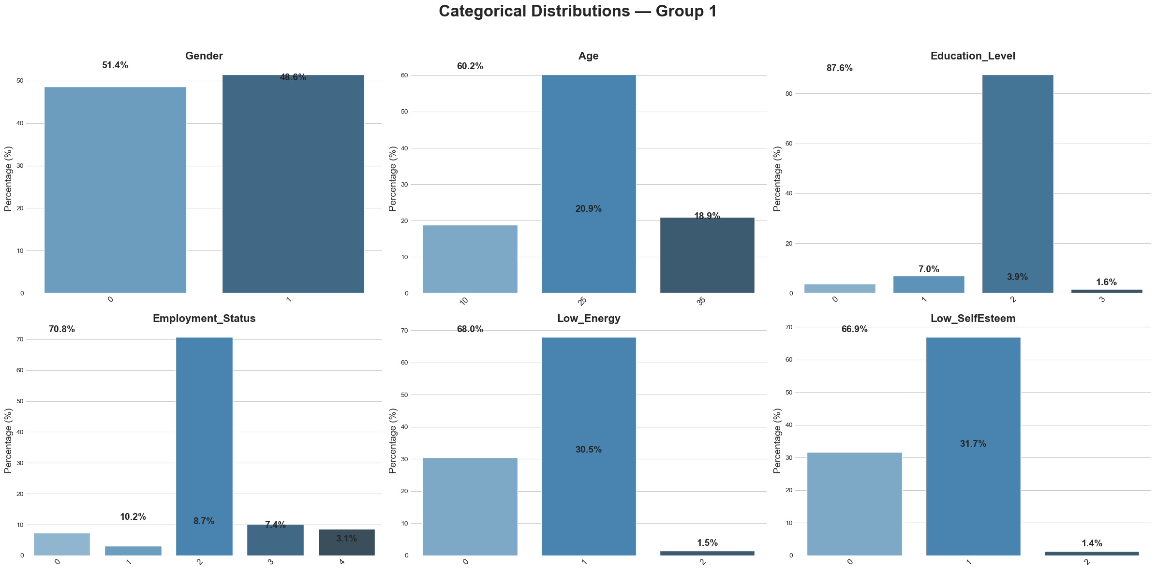
Category dominance is evident in various variable distributions. Symptoms are extremely unbalanced, with category 5 accounting for most reactions. Most individuals do not search for depression material online, but most report worsening depression symptoms. Skewed eating frequency: roughly 80% fit into group 0. Overeating and social media use while eating have unequal distributions, suggesting heterogeneous responded behaviour.This diagram has various behavior and symptom related factors with high category concentrations that my predict depression type (Diagram 5 )

Diagram 5: Distribution for categorical features (Group 2)
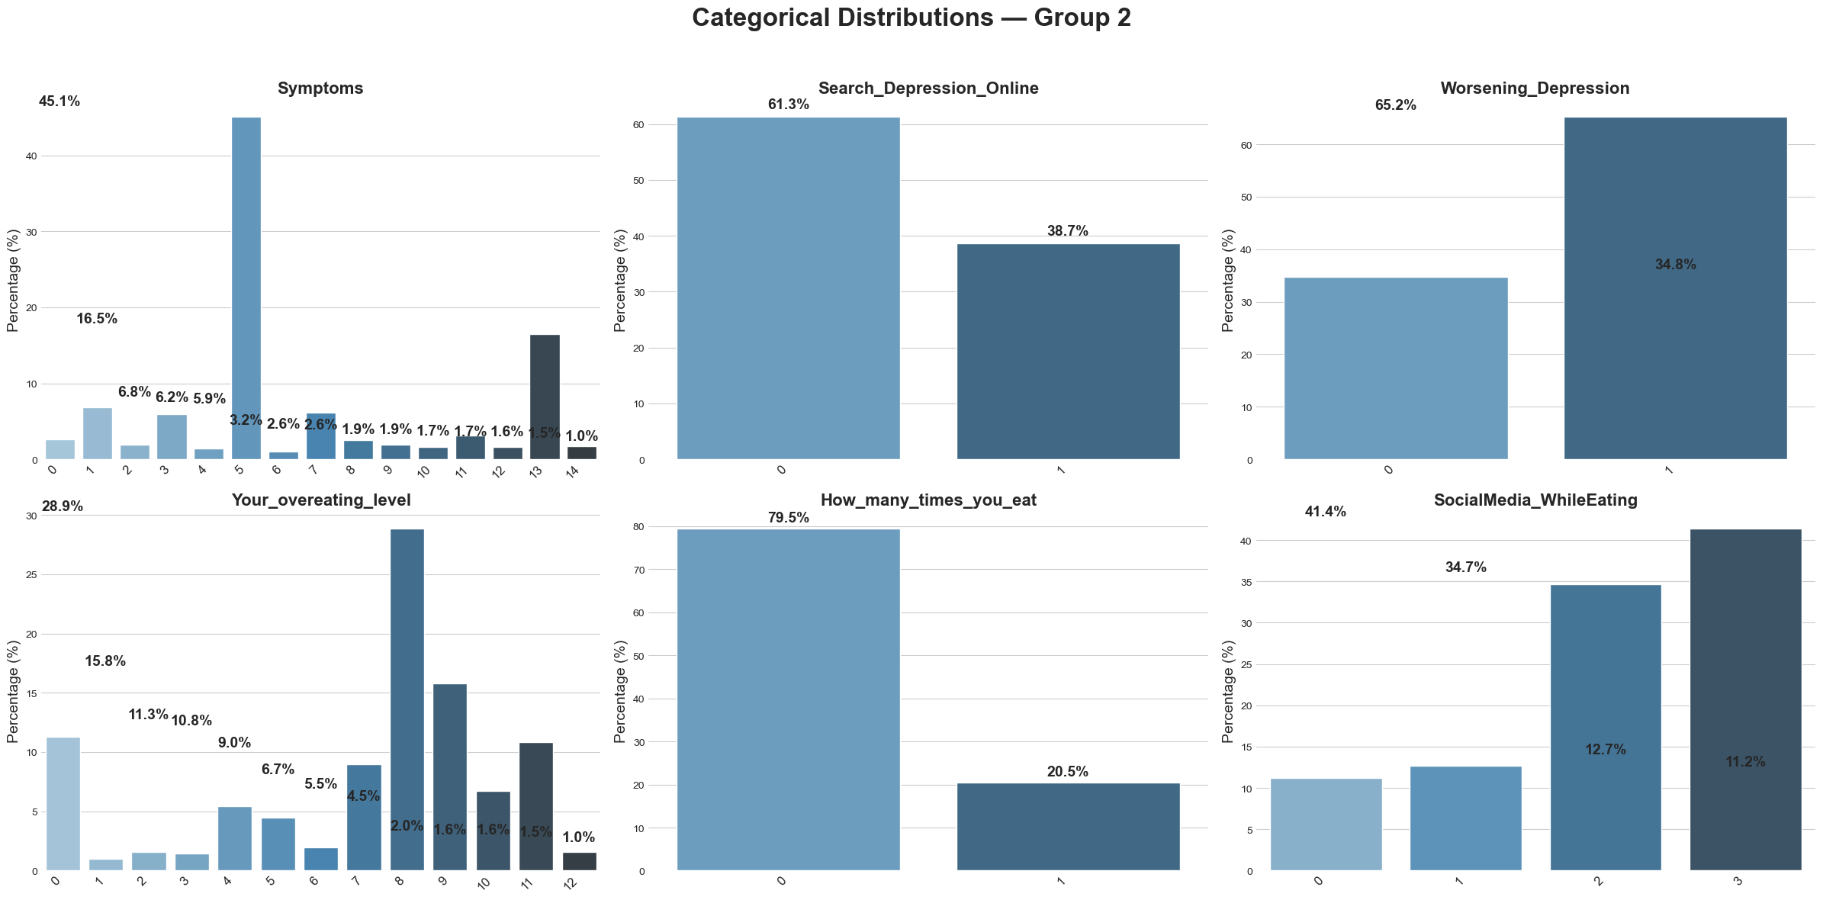

Diagram 6: Distribution for categorical variables (Group 3)
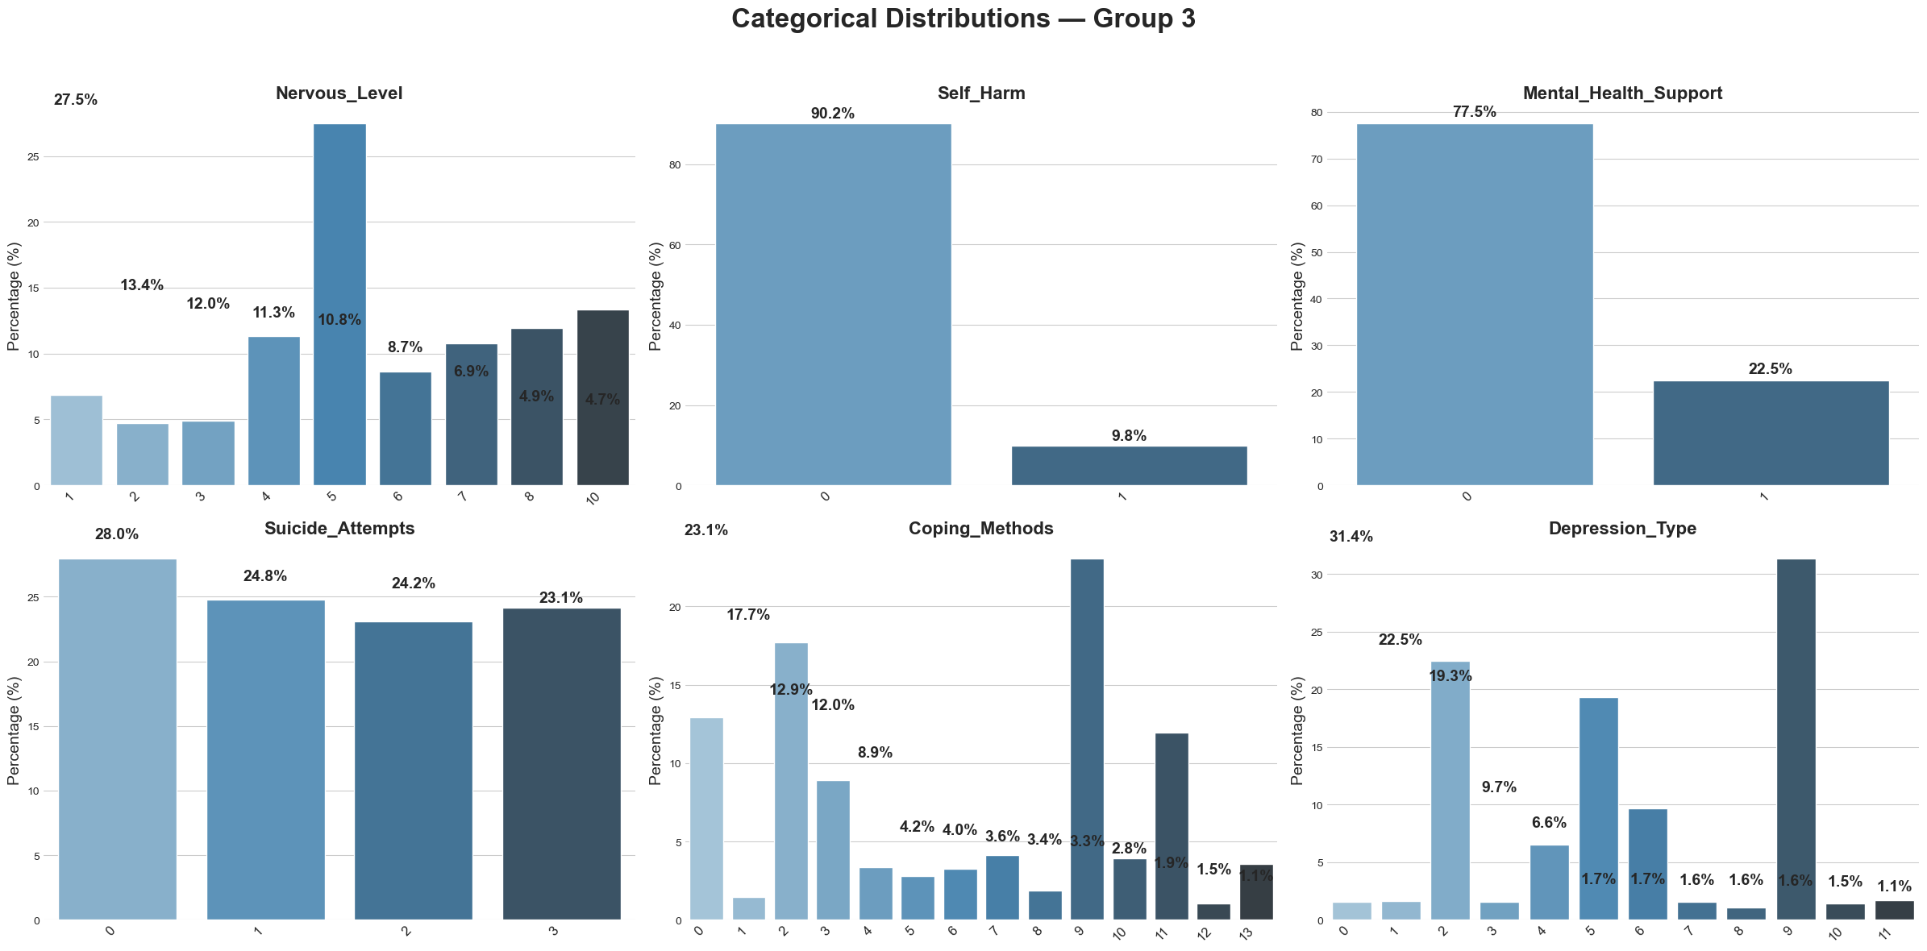
In this diagram, Nervous_Level is distributed throughout categories but peaks at category 5, suggesting respondents' anxiety levels. With 90% reporting no self-harm, Self_Harm is significantly unbalanced. 77.5% of individuals report not obtaining Mental_Health_Support. Suicide_Attempts has an equitable distribution across four categories, reflecting different sample experiences. Coping_Methods has several tactics, but few dominate. Depression_Type shows a considerable imbalance, with some depression types more common.This visualization has a mix of highly skewed and moderately dispersed traits, many of which describe depression-related psychological and behavioral aspects.(Diagram 6)

Most categorical characteristics are statistically associated with Depression_Type, according to the Chi-square test. Thus, education, self-esteem, low energy, symptom intensity, dietary habits, and mental-health behaviors vary significantly across depression categories. Gender, Age, and Suicide_Attempts are the only factors that do not significantly differentiate depression kinds.These results identify the categorization model's most important categorical predictors (Table 2)

Table 2: Chi-square test results for categorical features
Feature | P-value | Significant | Interpretation
Gender | 5.089e-01 | Not Significant | No association with Depression_Type
Age | 9.099e-01 | Not-Significant | Age groups do not differ across depression types
Education_Level | 1.344e-218 | Significant | Strong relationship with Depression_Type
Low_Energy | 1.583e-138 | Significant | Energy level differs significantly between depression types
Employment_  Status | 0.000e+00 | Significant | Employment category influences depression
Low_SelfEsteem | 1.328e-74 | Significant | Self-esteem strongly associated with depression type
Symptoms | 0.000e+00 | Significant | Symptom severity varies by depression type
Search_Depression_Online | 7.522e-69 | Significant | Online searching behavior relates to depression type
Worsening _Depression | 1.483e-57 | Significant | Whether symptoms worsen differs by depression type
Your_overeating_level | 0.000e+00 | Significant | Overeating patterns relate to depression type
How_many_times_you_eat | 1.356e-90 | Significant | Eating frequency varies across depression types
SocialMedia_WhileEating | 2.058e-137 | Significant | Social media during meals relates to depression types
Nervous_Level | 0.000e+00 | Significant | Nervousness levels differ significantly across
Self_Harm | 6.93e-44 | Significant | Self-harm history varies by depression type
Mental_Health_Support | 2.123e-83 | Significant | Support-seeking behavior differs by depression type
Suicide_Attempts | 6.538e-02 | Not Significant | No significant relationship with depression type
Coping_Methods | 0.000e+00 | Significant | Coping strategies differ across depression types

Diagram 7: Cramer’s V heatmap for categorical features
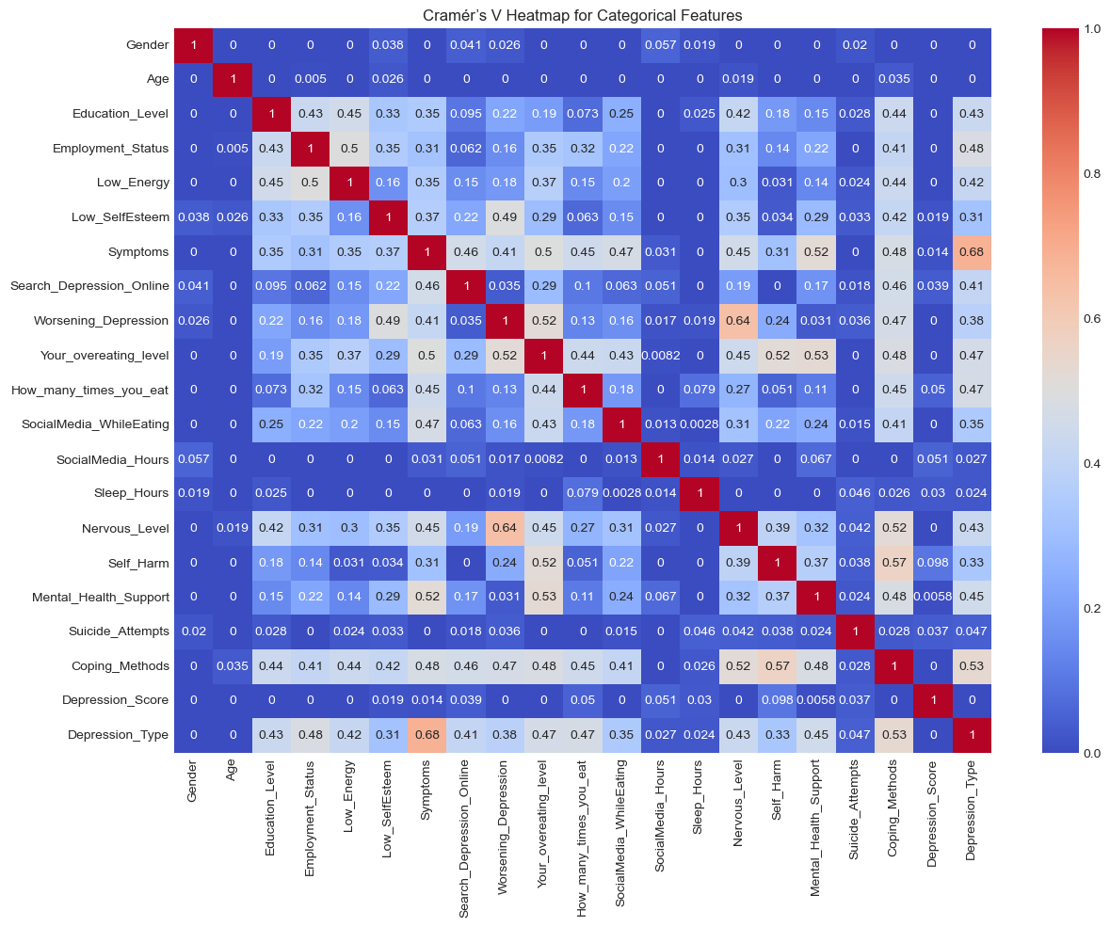
The majority of categorical features exhibit low to moderate correlations, indicating high feature independence and limited multicollinearity, according to the Cramer’S V heatmap. Symptoms, Low Energy, Low Self-Esteem, Worsening Depression, and Coping methods are among the psychological and behavioral factors that exhibit stronger connections and meaningful relationships with Depression_Type. The poor predictive usefulness of demographic characteristics such as gender and age, on the other hand, is confirmed by their extremely weak correlations.

3.1 Dataset preparation
A completeness check was performed after the data import to determine whether any duplicate values, null entries, or missing values were present. The study verified that there are no missing or redundant observations in the dataset. The dataset author had already encoded all of the categorical variables, thus the data was fully organized and structured for the next steps in the modeling process. Feature inspection was conducted to assess the significance of each variable in relation to the classification task. Following the EDA analysis and statistical tests, only the predictive features were selected for mode training. The variables Depression_Score and Age were excluded due to the insignificant contribution to the prediction of Depression_Type. Before modeling, essential transformations were implemented, including standardization for algorithms that are sensitive to the feature scale. A training - testing split was conducted to ensure a valid performance evaluation. Several machine learning classifiers were trained on the preprocessed dataset, including Logistic Regression, Random Forest, Naive Bayes and Decision Tree models. The preprocessing and feature engineering steps resulted in a clean, well-structured dataset, appropriate for effective model development.

4.1 Machine Learning algorithms
This project utilized a supervised learning method to classify depression and mental health classifications, with the categorical variable Depression_Type serving as the prediction target. Given that the task involves a multi-class classification, 4 supervised machine learning algorithms were chosen for model development and comparative assessment. Training of the model commenced with Logistic Regression, utilizing the optimal subset of features determined in the preprocessing phase. Additionally, Random Forest, Naive Bayes, and Decision Tree classifiers were trained to evaluate performance across various modeling, ensemble-based, distance-based, and probabilistic approaches. This modeling strategy facilitated a thorough comparison of algorithms for predicting types of depression.

4.1.1 Logistic Regression
Logistic Regression was trained with all optimal features and had an accuracy of 0.67. Depression Score (0.011332) and Age (0.014774) were minor contributing features to the model. Eliminating weak predictors increased model performance and reduced training noise, increasing accuracy to 0.68.

Table 3: AUC Performance Metrics
Metric | Score | Interpretation
Macro AUC | 0.9601 | Strong ability to distinguish all depression classes
Weighted AUC | 0.9007 | High overall performance even with class imbalance

The findings indicate that the model effectively differentiates among various categories of depression(Table 3)

Diagram 8: Confusion matrix and TPR&TNR Table - Logistic Regression
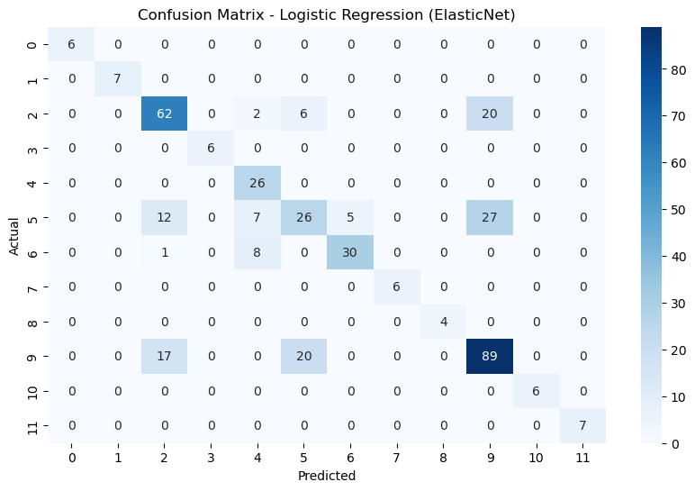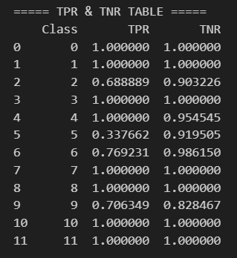
The confusion matrix indicates that the Logistic Regression (ElasticNet) model accurately classifies the majority of depression types, exhibiting minimal misclassification. The diagonal values of the matrix indicate a predominance of true positive predictions across multiple classes, notably Classes 3, 7, 8, 10, and 11, which exhibit perfect classification results. Misclassifications are observed in certain classes with larger sample sizes, specifically Classes 2, 5, amd 9, indicating overlapping feature patterns or class imbalance. (Diagram 8)
The model classifies various depression kinds with flawless TPR and TNR. Lower TPR scores in Clasess 2, 5, 6, and 9 suggest class imbalance or resemblance to neighboring categories, making these categories harder to recognize. High TNR values across all classes indicate that the model rarely mislabels other classes as these. (Diagram 8)

Table 4: Train-Test Accuracy Comparison
Metric | Train Accuracy | Test Accuracy | Interpretation
Accuracy | 0.682728 | 0.6875 | Similar values shows no overfitting; model generalises consistently

Table 5: Cross-Validation(CV) Performance Metrics
CV Metric | Mean Score | Std Dev | Interpretation
Accuracy | 0.658 | 0.0165 | Consistent accuracy; low variance indicates stable model performance across folds
F1-Weighted | 0.645 | 0.019 | Balanced results across classes; small deviation suggests reliable predictions
AUC-weighted | 0.897 | 0.0079 | Strong class-separation ability with minimal variability across folds

4.1.2 Naive Bayes Classification

Diagram 9: Class level and Test/Train Metrics
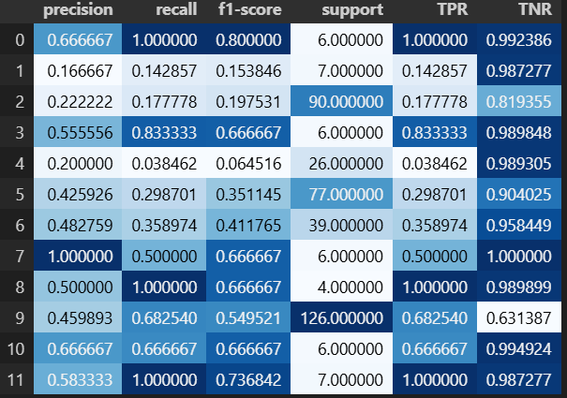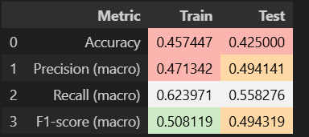
Naive Bayes has poor test accuracy (42% - 49%) and bad precision, recall, and F1-scores (below 0.50). Class-level findings show low TPR for several categories, despite good TNR, hence the model commonly misidentifies depression kinds. Performance is inconsistent berween classes, and accuracy is low on train and test sets, demonstrating that Naive Bayes cannot grasp complicated, correlated data patterns. Naive Bayes is unsiutable for this problem, unlike the better Random Forest model.(Diagram 9)

Diagram 10: Confusion Matrix (Test set)
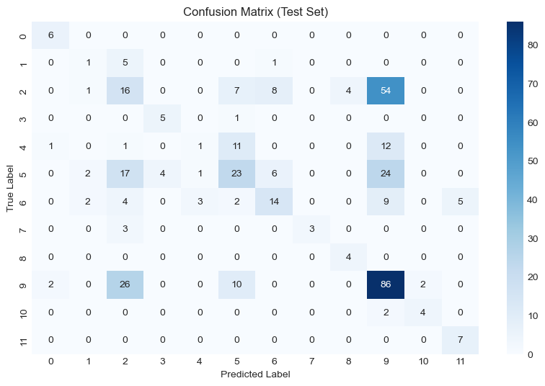
The confusion matrix shows only a few classes (0, 3, 7, 8, 11) accurately predicted by Naive Bayes. Classes 2, 5, 6, and 9 are strongly confused, indicating weak class separation. The matrix shows that Naive Bayes cannot identify the 12 depression groups and is unsuitable for this dataset (Diagram 10).

4.1.3 Decision Tree Classification
Gini-based Decision Tree outperforms Entropy in training, testing, and cross-validation stability. Entropy has a slightly higher macro AUC but lower accuracy and Cross-Validation, indicating wors generalization. Thus, Gini splits this dataset better (Table 6 and Diagram 11).

Table 6: Gini vs Entropy Performance Table
Criterion | Train Accuracy | Test Accuracy | AUC (Macro) | CV Accuracy | Interpretation
Gini | 0.7678 | 0.7750 | 0.9603 | 0.7863 | Best overall performance; higher accuracy and strong generalisation
Entropy | 0.7528 | 0.7275 | 0.9710 | 0.7498 | Slightly higher AUC but lower accuracy and stability

Diagram 11: Gini vs Entropy - Performance Comparison
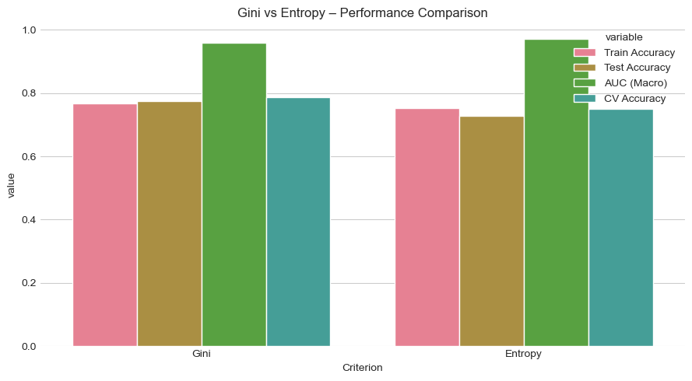
Gini criteria performance is more steady and dependable across most depression categories in class-level evaluation. Many Gini classes have flawless precision, recall, and F1-scores, proving great discrimination and detection. Performance reduces significantly for larger or more complex classes like 2, 5 and 9, but recall and F1-scores are still higher than Entropy. The Entropy-based model performs well in some classes but poorly in others, especially, Class 2, where recall reduces drastically. Gini is the preferred splitting approach for this multi-class depression classification problem due to its greater balance and resilience across all measures, even high TNR values for both criterion (Table 7)

Table 7: Gini Class-level metrics and Entropy class-level metrics
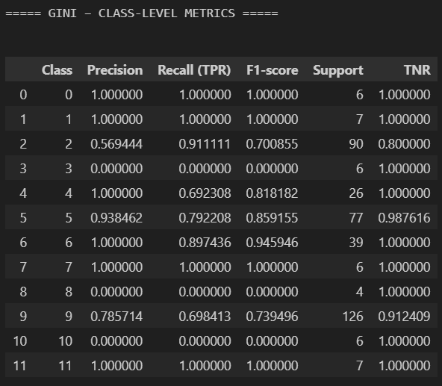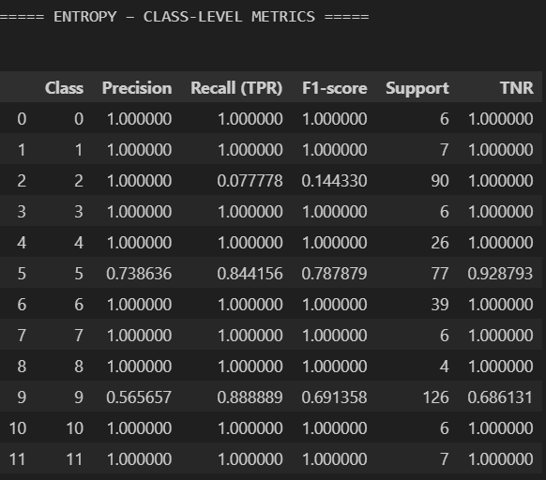

4.1.4 Random Forest Classification

Table 8: Train/Test Accuracy and Confusion Matrix
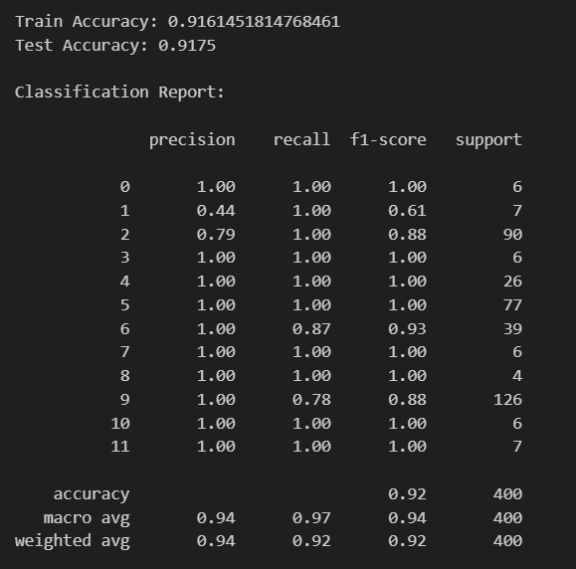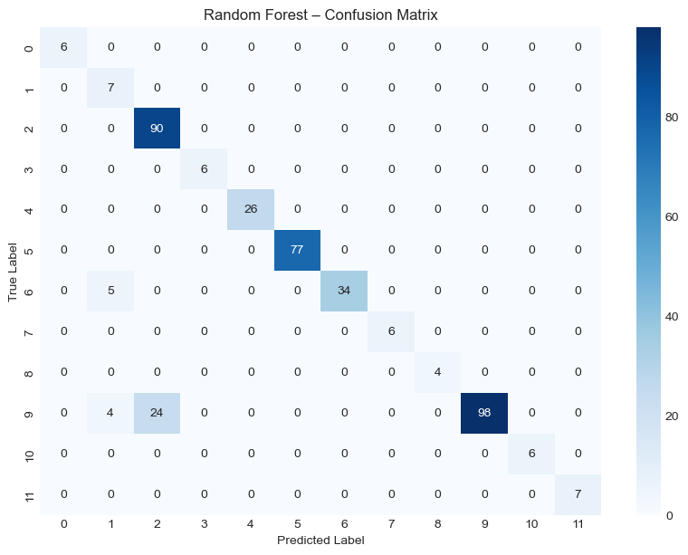
Train accuracy is 0.916 and test accuracy is 0.9175 for baseline Random Forest model, demonstrating good generalization without overfitting. Despite the multiclass imbalance, the classification report predicts most classes accurately with a macro F1-score of 0.92 and weighted F1-score of 0.92. High recall and precision values for classes 0, 3, 4, 5, 7, 8, 10, 11 show that the model accurately recognizes these depression kinds. However, Class 1 (F=0.61) and Class 9 (F1 = 0.88) perform poorly due to overlapping patterns or fewer training samples. The confusion matrix displays most predictions along the diagonal, indicating misclassifications are rare and concentrated in classes 1 and 9 (Table 8)
Diagram 12: Top 18 Important Features - Random Forest
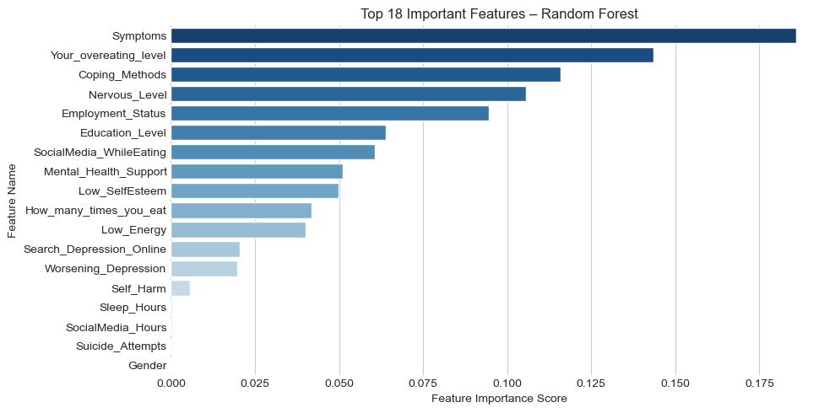
Symptoms predicted depression types more than any other factor in the Random Forest model. This is expected since depression types differ in symptom variety and intensity. Your_overeating_level, Coping_Methods, Nervous_Level, and Employment_Status are also relevant predictors, demonstrating that lifestyle habits, coping behaviours, emotional state, and occupational status distinguish depression groups. Mid-level contributors including Education_Level, SocialMedia_WhileEating, Mental_Health_Support, and low_SelfEsteem have psychological and social relevance and give discriminatory power. Lower-importance features like Self_Harm, Sleep_Hours, SocialMedia_Hours, Suicide_Attempts, and Gender have little effect on the model, suggesting weaker or indirect associations with depression type classification. (Diagram 12)

Table 9: Model Metrics
Metric | Score | Interpretation
Train Accuracy | 0.916 | Model fits the training data well without signs of overfitting
Test Accuracy | 0.9175 | High generalization performance; consistent with training accuracy
AUC(Macro) | 0.9964 | Excellent class separation across all 12 classes
AUC (Weighted) | 0.9880 | Strong discriminative ability considering class imbalance

GridSearchCV found the ideal parameters for 108 Random Forest Configurations using 5-fold cross-validation (540 total fits) : max_depth = 7, max_features = ‘sqrt’, min_samples_leaf = 2, min_samples_split = 10, and n_estimators = 300. Cross- validation accuracy of 0.9839 supports outstanding generalization and shows that the improved Random Forest is stable and effective for multi-class depression classification.

Table 10: Best Model Results
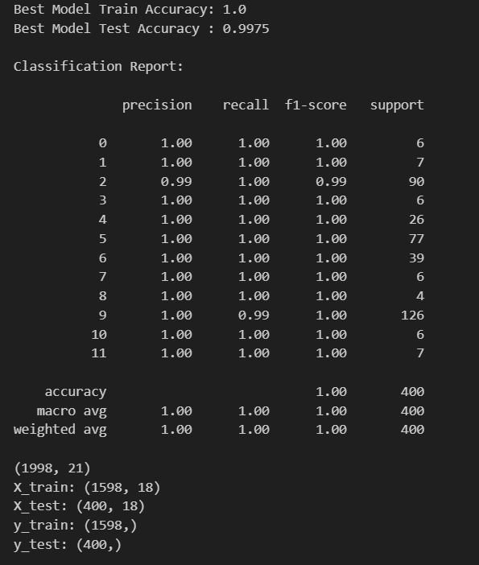
The Grid Search -optimized model had near-perfect accuracy, precision, recall, and AUC, however future leakage is possible when training accuracy reaches 100%. The model was retrained and evaluated after removing the 2 most influential variables.(Symptom and Nervous_Level) to check for unduly strong predictive signals. This further experiment determines if the model’s earlier performance was overstated. We may test the classifier’s generalization capabilities and confirm whether information leakage affected the original results by evaluating the model without these strong characteristics (Table 10).

Table 11: Train vs Test Performance Metrics for Best model(After removing top Features)
Metric | Train Score | Test Score | Interpretation
Accuracy | 0.9849 | 0.9800 | Train and test accuracies are almost identical, indicating strong generalization and no overfitting.
Precision (macro) | 0.9600 | 0.9556 | Precision remains high across classes, showing that the model makes few false-positive errors even after removing key predictors
Recall (macro) | 0.9944 | 0.9926 | Excellent recall on both sets, meaning the model successfully detects almost all relevant cases across depression types
F1-score (macro) | 0.9708 | 0.9658 | High F1 values confirm balanced precision and recall, demonstrating stable classification performance
AUC (macro) | 0.9992 | 0.9988 | Very high AUC scores show that the model maintains outstanding class separability and predictive reliability

The class-level TPR and TNR values reveal that the model excels in all depression areas. Most classes have flawless memory and specificity, demonstrating discrimination. Classes 5, 6, and 9 had lower recall, suggesting class imbalance or overlapping symptom patterns make the harder to recognize. Despite this, the model is reliable and balanced, accurately classifying numerous depression kinds. This confusion matrix indicates considerable class separation, with most predictions on the diagonal. Reduced-feature Random Forest has low misclassification, indication excellent accuracy. (Table 12)

Table 12: TPR & TNR (After removing top Features) and confusion matrix
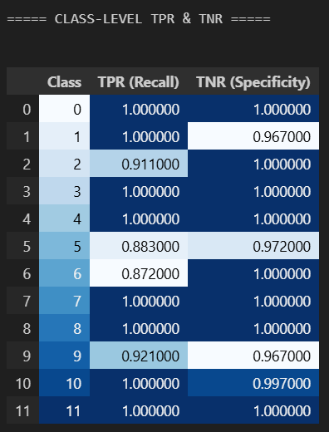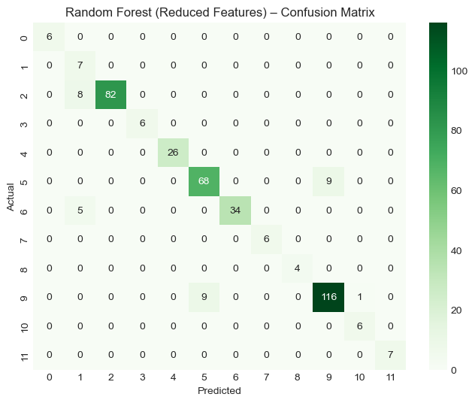

Summary evaluation metrics
Model | Key Metrics | Performance Summary | Interpretation
Logistic Regression | Accuracy =0.67 | Moderate performance; struggles with multiclass patterns | Suitable as baseline; limited for complex despression types
Decision Tree (Gini) | Test Accur = 0.77 | Performs better than linear models; sensitive to feature scaling | Captures non-linear patterns but less stable across classes
Decision Tree (Entropy) | Test Accur = 0.72 | Slightly weaker than Gini variant | Less effective splitting for this dataset
Naive Bayes | Accuracy = 0.42 | Assumes feature independence, limiting performance | Not ideal for correlated psychological variables
Random Forest (Baseline) | Train:0.916, Test:0.917 | Stable and robust, excellent class separation | Strong multiclass classifier, minor issue in few classes
Random Forest (GridSearch Optimized) | Train: 1.00, Test: 0.9975, AUC:0.999 | Exceptional performance across all metrics, highly stable. | Nearly perfect generalization, but possibble feature leakage
Random Forest (Reduced Features) | Train:0.985, Test:0.98 | Strong results even without top features | Best overall model: confirms no data leakage, model remain robust

5.1 Conclusion
This project used a structured mental-health dataset to test supervised machine learning models for depression classification. The Random Fores model with decreased features wast the most reliable and well-generalizing classifier after baseline comparison, feature importance analysis, hyper-parameter adjustment, and data-leakage tests. The model performed stable across all great AUC values after deleting the two Largest Predictors to demonstrate model resilience.
Based on feature importance rankings, symptoms, overeating level, and coping methods were the three most influential elements in depression type. These variables show key psychological and behavioral traits that distinguish depression patterns.
For multi-class depression classification, the reduced-feature Random Forest is accurate, interpretable, and leakage-free. These data shows that the algorithm works and that behavioral and emotional indicators are crucial to understanding depression outcomes.

References

Abdulrahman Aldkheel and Zhou, L. (2023). Depression Detection on Social Media: A Classification Framework and Research Challenges and Opportunities. Journal of Healthcare Informatics Research, 8(8:88–120). doi:https://doi.org/10.1007/s41666-023-00152-3. https://link.springer.com/article/10.1007/s41666-023-00152-3
Babu, N.V. and Kanaga, E.G.M. (2021). Sentiment Analysis in Social Media Data for Depression Detection Using Artificial Intelligence: a Review. SN Computer Science, [online] 3(1). doi:https://doi.org/10.1007/s42979-021-00958-1. https://link.springer.com/article/10.1007/s42979-021-00958-1
Das-Munshi, J., Goldberg, D., Bebbington, P.E., Bhugra, D.K., Brugha, T.S., Dewey, M.E., Jenkins, R., Stewart, R. and Prince, M. (2008). Public health significance of mixed anxiety and depression: beyond current classification. British Journal of Psychiatry, 192(3), pp.171–177. doi:https://doi.org/10.1192/bjp.bp.107.036707. https://www.cambridge.org/core/journals/the-british-journal-of-psychiatry/article/public-health-significance-of-mixed-anxiety-and-depression-beyond-current-classification/89CC9E015A8AB2771EF1B4001992EE3D
Hale, A.S. (1997). ABC of mental health: Depression. BMJ, 315(7099), pp.43–46. doi:https://doi.org/10.1136/bmj.315.7099.43 https://www.bmj.com/content/315/7099/43.short
Mao, K., Wu, Y. and Chen, J. (2023). A systematic review on automated clinical depression diagnosis. npj Mental Health Research, [online] 2(1), pp.1–17. doi:https://doi.org/10.1038/s44184-023-00040-z. https://www.nature.com/articles/s44184-023-00040-z
Paykel, E. (1983). The classification of depression. British Journal of Clinical Pharmacology, 15(S2), pp.155S159S. doi:https://doi.org/10.1111/j.1365-2125.1983.tb05860.x. https://pmc.ncbi.nlm.nih.gov/articles/PMC1427897/
Salas-Zárate, R., Alor-Hernández, G., Salas-Zárate, M. del P., Paredes-Valverde, M.A., Bustos-López, M. and Sánchez-Cervantes, J.L. (2022). Detecting Depression Signs on Social Media: A Systematic Literature Review. Healthcare, 10(2), p.291. doi:https://doi.org/10.3390/healthcare10020291. https://www.mdpi.com/2227-9032/10/2/291
Squires, M., Tao, X., Elangovan, S., Gururajan, R., Zhou, X., Acharya, U.R. and Li, Y. (2023). Deep learning and machine learning in psychiatry: a survey of current progress in depression detection, diagnosis and treatment. Brain Informatics, 10(1). doi:https://doi.org/10.1186/s40708-023-00188-6. https://link.springer.com/article/10.1186/s40708-023-00188-6
William, D. and Suhartono, D. (2021). Text-based Depression Detection on Social Media Posts: A Systematic Literature Review. Procedia Computer Science, 179(1877-0509), pp.582–589. doi:https://doi.org/10.1016/j.procs.2021.01.043. https://www.sciencedirect.com/science/article/pii/S1877050921000491
Mondol, Md Mahabub Rana; Kabir , Md Alamgir (2025), “Depression & Mental Health Classification”, Mendeley Data, V1, doi: 10.17632/xppzm3kv9g.1 https://data.mendeley.com/datasets/xppzm3kv9g/1

