Umbraco CMS in the Modular Monolith
What Umbraco is, what we use it for, and how the Angular app gets its pages
Prepared by: Abdullah Hamdo, Lumin Soft
Date: 25 September 2026
Solution: C:\modularMonolith (ModularDemo)
Status: Working prototype, running locally

1. Summary
We added Umbraco CMS 17 (LTS) to our modular monolith as a new Content module. Editors now create and publish pages in the Umbraco backoffice, and our new Angular 22 frontend reads those pages through a small JSON API. Developers are only needed when a new page type is needed, not for every text or image change.
This replaces an old open-source sample built on Umbraco 7.1.4 (2014), which has been out of support for years and cannot be upgraded in place. The new setup runs on .NET 10, stores content in SQL Server, and follows the same module pattern as our Orders and Shipping modules.
In one sentence: editors publish in Umbraco → the Content module serves the published page as JSON → Angular renders it at the matching URL.

2. What is Umbraco?
Umbraco is an open-source content management system (CMS) built on Microsoft .NET. It gives non-technical people a web interface (the backoffice) to manage a site's content, while developers decide the structure of that content and how it is displayed.

Key concepts
Concept | What it means
Document type | A template for a kind of page, e.g. "Home", "Article", "News item". It defines the fields (properties) editors fill in.
Property | One field on a document type, e.g. a title, rich text, image, date, or a link to another page.
Content node | An actual page created from a document type. Nodes form a tree, and the tree becomes the site's URLs (/about, /news/...).
Publish | Editors can save drafts. Only published content is visible through the API and the Angular site.
Media | The library for images and files, with automatic resizing and cropping.
Backoffice | The admin UI at /umbraco where editors and admins work.

Why Umbraco
- It's .NET: it runs inside our existing .NET 10 host and uses the same DI, logging and hosting as the rest of the monolith.
- Free and open source (MIT licence), with a large community and a paid cloud option if we ever want it.
- Headless ready: a built-in Content Delivery API lets any frontend (Angular, mobile) consume content as JSON.
- Long-term support: version 17 is LTS, with bug fixes until 27 Nov 2027 and security fixes until 27 Nov 2028.
- Editor friendly: drafts, preview, scheduled publishing, version history, roles and permissions, and multiple languages.

3. What we can use it for
Use case | Example
Marketing and corporate pages | Home, About, Services and Contact pages managed by the business, not developers.
News, blog and announcements | List pages that fill automatically from their child articles.
Help / FAQ / legal text | Terms, privacy policy, product help that changes often.
Content inside the product | Banners, onboarding text and email copy that other modules can read.
Multi-language content | The same page in Arabic and English, managed side by side.
Reacting to content changes | When a page is published, a ContentPublished event lets other modules react (for example, clear a cache or send a notification).

4. Old system vs new system
 | Old: UmbracoNodeApi (v7.1.4) | New: Content module (v17 LTS)
Platform | .NET Framework 4.5, Windows/IIS only | .NET 10, runs on Windows, Linux or Docker
Support | Ended years ago, no security fixes | Supported until Nov 2027 (security until Nov 2028)
Code API | NodeFactory / uQuery (removed in v8) | Published content cache + navigation services
Children in a response | Always returned the whole tree (slow) | Controlled with ?depth= (default 1, max 5)
Not found | HTTP 200 with Success = false | Real HTTP 404
Property values | Raw internal objects | Clean JSON (same format as Umbraco's Delivery API)
Architecture | Stand-alone site | One module in our monolith, with events on the shared bus
Database | SQL CE file in the repo | SQL Server (LocalDB for development)

Upgrading 7 → 17 in place is not realistic: Umbraco only supports stepping one major version at a time, and the APIs the old code used were removed. We rebuilt the functionality on a clean Umbraco 17 install instead.

5. Architecture
Umbraco runs inside the same process as our other modules (ModularDemo.Api). The Content module is a thin layer over Umbraco: it owns the public URLs under /api/content, and it turns Umbraco's internal "content published" notification into our own ContentPublished event. Other modules never reference Umbraco directly.
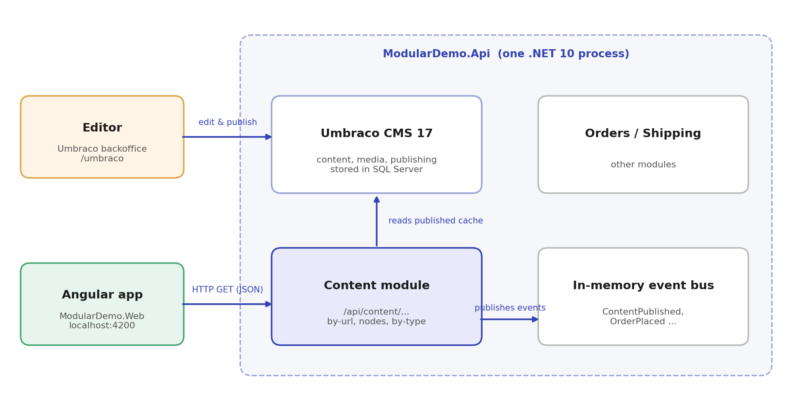
Figure 1. How Umbraco, the Content module and Angular fit together

Projects in the solution
Project | Responsibility
ModularDemo.Api | The single host. Starts Umbraco, registers all modules, maps their endpoints.
ModularDemo.Modules.Content | Reads published content and exposes /api/content/... Relays publish events to the bus.
ModularDemo.Modules.Content.Contracts | The ContentPublished event, so other modules can subscribe without depending on Umbraco.
ModularDemo.Modules.Orders / Shipping | Existing business modules (unchanged).
ModularDemo.Shared | Event bus and shared interfaces.
ModularDemo.Web | The Angular 22 frontend that displays the pages.

6. How Angular gets pages from Umbraco
Umbraco owns the site structure, so the Angular app doesn't hard-code pages or routes. It has one catch-all route: whatever URL the visitor opens, Angular asks the Content module for the page at that URL.

Request flow
- A visitor opens /about in the Angular app.
- Angular's router sends every path to one component, ContentPage.
- ContentPage calls GET /api/content/by-url?url=/about&depth=1. In development the Angular dev server forwards /api to the .NET host, so no CORS setup is needed.
- The Content module finds the page for that URL in Umbraco's published cache and returns it as JSON: name, type, URL, dates, all properties, and its child pages.
- Angular renders the page title, then each property by its shape (text, rich text, image, link, list), then cards for the child pages.
- If nothing is published at that URL, the API returns 404 and Angular shows a "Page not found" screen.
The top navigation works the same way: at start-up Angular loads the home page (/) with its children and turns them into menu links. A new page published under Home appears in the menu automatically.

API endpoints
Endpoint | Returns
GET /api/content/by-url?url=/about | The page at that URL (used by Angular for every page).
GET /api/content/nodes/{id or guid} | A page by its numeric ID or unique key.
GET /api/content/by-type/{alias} | All published pages of a document type, e.g. every newsItem.
?depth=N (any endpoint) | How many levels of child pages to include (default 1, max 5).
/umbraco/delivery/api/v2/... | Umbraco's own Content Delivery API, also enabled, with filtering, sorting and paging.

Example response
GET /api/content/by-url?url=/about
{
"id": 1057,
"key": "6078c6eb-01e3-446b-aa8a-07868b7c5485",
"name": "About us",
"contentType": "hello",
"url": "/about/",
"updateDate": "2026-09-25T12:00:00",
"properties": {
"text1": "212",
"bodyText": { "markup": "<p>We build modular things.</p>" }
},
"children": [ { "name": "Team", "url": "/about/team/", ... } ]
}

Main Angular files
File | Purpose
app.routes.ts | One catch-all route (**) that sends every URL to ContentPage.
content/content-page.ts | Loads the page for the current URL and shows loading, not-found and error states.
content/property-value.ts | Decides how to display each property value.
content/content.api.ts | Builds the API URLs in one place.
proxy.conf.json | Forwards /api and /media to the .NET host during development.

7. Editor workflow
- Developer: create a document type in Settings (for example "Article" with Title, Body and Image) and allow it at the root or under a parent.
- Editor: in Content, create a page from that type, fill in the fields, then click Save and publish.
- Result: the page is immediately available at its URL in the API and in the Angular app. No deployment is needed.
- Optional: for a custom layout for that type, a developer adds a dedicated Angular view that branches on contentType.

8. Running it locally
Part | How
.NET host + Umbraco | Open the solution, run ModularDemo.Api (IIS Express → https://localhost:44366).
Backoffice | https://localhost:44366/umbraco
Database | SQL Server LocalDB, database ModularDemoUmbraco (connection string in appsettings.json).
Angular app | In ModularDemo.Web: npm install, then npm start → http://localhost:4200
Requirements | .NET 10 SDK, SQL Server / LocalDB, Node.js 22.22.3+ or 24.15+

9. Before production: open points
Topic | Recommendation
Admin password | The development admin password is in appsettings.Development.json. Change it and move secrets to user-secrets or a vault.
Hosting the Angular app | Either serve the built Angular files from the .NET host (same domain, no CORS), or host them separately and add a CORS policy for that domain.
SEO | The Angular app renders in the browser. If search ranking matters, enable Angular SSR or pre-rendering.
Caching | Add output caching on /api/content and clear it on ContentPublished, which the event already supports.
API exposure | The content API is public and read-only (published content only). Decide whether preview of drafts is needed; it would need an API key.
Languages | If we need Arabic and English, enable languages in Umbraco and pass the culture from Angular to the API.
Module boundary | Shipping currently references the whole Orders project; it only needs Orders.Contracts. This is a small clean-up.
Upgrade path | Stay on v17 LTS. Plan the move to the next LTS (expected late 2027) before support ends in Nov 2027.

Recommendation: continue with Umbraco 17 LTS as our content module. Next, agree on the first real document types with the business, and choose how the Angular app will be hosted.

