Companies in Response to Money Settlements

By Rachel Lilja, Jose Casseres, Kianoosh Mokhtari from Not So Minority

**Introduction**

When consumers notice their money getting mishandled by a third party, they look to the bank to resolve it and sometimes the company is at fault. The company is not always willing to reveal publicly that they have made a blunder and may try to resolve things with just the customer, but this does not always work. We will be using the Consumer_Complaints.csv database retrieved from a government website to determine the type of monetary complaints that consumers have.

**Original Contributions and Broader Impact**

We will provide a means of allowing users to search through the database based on the date of the complaint, the type of complaint and from which company the complaint arose. We will use an HTML, CSS, JavaScript front-end with a Java JDBC back-end coupled with mySQL to achieve this display to the user. This will make sifting through the database easier for the user rather than looking at an Excel csv file for the information that they want and the broader impact will be that the user will be more informed about the companies that these complaints come from.

**Proposed System Architecture**

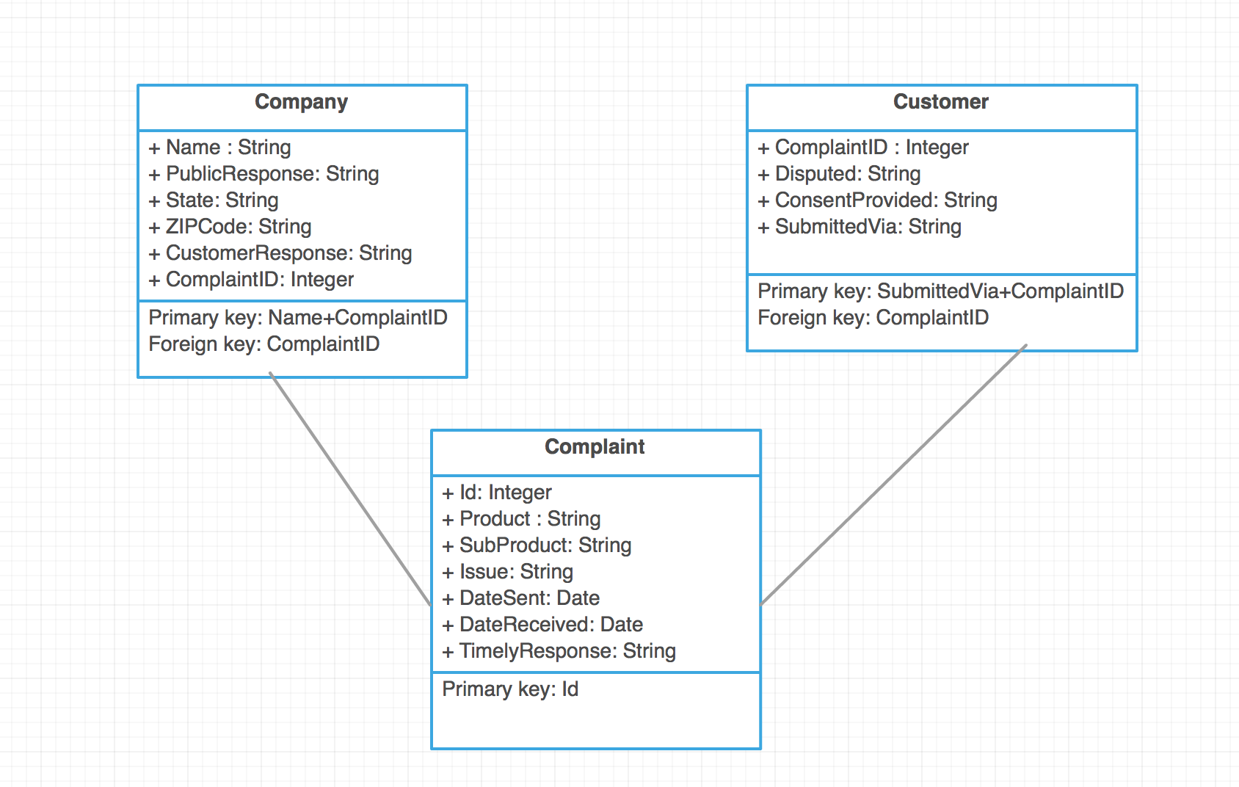

**Technical details**

HTML, CSS, and JavaScript will cover the GUI that the user will interact with. This appearance will allow the user to input their desired information into search boxes and get results back through clicking a submit button. Java JDBC and mySQL will be used for the back-end to provide the database information, communicating with the database and relaying the information to the front-end. The Consumer_Complaints.csv will be importing into a mySQL database dependent on the needed information and may be organized differently in mySQL than in the Excel csv. The Consumer_Complaints.csv will also be reduced to 20,000 tuples from its original 400,000+ tuples.

**Related work**

**Planned Timeline**

7/15/17-Organize the Excel csv into a proper database with foreign keys, primary keys, tables, columns, and indexes.

7/20/17-Have a functioning GUI that looks nice(more than basic) and allows the user to provide input and expect output in response.

7/23/17-Complete a powerpoint presentation of the final term project.

7/26/17-Present the final term project including a demo of the project.

**Team Members and Responsibilities**

Kianoosh Mokhtari-Will import the 20,000 tuples from the Excel csv into a database based on columns and tables from the mySQL database. He will also setup the foreign keys, primary keys, and indexes appropriately.

Jose Casseres-Will work on the GUI section to make an interactive web application that the user can place input into and request output dependent upon the parameters.

Rachel Lilja-Will work on the queries for the mySQL requests and the powerpoint for the final term project.

All-Edit the final term project for any inconsistencies and inaccuracies.

**Conclusion**

The database will provide information to the user that will assist them in deciding which companies to approach or avoid based on their complaints and how they were resolved by referring to an input based GUI web application based on HTML, CSS, JavaScript, Java JDBC, and mySQL.

**References**

Consumer Database Website: https://catalog.data.gov/dataset/consumer-complaint-database/resource/2f297213-7198-4be1-af1e-2d2623e7f6e9