**UI Design and Functionality Report**

**Plugin Window**:

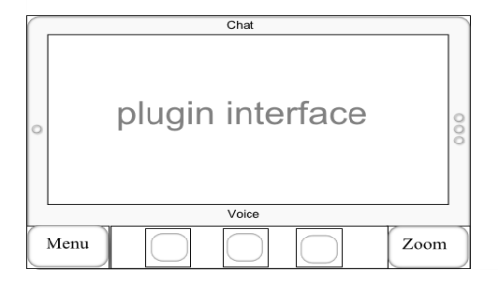

The plugin window is one of the key features of our chatting program. This is where the users of the client can interact with their own specified and customized plugins, anything ranging from games, to counters, to streaming video.

***Center Screen***: 2-1 ratio of length to width, length approx .895 of total length, width approx .67 of total width. 2:1 spacing and large overall area given to ensure the most possible spare room to visualize and interact with the plugin currently active. In addition, users may select a fullscreen mode under the Menu options for further flexibility.

***Borders***: The direct outline of the main plugin window keeps the 2:1 aspect ratio as the center screen. The borders themselves are approx .0458 and .0687 for length and width respectively. The vertical sides extend for .828 of the total width. Horizontal sides extend for the entire length. Centered at the top and bottom of the border are text indicators of the contect of the nearest virtual panes. Centered to the left and right of the border are indicators (in this case, small circles) of current location with respect to other private spaces. In the diagram indicated above, the arrangement indicates one private space to the left, and three to the right.

***Navigation:*** To navigate between different private spaces, one would swipe the screen as if you were pushing your current private space to the side (horizontally) to reveal the next private space. To navigate between the Chat, Plugins, and Conference, one could either click the word on the top or bottom of the screen, or touch the word and swipe toward the center of the screen. These navigation gestures apply to every screen except the Zoom screen.

***Bottom Row*:** The bottom row of the Plugin screen will cover approximately .171 of the height, and extend across the entire length of the screen. At the far right of the bottom row is positioned a button of length/width ratio of approximately 1.6-1 for “Zoom”. At the far left is situated a button of identical length/width and labeled “Menu”. Buttons will be .1875 horizontally, and .1725 vertically. In the center of the bottom row, a scrolling pane will appear with the avatars/icons of whoever is currently in this plugin pane. Icons should be 1:1 length/width, and the spacing along the bar will automatically adjust depending on the number of users.

***Miscellaneous*:** Menu for plugins will include an option to add/change plugins.

**Private Spaces:**

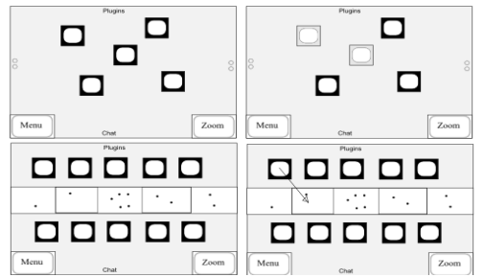





Private spaces and spacialization are the key differences between our program and other VOIP solutions currently available. Private spaces will allow users to hold instanced private chats separately yet simultaneously with the main chat. Spacialization will give us a realistic 3d audio environment that will make conversations seem more natural.

***Icons:*** Icons should be 1:1 length/width ratio. They should occupy no more than .104 horizontally, and .156 vertically. Icons are free to tap on and drag around. Tapping an icon once will display information about the user associated with the icon, and tapping the icon again will cause the display to disappear. Placement of icons will determine sound spacialization. Left and right corresponding to left/right. Up/down indicating distance, with down being closer to you, and up further away.

***Main Chat (Upper Left):*** Spacing of icons in the main voice area is linked with spacing in all private spaces. What changes in one, will change in every other space as well.

***Private Space(Upper Right):*** Icons remain solid/dark colored if the icon is associated with a user currrently inside the private space. Icons will grey out, and the audio input from those users will be faded slightly to indicate that they are no longer in the private space.

***Buttons:*** Button dimensions remain static on all panes/windows. During the Zoomed Out mode, the "Zoom" button will change into a "Back" button. When the "Back" button is pressed, then the screen will bring you to the screen you were previously viewing before pressing the "Zoom" button (whether it be a plugin, private space, or chat screen). This allows a convenient way for the user to switch back and forth between his/her previous screen and the Zoomed Out screen.

***Zoomed Out (Lower Left):*** Middle bar extends all the way across horizontally, and covers approximately .2 of the total vertical length. Across the entire bar is displayed a miniature version of all currently existing private spaces. Icons of users particpating in the chat are displayed across the top and bottom, centered between the top edge of the pane and the top edge of the buttons along the bottom.

***Zoomed Out (Private Space view):*** By default, the zoom button will bring you to either the main zoom screen, or a zoom screen corresponding to the private space in which it was pressed. Tapping and holding a particular private space will highlight that private space and any users' icons in the space. Tapping and holding a particular user will highlight all private spaces that user is in, along with connecting lines so that it is as clear as possible. In addition, a textbox description of the particular user will appear on the opposite side of his/her icon that may be edited.

***Private Space Creation:*** Creating a private space will be simple. There are two main options, one can either create new spaces from an option available in Menu, or tap and drag icons from zoom into an empty private space. Adding users to a private space will bring up a invitation to join a private space, which the receiver can either accept or reject.

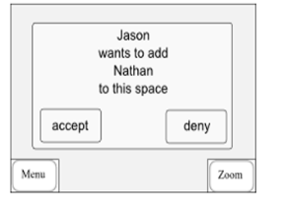

**Chat Pane:**

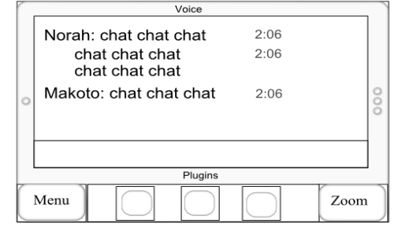

All dimensions for the chat pane are identical to that of the plugin pane, with the exception of an additional text entry field along the bottom of the main window. The field will vary from phone to phone, as some phones may have virtual keyboards, others may have actual qwerty keyboards built in.

**Login Screen:**

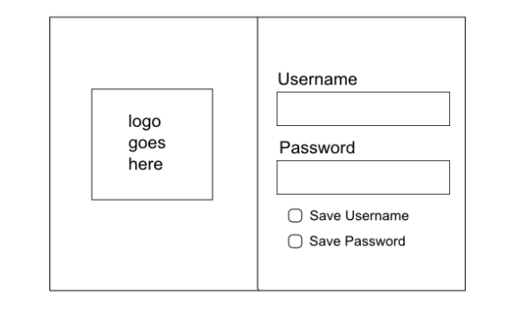

Basic login screen.

After logging in, the user will be taken to the main chat screen.

***Features:*** Username, Password, Save options, Account creation options