| C1 0,1uF
| C2 0,1uF
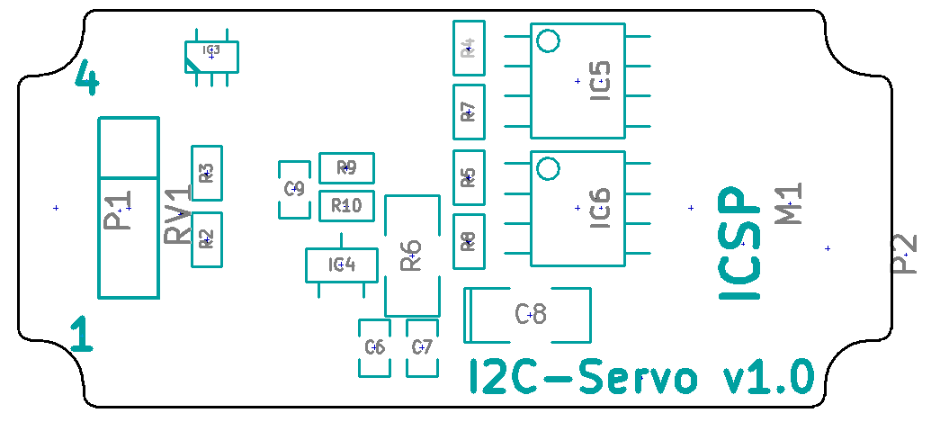
| C3 0,1uF
| C4 0,1uF
| C5 0,1uF
| C6 0,1uF
| C7 1,0uF
| C8 33uF
| C9 0,1uF
| C10 0,1uF
| C13 1uF
| D1 DIODESCH
| D2 ZENER 15V
| D3 DIODESCH
| IC1 LM3480
| IC2 ATMEGA168-A
| IC3 LM20
| IC4 ZXCT1009
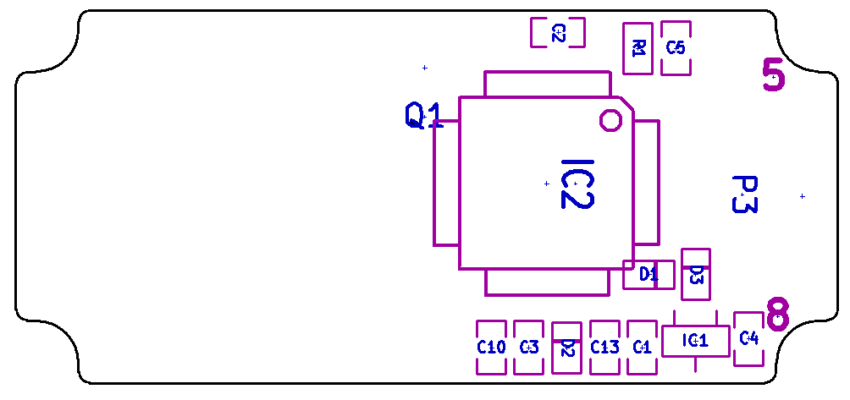
| IC5 SI4500BDY
| IC6 SI4500BDY
| M1 MOTOR
| P1 CONN_4
| P2 CONN_3X2
| P3 CONN_4
| Q1 PBRC-M
| R1 10k
| R2 5k6
| R3 1k5
| R4 100k
| R5 100k
| R6 0,1ohm
| R7 100k
| R8 100k
| R9 1k
| R10 1k
| RV1 POT

