**PROJECT 1: SCREEN PET**

1. **Introduction:**

Many people wish of having a fun, cute pet, now, what if you could get a virtual screen pet? It would help uplift your mood while working, just by looking at its face or stroking it, it might distract you from the stressful work.

This application can provide you with a cheerful pet, which when ignored might get a little upset, so try not to make it unhappy. You can keep it on the corner of your screen to keep tabs on your pet. Kids would love trying to keep the pet happy and cheerful.

1. **Technology Used:**

For this application I have used **Tkinter** module available in python. This helps create a Graphic User Interface (GUI) for the application. This provides a canvas, buttons, labels, text, widgets and more. I created a screen pet aka panda pet, as shown below:

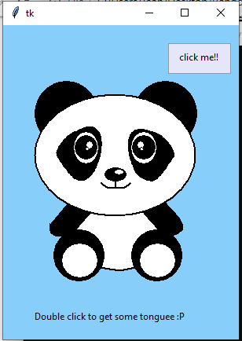

**Fig.1: Initial display of the screen pet**

1. **Flowchart:**

Make a pet

Make it blink

Check if pet happy (mouse on screen)

YES

Happy face with blush

NO

Make sad

Double click

Stick tongue out

YES

NO

Button click

Wave hand to say hi

YES

NO

1. **Code for the project:**
2. **Explanation of the code:**
3. **Importing libraries:**

Before running any program all the necessary libraries and modules should be imported into the program

1. **Designing the canvas:**

This shows the dimension of the window and background color of the canvas.

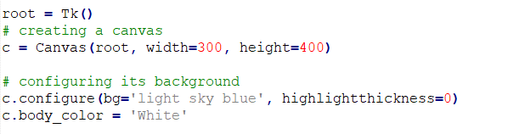

1. **Making the pet on the canvas:**

Using various shapes of various sizes to make the screen pet

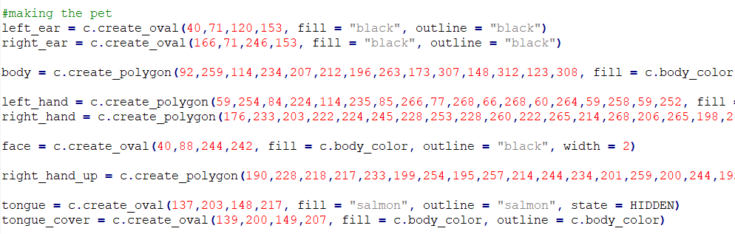Some of the code is shown below:

1. **Creating a function for making eyes blink:**

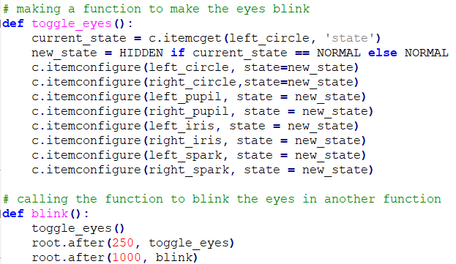

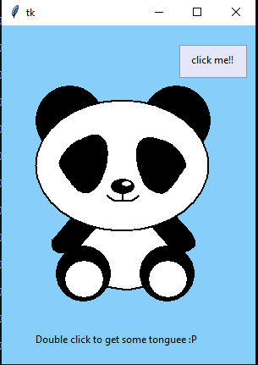

**Fig.2: Blinking screen pet, shown in the above 2 images**

1. **Creating a function to make the pet happy and blush:**

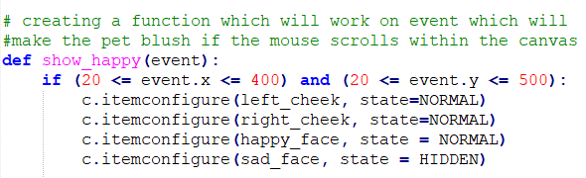If the user moves the curser on the canvas, the pet will smile and blush.

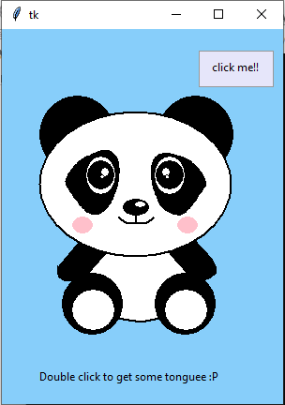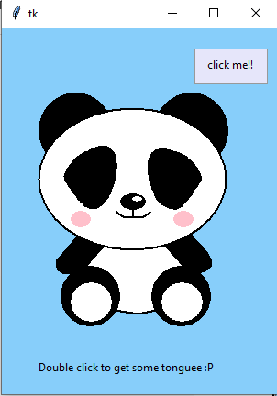

**Fig.3: Happy Pet, with blush, when cursor is on the pet, with eyes open and closed, as it’s always blinking**

1. **Creating a function to make the pet sad:**

If the cursor isn’t on the canvas, the pet will get sad.

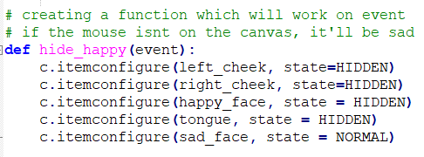

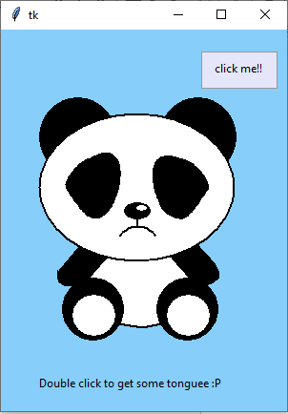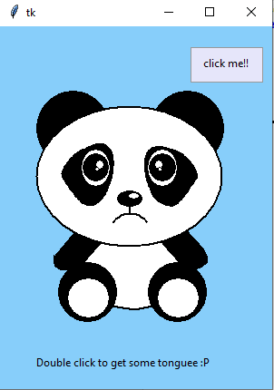

**Fig.4: Sad pet, when cursor isn’t on the pet, with eyes open and closed, as it’s always blinking**

1. **Creating a function to make the show the tongue:**

If the user, double clicks on the pet, the pet will show its tongue.

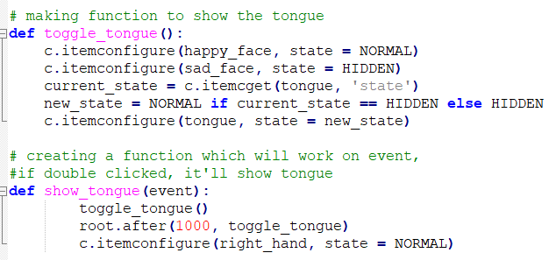

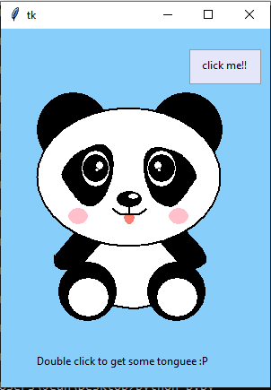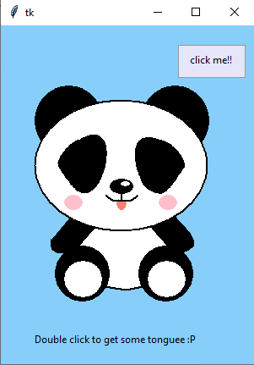

**Fig.5: Tongue sticking out pet after double clicking, with eyes open and closed, as it’s always blinking.**

1. **Creating a function to wave the hand:**

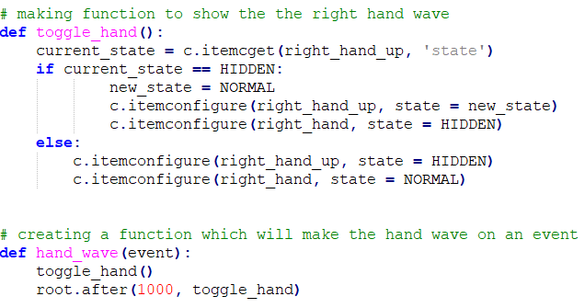

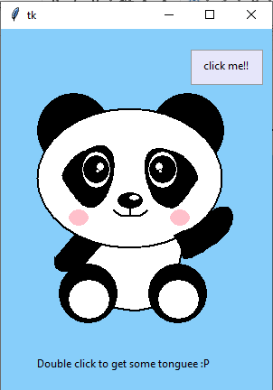

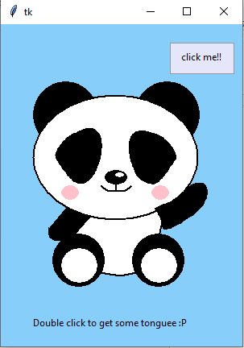**Fig.6: Upon clicking ‘click me!!’, the pet, waves it’s hand with eyes open and closed, as it’s always blinking.**

1. **Adding button, text and function to the button:**

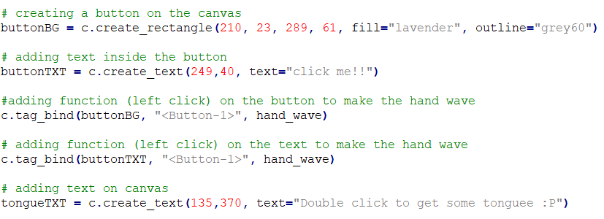Adding hand wave function to the button and text created. And adding another text to make sure that the user double clicks to see some tongue.



**Fig.7: click me button Fig.8: Text on the canvas**

1. **Adding created function to the motions:**

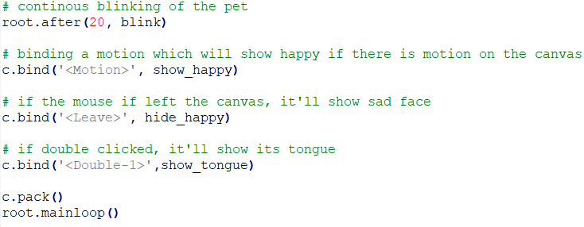Making the pet, blink continuously, adding motion to show happy face with blush, make a sad face and to show tongue.