Lab - 1

**Aim:** To create a visually appealing webpage.

**Hardware Requirement:** Laptop, PC.

**Software Requirement:** Visual Studio Code

**Knowledge Requirement:** Html, CSS

**Expectation:** I expect to create an appealing and user-friendly web page by applying basic CSS styling techniques like setting background colours, adjusting font properties and arranging images in a visually pleasing layout.

**Theory:**

1. **HTML (Hypertext Markup Language):**

* HTML is an acronym which stands for **Hyper Text Markup Language** which is used for creating web pages and web applications.

1. **Head Section:**

* The <head> section of an HTML document contains metadata about the document, such as the title, links to external resources like stylesheets and scripts, and other information that is not directly displayed to the user.
* <title>: This element sets the title of the webpage, which is displayed in the browser's title bar or tab.
* <style>: This element is used to embed CSS (Cascading Style Sheets) rules that define the visual presentation of the webpage.

1. **Body Section:**

* The <body> section of an HTML document contains the actual content that is displayed to the user.
* <header>: This is a semantic HTML5 element used to define a header section for the webpage. It typically contains introductory content or a heading.
* <div>: This is a generic container element used to group and style content within a division.
* Headings (<h1>, <h2>, <h3>): These elements are used to define headings of different levels. They provide hierarchical structure to the content.
* <p>: This element is used to define paragraphs of text.
* Lists (<ul>, <ol>, <li>): These elements are used to create unordered lists, ordered lists, and list items, respectively.
* <table>: This element is used to create tables with rows and columns.
* <a>: This element creates hyperlinks (links) to other web pages or resources.
* <img>: This element is used to display images on the webpage.

**3. CSS (Cascading Style Sheets):**

* CSS stands for Cascading Style Sheets
* CSS describes how HTML elements are to be displayed on screen, paper, or in other media
* CSS saves a lot of work. It can control the layout of multiple web pages all at once
* External stylesheets are stored in CSS files

**HTML Code:**

<!DOCTYPE html>

<html lang="en">

<head>

    <meta charset="UTF-8">

    <meta name="viewport" content="width=device-width, initial-scale=1.0">

    <title>About Me</title>

    <link rel="stylesheet" href="./style.css" />

</head>

<body>

    <h1>Welcome to My Page</h1>

    <p>My name is <strong>Moksha Dave</strong>, and my roll number is 22BCP366. I am currently pursuing a degree in Computer Science Engineering at Pandit Deendayal Energy University. I am a quick learner and fond of exploring new technologies.</p>

    <img src="./dp.JPG" class="pic">

    <h2>My Subjects This Semester:</h2>

    <ul>

        <li>Software Engineering</li>

        <li>Advanced Python</li>

        <li>Computer Networks</li>

        <li>Information Security</li>

        <li>Introduction to Web Technology</li>

        <li>Compiler Design</li>

        <li>Disaster Management</li>

    </ul>

    <h2>My Favorite Movies:</h2>

    <ol>

        <li>Avengers: Endgame</li>

        <li>Avengers: Infinity War</li>

        <li>La La Land</li>

    </ol>

    <img src="m1.jpg" class="photo">

    <img src="m2.jpg" class="photo">

    <img src="images.jpg" class="photo">

    <h2>My Favorite Books:</h2>

    <ol>

        <li>Atomic Habits - James Clear</li>

        <li>The Lost Symbol - Dan Brown</li>

        <li>The Monk Who Sold His Ferrari - Robin Sharma</li>

    </ol>

    <img src="61M6KzUbf7L._AC_UF350,350_QL80_.jpg" class="photo">

    <img src="61pZyTuNDYL._AC_UF1000,1000_QL80_.jpg" class="photo">

    <img src="81BlXbpNmuL._AC_UF1000,1000_QL80_.jpg" class="photo">

    <h2>My Favorite Web Series:</h2>

    <ol>

        <li>Friends</li>

        <li>Money Heist</li>

        <li>Stranger Things</li>

    </ol>

    <img src="frnds.jpg" class="photo">

    <img src="mh.webp" class="photo">

    <img src="MV5BMDZkYmVhNjMtNWU4MC00MDQxLWE3MjYtZGMzZWI1ZjhlOWJmXkEyXkFqcGdeQXVyMTkxNjUyNQ@@._V1_UY1200_CR165,0,630,1200_AL_.jpg" class="photo">

    <p>My colleague is Sameeksha Gupta. She is very confident and smart. She is from UP.</p>

    <img src="sami.jpeg" class="colleague">

    <p>CSS stands for Cascading Style Sheets. It adds style and design to our webpage, making it more appealing and improving user experience.

        For more information, you can go on to <a href="https://www.w3schools.com/css/">w3schools</a>

    </p>

</body>

</html>

**CSS Code:**

body {

    font-family: Arial, sans-serif;

    background-color: #e0e0e0;

    color: #333;

    padding: 20px;

}

h1 {

    color: white;

    background-color: blue;

    text-align: center;

    padding: 10px;

}

h2 {

    color: green;

    font-family: 'Courier New', Courier, monospace;

    font-size: 20px;

    font-weight: bold;

    font-style: italic;

}

p, ul, ol {

    font-size: 16px;

}

strong {

    color: red;

}

.pic {

    width: 150px;

    height: auto;

    border-radius: 50%;

    display: inline-block;

    margin: 10px;

}

.photo {

    width: 150px;

    height: auto;

    display: inline-block;

    margin: 10px;

}

.colleague {

    text-align: center;

    margin-bottom: 20px;

    border-radius: 20%;

    width: 150px;

    height: auto;

    display: inline-block;

    margin: 10px;

}

**Output:**

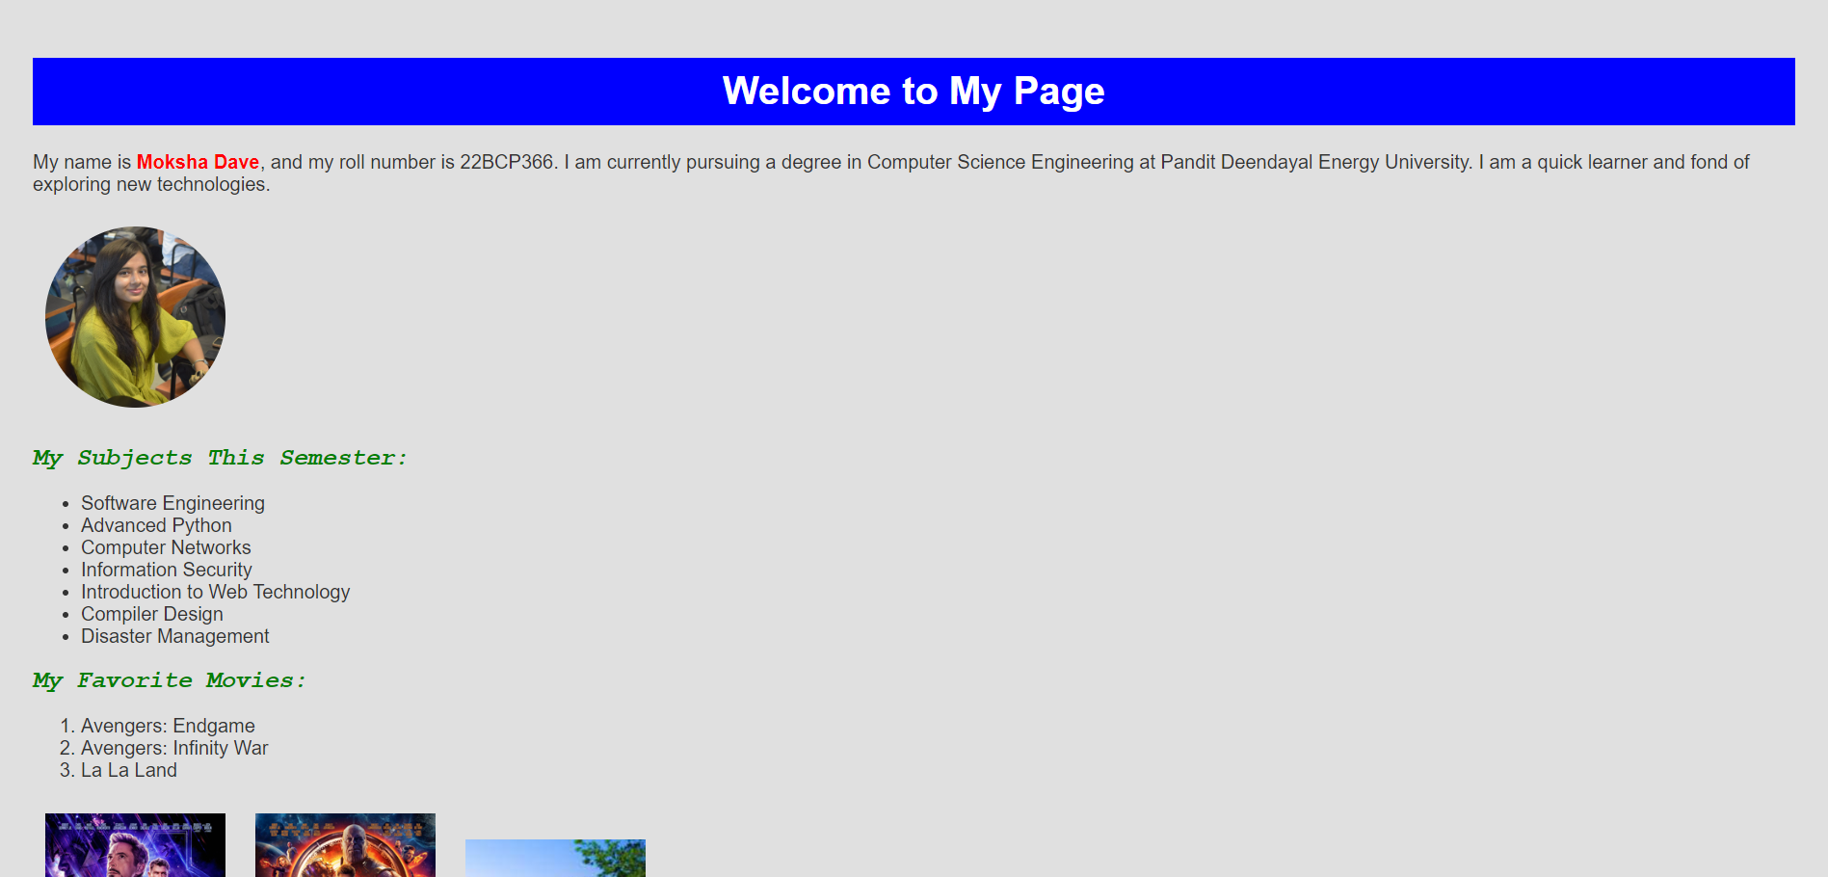  
  
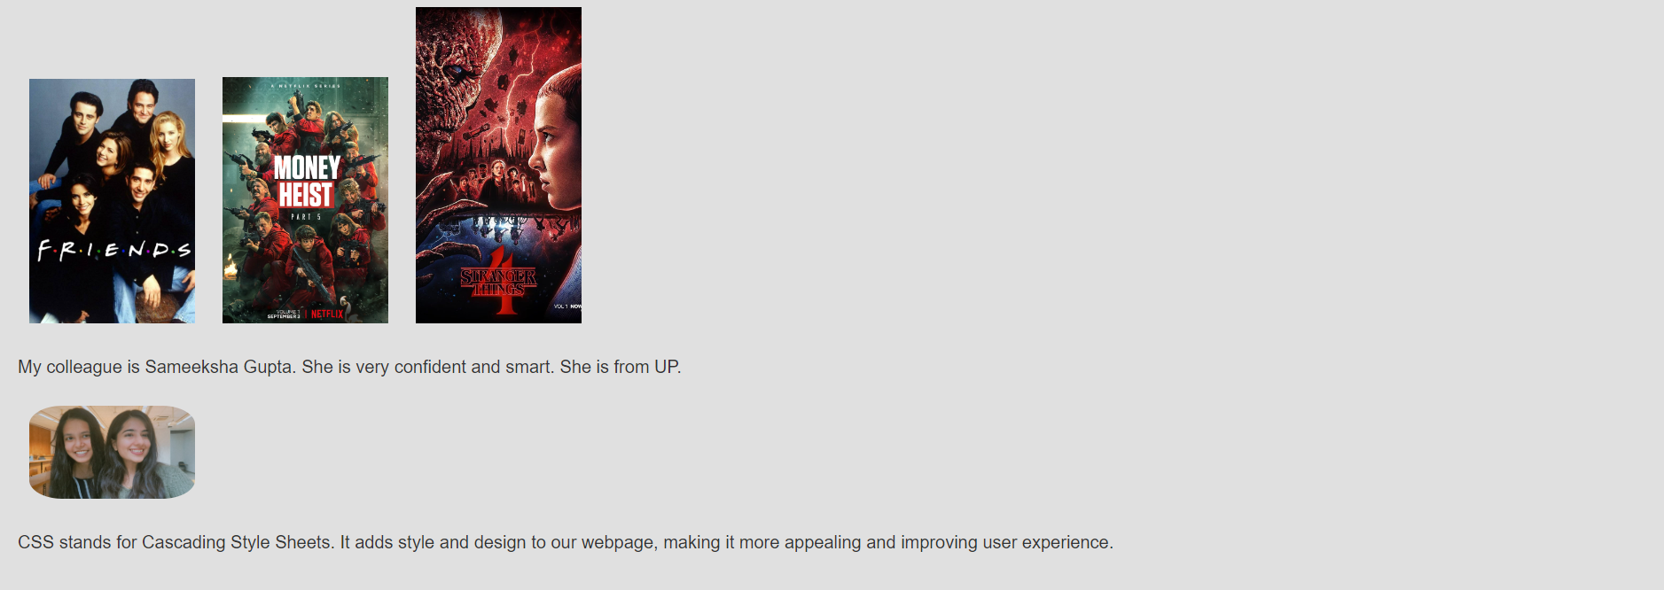

**Conclusion:**

Through this practical, I successfully demonstrated the impact of CSS on enhancing the visual appeal and usability of a web page. By applying background colours, adjusting font properties and arranging images horizontally, the web page became more engaging and aesthetically pleasing. This exercise highlights the importance of CSS in web development for creating attractive and user-friendly interfaces.

**References:-**

1. **Javatpoint :**-  <https://www.javatpoint.com/what-is-html>