QUERY-1
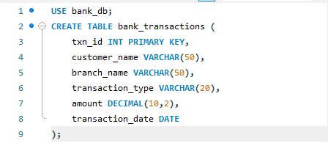
OUTPUT

QUERY-2
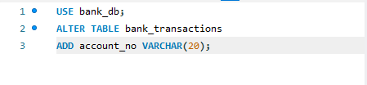
OUTPUT

QUERY-3
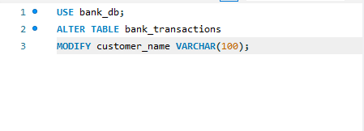
OUTPUT

QUERY-4
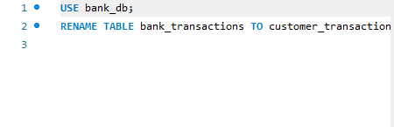
OUTPUT

QUERY-5

OUTPUT

QUERY-6
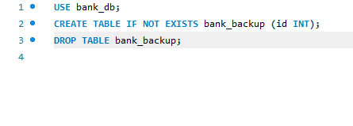
OUTPUT

QUERY-7
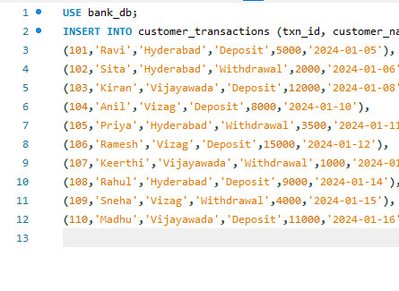
OUTPUT
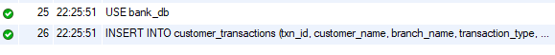

QUERY-8
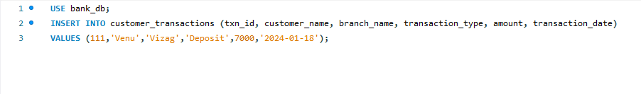
OUTPUT
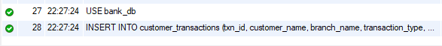
QUERY-9
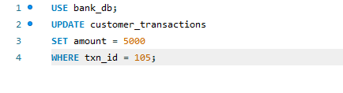
OUTPUT

QUERY-10

OUTPUT

QUERY-11
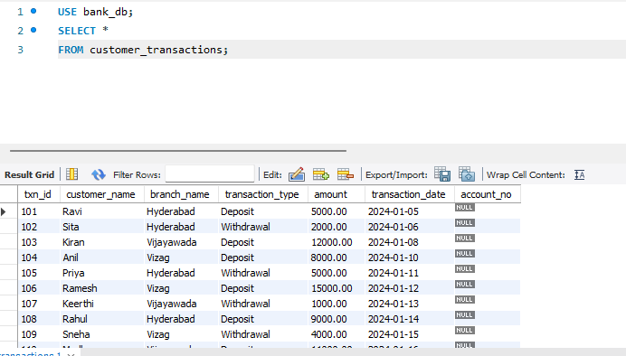
OUTPUT

QUERY-12
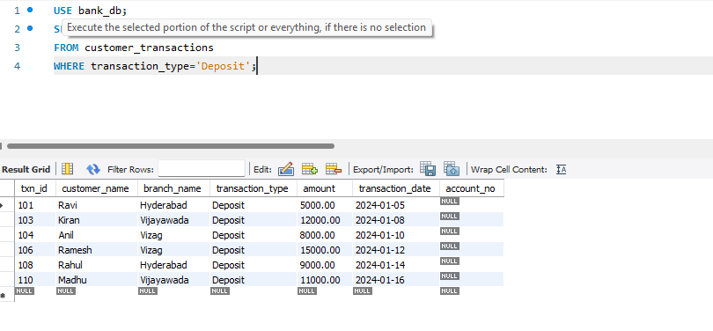
OUTPUT

QUERY-13
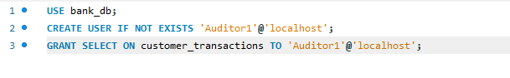
OUTPUT

QUERY-14
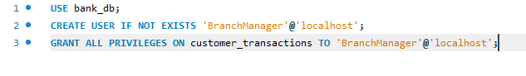
OUTPUT

QUERY-15

OUTPUT
QUERY-16
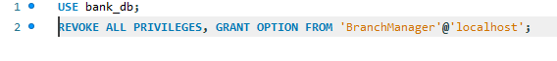
OUTPUT

QUERY-17
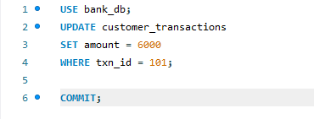
OUTPUT

QUERY-18

OUTPUT


QUERY-19

OUTPUT


QUERY-20

OUTPUT


