QUERY-1
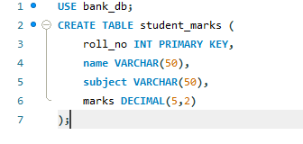
OUTPUT

QUERY-2
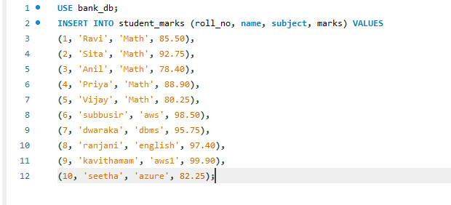
OUTPUT

QUERY-3
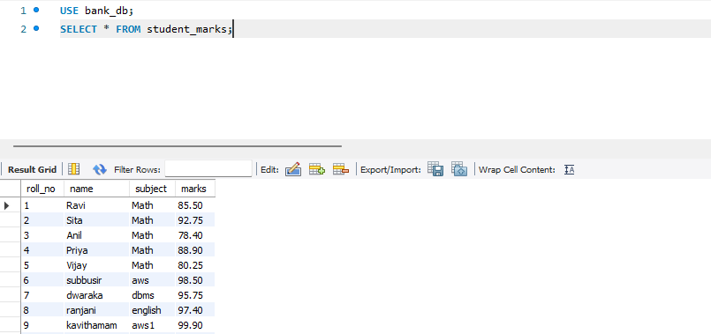
OUTPUT

QUERY-4
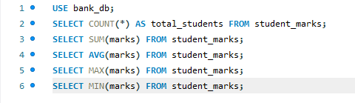
OUTPUT

QUERY-5
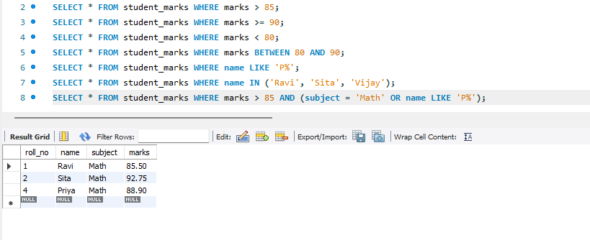
OUTPUT

QUERY-6
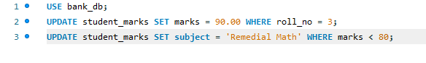
OUTPUT

QUERY-7
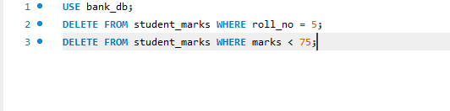
OUTPUT

QUERY-8
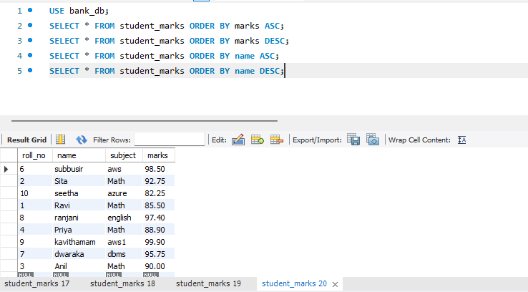
OUTPUT


QUERY-9
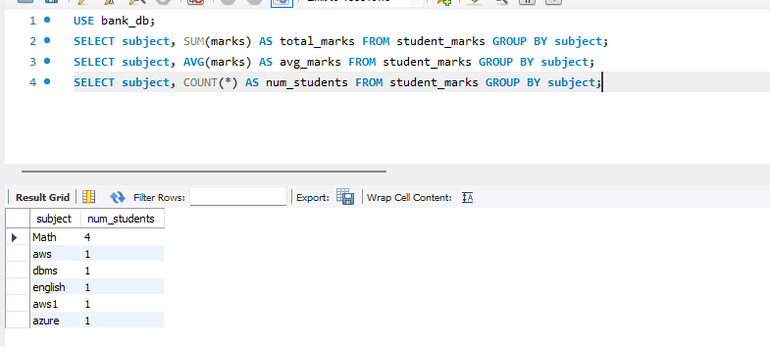
OUTPUT

QUERY-10
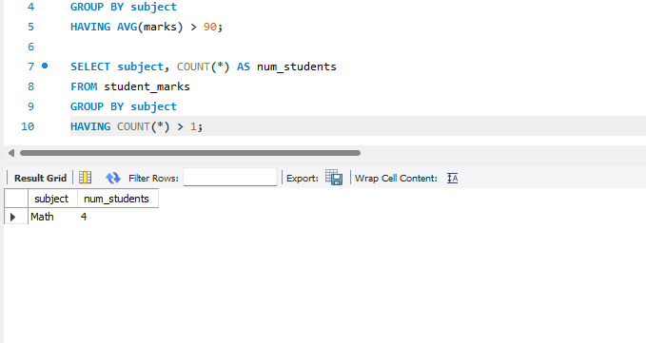
OUTPUT

