A CASE-STUDY BASED REPORT
ON
Farmland Zone Clustering Using K-Means and Agglomerative Hierarchical Clustering for Agricultural Planning
submitted in partial fulfilment of the requirements for the Course
MACHINE LEARNING
BACHELOR OF TECHNOLOGY
in
A.Y.: 2026-27
by
D Moksha Siva Sai Roll No. 2520030515
Musali Reddy Gari Adith Kumar Reddy Roll No. 2520030559
Under the Esteemed guidance of
Mr. Shaik Asif
Asst.Professor, Dept. of CSE




INDEX
Abstract 3
Introduction 3
Background 3
Motivation for the Project 4
Overview of the Work Carried Out 4
Scope and Responsible-Use Statement 4
Problem Statement 5
Case-Study Scenario 5
Central Case-Study Question 5
Formal Problem Definition 5
Objectives that Guide the Study 5
Assumptions and Limitations 6
Dataset and Exploratory Data Analysis 7
About the Dataset 7
Purpose of EDA 7
Preparation Steps Actually Performed 7
EDA Exploration - Implementation 8
Summary of EDA Findings 10
Algorithm Selection and Implementation 11

Conclusion 14

Signature of the Team members

Abstract
Agricultural land differs widely in soil fertility, water availability, rainfall and productivity, yet it is still commonly classified by manual assessment, which is slow, subjective and hard to scale. This case study applies unsupervised machine learning to group farmland parcels into agronomically meaningful zones. A dataset of 500 farm records described by five numerical features (soil quality score, irrigation availability, annual rainfall, crop yield and land area) was cleaned (seven missing values imputed with the column median), explored through descriptive statistics, histograms, box plots and a correlation matrix, and standardised with z-score scaling.
Two algorithms were implemented with scikit-learn: K-Means and Agglomerative Hierarchical Clustering (Ward linkage). The number of clusters was examined with the Elbow Method, Silhouette Score, Davies-Bouldin and Calinski-Harabasz indices; K = 3 was selected because it yields an actionable High / Moderate / Low zoning (silhouette 0.302) and is supported by a visible bend in the inertia curve. K-Means produced zones of 152, 215 and 133 farms. The hierarchical model reproduced the same structure: the two methods agree on 479 of 500 farms (95.8 %, Adjusted Rand Index 0.871). The resulting zones differ sharply in soil quality, irrigation, rainfall and yield and can support targeted irrigation planning, fertiliser distribution, crop recommendation and infrastructure investment.
Keywords: farmland zoning, K-Means, agglomerative hierarchical clustering, elbow method, silhouette score, exploratory data analysis, unsupervised learning.
Introduction
Background
Agriculture remains central to regional economies, and the efficient use of land, water and inputs depends on understanding how farmland parcels differ from one another. Parcels vary in soil quality, irrigation access, rainfall, size and the yield they deliver, and these factors interact. Traditional land classification relies on field surveys and expert judgement, which becomes time-consuming and inconsistent when many parcels have to be compared.
Clustering is an unsupervised learning technique that discovers natural groups in unlabeled data: observations in the same cluster are more similar to one another than to those in other clusters. It has been used widely in agriculture. Reviewed studies include the clustering of 2,778 US farming counties into six production-potential groups using agglomerative hierarchical clustering (Rasool and Abler, 2023, Agriculture), the delineation of soil management zones in olive cultivation using K-Means, hierarchical clustering and DBSCAN (Scientific Reports, 2025), site-specific management zones using spatial PCA with fuzzy K-Means (Geoderma Regional, 2022), and K-Means clustering of rice production data from Tamil Nadu, India (International Journal of Environment and Climate Change, 2022). Together they show that clustering is a recognised way to turn agricultural variability into decision-ready groups.
Motivation for the Project
Most existing work focuses on a specific crop, a single soil property, spatial or remote-sensing data, or very large regions. There is room for a simple and transparent study that uses a handful of commonly understood farm-level indicators and compares two classical clustering families side by side. Such a study is easy to reproduce, easy to explain to non-technical stakeholders, and shows how the choice of algorithm and the choice of the number of clusters affect the result. The practical motivation is that planners need defensible groups of similar farms in order to allocate irrigation, fertiliser and infrastructure budgets where they matter most.
Overview of the Work Carried Out
The work followed a standard machine-learning workflow:
- Data understanding: a CSV file of 500 farms and five numerical features was loaded and inspected for structure, duplicates and missing values.
- Preprocessing: seven missing cells were imputed with column medians and all features were standardised with z-scores.
- Exploratory data analysis: descriptive statistics, histograms, box plots (IQR outlier check) and a correlation heat-map were produced.
- Modelling: K-Means and Agglomerative Hierarchical Clustering (Ward linkage) were implemented; K was studied for 2 to 10 using the Elbow Method, Silhouette Score, Davies-Bouldin and Calinski-Harabasz indices.
- Evaluation and interpretation: the two methods were compared with internal validity indices and the Adjusted Rand Index, visualised using a dendrogram and a PCA projection, and the clusters were profiled and named as farmland zones.
Scope and Responsible-Use Statement
The study is limited to the five numerical features available in the dataset and to two clustering methods. It is a data-analysis case study for academic purposes: the zones describe statistical similarity between farms and are not a substitute for field surveys, soil testing or agronomic advice. Because the data file contains no geographic coordinates, the zones are not spatial maps. Any real-world use, such as allocating subsidies or inputs, should be validated by agronomists and reviewed so that no group of farmers, particularly small holders, is disadvantaged by an automated label. Only anonymous farm identifiers appear in the data, so no personal information is used.
Problem Statement
Case-Study Scenario
A district agriculture department manages hundreds of farm parcels. For each parcel it holds five records: a soil quality score, the percentage of irrigation availability, annual rainfall in millimetres, crop yield in tons and land area in acres. The department has limited funds for irrigation projects, fertiliser distribution and infrastructure. Officers currently classify parcels manually, which is slow and varies from officer to officer. They want an objective, repeatable way to discover which parcels resemble each other so that interventions can be planned per group rather than per parcel.
Central Case-Study Question
Can K-Means and Agglomerative Hierarchical Clustering, applied to standardised soil, water, rainfall, yield and land-area data, reliably identify distinct farmland zones, and how many well-separated zones does the data support?
Sub-questions: (i) Which number of clusters is best supported by the Elbow Method and Silhouette Score? (ii) Do the two algorithms discover the same groups? (iii) What agricultural profile characterises each zone and how can it guide planning?
Formal Problem Definition
Let X = {x₁, x₂, …, xₙ} be a set of n = 500 farms where each xᵢ ∈ ℝ⁵ holds the five features. After standardisation, z = (x − μ) / σ, the task is to partition X into K disjoint clusters C₁, …, Cₖ without using labels. For K-Means the partition minimises the within-cluster sum of squares:
J = Σₖ Σₓ∈Cₖ || x − μₖ ||²
where μₖ is the centroid of cluster Cₖ. For agglomerative clustering, a hierarchy of nested partitions is built by repeatedly merging the two clusters whose union gives the smallest increase in within-cluster variance (Ward linkage), and a partition with K clusters is obtained by cutting the dendrogram. The quality of the partitions is judged with internal validity measures and by the agreement between the two methods.
Objectives that Guide the Study
- To explore and prepare the farmland dataset (quality check, missing values, scaling).
- To understand feature distributions, outliers and relationships through exploratory data analysis.
- To implement K-Means and Agglomerative Hierarchical Clustering using scikit-learn and SciPy.
- To select a suitable number of clusters with the Elbow Method and Silhouette Score (supported by Davies-Bouldin and Calinski-Harabasz indices).
- To compare the two algorithms and measure how closely their results agree.
- To interpret the clusters as farmland zones and relate them to irrigation planning, fertiliser distribution, crop recommendation and infrastructure development.
Assumptions and Limitations
- The five features are assumed to be sufficient to describe farm similarity; other factors (soil type, crop type, slope, location, input costs) are not available.
- Euclidean distance on standardised features is assumed to be a meaningful measure of similarity, and all features are given equal weight.
- Missing values are assumed to be missing at random and are replaced by medians; the number of missing cells is very small (0.28 %).
- The dataset appears to be synthetic or simplified. The features are moderately correlated and clusters overlap, so zones are gradual rather than sharply separated (silhouette around 0.30).
- K-Means depends on random initialisation (controlled here with random_state = 42 and n_init = 10) and assumes roughly spherical clusters; Ward linkage is sensitive to noise and has O(n²) memory cost.
- Cluster labels have no ground truth; evaluation is internal only, so the zone names are interpretations rather than verified categories.
Dataset and Exploratory Data Analysis
About the Dataset
The dataset (farmland_zone_clustering_dataset.csv) contains 500 farm records and six columns: a unique identifier (Farm_ID, F0001 to F0500) and five numerical features. There are no duplicate rows and every identifier is unique. Farm_ID is used only for reference and is excluded from clustering.
Feature | Column name | Unit | Meaning
Soil Quality Score | Soil_Quality_Score | score (0-100) | Fertility and quality of the soil
Irrigation Availability | Irrigation_Availability_Percent | % | Access to irrigation / water supply
Annual Rainfall | Annual_Rainfall_mm | mm | Rainfall received per year
Crop Yield | Crop_Yield_Tons | tons | Agricultural production of the farm
Land Area | Land_Area_Acres | acres | Size of the farm

Table 1: Features in the farmland dataset
Purpose of EDA
Exploratory Data Analysis is carried out before any model is fitted. Its purpose here is to (a) check data quality such as missing values and duplicates, (b) understand the range, spread and shape of each feature, (c) detect unusual values that could distort distance-based clustering, (d) discover relationships between features, and (e) justify the preprocessing steps, in particular standardisation. K-Means and hierarchical clustering are distance-based, so the quality of the input data directly determines the quality of the zones.
Preparation Steps Actually Performed
Step | What was done | Result
1. Load data | Read the CSV with pandas; separated Farm_ID from the five features | 500 rows x 6 columns
2. Quality check | Counted nulls per column and checked duplicate rows / IDs | 7 missing cells; 0 duplicates
3. Missing values | Median imputation (Soil 66.1, Irrigation 63.1, Rainfall 727, Yield 3.37, Area 5.04) | No missing values remain
4. Outlier check | IQR rule (1.5 x IQR) on every feature | Only 1 flagged value (Land Area); retained
5. Range check | Looked at values at natural limits | 3 farms with soil score 100 and 4 with irrigation 100 %; valid, retained
6. Scaling | StandardScaler: z = (x - mean) / std | All features: mean 0, std 1

Table 2: Data preparation pipeline
The missing values were distributed as follows: Soil Quality Score 2, Irrigation Availability 1, Annual Rainfall 2, Crop Yield 1 and Land Area 1. Median imputation was chosen because it is robust to extreme values and keeps all 500 farms in the analysis. Standardisation is essential because rainfall is measured in hundreds of millimetres while land area is a few acres; without scaling, rainfall would dominate every distance calculation.
EDA Exploration - Implementation
Descriptive statistics
Feature | Mean | Std. Dev. | Min | Median | Max | Skewness
Soil Quality Score | 64.28 | 17.61 | 16.20 | 66.10 | 100.00 | -0.30
Irrigation Availability (%) | 62.00 | 20.80 | 5.60 | 63.10 | 100.00 | -0.19
Annual Rainfall (mm) | 729.43 | 188.25 | 250.00 | 727.00 | 1213.00 | -0.01
Crop Yield (tons) | 3.40 | 1.20 | 0.72 | 3.37 | 6.63 | 0.09
Land Area (acres) | 5.01 | 1.98 | 0.50 | 5.04 | 10.82 | 0.04

Table 3: Descriptive statistics (after imputation, n = 500)
All five features are close to symmetric (absolute skewness at most 0.30), which suggests roughly bell-shaped distributions. Rainfall varies most in absolute terms (std. 188 mm), and the different units and spreads confirm that scaling is needed.
Feature distributions
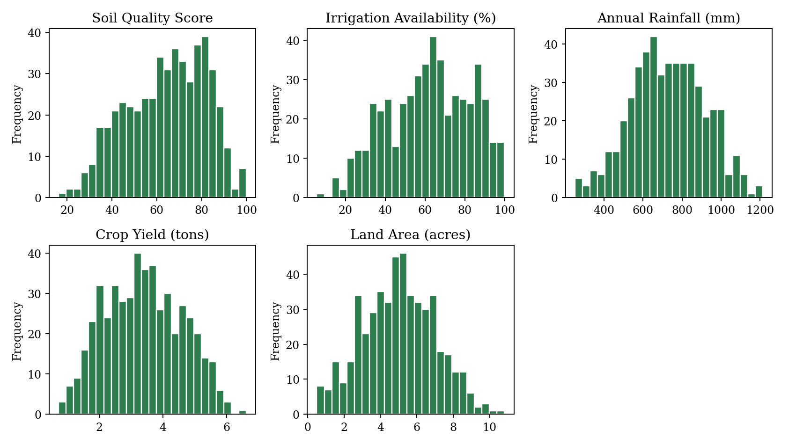
Figure 1: Histograms of the farmland features
The histograms show single-peaked, fairly symmetric distributions. Soil quality and irrigation availability are slightly left-skewed and are bounded at 100, which explains the small piles of values at the upper limit.
Outlier and spread analysis
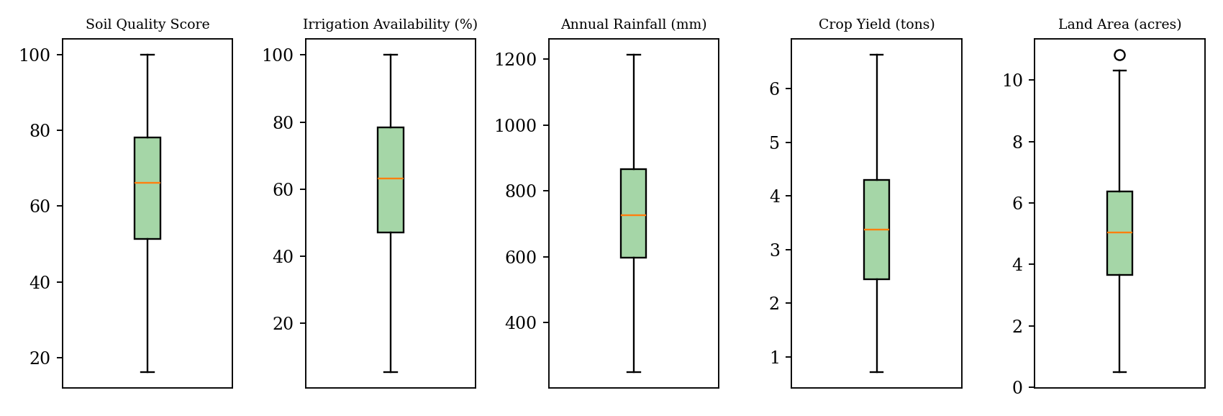
Figure 2: Box plots of the farmland features
The box plots show medians near the centre of each box and whiskers of similar length on both sides. Using the 1.5 x IQR rule, only one Land Area value is flagged as an outlier and none for the other four features, so the data are free of extreme values and no rows were removed.
Correlation analysis
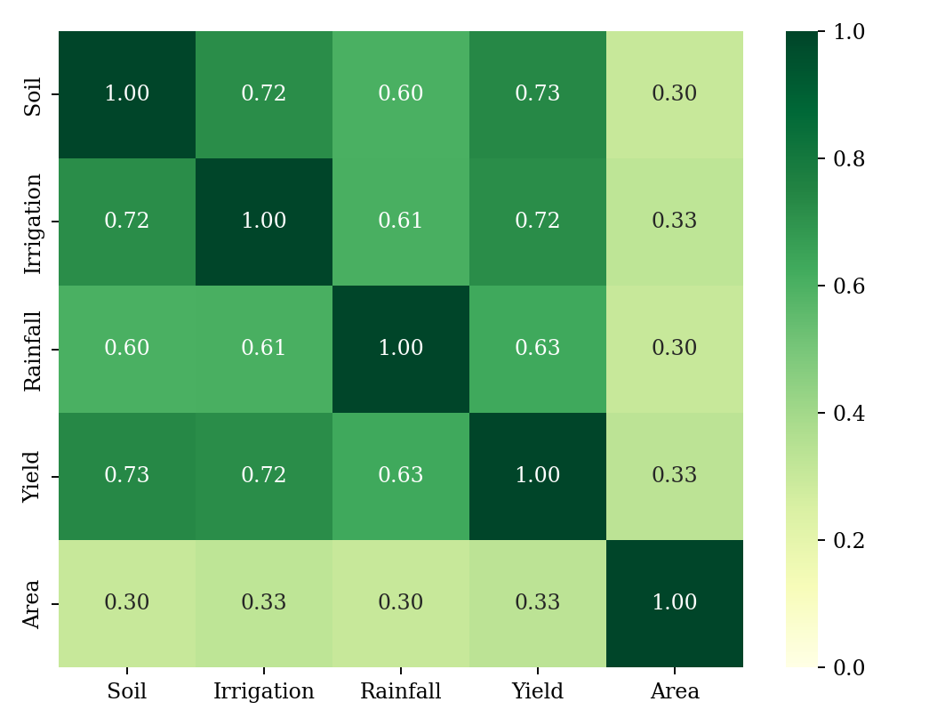
Figure 3: Correlation matrix of the features
Soil quality, irrigation availability, rainfall and crop yield are strongly and positively related. The highest correlations are Soil Quality-Crop Yield (0.73), Soil Quality-Irrigation (0.72) and Irrigation-Crop Yield (0.72), followed by Rainfall-Crop Yield (0.63). Land Area has only weak correlation (0.30 to 0.33) with all others. This pattern is what makes clustering meaningful: farms with good soil also tend to have better irrigation, more rainfall and higher yield, so they form recognisable groups. Because correlation does not prove causation, these relations are descriptive only.
Summary of EDA Findings
- The dataset has 500 farms and five numerical features; there are no duplicates and only 7 missing cells (0.28 %), which were median-imputed.
- The features have very different units and ranges, so standardisation is required before distance-based clustering.
- Distributions are approximately symmetric and there are practically no outliers (one Land Area value), so no records were dropped.
- Soil quality, irrigation, rainfall and yield are strongly positively correlated (r = 0.60 to 0.73), indicating natural groups of high-, medium- and low-potential farms.
- Land area is only weakly related to the other features and adds a separate dimension of variation.
Algorithm Selection and Implementation
Why these algorithms
The task is unsupervised and the features are numerical and standardised, so distance-based clustering is appropriate. K-Means was selected because it is fast, scalable and easy to interpret through its centroids; each centroid is the average profile of a zone. Agglomerative Hierarchical Clustering was selected to complement it: it does not need K in advance, produces a dendrogram that shows how farms and groups merge at different levels, and uses a different clustering principle, which allows the K-Means result to be cross-checked. Ward linkage was used because it merges the clusters that least increase the within-cluster variance, which matches the K-Means objective and works well on standardised numerical data. Density-based methods such as DBSCAN were not used because the data show no extreme outliers and no clear low-density gaps.
Implementation
The models were implemented in Python with pandas, scikit-learn, SciPy, Matplotlib and Seaborn. The core code is shown below.
import pandas as pd
from sklearn.preprocessing import StandardScaler
from sklearn.cluster import KMeans, AgglomerativeClustering
from sklearn.metrics import silhouette_score
from scipy.cluster.hierarchy import linkage, dendrogram

df = pd.read_csv('farmland_zone_clustering_dataset.csv')
features = df.columns[1:] # drop Farm_ID
df[features] = df[features].fillna(df[features].median())
X = StandardScaler().fit_transform(df[features])

# choose K
for k in range(2, 11):
km = KMeans(n_clusters=k, n_init=10, random_state=42).fit(X)
print(k, km.inertia_, silhouette_score(X, km.labels_))

# final models (K = 3)
kmeans = KMeans(n_clusters=3, n_init=10, random_state=42).fit(X)
agglo = AgglomerativeClustering(n_clusters=3, linkage='ward').fit(X)
Z = linkage(X, method='ward'); dendrogram(Z, truncate_mode='lastp', p=30)

Choosing the number of clusters
K | Inertia (WCSS) | Silhouette | Davies-Bouldin | Calinski-Harabasz
2 | 1421.0 | 0.337 | 1.099 | 378.1
3 | 1055.6 | 0.302 | 1.213 | 340.0
4 | 924.3 | 0.269 | 1.353 | 281.8
5 | 845.0 | 0.234 | 1.444 | 242.4
6 | 769.5 | 0.211 | 1.518 | 222.2
7 | 723.5 | 0.198 | 1.561 | 201.8
8 | 693.3 | 0.190 | 1.605 | 183.2
9 | 659.7 | 0.183 | 1.617 | 171.2
10 | 632.0 | 0.170 | 1.662 | 160.9

Table 4: Cluster-validity measures for K-Means, K = 2 to 10
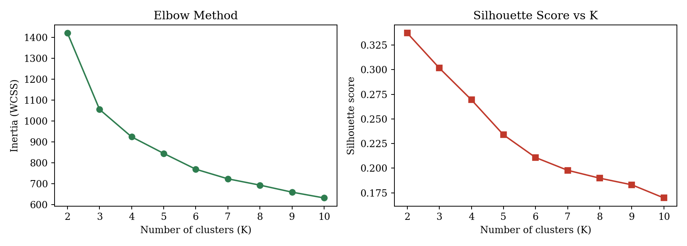
Figure 4: Elbow Method (left) and Silhouette Score (right)
Inertia falls steeply from K = 2 to K = 3 (1421 to 1056, a drop of about 26 %) and then more slowly (a further 12 % to K = 4 and smaller gains afterwards), so the curve bends around K = 3 although the elbow is not sharp. The silhouette score is highest at K = 2 (0.337) and decreases steadily; at K = 3 it is 0.302, still a reasonable value for overlapping, continuous agricultural data. K = 2 only separates "better" and "worse" farms, which is too coarse for planning, whereas K = 3 gives High, Moderate and Low zones that map to distinct interventions. K = 3 was therefore selected as a trade-off between statistical separation (silhouette, Davies-Bouldin, Calinski-Harabasz) and practical usefulness. Beyond K = 4 the silhouette drops below 0.24 and clusters become hard to distinguish.
Results: K-Means zones
Zone | Farms | Soil quality | Irrigation (%) | Rainfall (mm) | Yield (tons) | Area (acres)
Zone A - High potential | 152 | 81.6 | 83.9 | 915 | 4.73 | 6.16
Zone B - Moderate | 215 | 65.9 | 61.8 | 713 | 3.28 | 4.77
Zone C - Low potential | 133 | 41.9 | 37.3 | 544 | 2.05 | 4.10

Table 5: Average profile (centroid in original units) of each K-Means zone
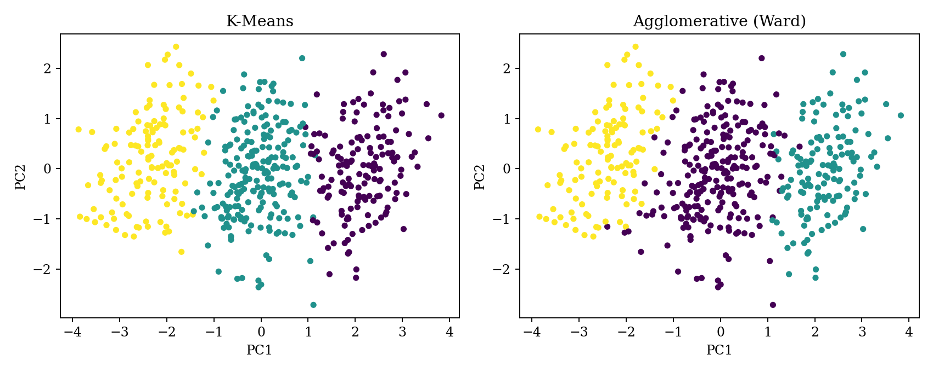
Figure 5: Clusters projected on the first two principal components (PC1 63.9 %, PC2 16.4 % of variance)
The three zones are ordered along the main axis of variation (PC1): farms in Zone A have good soil, high irrigation and rainfall, and about twice the yield of Zone C. Zone C farms have poor soil (about 42), limited irrigation (about 37 %), low rainfall (about 544 mm) and low yield (about 2.05 tons). Zone B lies between the two. The groups touch at their boundaries, which is consistent with the continuous nature of the data.
Results: Agglomerative Hierarchical Clustering
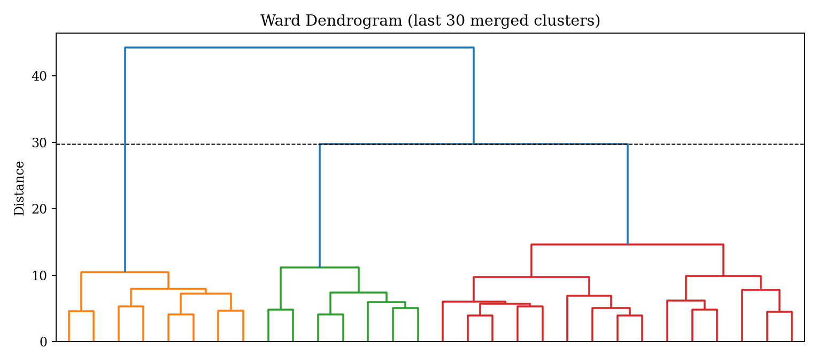
Figure 6: Ward dendrogram (last 30 merges shown); the dashed line cuts the tree into three clusters
The dendrogram shows that the final merges occur at much larger distances than the earlier ones; cutting the tree just below the top two merges gives three clusters. The cophenetic correlation of 0.62 indicates a moderate fit between the tree distances and the original pairwise distances.
Comparison of the two algorithms
Measure | K-Means (K = 3) | Agglomerative, Ward (K = 3)
Silhouette Score (higher is better) | 0.302 | 0.296
Davies-Bouldin Index (lower is better) | 1.213 | 1.188
Calinski-Harabasz Index (higher is better) | 340.0 | 326.9
Agreement between methods | ARI = 0.871 | 479 of 500 farms (95.8 %)

Table 6: Comparison of K-Means and Agglomerative clustering
The two algorithms give almost identical quality scores and assign 479 of 500 farms to the same group (after matching labels); only 21 farms near zone boundaries differ. This agreement, with an Adjusted Rand Index of 0.871, shows that the zones are a stable property of the data and not an artefact of one algorithm. K-Means is slightly better on the silhouette and Calinski-Harabasz measures and is much cheaper to run, so it is preferable for large datasets; the hierarchical method is slightly better on Davies-Bouldin and offers the dendrogram, which is useful for exploring zones at several levels of detail.
Interpretation and agricultural use of the zones
Zone | Profile | Suggested planning action
A - High potential (152 farms) | Best soil, high irrigation and rainfall, highest yield, largest farms | Protect productivity; promote high-value crops; maintain irrigation and storage infrastructure
B - Moderate (215 farms) | Average values on all features | Targeted fertiliser and water-management advice; the group with the largest scope for yield gain
C - Low potential (133 farms) | Weakest soil, limited irrigation, low rainfall, lowest yield | Prioritise irrigation development and soil improvement; drought-tolerant crop recommendations

Table 7: Farmland zones and their planning implications
Conclusion
This case study showed that unsupervised clustering can turn raw farm-level data into clear, usable farmland zones. After cleaning, exploratory analysis and standardisation of 500 farm records, K-Means and Agglomerative Hierarchical Clustering both identified three zones: a high-potential zone (152 farms), a moderate zone (215 farms) and a low-potential zone (133 farms). The zones differ markedly in soil quality, irrigation, rainfall and yield, and the two algorithms agree on 95.8 % of farms (ARI 0.871), which gives confidence in the result.
The EDA revealed strong positive relationships among soil quality, irrigation, rainfall and yield, and confirmed that scaling is required. The Elbow Method and Silhouette Score show that the structure is continuous rather than sharply separated: the silhouette is highest for K = 2 (0.337), but K = 3 (0.302) was chosen because it gives a practical three-level classification. The main limitations are the small number of features, the lack of location data and the absence of ground-truth labels. Future work could add spatial coordinates, soil type and crop information, test other methods such as Gaussian Mixture Models or DBSCAN, and validate the zones with agronomists. Overall, the study meets its objectives and shows how data-driven zoning can support irrigation planning, fertiliser distribution, crop recommendation and infrastructure development.

