Exploratory Data Analysis (EDA)
Farmland Zone Clustering
  - K-Means and Agglomerative Hierarchical Clustering

1. Introduction
Exploratory Data Analysis (EDA) is the process of examining a dataset before applying machine learning. In this project, EDA is used to understand the farmland data, check data quality, study feature distributions, identify possible outliers, and examine relationships between variables.

2. Dataset Overview
The working dataset contains 120 farmland records and five numerical features:
Feature | Meaning
Soil Quality Score | Represents soil fertility/quality.
Irrigation Availability (%) | Represents access to irrigation or water supply.
Annual Rainfall (mm) | Represents annual rainfall received.
Crop Yield (tons) | Represents agricultural production.
Land Area (acres) | Represents farmland size.

3. Data Quality Check
The working dataset contains no missing values. Missing-value checks are important because incomplete records can affect clustering results.
All five variables are numerical, so they can be prepared for distance-based clustering after standardization.

4. Descriptive Statistics
Feature | Mean | Std. Dev. | Min | Median | Max
Soil Quality Score | 67.28 | 9.42 | 44.59 | 67.60 | 93.70
Irrigation Availability (%) | 63.88 | 19.11 | 22.05 | 62.05 | 100.00
Annual Rainfall (mm) | 914.38 | 224.65 | 350.00 | 924.71 | 1500.00
Crop Yield (tons) | 6.18 | 1.52 | 2.70 | 6.25 | 10.10
Land Area (acres) | 24.23 | 9.88 | 5.00 | 24.22 | 49.20

5. Feature Distribution Analysis
Histograms show how frequently values occur. They help us understand the typical range and spread of each agricultural feature.
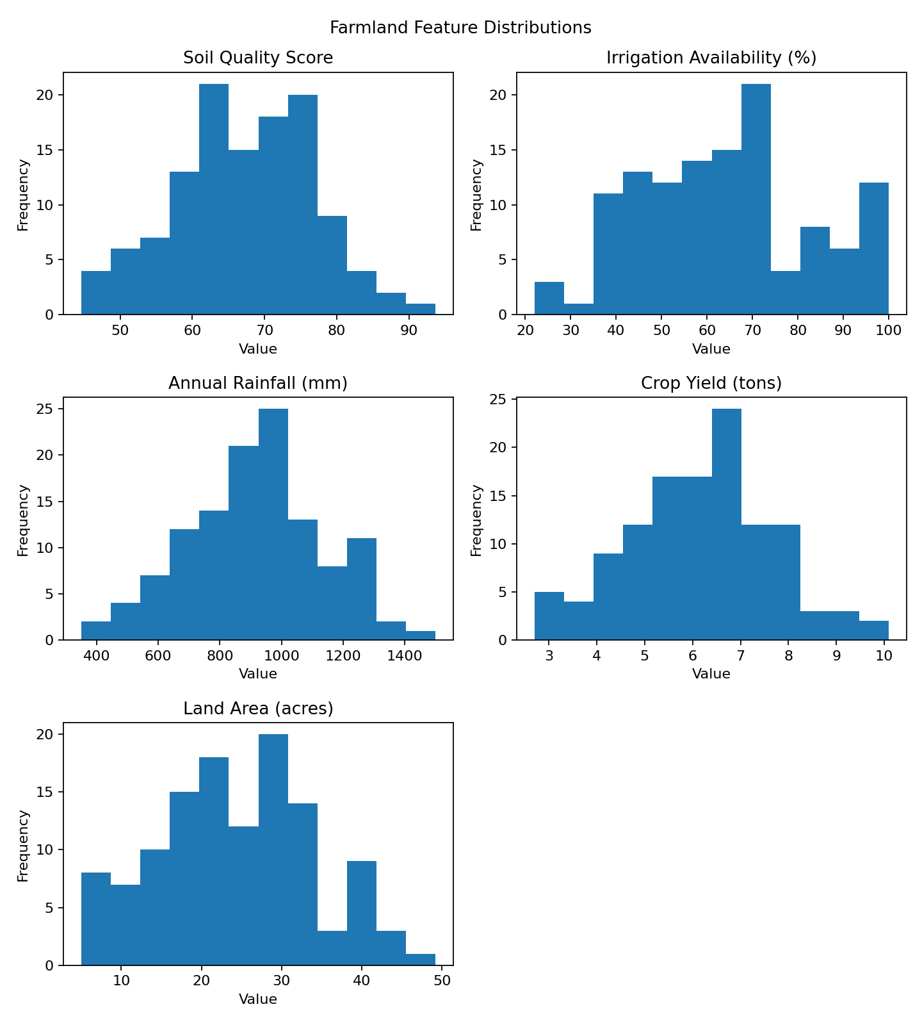

6. Outlier and Spread Analysis
Box plots show the median, spread and possible outliers. Outliers are unusually distant observations and are important because distance-based clustering can be influenced by extreme values.
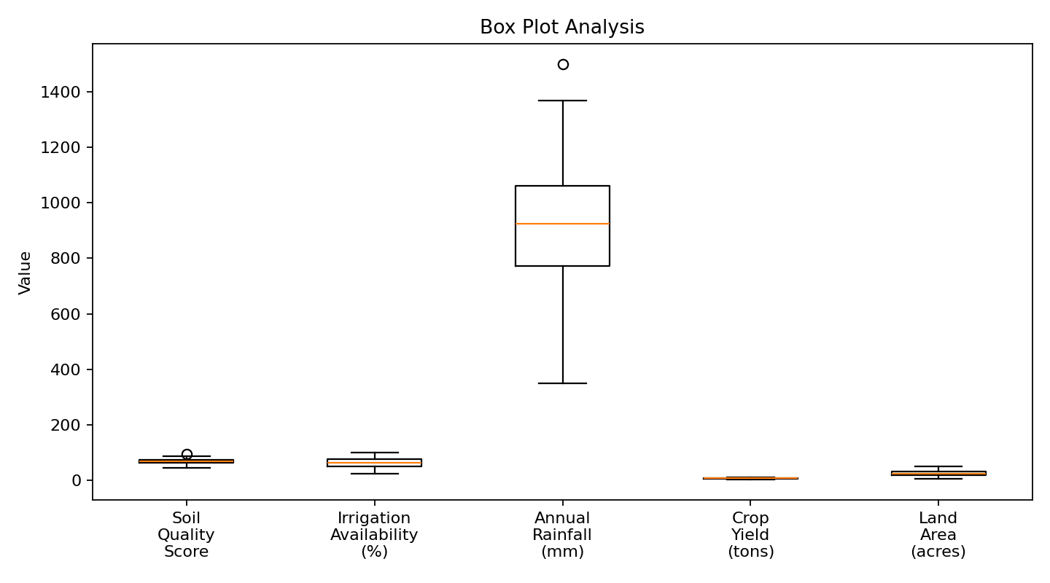

7. Correlation Analysis
The correlation matrix shows the strength and direction of relationships between numerical features. A positive value indicates that two variables tend to increase together; a negative value indicates an inverse relationship. Correlation does not prove causation.
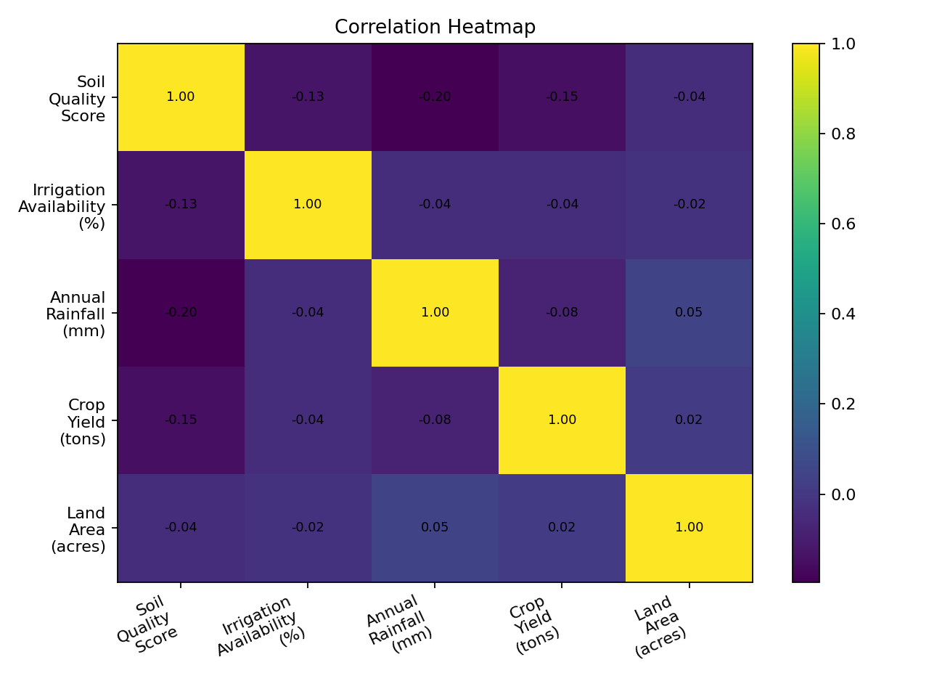
In this working dataset, the strongest absolute pairwise correlation is between Soil Quality Score and Annual Rainfall (mm) (approximately -0.20).

8. Why Standardization is Required
The features use different units and scales. Rainfall is measured in millimetres, land area in acres, and soil quality is a score. Since K-Means and hierarchical clustering rely on distances, standardization prevents a large-scale variable from dominating the distance calculation.
z = (x − μ) / σ
StandardScaler applies this transformation so the features are on a comparable standardized scale before clustering.

9. EDA Findings
- The dataset contains five agricultural features relevant to farmland similarity.
- The working dataset has no missing values.
- The features have different numerical ranges and units.
- Box plots help identify the spread and possible outliers.
- The correlation matrix helps understand relationships among the agricultural variables.
- Standardization is required before distance-based clustering.

10. Connection to the Clustering Stage
EDA is the analysis and preparation stage before clustering. After EDA, the cleaned and standardized feature matrix is supplied to K-Means and Agglomerative Hierarchical Clustering. K is then evaluated using the Elbow Method and Silhouette Score, and the resulting farmland clusters are visualized and interpreted.

11. Short Viva Explanation
“First, we performed EDA to understand our farmland dataset. We checked the features, missing values, distributions, outliers and correlations. We found that the features have different scales, so we standardized them before clustering. This prepared the dataset for K-Means and Agglomerative Hierarchical Clustering.”

