**Jenkins**

Prerequisite:

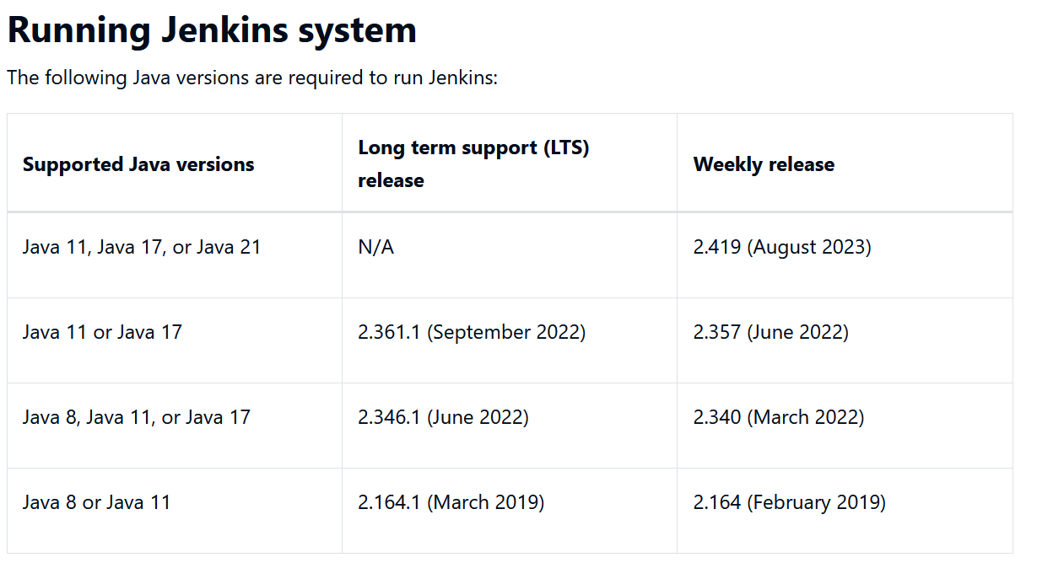

**In Windows OS**

To download Java17

---------------------------------------------------------

https://www.oracle.com/java/technologies/downloads/#jdk17-windows

To download Jenkins

-------------------------------------------------------------------

<https://www.jenkins.io/download/#downloading-jenkins>

**Installing Jenkins in RedHat in AWS**

Reference Links:

<https://www.jenkins.io/doc/book/installing/linux/#red-hat-centos>

Steps to create RedHat Instance in AWS:

1. Go to EC2 service in AWS account 🡪Click on Instances
2. Click on Launch instance
3. Fill/Select instance details as follows
   1. Enter name as “Jenkin_Server”

* 1. Select RedHat from available OS images



* 1. Select keyvalue pair -> click on create new key pair

* 1. The following window will be generated. Enter any name like “jenkinkey” in text box and click create new key pair of type RSA in **.pem** file format.

A file will be downloaded as below.



* 1. Once instance comes to the running status.
     1. Click on instance id and then security

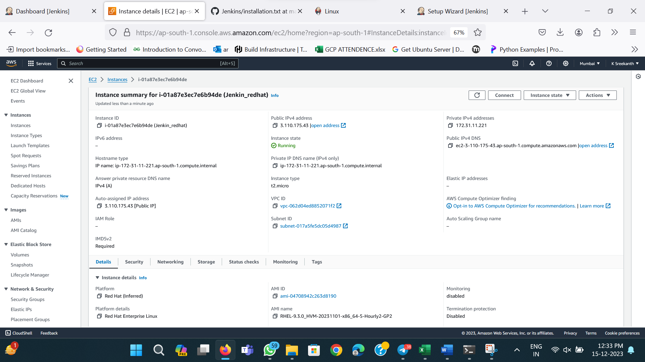



* 1. Set inbound rules under security. Add custom TCp with Port no 8080

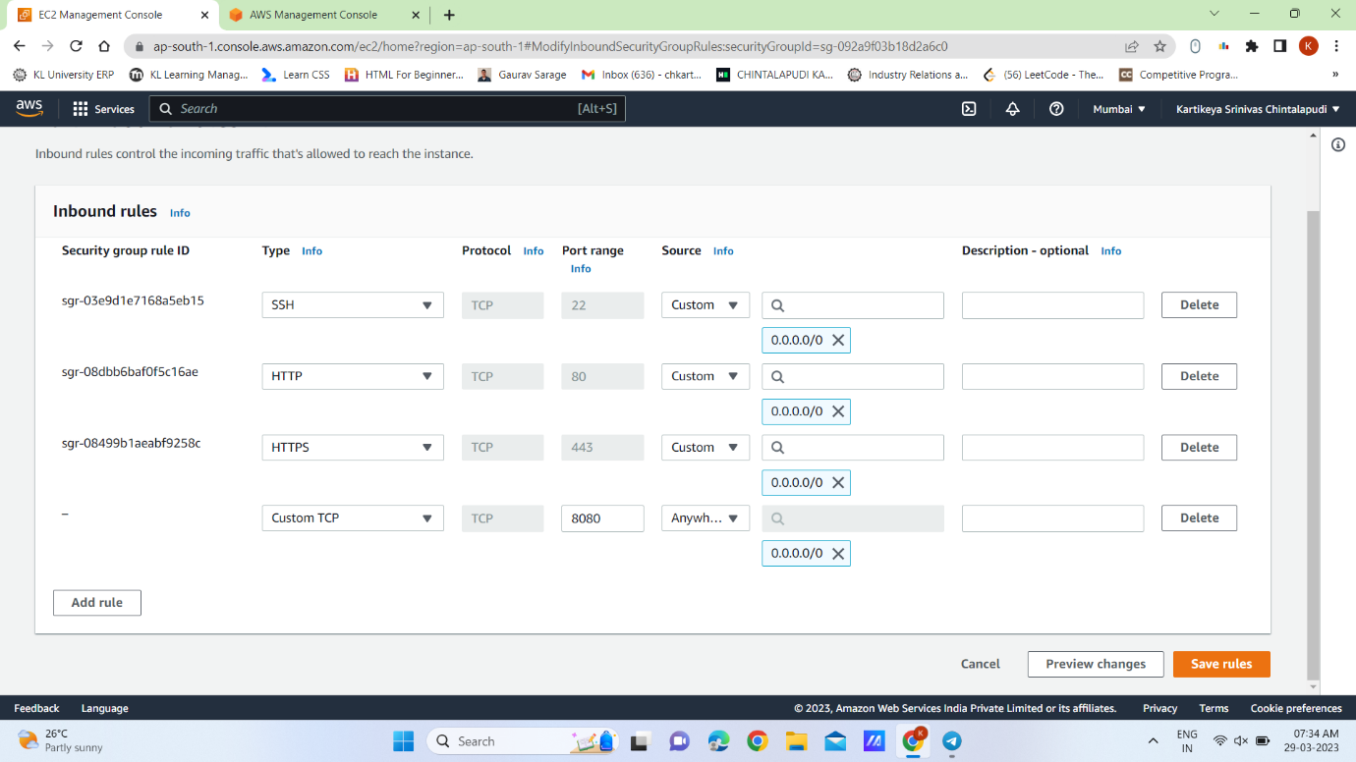



1. Connect EC2 from Powershell

Click on connect instance

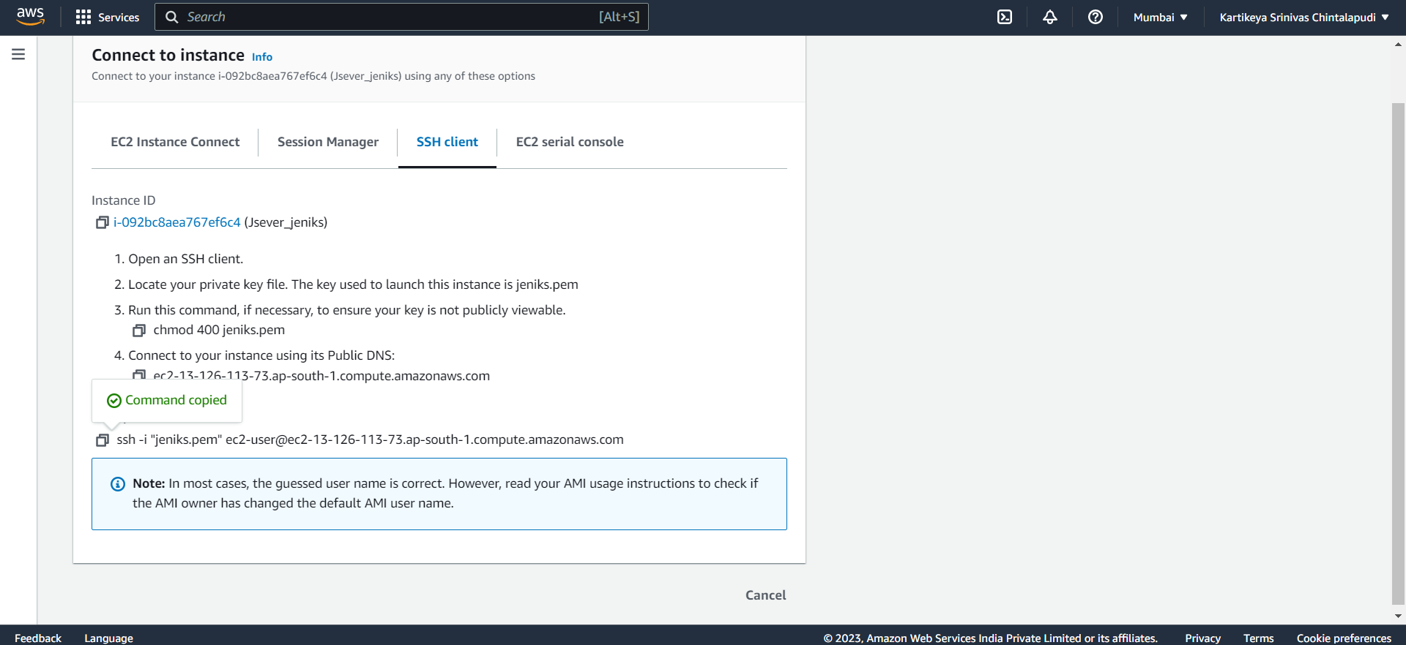



Open powershell

Copy the highlighted command and update **.pem** key file name with your downloaded file path as follows

**ssh -i "C:\Users\anjana\Downloads\jenkinkey.pem"** **ec2-user@ec2-3-110-175-43.ap-south-1.compute.amazonaws.com**

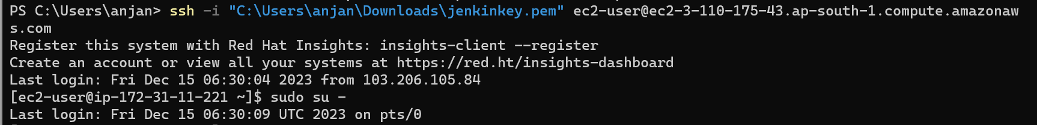

**Run the following commands.**

1. Sudo su –
2. yum install wget -y
3. wget -O /etc/yum.repos.d/jenkins.repo \

<https://pkg.jenkins.io/redhat-stable/jenkins.repo>

1. rpm --import https://pkg.jenkins.io/redhat-stable/jenkins.io-2023.key
2. yum upgrade
3. yum install fontconfig java-17-openjdk
4. sudo yum install jenkins
5. sudo systemctl daemon-reload
6. systemctl enable Jenkins
7. systemctl start jenkins
8. systemctl status Jenkins

Run Jenkins with following **url** from browser: http://<public-ip>:8080

sudo cat /var/lib/jenkins/secrets/initialAdminPassword

Then copy the password and paste in admintrator

Then select install suggested plugins

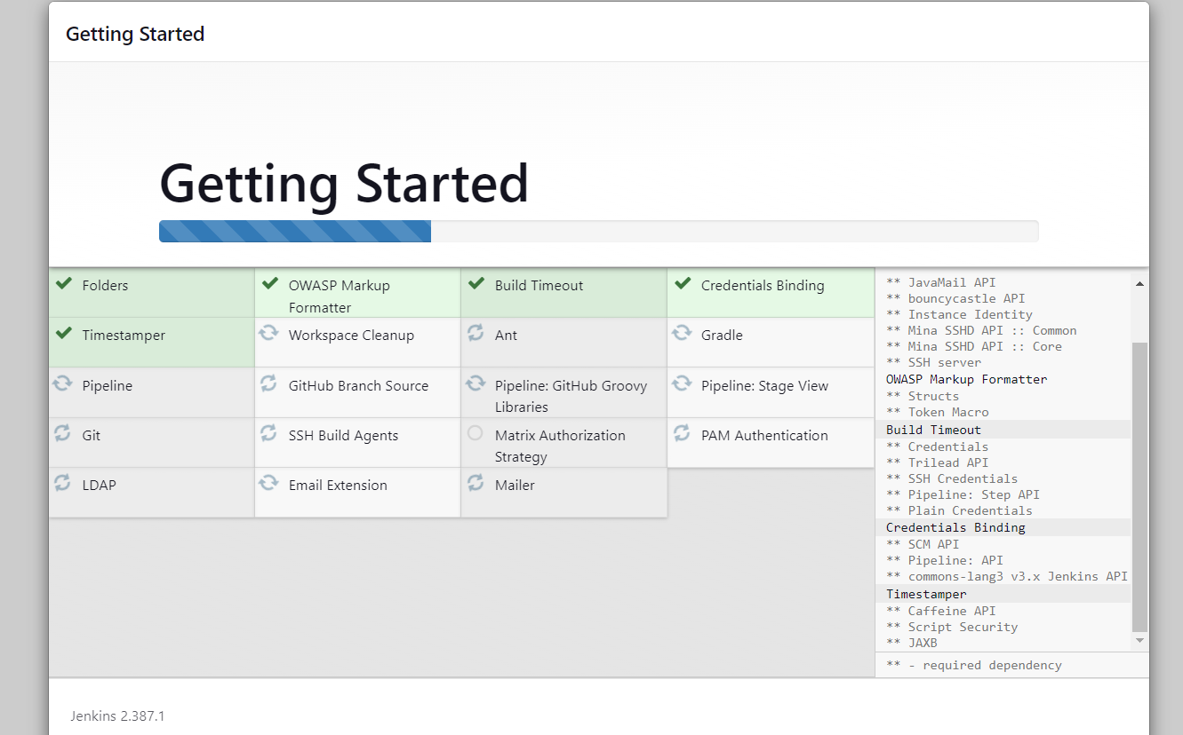

**To integrate git with Jenkins**

**Install git on Jenkins Server using following command**

yum install git

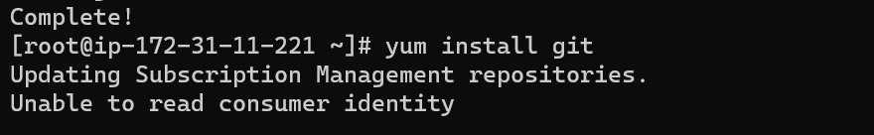

Follow steps as given in the below webpage

https://www.blazemeter.com/blog/how-to-integrate-your-github-repository-to-your-jenkins-project