3,4 Explore Docker Hub for images that will run a website and get them into your development environment and practice.
Step 1: Visit the Docker Hub website
- Go to the Docker Hub website at https://hub.docker.com/.
Step 2: Search for website-related images
- In the search bar, enter keywords related to the website technology or framework you want to use. For example, if you want to run a website using Node.js, search for "node" or "node.js".
Step 3: Create a docker file in the location of the website you want to an create image
- inside the docker file give the configuration according to your requirements
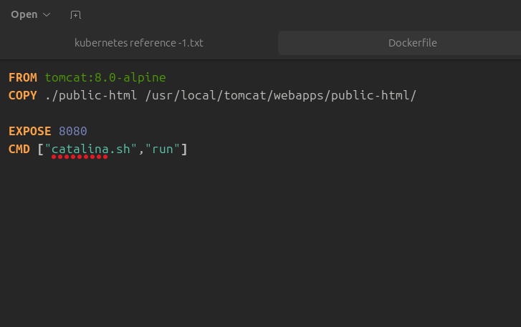
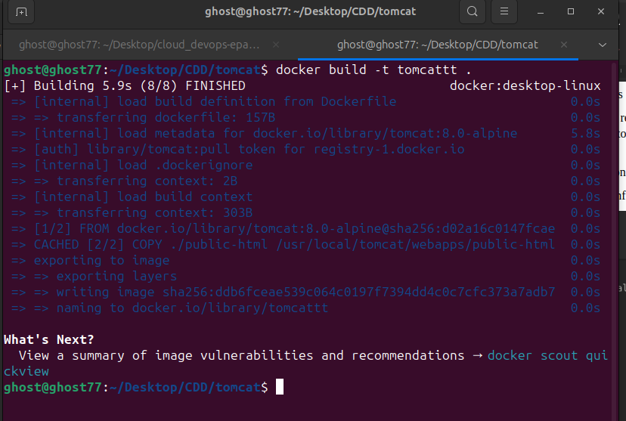
Step 4: Build the Project uisng Docker Build
ex:docker build -t Tomcat_website

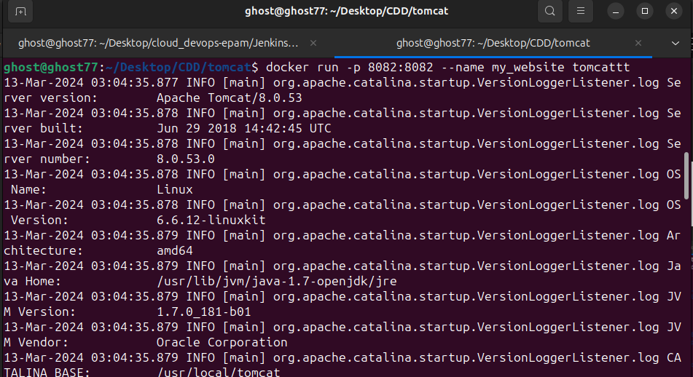
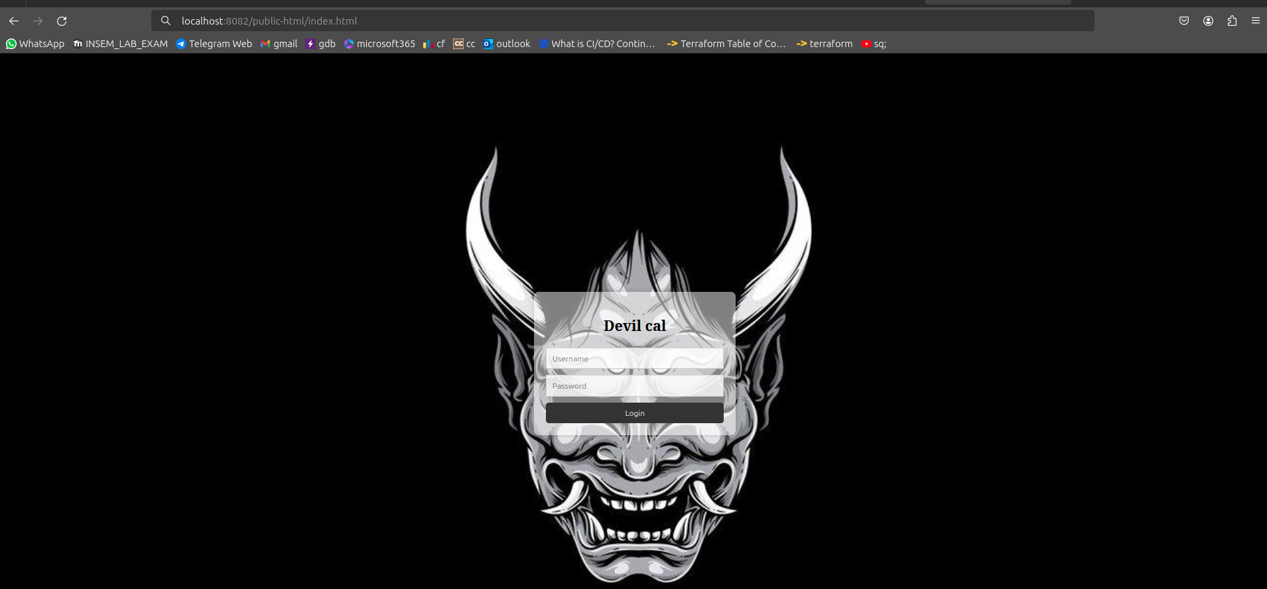
Step 5: Run the container from the image
ex: docker run -p 8082:8082 - -name my_website tomcattt
Result in port 8082:

