10. Continuous Integration with Jenkins
To build a pipeline with Jenkins that runs a Java file from GitHub, you can follow these steps:
- Set up Jenkins:
  - Install Jenkins on your server or machine by following the official installation guide.
  - Set up any necessary configurations and plugins required for your project.
- Create a new Jenkins Pipeline:
  - In Jenkins, create a new Pipeline project.
  - Configure the pipeline to connect to your version control system (GitHub) and specify the repository URL.
- Define the Jenkinsfile:
  - In the root directory of your GitHub repository, create a file named Jenkinsfile. This file defines the steps of your Jenkins pipeline using Groovy syntax.
  - Open the Jenkinsfile in a text editor and define the stages and steps for your pipeline.
- Define Stages and Steps:
  - Inside the Jenkinsfile, define the stages and steps required for your pipeline. For example:
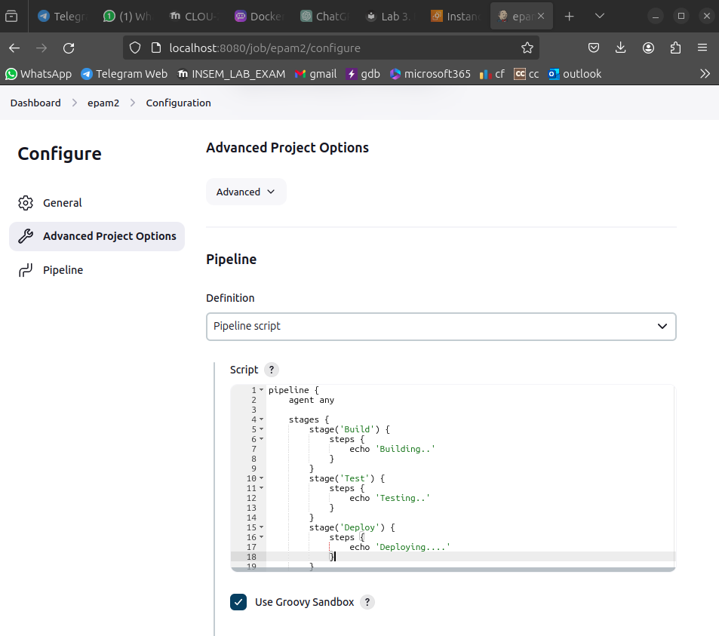
In this example, the pipeline has three stages: Checkout, Build, and Test. The Checkout stage checks out the source code from the GitHub repository. The Build stage compiles the Java file using the javac command. The Test stage runs the compiled Java file using the java command.
- Save and commit the Jenkinsfile to your GitHub repository.
- Run the Jenkins Pipeline:
  - Go back to Jenkins and trigger the pipeline either manually or by setting up a webhook to automatically trigger the pipeline upon code changes in the GitHub repository.
  - Jenkins will run the pipeline, cloning the repository, compiling the Java file, and running it.
Note: Make sure you have the necessary build tools and Java environment configured on the Jenkins server. Adjust the pipeline steps and commands as per your project requirements.
