5. Push and Pull your own image with pre-installations to/from repository
To push and pull your own Docker image with pre-installations to and from a repository, follow these steps:
- Create a Dockerfile: Start by creating a Dockerfile that describes the configuration of your Docker image. This file specifies the base image, any additional configurations or dependencies, and the commands needed to set up your application. You can use a text editor to create a file named "Dockerfile" (with no file extension) in your project directory.
- Build the Docker image: Open a terminal or command prompt and navigate to the directory containing your Dockerfile. Use the docker build command to build the Docker image.
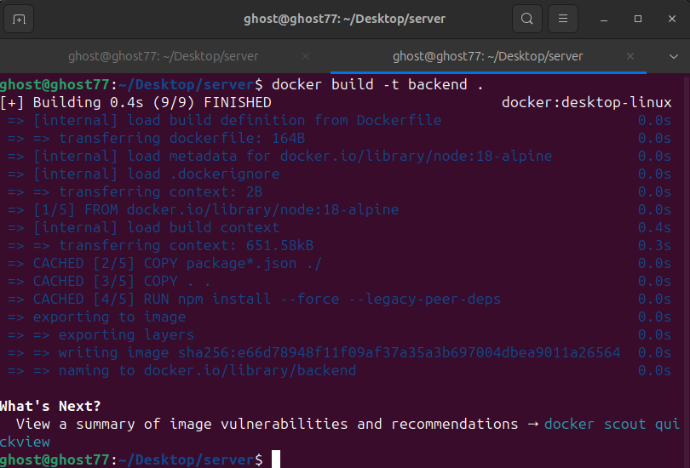
- Tag the image: After successfully building the image, you need to tag it with a repository name. Use the docker tag command to assign a repository name to your image. The command syntax is as follows:
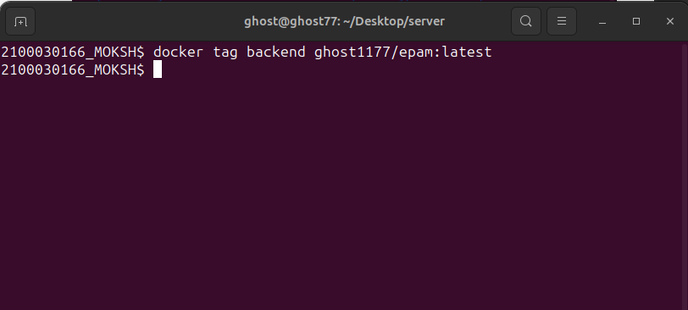
- Authenticate Docker: Before pushing the image to Docker Hub, you need to authenticate Docker to your Docker Hub account. Use the docker login command and provide your Docker Hub credentials when prompted:
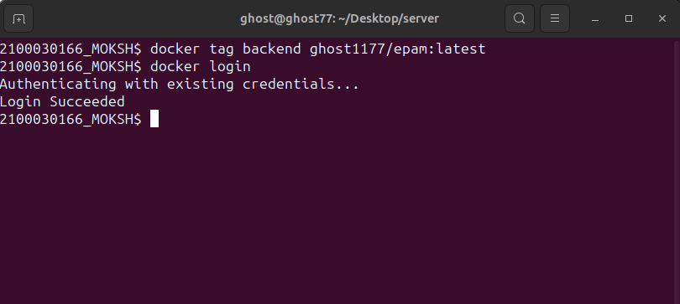

- Push the image: Once authenticated, you can push the tagged image to your Docker Hub repository using the docker push command. The command syntax is as follows:
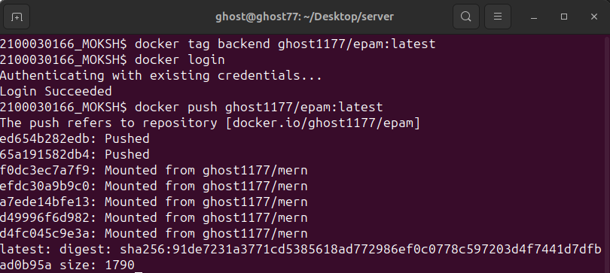
- Pull the image: To pull the image from the repository, use the docker pull command followed by the repository name and tag. The command syntax is as follows:
