6. Create a Docker Container Network

To create a Docker container network, you can use the Docker CLI or Docker Compose. I'll provide instructions for creating a bridge network using the Docker CLI:
- Open a terminal or command prompt.
- Run the following command to create a Docker bridge network:
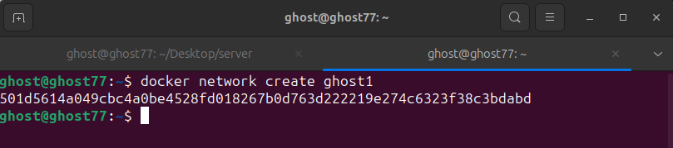
Replace your-network-name with the desired name for your network. For example, you can use a name like my-network.
By default, the bridge network driver is used, which allows containers to communicate with each other on the same host.
- Verify that the network has been created by running the following command:
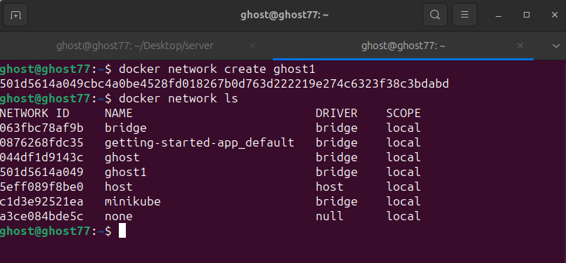
This command lists all the Docker networks on your system.
You should see your newly created network in the list along with its name, ID, and other details.

To use this network when running Docker containers, specify the network name with the --network option. For example:
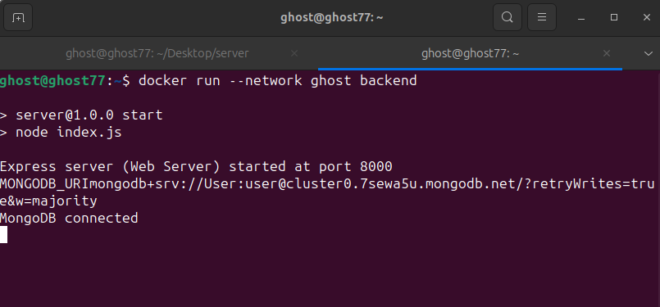
Replace your-network-name with the name of your network and your-image-name with the name of the Docker image you want to run.
By creating a Docker container network, you enable communication between containers within the network, allowing them to interact and exchange data efficiently.

