7. Three Tier web application using Kubernetes

Step 1: Clone the Guestbook Repository
- Open your terminal.
- Clone the GitHub repository containing the guestbook application by running the following command:
bash
- git clone https://github.com/IBM/guestbook.git
- Change directory to the version 1 of the guestbook application:
- cd guestbook/v1
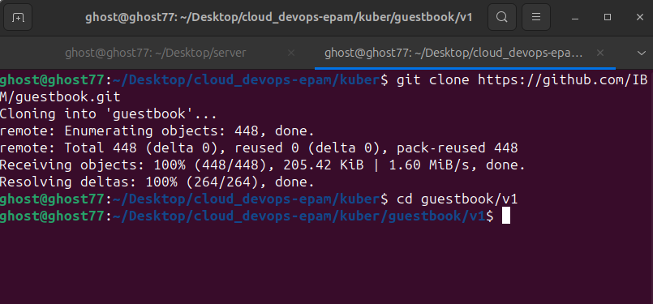
Step 2: Deploy the Guestbook Application
- Deploy the guestbook application by creating a Deployment using the provided configuration file:
- kubectl create -f guestbook-deployment.yaml
- Verify that the pods have been created by listing the pods with the label app=guestbook:
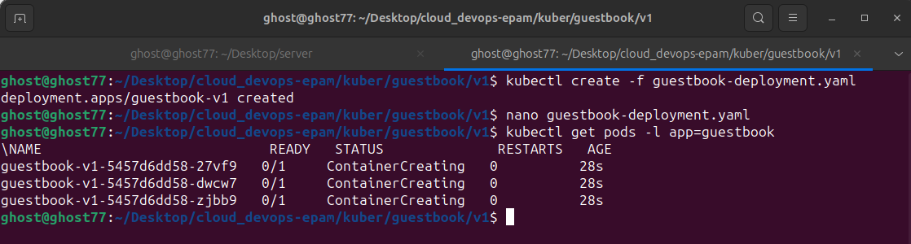
- kubectl get pods -l app=guestbook

Step 3: Expose the Guestbook Application
- Create a Service to expose the guestbook application:
- kubectl create -f guestbook-service.yaml
- To access the guestbook application, find out the NodePort and Public IP by running the following commands:
- kubectl describe service guestbook
kubectl get nodes -o wide
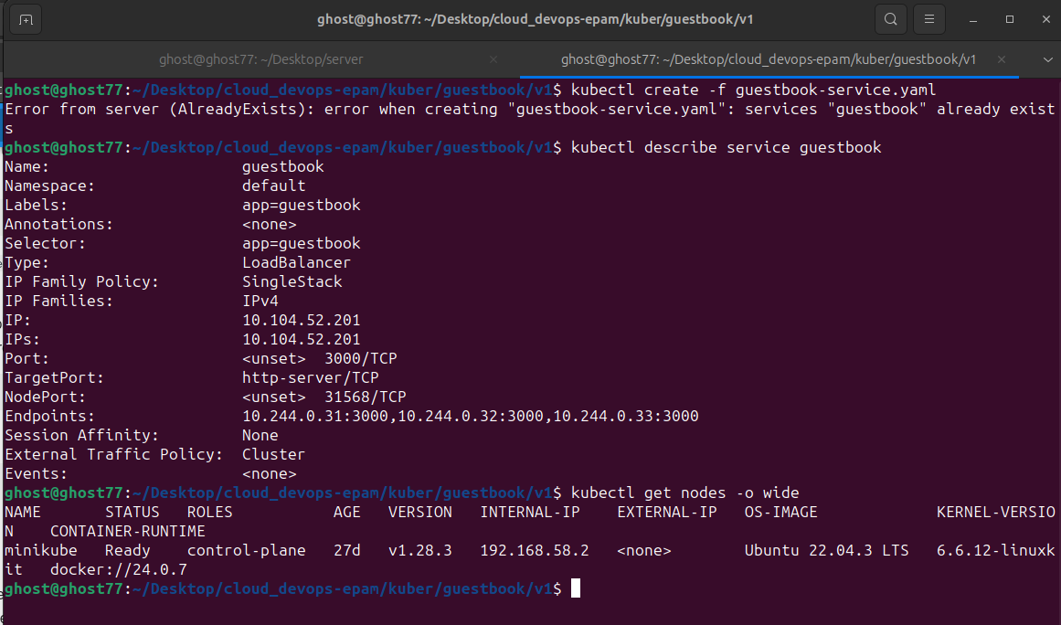
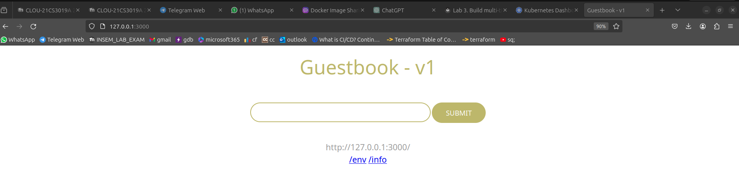
Step 4: Connect to the Backend Service (Redis)
- Deploy the Redis database by creating a Deployment using the provided configuration file:
lua
- kubectl create -f redis-master-deployment.yaml
- Verify that the Redis server pod is running:

- kubectl get pods -l app=redis,role=master
- Test the Redis standalone by connecting to the Redis server pod using the redis-cli:
- kubectl exec -it <redis-pod-name> redis-cli
You can exit the Redis CLI by typing exit.
- Create a Service to expose the Redis master:
lua
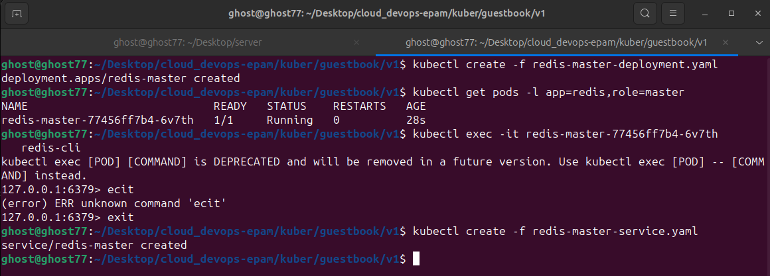
- kubectl create -f redis-master-service.yaml

Step 5: Update the Guestbook Application to Use Redis
- Restart the guestbook application to make it use the Redis service:

- kubectl delete deploy guestbook-v1
kubectl create -f guestbook-deployment.yaml
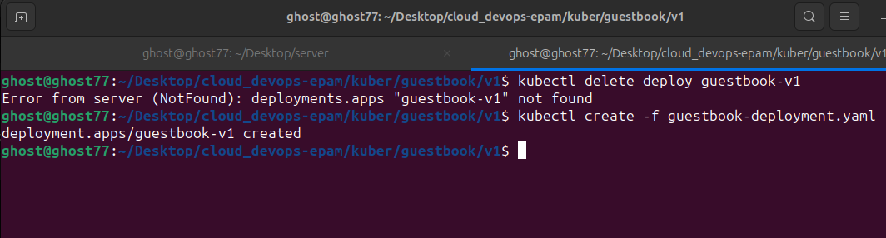
- Test the guestbook app again using a browser.
Step 6: Scale the Backend Service (Redis) for Read Operations
- Deploy the Redis slave by creating a Deployment using the provided configuration file:
- kubectl create -f redis-slave-deployment.yaml
- Verify that the Redis slave pods are running:
- kubectl get pods -l app=redis,role=slave
- Test the Redis slave by connecting to one of the pods using the redis-cli.
- Create a Service to expose the Redis slave:
- kubectl create -f redis-slave-service.yaml
- Restart the guestbook application to make it use the Redis slave service:
- kubectl delete deploy guestbook-v1
kubectl create -f guestbook-deployment.yaml
- Test the guestbook app again using a browser.
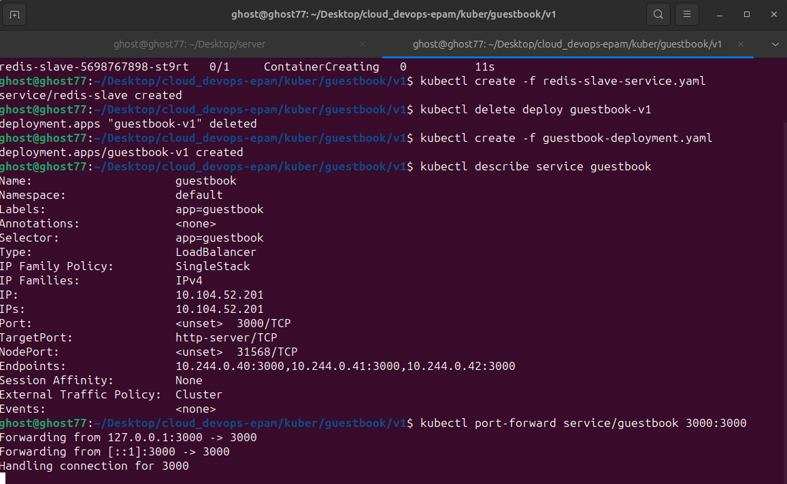
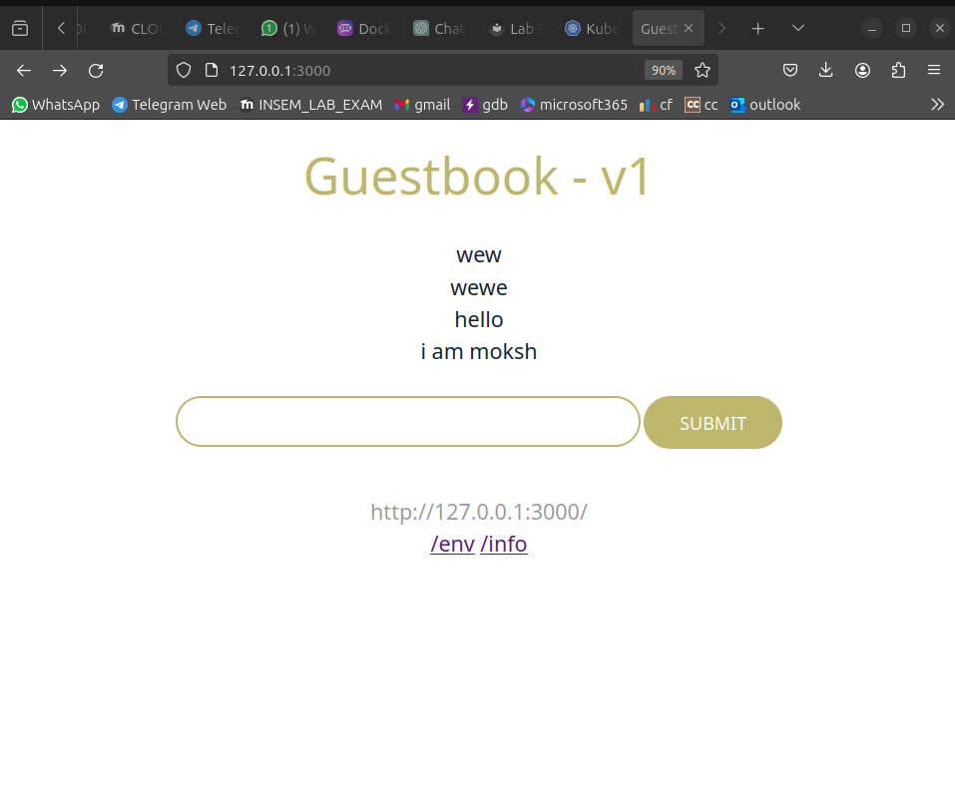
S

