EfficientNetV2-MSAF: Multi-Scale Attention Fusion for Leakage-Free, Calibrated and Field-Robust Crop Leaf Disease Diagnosis
[Author 1], [Author 2], [Author 3]
[Department], [University]
[City], India
[email addresses] · Guide: [Name, Designation]

Abstract—Convolutional networks exceed 99% accuracy on the PlantVillage leaf disease benchmark, yet fail on photographs taken outside the laboratory. Three practices contribute: augmented copies of a leaf leak across the train–test split, single-scale classifier heads average away small lesions, and models are judged by clean accuracy alone. A leaf-grouped split of 87,867 images (14 crops, 38 classes) removes the leakage of a random split, in which 67.5% of test images had a copy in training or validation. On this split, EfficientNetV2-MSAF, a head that applies convolutional block attention, generalised-mean pooling and scale-dropout at three backbone depths (+1.09% parameters), is compared with EfficientNetV2-S and a single-scale attention variant, each with and without field augmentation, using macro-F1, six corruptions, calibration error, selective prediction and McNemar tests. All models reach 99.51–99.62% clean accuracy with no significant difference. MSAF halves the raw expected calibration error (10.57% to 5.14%) and lowers selective risk by 20%, while field augmentation supplies most corruption robustness. The combined system raises mean corrupted accuracy from 82.20% to 94.84% and is deployed with a leaf gatekeeper, Grad-CAM explanations and treatment guidance.
Index Terms—Plant disease classification, EfficientNetV2, attention, multi-scale feature fusion, data leakage, calibration, corruption robustness, explainable AI.
I. Introduction
A. Background and Research Context
Plant pathogens and pests remove an estimated 17–30% of the global harvest of major staple crops [1]. Plant pathologists are scarce in rural areas, so a first diagnosis from a smartphone photograph is a low-cost alternative. The open PlantVillage collection [2] made such systems practical, and CNNs trained on it exceeded 99% accuracy in 2016 [3].
B. Research Problem and Its Significance
Laboratory accuracy on PlantVillage has saturated between 99% and 100%, while accuracy on other photographs remains far lower: 31.4% on images from other sources in [3], and 68% for a 2025 vision transformer transferred to the in-the-wild PlantDoc images [4], [5]. A tool that is confident and wrong in the field can lead to the wrong treatment.
C. Limitations of Conventional Approaches
Three weaknesses recur. The augmented PlantVillage release stores rotated and flipped copies of each leaf as separate files, so a random file split places copies of one leaf in both training and test sets. Most classifiers decide from the coarsest feature map, where a small lesion is averaged away by global pooling. Models are compared by clean accuracy alone, although robustness and the reliability of confidence decide whether a prediction can be trusted [6].
D. Motivation and Objectives
This work treats the evaluation protocol and the classifier head as one problem. Its objectives are to (i) remove augmented-copy leakage, (ii) design a lightweight head that preserves small-lesion evidence on an EfficientNetV2 backbone [7], (iii) evaluate robustness, calibration and selective risk alongside accuracy, and (iv) deploy the result in a usable application.
E. Research Challenges
Because clean accuracy is saturated, gains must be shown on other measures without overstating small differences; training must fit a 4 GB GPU, and labelled field photographs are scarce.
F. Contributions
1) A leaf-disjoint split of the 38-class augmented PlantVillage release, showing that 67.5% of a random split's test images had a training or validation sibling.
2) EfficientNetV2-MSAF, a head applying CBAM [8], generalised-mean pooling and scale-dropout at three backbone depths for +1.09% parameters.
3) A five-model comparison covering macro-F1, six corruptions, calibration before and after temperature scaling [9], [10], selective prediction and significance tests.
4) A deployed system with a leaf gatekeeper, Grad-CAM, severity estimate and treatment guidance.
G. Organization of the Paper
Sections II–V cover related work, method, results and conclusions.
II. Literature Review
Work from 2022 to 2026 has pursued lighter CNNs, hybrids that add self-attention or state-space blocks, and, recently, evaluation beyond clean accuracy. Of sixteen original studies selected, five are analysed below, six are compared in Table I, and the five closest to this work are examined in Section III-C.
A. Multi-Scale and Hybrid Architectures
Zhu et al. [11] fused multi-scale convolution with self-attention at shallow and deep levels (MSCVT), reaching 99.86% on PlantVillage and 97.50% on an apple leaf set. Combining shallow and deep features helps small lesions, but robustness and confidence were not examined; this work keeps the multi-scale premise with a pure CNN and tests it under corruption.
Guan et al. [12] built the 13.3 MB Dise-Efficient on EfficientNetV2; it reached 99.80% on PlantVillage but 64.40% on the field-captured IP102 pest set. This 35-point gap shows that laboratory accuracy does not transfer to the field even with a strong backbone, which motivates the corruption and field tests used here.
Gole et al. [13] (TrIncNet, a ViT with inception blocks) gained 5.38 points over a plain ViT on PlantVillage but only 2.87 points on in-field maize images, without calibration or robustness tests.
Meng et al. [14] fused convolutional and transformer branches, reaching 99.71% on PlantVillage with 4.9 M parameters, but did not describe how augmented copies of a leaf are kept out of the test split.
Zhang and Liu [15] fused shallow, medium and deep features with adaptive channel attention in a Vision Mamba network on field-acquired PlantDoc images, reaching 92.67% accuracy, 5.33 points above its baseline, with paired t-tests; calibration was not measured.
B. Comparative Survey of Further Studies
Table I summarises six further original studies.

TABLE I
Comparative survey of related studies
No. | Authors and Year | Dataset | Methodology | Reported Results | Limitations
[16] | Andrew et al., 2022 | PlantVillage, 54,305 images, 38 classes | Fine-tuned DenseNet-121, ResNet-50, VGG-16, Inception V4 | DenseNet-121: 99.81% accuracy | Single curated dataset; no field, corruption or calibration tests
[17] | Hassan and Maji, 2022 | PlantVillage, rice, cassava | Inception layers, residual links, depthwise separable convolution | 99.39%, 99.66%, 76.59% | Large drop on the harder cassava set
[18] | Borhani et al., 2022 | Multiple leaf datasets | ViT, CNN and CNN–ViT hybrids | Attention raised accuracy but slowed prediction; hybrids recovered speed | Accuracy–speed trade-off only; no robustness analysis
[19] | Li and Li, 2022 | Self-built apple leaf set with complex backgrounds | ConvViT: convolution plus linear-complexity attention | 96.85%, comparable to Swin-Tiny at 32.7% of its parameters | One crop; self-built data limit comparison
[20] | Lin et al., 2022 | PlantVillage-based few-shot tasks, intra- and cross-domain | Meta-Baseline with cascaded multi-scale features and channel attention | 5-shot: 77.43% single-plant, 92.83% multi-plant | Few-shot setting; accuracy still modest
[21] | De Silva and Brown, 2023 | Self-collected multispectral set, six filters | CNNs, ViT-B16 and hybrids | ViT-B16: 83.3% accuracy, 89.5% F1 (average) | Specialised optics; moderate accuracy

C. Research Trends and Gap
PlantVillage accuracy has converged at 99.4–99.9% [11], [12], [14], [16], [17], so clean gains no longer discriminate between designs. Multi-scale fusion and attention are standard for small lesions [11], [15], [20], but are applied inside the backbone or at one output scale. Every study that tested harder data observed a large drop [12], [13], [17], [21], yet only [6] measures robustness and calibration. None (i) controls augmented-copy leakage, (ii) fuses attention-refined features from several depths at an EfficientNetV2 head, and (iii) reports calibration, selective risk and robustness together. The closest studies [4], [6], [22]–[24] inform Section III.
III. Methodology
A. Dataset Overview
The study uses the augmented PlantVillage release on Kaggle [25], derived from [2]: 87,867 RGB images of single detached leaves on uniform backgrounds, covering 14 crops and 38 classes (26 diseased, 12 healthy). Rotated, flipped and pixel-shifted copies of each photograph are stored as separate files with suffixes such as _90deg and _flipTB. Table II gives the split.
TABLE II
Leaf-disjoint data split
Subset | Images | Share | Role
Training | 70,146 | 79.8% | Weight updates
Validation | 8,832 | 10.1% | Checkpoint, temperature
Test | 8,889 | 10.1% | All reported results
Total | 87,867 | 100% | 14 crops, 38 classes

The images are laboratory captures of one leaf each, and no labelled field photographs are included, so eight field photographs of supported classes were collected as a qualitative check.
B. Dataset Preprocessing
Leakage audit and leaf-grouped split. Each file is mapped to its source leaf ℓ(f) by stripping the augmentation suffix. Under a random file split, 67.5% of test images had a sibling in training or validation, so all files sharing ℓ(f) are assigned to the same subset (80/10/10 over leaf groups, seed 42):
$ℓ(f_{i})=ℓ(f_{j})⇒split(f_{i})=split(f_{j})$ (1)
A one-copy-per-leaf sampler draws one copy of each leaf per epoch, so leaves with many stored copies are not over-weighted.
Standard augmentation. Training uses a random resized crop to 224 × 224, horizontal and vertical flips and colour jitter (0.2 brightness, contrast and saturation; 0.1 hue); evaluation resizes to 256 and centre-crops 224. Images are normalised with ImageNet channel statistics μ_{c}, σ_{c}:
${\hat{x}}_{c}=\frac{x_{c}−μ_{c}}{σ_{c}}$ (2)
Field augmentation (optional). Gaussian blur (kernel 9, σ ∈ [0.5, 3]) and the sensor noise of Eq. (3) are each applied to 30% of training images. Motion blur, JPEG, low light and overexposure are never used in training, so they measure generalisation to unseen degradations.
$x^{′}={clip}_{\left[0 , 1\right]}\left(x + 0.12uε\right),u\sim 𝒰(0,1),ε\sim 𝒩(0,I)$ (3)
C. Methodology Overview
Fig. 1 shows the workflow: development (leakage audit, split, training of five models, evaluation under seven conditions) and deployment (gatekeeper, classifier, temperature scaling, Grad-CAM, severity, treatment lookup). Table III summarises the five studies that shaped the design.

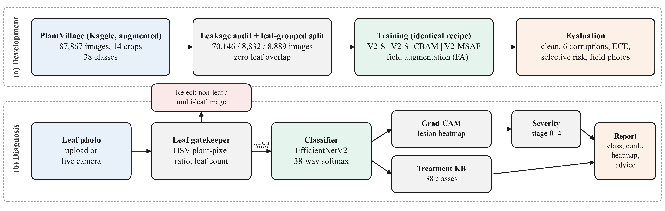
Fig. 1. Proposed methodology and system workflow: (a) development path, from the leakage audit and leaf-disjoint split to training and evaluation; (b) diagnosis path of the deployed application.

TABLE III
The five most relevant studies and their influence on this work
Ref. | Study | Method | Reported results | Limitation | Use in this work
[22] | Albattah et al., 2022, Frontiers in Plant Science | EfficientNetV2-B4 with added dense layers | Precision 99.63%, recall 99.93%, accuracy 99.99% | Clean test only; leakage control not described | Confirms EfficientNetV2 as backbone family
[23] | Zhao et al., 2022, Computers and Electronics in Agriculture | Inception-residual CNN with embedded modified CBAM; web deployment | 99.55% overall; 98.44%, 99.43%, 95.20% per crop | Attention at one stage; three crops | CBAM for lesion focus; deployed web system
[24] | Wang et al., 2024, Frontiers in Plant Science | CBAM in backbone, shallow features fused through BiRepGFPN in YOLOv6 | Tomato mAP 93.8%, F1 94.0%; mAP +2.6 to +11.8 points over YOLO variants on PlantDoc | Detection task; no calibration analysis | Shallow-feature fusion for small lesions
[4] | Salman et al., 2025, Frontiers in Plant Science | ViT with mixture of experts, entropy and orthogonal regularisation | +20% over ViT; 68% PlantVillage to PlantDoc | Large model; field accuracy still low | Defines the field-generalisation problem
[6] | Das et al., 2025, IEEE ICCCMLA | ResNet-18, EfficientNet-B0, ConvNeXt-Tiny under 8 corruptions at 3 severities | Similar clean accuracy, divergent mCE and ECE; ConvNeXt-Tiny most robust | Existing models only; no new design | Robustness and calibration protocol

The head keeps the EfficientNetV2 backbone validated in [22], applies CBAM as in [23] but at three depths, and fuses shallow and deep features as [24] does for detection. It targets the field gap of [4] with a 0.22 M-parameter head rather than an expert ensemble, and extends the evaluation view of [6] with temperature scaling, selective prediction and significance tests.
Multi-scale attention fusion (MSAF). As Fig. 2 shows, the ImageNet-pretrained EfficientNetV2-S [7] is tapped at stage 3 (64 channels, 28 × 28), stage 5 (160 channels, 14 × 14) and the final 1 × 1 projection (1,280 channels, 7 × 7). Each map F is refined by CBAM [8]: channel attention M_{c} (shared MLP, reduction 16) gives F′ = M_{c} ⊗ F, spatial attention M_{s} (7 × 7 convolution) is applied to F′, and the block returns F + M_{s} ⊗ F′ (residual):
$M_{c}(F)=σ(MLP(AvgPool(F))+MLP(MaxPool(F)))$ (4)
$M_{s}(F^{′})=σ(f^{7×7}([{AvgPool}_{c}(F^{′});{MaxPool}_{c}(F^{′})]))$ (5)
Global average pooling dilutes small, strong lesion activations, so each refined map is pooled by GeM [26] with learnable p (initialised to 3) over spatial positions Ω:
$d_{k}=(\frac{1}{\left|Ω\right|}\sum_{(i,j)∈Ω}{x_{k,i,j}^{p}})^{1/p}$ (6)
The three descriptors are layer-normalised so that the small fine-scale vectors are not dominated. During training, scale-dropout multiplies each by m_{s} ~ Bernoulli(0.9), keeping at least one scale. The fused 1,504-d vector z of Eq. (7) passes through dropout (0.3) and a linear layer, ŷ = W·Dropout(z) + b:
$z=[m_{1}LN(d^{\left(1\right)});m_{2}LN(d^{\left(2\right)});m_{3}LN(d^{\left(3\right)})]$ (7)

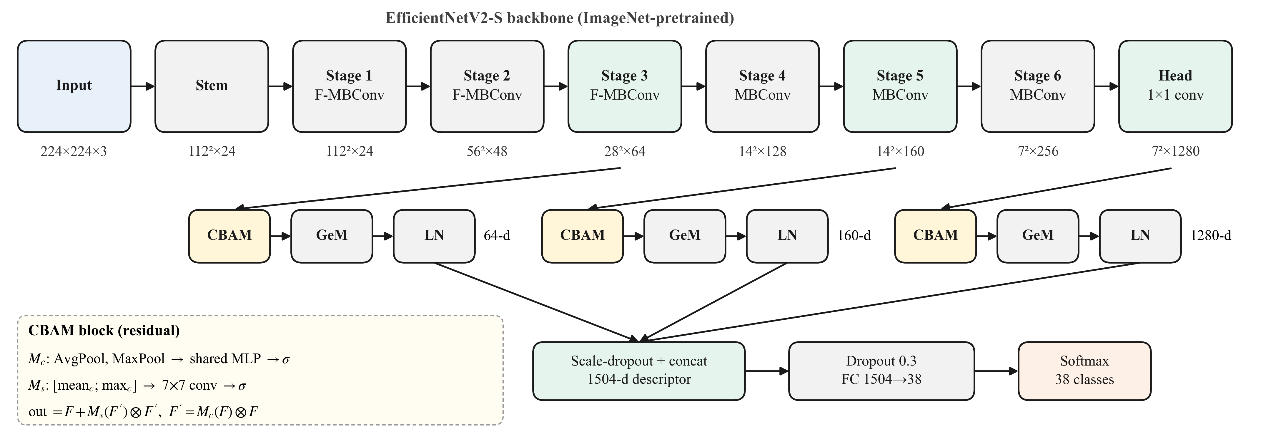
Fig. 2. EfficientNetV2-MSAF architecture. Three backbone depths are each refined by CBAM, pooled by GeM and layer-normalised, then concatenated with scale-dropout before a single linear classifier.

The head adds 220,841 parameters (+1.09%, 20.45 M total) at an unchanged 2.85 GMACs. Two controls isolate its effect: the stock head (baseline) and one CBAM block on the 1,280-channel map (CBAM variant).
D. Model Training and Implementation
All five models (baseline, CBAM, MSAF, and baseline and MSAF with field augmentation) share one recipe: 8 epochs, batch 32, AdamW [27] (learning rate 10⁻³, weight decay 10⁻⁴), a one-cycle schedule [28], mixed precision, seed 42 and cross-entropy with label smoothing [29] ε = 0.1 over K = 38 classes:
$ℒ=−\sum_{k=1}^{K}{[(1−ε)}y_{k}+\frac{ε}{K}]log{\hat{y}}_{k}$ (8)
The best-validation checkpoint is kept, and a temperature T is fitted on the validation set by minimising NLL (Eq. 9). Training on an NVIDIA RTX 3050 (4 GB) took 37.8, 35.8 and 48.7 min for the baseline, CBAM and MSAF models.
${\hat{p}}_{k}=\frac{exp(z_{k}/T)}{\sum_{j=1}^{K}{exp(}z_{j}/T)}$ (9)
The deployed Streamlit application follows Algorithm 1.
Algorithm 1: Diagnosis pipeline
1: Input: photograph I. Output: diagnosis report or rejection.
2: Run the leaf gatekeeper; if I is not a plant image or shows several leaves, reject it with a reason and stop.
3: Resize and normalise I (Eq. 2) and compute logits z with the classifier.
4: Calibrate the probabilities with temperature T (Eq. 9); flag low-confidence predictions.
5: Compute the Grad-CAM map [30] for the predicted class.
6: Segment the leaf and compute the severity index as the share of leaf pixels flagged by Grad-CAM; map it to one of four stages.
7: Look up the pathogen, symptoms, organic and chemical controls and prevention for the class, and return the report (optionally as PDF).
The application uses the EfficientNetV2-S checkpoint, because standard Grad-CAM gives noisy maps on MSAF, whose per-scale layer normalisation cancels much of the gradient weighting. The severity index is a heuristic, not a laboratory measurement.
IV. Results and Discussion
A. Experimental Setup
All results use the 8,889-image leaf-disjoint test set under clean images and six fixed-severity corruptions in the style of [10] (Gaussian blur, motion blur, sensor noise, low light, JPEG quality 10, overexposure). Metrics are accuracy, macro-F1, mean corrupted accuracy (mCA), expected calibration error (ECE, 15 bins) before and after temperature scaling (TS), and selective prediction [31] on pooled corrupted images: area under the risk–coverage curve (AURC), error-detection AUROC and accuracy at 90% coverage. Paired differences use exact McNemar tests [32] and 95% bootstrap intervals. Latency is per image on the RTX 3050 and a 4-thread CPU.
B. Quantitative Results
Table IV reports the main results. Clean accuracy spans 99.51–99.62% and no pairwise difference is significant (baseline vs. MSAF p = 0.143; vs. CBAM p = 0.164; field-augmented pair p = 0.86), so clean accuracy cannot separate the architectures.

TABLE IV
Main results on the leaf-disjoint test set (8,889 images)
Model | Params (M) | Clean acc. (%) | Macro-F1 (%) | mCA (%) | ECE raw (%) | ECE after TS (%) | Corrupted ECE after TS (%) | AURC (%) | Error-detection AUROC (%) | Field photos
EfficientNetV2-S (baseline) | 20.23 | 99.62 | 99.61 | 82.20 | 10.57 | 0.17 | 12.23 | 5.21 | 85.49 | 6/8
+ CBAM | 20.43 | 99.51 | 99.51 | 83.08 | 10.17 | 0.29 | 11.65 | 5.16 | 85.29 | 8/8
EfficientNetV2-MSAF | 20.45 | 99.51 | 99.51 | 82.99 | 5.14 | 0.29 | 10.83 | 4.16 | 87.27 | 8/8
Baseline + field aug. | 20.23 | 99.58 | 99.57 | 95.67 | 10.56 | 0.19 | 2.49 | 0.45 | 93.82 | 6/8
MSAF + field aug. (proposed system) | 20.45 | 99.56 | 99.55 | 94.84 | 5.44 | 0.21 | 2.77 | 0.50 | 93.98 | 8/8

Calibration. MSAF's raw ECE is 5.14% against 10.57% for the baseline (−5.43 points, 95% CI −5.55 to −5.26); single-scale CBAM lowers it by only 0.40 points, so the gain comes from the multi-scale head. TS brings clean ECE below 0.3% for all models, but without field augmentation it worsens corrupted-image ECE (baseline 8.81% to 12.23%); only the field-augmented models keep it low (2.49% and 2.77%).
Robustness. Without field augmentation, MSAF raises mCA by 0.79 points (95% CI 0.48 to 1.10): it is better under sensor noise (85.43% vs. 80.64%, p < 10⁻³⁷) and low light (94.35% vs. 90.04%, p < 10⁻⁴³) but worse under motion blur (50.11% vs. 54.48%, p < 10⁻¹⁸). Field augmentation lifts mCA by 12–13 points, and unseen motion blur rises to 86.32% (baseline) and 81.85% (MSAF); with it, MSAF trails the baseline by 0.83 points (95% CI −1.01 to −0.64), mainly on motion blur (Fig. 3).

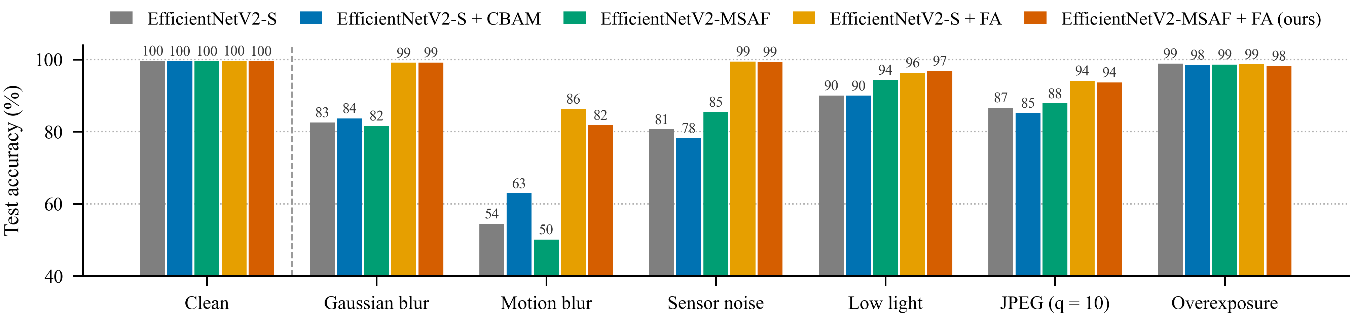
Fig. 3. Test accuracy (%) of the five models under clean and six corrupted conditions (FA: field augmentation). Field augmentation raises accuracy under blur and noise; the head type changes the result mainly under motion blur, sensor noise and low light.

Selective prediction. Without field augmentation, MSAF lowers AURC from 5.21% to 4.16% and raises error-detection AUROC from 85.49% to 87.27%. With field augmentation, both models reach AURC of about 0.5% and 98.5–99.0% accuracy at 90% coverage.
Efficiency. MSAF adds 4.1 ms GPU and 9.8 ms CPU latency per image at unchanged GMACs (Table V).
TABLE V
Computational cost (224 × 224 input, batch 1)
Model | Params (M) | GMACs | GPU (ms) | CPU, 4 thr. (ms) | Train (min)
Baseline | 20.23 | 2.85 | 14.63 | 56.0 | 37.8
+ CBAM | 20.43 | 2.85 | 15.02 | 58.0 | 35.8
MSAF | 20.45 | 2.85 | 18.68 | 65.8 | 48.7

Errors and gatekeeper. The most frequent clean error is corn gray leaf spot predicted as northern leaf blight (9–15 images), the baseline's two lowest per-class F1 scores (97.07%, 97.64%). The gatekeeper rejected five of six non-leaf images; without it, a text document was labelled healthy corn at 81.2%. The one that passed, random noise, received 18.3% confidence and triggered the warning.
C. Graphical Results
Fig. 4 shows Grad-CAM explanations from the deployed model on test leaves and field photographs.
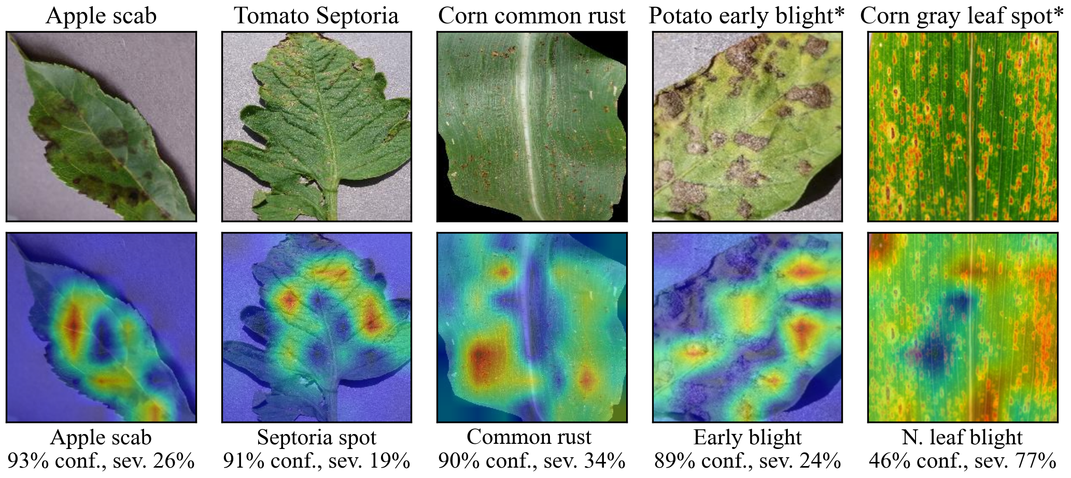
Fig. 4. Grad-CAM explanations from the deployed EfficientNetV2-S model (top: input; bottom: heatmap; below: prediction, calibrated confidence and severity). Columns marked * are field photographs. Heat concentrates on lesions in the test leaves. The corn gray leaf spot field photo is misclassified as northern leaf blight at 46% confidence, the same confusion that dominates the test-set errors, and its low confidence would trigger the app's warning.
D. Comparison With Existing Research
Table VI is indicative only: published models were not re-run, use random splits that may leak augmented copies, and report no robustness or calibration on PlantVillage.

TABLE VI
Comparison with published results (as reported by each study)
Study | Model | Test data and split | Clean accuracy | Harder or field data | Calibration reported
Mohanty et al. [3] | GoogLeNet | PlantVillage, random split | 99.35% | 31.4% on images from other sources | No
Andrew et al. [16] | DenseNet-121 | PlantVillage, 38 classes | 99.81% | Not tested | No
Albattah et al. [22] | EfficientNetV2-B4 + dense | PlantVillage (Kaggle) + drone | 99.99% | Drone images included in test | No
Guan et al. [12] | Dise-Efficient (EfficientNetV2) | PlantVillage; IP102 | 99.80% | 64.40% on IP102 | No
Meng et al. [14] | CNN–ViT dual branch, 4.9 M | PlantVillage | 99.71% | Not tested | No
Salman et al. [4] | ViT + mixture of experts | PlantVillage to PlantDoc | Not compared here | 68% cross-domain | No
This work | EfficientNetV2-MSAF + field aug. | Augmented PlantVillage, leaf-disjoint | 99.56% | mCA 94.84% over 6 corruptions; 8/8 field photos | Yes: ECE 5.44% raw

On clean images the system is on par with published models on a stricter test set; its distinguishing results are measured robustness, calibrated confidence and non-leaf rejection. The 8/8 field result is not comparable with the 31.4% or 68% figures, which come from hundreds of images.
E. Critical Result Analysis
The baseline concentrates confidence near 0.90 even on clean images (mean 89.08% at 99.62% accuracy), a sign of label-smoothing saturation; fusing layer-normalised descriptors from three depths spreads the logits and lowers NLL (0.069 vs. 0.123). Fine 28 × 28 features help when noise and darkness corrupt texture uniformly, but motion blur smears exactly those details. As in [6], robustness depends more on training data than on architecture.
Each model was trained once with one seed, so differences under about one point should not be over-read even when McNemar tests are significant. In practice, a deployed tool should be trained with capture-style augmentation and report calibrated confidence, and the MSAF head is worth its cost when trustworthy confidence matters more than motion-blur robustness.
V. Conclusion and Future Work
This study addressed the gap between near-perfect laboratory accuracy and unreliable field performance in crop disease diagnosis. A leaf-disjoint split of 87,867 PlantVillage images removed augmented-copy leakage that affected 67.5% of a random split's test images, and EfficientNetV2-MSAF fused attention-refined features from three backbone depths for 1.09% more parameters. All five models reached 99.51–99.62% clean accuracy with no significant difference, while the multi-scale head halved raw calibration error (10.57% to 5.14%) and reduced selective risk under unseen corruptions by 20%. Field augmentation supplied most robustness, and the deployed system, with a leaf gatekeeper, Grad-CAM and treatment guidance, raised mean corrupted accuracy from 82.20% to 94.84% and classified all eight field photographs correctly. Its main limitations are single-seed training, synthetic corruptions at one severity and only eight field images. Future work will evaluate on PlantDoc, repeat training over several seeds, add motion-blur and multi-severity augmentation, and validate severity against expert scoring.
REFERENCES
[1] S. Savary, L. Willocquet, S. J. Pethybridge, P. Esker, N. McRoberts, and A. Nelson, “The global burden of pathogens and pests on major food crops,” Nature Ecology & Evolution, vol. 3, no. 3, pp. 430–439, 2019, doi: 10.1038/s41559-018-0793-y.
[2] D. P. Hughes and M. Salathé, “An open access repository of images on plant health to enable the development of mobile disease diagnostics,” arXiv:1511.08060, 2015.
[3] S. P. Mohanty, D. P. Hughes, and M. Salathé, “Using deep learning for image-based plant disease detection,” Frontiers in Plant Science, vol. 7, Art. no. 1419, 2016, doi: 10.3389/fpls.2016.01419.
[4] Z. Salman, A. Muhammad, and D. Han, “Plant disease classification in the wild using vision transformers and mixture of experts,” Frontiers in Plant Science, vol. 16, Art. no. 1522985, 2025, doi: 10.3389/fpls.2025.1522985.
[5] D. Singh, N. Jain, P. Jain, P. Kayal, S. Kumawat, and N. Batra, “PlantDoc: A dataset for visual plant disease detection,” in Proc. 7th ACM IKDD CoDS and 25th COMAD, 2020, pp. 249–253.
[6] J. Das, Y. Panjwani, and E. Uchoi, “Beyond accuracy: Robustness and calibration evaluation of deep learning models for plant disease detection,” in Proc. IEEE 7th Int. Conf. Cybernetics, Cognition and Machine Learning Applications (ICCCMLA), 2025, pp. 1–6, doi: 10.1109/ICCCMLA66092.2025.11581126.
[7] M. Tan and Q. V. Le, “EfficientNetV2: Smaller models and faster training,” in Proc. 38th Int. Conf. Machine Learning (ICML), 2021, pp. 10096–10106.
[8] S. Woo, J. Park, J.-Y. Lee, and I. S. Kweon, “CBAM: Convolutional block attention module,” in Proc. European Conf. Computer Vision (ECCV), 2018, pp. 3–19.
[9] C. Guo, G. Pleiss, Y. Sun, and K. Q. Weinberger, “On calibration of modern neural networks,” in Proc. 34th Int. Conf. Machine Learning (ICML), 2017, pp. 1321–1330.
[10] D. Hendrycks and T. Dietterich, “Benchmarking neural network robustness to common corruptions and perturbations,” in Proc. Int. Conf. Learning Representations (ICLR), 2019.
[11] D. Zhu, J. Tan, C. Wu, K. Yung, and A. W. H. Ip, “Crop disease identification by fusing multiscale convolution and vision transformer,” Sensors, vol. 23, no. 13, Art. no. 6015, 2023, doi: 10.3390/s23136015.
[12] H. Guan, C. Fu, G. Zhang, K. Li, P. Wang, and Z. Zhu, “A lightweight model for efficient identification of plant diseases and pests based on deep learning,” Frontiers in Plant Science, vol. 14, Art. no. 1227011, 2023, doi: 10.3389/fpls.2023.1227011.
[13] P. Gole, P. Bedi, S. Marwaha, M. A. Haque, and C. K. Deb, “TrIncNet: A lightweight vision transformer network for identification of plant diseases,” Frontiers in Plant Science, vol. 14, Art. no. 1221557, 2023, doi: 10.3389/fpls.2023.1221557.
[14] Q. Meng, J. Guo, H. Zhang, Y. Zhou, and X. Zhang, “A dual-branch model combining convolution and vision transformer for crop disease classification,” PLOS ONE, vol. 20, no. 4, Art. no. e0321753, 2025, doi: 10.1371/journal.pone.0321753.
[15] S. Zhang and R. Liu, “Multi-scale feature fusion-based vision Mamba for robust plant disease image classification on field-acquired PlantDoc data,” Frontiers in Plant Science, vol. 17, Art. no. 1842426, 2026, doi: 10.3389/fpls.2026.1842426.
[16] J. Andrew, J. Eunice, D. E. Popescu, M. K. Chowdary, and J. Hemanth, “Deep learning-based leaf disease detection in crops using images for agricultural applications,” Agronomy, vol. 12, no. 10, Art. no. 2395, 2022, doi: 10.3390/agronomy12102395.
[17] S. M. Hassan and A. K. Maji, “Plant disease identification using a novel convolutional neural network,” IEEE Access, vol. 10, pp. 5390–5401, 2022, doi: 10.1109/ACCESS.2022.3141371.
[18] Y. Borhani, J. Khoramdel, and E. Najafi, “A deep learning based approach for automated plant disease classification using vision transformer,” Scientific Reports, vol. 12, Art. no. 11554, 2022, doi: 10.1038/s41598-022-15163-0.
[19] X. Li and S. Li, “Transformer help CNN see better: A lightweight hybrid apple disease identification model based on transformers,” Agriculture, vol. 12, no. 6, Art. no. 884, 2022, doi: 10.3390/agriculture12060884.
[20] H. Lin, R. Tse, S.-K. Tang, Z.-P. Qiang, and G. Pau, “Few-shot learning approach with multi-scale feature fusion and attention for plant disease recognition,” Frontiers in Plant Science, vol. 13, Art. no. 907916, 2022, doi: 10.3389/fpls.2022.907916.
[21] M. De Silva and D. Brown, “Multispectral plant disease detection with vision transformer–convolutional neural network hybrid approaches,” Sensors, vol. 23, no. 20, Art. no. 8531, 2023, doi: 10.3390/s23208531.
[22] W. Albattah, A. Javed, M. Nawaz, M. Masood, and S. Albahli, “Artificial intelligence-based drone system for multiclass plant disease detection using an improved efficient convolutional neural network,” Frontiers in Plant Science, vol. 13, Art. no. 808380, 2022, doi: 10.3389/fpls.2022.808380.
[23] Y. Zhao, C. Sun, X. Xu, and J. Chen, “RIC-Net: A plant disease classification model based on the fusion of Inception and residual structure and embedded attention mechanism,” Computers and Electronics in Agriculture, vol. 193, Art. no. 106644, 2022, doi: 10.1016/j.compag.2021.106644.
[24] Y. Wang, P. Zhang, and S. Tian, “Tomato leaf disease detection based on attention mechanism and multi-scale feature fusion,” Frontiers in Plant Science, vol. 15, Art. no. 1382802, 2024, doi: 10.3389/fpls.2024.1382802.
[25] “New Plant Diseases Dataset (Augmented),” Kaggle, 2018. [Online]. Available: https://www.kaggle.com/datasets/vipoooool/new-plant-diseases-dataset
[26] F. Radenović, G. Tolias, and O. Chum, “Fine-tuning CNN image retrieval with no human annotation,” IEEE Trans. Pattern Analysis and Machine Intelligence, vol. 41, no. 7, pp. 1655–1668, 2019.
[27] I. Loshchilov and F. Hutter, “Decoupled weight decay regularization,” in Proc. Int. Conf. Learning Representations (ICLR), 2019.
[28] L. N. Smith and N. Topin, “Super-convergence: Very fast training of neural networks using large learning rates,” in Proc. SPIE Artificial Intelligence and Machine Learning for Multi-Domain Operations Applications, vol. 11006, 2019, Art. no. 1100612.
[29] C. Szegedy, V. Vanhoucke, S. Ioffe, J. Shlens, and Z. Wojna, “Rethinking the Inception architecture for computer vision,” in Proc. IEEE Conf. Computer Vision and Pattern Recognition (CVPR), 2016, pp. 2818–2826.
[30] R. R. Selvaraju, M. Cogswell, A. Das, R. Vedantam, D. Parikh, and D. Batra, “Grad-CAM: Visual explanations from deep networks via gradient-based localization,” in Proc. IEEE Int. Conf. Computer Vision (ICCV), 2017, pp. 618–626.
[31] Y. Geifman and R. El-Yaniv, “Selective classification for deep neural networks,” in Advances in Neural Information Processing Systems (NeurIPS), vol. 30, 2017, pp. 4878–4887.
[32] T. G. Dietterich, “Approximate statistical tests for comparing supervised classification learning algorithms,” Neural Computation, vol. 10, no. 7, pp. 1895–1923, 1998.

