7 | A college employs a large number of security personnel who are assigned duties at various locations across the campus. Each security person follows a duty schedule that includes date, duty start time, duty end time, and assigned location, ensuring that every campus location is covered. If a security person takes leave, it is recorded manually, and at the end of each month, salaries are calculated based on duties performed and leaves taken. Since manual handling of duty allocation, leave management, and salary calculation is time-consuming and complex, the college plans to develop an Online Security Management System to automate these activities. Develop Class Diagram, Use case Diagram and Activity Diagramto represent the workflow of the Online Security Management System. | Umbrello | CO1

Objective
To design UML diagrams for an Online Security Management System that automates duty allocation, leave management, and salary calculation of security personnel.

System Description (Short)
The system manages:
- Security personnel details
- Duty schedules
- Leave records
- Salary calculation
It automates manual processes for efficiency and accuracy.

🔹 PART 1 — CLASS DIAGRAM

Step 1: Open Umbrello
Open Umbrello UML Modeller
Click File → New

Step 2: Create Class Diagram
- Right-click Logical View
- Click New Diagram → Class Diagram
- Rename as:
SecurityManagement_ClassDiagram

Step 3: Create Classes
Add these classes:
- SecurityStaff
- DutySchedule
- Location
- Leave
- Salary
- Admin

Step 4: Add Attributes and Methods
🔹SecurityStaff
Attributes:
- staffId
- name
- phone
- designation
Methods:
- viewDuty()
- applyLeave()

🔹DutySchedule
Attributes:
- dutyId
- date
- startTime
- endTime
Methods:
- assignDuty()
- updateDuty()

🔹 Location
Attributes:
- locationId
- locationName
Methods:
- updateLocation()

🔹 Leave
Attributes:
- leaveId
- leaveDate
- reason
Methods:
- approveLeave()

🔹 Salary
Attributes:
- salaryId
- month
- amount
Methods:
- calculateSalary()

🔹 Admin
Attributes:
- adminId
- name
Methods:
- assignDuty()
- manageLeave()
- generateSalary()

Step 5: Draw Relationship
Use Association / Aggregation:
From | To | Relationship
SecurityStaff | DutySchedule | Association
DutySchedule | Location | Association
SecurityStaff | Leave | Association
SecurityStaff | Salary | Association
Admin | SecurityStaff | Association

Step 6: Save Diagram
File → Save
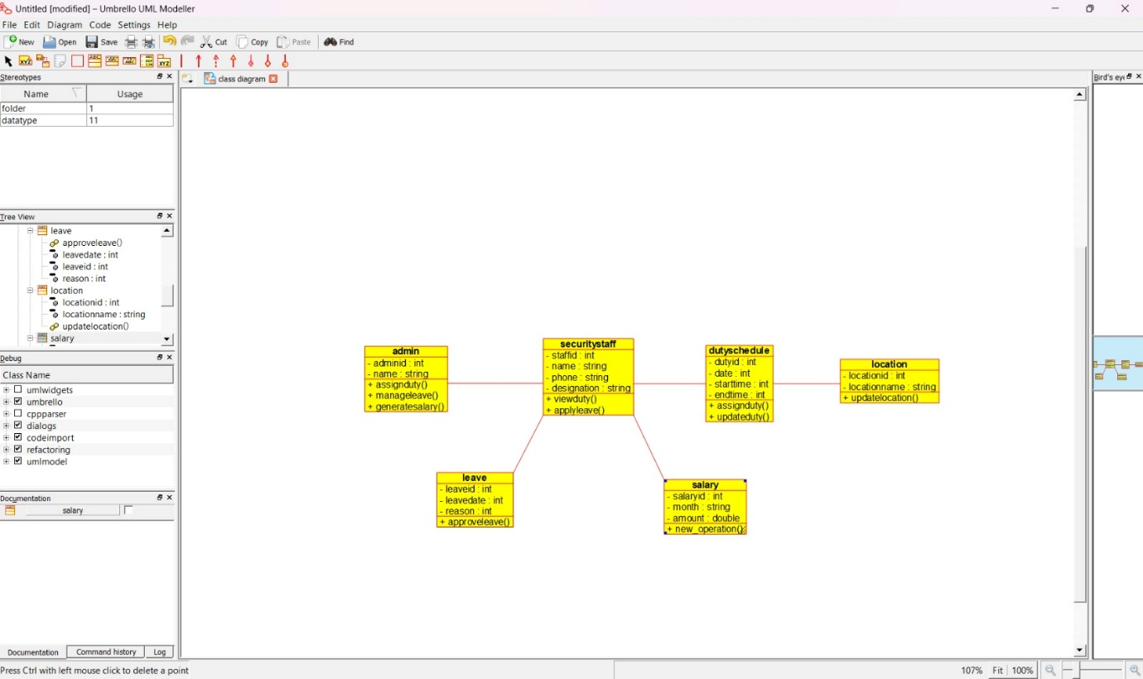

🔹 PART 2 — USE CASE DIAGRAM

Step 1: Create Use Case Diagram
Right-click Use Case View → New Diagram
Rename as:
SecurityManagement_UseCaseDiagram

Step 2: Add Actors
Add:
- Admin
- Security Staff

Step 3: Add Use Cases
Admin Use Cases
- Assign Duty
- Update Duty
- Approve Leave
- Calculate Salary
- Generate Salary Report

Security Staff Use Cases
- View Duty Schedule
- Apply Leave
- View Salary

Step 4: Connect Actors to Use Cases
Use association lines between:
- Admin → admin use cases
- Security Staff → staff use cases

Step 5: Save Diagram
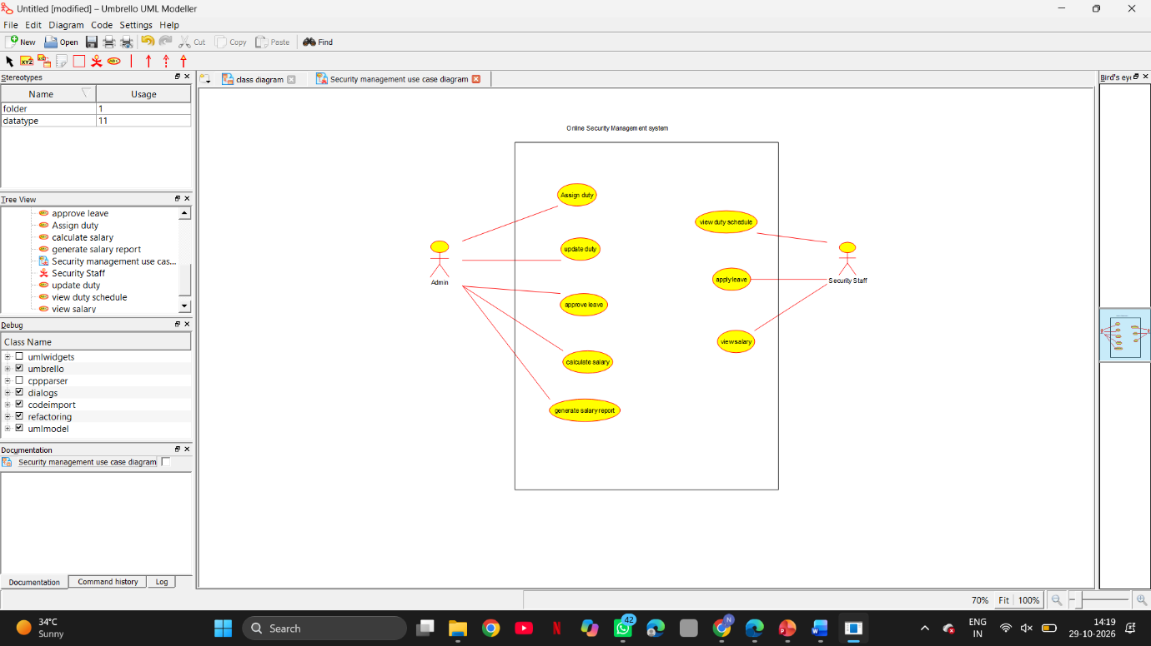

🔹 PART 3 — ACTIVITY DIAGRAM

Step 1: Create Activity Diagram
Right-click Logical View → New Diagram → Activity Diagram
Rename as:
SecurityManagement_ActivityDiagram

Step 2: Add Activities in Order
- Start
- Admin Assigns Duty
- Security Staff Views Duty
- Security Staff Performs Duty
- Apply Leave (if required)
- Admin Approves Leave
- Monthly Duty Completion
- Calculate Salary
- Generate Salary
- Security Staff Views Salary
- Stop

Step 3: Add Decision Node
After Apply Leave
Decision:
Leave Approved?
- Yes → Continue
- No → Duty Continues

Step 4: Connect All Activities with Arrows
Use control flow arrows to show sequence.

Step 5: Save Diagram
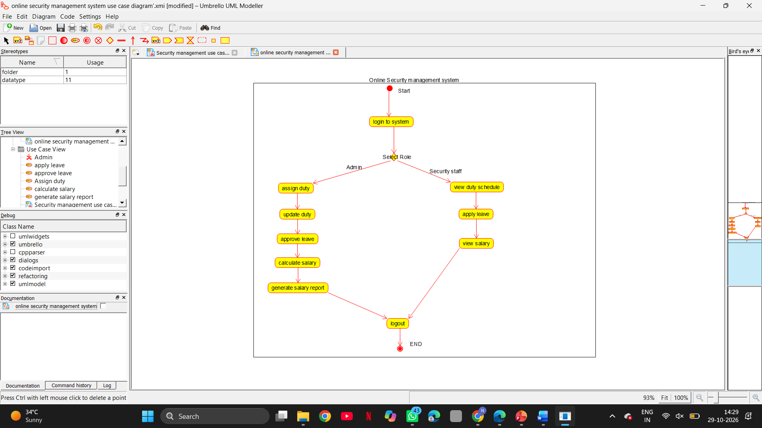
Result
Thus, Class Diagram, Use Case Diagram, and Activity Diagram for the Online Security Management System were successfully designed using Umbrello UML Modeller.

