10 | Use the following requirements for a Library Management System:  - Add a feature to search books by title and author.  - Implementation line book reservation system.  - Generate monthly reports on borrowed books for administrators.  - Enable email notifications for overdue books.  - Add support for QR code scanning for borrowing and returning books.  - Create a user-friendly dashboard for librarians.  - Allow users to review and rate books.  - Integrate a chatbot for user assistance.  - Develop a mobile app version of the system.  - Provide multi-language support.  Categorize each requirement using MOSCOW Method (Must-Have, Should-Have, Could-Have, or Won’t-Have) based on the following criteria:  - Impact on the users and stakeholders.  - Feasibility considering time, budget ,and resource constraints.  Finally Submit the completed Google Sheet or Excel file with all requirements categorized and justified. | Google Sheetor Excel | CO2

Objective
To categorize system requirements using the MoSCoW prioritization method based on user impact and feasibility, and document them in Google Sheets / Excel.

Step-by-Step Procedure (Google Sheets / Excel)

🔹 Step 1: Open Spreadsheet
Open:
- Google Sheets → Blank Sheet
OR
- Excel → New Workbook

🔹 Step 2: Create Column Headings
In Row 1, enter:
A1 | B1 | C1 | D1 | E1
Requirement ID | Requirement Description | MoSCoW Category | Justification | Priority Reason

🔹 Step 3: Enter Requirements
Enter all given requirements:
ID | Requirement
R1 | Search books by title and author
R2 | Online book reservation
R3 | Monthly borrowed books report
R4 | Email notifications for overdue books
R5 | QR code scanning
R6 | Librarian dashboard
R7 | Review and rate books
R8 | Chatbot integration
R9 | Mobile app version
R10 | Multi-language support

🔹 Step 4: Apply MoSCoW Categorization
Fill columns C, D, and E as follows:

Final Categorized Table
Req ID | Requirement | MoSCoW Category | Justification | Priority Reason
R1 | Search books by title and author | Must-Have | Core library functionality | Essential for users
R2 | Online book reservation | Must-Have | Improves accessibility | High user demand
R3 | Monthly reports | Should-Have | Important for administration | Operational efficiency
R4 | Email overdue notification | Must-Have | Prevents book loss | High impact
R5 | QR code scanning | Could-Have | Enhances speed | Requires extra hardware
R6 | Librarian dashboard | Must-Have | Required for management | Core system control
R7 | Review and rating | Could-Have | Improves engagement | Optional feature
R8 | Chatbot | Could-Have | Helps users | Resource intensive
R9 | Mobile app version | Should-Have | Improves accessibility | Medium feasibility
R10 | Multi-language support | Won’t-Have | High cost and complexity | Low priority initially

🔹 Step 5: Color Code (Optional but Recommended)
Apply colors:
- Must-Have → Green
- Should-Have → Blue
- Could-Have → Yellow
- Won’t-Have → Red
This improves visual clarity.

🔹 Step 6: Save File
Google Sheets:
File → Share → Copy link
Excel:
File → Save As → Library_MoSCoW.xlsx

📘 Explanation of MoSCoW Method
Category | Meaning
Must-Have | Critical for system
Should-Have | Important but not urgent
Could-Have | Optional features
Won’t-Have | Not in current version

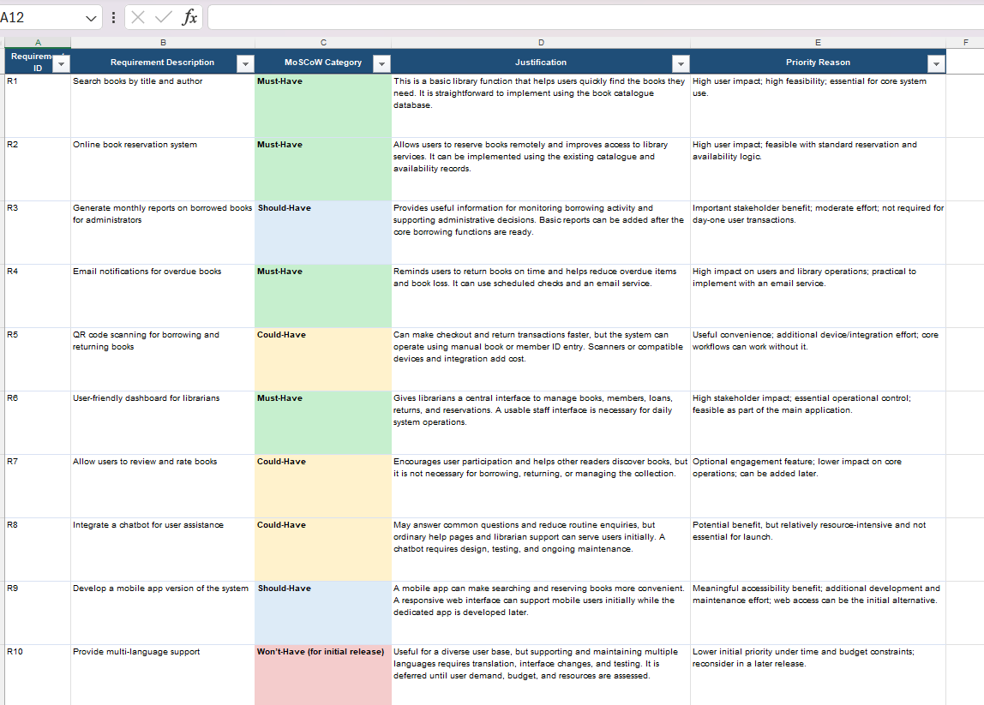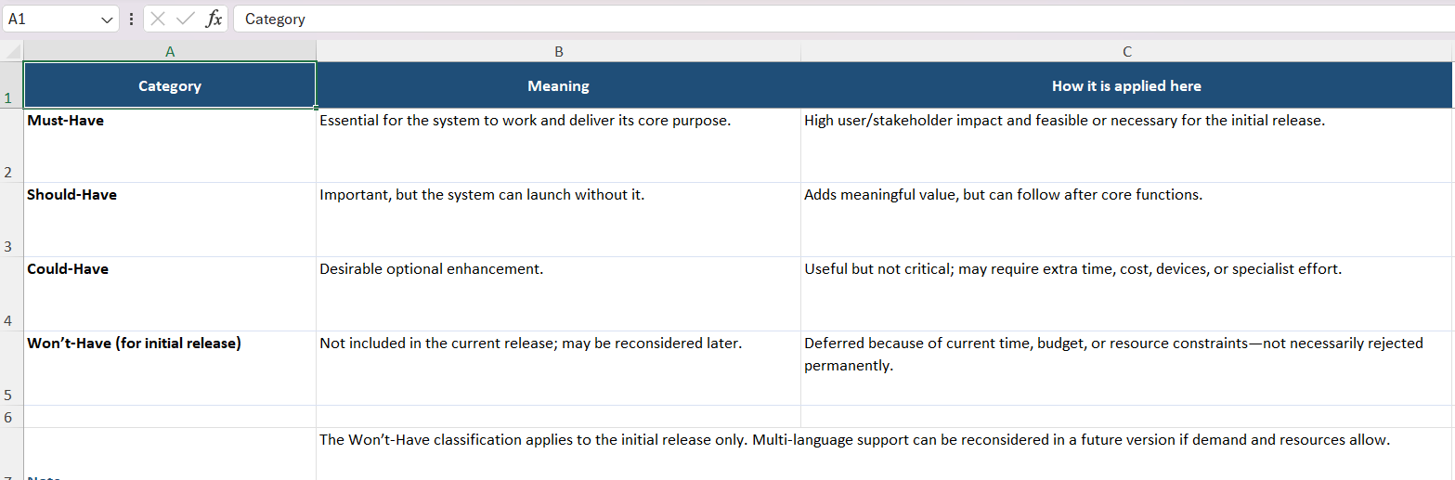Result
Thus, the Library Management System requirements were successfully categorized using the MoSCoW method and documented in Google Sheets / Excel.

