A
Report
ON
Analyzing Income Tax on Reddit Using Data Scraping
Presented by:
M.SAI MOKSHITHA
AV.SC.U4CSE24151
DR.T K BALAJI
Asst. Professor (Sr.Gr.)



Department of Computer Science and Engineering
Amrita Vishwa Vidhyapeetham, Amaravathi

Amrita Vishwa Vidyapeetam

Analyzing Income Tax on Reddit Using Data Scraping

ABSTARCT:In this project I collected and studied what people talk about regarding income tax on Reddit.I have used computer programs to scrape many comments and posts where I have shared their questions worries and opinions about income tax.

Before moving on Reddit I initially tried scraping Twitter but could only collect around 3000 to 4000 tweets for this also I have followed many ways means I have used twitter, apify, tweepy,twint,ntscraper but with this they includes have less credentials.so I have used workflow of n8n so I have worked on that really in n8n I have scrapped but I need bulk of data so that ,I decided to concentrate on Reddit,which provided bulk of data .

After cleaning and organizing the Reddit data,I analyzed it to find popular topics and frequently encountered problems.Using graphs and charts,I demonstrated how people feel about income tax and which questions are most common.This work taught me important practical skills in gathering and analyzing social media and also I have gained experience in machine learning and deep learning and also word clouding .

INTRODUCTION:
Income tax is the money that usually people pay to the government based on their earning actually nowadays for everything the income tax is paid from base level product to marketing level product .The money collected by the government will be given to the schools,hospitals,road,and other facilities for all the common people .

Always this system is confusing be cause there will be rules and regulations means there will be different type of taxes like GST and also there will be income tax rides also if the people are purchasing items or more than their income so that the government will handover all the property by ceasing the property and also for starting people it is difficult to understand especially for the young professionals and first-time filers.

BASED ON SOCIAL MEDIA :
In social media every people share their live experiences what happened to them so there are many platforms like Instagram,Facebook,twitter,YouTube,reddit and many more so i have chosen reddit because we can scrape many comments with the help of reddit when we compare to other platforms .I have scrapped 85,000 above comments from the reddit platform .so to produce a detailed information about what is happening on the income tax I have chosen this platform by this we will obtain a clear information for taxpayers.

Facing issues with twitter scraping to overcome the limitation which iam getting only 3000 to 4,000 posts with n8n .So having many restrictions and also techinical difficulties I have choosen reddit for better and larger quality datset.so on scraping Reddit to analysis and to understand real people,s concern about income tax

LITERATE REVIEW:

To understand the importance and challenges of collecting data about income tax discussions on social media, I studied several research papers, articles, and reports that have used online platforms for analyzing public opinions about finance and taxes. This section presents a clear review of existing work related to social media scraping, finance discussions, and tax sentiment analysis.

Social Media Data and Finance Research:
Social media platforms like Twitter, Facebook, and Reddit have become powerful sources for studying public opinion because millions of users share their thoughts in real time.For example, researchers observed how tweets on tax policies reflect public frustration during tax season. However, Twitter data sometimes lacks depth because the messages are brief.

Unlike Twitter, Reddit contains longer posts and detailed comment threads. This makes Reddit especially useful for complex topics like income tax, where people need explanations and share experiences.Research shows that Reddit users in subreddits such as india Tax genuine doubts about tax forms, refund delays, and eligibility for deductions. This platform allows conversations to evolve over time, with users helping each other by answering questions and clearing confusions

Python libraries like PRAW (for Reddit) and Tweepy (for Twitter) have been widely used. These libraries allow programmatic access to public data, making large-scale studies possible. Many papers underline the need for proper data cleaning before analysis due to noise like spam, irrelevant posts, or duplicates.

WORK ON SENTIMENT ANALYSIS:
Some studies have specially targeted income tax content online.For instance :
Many users complain about refund delays and complicates filing procedures and also people need clear explanation of income taxes
While social media finance research is growing, there are fewer detailed studies focused on Reddit discussions about Indian income tax. Most existing works study Twitter or Facebook. Reddit’s discussion format offers a richer data source that can provide insights missed in shorter messages

Indian income taxpayers’ concerns, applying modern text analysis methods to understand sentiment and topics raised by real users

METHODOLOGY/IMPLEMENTATION:
This section consists of the step by step details of project and whole workflow in a detailed way.it consists of setting up environment and downloading the required libraries and obtaining comments and then doing processioning of the comments and posts.we got a clear data and then the terms like post-tittle,Post Id,comment,Author-id,Body,preprocessed Text.

- Setting Up the Environment:
Before starting, I installed the necessary Python libraries to work with Reddit data:
PRAW (Python Reddit API Wrapper) for collecting Reddit posts and comments.
pandas for handling data tables.
Text-blob and NLTK for text and sentiment analysis.
sklearn for machine learning models.
matplotlib and sea-born for making graphs.
I also created a Reddit developer account and made an app to get credentials (client_id, client_secret) required to connect pro-grammatically to Reddit.

- Data Collection with PRAW:
Using PRAW, I connected to Reddit with a read-only mode that lets you access public posts and comments but nothing private. I focused on sub reddits where Indian taxpayers discuss income tax, like r/India-tax.I searched for posts containing keywords such as “income tax,” “ITR,” “refund,” and “deduction.”

FLOWCHART:
Start

Data collection via Reddit
PRAW.

Data cleaning,remove
empty,duplicate

Feature Extract and count
vectorizer

Model training and graphs
visualizing

Results and conclusion

END

Example Python snippet I used:
Step1:Install required Libraries
!pip install pandas openpyxl

Step2:Load Existing Data or Create a new Data Frame
import pandas as pd

import pandas as pd
try:
# Try loading from an existing file
df = pd.read_csv('reddit_posts.csv', encoding='utf-8')
except FileNotFoundError:
# If file doesn't exist, create an empty DataFrame
df = pd.DataFrame(columns=[
"Post ID", "Post Title", "Comment ID", "Author", "Created At", "Body", "prepossessed_text"
])
import praw
# Replace the below with your own Reddit app credentials
reddit = praw.Reddit(
client_id='my_1234567890',
client_secret='abc123def456ghi789',
user_agent='my-reddit-test-useragent'
)

subreddit = reddit.subreddit('IndiaTax')

posts = []
for post in subreddit.search('income tax', limit=5): # Example: Only fetching 5 for demonstration
posts.append([
post.id,
post.title,
'', # Comment ID ('' here, you can expand to fetch comments too)
str(post.author),
post.created_UTC,
post.selftext, # Body
post.self-text # prepossessed_text (here just a copy; replace with actual prepossessed text logic)
])

# Convert posts to Data-frame and concatenate to the original df
posts_df = pd.DataFrame(posts, columns=df.columns)
df = pd.concat([df, posts_df], ignore_index=True)

print(df.head())

Step3:Preprocess the Text
def preprocess(text):
text = str(text)
text = text.lower()
text = re.sub(r'http\S+', '', text) # Remove URLs
text = re.sub(r'[^a-z0-9\s]', '', text) # Remove special characters
text = re.sub(r'\s+', ' ', text) # Remove extra whitespace
return text.strip()

df['preprocessed_text'] = df['Body'].apply(preprocess)
print("Preprocessed all Body text.")

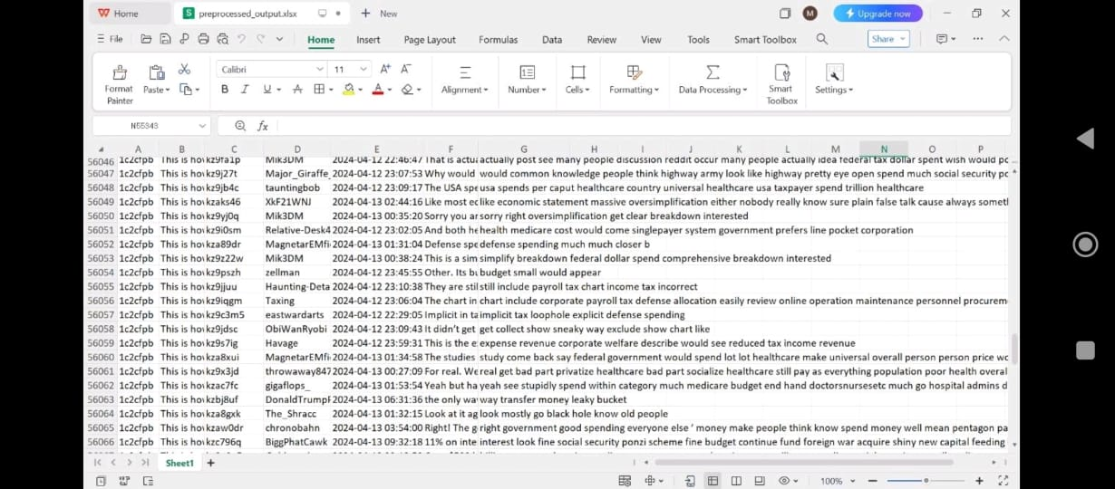

Step4:Update the existing Rows
df.loc[df['Post ID'] == 'abc123', 'Body'] = "Update: My refund arrived after 7 months!"
df.loc[df['Post ID'] == 'abc123', 'preprocessed_text'] = preprocess("Update: My refund arrived after 7 months!")
print("Updated existing row matching Post ID abc123.")

Step5:Save to csv or Excel:

df.to_csv('reddit_posts_updated.csv', index=False, encoding='utf-8')
df.to_excel('reddit_posts_updated.xlsx', index=False, engine='openpyxl')
print("Saved to reddit_posts_updated.csv and reddit_posts_updated.xlsx")
This process is for just collecting for the preprocessing data only for the sentiment analysis we have used

TEXT ANALYTICS PREPARATION(FEAUTURE EXTRACTION):
After cleaning the dataset and making collecting the information of income tax we go deepper analysis.means we have gone through the machine learning which do not work directly with text so for that we need to convert the text into numbers for each post.For this we use a methos called “Bag of Words”approach.

This process turns thousands of posts into a big table where each row shows a post, and each column represents a unique word found across all posts. The number in each table cell tells how many times a certain word was used in that post. To make the data cleaner and more meaningful, common words like "the", "is", and "and" (called stop words) are removed because they do not add useful information. We also convert all words to lowercase so that the same word is counted consistently regardless of capitalization.

This numerical representation allows machine learning models to analyse patterns and relationships within and also for the further methods like sentiment detection and more effective

SENTIMENT ANALYSIS:
Sentiment analysis means figuring out how people feel when they write a post. For example, are they happy, angry, confused, or neutral about income tax? To do this, we calculate a sentiment score for each post's text. Tools like TextBlob assign a polarity score between -1 and 1, where negative values mean unhappy or negative sentiment, zero means neutral, and positive values indicate happiness or satisfaction. By adding a label like "positive," "neutral," or "negative" to each post based on its polarity, we can group all the posts by feelings. This is useful to see if people mostly complain about tax problems or share positive experiences. Although simple methods work fairly well, sentiment analysis can struggle with sarcasm, jokes, or complex expressions. But overall, it is a quick way to get a sense of public mood towards tax topics.

MODEL BUILDING,TRAINING AND EVALUATION USING NAVIE BAYES:

When I began working on sentiment analysis for Reddit posts about income tax, I explored multiple models to find which one would give the best results. I tested five different approaches including Naive Bayes, Random Forest, Support Vector Machine (SVM), Logistic Regression, and also used TextBlob and VADER, which are popular sentiment analysis tools. Each model has its own strengths and weaknesses; some are better at handling certain types of text or larger datasets, while others can be faster or more accurate depending on the data.
After experimenting with all these models on my cleaned Reddit dataset, which contained a variety of posts expressing different emotions and opinions about taxes, I closely evaluated their performance based on accuracy metrics—how often the model's predicted sentiment matched the actual sentiment. Naive Bayes stood out as the most accurate and reliable for this particular dataset. It was able to correctly classify the posts into positive, neutral, and negative sentiments with greater precision than the other models. This is likely because Naive Bayes works very well for text data where word frequencies can strongly indicate the sentiment class.

WORKING WITH NAVIE BAYES:
After assigning sentiment labels to each post, I used these labeled data to train a machine learning model called Naive Bayes, which is widely used for text classification tasks because it is fast and effective. Naive Bayes models work by learning the probability of words appearing in positive, neutral, and negative posts and then using this to predict the sentiment of new posts.
To build and test the model properly, the dataset is split into two parts: a training set (about 70% of the data) and a testing set (the remaining 30%). The training set teaches the Naive Bayes algorithm how to associate word patterns with sentiment labels. Once the model is trained, it predicts the sentiment of the posts in the testing set, which the model has never seen before. This simulates how well the model might perform on completely new data.
The performance of the model is measured using several important metrics:
Accuracy: tells us the overall percentage of posts for which the model correctly predicted the sentiment.
Precision: measures how many of the posts predicted as positive, neutral, or negative actually belong to those categories.
Recall explains how many of the actual positive, neutral, or negative posts were correctly found by the model.
F1-score: combines precision and recall into a single number to give a balanced evaluation.
Additionally, a confusion matrix is used to visualize the number of correct and incorrect predictions across the three sentiment categories. This helps identify which sentiments the model struggles to distinguish well (for example, sometimes neutral posts may be classified as negative).
Using Naive Bayes gave this project a simple yet powerful way to automatically detect sentiment in thousands of Reddit posts. The model’s accuracy, which was satisfactory for the size and diversity of the data, indicates that it can reliably classify user sentiments about income tax discussions while being efficient and straightforward to implement.
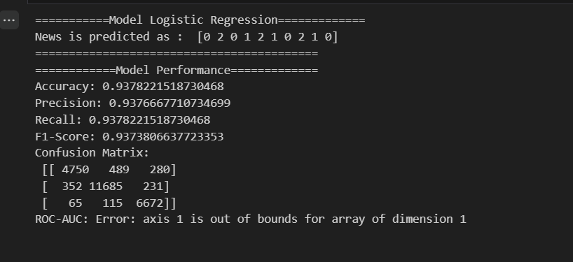

RESULTS AND VISUALIZATION:
To make the analysis understandable to everyone I have created several visualizations:

HISTOGRAM: A histogram showing the distribution of sentiments: how many posts were positive, neutral, or negative. This helps see quickly if people mostly feel frustrated, confused, or positive regarding income tax topics.
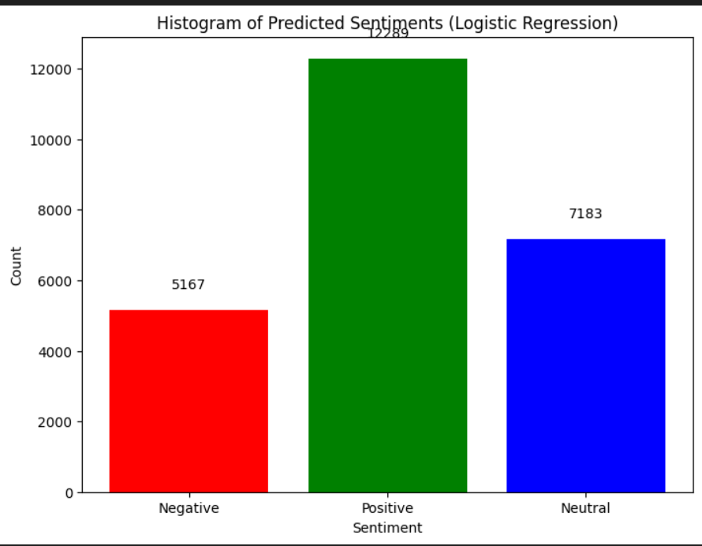
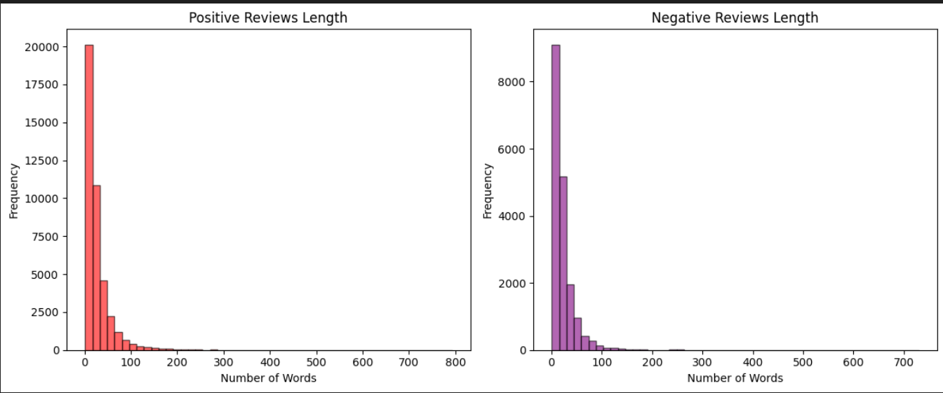

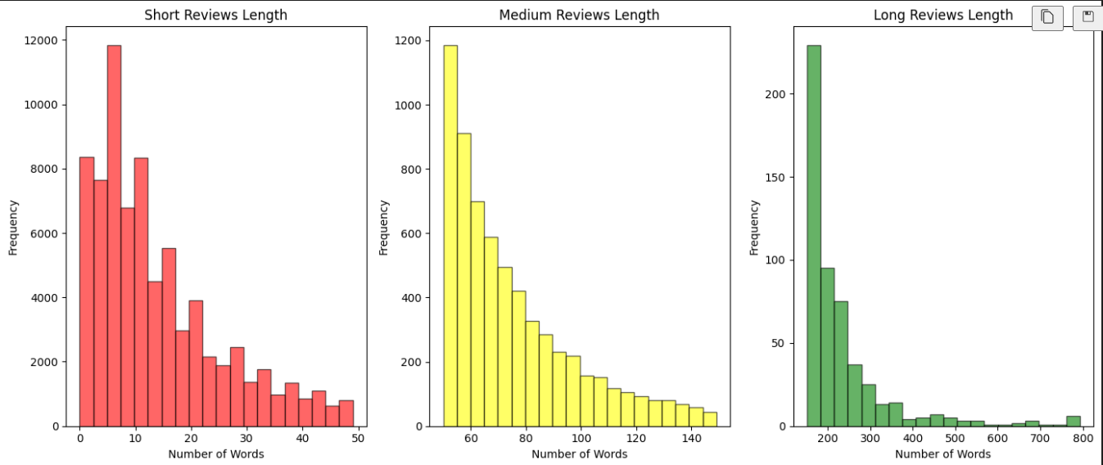

BAR GRAPHS:to highlight the most frequent words users used when discussing income tax, such as “refund”, “deadline”, or “deduction,” showing main concerns or interests.

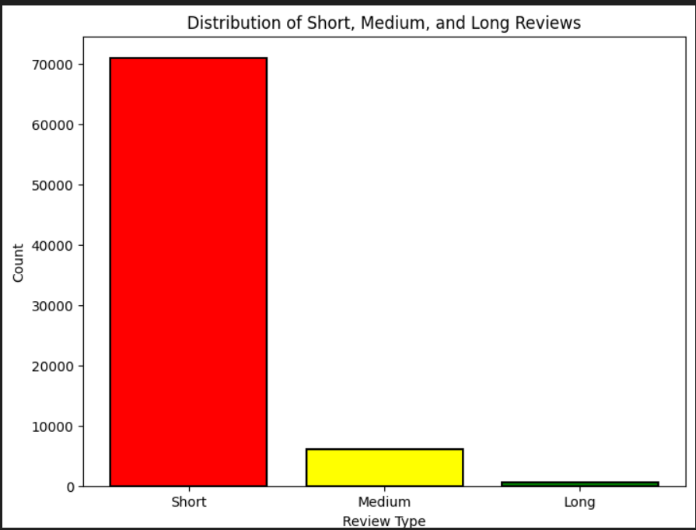

CONFUSION MATRIX CHART: visualizes how well the Naive Bayes model predicted sentiments compared to the actual labels in the test data
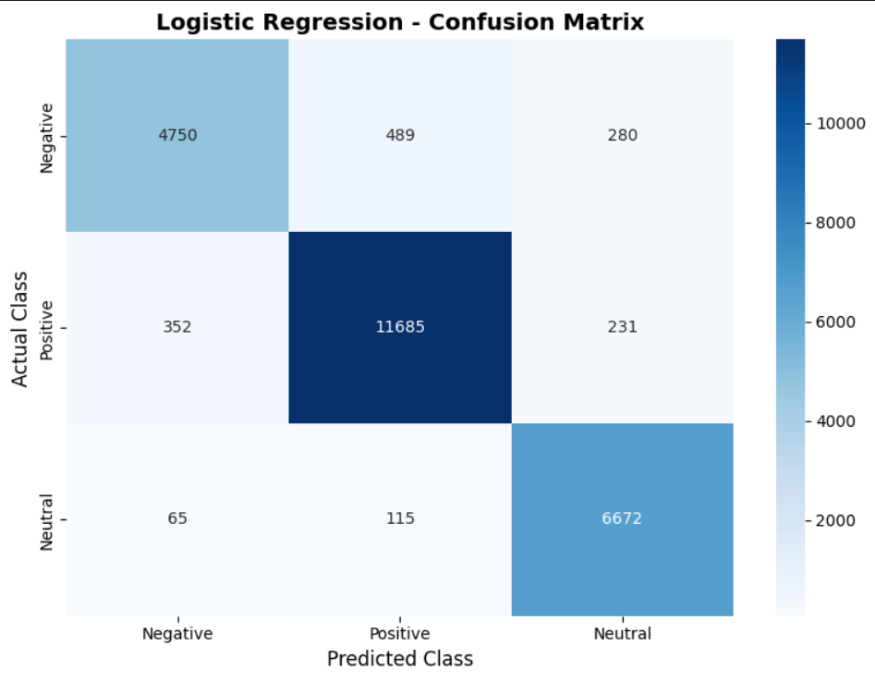

WORD CLOUD: A word cloud is a picture that shows which words appear most often in your data. The bigger a word looks in the cloud, the more times it appears in your comments.

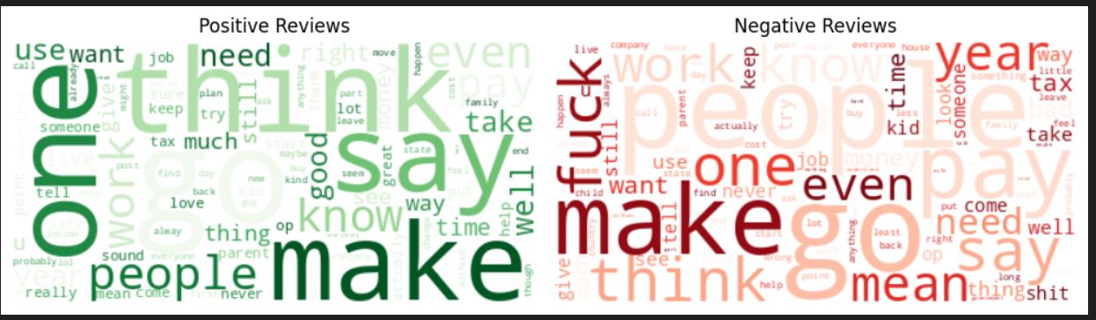
Result:
This project involved testing several models for sentiment analysis on Reddit posts about income tax, including Naive Bayes, Random Forest, Support Vector Machine (SVM), Logistic Regression, and tools like Text Blob and VADER. After carefully evaluating their accuracy on the data, I found that Naive Bayes gave the best results for my data set. Its strength lies in handling text data effectively by using the probability of words appearing in positive, negative, or neutral posts to classify sentiment. Choosing Naive Bayes as my working model, I input my processed Reddit posts into it to predict the sentiment values of each post.
Following sentiment prediction, I generated various visualizations such as sentiment histograms and graphs that clearly showed how Reddit users felt about income tax topics. The histograms illustrated the proportion of positive, neutral, and negative sentiments, highlighting that most posts tended to be neutral or negative, indicating common user concerns or frustrations. This process not only confirmed the model’s reliability but also gave insights into the collective mood of taxpayers discussing their experiences and questions online.
Overall, this project demonstrated how combining data collection, text p reprocessing, and model evaluation can lead to meaningful sentiment insights on social media data. The Naive Bayes model’s good accuracy ensures that the sentiment classifications are trustworthy, enabling better understanding of user sentiments. These insights can help policymakers, educators, and service providers grasp public opinion and improve how tax information and support are delivered, making it easier for people to navigate the complex topic of income tax.

