- #include <stdio.h>
#include <sys/types.h>
#include <sys/stat.h>

int main()
{
if (mkfifo("myfifo", 0666) == -1)
{
perror("mkfifo");
return 1;
}

printf("FIFO created\n");

return 0;
}

- FIFO_READ
#include <stdio.h>
#include <fcntl.h>
#include <unistd.h>

int main()
{
int fd;
char buffer[100];

fd = open("myfifo", O_RDONLY);

read(fd, buffer, sizeof(buffer));

printf("Received: %s\n", buffer);

close(fd);

return 0;
}

- FIFO_write.c

#include <stdio.h>
#include <fcntl.h>
#include <unistd.h>
#include <string.h>

int main()
{
int fd;
char message[] = "Hello from Writer";

fd = open("myfifo", O_WRONLY);

write(fd, message, strlen(message) + 1);

close(fd);

printf("Message sent\n");

return 0;
}
New terminal
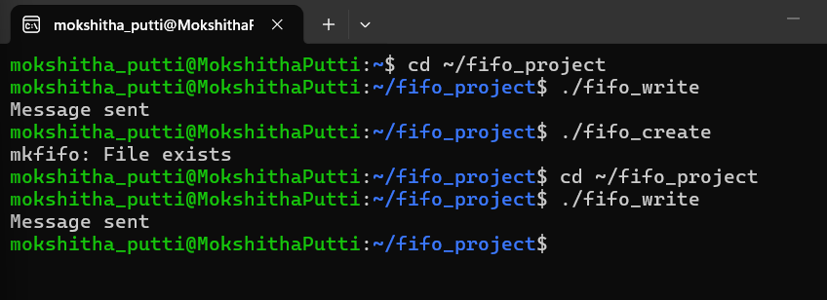

Other terminal
