25MT1306E - Mathematics for Data Science and Analytics
Project Report
on
Vehicle Price Analysis
Using Mathematical and Statistical Methods
Under the Guidance of

Dr. M P Mallesh
(Course Faculty)

Mr. M. Nagesh
(Project Guide)
Department of Mathematics

Submitted By
Mokshith M | 2510030184
Aneesha M | 2510030375
T Ashish Reddy | 2510080030



Department Of Mathematics
K L Deemed to be University
Aziznagar, Moinabad, Hyderabad – 500075
June 2026

BONAFIDE CERTIFICATE
This is to certify that the project titled "Vehicle Price Analysis Using Mathematical and Statistical Methods" is a bonafide record of the work done by
Mokshith M 2510030184
Aneesha M 2510030375
T Ashish Reddy 2510080030
in partial fulfilment of the requirements for the course 25MT1306E - Mathematics for Data Science and Analytics during the academic year 2025-2026.
____________________ | ____________________
Project Guide | Head of Department

Project Submitted on ____________________
Internal Examiner | External Examiner

ACKNOWLEDGEMENT
We express our sincere gratitude to the Department of Mathematics for providing us with the opportunity to complete this project as a part of the Mathematics for Data Science and Analytics course. This project helped us understand how mathematical and statistical concepts can be applied to a real-world vehicle pricing problem rather than remaining only as theoretical classroom topics.
We are deeply thankful to our faculty members, Dr. M. P. Mallesh and Mr. M. Nagesh, for their constant guidance, valuable suggestions, and encouragement throughout the project. Their academic support helped us understand the practical application of mathematical, statistical, and data analytical concepts in solving real-world problems. Their guidance helped us organize the work into a proper analytical sequence consisting of data cleaning, exploratory data analysis, probability analysis, statistical inference, regression modelling, and performance visualization.
We also thank K L Deemed to be University and the Department of Mathematics for providing the academic environment and resources required to complete this project. The project improved our practical understanding of Python libraries such as Pandas, NumPy, Matplotlib, Seaborn, SciPy, and Scikit-learn.
We extend our appreciation to all faculty members of the Department of Mathematics whose teaching and academic support throughout the course provided a strong foundation for this project. The concepts learned during classroom sessions played an important role in understanding data analysis, statistical reasoning, and predictive modelling techniques used in this study.
We acknowledge the open-source learning community and dataset providers for making structured data and documentation available. Working on this project helped us learn how raw data can be transformed into useful insights through systematic preprocessing, visualization, and model evaluation.
Finally, we thank all team members for their contribution, cooperation, and effort in completing the project successfully. Each stage of the project strengthened our understanding of data-driven decision making and predictive modelling.

ABSTRACT
This project presents a comprehensive mathematical and statistical analysis of a used vehicle dataset. The dataset contains vehicle-related attributes such as vehicle name, year of manufacture, selling price, kilometers driven, fuel type, seller type, transmission, ownership status, mileage, engine capacity, maximum power, torque, and seating capacity. After data cleaning and preprocessing, the final dataset contained 6,926 vehicle records.
The primary objective of this study is to analyze the factors influencing used vehicle selling prices and to develop a predictive regression model capable of estimating vehicle resale value. The analytical pipeline includes data cleaning, duplicate removal, missing value imputation, data type conversion, exploratory data analysis, probability analysis, statistical inference, and multiple linear regression modelling.
Exploratory Data Analysis (EDA) was performed to identify patterns, trends, and relationships among variables. Statistical techniques such as probability analysis, confidence interval estimation, hypothesis testing, and regression analysis were applied to derive meaningful insights from the dataset. Feature engineering was also performed to improve model performance and predictive capability.
The results indicate that selling price is significantly influenced by vehicle age, maximum power, engine capacity, mileage, and ownership history. By extracting vehicle brand and model information and applying appropriate preprocessing techniques, the final regression model achieved an R² score of approximately 0.804, demonstrating strong predictive performance. This project highlights the practical application of mathematical, statistical, and machine learning concepts in solving real-world data analytics problems and supporting data-driven decision making.

TABLE OF CONTENTS
Section | Title | Page
Chapter 1 | Introduction | 1
Chapter 2 | Data Cleaning and Preprocessing - M1 | 3
Chapter 3 | Exploratory Data Analysis - M2 | 7
Chapter 4 | Probability Analysis - M3 | 11
Chapter 5 | Statistical Inference - M4 | 13
Chapter 6 | Predictive Modeling and Regression Analysis - M5 | 14
Chapter 7 | Model Visualization and Performance Dashboard - M6 | 17
Chapter 8 | Final Project Conclusion | 18
References | References | 20
Appendix | Supporting Documentation and Project Notes | 21

List of Figures
Figure | Description
Figure 2.1 | Outlier Detection in Selling Price
Figure 2.2 | Outlier Detection in Kilometers Driven
Figure 2.3 | Outlier Detection in Maximum Power
Figure 3.1 | Distribution of Vehicle Selling Prices
Figure 3.2 | Fuel Type Distribution
Figure 3.3 | Transmission Type Distribution
Figure 3.4 | Correlation Heatmap of Numerical Features
Figure 3.5 | Selling Price vs Maximum Power
Figure 4.1 | Probability Analysis of Vehicle Characteristics
Figure 6.1 | Actual vs Predicted Vehicle Selling Price

1. Introduction

1.1 Background of the Topic
The used-vehicle market is an important part of the automobile industry because it allows buyers to purchase vehicles at lower prices and enables sellers to recover value from vehicles they no longer need. However, deciding a fair resale price is difficult because the value of a vehicle depends on many interrelated factors. These include the year of manufacture, kilometers driven, fuel type, transmission type, ownership history, engine capacity, maximum power, brand, and vehicle model.
Mathematical and statistical methods provide a structured way to analyze such price-related data. Instead of relying only on guesswork, historical records can be used to identify patterns and build models that estimate selling price. This project demonstrates how data science techniques can convert raw vehicle data into meaningful insights and predictive models.
The dataset is suitable for this analysis because it contains both numerical and categorical attributes. Numerical variables such as selling price, kilometers driven, mileage, engine capacity, and maximum power help quantify vehicle specifications, while categorical variables such as fuel type, seller type, transmission, owner category, brand, and vehicle model capture market identity and buyer preference.

1.2 Importance and Significance
Accurate vehicle price estimation is useful for buyers, sellers, dealerships, and online automobile platforms. Buyers can avoid overpaying, sellers can decide realistic asking prices, and platforms can recommend fair prices automatically. Statistical analysis also helps identify which features affect vehicle prices most strongly.
This project is significant because it connects course concepts such as probability, descriptive statistics, confidence intervals, hypothesis testing, correlation, and regression with a real-world pricing problem. The project also demonstrates how feature engineering can improve model performance beyond basic numerical analysis.
Significance of the Study
The study shows that vehicle price prediction improves when raw variables are combined with engineered features such as brand and detailed vehicle model. This makes the analysis more realistic because market identity strongly influences resale value.

1.3 Dataset Overview
Attribute Category | Examples | Purpose
Vehicle Identity | name, brand, car_model | Captures manufacturer and variant-level pricing information
Price and Usage | selling_price, km_driven, year | Measures resale value, vehicle age, and usage
Specifications | mileage, engine, max_power, torque, seats | Represents performance and physical characteristics
Market Categories | fuel, seller_type, transmission, owner | Captures buyer preference and ownership conditions

After cleaning, the dataset contained 6,926 records. The final analysis focused on the selling price as the target variable. Important predictor variables included year, kilometers driven, mileage, engine capacity, maximum power, seats, fuel type, transmission type, seller type, ownership category, brand, and detailed vehicle model.

1.4 Problem Statement
Can we analyze the used-vehicle dataset to identify the major factors affecting selling price and build a regression model capable of predicting vehicle resale value with reasonable accuracy?

1.5 Objectives
No. | Objective
1 | Clean and preprocess the dataset by handling missing values, duplicates, and inconsistent data types.
2 | Perform exploratory analysis to understand distributions, outliers, and relationships.
3 | Apply probability analysis to quantify the likelihood of important vehicle characteristics.
4 | Use statistical inference to estimate and test meaningful price-related conclusions.
5 | Build and compare multiple regression models for vehicle price prediction.
6 | Improve model performance using feature engineering and summarize results using a dashboard.

1.6 Tools and Libraries
Library | Purpose
Python | Core programming language used for analysis and modeling
Pandas | Data loading, cleaning, manipulation, and tabular analysis
NumPy | Numerical computation and array operations
Matplotlib | Base plotting library for charts and visualizations
Seaborn | Statistical visualization including heatmaps and regression plots
SciPy | Statistical inference including confidence interval and t-test
Scikit-learn | Train-test split, linear regression, and model evaluation metrics

2. Data Cleaning and Preprocessing - M1
Data cleaning is the foundation of any data science project. Raw datasets often contain missing values, duplicate records, inconsistent data types, and outliers. If these issues are not handled properly, later stages such as EDA, statistical inference, and regression modeling may produce unreliable results. In this project, the cleaning stage focused on preparing the vehicle dataset for mathematical and statistical analysis.

2.1 Loading the Dataset
The dataset was loaded using Pandas. After loading, the shape, first few rows, column names, and data types were inspected. This helped identify which variables were numerical and which variables were categorical.
# Step 1: Read the data
df = pd.read_csv('Vehicle details v3.csv')
# Step 2: Check shape and preview
print(df.shape)
print(df.head())
print(df.info())
The initial dataset contained more than 8,000 records before duplicate removal. After cleaning and removing repeated rows, 6,926 valid records were retained for the final analysis.

2.2 Handling Missing Values
Missing values were checked column-wise using isnull().sum(). Numerical columns were filled using the median because the median is less affected by extreme values. Categorical columns were filled using the mode because it represents the most frequent category.
# Fill numerical columns with median
num_cols = df.select_dtypes(include='number').columns
df[num_cols] = df[num_cols].fillna(df[num_cols].median())
# Fill categorical columns with mode
cat_cols = df.select_dtypes(include='object').columns
for col in cat_cols:
df[col] = df[col].fillna(df[col].mode()[0])
This ensured that no missing values remained before the dataset was used for analysis and modeling.

2.3 Removing Duplicate Records
Duplicate records can distort analysis by giving repeated observations extra weight. The dataset contained 1,202 duplicate records. These were removed using drop_duplicates(), and the index was reset.
# Check and remove duplicates
print(df.duplicated().sum())
df.drop_duplicates(inplace=True)
df.reset_index(drop=True, inplace=True)
print(df.duplicated().sum())
After duplicate removal, the dataset became more reliable and represented unique vehicle records only.

2.4 Data Type Conversion
Some important numerical variables were stored as object/string values because they contained units such as 'kmpl', 'CC', and 'bhp'. These unit strings were removed and the columns were converted into numerical format.
df['mileage'] = df['mileage'].str.replace(' kmpl', '')
df['mileage'] = pd.to_numeric(df['mileage'], errors='coerce')
df['engine'] = df['engine'].str.replace(' CC', '')
df['engine'] = pd.to_numeric(df['engine'], errors='coerce')
df['max_power'] = df['max_power'].str.replace(' bhp', '')
df['max_power'] = pd.to_numeric(df['max_power'], errors='coerce')
This conversion was essential because mathematical calculations, correlation analysis, and regression modeling require numeric input values.

2.5 Outlier Detection
Outliers were studied using boxplots. Outliers are not always errors; in vehicle pricing, they may represent luxury cars, unusually high mileage vehicles, or high-performance vehicles. Therefore, the project identifies and interprets outliers instead of blindly deleting them.
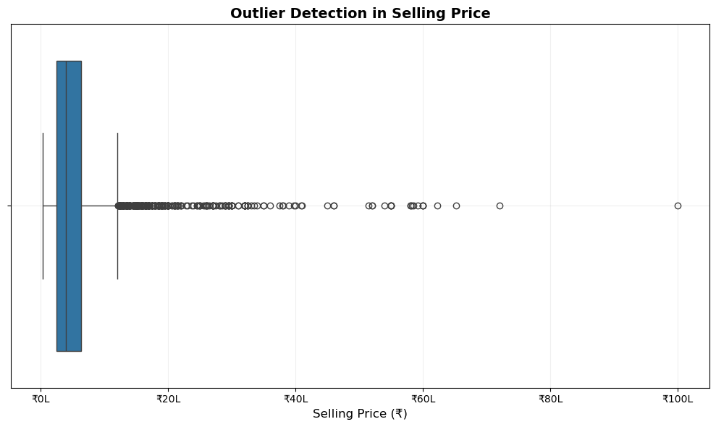
Figure 2.1: Outlier Detection in Selling Price
Diagram Description: This boxplot shows the spread of selling prices in the cleaned dataset. The majority of vehicles are concentrated in the lower price range, while several points lie far to the right of the whisker.
Interpretation: The extreme values represent premium or luxury vehicles with unusually high resale prices. These values explain why the selling price distribution is positively skewed and why median-based methods are useful during cleaning.
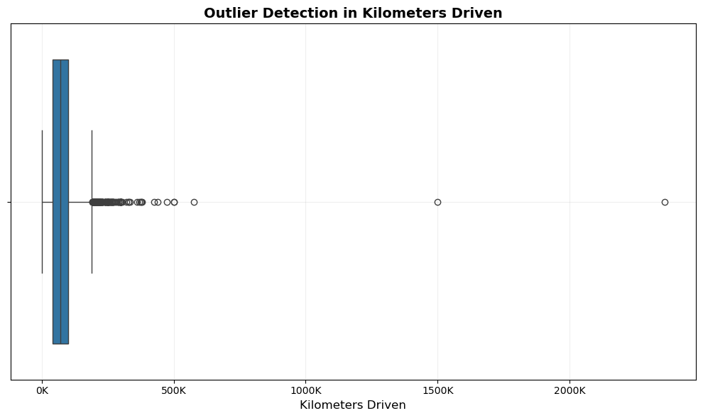
Figure 2.2: Outlier Detection in Kilometers Driven
Diagram Description: This boxplot displays the distribution of kilometers driven. Most vehicles fall within a moderate usage range, while some records show very high kilometer readings.
Interpretation: High kilometer values may represent older commercial or heavily used vehicles. These values are important because usage directly affects resale value and buyer preference.
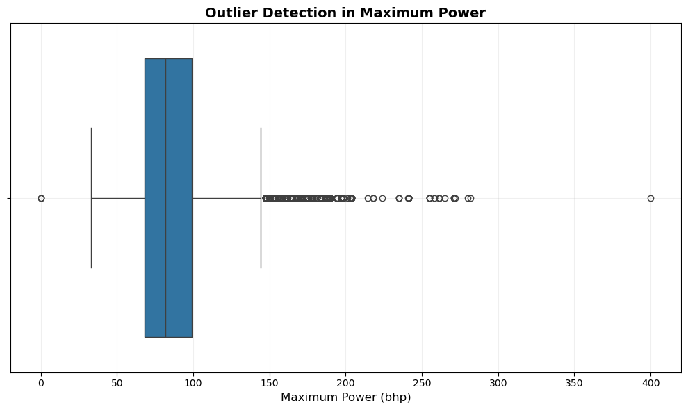
Figure 2.3: Outlier Detection in Maximum Power
Diagram Description: This boxplot shows the distribution of maximum power values measured in bhp. A few high-power vehicles appear as outliers.
Interpretation: High maximum power values usually correspond to premium or performance-oriented vehicles. These outliers are meaningful market observations rather than simple data errors.

2.6 M1 Summary
Cleaning Step | Result
Missing values | Handled using median and mode imputation
Duplicates | 1,202 duplicate records removed
Data type conversion | mileage, engine, and max_power converted to numeric
Outlier analysis | Performed using boxplots for selling_price, km_driven, and max_power
Final dataset | 6,926 cleaned records

M1 Observation
The dataset became clean, consistent, and ready for further analysis. The presence of outliers was expected in a used-vehicle dataset because premium vehicles, high-mileage vehicles, and powerful vehicles naturally create extreme values.

3. Exploratory Data Analysis - M2
Exploratory Data Analysis (EDA) is used to understand the structure, distribution, and relationships within the dataset. In this project, EDA helped identify price patterns, category distributions, feature relationships, and potential predictors of selling price.

3.1 EDA Summary
Figure | Visualization | Key Insight
3.1 | Selling Price Histogram | Selling price is positively skewed
3.2 | Fuel Type Bar Chart | Diesel and Petrol vehicles dominate
3.3 | Transmission Bar Chart | Manual transmission is most common
3.4 | Correlation Heatmap | max_power has strongest positive correlation with price
3.5 | Selling Price vs Max Power | Higher power generally increases selling price

3.2 Selling Price Distribution
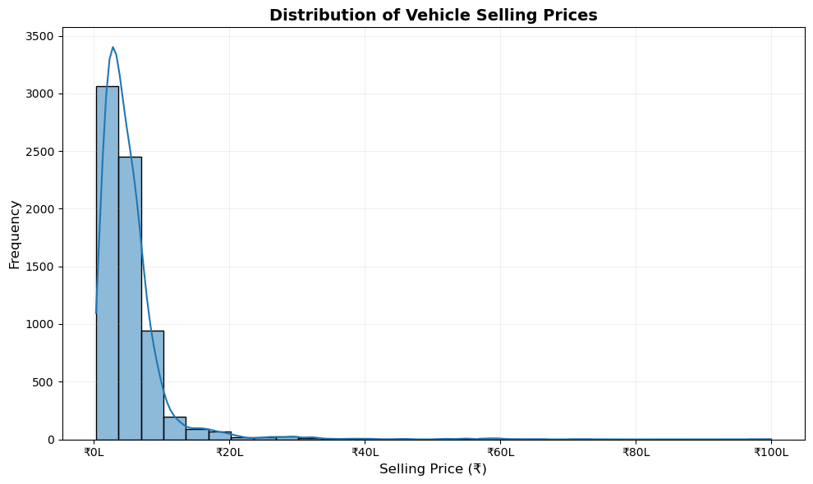
Figure 3.1: Distribution of Vehicle Selling Prices
Diagram Description: The histogram shows the distribution of selling prices after cleaning. Most vehicles fall in the lower and middle price ranges, while a smaller number of expensive vehicles extends the distribution to the right.
Interpretation: The distribution is right-skewed. The mean selling price is higher than the median, indicating that a few high-value vehicles increase the average price. This supports the use of median-based imputation during cleaning.

3.3 Fuel Type Distribution
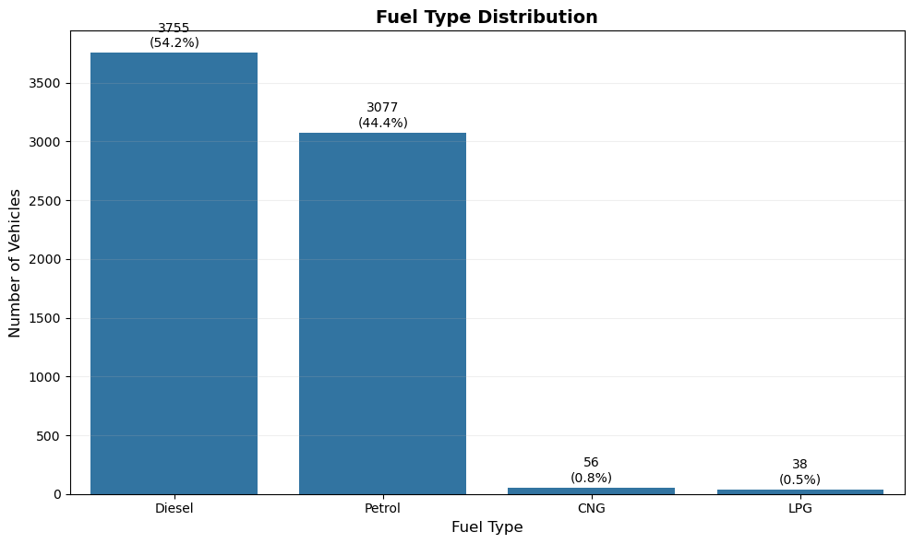
Figure 3.2: Fuel Type Distribution
Diagram Description: This bar chart shows the number and percentage of vehicles belonging to each fuel type category. Diesel and Petrol vehicles form the majority of the dataset.
Interpretation: Diesel vehicles slightly outnumber Petrol vehicles. CNG and LPG vehicles appear in much smaller proportions, showing that the used-vehicle market in this dataset is dominated by Diesel and Petrol vehicles.

3.4 Transmission Distribution
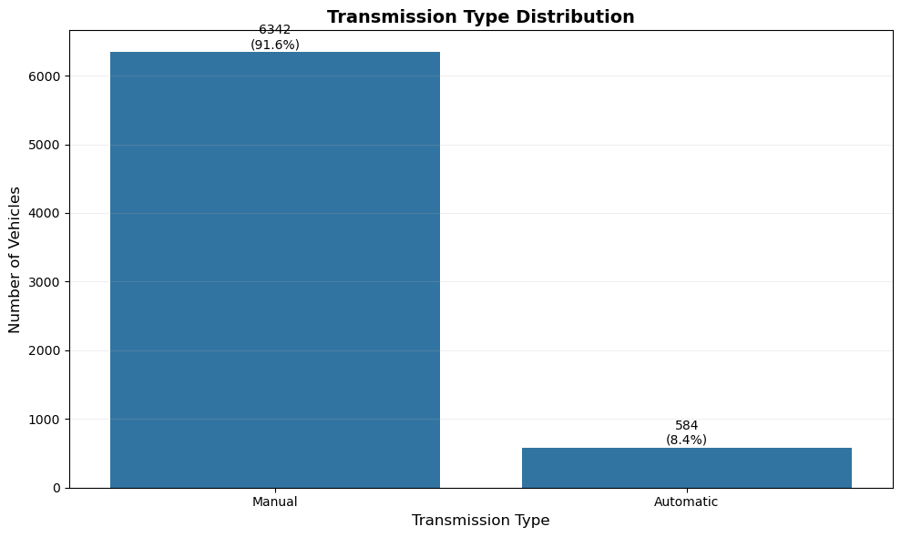
Figure 3.3: Transmission Type Distribution
Diagram Description: This chart compares the number of Manual and Automatic vehicles. Manual vehicles occur much more frequently than Automatic vehicles.
Interpretation: Manual transmission dominates the dataset with more than 91% probability of occurrence. This reflects common market conditions where manual vehicles are more common in used-vehicle listings.

3.5 Correlation Heatmap
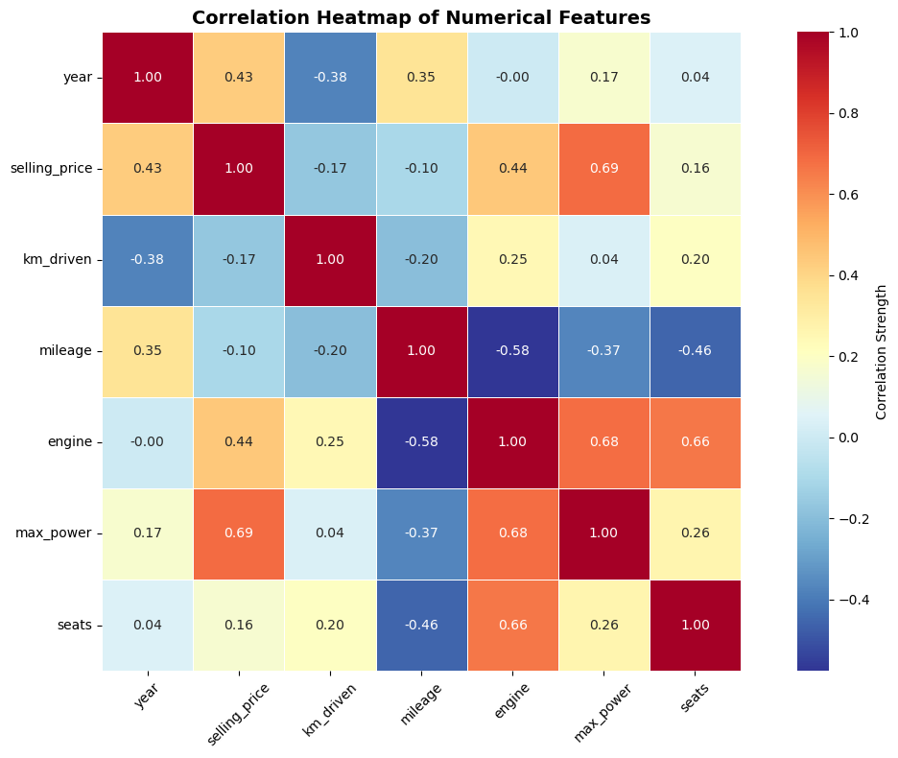
Figure 3.4: Correlation Heatmap of Numerical Features
Diagram Description: The heatmap shows Pearson correlation coefficients among numerical variables. Positive values indicate direct relationships and negative values indicate inverse relationships.
Interpretation: max_power shows the strongest positive correlation with selling price. Engine capacity and year also show moderate positive correlations, while kilometers driven has a weak negative relationship with selling price.

3.6 Selling Price vs Maximum Power
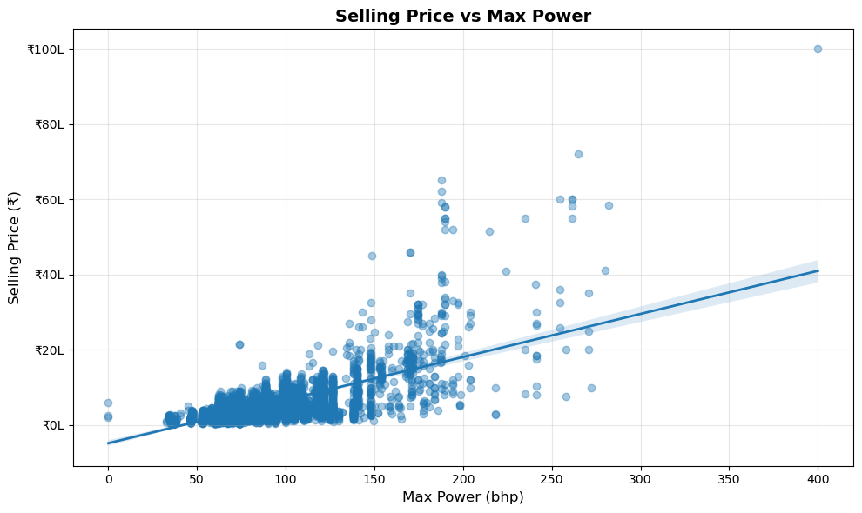
Figure 3.5: Selling Price vs Maximum Power
Diagram Description: The scatter plot compares maximum power against selling price. The trend line shows the overall direction of the relationship.
Interpretation: Vehicles with higher maximum power generally have higher selling prices. However, the spread of points shows that power alone is not enough to fully explain price variation; brand, model, year, and other factors also matter.

3.7 M2 Summary
The EDA stage revealed that the dataset is dominated by Diesel/Petrol vehicles and Manual transmissions. Selling price is positively skewed due to premium vehicles. Among numerical features, max_power, engine capacity, and year are the strongest predictors of selling price. EDA therefore guided feature selection for the regression modeling stage.
M2 Observation
The EDA results confirm that vehicle performance, age, and market identity influence used-vehicle selling prices. These findings motivated the inclusion of both numerical and categorical variables in later models.

4. Probability Analysis - M3
Probability analysis quantifies the likelihood of different vehicle characteristics occurring in the dataset. This helps transform categorical observations into measurable insights. In this project, probability was calculated for fuel type, transmission, ownership status, and seller type.

4.1 Basic Probability
The probability of an event is calculated as the number of favorable outcomes divided by the total number of observations. For example, the probability of selecting a Diesel vehicle is calculated as the number of Diesel vehicles divided by the total number of vehicles.
diesel_count = len(df[df['fuel'] == 'Diesel'])
total_count = len(df)
prob_diesel = diesel_count / total_count
manual_count = len(df[df['transmission'] == 'Manual'])
prob_manual = manual_count / total_count
Characteristic | Probability
Diesel vehicle | 54.22%
Petrol vehicle | 44.42%
Manual transmission | 91.57%
First owner vehicle | 61.25%
Individual seller | 89.78%

4.2 Probability Visualization
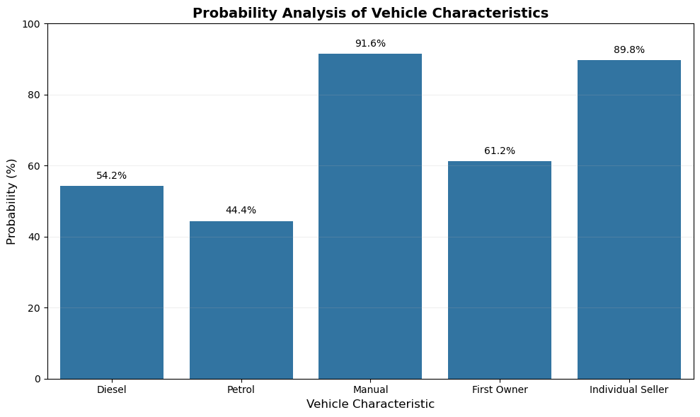
Figure 4.1: Probability Analysis of Vehicle Characteristics
Diagram Description: The bar chart compares the probability of major vehicle characteristics such as Diesel fuel, Petrol fuel, Manual transmission, First Owner vehicles, and Individual Seller listings.
Interpretation: Manual transmission and Individual Seller categories have the highest probabilities. This confirms that the dataset is heavily dominated by manually driven vehicles sold by individual sellers.

4.3 Interpretation of Probability Results
Probability analysis helps understand the expected composition of the dataset. For example, if one vehicle is randomly selected from the cleaned dataset, it is highly likely to be a Manual transmission vehicle and also likely to be sold by an Individual Seller. Such probability values are useful for understanding dataset imbalance and market representation.
The probability of selecting a First Owner vehicle is also high, indicating that many listings are relatively early in ownership history. Since ownership status can influence resale value, it becomes an important categorical variable for regression modeling.

4.4 M3 Summary
M3 Observation
Probability analysis showed that Manual transmission and Individual Seller vehicles dominate the dataset. Diesel vehicles are slightly more common than Petrol vehicles, and First Owner vehicles form a large portion of the records.

5. Statistical Inference - M4
Statistical inference allows conclusions to be drawn about the wider population using sample data. In this project, inference was used to estimate the average selling price and test whether the observed mean selling price differs significantly from a hypothesized value.

5.1 Mean Selling Price
The mean selling price of vehicles in the cleaned dataset was approximately Rs. 5.17 lakh. Since the dataset contains vehicles from many price ranges, including luxury vehicles, the mean is influenced by high-price outliers.
Metric | Value
Mean Selling Price | Rs. 5,17,271
95% Confidence Interval Lower Bound | Rs. 5,05,029
95% Confidence Interval Upper Bound | Rs. 5,29,512
t-statistic | 2.7653
p-value | 0.0057

5.2 Confidence Interval
A 95% confidence interval was calculated for the population mean selling price. The confidence interval ranged from approximately Rs. 5.05 lakh to Rs. 5.30 lakh. This means that based on the sample data, the true average used-vehicle selling price is expected to lie within this interval with 95% confidence.
mean_price = df['selling_price'].mean()
std_price = df['selling_price'].std()
n = len(df)
confidence_level = 0.95
t_value = stats.t.ppf((1 + confidence_level) / 2, n-1)
margin_error = t_value * (std_price / np.sqrt(n))
lower_bound = mean_price - margin_error
upper_bound = mean_price + margin_error

5.3 One-Sample t-Test
A one-sample t-test was performed using Rs. 5,00,000 as the hypothesized mean selling price. The null hypothesis assumed that the average selling price equals Rs. 5,00,000. The p-value obtained was 0.0057, which is less than 0.05.
Since the p-value is below the 5% significance level, the null hypothesis is rejected. This indicates that the average selling price in the dataset is statistically different from Rs. 5,00,000.

5.4 M4 Summary
M4 Observation
The statistical inference section confirmed that the mean selling price is approximately Rs. 5.17 lakh and is significantly different from the hypothesized value of Rs. 5,00,000. The confidence interval supports the reliability of this conclusion.

6. Predictive Modeling and Regression Analysis - M5
Predictive modeling was performed to estimate vehicle selling prices using Linear Regression. The target variable was selling_price, while predictor variables included numerical features, categorical features, and engineered features extracted from the vehicle name.

6.1 Regression Modeling Approach
Multiple regression models were developed using different combinations of features. The purpose was to observe how prediction performance changes as more relevant variables are included. The models were evaluated using MAE, MSE, RMSE, and R² Score.
Metric | Meaning
MAE | Average absolute prediction error
MSE | Average squared prediction error
RMSE | Error measure in the original price scale
R² Score | Proportion of price variation explained by the model

6.2 Feature Engineering
A major improvement in model performance came from feature engineering. Initially, the model used basic numerical variables such as engine capacity, maximum power, year, kilometers driven, mileage, and seats. However, used-vehicle prices depend strongly on vehicle identity. A budget hatchback, a mid-range sedan, and a premium SUV may have very different market values even when some numerical features overlap.
To capture this hidden information, the vehicle name column was used to extract brand and detailed vehicle model/variant information. These categorical values were then encoded using one-hot encoding and included in the regression model.
df_model['brand'] = df_model['name'].str.split().str[0]
df_model['car_model'] = (
df_model['name']
.str.split()
.str[1:4]
.str.join('_')
)
df_model = pd.get_dummies(
df_model,
columns=['fuel', 'seller_type', 'transmission', 'owner', 'brand', 'car_model'],
drop_first=True
)
Why Feature Engineering Worked
The name column contained important market information. By extracting brand and detailed vehicle model/variant, the model learned manufacturer-specific and model-specific pricing patterns that were not present in basic numerical variables alone.

6.3 Model Comparison
Rank | Model | Main Features | R² Score
1 | Model 8 | Numerical + categorical + brand + vehicle model | 0.804
2 | Model 6 | Numerical + fuel + transmission | 0.563
3 | Model 3 | Engine + max_power + year | 0.562
4 | Model 7 | Seller and owner added | 0.547
5 | Model 5 | Numerical + mileage + seats | 0.546
6 | Model 4 | Top numerical features | 0.545
7 | Model 1 | Max power only | 0.436
8 | Model 2 | Engine + max power | 0.435

6.4 R² = 0.804 Discussion
The final model achieved an R² score of approximately 0.804. This means that about 80.4% of the variation in vehicle selling price was explained by the selected features. The improvement was not random; it came from systematic model comparison and feature engineering.
The initial full numerical/categorical model gave moderate performance. After adding brand information, performance increased significantly because different manufacturers have different resale values. After adding detailed vehicle model and variant information, the model improved further because model-level identity captures features such as segment, popularity, market demand, and specification differences.
The model did not reach 100% because used-vehicle prices also depend on factors not present in the dataset, such as vehicle condition, accident history, service records, insurance status, exact location, negotiation, modifications, and current market demand.

6.5 Model Evaluation Summary
Final Metric | Value
Best Model | Model 8
R² Score | 0.804
RMSE | Rs. 2,07,320
MAE | Rs. 87,969
Total Features Used | 1,383

6.6 Actual vs Predicted Visualization
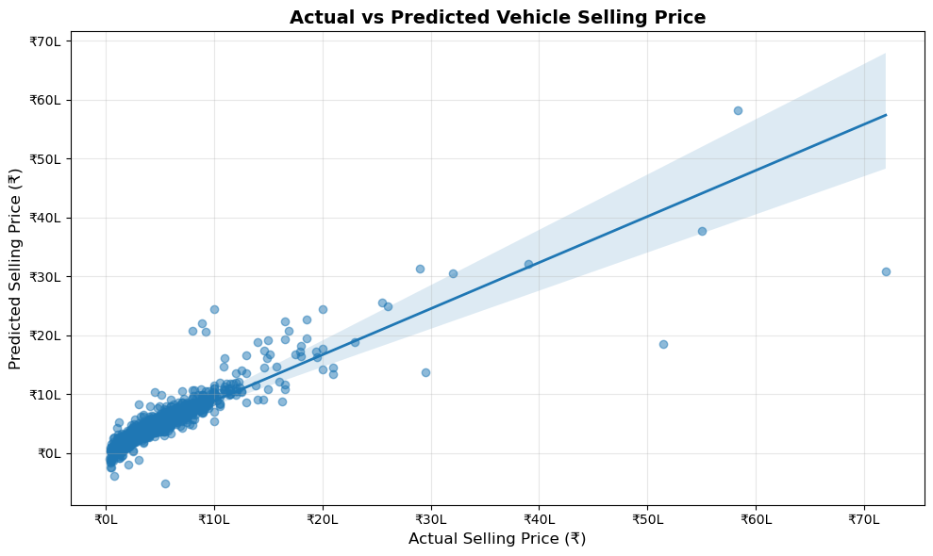
Figure 6.1: Actual vs Predicted Vehicle Selling Price
Diagram Description: This regression plot compares actual selling prices with predicted selling prices from the final model. The trend line shows the overall alignment between actual and predicted values.
Interpretation: The strong positive pattern indicates that the final regression model predicts vehicle prices reasonably well. Some spread remains, which is expected because real-world vehicle prices are affected by additional factors not present in the dataset.

6.7 M5 Summary
M5 Observation
Eight regression models were compared. Model 8 performed best after including numerical features, categorical features, brand information, and detailed vehicle model/variant features. The final R² score of 0.804 shows strong predictive performance for a real-world used-vehicle dataset.

7. Model Visualization and Performance Dashboard - M6
The final module summarizes the performance of the selected model visually and numerically. The Actual vs Predicted plot helps evaluate how closely predicted prices follow actual prices, while the dashboard presents the most important performance metrics in a compact format.

7.1 Dashboard Metrics
Metric | Value
Total Records | 6,926
Total Features Used | 1,383
Best Model | Model 8
R² Score | 0.804
RMSE | Rs. 2,07,320
MAE | Rs. 87,969

The dashboard confirms that the final model explains around 80% of price variation. RMSE and MAE show the average prediction errors in rupee terms, making the model results easier to interpret for real-world vehicle pricing.

7.2 Practical Interpretation
A mean absolute error of around Rs. 87,969 means that, on average, the model's predicted vehicle price differs from the actual selling price by about this amount. For a used-vehicle dataset containing both budget and premium vehicles, this is a reasonable error level.
The RMSE is higher than MAE because it gives more weight to large errors. Large errors are expected for luxury vehicles and unusual records because such prices depend on factors like vehicle condition, modifications, accident history, and exact variant details.

7.3 M6 Summary
M6 Observation
The dashboard and Actual vs Predicted plot confirm that the final model is effective for price estimation. The model is not perfect, but it provides a strong and explainable prediction system based on available vehicle characteristics.

8. Final Project Conclusion
This project successfully applied mathematical, statistical, and machine learning techniques to analyze a used vehicle dataset. The complete workflow included data cleaning, missing value treatment, duplicate removal, data type conversion, outlier analysis, exploratory data analysis, probability analysis, statistical inference, multiple regression modeling, and dashboard visualization.
Exploratory analysis revealed that selling prices are positively skewed and that most vehicles belong to the Diesel/Petrol and Manual transmission categories. The correlation heatmap showed that maximum power, engine capacity, and manufacturing year are important numerical predictors of selling price.
Probability analysis quantified the occurrence of important vehicle characteristics, while statistical inference provided confidence-based conclusions about the average selling price. The mean selling price was approximately Rs. 5.17 lakh, and the 95% confidence interval suggested that the true average used-vehicle selling price lies between Rs. 5.05 lakh and Rs. 5.30 lakh.
The strongest part of the project was predictive modeling. Multiple regression models were compared, and the best model achieved an R² score of approximately 0.804. This improvement was mainly achieved through feature engineering by extracting brand and detailed vehicle model information from the name column.
Overall, the project demonstrates that data science techniques can effectively support used-vehicle price estimation. The final model is explainable, statistically meaningful, and practically useful for understanding the major factors affecting resale value.

8.1 Key Outcomes
Outcome | Result
Cleaned records | 6,926
Duplicate rows removed | 1,202
Most common transmission | Manual
Dominant fuel categories | Diesel and Petrol
Strongest numerical correlation with price | max_power
Best model | Model 8
Final R² Score | 0.804

8.2 Limitations
Although the model performed well, some important real-world variables were not available in the dataset. These include accident history, service records, insurance status, physical condition, location-specific demand, number of previous repairs, and negotiation details. Including such features could further improve prediction accuracy.

8.3 Future Scope
Future work can include advanced algorithms such as Random Forest Regressor, Gradient Boosting, XGBoost, and CatBoost. These models can capture non-linear relationships better than Linear Regression. A web-based price prediction application can also be built using the final trained model.

References
No. | Reference
1 | Python Documentation - Core programming language used for analysis.
2 | Pandas Documentation - Data cleaning and manipulation.
3 | NumPy Documentation - Numerical computation.
4 | Matplotlib Documentation - Base plotting library.
5 | Seaborn Documentation - Statistical visualization.
6 | SciPy Documentation - Statistical inference and hypothesis testing.
7 | Scikit-learn Documentation - Regression model training and evaluation.
8 | Used Vehicle Dataset - Source dataset used for vehicle price analysis.

APPENDICES

Appendix A - Data Dictionary
This appendix summarizes the major variables used in the Vehicle Price Analysis project. The dataset contains both numerical and categorical attributes. Numerical variables are useful for mathematical calculations and regression analysis, while categorical variables help capture market segments and vehicle identity.
Column | Type | Description
name | Categorical | Full vehicle name containing brand, model, and variant information
year | Numerical | Manufacturing year of the vehicle
selling_price | Numerical | Target variable representing resale price
km_driven | Numerical | Total kilometers driven by the vehicle
fuel | Categorical | Fuel type such as Diesel, Petrol, CNG, or LPG
transmission | Categorical | Manual or Automatic transmission
owner | Categorical | Ownership history of the vehicle
mileage | Numerical | Fuel efficiency after unit cleaning
engine | Numerical | Engine capacity in CC after conversion
max_power | Numerical | Maximum power in bhp after conversion

The name column became especially important in the modeling stage because it contained hidden information about brand and vehicle model. Extracting this information helped improve the final R² score substantially.

Appendix B - Data Cleaning Checklist
The data cleaning stage ensured that the dataset was suitable for statistical analysis and machine learning. Each cleaning step had a specific purpose and directly improved the reliability of the project.
Cleaning Task | Action Taken | Reason
Missing values | Median/mode imputation | Preserves data while reducing distortion
Duplicate rows | 1,202 duplicates removed | Avoids repeated records influencing results
Text units | Removed kmpl, CC, bhp | Required for numerical analysis
Datatype conversion | Converted to numeric | Needed for correlation and regression
Outlier study | Boxplots used | Identifies extreme but meaningful vehicle records

The cleaning process was not limited to removing errors. In this dataset, some extreme values represented real market cases such as luxury vehicles or high-performance vehicles. Therefore, the project interpreted outliers carefully instead of blindly deleting them.
Code Used for Final Dataset Validation
print("Final Shape:", df.shape)
print("Missing Values:", df.isnull().sum().sum())
print("Duplicate Records:", df.duplicated().sum())
print(df.dtypes)

Appendix C - Detailed EDA Interpretation
Exploratory Data Analysis helped convert raw data into visual and statistical understanding. The selling price histogram showed right skewness, which is common in used-vehicle price datasets because most vehicles are affordable while a few premium vehicles create a long upper tail.
Fuel type and transmission distribution graphs revealed dataset imbalance. Diesel and Petrol vehicles dominated the fuel categories, while Manual transmission dominated the transmission category. These insights helped explain why categorical encoding was necessary before modeling.
The correlation heatmap showed that max_power had the strongest positive relationship with selling_price among the numerical variables. Engine capacity and year also showed useful positive relationships. This supported the selection of these variables in early regression models.
The Selling Price vs Max Power plot confirmed that powerful vehicles generally sell at higher prices. However, the scatter also showed variation, proving that power alone cannot explain resale price completely.
EDA Code Pattern
plt.figure(figsize=(10,6))
sns.histplot(df['selling_price'], bins=30, kde=True)
plt.title('Distribution of Vehicle Selling Prices')
plt.xlabel('Selling Price')
plt.ylabel('Frequency')
plt.show()

Appendix D - Probability Calculation Notes
Probability analysis was used to quantify the likelihood of different vehicle categories. The project calculated probabilities using the relative frequency method, where probability equals favorable outcomes divided by total observations.
Probability = Number of favorable outcomes / Total number of observations
Example:
P(Diesel) = Number of Diesel vehicles / Total number of vehicles
Event | Probability | Interpretation
Diesel vehicle | 54.22% | Diesel vehicles are slightly more common than Petrol vehicles
Petrol vehicle | 44.42% | Petrol vehicles are the second-largest fuel category
Manual transmission | 91.57% | Manual vehicles dominate the dataset
First owner vehicle | 61.25% | Most vehicles belong to the first-owner category
Individual seller | 89.78% | Most vehicles are sold by individual sellers

These probabilities helped describe the composition of the dataset mathematically and supported later interpretations about market representation.

Appendix E - Statistical Inference Notes
Statistical inference was used to draw conclusions about the broader vehicle population from the sample dataset. The confidence interval estimated the likely range of the true average selling price, while the one-sample t-test checked whether the observed mean differed significantly from a hypothesized value.
95% Confidence Interval:
mean ± t-critical * (standard deviation / sqrt(n))
One-sample t-test:
H0: mean selling price = Rs. 5,00,000
H1: mean selling price != Rs. 5,00,000
The p-value obtained from the t-test was 0.0057. Since this value is lower than 0.05, the null hypothesis was rejected. This means the average selling price in the dataset was statistically different from Rs. 5,00,000.
The 95% confidence interval ranged approximately from Rs. 5.05 lakh to Rs. 5.30 lakh, supporting the conclusion that the average price is close to Rs. 5.17 lakh.

Appendix F - Regression Model Progression
The regression modeling section followed a gradual model-building strategy. Instead of building only one model, multiple models were compared to understand how different sets of features affected predictive performance.
Stage | Feature Set | Purpose
Model 1 | max_power | Tests strongest single numerical predictor
Model 2 | engine + max_power | Adds engine capacity
Model 3 | engine + max_power + year | Adds vehicle age-related information
Model 4-7 | Numerical + categorical groups | Tests progressive feature combinations
Model 8 | Full model + brand + vehicle model | Final feature-engineered model

The final model performed best because it included both measurable vehicle specifications and vehicle identity features. This allowed the regression model to capture manufacturer and model-level effects.
Evaluation Function
def evaluate_model(features):
X = df_model[features]
y = df_model['selling_price']
X_train, X_test, y_train, y_test = train_test_split(
X, y, test_size=0.2, random_state=42
)
model = LinearRegression()
model.fit(X_train, y_train)
y_pred = model.predict(X_test)
mae = mean_absolute_error(y_test, y_pred)
mse = mean_squared_error(y_test, y_pred)
rmse = np.sqrt(mse)
r2 = r2_score(y_test, y_pred)
return mae, mse, rmse, r2

Appendix G - Feature Engineering Explanation
Feature engineering was the most important reason behind the improvement in R² score. The original dataset contained a name column with values that included brand, model, and variant details. This column was not directly usable by Linear Regression because it was text data.
The project extracted brand and detailed vehicle model/variant information from this column. These values were then converted into dummy variables using one-hot encoding. This gave the model access to market identity information that strongly affects resale value.
df_model['brand'] = df_model['name'].str.split().str[0]
df_model['car_model'] = (
df_model['name']
.str.split()
.str[1:4]
.str.join('_')
)
brand_cols = [col for col in df_model.columns if col.startswith('brand_')]
model_cols = [col for col in df_model.columns if col.startswith('car_model_')]
This transformation helped the model distinguish between vehicles belonging to different brands and variants, which is crucial in the used-vehicle market.

Appendix H - Model Limitations
Although the final model achieved an R² score of 0.804, it is not perfect. Real-world vehicle prices depend on many factors that were not available in the dataset.
Missing Factor | Possible Effect on Price
Vehicle condition | Accident-free and well-maintained vehicles sell for more
Service history | Regular service records increase buyer confidence
Location | Demand and pricing differ by city and region
Accident history | Damaged vehicles lose resale value
Insurance validity | Valid insurance can increase price
Negotiation | Actual sale price may differ from listed price

These missing variables explain why the model does not achieve 100% accuracy. An R² of around 0.80 is strong for a real-world used-vehicle dataset using Linear Regression.

Appendix I - Viva Preparation
This section contains concise answers to questions that may be asked during project presentation.
Question | Answer
Why did you use median imputation? | Median is less affected by outliers than mean.
Why remove duplicates? | Duplicate records can bias analysis and inflate sample size.
Why did R² improve? | Brand and vehicle model features captured hidden market information.
Why not 100% accuracy? | Important real-world factors such as condition and accident history are missing.
Which model was best? | Model 8 with numerical, categorical, brand, and vehicle model features.
What does R² = 0.804 mean? | The model explains about 80.4% of selling price variation.

The most important answer to remember is that the score improved because of feature engineering on the vehicle name column.
Short Viva Answer
The R² score improved to 0.804 because brand and detailed vehicle model information were extracted from the name column and encoded as additional features. These engineered features captured manufacturer-specific and model-specific price patterns, which basic numerical variables alone could not capture.

Appendix J - Final Submission Checklist
Before submitting the project, the following checks should be completed to ensure the report and notebook are consistent.
Checklist Item | Status
Notebook runs from top to bottom | Required
All graphs visible | Required
Final R² score shown as 0.804 | Required
M1-M6 observations included | Required
Dashboard metrics included | Required
Report PDF generated | Completed
Backup copy saved | Recommended

The project is ready for presentation once the notebook runs successfully after restarting the kernel and all outputs match the final report.

Appendix K - Extended Code Reference
This appendix preserves the key code structure used in the project. The purpose is not to reproduce every notebook cell, but to document the main analytical steps in a readable form.
Model Comparison Loop
results = []
for model_name, features in models.items():
mae, mse, rmse, r2 = evaluate_model(features)
results.append([
model_name,
len(features),
mae,
mse,
rmse,
r2
])
results_df = pd.DataFrame(
results,
columns=['Model', 'No. of Features', 'MAE', 'MSE', 'RMSE', 'R² Score']
)
results_df = results_df.sort_values(
by='R² Score',
ascending=False
).reset_index(drop=True)
This loop evaluated every model using the same train-test split and metrics. Keeping the evaluation process consistent ensured that the comparison between models was fair.

Appendix L - Best Model Summary Code
The final model summary presented the best model, R² score, RMSE, and MAE in a compact table. These values were later used in the dashboard section.
best_model_name = results_df.iloc[0]['Model']
best_r2 = results_df.iloc[0]['R² Score']
best_rmse = results_df.iloc[0]['RMSE']
best_mae = results_df.iloc[0]['MAE']
best_model_summary = pd.DataFrame({
'Metric': ['Best Model', 'R² Score', 'RMSE', 'MAE'],
'Value': ['Model 8', f'{best_r2:.3f}', rupees_short(best_rmse), rupees_short(best_mae)]
})
best_model_summary
This summary is useful in presentations because it focuses only on the final selected model rather than all intermediate models.

Appendix M - Dashboard Interpretation
The dashboard section summarized the entire modeling outcome in a small number of metrics. This is useful because decision-makers may not want to inspect all model details but still need to understand the final result.
Dashboard Metric | Meaning
Total Records | Number of cleaned records used in the project
Total Features Used | Number of columns used by the final model after encoding
Best Model | Highest-performing regression model
R² Score | Amount of price variation explained by the model
RMSE | Prediction error with strong penalty for large errors
MAE | Average absolute price prediction error

The dashboard also helped connect the technical model evaluation to a simple business interpretation. It showed that the final model explains around 80% of price variation while maintaining a reasonable average prediction error.

Appendix N - Final Presentation Script
This short presentation script can be used while explaining the project.
Our project is based on used-vehicle price analysis. We started by cleaning the dataset, removing duplicates, handling missing values, and converting important columns like mileage, engine, and max_power into numerical form.
After cleaning, we performed exploratory data analysis. We found that selling prices are right-skewed and that Diesel/Petrol vehicles and Manual transmission vehicles dominate the dataset. The correlation heatmap showed that max_power, engine, and year are important numerical predictors.
In probability analysis, we calculated the likelihood of important vehicle characteristics such as fuel type, transmission, seller type, and ownership category. In statistical inference, we estimated the average selling price and tested whether it was significantly different from Rs. 5,00,000.
For modeling, we built eight regression models. The biggest improvement came from feature engineering. We extracted brand and detailed vehicle model information from the name column and encoded it. This improved the final R² score to 0.804. This means our final model explains about 80.4% of variation in selling price.

