

SIMATS ENGINEERING
Department of Computer Science and Engineering
ASSIGNMENT – 4
Sub Code: CSA10 | Subject Name: Software Engineering

Q1. Mutation Testing and Fuzz Testing | 7 Marks | CO4

Mutation Testing and Fuzz Testing are both white/black-box testing techniques used to evaluate the quality of a test suite and the robustness of software respectively. While mutation testing measures how well existing tests detect small faults, fuzz testing actively searches for unexpected inputs that break a program. Together they strengthen both the reliability (correct functioning under expected and unexpected conditions) and security (resistance to malicious or malformed input) of a software system.

1.1 Mutation Testing
Mutation Testing is a white-box technique used to evaluate the effectiveness of a test suite. It works by deliberately introducing small, syntactic changes (faults) into the program's source code to create a number of faulty versions called mutants. Each mutant differs from the original program by one small modification, such as changing a relational operator, an arithmetic operator, or a logical condition.
The typical process followed in mutation testing is:
- Generate mutants: A mutation tool applies mutation operators (e.g., Arithmetic Operator Replacement – AOR, Relational Operator Replacement – ROR, Logical Connector Replacement – LCR) to the source code to create many mutant versions.
- Execute the test suite: The existing test suite is run against every mutant.
- Classify the result: If a test case fails on a mutant, the mutant is said to be “killed” — this shows the test suite can detect that fault. If all tests pass on the mutant (i.e., the fault goes unnoticed), the mutant “survives”, revealing a weakness in the test suite.
- Compute the mutation score: Mutation Score = (Number of Killed Mutants ÷ Total Number of Mutants) × 100. A higher score indicates a stronger, more fault-sensitive test suite.
- Strengthen tests: New test cases are written specifically to kill the surviving mutants, and the cycle repeats.
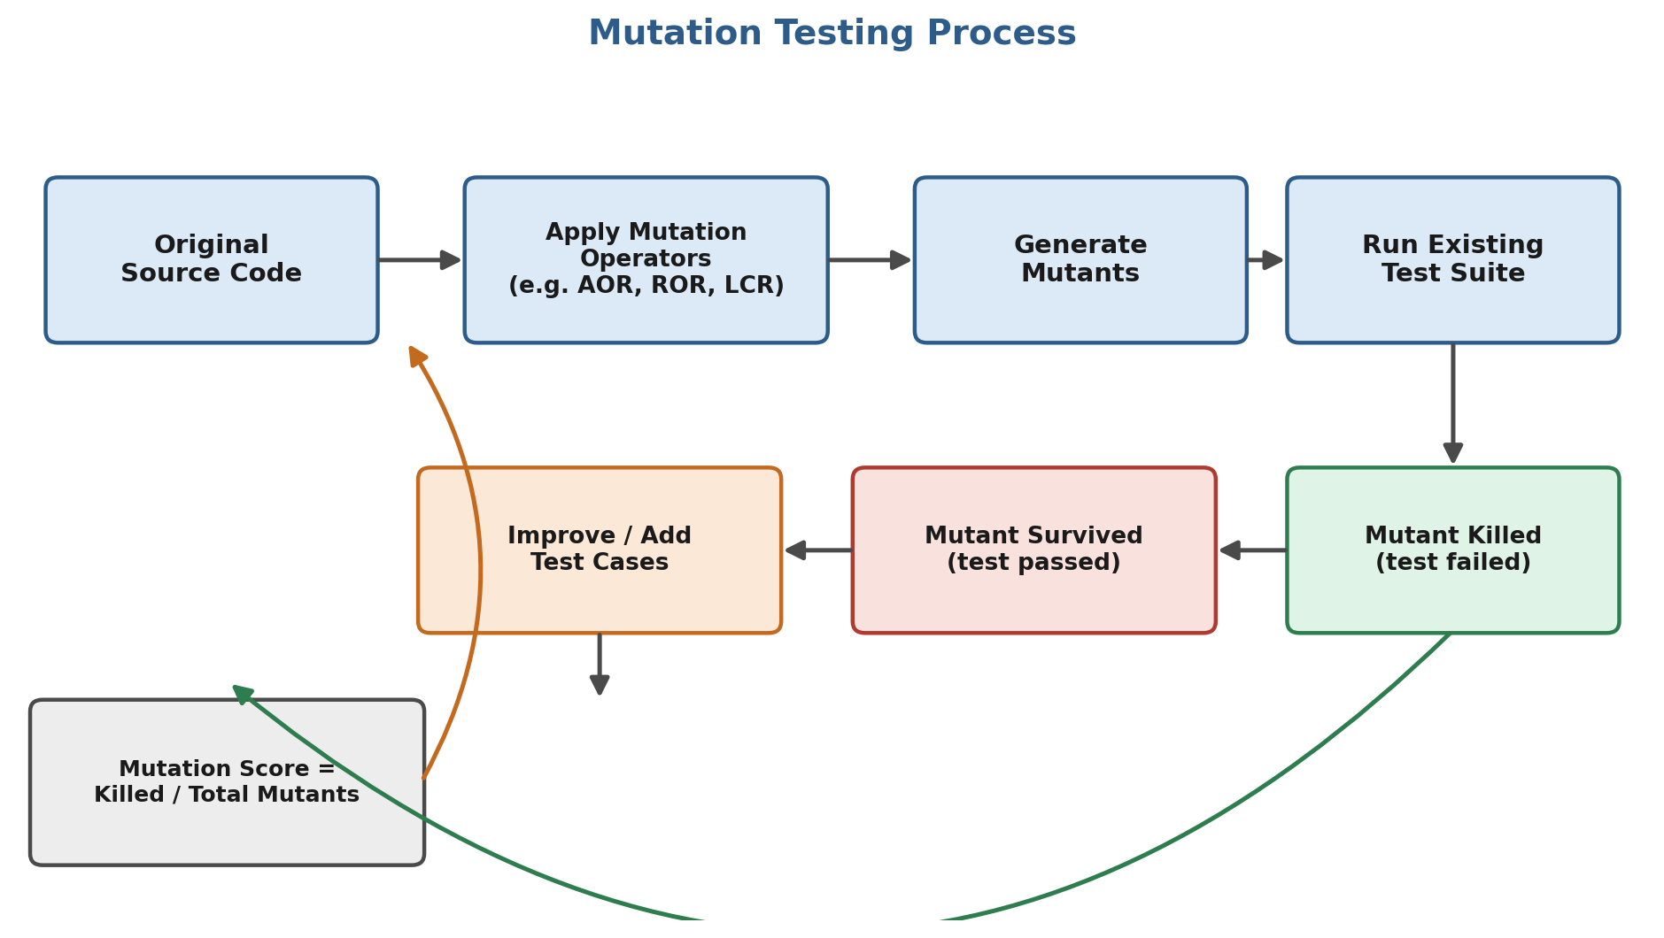
Figure 1.1 – Mutation Testing Process

1.2 Fuzz Testing
Fuzz Testing (or Fuzzing) is a dynamic testing technique, often used as black-box testing, that feeds a program with large volumes of random, malformed, or unexpected input data (“fuzz”) in order to uncover crashes, memory leaks, unhandled exceptions, and security vulnerabilities such as buffer overflows or injection flaws. Fuzzers can be:
- Generation-based — inputs are constructed from a defined grammar or protocol specification.
- Mutation-based — inputs are created by randomly mutating valid seed inputs (e.g., bit-flipping, byte-swapping).
- Coverage-guided — the fuzzer (e.g., AFL, libFuzzer) uses code-coverage feedback to evolve inputs that reach deeper program paths.
The general fuzz testing workflow is as follows:
- Seed corpus: A set of valid sample inputs is collected as the starting point.
- Input generation: The fuzzer mutates or generates new inputs from the seeds.
- Execution & monitoring: Each input is fed to the target program while the fuzzer monitors for crashes, hangs, assertion failures, or memory errors.
- Triage: Inputs that trigger anomalies are logged and saved for developers to analyze and fix the underlying defect.
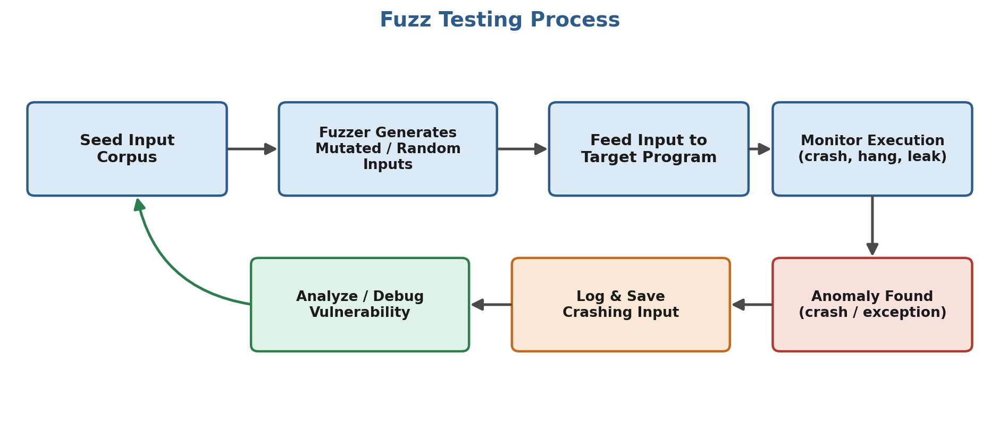
Figure 1.2 – Fuzz Testing Process

1.3 How These Techniques Enhance Reliability and Security
Aspect | Mutation Testing | Fuzz Testing
Primary Goal | Measures adequacy of the test suite itself | Discovers unknown defects/vulnerabilities in the program
Reliability Benefit | Ensures tests genuinely detect logical faults, not just achieve coverage | Exposes crashes and edge-case failures before release, improving robustness
Security Benefit | Indirectly improves security by forcing stronger tests around critical logic (e.g., authentication conditions) | Directly uncovers exploitable issues such as buffer overflows, injection points and unhandled exceptions
When Used | After a test suite is written, to assess and improve its quality | Continuously or before release, especially on components that parse external/untrusted input
Typical Tools | PIT (Java), MutPy (Python), Stryker (JS/.NET) | AFL/AFL++, libFuzzer, OSS-Fuzz, Peach Fuzzer

In combination, mutation testing raises confidence that the test suite will catch regressions introduced by future changes, while fuzz testing continuously probes the application with adversarial input to surface defects that structured test cases rarely cover. Using both techniques together therefore improves overall software reliability (fewer undetected logical bugs) and security (fewer exploitable vulnerabilities reaching production).

Q2. Key Stages of a CI/CD Pipeline and Docker for Continuous Delivery | 7 Marks | CO4

Continuous Integration/Continuous Delivery (CI/CD) is a DevOps practice that automates the process of building, testing, and deploying code so that changes can be released to users quickly, frequently, and reliably. Tools such as Jenkins and GitHub Actions automate this pipeline by triggering a defined sequence of stages whenever code is pushed to a repository.

2.1 Key Stages of a CI/CD Pipeline
- Source Stage: The pipeline is triggered by a source-control event — a git push or a pull request. Jenkins polls or receives a webhook from the SCM (e.g., GitHub, GitLab); GitHub Actions is triggered natively by repository events defined under the “on:” key of the workflow file.
- Build Stage: The source code is compiled and dependencies are installed/restored (e.g., mvn compile, npm install). This stage verifies that the codebase is buildable.
- Test Stage: Automated unit tests, integration tests, and static-analysis/linting checks are executed. A failure here stops the pipeline immediately, giving developers fast feedback (the core idea of Continuous Integration).
- Package Stage: The verified build is packaged into a deployable artifact — a JAR/WAR file, a zipped bundle, or, most commonly today, a Docker image that is tagged and pushed to a container registry (Docker Hub, Amazon ECR, GitHub Container Registry, etc.).
- Deploy Stage: The artifact/image is deployed to a target environment — first to a staging environment for further validation, and then, either automatically (Continuous Deployment) or after manual approval (Continuous Delivery), to production.
- Monitor & Feedback Stage: Post-deployment monitoring (health checks, logs, metrics) confirms the release is healthy and feeds information back to the team for the next iteration.
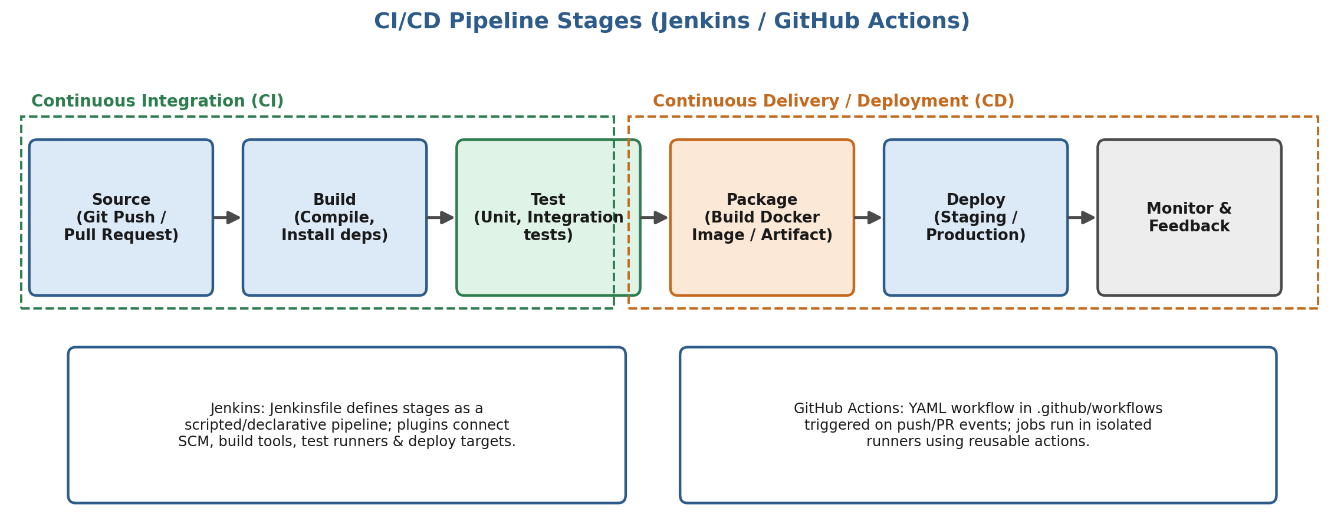
Figure 2.1 – CI/CD Pipeline Stages using Jenkins / GitHub Actions

2.2 Example Pipeline Definitions
A minimal declarative Jenkins pipeline (Jenkinsfile):
pipeline {
agent any
stages {
stage('Build') { steps { sh 'mvn clean compile' } }
stage('Test') { steps { sh 'mvn test' } }
stage('Package'){ steps { sh 'docker build -t myapp:${BUILD_NUMBER} .' } }
stage('Deploy') { steps { sh 'kubectl apply -f deployment.yaml' } }
}
}

An equivalent GitHub Actions workflow (.github/workflows/ci-cd.yml):
on: [push]
jobs:
build-test-deploy:
runs-on: ubuntu-latest
steps:
- uses: actions/checkout@v4
- run: mvn clean compile
- run: mvn test
- run: docker build -t myapp:${{ github.sha }} .
- run: kubectl apply -f deployment.yaml

2.3 How Docker Supports Continuous Delivery
Docker packages an application together with its runtime, libraries, and configuration into a lightweight, portable container image. Using Docker within the Package stage of the pipeline directly supports Continuous Delivery in several ways:
- Environment consistency — the same image that passed tests in CI runs unchanged in staging and production, eliminating “works on my machine” issues.
- Fast, isolated startup — containers start in seconds and run isolated from the host and from each other, enabling quick, parallel test/deploy cycles.
- Immutable, versioned artifacts — every image is tagged (e.g., with the commit SHA or build number), so a specific release can always be traced back and redeployed.
- Easy scaling and rollback — orchestrators such as Kubernetes or Docker Swarm can scale identical containers horizontally, and a bad release can be rolled back simply by redeploying the previous image tag.
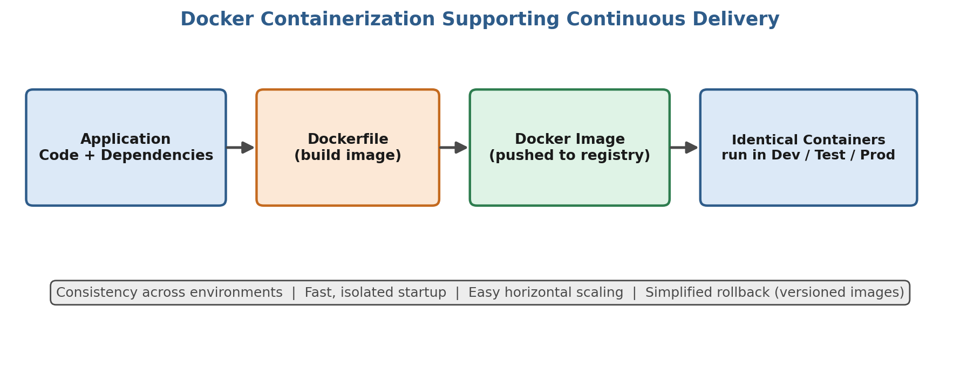
Figure 2.2 – Role of Docker Containerization in Continuous Delivery

Q3. Case Study – Intermittent Slowdowns in a Large SaaS Application | 7 Marks | CO4

Scenario: A large SaaS application serving thousands of concurrent users experiences intermittent slowdowns — response times occasionally spike, but the issue is not constant, making it hard to reproduce and diagnose using ad-hoc debugging alone. In such distributed, high-scale systems, dedicated monitoring and logging tools are essential to detect, diagnose, and resolve performance issues systematically.

3.1 Detection — Metrics Monitoring with Prometheus and Grafana
- Prometheus: Prometheus is an open-source monitoring system that periodically “scrapes” metrics (CPU usage, memory, request latency, error rate, queue length, etc.) from instrumented services and stores them as time-series data. Alerting rules can be defined so that Prometheus's Alertmanager automatically notifies the operations team (via email, Slack, PagerDuty, etc.) the moment latency or error rates cross a threshold — this is how the intermittent slowdown would first be detected in near real time, rather than through user complaints.
- Grafana: Grafana connects to Prometheus (and other data sources) to visualize these metrics as dashboards and graphs. Engineers can plot response-time percentiles (p95/p99), CPU/memory usage, and database query times over time, making it easy to visually correlate the slowdown spikes with specific services, time windows, or deployment events.

3.2 Diagnosis — Centralized Logging with the ELK Stack
Once metrics indicate that a slowdown is occurring, the ELK Stack (Elasticsearch, Logstash, Kibana) is used to drill down into the root cause:
- Logstash (with Filebeat/Beats agents): Collects, parses, and enriches log data from all application instances, servers, and microservices — centralizing logs that would otherwise be scattered across many machines.
- Elasticsearch: Indexes and stores the parsed logs, enabling fast, full-text search and aggregation across millions of log entries — for example, searching for all slow-query or timeout log lines within the exact time window a slowdown was observed in Grafana.
- Kibana: Provides a dashboard and search interface over Elasticsearch, allowing engineers to filter logs by service, correlate error spikes with the metric spikes seen in Grafana, and trace a slow request through multiple microservices to isolate the bottleneck (e.g., a slow database query, an overloaded downstream API, or a memory leak in a specific service).
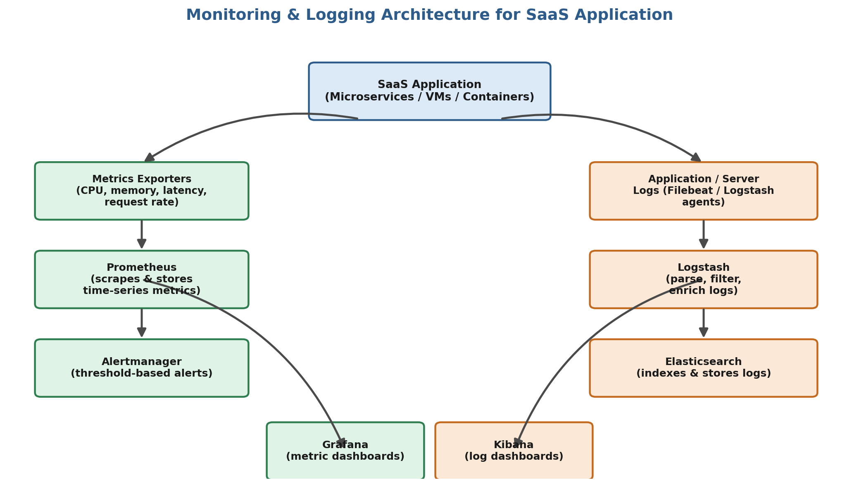
Figure 3.1 – Monitoring and Logging Architecture (Prometheus, Grafana, ELK Stack)

3.3 Resolution and Prevention
Combining both toolchains gives a structured detect → diagnose → resolve workflow:
Step | Tool(s) Used | Purpose
Detect | Prometheus + Alertmanager, Grafana | Continuously monitor metrics; trigger an alert as soon as latency/error thresholds are breached
Diagnose | Grafana dashboards, Kibana + Elasticsearch, Logstash | Correlate the time of the slowdown with resource metrics and search centralized logs to trace the request path and pinpoint the failing component
Resolve | Engineering fix + redeploy via CI/CD, Grafana/Kibana | Apply the fix (e.g., optimize a query, add caching, scale a service), redeploy, then confirm via dashboards that latency has returned to normal
Prevent | Prometheus alerting rules, Kibana saved searches | Add new alert rules/dashboards for the identified failure pattern so future recurrences are caught immediately

By pairing Prometheus/Grafana for real-time metrics monitoring with the ELK Stack for deep log-level diagnosis, the operations team can move from “users are complaining about slowness” to “service X's database query Y is timing out under load Z” within minutes rather than hours — allowing the intermittent performance issue to be detected, root-caused, and resolved efficiently, and preventing its recurrence through targeted alerts.

